DEPARTM ENT OF APPLIED SCIENCES (M ATHEM ATICS)

Assignment No. 2
Title of Co urse:Discrete Structures
Course Code: AML4209
Topic Name: Graph Theory

- Draw the directed graph G whose adjacency matrix is 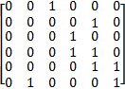
- For what value of m and n a complete bipartite graph k_{m,n} has an Hamilton’s circuit?
- Draw the directed graph G whose incidence matrix is 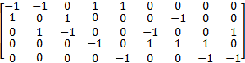
- Determine whether the given pair of graphs is isomorphic

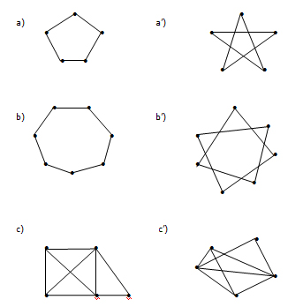
3. Represent these graph with an adjacency matrix a) K₆ b) K_{3,4}
4. a) Draw a complete bipartite gtraph which is not regular
b) Draw a graph which is regular but not bipartite
c) Construct a graph which is regular and bipartite.
5. a) Determine the number of edges in a graph with 6 nodes, 2 of degree 4 and 4 of degree 2. Draw two such graphs.
b) Is there exist a regular graph of degree 5 on 9 vertices?
6. Find the chromatic numbers of the following graph:
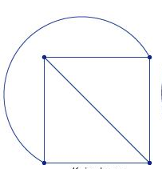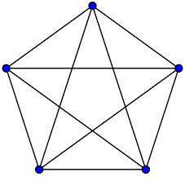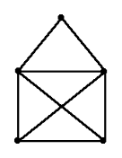

7. Use the Nearest-Neighbour method to solve the Travelling Salesman Problem, for the graphs as shown in figure:
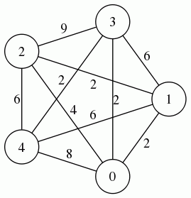
8. Find the circuit of minimum total weigh in a weighted, complete, undirected graph that visits each vertex exactly once and returns to its starting point
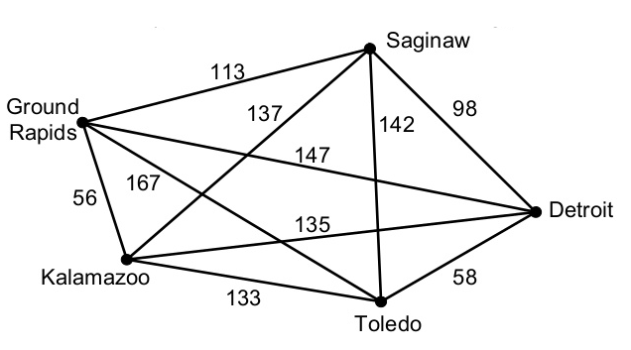

9. Disscuss Konigsberg Bridge Problem.
10. Construct a graph which is:
a) Hamiltionain but not Eulerian
b) Eulerian but not Hamiltonian
c) Eulerian as well as Hamiltonian
11. Suppose G=(V,E) is a simple undirected graph with no self-loop; moreover, the graph G has n=|V|≥1 vertices, m=|E| edges, k connected components, p odd cycles, q even cycles and chromatic number X
Determine if the following is true.
- if p+q=0, then m≤n−1
- if p=3, then X=2
- if the graph is planar, then X≥k
- if X=n, then m=n(n−1)/2
12. Draw all connected graphs of order 5 in which the distance between every two distinct vertices is odd. Explain why you know that you have drawn all such graphs.
13. Consider multigraphs G in figure,which of them are cycle-free.
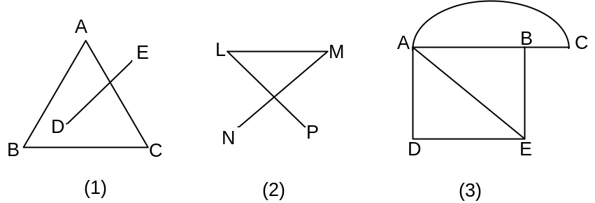

- Find the diameter of graph
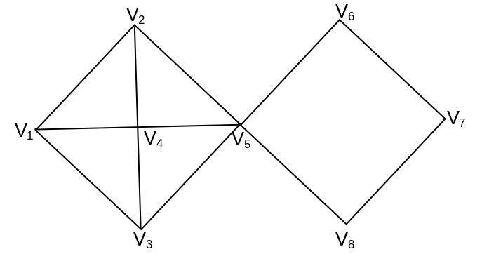
- 1) Find a Hamilton cycle of shortest total distance.
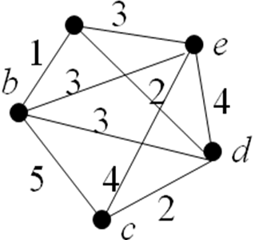
2) Draw the planar graphs of K₄ and K₅.

- A graph G has 21 edges, 3 vertices of degree 4 and other vertices are of degree 3. Find the number of vertices in G.
- Find the maximum number of edges possible in a planar graph with four vertices.
- Suppose that a connected graph has 30 edges. If a planar representation of this graph divides the plane into 20 regions, how many vertices does this graph have?
- Suppose that a graph has 7 vertices, each of degree 6. Into how many regions is the plane divided by planar representation of this graph.
- Determine whether it is possible to construct a graph with 12 edges such that 2 of the nodes have degree 3 and the remaining nodes have degree 4.
- a) Find the number of edges in a graph with 6 vertices, 4 of degree 2 and 2 of degree 3.
b) Draw two such graph which are not isomorphic.
- a) Can there be a graph with 8 vertices and 29 edges?
b) How many vertices are there in a graph with 10 edges if each vertex has degree 2?
c) Does there exists a graph with two vertices each of degree 4 ? If so draw it.
- Draw a multi-graph with four vertices and which is 5-regular graph.
- Which of the following sequences are graphical
- 6,5,5,4,3,3,2,2,2
- 4,3,2,2,1
- 5,5,3,3,2,2,2
- A salesman wants to visit cities 1, 2, 3 and 4. He does not want to visit any city twice before completing the tour of all the cities and wishes to return to his home city. The city cost of going from one city to another in rupees is given. Find the least cost route.
To city
 | 1 | 2 | 3 | 4
1 | 0 | 3 | 8 | 5
2 | 4 | 0 | 14 | 3
3 | 4 | 5 | 0 | 2
4 | 7 | 8 | 13 | 0

From city

