4 IMPLEMENTATION PHASE

4.1 CODING

Home.java

package BPO;

import java.awt.BorderLayout;
import java.awt.Color;
import java.awt.Font;
import java.awt.event.ActionEvent;
import java.awt.event.ActionListener;
import javax.swing.JButton;
import javax.swing.JFrame;
import javax.swing.JPanel;

public class Home
{
public static void main(String[] args)
{
JFrame frame = new JFrame();
frame.setTitle("BPO Management System");
JButton btnUSER = new JButton("\n USER \t"); btnUSER.setBounds(600,500,300,60); btnUSER.setBackground(Color.white);
btnUSER.setFont(new Font("Comic Sans MS", Font.BOLD, 20));
btnUSER.addActionListener(new ActionListener()
{
public void actionPerformed(ActionEvent e)
{
frame.dispose();
Logii u=new Logii();
u.main(null);
}

});

JButton btnADMIN= new JButton(" ADMIN \t");
btnADMIN.setBounds(600,400,300,60);
btnADMIN.setBackground(Color.white);
btnADMIN.setFont(new Font("Comic Sans MS", Font.BOLD, 20));
btnADMIN.addActionListener(new ActionListener()
{
public void actionPerformed(ActionEvent e)
{
frame.dispose();
Logi u1=new Logi();
u1.main(null);
}
});
JPanel buttonPanel = new JPanel( );
buttonPanel.add(btnUSER);
buttonPanel.add(btnADMIN);
frame.setDefaultCloseOperation(JFrame.EXIT_ON_CLOSE);
frame.setSize(2000, 2000);
frame.getContentPane( ).add(buttonPanel,BorderLayout.NORTH);
JButton btn = new JButton();
btn.setBackground(Color.blue);
btn.setForeground(Color.yellow);
frame.add(btn);
frame.setVisible(true);

}

}

ADMIN SIDE
Logi.java :
package BPO;
import javax.swing.*;
import java.awt.*;
import java.awt.event.*;
import java.sql.*;

public class Logi extends JFrame
{
/**
*
*/
private static final long serialVersionUID = 1L;
JButton SUBMIT;
JFrame f=new JFrame();
JLabel label1,label2;
JTextField text1;
JTextField text2;
Logi()
{
f.setTitle("Welcome !!!!");

f.getContentPane().setLayout(null);
f.setForeground(Color.pink);
label1 = new JLabel();
label1.setBackground(Color.blue);
label1.setText("USERNAME:");
label1.setBounds(500,70,130,20);
label1.setFont(new Font("Comic Sans MS", Font.BOLD, 15));
text1 = new JTextField(25);
text1.setBounds(600,70,150,20);

label2 = new JLabel();
label2.setBackground(Color.blue);

label2.setText("PASSWORD:");
label2.setBounds(500,100,130,20);
label2.setFont(new Font("Comic Sans MS", Font.BOLD, 15));

text2 = new JPasswordField(25);
text2.setBounds(600,100,150,20);

SUBMIT=new JButton("LOGIN");
SUBMIT.setBounds(480,500,300,60);
SUBMIT.setBackground(Color.white);
SUBMIT.setForeground(Color.blue);
SUBMIT.setFont(new Font("Comic Sans MS", Font.BOLD, 20));
f.add(label1);
f.add(text1);
f.add(label2);
f.add(text2);
f.add(SUBMIT);
f.setSize(3500,3500);

f.setTitle("BPO Management System-Welcome !!!!");

f.setVisible(true);

SUBMIT.addActionListener(new ActionListener()
{
public void actionPerformed(ActionEvent ae)

{
String value1=text1.getText();
String value2=text2.getText();

String user1="";
String pass1="";
String user2="";
String pass2="";
try

{

Class.forName ("oracle.jdbc.OracleDriver");
Connectioncon=DriverManager.getConnection("jdbc:oracle:thin:@kavithaprabhu:1521:orcl","system","preethi");
Statement st = con.createStatement();

ResultSet res = st.executeQuery("SELECT * FROM Logi where name='"+value1+"' and pass='"+value2+"'");

while (res.next())

{
user1 = res.getString("name");
pass1 = res.getString("pass");

}

if(value1.equals(user2) && value2.equals(pass2))

{
JOptionPane.showMessageDialog(null,"Incorrect login or password","Error",JOptionPane.ERROR_MESSAGE);
}

else if(value1.equals(user1) && value2.equals(pass1))

{
System.out.println("check");

f.dispose();
Customer b1=new Customer();
b1.main(null);

}
else

{
JOptionPane.showMessageDialog(null,"Incorrect login or password","Error",JOptionPane.ERROR_MESSAGE);

}

}

catch(Exception e)
{

System.out.println(e.getMessage());
}

}
});

}

public static void main(String[] args) {
// TODO Auto-generated method stub
Logi l=new Logi();
}
}
Customer.java:
package BPO;
import javax.swing.*;
import java.awt.*;
import java.awt.event.*;
import java.sql.*;
import java.util.Vector;

public class Customer extends JFrame implements ActionListener
{
/**
*
*/
private static final long serialVersionUID = 1L;
JLabel l, l1, l2, l3, l4, l5;
JButton b,SUBMIT;
JTextField tf1, tf2, tf3;
JTextField tf4;
JComboBox<String> bx;
String str;
Customer()
{
setVisible(true);
setSize(3700, 3700);
setLayout(null);
setDefaultCloseOperation(JFrame.EXIT_ON_CLOSE);
setTitle("JDBC DEMO");
l = new JLabel("Select Name:");
b = new JButton("Submit");
tf1 = new JTextField();
tf2 = new JTextField();
tf3 = new JTextField();
tf4 = new JTextField();
l.setBounds(520, 120, 200, 20);
b.setBounds(550, 150, 150, 30);
add(l);
add(b);

tf1.setEditable(false);
tf2.setEditable(false);
tf3.setEditable(false);
tf4.setEditable(false);
b.addActionListener(this);
try
{
Class .forName("oracle.jdbc.driver.OracleDriver");
Connection con = DriverManager.getConnection("jdbc:oracle:thin:@kavithaprabhu:1521:orcl", "system", "preethi");
PreparedStatement ps = con.prepareStatement("select name from custo");
ResultSet rs = ps.executeQuery();
Vector v = new Vector();
while (rs.next()) {
String s = rs.getString(1);
v.add(s);
}
bx = new JComboBox(v);
bx.setBounds(700, 120, 200, 20);
add(bx);
}
catch (Exception ex)
{
System.out.println(ex);
}
}
public void actionPerformed(ActionEvent e)
{
JFrame f1 = new JFrame();
f1.setVisible(true);
f1.setSize(4000, 4000);
f1.setLayout(null);
f1.setTitle("JDBC DEMO");
l5 = new JLabel("Displaying Customer Data:");
l5.setForeground(Color.red);
l5.setFont(new Font("Serif", Font.BOLD, 20));
l1 = new JLabel("Customer Name:");
l2 = new JLabel("Customer Address:");
l3 = new JLabel("Customer Email_id:");
l4 = new JLabel("Customer Phone_No:");
SUBMIT=new JButton("MAKE A CALL");

SUBMIT.addActionListener(new ActionListener()
{
public void actionPerformed(ActionEvent e)
{
f1.dispose();
Proceed u=new Proceed();
u.main(null);
}

});

l5.setBounds(400, 50, 300, 30);
l1.setBounds(400, 110, 200, 20);
l2.setBounds(400, 140, 200, 20);
l3.setBounds(400, 170, 200, 20);
l4.setBounds(400, 200, 200, 20);
tf1.setBounds(600, 110, 200, 20);
tf2.setBounds(600, 140, 200, 20);
tf3.setBounds(600, 170, 200, 20);
tf4.setBounds(600, 200, 200, 20);
SUBMIT.setBounds(410,400,400,80);
f1.add(l5);
f1.add(l1);
f1.add(tf1);
f1.add(l2);
f1.add(tf2);
f1.add(l3);
f1.add(tf3);
f1.add(l4);
f1.add(tf4);
f1.add(SUBMIT);

str = (String) bx.getSelectedItem();
try {
Class .forName("oracle.jdbc.driver.OracleDriver");
Connection con = DriverManager.getConnection("jdbc:oracle:thin:@kavithaprabhu:1521:orcl", "system", "preethi");
PreparedStatement ps = con.prepareStatement("select * from custo where name=?");
ps.setString(1, str);
ResultSet rs = ps.executeQuery();
while (rs.next()) {
tf1.setText(rs.getString(1));
tf2.setText(rs.getString(2));
tf3.setText(rs.getString(3));
tf4.setText(rs.getString(4));
}
}

catch (Exception ex) {
System.out.println(ex);
}
}

public static void main(String[] args) {
// TODO Auto-generated method stub
Customer c=new Customer();
}

}
Proceed.java:
package BPO;
import javax.swing.*;

import java.awt.*;
import java.awt.event.*;
import java.sql.*;

public class Proceed extends JFrame
{
/**
*
*/
private static final long serialVersionUID = 1L;
JButton SUBMIT;
JFrame f;
JLabel l1;

Proceed()
{
f=new JFrame();
f.getContentPane().setLayout(null);
l1=new JLabel();
l1.setText("CALL CONNECTED TO THE CUSTOMER ;PROCEED TO THE ANOTHER CUSTOMER" );
l1.setBounds(500,80,800,20);
SUBMIT=new JButton("PROCEED");
SUBMIT.setBounds(800,200,100,20);
f.add(l1);
f.add(SUBMIT);
f.setSize(4000,4000);
f.setVisible(true);
f.setTitle("BPO Management System");
SUBMIT.addActionListener(new ActionListener()
{
public void actionPerformed(ActionEvent a)
{
String action=a.getActionCommand();
if(action.equals("PROCEED"))
f.dispose();
Prod c=new Prod();
c.main(null);
}
});

}

public static void main(String[] args) {
// TODO Auto-generated method stub
Proceed p=new Proceed();

}
}

Prod.java:
package BPO;

import java.awt.Color;
import java.awt.Font;
import java.awt.event.ActionEvent;
import java.awt.event.ActionListener;
import java.sql.Connection;
import java.sql.DriverManager;
import java.sql.PreparedStatement;
import java.sql.ResultSet;
import java.util.Vector;
import javax.swing.JButton;
import javax.swing.JComboBox;
import javax.swing.JFrame;
import javax.swing.JLabel;
import javax.swing.JTextField;

public class Prod extends JFrame implements ActionListener
{
private static final long serialVersionUID = 1L;
JLabel l, l1, l2, l3, l4, l5;
JButton b,SUBMIT;
JTextField tf1, tf2, tf3;
JTextField tf4;
JComboBox<String> bx;
String str;
Prod()
{
setVisible(true);
setSize(3700, 3700);
setLayout(null);
setDefaultCloseOperation(JFrame.EXIT_ON_CLOSE);
setTitle("JDBC DEMO");
l = new JLabel("Available Products");
b = new JButton("Submit");
tf1 = new JTextField();
tf2 = new JTextField();
tf3 = new JTextField();
tf4 = new JTextField();
l.setBounds(520, 120, 200, 20);
b.setBounds(550, 150, 150, 30);
add(l);
add(b);

tf1.setEditable(false);
tf2.setEditable(false);
tf3.setEditable(false);
tf4.setEditable(false);
b.addActionListener(this);
try
{
Class .forName("oracle.jdbc.driver.OracleDriver");
Connection con = DriverManager.getConnection("jdbc:oracle:thin:@kavithaprabhu:1521:orcl", "system", "preethi");
PreparedStatement ps = con.prepareStatement("select name from product");
ResultSet rs = ps.executeQuery();
Vector v = new Vector();
while (rs.next()) {
String s = rs.getString(1);
v.add(s);
}
bx = new JComboBox(v);
bx.setBounds(700, 120, 200, 20);
add(bx);
}
catch (Exception ex)
{
System.out.println(ex);
}
}
public void actionPerformed(ActionEvent e)
{
JFrame f1 = new JFrame();
f1.setVisible(true);
f1.setSize(4000, 4000);
f1.setLayout(null);
f1.setTitle("JDBC DEMO");
l5 = new JLabel("Displaying Product Data:");
l5.setForeground(Color.red);
l5.setFont(new Font("Serif", Font.BOLD, 20));
l1 = new JLabel("Product Name:");
l2 = new JLabel("Product Address:");
l3 = new JLabel("Product Email_id:");
l4 = new JLabel("Product Phone_No:");
SUBMIT=new JButton("Sell");

SUBMIT.addActionListener(new ActionListener()
{
public void actionPerformed(ActionEvent e)
{
f1.dispose();
Sold u=new Sold();
u.main(null);
}

});

l5.setBounds(400, 50, 300, 30);
l1.setBounds(400, 110, 200, 20);
l2.setBounds(400, 140, 200, 20);
l3.setBounds(400, 170, 200, 20);
l4.setBounds(400, 200, 200, 20);
tf1.setBounds(600, 110, 200, 20);
tf2.setBounds(600, 140, 200, 20);
tf3.setBounds(600, 170, 200, 20);
tf4.setBounds(600, 200, 200, 20);
SUBMIT.setBounds(410,400,400,80);
f1.add(l5);
f1.add(l1);
f1.add(tf1);
f1.add(l2);
f1.add(tf2);
f1.add(l3);
f1.add(tf3);
f1.add(l4);
f1.add(tf4);
f1.add(SUBMIT);

str = (String) bx.getSelectedItem();
try {
Class .forName("oracle.jdbc.driver.OracleDriver");
Connection con = DriverManager.getConnection("jdbc:oracle:thin:@kavithaprabhu:1521:orcl", "system", "preethi");
PreparedStatement ps = con.prepareStatement("select * from product where name=?");
ps.setString(1, str);
ResultSet rs = ps.executeQuery();
while (rs.next()) {
tf1.setText(rs.getString(1));
tf2.setText(rs.getString(2));
tf3.setText(rs.getString(3));
tf4.setText(rs.getString(4));
}
}

catch (Exception ex) {
System.out.println(ex);
}

}
public static void main(String[] args) {
// TODO Auto-generated method stub
Prod p=new Prod();
}
}

Sold.java:
package BPO;

import java.awt.event.ActionEvent;
import java.awt.event.ActionListener;
import javax.swing.JButton;
import javax.swing.JFrame;
import javax.swing.JLabel;

public class Sold {
private static final long serialVersionUID = 1L;
JButton SUBMIT;
JFrame f;
JLabel l1;

Sold()
{
f=new JFrame();
f.getContentPane().setLayout(null);
l1=new JLabel();
l1.setText(" CUSTOMER Satisfied and Bought the Product" );
l1.setBounds(500,80,800,20);
SUBMIT=new JButton("Logout");
SUBMIT.setBounds(800,200,100,20);
f.add(l1);
f.add(SUBMIT);
f.setSize(4000,4000);
f.setVisible(true);
f.setTitle("BPO Management System");
SUBMIT.addActionListener(new ActionListener()
{
public void actionPerformed(ActionEvent a)
{
String action=a.getActionCommand();
if(action.equals("Logout"))
f.dispose();
Logi c=new Logi();
c.main(null);
}
});

}

public static void main(String[] args) {

// TODO Auto-generated method stub

Sold s=new Sold();

}
}
USER SIDE
Logii.java:
package BPO;

import java.awt.Color;
import java.awt.Font;
import java.awt.event.ActionEvent;
import java.awt.event.ActionListener;
import java.sql.Connection;
import java.sql.DriverManager;
import java.sql.ResultSet;
import java.sql.Statement;
import javax.swing.JButton;
import javax.swing.JFrame;
import javax.swing.JLabel;
import javax.swing.JOptionPane;
import javax.swing.JPasswordField;
import javax.swing.JTextField;

public class Logii extends JFrame {
private static final long serialVersionUID = 1L;
JButton SUBMIT;
JFrame f=new JFrame();
JLabel label1,label2;
JTextField text1;
JTextField text2;

Logii()

{

f.setTitle("Welcome !!!!");
f.getContentPane().setLayout(null);
f.setForeground(Color.pink);
label1 = new JLabel();
label1.setBackground(Color.blue);
label1.setText("USERNAME:");
label1.setBounds(500,70,130,20);
label1.setFont(new Font("Comic Sans MS", Font.BOLD, 15));
text1 = new JTextField(25);
text1.setBounds(600,70,150,20);
label2 = new JLabel();
label2.setBackground(Color.blue);
label2.setText("PASSWORD:");
label2.setBounds(500,100,130,20);
label2.setFont(new Font("Comic Sans MS", Font.BOLD, 15));
text2 = new JPasswordField(25);
text2.setBounds(600,100,150,20);
SUBMIT=new JButton("LOGIN");
SUBMIT.setBounds(480,500,300,60);
SUBMIT.setBackground(Color.white);
SUBMIT.setForeground(Color.blue);
SUBMIT.setFont(new Font("Comic Sans MS", Font.BOLD, 20));
f.add(label1);
f.add(text1);
f.add(label2);
f.add(text2);
f.add(SUBMIT);
f.setSize(3500,3500);
f.setTitle("BPO Management System-Welcome !!!!");
f.setVisible(true);

SUBMIT.addActionListener(new ActionListener()
{
public void actionPerformed(ActionEvent ae)

{
String value1=text1.getText();
String value2=text2.getText();

String user1="";
String pass1="";
String user2="";
String pass2="";
try

{

Class.forName ("oracle.jdbc.OracleDriver");
Connection con = DriverManager.getConnection("jdbc:oracle:thin:@kavithaprabhu:1521:orcl","system","preethi");
Statement st = con.createStatement();

ResultSet res = st.executeQuery("SELECT * FROM logii where name='"+value1+"' and pass='"+value2+"'");

while (res.next())

{
user1 = res.getString("name");
pass1 = res.getString("pass");

}

if(value1.equals(user2) && value2.equals(pass2))

{
JOptionPane.showMessageDialog(null,"Incorrect login or password","Error",JOptionPane.ERROR_MESSAGE);
}

else if(value1.equals(user1) && value2.equals(pass1))

{
System.out.println("check");

f.dispose();
Userd b1=new Userd();
b1.main(null);

}
else

{
JOptionPane.showMessageDialog(null,"Incorrect login or password","Error",JOptionPane.ERROR_MESSAGE);

}

}

catch(Exception e)
{

System.out.println(e.getMessage());
}

}
});

}

public static void main(String[] args) {
// TODO Auto-generated method stub
Logii l=new Logii();
}

}
Userd.java:
package BPO;

import java.awt.Color;
import java.awt.Font;
import java.awt.event.ActionEvent;
import java.awt.event.ActionListener;
import java.sql.Connection;
import java.sql.DriverManager;
import java.sql.PreparedStatement;
import java.sql.ResultSet;
import java.util.Vector;
import javax.swing.JButton;
import javax.swing.JComboBox;
import javax.swing.JFrame;
import javax.swing.JLabel;
import javax.swing.JTextField;

public class Userd extends JFrame implements ActionListener
{
private static final long serialVersionUID = 1L;
JLabel l, l1, l2, l3, l4, l5;
JButton b,SUBMIT;
JTextField tf1, tf2, tf3;
JTextField tf4;
JComboBox<String> bx;
String str;

Userd()
{
setVisible(true);
setSize(3700, 3700);
setLayout(null);
setDefaultCloseOperation(JFrame.EXIT_ON_CLOSE);
setTitle("JDBC DEMO");
l = new JLabel("Select Your Name:");
b = new JButton("Submit");
tf1 = new JTextField();
tf2 = new JTextField();
tf3 = new JTextField();
tf4 = new JTextField();
l.setBounds(520, 120, 200, 20);
b.setBounds(550, 150, 150, 30);
add(l);
add(b);

tf1.setEditable(false);
tf2.setEditable(false);
tf3.setEditable(false);
tf4.setEditable(false);
b.addActionListener(this);
try
{
Class .forName("oracle.jdbc.driver.OracleDriver");
Connection con = DriverManager.getConnection("jdbc:oracle:thin:@kavithaprabhu:1521:orcl", "system", "preethi");
PreparedStatement ps = con.prepareStatement("select name from custo");
ResultSet rs = ps.executeQuery();
Vector v = new Vector();
while (rs.next()) {
String s = rs.getString(1);
v.add(s);
}
bx = new JComboBox(v);
bx.setBounds(700, 120, 200, 20);
add(bx);
}
catch (Exception ex)
{
System.out.println(ex);
}
}
public void actionPerformed(ActionEvent e)
{
JFrame f1 = new JFrame();
f1.setVisible(true);
f1.setSize(4000, 4000);
f1.setLayout(null);
f1.setTitle("User Page");
l5 = new JLabel("Displaying Your Data:");
l5.setForeground(Color.red);
l5.setFont(new Font("Serif", Font.BOLD, 20));
l1 = new JLabel(" Name:");
l2 = new JLabel(" Address:");
l3 = new JLabel(" Email_id:");
l4 = new JLabel(" Phone_No:");
SUBMIT=new JButton("BACK");

SUBMIT.addActionListener(new ActionListener()
{
public void actionPerformed(ActionEvent e)
{
f1.dispose();
Home u=new Home();
u.main(null);
}

});

l5.setBounds(400, 50, 300, 30);
l1.setBounds(400, 110, 200, 20);
l2.setBounds(400, 140, 200, 20);
l3.setBounds(400, 170, 200, 20);
l4.setBounds(400, 200, 200, 20);
tf1.setBounds(600, 110, 200, 20);
tf2.setBounds(600, 140, 200, 20);
tf3.setBounds(600, 170, 200, 20);
tf4.setBounds(600, 200, 200, 20);
SUBMIT.setBounds(410,400,400,80);
f1.add(l5);
f1.add(l1);
f1.add(tf1);
f1.add(l2);
f1.add(tf2);
f1.add(l3);
f1.add(tf3);
f1.add(l4);
f1.add(tf4);
f1.add(SUBMIT);

str = (String) bx.getSelectedItem();
try {
Class .forName("oracle.jdbc.driver.OracleDriver");
Connection con = DriverManager.getConnection("jdbc:oracle:thin:@kavithaprabhu:1521:orcl", "system", "preethi");
PreparedStatement ps = con.prepareStatement("select * from custo where name=?");
ps.setString(1, str);
ResultSet rs = ps.executeQuery();
while (rs.next()) {
tf1.setText(rs.getString(1));
tf2.setText(rs.getString(2));
tf3.setText(rs.getString(3));
tf4.setText(rs.getString(4));
}
}

catch (Exception ex) {
System.out.println(ex);
}
}

public static void main(String[] args) {
// TODO Auto-generated method stub
Userd u=new Userd();

}
}

OUTPUT SCREENSHOTS:
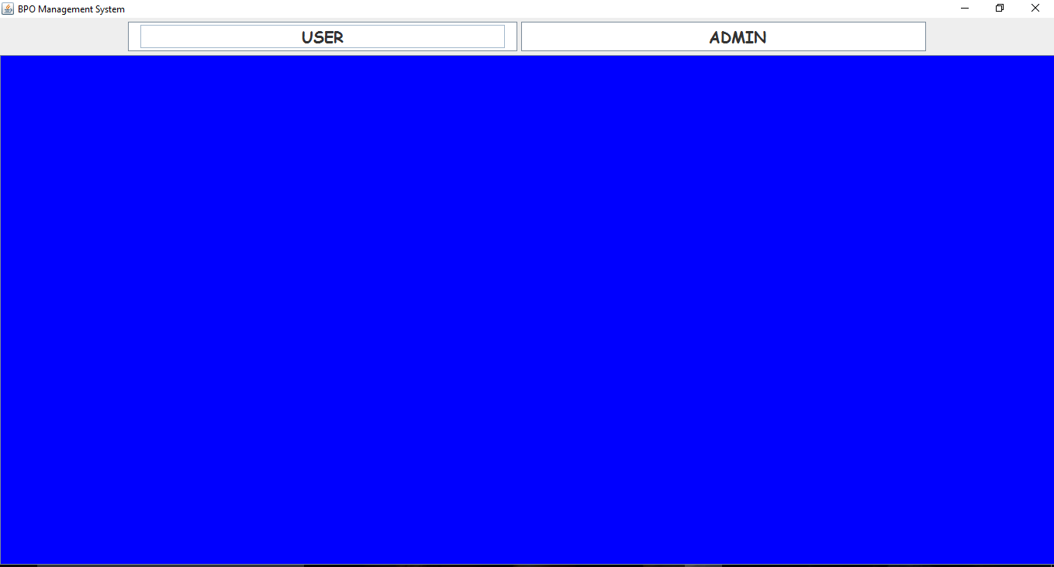

ADMIN SIDE:
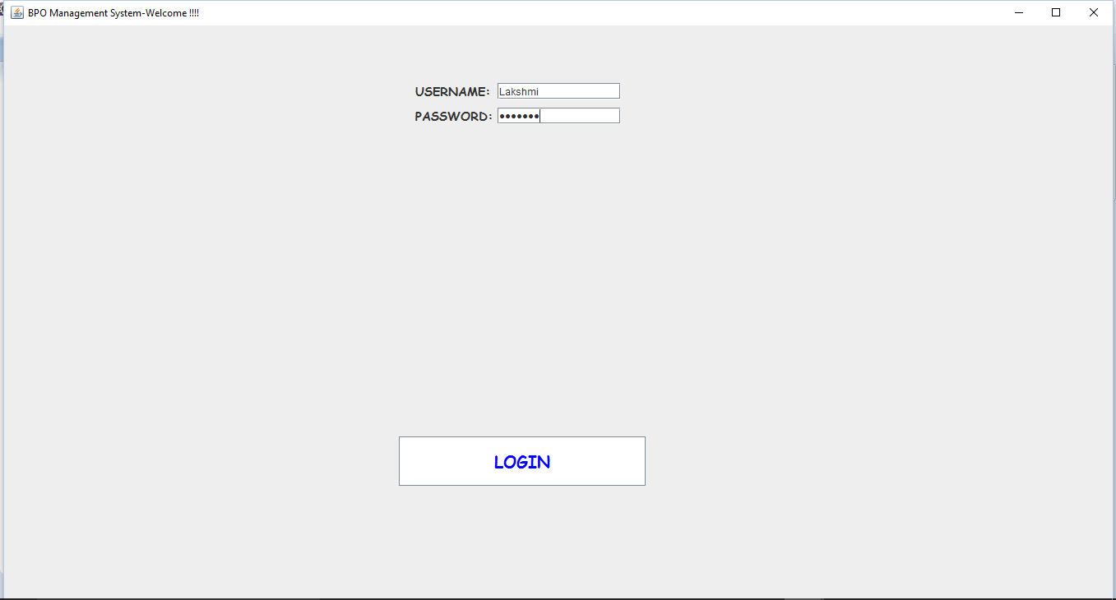
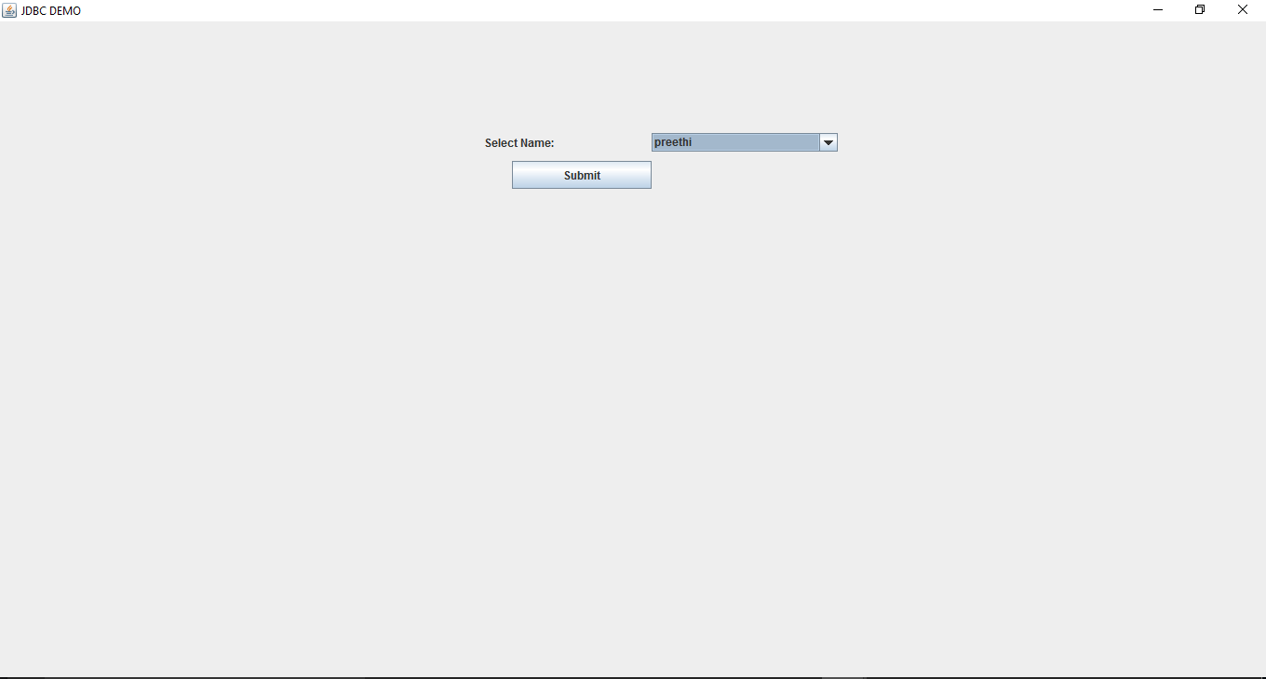
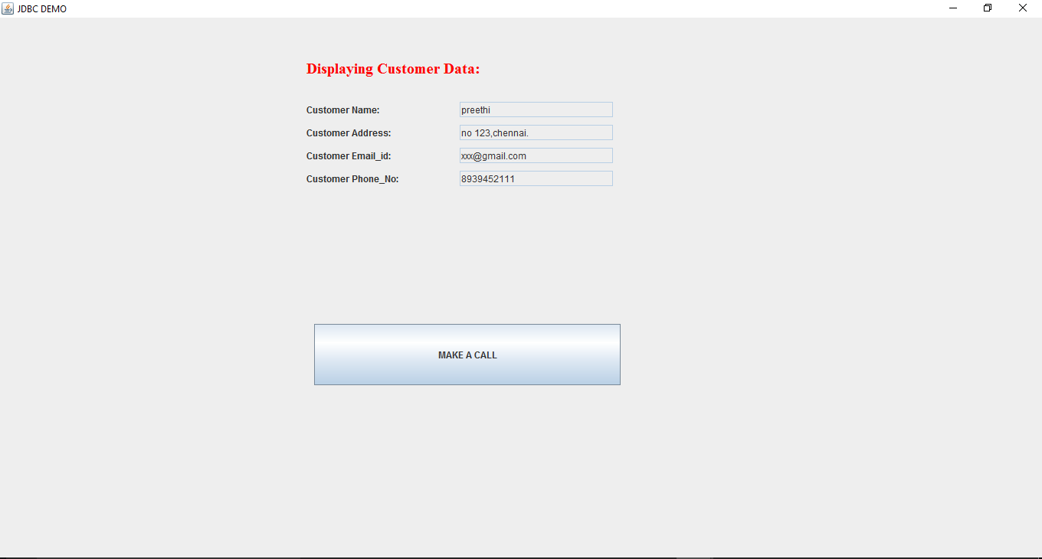
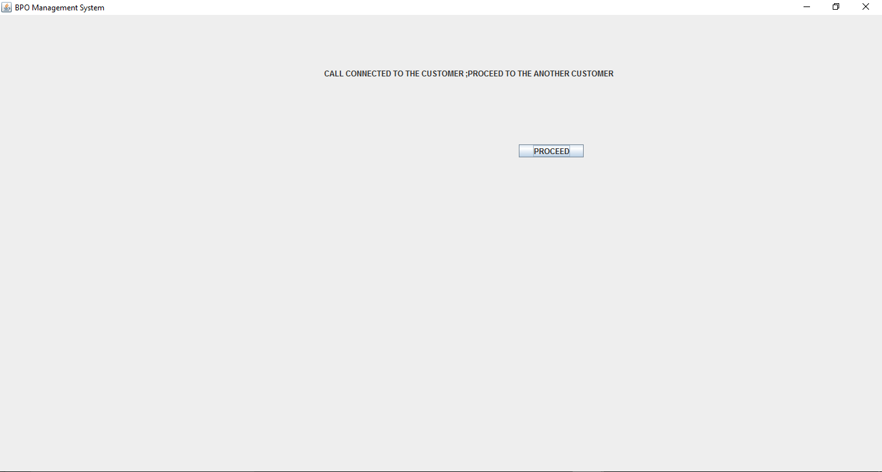
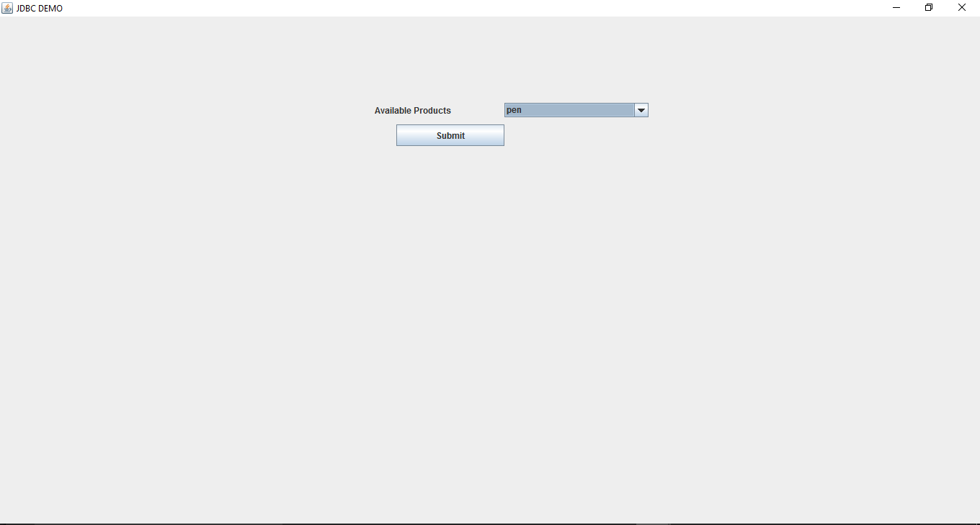
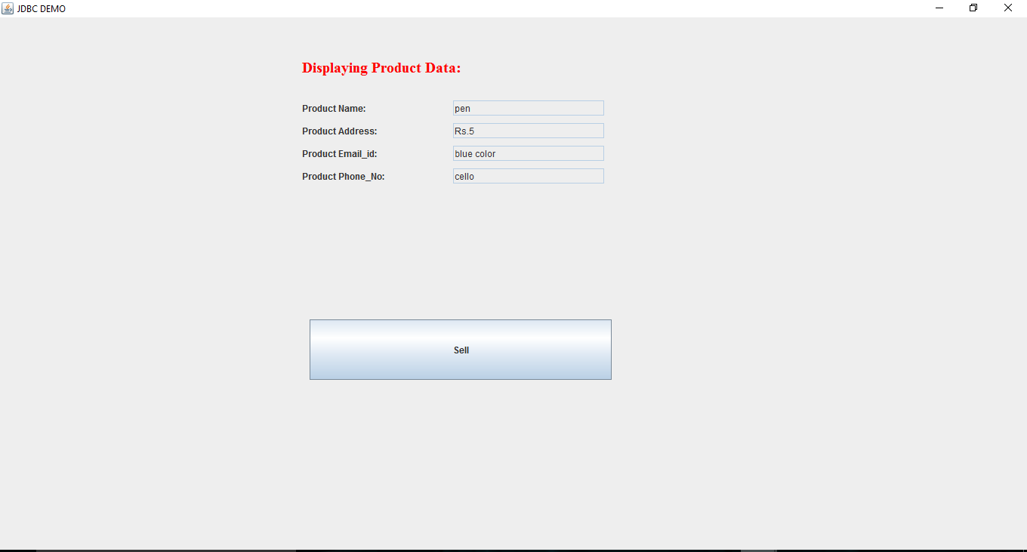

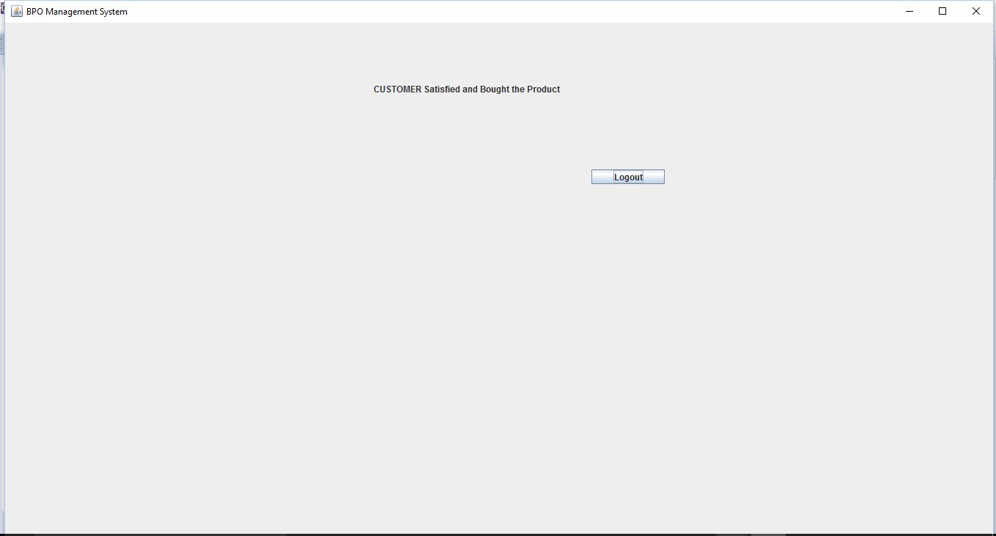

USER SIDE:
