5/12 FYP meeting

Attendees:

Henry, DB62607

Roy, DB625396

Professor Yuan Wu.

Finished items (from the last meeting notes)

Draft function.

Discussion

What should we focus on?

Challenges:

Implement a samplee demo with basic function.

Schedule:

Implement:

1. Invite member function.

2. Scope project function.

3. A function allow to create a question with tags.

User Interface:

Sign up: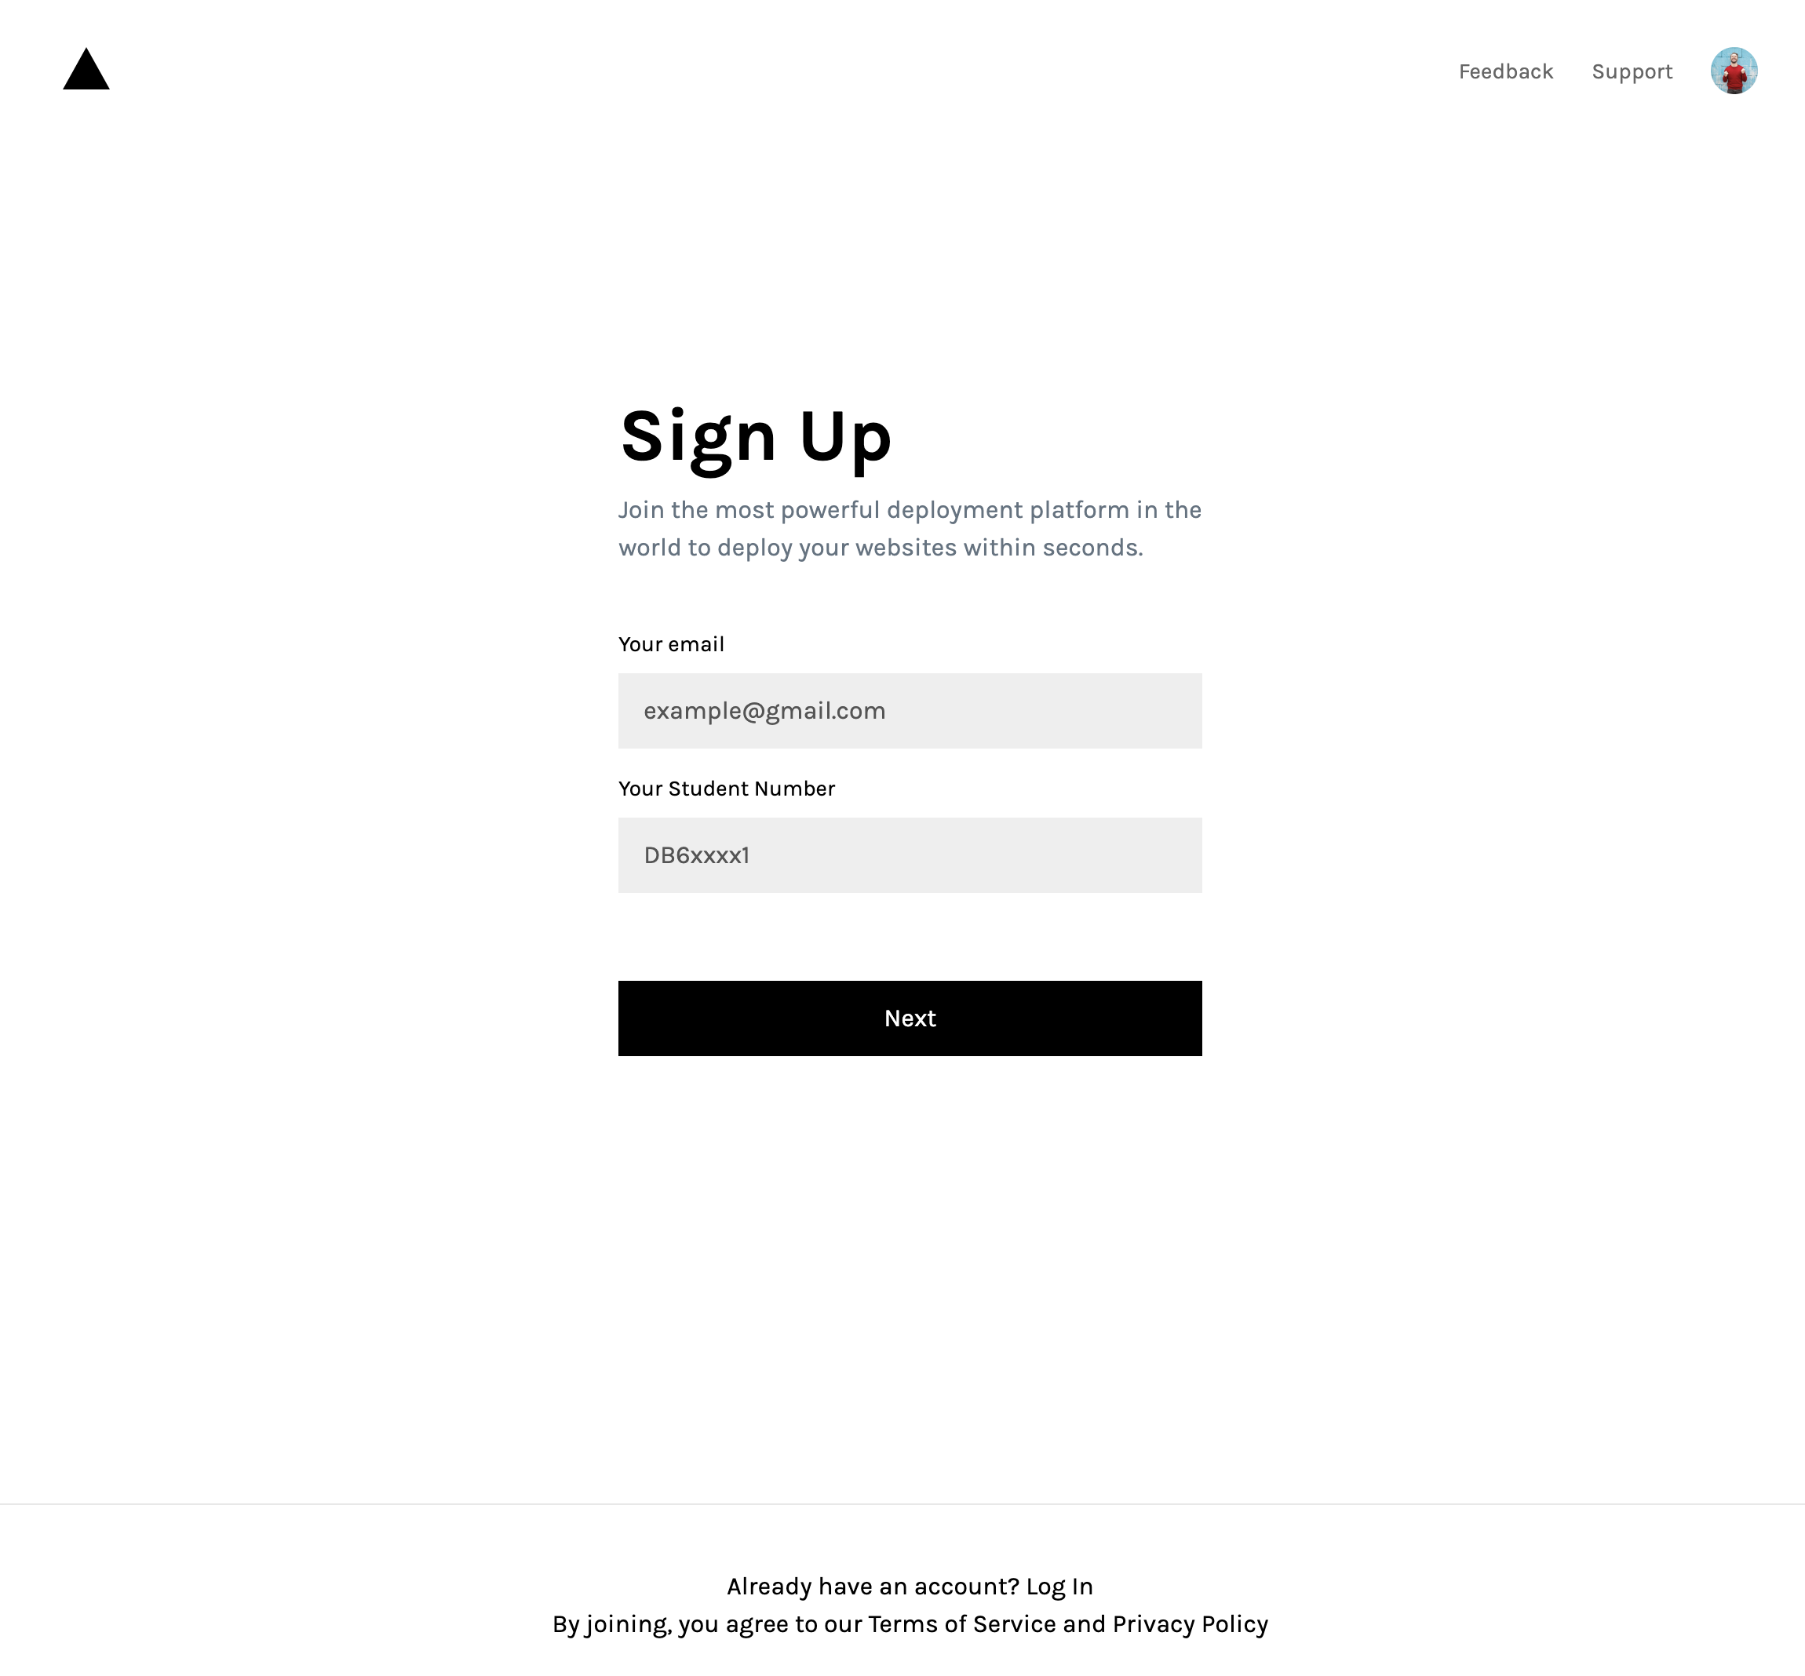

Home Page:

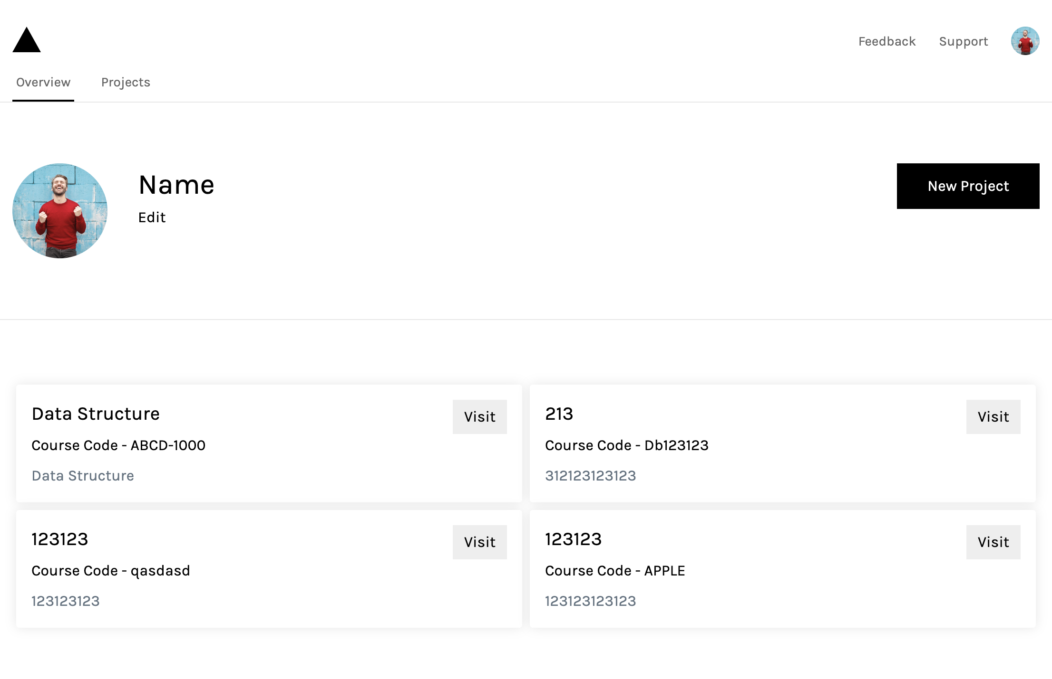

Course Page:

