15/10 FYP meeting

Attendees:

Henry, DB62607

Roy, DB625396

Professor Yuan Wu.

Finished items (from the last meeting notes)

Find the reference modal at least two and list all the points of our project and compare it to another product which is similar of us and list the difference.:

1. ummoodle: <https://ummoodle.um.edu.mo>
2. stackoverflow: <https://stackoverflow.com>
3. Discourse: <https://discourse.org/>

Discussion

Discuss what is the similar product on the market? What is the difference? What is the main features in this project? What is the advantage of our product?

Challenges:

Oct Timeline:

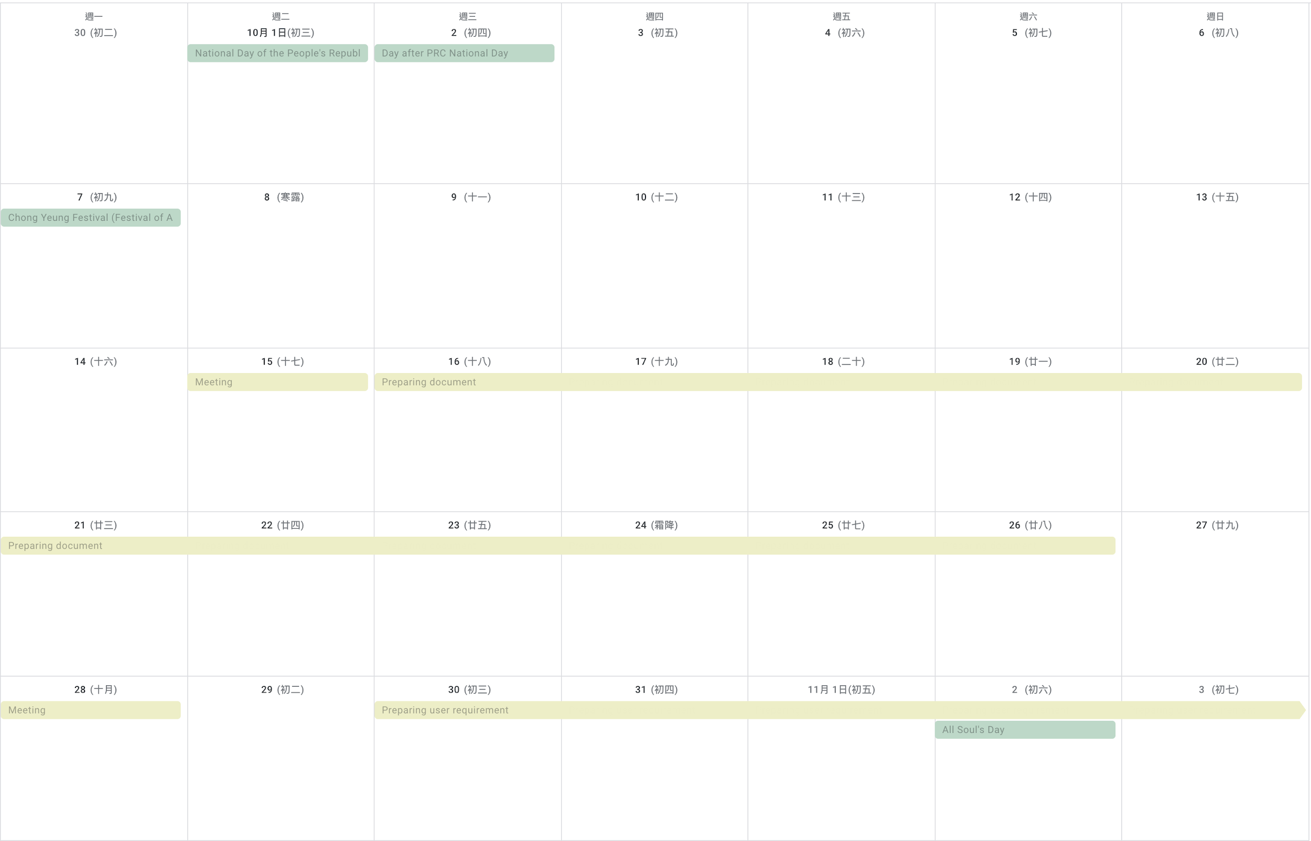

Schedule:

Planning and preparing a simple document before the next meeting.