15/11 FYP meeting

Attendees:

Henry, DB62607

Roy, DB625396

Professor Yuan Wu.

Finished items (from the last meeting notes)

Discussion

1. Group function

2. Announce hw function

3. Submit function

4. Data analysis(the main function)

5. Machine learning(Classification problem)

Challenges:

Improvements the function in basic demo

Schedule:

Improvement the group function, announce assignment function and submit function,after prepare for machine learning for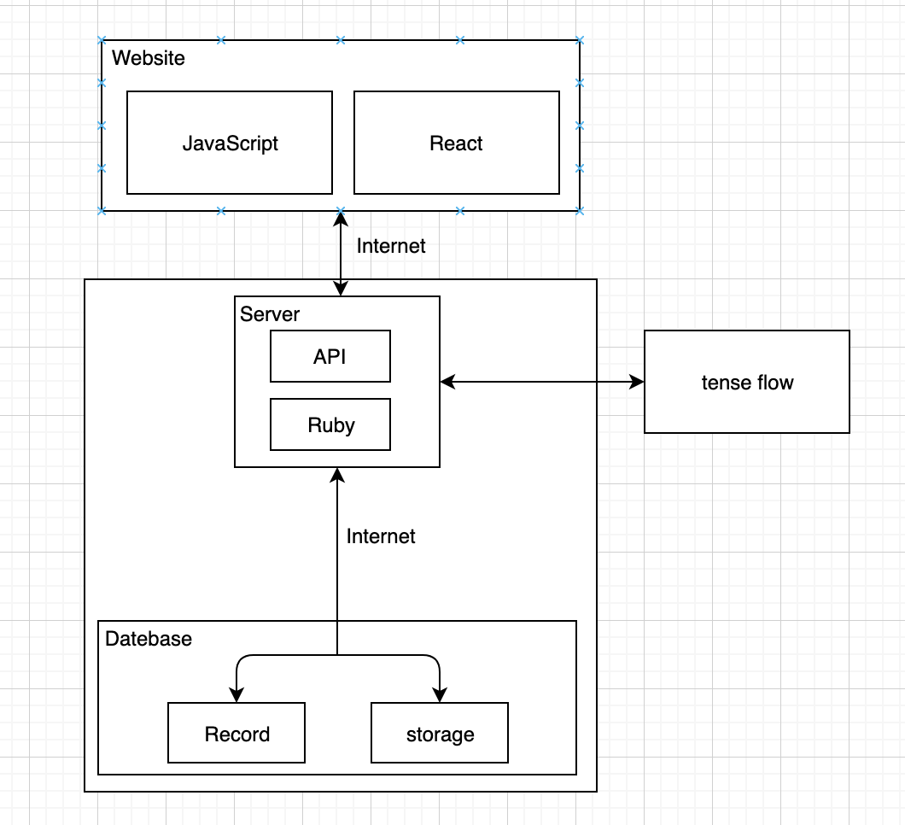 training.

