24/12 FYP meeting

Attendees:

Henry, DB62607

Roy, DB625396

Professor Yuan Wu.

Finished items (from the last meeting notes)

1. Invite member function.

2. Scope project function.

3. A function allow to create a question with tags.

Discussion

Discuss how to build up a great data analysis system for the professor, brainstorming a new features.

Challenges:

Create a unique functions in the system.

Schedule:

User Interface:

Create a question page:

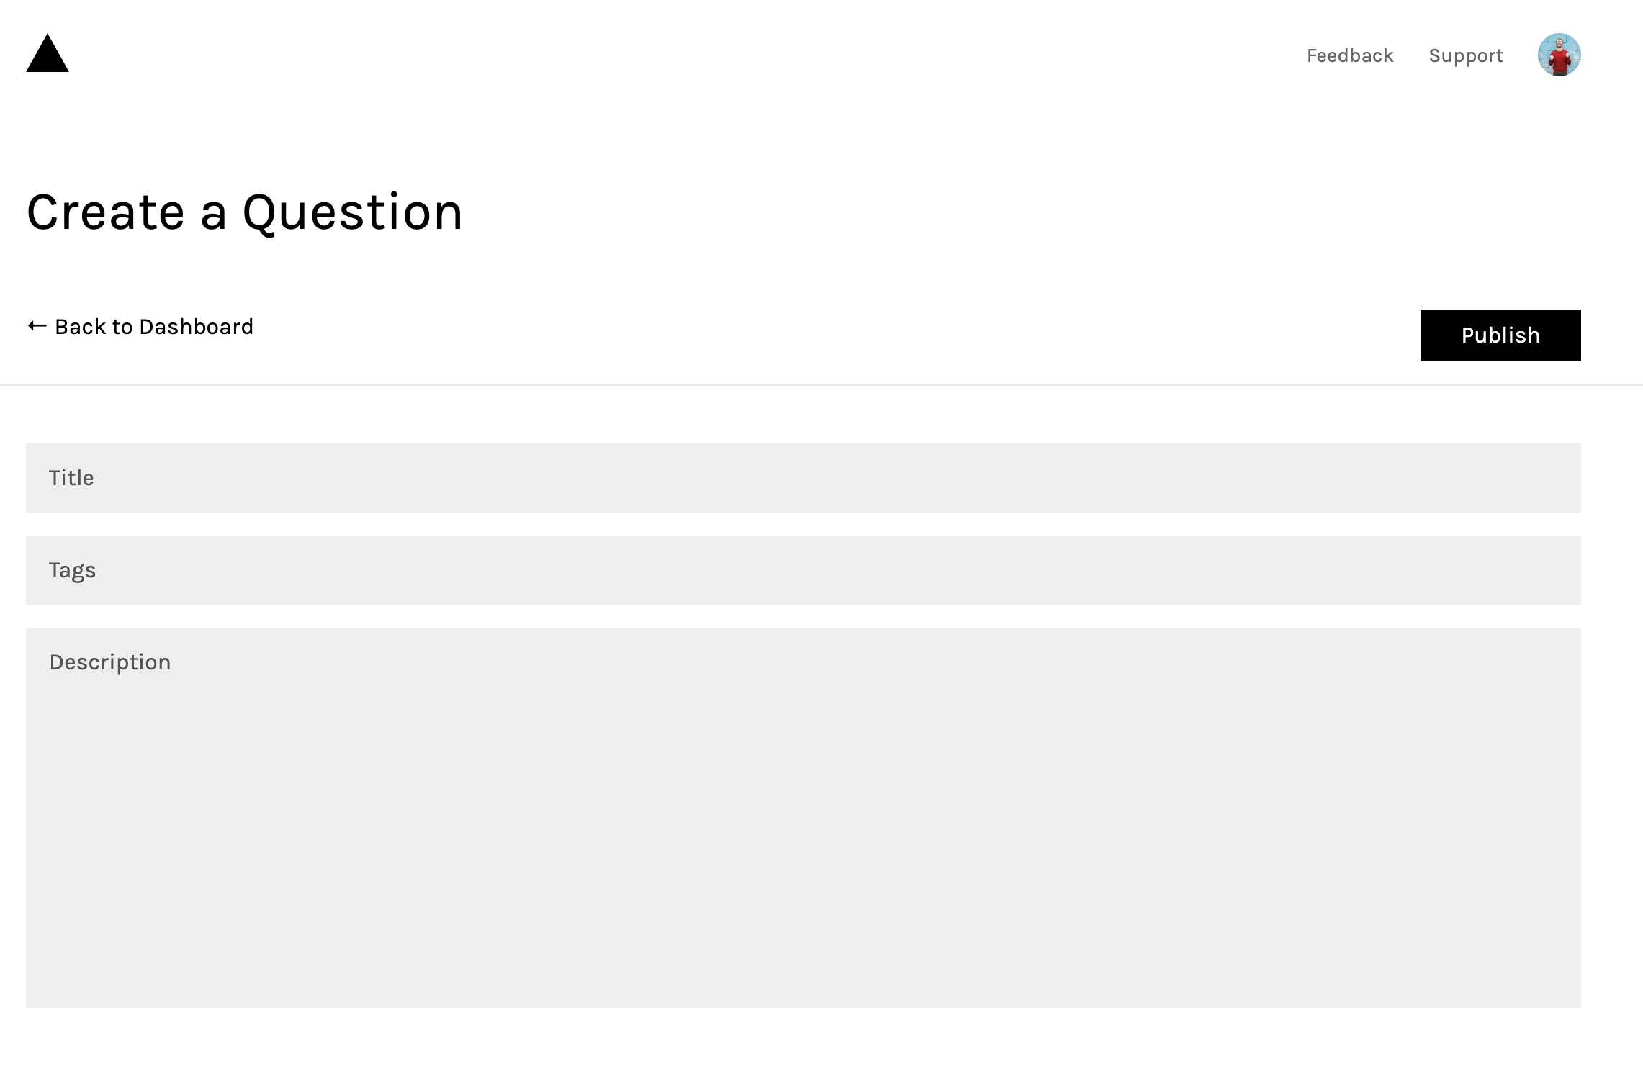

Post page:

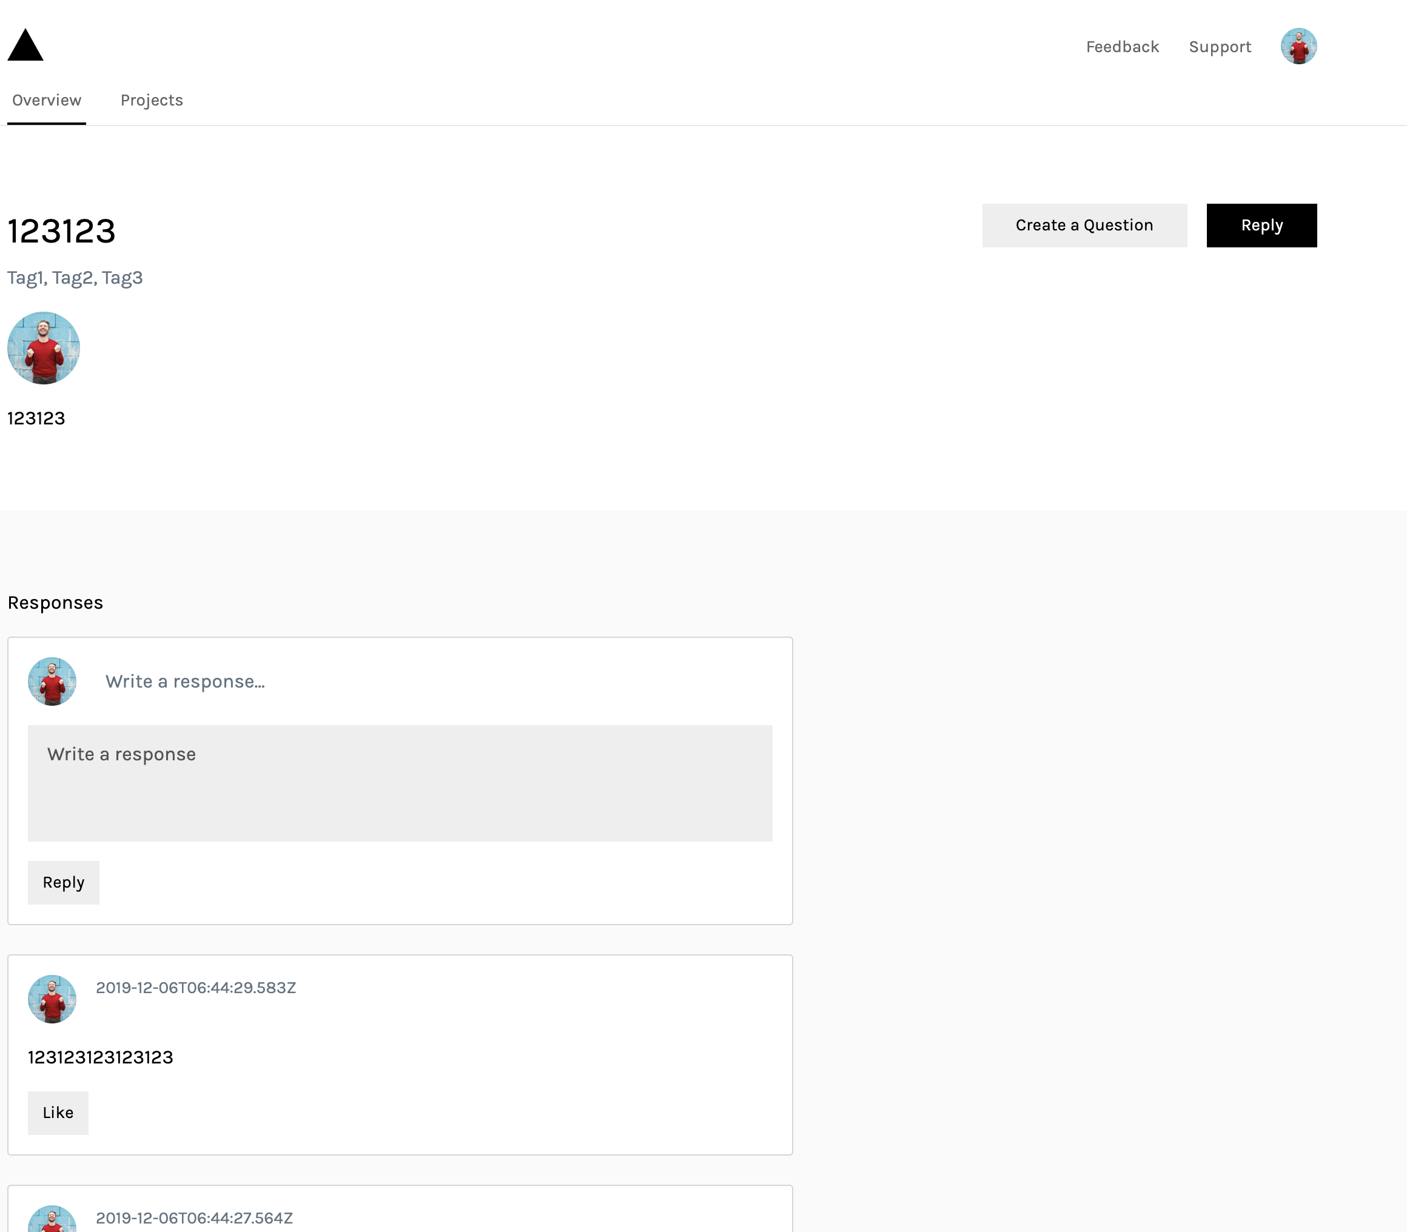

Member list page:

