25/11 FYP meeting

Attendees:

Henry, DB62607

Roy, DB625396

Professor Yuan Wu.

Finished items (from the last meeting notes)

Completed the block diagram.

Discussion

Describe each module and functional in the draft block diagram which we prepare in advance, and discuss how to build a correct block diagram, and discuss how to implements the basic demo.

Challenges:

Implement a samplee demo with basic function.

Schedule: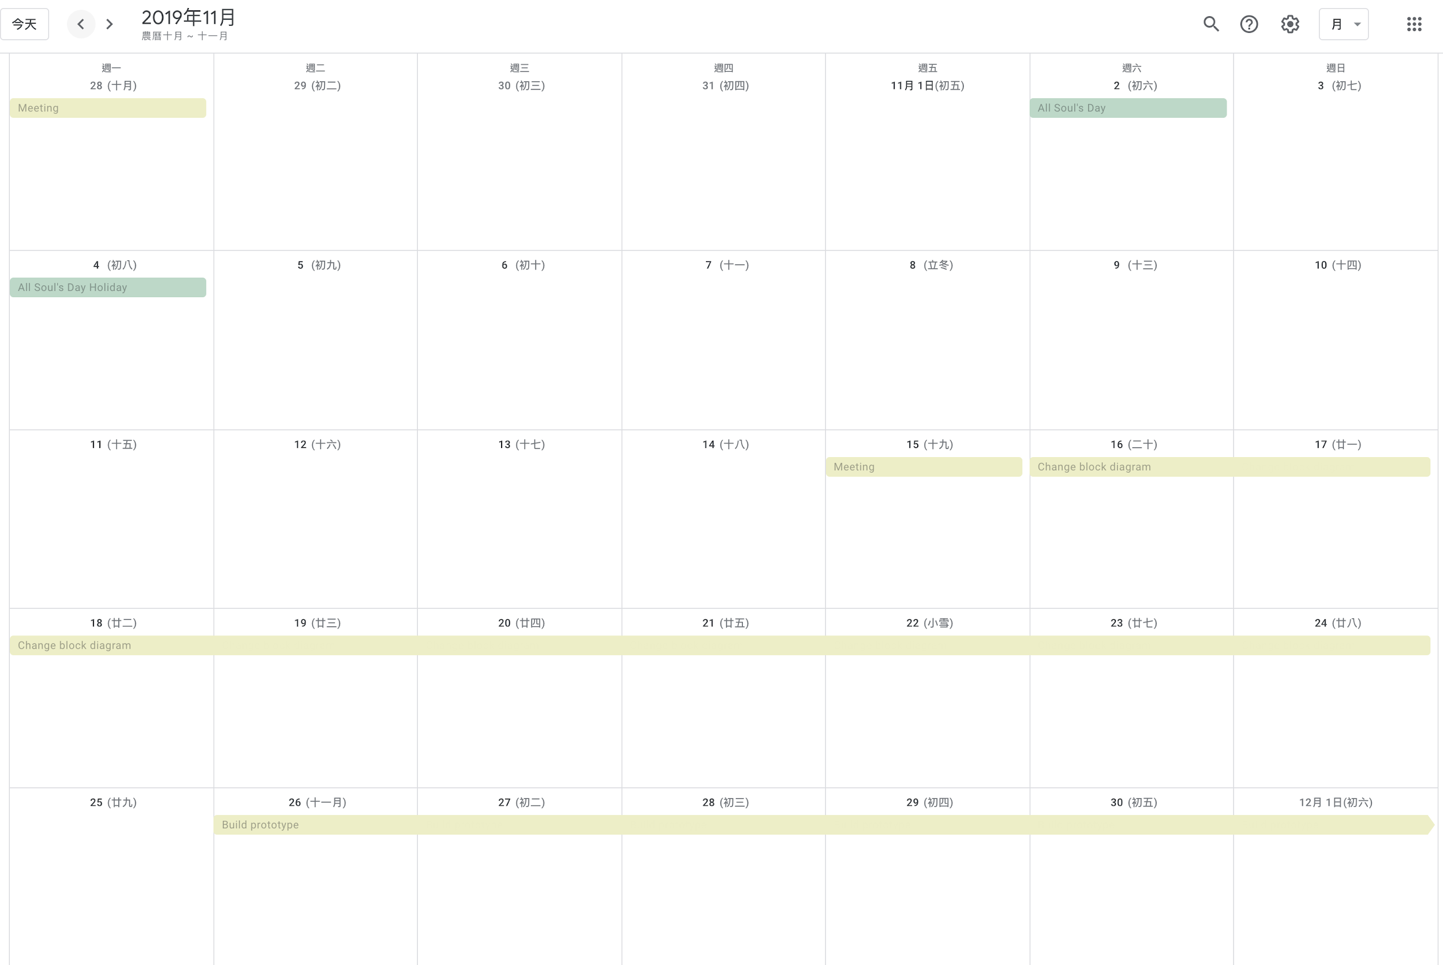

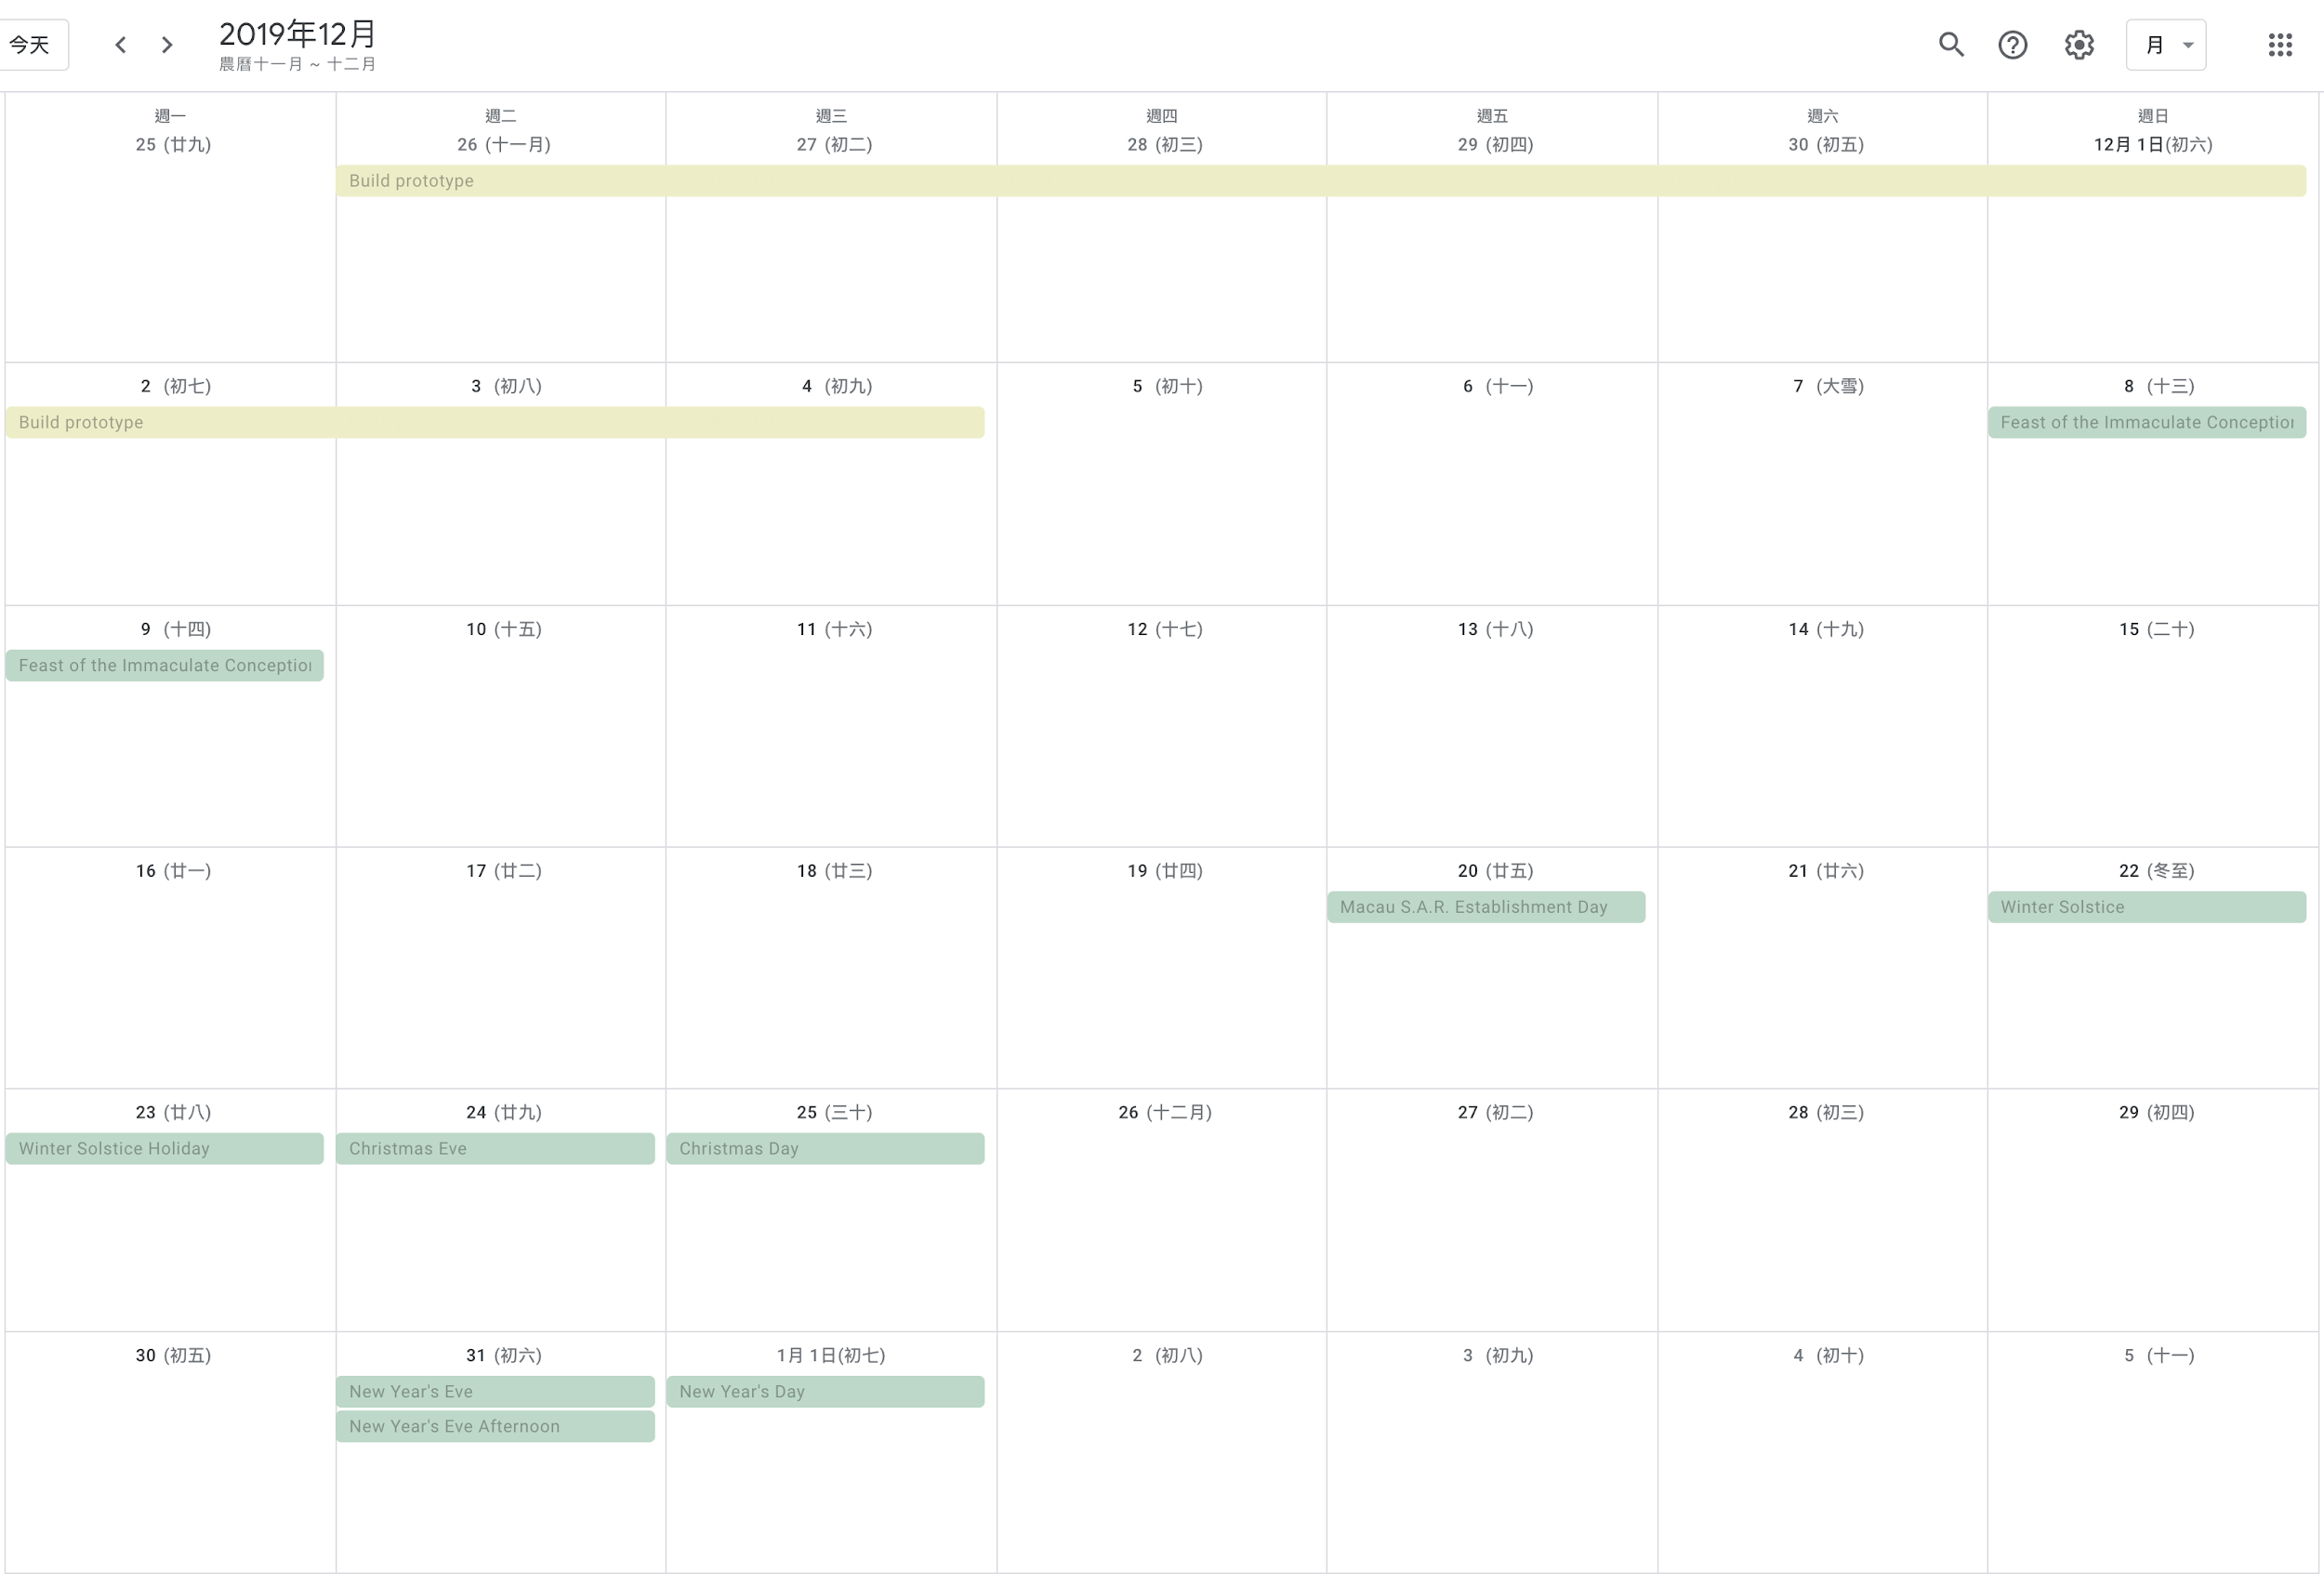

Next meeting targets:

Implement a samplee demo with basic function.