28/10 FYP meeting

Attendees:

Henry, DB62607

Roy, DB625396

Professor Yuan Wu.

Finished items (from the last meeting notes)

Find the references:

1. ummoodle: <https://ummoodle.um.edu.mo>
2. stackoverflow: <https://stackoverflow.com>
3. Discourse: <https://discourse.org/>

Discussion

Discuss how to write block diagram, confirm which part is able to share to your partner and job division, how to convert the student and professor requirements and user story to a table and also make a clean schedule for the project and prototype for the project.

Challenges:

Find the difference between our products and market products, how to build d core function in our project.

Oct Timeline:

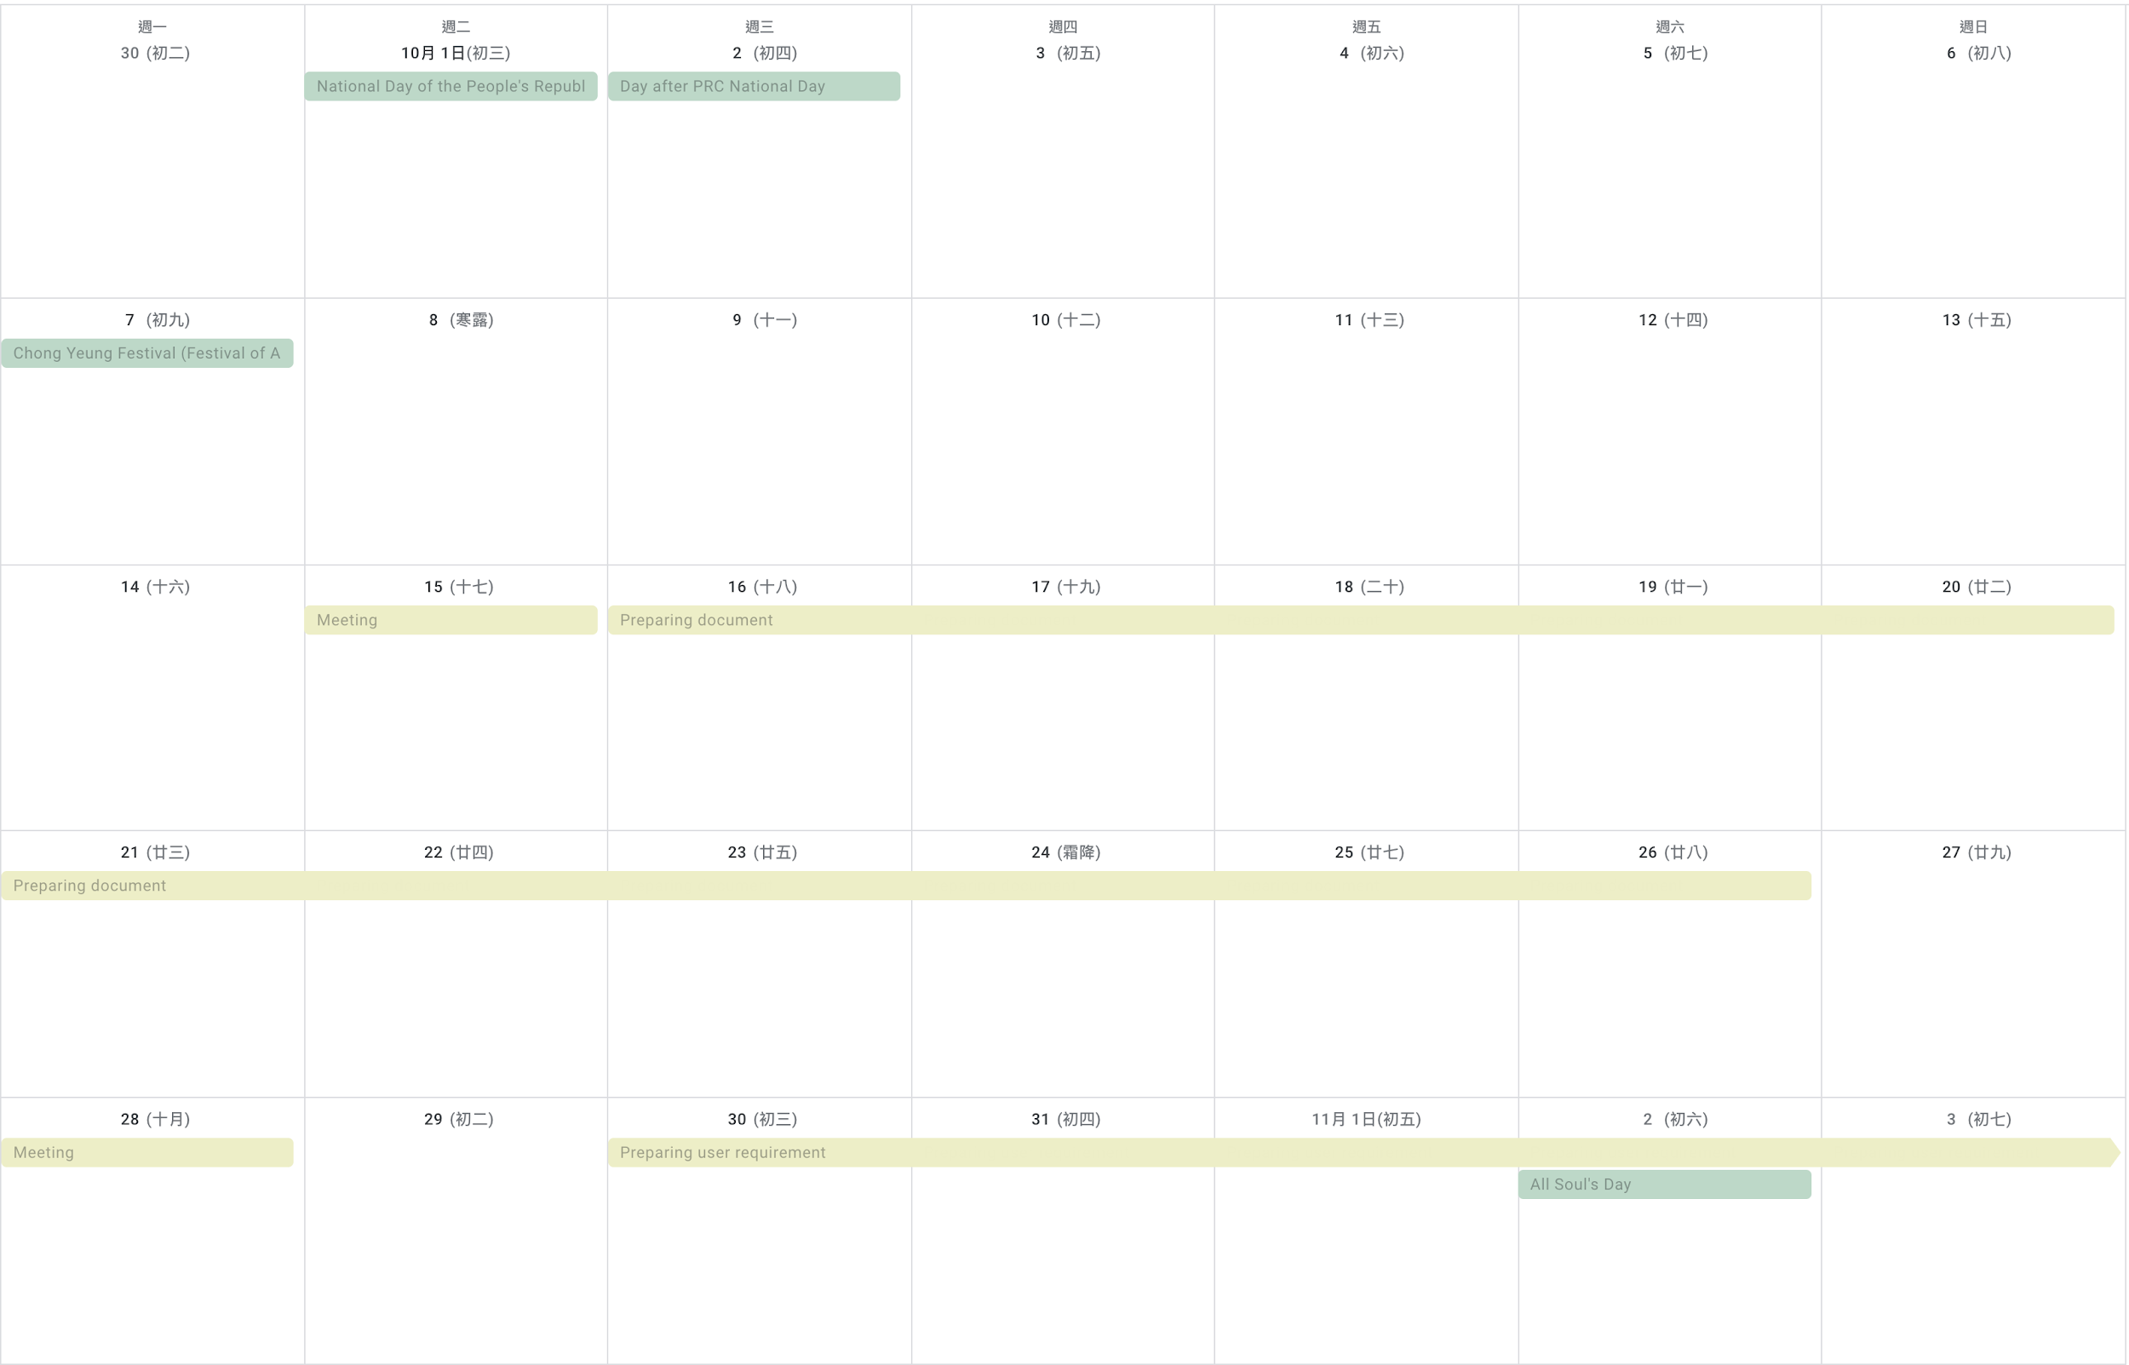

Schedule:

Prepare a block diagram and client requirement in next meeting.