

**Sentiment Analysis on Russia-Ukraine War**

**Written by:**

**Group 6**

**Zhimeng Cao, Leon Ip, Lu Jiang**

**Yifan Liu, Jingyi Nie, Haizheng Sun**

**Written on:**

**April 2, 2023**

**Table of Content**

**Introduction 2**

**Code Relevant Analysis 3**

**Part 1-Sentiment Modeling 3**

**Part 2-Sentiment Classification 4**

**Part 3-Factor and Topics Identification via Machine Learning 4**

**Part 4-Visualizations, Storytelling 5**

**Internal and External Analysis 7**

**External Analysis 7**

**Internal Analysis 8**

**Recommendations 9**

**Conclusion 11**

**References 12**

**Appendix 13**

# **Introduction**

In today's interconnected world, social media has become an increasingly influential platform for individuals to express their thoughts and opinions on a wide range of topics. As young individuals who regularly use social media, we are constantly exposed to people's views and emotions on current events. One recent event that has caught our attention is the ongoing conflict between Ukraine and Russia.

The conflict between Ukraine and Russia started in 2014 and continues to this day, resulting in thousands of casualties and millions of displaced individuals. The international community has been divided on how to respond to the conflict, with some nations imposing economic sanctions on Russia while others maintain a neutral stance. For Ukraine, understanding how the conflict is perceived on the global stage is crucial in promoting its interests and working towards a resolution. Furthermore, since the people are the backbone of a nation, comprehending their thoughts and emotions is essential, as it can significantly impact future scenarios. Besides, analyzing social media may provide quite valuable insights on decision-making for foreign investors who majorly concern about insecurity, instability, and uncertainty of Ukraine's investment environment.

As consultants hired by the Ukrainian government, our primary objective is to assess how Ukraine and the war are perceived globally and recommend measures to enhance Ukraine's international image and regain foreign investors’ trust. To accomplish this, our team of researchers analyzed social media posts and determined the crucial factors, reasons, and topics that shape Ukraine's international image. Our analysis was comprehensive, covering posts from three major social media platforms: Twitter, Reddit, and YouTube. We obtained these data from Kaggle, and two of these platforms have timestamps, thus allowing us to analyze the posts' temporal changes. By leveraging sentiment analysis, which includes cleaning the data, plotting word clouds, selecting features using the TF-IDF algorithm, and testing four classification models, this approach helps us identify trends in the attitudes and emotions expressed by social media users. In addition, we had supplemented our findings with additional research to provide a more comprehensive analysis of Ukraine's image both internally and externally. It provides us with a more profound and more nuanced understanding of how Ukraine is portrayed in the global media landscape. Finally, based on our analysis, we provided recommendations on how the Ukrainian government can enhance Ukraine’s international image and promote its interests on the global stage by preserving or adjusting their current strategies to minimize economic loss.

# **Code Relevant Analysis**

## **Part 1-Sentiment Modeling**

Firstly, in order to have an overall understanding of the dataset, we imported the data from the csv file and drew a histogram to show the length and number of the negative and positive tweets. As the comparison shows (see Figure 1 in Appendix), both length and number of positive tweets are higher than that of the negative tweets, indicating the positive samples are apt to have more insightful remarks.

For the data cleaning, we removed the unnecessary parts of the text data, such as symbols, punctuations, advertisements, stop words and reply tweets. We unified the capital letters to lowercase and permute the “&amp” to “and”. After the cleaning, we can extract the informative part of the data samples through ignoring the html tags, hashtags and user tags. In order to have an intuitive impression of the word frequency, we developed a function to visualize data by plotting them in the form of the word clouds. The function splits sentences into pieces of words and calculates the frequency of each word. Words with high frequency are printed with a large font size in the word cloud space (see Figures 2-7 in Appendix).

Secondly, we splitted data into training and test datasets and selected key features from them with the TF-IDF algorithm. TF-IDF vectorizer converts text data to a matrix of features and each feature is an English word or short phrase. In order to avoid high computation cost of the model, we set the size of max features of the vectorizer to 1000. According to the linguistic study, the most frequent 1000 words make up approximately 80%-85% of English usage. Thus, we can cover most words that appear in the tweets with 1000 features.

Finally, for the classification models, we chose logistic regression, decision tree, random forest and multi-layer perceptron. We performed the hyperparameter tuning and cross-validation for all models. The integrated result is shown in the table below (Table 1).

Table 1: Performance of Various Classification Models

| Model | Tuning Result | Cross-validation Accuracy | Variance of Accuracy | Test Accuracy |
| --- | --- | --- | --- | --- |
| Logistic Regression | C=10  Solver=liblinear | 93.40% | 6.03 | 93.37% |
| Decision Tree | max_depth=100  splitter=best | 91.36% | 2.55 | 91.37% |
| Random Forest | max_depth=100  n_estimators=10 | 91.27% | 2.25 | 91.10% |
| Multi-layer Perceptron | hidden_layer_size=(100,10)  activation=relu | 93.10% | 5.79 | 93.26% |

From the results we can tell, the logistic regression model has the highest test accuracy indicating a good performance of generalization. Besides, the computation time of the model is relatively low. Thus, we decided to select the logistic model for further steps.

## **Part 2-Sentiment Classification**

For the comparison of pre-trained models and the best model from part 1, we calculated the accuracy of different models on the tweets of Elon Musk dataset. For pre-trained models, we selected VADER, TextBlob and the flair sentiment classifier. VADER stands for Valence Aware Dictionary for Sentiment Reasoning, which is a lexicon and rule-based sentiment analysis model for web media. VADER examines sentiment related words in the text data with the pre-labeled dictionary to decide the sentiment direction and polarity score. TextBlob is a python library offering simple APIs with rule-based Part-of-speech tagging for sentiment analysis. Flair’s sentiment classifier is based on a character-level LSTM network which takes sequences of letters and words into account when predicting. The performance of models is shown in the table below (Table 2). Although the pre-trained models have effective APIs which can simplify the training process, our best model of logistic regression is still outstanding.

Table 2: Training Accuracy between Pre-trained models and

| Model | VADER | TextBlob | Flair | Logistic Regression |
| --- | --- | --- | --- | --- |
| Accuracy | 85.65% | 79.67% | 86.87% | 93.37% |

In order to have a comprehensive insight of the data, we searched for additional datasets. The dataset “2022 Russia-Ukraine War Tweets by Key Event” illustrates the trends of positive and negative tweets over time and corresponding key events sequence. The Russian Invasion of Ukraine provides more comments from Reddit, and the Russian Ukraine War YouTube Discussion dataset collects the opinions from YouTube. The summary of additional data is elaborated in Part 4.

## **Part 3-Factor and Topics Identification via Machine Learning**

In order to illustrate the factors that drive sentiment analysis in the logistic model, we printed out the top 10 weights of positive and negative identification. The weight represents how probable it is to classify tweets with certain words as having a particular sentiment. For example, if the weight of the word "happy" is +23, it means that if a sentence includes the word "happy", it's log(23) times more likely to be classified as a positive sentiment than a sentence without that word, assuming all other factors remain the same. Similarly, the features with negative weights have a larger likelihood of being classified as negative sentiment direction.

In the analysis of additional datasets, we listed the topics that drive sentiment classification by selecting 10 comments with highest predicted probability generated by the logistic model. Considering the stop words are removed from the data, the remaining parts of the comments, such as “sad terrible sacrifice”, are the classification reasons. The results are shown in the top 10 negative comments and 10 positive comments sections.

## **Part 4-Visualizations, Storytelling**

After conducting sentiment analysis on public media platforms including Twitter, Reddit, and YouTube, the results are visualized in order to facilitate the analysis of public sentiment. The visualization includes five different types of displays, each offering unique insights into the data, including the length of negative and positive posts, negative and positive word clouds, the top 10 negative and positive posts, the percentage of negative and positive posts against time, and the number of negative and positive posts.

The length of negative and positive posts is examined in **Figure 1** to gain insight into the overall sentiment of the comments. The trend for Twitter is very different from that of Reddit and YouTube comments. Negative tweets show a bimodal distribution, indicating that people tend to write either very short or very long posts, while positive posts are generally longer and of higher quality. This suggests that on Twitter, people prefer to express negative emotions through short, derogatory posts that are recognized as negative. Moreover, due to the bandwagon effect, people tend to imitate and follow negative sentiment expressions, leading to an increase in meaningless expressions of negative sentiment. Although the trend for twitter is more distinct, we can still observe a steeper peak for negative posts in both Reddit and Youtube comments, indicating a similar pattern. This suggests that we should focus more on longer posts when trying to guide public opinion or highlight important information, as they may contain more detailed and nuanced perspectives.

Moving on to the word clouds, as shown in **Figures 2 to 7**, we can observe that the negative sentiment is conveyed through words such as “invasion”, “worldwar3”, “fighting”, “nato”, and “propaganda”. These terms shed light on the aspects of the conflict that the public dislikes the most. Firstly, there is a strong aversion to the war itself, as people view Russia's actions against Ukraine as aggressive and even potentially leading to a third world war. Secondly, the NATO alliance is a contentious issue, as the vacillating attitudes of various governments towards Ukraine's membership in NATO have frustrated many. Lastly, propaganda has been used to manipulate public opinion, with the aim of benefiting certain individuals or groups to fulfill their political purposes, and this biased approach to disseminating information has been widely criticized.

Fortunately, the vast array of information sources available to society nowadays has led many to recognize this issue and oppose it strongly. In contrast, when it comes to positive words, aside from commonly used positive words, we can see words such as “support”, “solidarity”, “brave”, and “hope”. These words indicate the support from the public, as seen in the European Solidarity political party in Ukraine. People recognize Ukrainians’ bravery and believe that there is still hope for Ukraine’s future situation. By combining these words with top posts from these social platforms, we can observe that negative posts do not necessarily oppose a particular country. Instead, people express sadness and regret for the suffering of the civilians caused by the war. On the other hand, positive posts often contain the phrase "Slava Ukraini" (Glory to Ukraine). This phrase is a historic slogan in Ukraine that has been widely used in wars and protests to voice the independence of the country throughout Ukrainian history. Originally intended to save lives, support the Ukrainian army, and provide humanitarian aid to civilians, it has become a symbol of solidarity and patriotism among Ukrainians (Fram, 2023). In the current context, this phrase expresses people's support and approval of Ukraine.

In addition, we can examine the negative and positive posts against the dates for Twitter and Reddit. As shown in **Figure 8**, we can observe a significant increase in the number of positive posts and a decrease in the number of negative posts in April, 2022. This is due to President Biden's administration prohibiting US investment in Russia and calling for the expulsion of Russia from G20 and UN Human Rights Council on April 6-7, 2022. However, in July, we can see a rise in the number of negative posts and a decline in the number of positive posts. This is because on July 3-4, 2022, Russia claimed to have taken Lysychansk, expanding its goals to include other cities in Ukraine and marking the start of phase 3. This indicates that the majority of people still support Ukraine, and when the US imposes sanctions on Russia, they become more supportive and pleased. On the other hand, when Russia escalates and launches the war, people become more opposed and express more negative sentiments.

Furthermore, we had plotted the percentage of negative and positive comments on all three platforms, as shown in **Figure 9 to 11**. It can be observed that on Twitter and YouTube, negative posts account for about 70% of the total, while on Reddit, negative posts make up about 80%, which is 10% higher than the previous two platforms. However, it is reasonable to note that the overall number of negative posts is significantly higher than positive posts, which is expected because war is inherently negative and can evoke feelings of frustration and resentment. Apart from expressing blessings and prayers, it is difficult to rationalize and support war. For YouTube comments, we also plotted the percentage of negative and positive comments among the top 50 liked comments, as it has an additional "like" feature. The results are shown **in Figure 12**. We found that while only 29.1% of positive comments are among the top 50, 46% of the comments that people liked are positive, representing a significant increase. This indicates that people prefer warm and positive comments, so we should focus more on these aspects to have a positive impact on Ukraine's international presence and image.

# **Internal and External Analysis**

To make our report more comprehensive, we found some materials to support our analysis. Based on those materials, we analyze them externally and internally. The external analysis focuses on the actions and ideas of countries other than Ukraine while the internal analysis focuses on the internal conditions such as the resources, capabilities, and competencies of Ukraine.

## **External Analysis**

In the political aspect, many western countries took political actions to support Ukraine. On April 6th and 7th, 2022, president Biden prohibited US investment in Russian and appealed to let Russia leave G20 and UN Human (Olonade, 2023). Also, many western leaders travel to Kyiv to make the complex journey (Kirby, 2023). Moreover, both humanitarian and international partners are negatively affected by the conflict such as being unable to cross between government-controlled and Russian-controlled areas, the property of the support institution being hijacked and shipped to Russia, Red Cross being attacked during the war with one staff died (DATA FRIENDLY SPACE, 2022). Also, western countries ignore Russia’s warnings and promise that NATO won’t be split (Kirby, 2023). We also find the word “nato” in the word cloud, which shows that public opinion is similar to the international situation. As a result, we can see that Ukraine gets a lot of political aid, which means most countries support Ukraine. This was the strength of Ukraine.

In the economic aspects, the foreign partners gave much financial support that nearly half of the expenses of the state budget are covered by them (DATA FRIENDLY SPACE, 2022), which was the strength of Ukraine (see Figure 13 in Appendix). Unfortunately, the maritime obstruction by Russia has a big negative impact on Ukraine’s export, which makes the already bad economic situation become worse (DATA FRIENDLY SPACE, 2022). This was the weakness of Ukraine. In conclusion, although foreign partners would like to help, Russia’s attack action caused big problems for Ukraine’s economic situation.

In the social aspects, from our code output, we can see that most people show a negative attitude with not only rejected ideas but also sad emotional thoughts about the war. This is an opportunity for Ukraine. This is because people’s anti-war sentiments and sad attitudes will make them support the side being invaded, which may help Ukraine to gain more aid and a good reputation.

In the aspect of technology, many western countries provided advanced weapons to support Ukraine; for example, the US provided Himars missiles and Germany provided Leopard 2 tanks (Kirby, 2023). That technology support gives Ukraine greater power in the fight against aggression, which can be seen as the strength of Ukraine.

In terms of the environmental aspect, many countries gave an analysis of the loss caused by the war. The UN human rights commissioner estimated that the war caused at least the death of 8006 civilians and 13287 injured while the actual data will be greater than the estimation (Kirby, 2023). We can also see the word “world war 3” in the negative word cloud, which shows the negative opinion of the public. Also, UK Defence Intelligence thinks the casualties of Russia in the war were heavy, which approach 175-200,000 in total with 40-60,000 of them were killed, and the US estimate that there is a 100,000 estimation of Ukrainians killed or wounded (Kirby, 2023), which demonstrated the brutality and terrible effects of war. This can be the opportunity for Ukraine to achieve more help all over the world.

## **Internal Analysis**

The financial condition is highly negatively affected by the conflict. The GDP of Ukraine shows a downward trend with a 30.4% decrease in 2022 while the inflation (estimated greater than 26%) and unemployment rate (estimated to be 30% which is about 4.7 million people) are increasing (DATA FRIENDLY SPACE, 2022). The increase in product price and the shortage of income makes it difficult to meet people’s basic needs (DATA FRIENDLY SPACE, 2022).

There are many physical damages in different aspects. Ukrainian authorities announce that the ecology is severely damaged which is estimated at US$35.5 billion (DATA FRIENDLY SPACE, 2022). The UNEP said that the conflict causes contaminated soils, and water resources, and bad impact on fauna and flora (DATA FRIENDLY SPACE, 2022). Also, 3098 educational institutions experienced bombing and shelling, especially 438 of them have been destroyed completely (DATA FRIENDLY SPACE, 2022). Worse still, about 200 health institutions were destroyed and 1200 experienced attacks during the conflict (DATA FRIENDLY SPACE, 2022). Moreover, the cultural infrastructure is severely damaged (DATA FRIENDLY SPACE, 2022). Because the energy infrastructure was highly damaged, Ukraine changed from exporting electricity (before the conflict) to importing from the EU (DATA FRIENDLY SPACE, 2022). Sadly, the damage to the energy infrastructure causes a big problem in the daily life of the whole population of the country (DATA FRIENDLY SPACE, 2022).

In the aspect of human resources, the Ukrainian soldiers, National Guard, and other defense and law enforcement servicemen try their best to actively fight to resist Russian aggression (Ministry of Foreign Affairs of Ukraine, 2019).

In terms of the reputation of Ukraine, most of the countries are condemning Russia’s aggression when the invasion just happens a week (Coles et al., 2023). The UN defined Russia as an occupying power by resolution 71/205 "The situation of human rights in the Autonomous Republic of Crimea and the city of Sevastopol (Ukraine)" during the assembly (Ministry of Foreign Affairs of Ukraine, 2019). Overall, most countries empathize with Ukraine and oppose the conflict. This also can be shown from the output of our code that the word “sad” appears many times which means people not only reject war but also feel sad about the conflict.

# **Recommendations**

1. Create and maintain positive hashtags and posts

After analyzing the positive comments, we notice that many individuals on the Internet express their support for Ukraine by using hashtags like "standwithukraine." By tagging comments with a hashtag, individuals can improve the search engine optimization (SEO) of their content, leading to increased exposure. As a result, we recommend creating and maintaining additional hashtags on social media to promote the history of Ukraine, the Russia-Ukraine war, and related topics using keywords found in word clouds. Suggested hashtags to generate positive sentiments are “#SupportUkraine”, “#SoliderityWithUkraine”, “#BraveUkrainianSoldier”, “#BlessUkraine”, and “#HopeAndPeaceUkraine”. Regarding hashtags to generate negative sentiments that favor in Ukraine’s international image, those are “#FightAgainstRussia”, “#WorldWar3Russia”, “#WW3Russia”, “#StopRussiaPropoganda”, and “#StopPutin”. Also, we suggest the Ukrainian government can encourage and invite some social influencers to create positive hashtags and give opinions on official posts about Ukraine's history and share their opinions and feelings as we know social influencers have a relatively significant impact on the sentiment direction.

1. Promote Ukraine’s national identity and historical culture

We were not aware of Ukraine’s history of independence until we noticed the “#SlavaUkraini” hashtag. However, after reading comments on Twitter, we learned about the Ukrainian people's courage during the War of Independence and deepened our understanding of Ukraine (Fram, 2023). Promoting national identity and historical culture around the Independence Day of Ukraine, which falls on August 24th, is an ideal time to celebrate the country's independence and showcase its unique culture and traditions (Zaliznyak & Davies, 2022). This can be done by creating social media campaigns that feature images, videos, and stories that highlight the country's rich history and diverse population. Similarly, around the Independence Day of the US, which falls on July 4th (History.com Editors, 2022), we can also promote Ukraine's national identity and historical culture when there is a huge population of US people that share the same values and can provide empathy (Pflughoeft, 2022). Acclaiming independence from the Soviet Union in 1991, which is one of good historical moments, shows the world the resilience of Ukrainians, the strength of Ukraine, and the determination and optimism to overcome any challenge that they will face (Zaliznyak & Davies, 2022).

1. Seek more international exposure

When looking at the timeline, we have observed a significant increase in the number of positive comments when the United States and other allied countries publicly expressed their support for Ukraine. Therefore, we suggest actively seeking support and assistance from other countries on an international level. The Ukrainian government can take a more active role in international conferences by expressing its opinions to gain more allies and publicizing the demands and expectations of its people. Additionally, for groups and countries that have already provided aid, such as the US, Canada, Germany (see Figure 13 in Appendix), we can promote the economic, military, and humanitarian assistance of Western countries to Ukraine on social media. By taking advantage of people's inclination to follow the actions of influential leaders, when the heads of Western countries take actions to help Ukraine, a larger audience will likely support Ukraine.

1. Advocate for peace and build monuments

Based on the top 10 comments, it is clear that both positive and negative comments express dissatisfaction with the casualties of war. This shows that people have a strong anti-war sentiment. Therefore, we recommend promoting the Ukrainian people as victims of war in social media and news, and advocating for the peace that the people want. As a victim of aggressive war, Ukraine can gain more empathy through peace-oriented propaganda. The government can promote anti-war themes in the international community, and establish monuments and museums to honor the people and soldiers who sacrificed in this war. Calling for peace can not only help Ukraine establish a positive image in the international community, but also promote the establishment of a relationship of unity and love among people around the world in the future.

1. Propaganda through traditional media and institutions

From social media sentiment analysis, we have observed the tremendous impact of public opinion propaganda. As such, we propose expanding positive publicity for Ukraine beyond social media to traditional media and educational institutions. For instance, establishing a dedicated column in major newspapers and broadcasting documentaries to regularly report on the latest updates regarding the Ukrainian conflict could prevent people from turning focus over time. Additional benefit of traditional media is its readership demographics, which encompasses a wider age range compared to social media platforms that primarily attract younger users. Moreover, newspapers and media organizations often feature serious and authoritative literature, which can be more convincing to readers. As for education, incorporating content on the Russia-Ukraine War into primary and secondary school history and politics curricula is recommended.

1. Monitor misinformation

Although online propaganda has many advantages, we must also be cautious about the prevalence of misinformation in tweets. To address this issue, we recommend strengthening the monitoring and regulation of fake news, and promptly correcting misinformation. This can be achieved by increasing scrutiny of sensitive words and phrases, identifying and disabling accounts that use bots to repeatedly post extreme comments.

# 

# **Conclusion**

In summary, the analysis of social media sentiment towards Ukraine provides valuable insights into the country's international reputation and people's attitudes towards the Russia-Ukraine conflict. Our findings indicate that although there is a significant amount of negative sentiment towards the war, there is also a considerable amount of positive sentiment expressed towards Ukraine. Many individuals and organizations express support for Ukraine and are inspired by the resilience and bravery of the Ukrainian people in the face of adversity. These insights suggest that the government can utilize this positive sentiment to improve its global reputation.

Furthermore, we conducted an analysis on Ukraine's internal and external factors. The external analysis prioritizes political, economic, social, technological, and environmental factors, highlighting Ukraine's strengths and weaknesses, such as the political and technological support received and the economic loss. The internal analysis focuses on Ukraine's resources, capabilities, and competitiveness, revealing severe damage to its finances, infrastructure, and human resources, but also noting that Ukraine takes advantages over a good international reputation.

Based on the analyses, we proposed several recommendations for the Ukrainian government to enhance the country's international image. The government can achieve this by creating and promoting positive hashtags, promoting Ukraine’s national identity and historical culture, seeking more international exposure and support, advocating for peace, and promoting Ukraine through traditional media and educational institutions. Furthermore, the government can monitor and correct misinformation to ensure that the public has a precise understanding of the conflict and its impact.

# 

# **References**

Fram, T. (2023, March 13). Slava Ukraini: How to say glory to Ukraine in Ukrainian. Gwara Media. Retrieved March 31, 2023, from https://gwaramedia.com/en/slava-ukraini-how-to-say-glory-to-ukraine-in-ukrainian/#:~:text=%E2%80%9CSlava%20Ukraini%E2%80%9D%20and%20its%20meaning%20today&amp;text=Glory%20to%20heroes!%E2%80%9D%20became%20in,suppress%20the%20Ukrainian%20insurgent%20movement.

Coles, S., Ash, T., Sagoo, R., Lutsevych, O., Szostek, J., Bullough, O., Nixey, J., Benton, T., Wellesley, L., Lough, J., Froggatt, A., Lewis, P., Giles, K., Karalis, M., Jie, Y., Wolczuk, K., Shea, J., Billon-Galland, A., Vakil, S., … Rellstab, L. (2023, March 16). *Seven Ways Russia's war on Ukraine has changed the world*. Chatham House – International Affairs Think Tank. Retrieved March 26, 2023, from https://www.chathamhouse.org/2023/02/seven-ways-russias-war-ukraine-has-changed-world

DATA FRIENDLY SPACE (2022, April 27). *UKRAINIAN CRISIS Situational Analysis (February 24th, 2023)*. Data Friendly Space. Retrieved March 26, 2023, from https://datafriendlyspace.org/ukraine-analyses/?gclid=Cj0KCQjw2v-gBhC1ARIsAOQdKY0lNofcNwt7lkGI_sBtJ74P4B3YkqnqIBdolhNas0v6eusRK0UU_PgaAnt7EALw_wcB

History.com Editors. (2022, December 12). Fourth of July – Independence Day. HISTORY. Retrieved April 1, 2023, from https://www.history.com/topics/holidays/july-4th

Kirby, P. (2023, February 24). *Has putin's war failed and what does Russia want from Ukraine?* BBC News. Retrieved March 26, 2023, from https://www.bbc.com/news/world-europe-56720589

Ministry of Foreign Affairs of Ukraine (2019, December 19). *10 facts you should know about Russian military aggression against Ukraine*. Ministry of Foreign Affairs of Ukraine. Retrieved March 26, 2023, from https://mfa.gov.ua/en/10-facts-you-should-know-about-russian-military-aggression-against-ukraine

Olonade, Y. (2023, January 5). *2022 Russia-ukraine war tweets by key events*. Kaggle. Retrieved March 26, 2023, from https://www.kaggle.com/datasets/yusufolonade/2022-russiaukraine-war-tweets-by-key-events

Pflughoeft, A. (2022, August 24). It’s Ukrainian Independence Day. How people in US are celebrating amid Russia assault. MiamiHerald. Retrieved April 1, 2023, from https://www.miamiherald.com/news/nation-world/national/article264790829.html

Zaliznyak, Y., &amp; Davies, G. (2022, August 24). Ukraine celebrates Independence Day as it marks 6 months of war. ABC News. Retrieved March 31, 2023, from https://abcnews.go.com/International/ukrainian-celebrates-independence-day-marks-months-war/story?id=88728029

# 

# **Appendix**

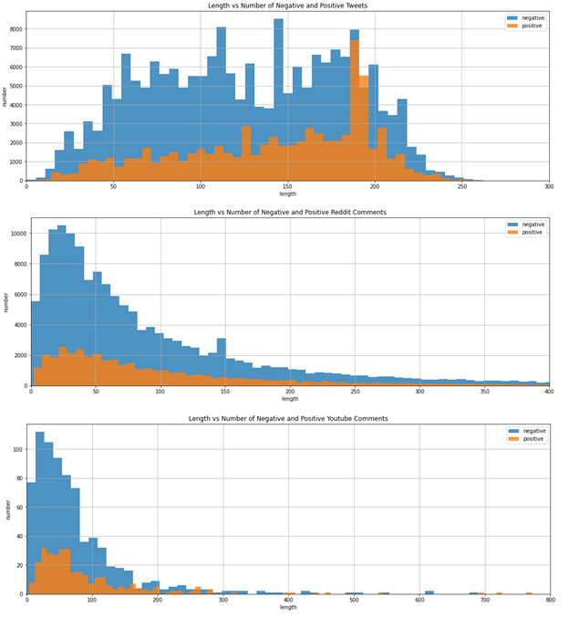

Figure 1. Length vs Number of Negative and Positive post on three social media platform

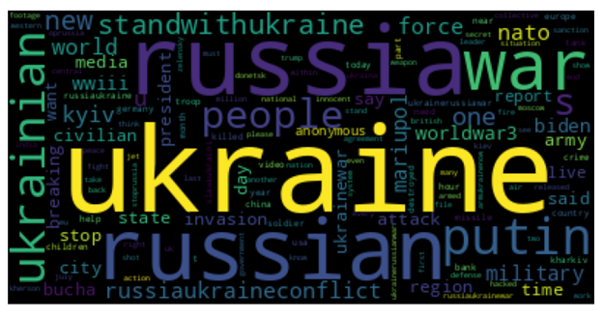

Figure 2. Negative Word Cloud for Twitter

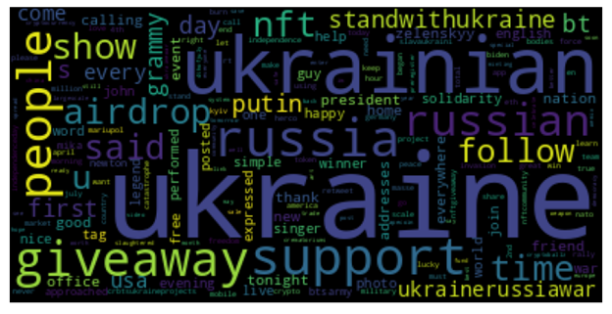

Figure 3. Positive Word Cloud for Twitter

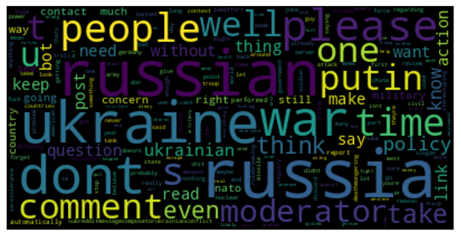

Figure 4. Negative Word Cloud for Reddit

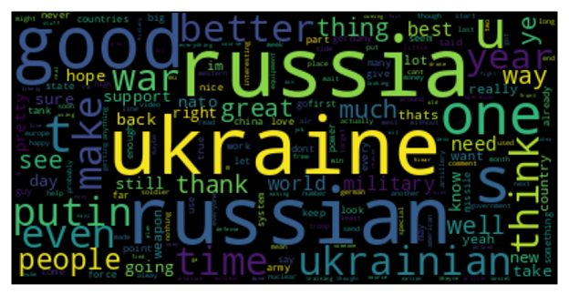

Figure 5. Positive Word Cloud for Reddit

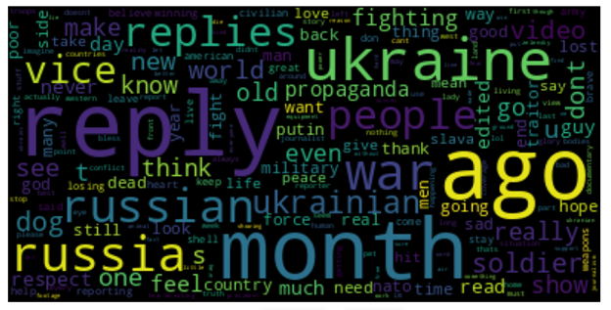

Figure 6. Negative Word Cloud for Youtube Comment

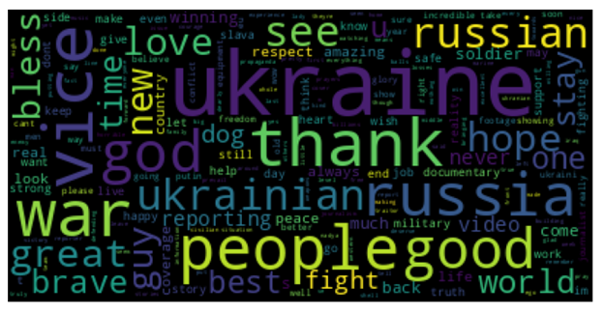

Figure 7. Positive Word Cloud for Youtube Comment

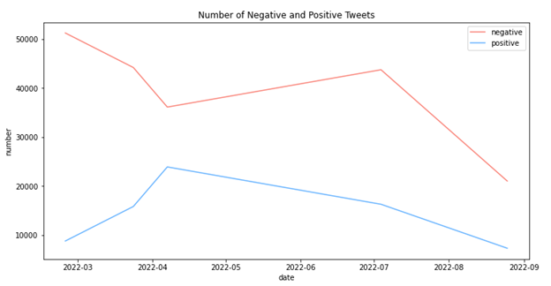

Figure 8. Negative and positive posts against the dates in Twitter

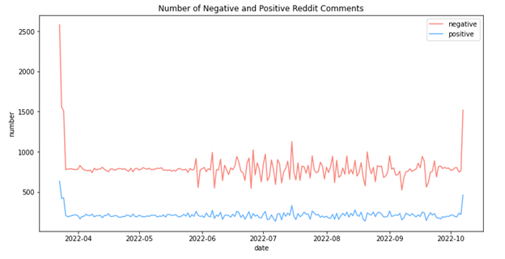

Figure 9. Negative and positive posts against the dates in Reddit

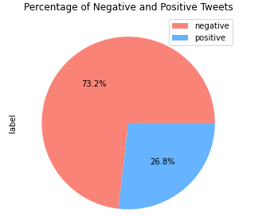

Figure 9. Percentage of negative and positive tweets

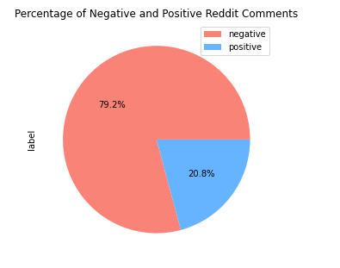

Figure 10. Percentage of negative and positive Reddit posts

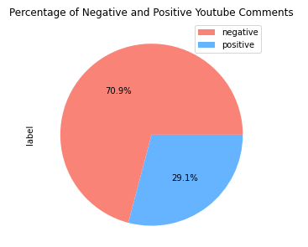

Figure 11. Percentage of negative and positive YouTube comments

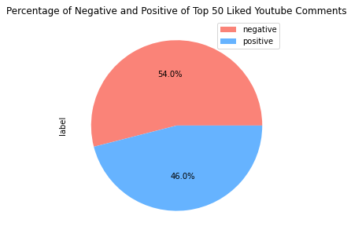

Figure 12. Percentage of negative and positive of Top 50 liked Youtube comments

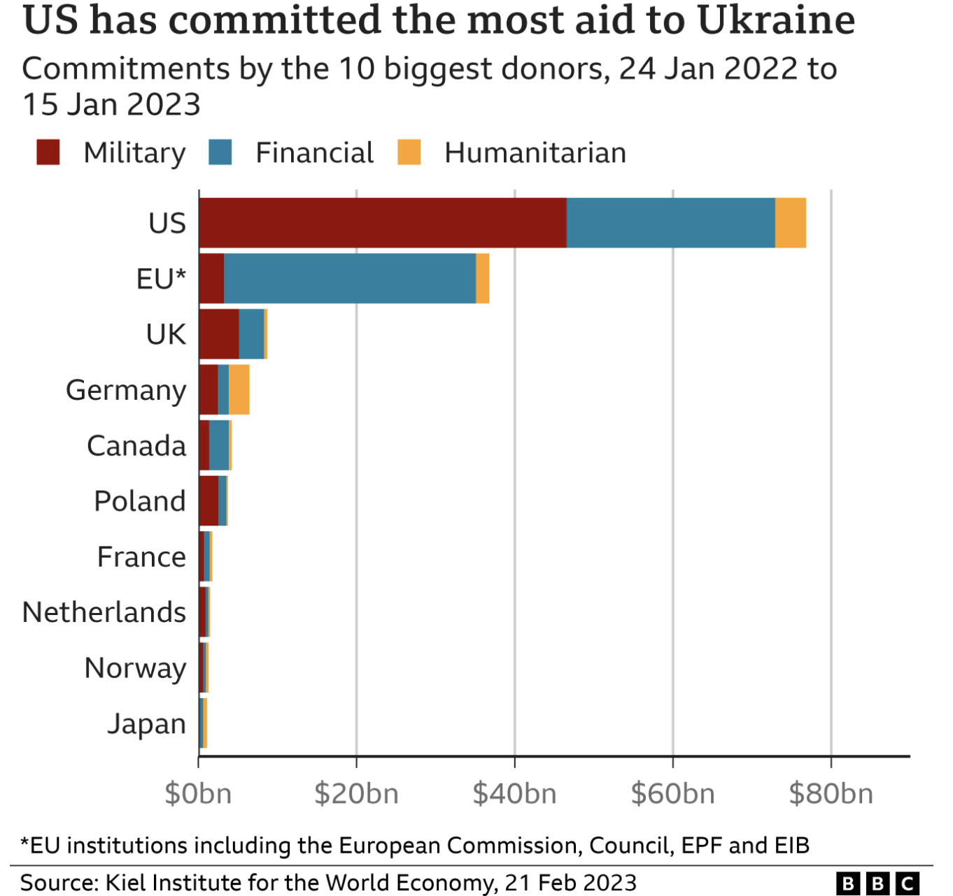

Figure 13. Commitments by the 10 biggest donors