**GARCH model**

The following results indicated that GARCH (1,1) is ideally equipped than GARCH (2,1) and GARCH (1,2) with a lower criteria value when comparing the values of Akaike (AIC), which is the information criteria used to evaluate model fitness. As a result, in the following analysis, the GARCH (1,1) will be applied to capture the progression of volatility of the two stocks in the portfolio from Jan 2005 to Dec 2014 (including global financial crisis in 2007-2009 and European sovereign debt in 2010-2012) and the returns will be filtered by fitting the chosen GARCH model to gain residuals and standardized residuals.

|  |  |  |  |
| --- | --- | --- | --- |
|  | GARCH（1，1） | GARCH（1，2） | GARCH（2，1） |
| WFC | -5.372507 | -5.368837 | -5.368688 |
| VOD | -5.379246 | -5.375881 | -5.376133 |

Table 1. AIC values for WFC & VOD based on different GARCH

Thus, we apply the GARCH (1,1) model to extract the volatility of the two stocks. As shown in Figure 1, these two stocks presented the different volatility facing the global financial crisis and European sovereign debt crisis. WFC’s volatility was at peak reaching12% at the end of 2008 and it has a evident fluctuation in 2011. However, VOD fluctuated with a relatively steady trend, showing a better ability to bear pressure over the same period.

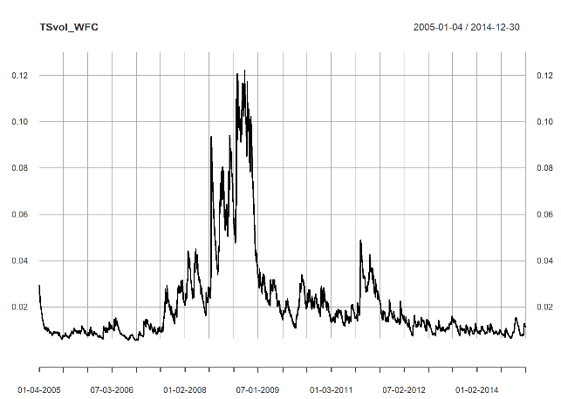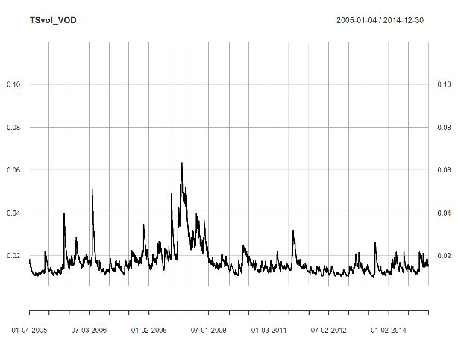

Figure1. The estimated volatility of WFC (left) and VOD (right) during the period

**Fitting and comparison of Marginal Distributions**

The greater log-likelihood value and lower AIC value represent a better fit of the relevant distribution with data(引用). Given the standardized residuals of the two businesses' stock log returns, the fitting quality of the t-distribution is superior than Gaussian distribution (As shown in Table 2).

|  |  |  |  |  |
| --- | --- | --- | --- | --- |
|  | Gaussian | | t | |
| Stock | Log-likelihood | AIC | Log-likelihood | AIC |
| WFC | -3585.134 | 7174.269 | -3496.589 | 6999.178 |
| VOD | -3564.161 | 7132.322 | -3421.569 | 6849.138 |

Table 2. Log-likelihood and AIC values for Gaussian, t

In addition, we built the histogram of density and standardized residual for these two companies and it is clear that the fitting quality of t copula distribution is better that Gaussian distribution, which leads the same conclusion of log-likelihood and AIC comparison.

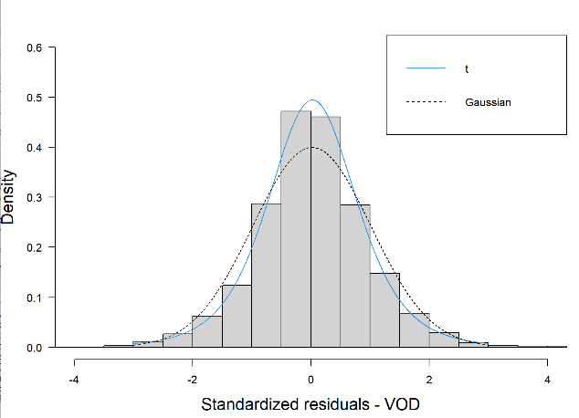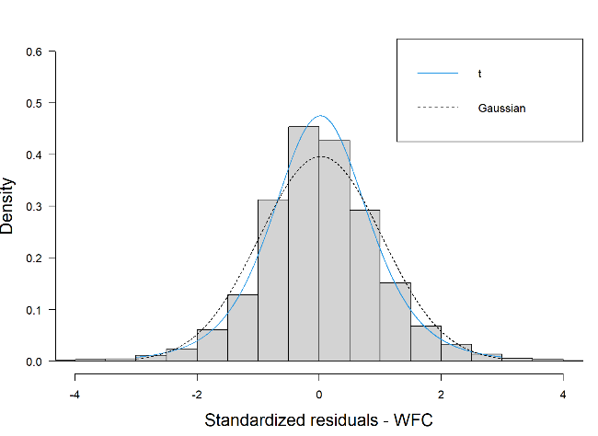

Figure 2. Plotting of Gaussian copula, t copula

**Copula correlation and multivariate distribution**

|  |  |  |
| --- | --- | --- |
| Coef (normal copula) | WFC | VOD |
| WFC | 1 | 0.4084652 |
| VOD | 0.4084652 | 1 |

Table 3. Correlation matrix of the fitted Gaussian copula

|  |  |
| --- | --- |
| copula | Log-likelihood |
| Gaussian | 229.5 |
| t | 242.5 |

Table 4. Results of copula fit

|  |  |  |
| --- | --- | --- |
| Coef (t copula) | WFC | VOD |
| WFC | 1 | 0.4149912 |
| VOD | 0.4149912 | 1 |

Table 5. Correlation matrix of the fitted t copula

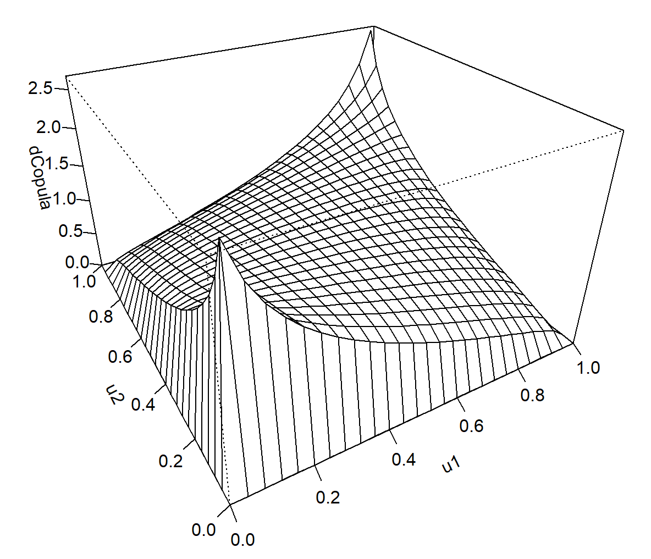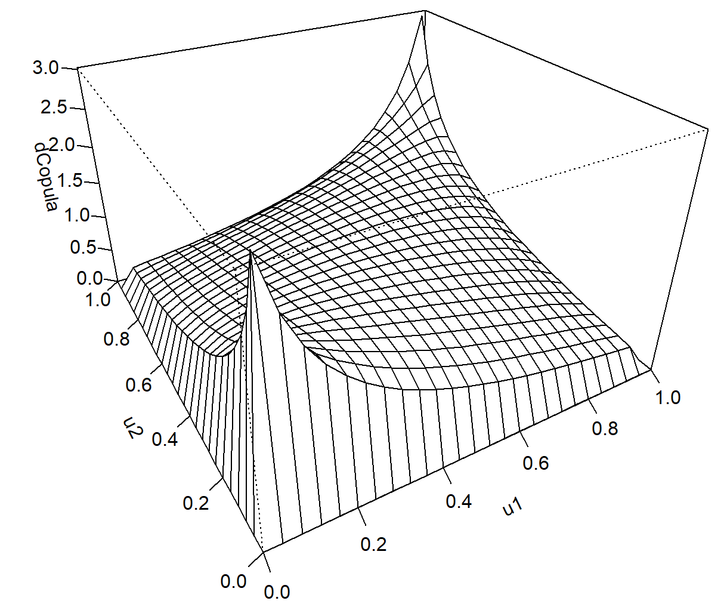

Figure 3. Multivariate distribution

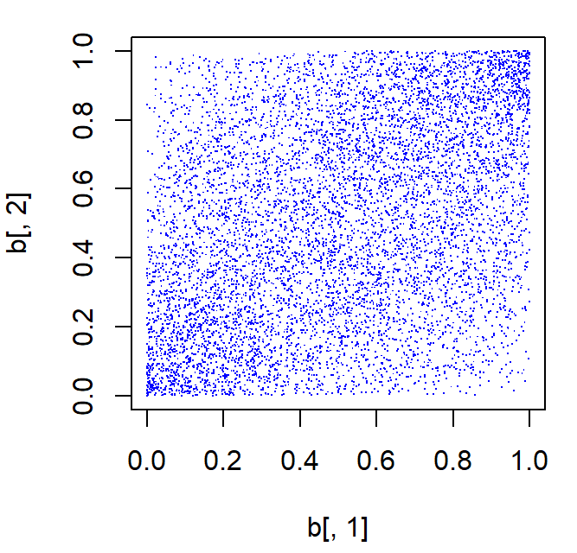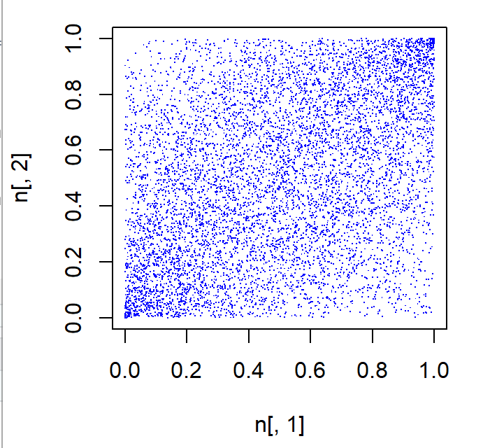

Garch lec3

Likelihood 5