

COURSE CPT 113

ASSIGNMENT 1

|  |  |
| --- | --- |
| NAME : | LEE HUI YING |
| MATRIC NUMBER : | 149044 |
| GROUP : | C |
| LECTURER’S NAME : | DR. MAZIANI SABUDIN |

|  |  |
| --- | --- |
| Contents | Pages |
| Problem Analysis | 3 |
| Specification of Requirements | 4-5 |
| UML Diagram | 6 |
| Source code ( C++ Codes ) | 7-65 |
| Print Screen of Output | 66-82 |

Table of Content

Problem Analysis

Let’s get fit is a program basically to help person in calculating their Body Mass Index (BMI), Basal Metabolic Rate (BMR), and Resting Metabolic Rate (RMR) by input their basic information, which are name, staff ID or IC number, gender, weight (in kg) and height (in cm). It can help person to analyze their body weight by classifying into 4 basic classes : underweight, normal weight, overweight and obese. It helps to calculate their ideal body weight too. It is applied to a group of staff which help to analysis the overall information of the staff such as average body weight, number of staff are being underweight, normal weight, overweight and obese and other analysis.

This program is able to let user input two files which are file consist of all the personal information ( name, staff ID and gender) and a file consists of all the fitness information ( height and weight ) and staff ID. The program will read in the file, analyze it and store it into an output file.

The data will be stored into an array of objects separated into two base classes which are personalinfo stores the data of name, staff ID and gender and fitnessinfo stores the data of staff ID, weight and height. After that, this program is able to determine the date of birth, age, BMI, BMR and RMR and the data will be stored into a derived class called calculation.

This program will demonstrate a main menu to allow user to choose the functions which are adding new staff information, display all the staff information according to name, staff ID and age, searching feature ( by name, age, gender, staff ID, height or weight) , modify and update the latest information of staff to get accurate and latest analysis, analysis of a staff or an overall analysis among all the staff and deletion to delete a staff information to update the overall analysis.

This program also allow user to key in the name of output file where they want to save the staff information after the program ends. Thus it will not cause a information lost after ending the program.

Specific Requirement

INPUT :

1. Main Menu option
2. name
3. staff ID
4. weight
5. height
6. Search option
7. Modify option
8. Analysis option
9. Deletion option

OUTPUT ：

name, staff ID, age, date of birth, weight ( in kg ) , height ( in cm ), BMI, BMR, RMR, Ideal Body Weight, weight category, average age, average weight, average height, average BMI, average BMR, average RMR and number of staff by comparing gender or age group .

CONSTRAIN :

1. This program can only store 500 data of staff information since the size of object array is 500.
2. The age of staff must between 12 to 91 years old.
3. The program must be updated yearly to renew the time setting for year to calculate the age of staff.
4. The program is not able to calculate the Ideal Body Weight of a staff who shorter than 152.4cm due to the formula to calculate Ideal Body Weight.

FORMULA :

BMI index:

BMI = weight / pow((height/100),2)

**BMR** (Mifflin-St Jeor Equation) :

Men :

BMR = (10 * weight) + (6.25 * height) – (5 * age) + 5

Women :

BMR = (10 * weight) + (6.25 * height) – (5 * age) – 161

**RMR** (Harris-Benedict Equation) :

Men :

RMR = 88.362 + (13.397 * weight) + (4.799 * height) - (5.677 * age)

Women :

RMR = 447.593 + (9.247 * weight) + (3.098 * height) - (4.330 * age)

Ideal Body Weight (IDW):

Men :

IDW = 50 + (0.91 * (height - 152.4) )

Women :

IDW = 45.5 + (0.91 * (height - 152.4) )

Date of birth :

birth = ((staff ID) / 1000000)

day = birth % 100

month = (birth/100) % 100

year = (birth / 10000)

if (year < 9)

year += 2000

else

year += 1900

Age :

age = 2020 – year

Average age :

Average age = （total age） / （number of staff）

Average weight :

Average weight = （total weight） / （number of staff）

Average height :

Average height = （total height） / （number of staff）

UML Diagram

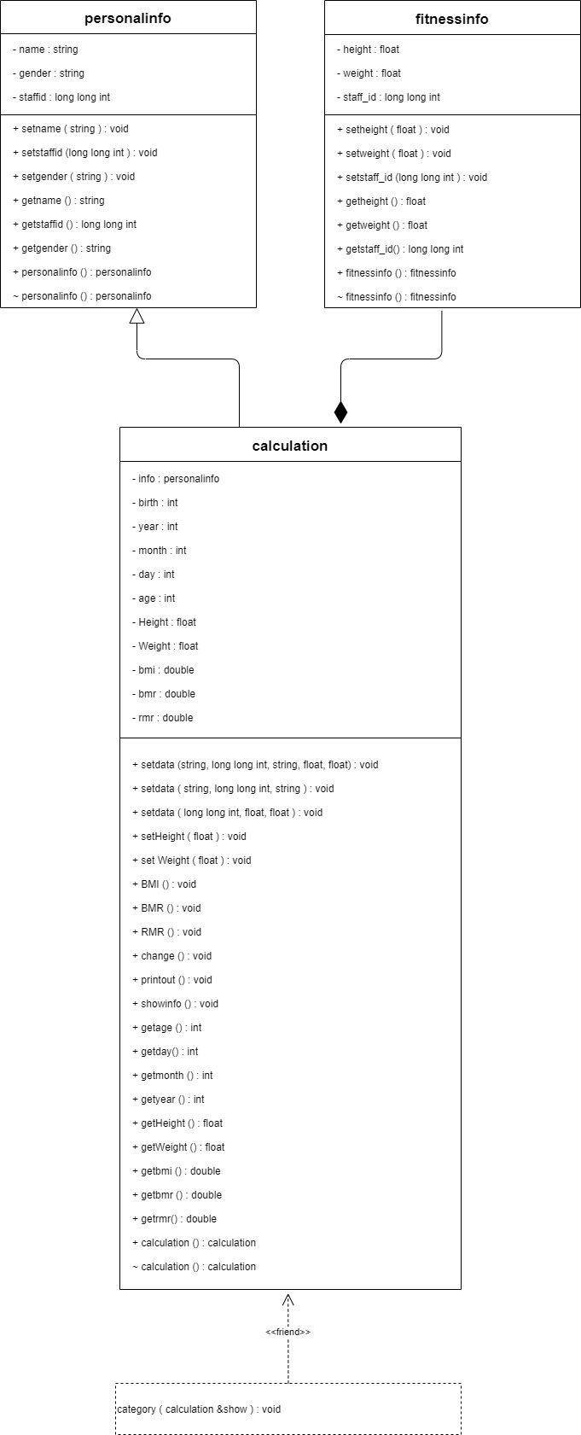

Source code ( C++ Codes )

Class of personalinfo

class personalinfo // Class of Personal Information to store data ( name, staff ID and gender ) of the staff

{

private:

string name;

long long int staffid;

string gender;

public:

personalinfo();

~personalinfo();

void setname(string);

void setstaffid(long long int);

void setgender(string);

string getname();

long long int getstaffid();

string getgender();

};

personalinfo::personalinfo()

{

name = " ";

staffid = 0;

gender = " ";

}

personalinfo::~personalinfo()

{

name = " ";

staffid = 0;

gender = " ";

}

void personalinfo::setname(string NAME)

{

name = NAME;

}

void personalinfo::setstaffid(long long int ID)

{

staffid = ID;

}

void personalinfo::setgender(string GENDER)

{

gender = GENDER;

}

string personalinfo::getname()

{

return name;

}

long long int personalinfo::getstaffid()

{

return staffid;

}

string personalinfo::getgender()

{

return gender;

}

Class of fitnessinfo

class fitnessinfo //Class of Fitness Information to store data ( staff ID, weight and height ) of staff

{

private:

float height, weight;

long long int staff_id;

public:

fitnessinfo();

~fitnessinfo();

void setstaff_id(long long int);

void setweight(float);

void setheight(float);

long long int getstaff_id();

float getweight();

float getheight();

};

fitnessinfo::fitnessinfo()

{

height = weight = 0;

}

fitnessinfo::~fitnessinfo()

{

height = weight = 0;

}

void fitnessinfo::setstaff_id(long long int ID)

{

staff_id = ID;

}

void fitnessinfo::setweight(float w)

{

weight = w;

}

void fitnessinfo::setheight(float h)

{

height = h;

}

long long int fitnessinfo::getstaff_id()

{

return staff_id;

}

float fitnessinfo::getweight()

{

return weight;

}

float fitnessinfo::getheight()

{

return height;

}

Class of calculation

class calculation : public personalinfo // Derived class for calculation of

{ // Date of Birth, Age, BMI,BMR,RMR,Weight category

private:

double bmi, bmr, rmr;

int day, month, year, birth, age;

float Weight, Height;

fitnessinfo info;

public:

calculation();

~calculation();

void setdata(string, long long int, string, float, float);

void setdata(string, long long int, string);

void setdata(long long int, float, float);

void setHeight( float);

void setWeight(float);

void BMI();

void BMR();

void RMR();

void change();

int getage();

int getday();

int getmonth();

int getyear();

int gets();

float getWeight();

float getHeight();

double getbmi();

double getbmr();

double getrmr();

void printout();

void showinfo();

friend void category (calculation& show);

};

calculation::calculation()

{

day = month = year = birth = age = 0;

bmi = 0;

bmr = 0;

rmr = 0;

}

calculation::~calculation()

{

day = month = year = birth = age = 0;

bmi = 0;

bmr = 0;

rmr = 0;

}

void calculation:: setdata(string NAME, long long int ID, string GENDER, float w, float h)

{

setname(NAME);

setstaffid(ID);

setgender(GENDER);

info.setweight(w);

info.setheight(h);

}

void calculation:: setdata(string NAME, long long int ID, string GENDER)

{

setname(NAME);

setstaffid(ID);

setgender(GENDER);

}

void calculation:: setdata(long long int ID,float w, float h)

{

personalinfo::setstaffid(ID);

info.setweight(w);

info.setheight(h);

}

void calculation:: setHeight(float h)

{

info.setheight(h);

}

void calculation:: setWeight(float w)

{

info.setweight(w);

}

void calculation::change () // Function calculation class to calculate the date of birth and age of staff

{

birth = (getstaffid() / 1000000);

day = birth % 100 ;

month = (birth/100) % 100;

year = (birth / 10000);

if (year < 9)

{

year += 2000;

}

else

{

year += 1900;

}

age = 2020 - year;

}

int calculation::getage()

{

return age;

}

int calculation::getyear()

{

return year;

}

int calculation::getmonth()

{

return month;

}

int calculation::getday()

{

return day;

}

float calculation::getWeight()

{

return info.getweight();

}

float calculation::getHeight()

{

return info.getheight();

}

void calculation::BMI() // Function calculation class to calculate BMI

{

bmi = info.getweight() / pow((info.getheight()/100),2);

}

void calculation::BMR() // Function in calculation class to calculate BMR

{

if (getgender() == "MALE" || getgender() == "M")

bmr = (10 * info.getweight()) + (6.25 * info.getheight()) - (5 * (getage())) + 5;

else if (getgender() == "FEMALE" || getgender() == "F")

bmr = (10 * info.getweight()) + (6.25 * info.getheight()) - (5 * (getage())) - 161;

}

void calculation::RMR() // Function in calculation class to calculate RMR

{

if (getgender() == "MALE" || getgender() == "M")

rmr = 88.362 + (13.397 * info.getweight()) + (4.799 * info.getheight()) - (5.677 * (getage()));

else if (getgender() == "FEMALE" || getgender() == "F")

rmr = 447.593 + (9.247 * info.getweight()) + (3.098 * info.getheight()) - (4.330 * (getage()));

}

double calculation::getbmi()

{

return bmi;

}

double calculation::getbmr()

{

return bmr;

}

double calculation::getrmr()

{

return rmr;

}

void category(calculation &show) // Friend function in calculation class to estimate the weight category and give some advice

{

double IDW;

double low;

cout << fixed << showpoint;

if (show.getbmi() <20 )

{

cout << "\n\t\t\t\t\t\t || Weight category : " << "\t" << "Underweight" << " ||";

}

else if(show.getbmi() >= 20 && show.getbmi() < 25)

{

cout << "\n\t\t\t\t\t\t || Weight category : " << "\t" << "Normal weight" << " ||";

}

else if(show.getbmi() >= 25 && show.getbmi() < 30)

{

cout << "\n\t\t\t\t\t\t || Weight category : " << "\t" << "Overweight" << " ||";

}

else if(show.getbmi() >= 30)

{

cout << "\n\t\t\t\t\t\t || Weight category : " << "\t" << "Obese" << " ||";

}

cout << endl;

cout << "\t\t\t\t\t\t ____________________________________________________" << endl;

if( show.info.getheight() >= 152.4)

{

if (show.getgender() == "MALE" || show.getgender() == "M")

{

IDW = 50 + (0.91 * (show.info.getheight() - 152.4));

cout << "\n\t\t\t\t\t\t Ideal Body Weight : " << "\t" << left << std::setw(5) << setprecision(2) << IDW ;

}

else if (show.getgender() == "FEMALE" || show.getgender() == "F")

{

IDW = 45.5 + (0.91 * (show.info.getheight() - 152.4));

cout << "\n\t\t\t\t\t\t Ideal Body Weight : " << "\t" << left << std::setw(5) << setprecision(2) << IDW;

}

cout << endl;

if( show.info.getweight() < IDW && show.getbmi() <20)

{

low = ((IDW - show.info.getweight()) / IDW) * 100;

cout << "\n\t\t\t\t\t\t It is " << setprecision(2) << low << "% below Ideal Body Weight.";

cout << "\n\t\t\t\t\t\t You should eat more frequently.";

cout << "\n\t\t\t\t\t\t Choose nutrient-rich foods. As part of an ";

cout << "\n\t\t\t\t\t\t overall healthy diet, choose whole-grain breads,";

cout << "\n\t\t\t\t\t\t pastas and cereals; fruits and vegetables;\n\t\t\t\t\t\t dairy products; lean protein sources; and nuts and seeds.";

}

else if( low < 0.01)

{

if( show.info.getweight() < IDW )

cout << "\n\t\t\t\t\t\t It is " << left << std::setw(29) << setprecision(2) << low << "% below Ideal Body Weight.";

else if( show.info.getweight() > IDW)

cout << "\n\t\t\t\t\t\t It is " << setprecision(2) << low << "% above Ideal Body Weight.";

cout << "\n\t\t\t\t\t\t Well Done !!! You have archived your ideal \n\t\t\t\t\t\t body weight.";

}

else if( show.info.getweight() > IDW && show.getbmi() >= 25 && show.getbmi() < 30)

{

low = (( show.info.getweight()) - IDW / IDW) * 100;

cout << "\n\t\t\t\t\t\t It is " << setprecision(2) << low << "% above Ideal Body Weight.";

cout << "\n\t\t\t\t\t\t You should do more exercise and eat more vegetables \n\t\t\t\t\t\t and fruit.";

}

else if(show.info.getweight() != IDW && show.getbmi() >= 20 && show.getbmi() < 25)

{

if( show.info.getweight() < IDW )

cout << "\n\t\t\t\t\t\t It is " << setprecision(2) << low << "% below Ideal Body Weight.";

else if( show.info.getweight() > IDW)

cout << "\n\t\t\t\t\t\t It is " << setprecision(2) << low << "% above Ideal Body Weight.";

cout << "\n\t\t\t\t\t\t However you have a normal weight, continue \n\t\t\t\t\t\t embracing a healthy to maintain your weight.";

}

else if(show.info.getweight() > IDW && show.getbmi() >= 30)

{

low = (( show.info.getweight()) - IDW / IDW) * 100;

cout << "\n\t\t\t\t\t\t It is " << setprecision(2) << low << "% above Ideal Body Weight.";

cout << "\n\t\t\t\t\t\t Losing weight can reduce your risk of heart disease ";

cout << "\n\t\t\t\t\t\t and stroke; risk factors likehigh blood pressure,";

cout << "\n\t\t\t\t\t\t plasma glucose and sleep apnea. It can also help " ;

cout << "\n\t\t\t\t\t\t lower your total cholesterol and triglycerides.\n\t\t\t\t\t\t Losing weight can mean less heart disease, less diabetes and less cancer.";

cout << "\n\t\t\t\t\t\t Please take care of your body.";

cout << "\n\t\t\t\t\t\t you may change you diet. To lose weight, you have to reduce the ";

cout << "\n\t\t\t\t\t\t amount of calories you consume.You must do more physical activities.";

}

}

else

cout << "\n\t\t\t\t\t\t Ideal Body Weight : " << "\n\t\t\t\t\t\t Not appropriate, since the height is below 152.4 cm";

} // End category friend function

void calculation::printout() // Function in calculation class to display the information of all the staff

{

cout << "\t| " << left << setw(27) << getname();

if(getstaffid() <= 99999999999 && getstaffid() > 9999999999 )

cout << "| 0" << left << setw(13) << getstaffid();

else if(getstaffid() <= 9999999999 && getstaffid() > 999999999)

cout << "| 00" << left << setw(12) << getstaffid();

else if(getstaffid() <= 999999999 && getstaffid() > 99999999)

cout << "| 000" << left << setw(11) << getstaffid();

else

cout << "| " << left << setw(14) << getstaffid();

cout << "| " << left << setw(5) << getage();

if (getgender() == "FEMALE" || getgender() == "F")

cout << left << setw(11) << "| Female";

else if (getgender() == "MALE" || getgender() == "M")

cout << left << setw(11) << "| Male";

else;

cout << "| " << setw(5) << getyear() << left << setw(2) <<"-" ;

if(getmonth() <10) cout << "0" << left << setw(2) << getmonth();

else cout << left << setw(3) << getmonth() ;

cout << left << setw(2) << "-" ;

if ( getday() < 10) cout << "0" << left << setw(4) << getday();

else cout << left << setw(5) << getday();

cout << fixed << showpoint;

cout << "| " << left << setw(11) << setprecision(2) << info.getweight();

cout << "| " << left << setw(10) << setprecision(2) << info.getheight();

cout << "| " << left << setw(7) << setprecision(2) << getbmi();

cout << "| " << left << setw(9) << setprecision(2) << getbmr();

cout << "| " << left << setw(8) << setprecision(2) << getrmr() << "||" << endl;

} // End printout function

void calculation::showinfo() // Function in calculation class to display a staff information

{

cout << "\n\t\t\t\t\t\t\t\t Staff's information" << endl;

cout << "\t\t\t\t\t\t ____________________________________________________" << endl;

cout << "\n\t\t\t\t\t\t || Name :" << "\t" << left << std::setw(29) << getname() << "||"<< endl;

cout << "\n\t\t\t\t\t\t || ID :" << "\t" ;

if(getstaffid() <= 99999999999 && getstaffid() > 9999999999 )

cout << "0" << left << std::setw(28) << getstaffid() << "||"<< endl;

else if(getstaffid() <= 9999999999 && getstaffid() > 999999999)

cout << "00" << left << std::setw(27) << getstaffid() << "||" << endl;

else if(getstaffid() <= 999999999 && getstaffid() > 99999999)

cout << "000" << left << std::setw(26)<< getstaffid() << "||" << endl;

else

cout << left << std::setw(29) << getstaffid() << "||" << endl;

cout << "\n\t\t\t\t\t\t || Age :" << "\t" << left << std::setw(29) << getage() << "||" << endl;

cout << "\n\t\t\t\t\t\t || Gender :" << "\t" ;

if (getgender() == "FEMALE" || getgender() == "F")

cout << left << std::setw(29) << "Female" << "||" << endl;

else if (getgender() == "MALE" || getgender() == "M")

cout << left << std::setw(29) << "Male" << "||" << endl;

cout << "\n\t\t\t\t\t\t || Date of Birth :" << "\t" << left << std::setw(5) << getyear() << "-" << left << std::setw(2)<< getmonth() << "-" << left << std::setw(20)<< getday() << "||" << endl;

cout << "\n\t\t\t\t\t\t || Weight :" << "\t" << left << std::setw(29) << setprecision(2) << info.getweight() << "||" << endl;

cout << "\n\t\t\t\t\t\t || Height :" << "\t" << left << std::setw(29) << setprecision(2) << info.getheight() << "||" << endl;

} // End calculation function

Main function

#include <iostream>

#include <fstream>

#include <string>

#include <cmath>

#include <iomanip>

#include <algorithm>

#include "personalinfo.h"

#include "fitnessinfo.h"

#include "calculation.h"

using namespace std;

void print(int &, int &, int &, int &, int &, int &, float &, float &, float &, float &, float &, float &, int &, int &, int &, int &, int &, int &, int &, int &, int &, int &, int &, int &);

void oprint(fstream &, int &, int &, int &, int &, int &, int &, float &, float &, float &, float &, float &, float &, int &, int &, int &, int &, int &, int &, int &, int &, int &, int &, int &, int &);

void addinfo(string &,unsigned long long int &, string &, float &, float &, unsigned int &);

void category(calculation &);

void choosemenu(unsigned int &);

void calavg(int &, int &, float &, float &, int &, float &, float &);

void bmicat(calculation [], int &, int &, int &, float &, float &, int &, int &, int &, int &);

int main() // Main function

{ // Declare functions and variables

calculation read[501];

void openfile(calculation []);

openfile(read); // Call open fill function to read in file

system("pause");

return 0;

} // End main

void openfile(calculation read[]) // Function to read in the file

{

fstream indata, infile, outdata; // Function and variables declaration

int numfile, x, y ;

char q;

string name,gender, dataname, filename, outfile;

unsigned long long int staffid;

unsigned int choice = 14;

float weight, height;

void dothing(calculation [], int &,fstream &, string & );

cout << "\n\n\n\t\t\t ---------------------------------------------------------------------------------------- ----------" << endl; // Name of the program to welcome user

cout << "\t\t\t || WELCOME TO LET'S GET FIT ||" << endl;

cout << "\t\t\t ------------------------------------------------------------------------------------------------- -" << endl;

cout << "\n\t\t\t\t\t Please enter two file name :" << endl;

file1:

cout << "\n\t\t\t\t\t ( personal information in form of staff ID, name and gender)";

cout << "\n\t\t\t\t\t (exit program by entering '?' ) \n\n\t\t\t\t\t File 1: "; // Get the file name 1 from user

getline(cin,dataname);

if ( dataname == "?") { cout << "\n\t\t\t\t\t\t\tTHANK YOU !!!";exit(1);}

dataname += ".txt";

indata.open(dataname.c_str(), ios::in); // Open file 1 ( Perosnal information file )

while (indata.fail()) // Test the error of opening input file 1

{

indata.clear();

cout << "\n\t\t\t\tERROR :" << dataname << " could not be opened!!!";

cout << "\n\t\t\t\t Pleases enter again ";

goto file1;

}

cout << "\n\t\t\t ---------------------------------------------------------------------------------------------- ---";

file2:

cout << "\n\t\t\t\t\t ( fitness information in form of staff ID, weight and height)";

// Get the file name 2 from user

cout << "\n\t\t\t\t\t (exit program by entering '?' ) \n\n\t\t\t\t\t File 2: ";

getline(cin,filename);

if ( filename == "?") { cout << "\n\t\t\t\t\t\t\tTHANK YOU !!!";exit(1);}

filename += ".txt";

infile.open(filename.c_str(), ios::in); // Open file 2 ( Fitness information file )

while (infile.fail()) // Test the error of opening the input file 2

{

indata.clear();

cout << "\n\t\t\t\tERROR :" << filename << " could not be opened!!!";

cout << "\n\t\t\t\t Pleases enter again.";

goto file2;

}

system("cls");

choosemenu (choice);

cout << "\n\t\t\t\t An output file is to save all the latest staff information after the program ends.\n\t\t\t\tOtherwise, the data will be lost after the program ends.";

cout << "\n\t\t\t\t Please enter the set a name for the output file or if it is exist, key in the file name" << endl;

cout << "\n\t\t\t\t A file name cannot contain '\\' '/' ':' '*' '?' ' \" ' '<' '>' or '|' \n";

file3:

cout << "\n\t\t\t\t\t (exit program by entering '?' ) \n\n\t\t\t\t\t Output File : "; getline(cin, outfile); // Get the file name from user

if ( outfile == "?") { cout << "\n\t\t\t\t\t\t\tTHANK YOU !!!";exit(1);}

outfile += ".txt";

outdata.open(outfile.c_str(),ios::out); // Open file 3 ( Output file )

if (outdata.fail()) // Test the error of opening this output file

{

outdata.clear();

cout << "\n\t\t\t\tERROR : Output file could not be opened!!!";

cout << "\n\t\t\t\t All the data will be lost after exiting this program. Please check it.";

cout << "\n\t\t\t\t A file name cannot contain '\\' '/' ':' '*' '?' ' \" ' '<' '>' or '|' \n\n";

goto file3;

}

else // If the output file can be opened, tell the user that the output file is succesfully opened

cout << "\n\t\t\t\t An output file (" << outfile << ") exists to store all the latest staff information\n\t\t\t\t after the program ends.";

cout << "\n\n\t\t\t\t Reading file" << endl <<endl << "\t\t\t\t\t";

// Inform the user that the file is being read

x=0;

system("pause");

while(!indata.eof()) // Test the end of input file 1

{

indata >> staffid;

getline(indata, name, '\t');

getline(indata, name, '\t');

transform(name.begin(), name.end(), name.begin(), ::toupper);

indata >> gender;

transform(gender.begin(), gender.end(), gender.begin(), ::toupper);

read[x].setdata(name, staffid, gender);

x++;

if (indata.eof())

break;

}

y=x;

while (!infile.eof()) // Test the end of file of input file 2

{

infile >> staffid >> weight >> height;

read[y].setdata(staffid, weight, height);

for(int j = 0; j < x ; j++)

{

if(read[j].getstaffid() == read[y].getstaffid())

read[j].setdata(staffid, weight, height);

}

y++;

if(infile.eof())

break;

}

cout << "\n\t\t\t\t File recorded" << endl << "\n\t\t\t\t\t";

system("pause");

numfile = x;

dothing(read, numfile, outdata, outfile); // Call function to do operation of the system

indata.close(); // Close the file 1 ( personal information file )

infile.close(); // Close the file 2 ( fitness information file )

outdata.close(); // Close the file 3 ( output file )

} // End openfile function

void dothing(calculation read[], int &numfile, fstream &outdata, string &outputfile) // Function to do all the operations

{

unsigned int option,choice; // Variables declaration

string name,gender;

unsigned long long int staffid;

float weight, height;

void display(calculation [], int &); // Function declaration

void add(calculation [], int &);

void asccedingdisplay(calculation [], int &, unsigned int&);

void searchinfo (calculation [], int &);

void modifyinfo(calculation [], int &);

void analysisinfo(calculation [], int &,fstream &);

void deleteinfo(calculation [], int &, unsigned int &);

void outfile(calculation [], int &, fstream &outdata);

display(read, numfile); // Display the file read in

menu: system("cls"); // Main menu

choice =14;

choosemenu(choice);

choice =13;

choosemenu(choice);

valid1:

cout << "Your choice : ";cin >> option; // Let user to make a choice

if(cin.fail() || option > 8) // Limit user to input a correct and valid choice

{

cin.clear();

cin.ignore(INT_MAX,'\n');

cout << "\n\t\t\t\t\tPlease enter a valid number : ";

goto valid1;

}

else

{ // Call the functions to do the operations according to the main menu

if (option == 1)

add(read, numfile); // Call the function to add new staff information

else if (option ==2 || option ==3 || option ==4)

asccedingdisplay(read, numfile, option);

// Call the function to display all the staff information

else if (option ==5)

searchinfo(read, numfile); // Call the function to search staff by a information

else if (option ==6)

modifyinfo(read, numfile); // Call the function to modify some specific information of a staff

else if (option ==7)

analysisinfo(read, numfile, outdata);

// Call the function to analysis a staff information or the overall information

else if (option == 8)

deleteinfo(read, numfile, option);

// Call the function to delete a staff information

else goto Exit;

}

goto menu;

Exit:

system("cls");

choice =14;

choosemenu(choice); // Display a thank you to user after user chose to end the program

cout << "\n\n\n\n\n\n\n\n\n\n\n\t\t\t\t ================================= ===========================================";

cout << "\n\t\t\t\t || THANK YOU!!!! ||";

cout << "\n\t\t\t\t ==================================================== ========================";

cout << "\n\n\t\t\t\t All the latest staff information are saved into a text file called " << outputfile ;

cout << "\n\t\t\t\t You may press enter to exit...";

cin.get();

cin.get();

outfile(read,numfile, outdata); // Call function to store all the latest staff information into a output text file ;

system("cls");

exit(1);

} // End dothing funtion

void display(calculation read[], int &numfile) // Function to display all the staff informations

{

unsigned int choice =3;

choosemenu(choice);

for (int y = 0; y < numfile; y++)

{

read[y].change();

read[y].BMI();

read[y].BMR();

read[y].RMR();

cout << " " << y+1 << ")";

read[y].printout();

}

cout << "\t____________________________________________________________ _________________________________________________________________ ______________________" << endl << "\t\t\t\t\t";

system("pause");

} // End display function

void add(calculation read[], int & numfile) // Function to add new staff information

{

unsigned int choice =14 ;

string name,gender;

unsigned long long int staffid;

float weight, height;

string back;

Addinfo:

do{

system("cls");

choosemenu(choice);

if ( numfile >= 500) // when the array of object is full due to the limit , inform the user that the storage is full

{

cout << "\n\t\t\t\tThe storage is full, please remove some unnecessary information to add new information.\n\t\t\t\t";

system("pause");

goto endadd;

}

cout << "\n\t\t\t\t\t\t ===============================================" << endl;

cout << "\n\t\t\t\t\t\t Please enter the staff information." << endl;

cout << "\n\t\t\t\t\t\t ===============================================" << endl;

choice =1;

addinfo(name, staffid, gender, weight, height,choice);

if(height==0)

goto endadd;

read[numfile].setdata(name, staffid, gender, weight, height);

read[numfile].change();

read[numfile].BMI();

read[numfile].BMR();

read[numfile].RMR();

cout << "\n\n\t\t\t\t\t\t\tNew staff information added.\n\t\t\t\t\t\t\tPlease press ENTER to continue" << endl << endl;

cin.ignore();cin.get();

system("cls");

choice = 14;

choosemenu(choice);

// Display the newly added staff information

read[numfile].showinfo();

cout << "\n\t\t\t\t\t\t _______________________________________________ _____" << endl << endl << endl << endl;

numfile++;

cout << "\n\t\t\t\t\t\tDo you what to continue to add new staff information ?";

cout << "\n\t\t\t\t\t\tPress 'y' to search again or press any key to go back."; // Ask the user to continue add another new staff information or not

cout << "\n\t\t\t\t\t\tYour choice : ";cin >> back;

transform(back.begin(), back.end(), back.begin(), ::toupper);

}while(back == "Y");

endadd:

cout << " ";

} // End add function

void asccedingdisplay(calculation read[], int &numfile, unsigned int&option) // Function to display all the staff information according to

{ // name , staff ID or age

if(option == 2) // Display according to name

{

for(int i=0; i<= numfile ;i++)

for(int j=0; j<numfile; j++)

if(read[j].getname() > read[j+1].getname())

{

read[numfile] = read[j];

read[j] = read[j+1];

read[j+1] = read[numfile];

}

}

else if (option == 3) // Display according to staff ID

{

for(int i=0; i<= numfile ;i++)

for(int j=0; j<numfile; j++)

if(read[j].getstaffid() > read[j+1].getstaffid())

{

read[numfile] = read[j];

read[j] = read[j+1];

read[j+1] = read[numfile];

}

}

else if(option ==4) // Display according to age

{

for(int i=0; i<= numfile ;i++)

for(int j=0; j<numfile; j++)

if(read[j].getage() > read[j+1].getage())

{

read[numfile] = read[j];

read[j] = read[j+1];

read[j+1] = read[numfile];

}

}

display(read,numfile);

} // End asscedingdsiplay function

void searchinfo(calculation read[], int &numfile) // Function to search the staff information

{

unsigned int choice;

string name,gender;

unsigned long long int staffid;

float weight, height;

do{

int s=0;

system("cls");

choice = 14;

choosemenu(choice); // Display Searching Menu to let user to choose the method to search the staff information

unsigned int option =5;

choosemenu(option);

valid2:

cout << "Your choice : ";cin >> choice;

if(cin.fail() || choice >6 ) // To limit the user to input a correct and valid choice

{

cin.clear();

cin.ignore(INT_MAX,'\n');

cout << "\n\t\t\t\tERROR !!!\n\t\t\t\t\tPlease enter a valid number again : ";

goto valid2;

}

if (choice == 1) // Searching by name of staff

{

search1:

cout << "\n\t\t\t\t\tPlease enter the name which you want to search:";

getline(cin, name);

getline(cin, name);

transform(name.begin(), name.end(), name.begin(), ::toupper);

system("cls");

option=2;

for (int i = 0; i < numfile; i++)

if (name == read[i].getname())

{

choosemenu(option);

s++; option+=20;

cout << " " << s << ") ";

read[i].printout();

}

if(s==0) // Tell the user that the name searched could not be found

{

option = 14;

choosemenu(option);

cout << "\n\n\t\t\t\t\tThe staff "<< name <<" could not be found.(The name recorded might have spaces or tabs)";

}

else if (s > 0)

cout << "\n\n\n\t\t(If the name you search do not show in this list it means the name consists of some tabs or spaces at the end or you spell it wrongly.";

cout << "\n\t\t\t\t\t";

system("pause");

}

else if( choice ==2 ) //Searching by staff ID

{

search2:

s=0;

cout << "\n\t\t\t\t\t\tPlease enter the staff ID which you want to search (IC no. consists of 12 numbers) : \n\t\t\t\t\t\t";

idagain1:

cin >> staffid;

if(cin.fail() || staffid > 991231000000 || staffid < 101000000 ) // Limit the user to key in the correct and valid staff ID

{

cin.clear();

cin.ignore(INT_MAX,'\n');

cout << "\n\t\t\t\tERROR!!!\n\t\tInvalid staff ID : \n\t\t\t\t\tPlease enter staff ID again (IC no consists of 12 numbers ) : \n\t\t\t\t\t";

goto idagain1;

}

system("cls");

option=2;

for (int i = 0; i < numfile; i++)

if (staffid == read[i].getstaffid())

{

choosemenu(option);

s++; option+=20;

cout << " " << s << ") ";

read[i].printout();

}

if(s==0) // Tell the user that the staff ID searched could not be found

{

option = 14;

choosemenu(option);

cout << "\n\n\t\t\t\t\tThe staff ID could not be found.";

}

cout << "\n\t\t\t\t\t";

system("pause");

}

else if (choice ==3 ) // Searching by age of staff

{

unsigned int age;

s=0;

cout << "\n\t\t\t\t\tPlease enter the age which you want to search :";

ageagain:

cin >> age;

if(cin.fail()) // Limit the user to input correct and valid age

{

cin.clear();

cin.ignore(INT_MAX,'\n');

cout << "\n\t\t\t\tERROR!!!\n\t\t\tInvalid number : \n\t\t\t\t\tPlease enter the age again : ";

goto ageagain;

}

system("cls");

option=2;

for (int i = 0; i < numfile; i++)

if ( age == read[i].getage())

{

choosemenu(option);

s++; option+=20;

cout << " " << s << ") ";

read[i].printout();

}

if(s==0) // Tell the user that the age searced could not be found

{

option = 14;

choosemenu(option);

cout << "\n\n\t\t\t\t\tThe staff with age "<< age <<" could not be found.";

}

cout << "\n\t\t\t\t\t";

system("pause");

}

else if (choice == 4 ) // Searching by gender of staff

{

s=0;

cout << "\n\t\t\t\t\tPlease enter the gender which you want to search ('m' for male and 'f' for female) :";

genderagain1:

cin >> gender;

transform(gender.begin(), gender.end(), gender.begin(), ::toupper);

if(gender!= "M" && gender != "F") // Limit the user to input a correct and valid information

{

cout << "\n\t\t\t\tERROR!!!\n\t\t\t\t\tPlease enter a valid gender again : ";

goto genderagain1;

}

if(gender == "M")

gender ="MALE";

else if (gender=="F")

gender = "FEMALE";

option=2;

for (int i = 0; i < numfile; i++)

if (gender == read[i].getgender())

{

choosemenu(option);

s++; option+=20;

cout << " " << s << ") ";

read[i].printout();

}

if(s==0) // Tell the user that the gender searchd could not be found

{

option = 14;

choosemenu(option);

cout << "\n\n\t\t\t\t\tNo " << gender <<" could not be found.";

}

cout << "\n\t\t\t\t\t";

system("pause");

}

else if (choice ==5 ) // Searching by weight of staff

{

s=0;

cout << "\n\t\t\t\t\tPlease enter the weight which you want to search :";

weightagain:

cin >> weight;

if(cin.fail() || weight <= 0) // Limit the user to key in a correct and valid weight

{

cin.clear();

cin.ignore(INT_MAX,'\n');

cout << "\n\t\t\t\tERROR!!!\n\t\t\tInvalid number : \n\t\t\t\t\tPlease enter the weight again : ";

goto weightagain;

}

system("cls");

option =2;

for (int i = 0; i < numfile; i++)

if ( weight == read[i].getWeight())

{

choosemenu(option);

s++; option+=20;

cout << " " << s << ") ";

read[i].printout();

}

if(s==0) // Tell the user that the weight searched could not be found

{

option = 14;

choosemenu(option);

cout << "\n\n\t\t\t\t\tThe staff with " << weight << "kg could not be found.";

}

cout << "\n\t\t\t\t\t";

system("pause");

}

else if (choice ==6 ) // Searching by height of staff

{

s=0;

cout << "\n\t\t\t\t\tPlease enter the height which you want to search :";

heightagain:

cin >> height;

if(cin.fail() || height <= 0) // Limit the user to key in a correct and valid height

{

cin.clear();

cin.ignore(INT_MAX,'\n');

cout << "\n\t\t\t\tERROR!!!\n\t\t\tInvalid number : \n\t\t\t\t\tPlease enter the height again";

goto heightagain;

}

system("cls");

option=2;

for (int i = 0; i < numfile; i++)

if ( height == read[i].getHeight())

{

choosemenu(option);

s++; option+=20;

cout << " " << s << ") ";

read[i].printout();

}

if(s==0) // Tell the user that the height searched could not be found

{

option = 14;

choosemenu(option);

cout << "\n\n\t\t\t\t\tThe staff with " << height << "cm could not be found.";

}

cout << "\n\t\t\t\t\t";

system("pause");

}

}while(choice != 0);

} // End searchinfo function

void modifyinfo(calculation read[], int & numfile) // Function to modify the staff information

{

int s,k,u=0;

int ar[500], br[500];

string name,gender;

unsigned long long int staffid;

unsigned int option, choice;

float weight, height;

modifymenu:

system("cls");

s=0;

choice = 14;

choosemenu(choice);

option =6;

choosemenu(option); // Modifying menu to let user to choose the method they want to search and update a staff information

typeagain:

cout << "Your choice : ";cin >> choice;

if(choice >2 || cin.fail()) // Limit the user to input a correct and valid choice

{

cin.clear();

cin.ignore(INT_MAX,'\n');

cout << "\n\t\t\t\tERROR!!!\n\t\t\t\t\tPlease enter a valid number : " ;

goto typeagain;

}

if (choice == 1) // Searched by name then modify it

{

modifyname:

cout << "\n\t\t\t\t\tPlease enter the staff's name : "; // Let user to input the name that user wants to search and modify

getline(cin, name);

getline(cin, name);

transform(name.begin(), name.end(), name.begin(), ::toupper);

s = 0;

int i = 0;

option=2;

for (; i < numfile; i++)

{

if (name == read[i].getname()) // Program will search and display all the name the match with the name searched by user

{

choosemenu(option);

k=i;

s++; option+=20; ar[i]=1;

cout << " " << ++i << ". ";

i--;

read[i].printout();

}

}

if(s>0)

{

if(s > 1)

{

// if more then one results found, program aks the user to choose to update a staff information and can input '-1' to cancel modifying

cout << "\n\n\n\t\tIf the name you search do not show in this list it means the name consists of some tabs or spaces at the end or you spell it wrongly.";

numname:

cout << "\n\t\t\t\t\tPlease enter the number that you want to modify (cancel by entering '-1') \n\n\t\t\t\t\t\tYour choice : ";

cout << "Your choice : ";cin >> i;

i--;

if ( i==-2 )

goto modifymenu;

if(cin.fail() || i <0 || i>= 500 || read[i].getname() == " " || ar[i] != 1)

// Limit the user to input a correct and valid choice

{

cin.clear();

cin.ignore(INT_MAX,'\n');

cout << "\n\t\t\t\tERROR!!!\n\t\t\tInvalid number : ";

goto numname;

}

}

else if (s==1){i=k;}

cout << "\n\n\n\t\t\t\t\tPlease enter the new information of the staff " << name << " again .\n\t\t\t\t\t";

system ("pause");

modifyingmenu1:

system("cls");

option =14;

choosemenu(option);

option =10;

choosemenu(option);

// Display Modifying menu to allow user to choose the information that user wants to update

valid4:

cout << "Your choice : ";cin >> choice;

if ( choice > 7 ||choice ==0 || cin.fail())

// Limit the user to input a correct and valid choice

{

cin.clear();

cin.ignore(INT_MAX,'\n');

cout << "\n\t\t\t\tERROR!!!\n\t\t\t\t\tPlease enter a valid number : ";

goto valid4;

}

if (choice == 1 ) // Modify the whole information

{

u++;

addinfo(name, staffid, gender, weight, height, choice);

if (height ==0)

goto modifyingmenu1;

read[i].setdata(name, staffid, gender, weight, height);

read[i].change();

read[i].BMI();

read[i].BMR();

read[i].RMR();

cout <<"\n\t\t\t\t\t\t\tInformation modified.";

system("pause");

goto modifyingmenu1;

}

else if( choice ==2) // Modify the name of staff

{

u++;

addinfo(name, staffid, gender, weight, height, choice);

read[i].setname(name);

cout <<"\n\t\t\t\t\t\t\tInformation modified.";

system("pause");

goto modifyingmenu1;

}

else if(choice == 3) // Modify the staff ID

{

u++;

addinfo(name, staffid, gender, weight, height, choice);

read[i].setstaffid(staffid);

read[i].change();

read[i].BMI();

read[i].BMR();

read[i].RMR();

cout <<"\n\t\t\t\t\t\t\tInformation modified.";

system("pause");

goto modifyingmenu1;

}

else if (choice == 4) // Modify the gender of staff

{

u++;

addinfo(name, staffid, gender, weight, height, choice);

read[i].setgender(gender);

read[i].BMI();

read[i].BMR();

read[i].RMR();

cout <<"\n\t\t\t\t\t\t\tInformation modified.";

system("pause");

goto modifyingmenu1;

}

else if( choice ==5) // Modify the weight of staff

{

u++;

addinfo(name, staffid, gender, weight, height, choice);

read[i].setWeight(weight);

read[i].change();

read[i].BMI();

read[i].BMR();

read[i].RMR();

cout <<"\n\t\t\t\t\t\t\tInformation modified.";

system("pause");

goto modifyingmenu1;

}

else if( choice ==6 ) // Modify the height of staff

{

u++;

addinfo(name, staffid, gender, weight, height, choice);

read[i].setHeight(height);

read[i].BMI();

read[i].BMR();

read[i].RMR();

cout <<"\n\t\t\t\t\t\t\tInformation modified.";

system("pause");

goto modifyingmenu1;

}

else if(choice == 7 && u ==0 )

// Go back to the previous menu without modifying any information

{

goto modifymenu;

}

else if ( choice == 7 && u > 0)

// Display the staff information modified and go back to previous menu

{

system("cls");

choice = 14;

choosemenu(choice);

cout << "\n\t\t\t\t\t\t\t\tStaff information modified." << endl;

read[i].showinfo();

cout << "\n\t\t\t\t\t\t _______________________ _____________________________" << endl << endl << "\n\t\t\t\t\t\t\t";

system("pause"); goto modifymenu;

}

}

else

{

cout << "\n\n\n\t\t\t\t\tThe staff " << name <<" could not be found.(The name recorded might have spaces or tabs)\n\t\t\t\t\t";

system("pause");

goto modifymenu;

}

}

else if (choice ==2) // Searched by staff ID then modify it

{

modifyid:

system("cls");

choice = 14;

choosemenu(choice);

cout << "\n\t\t\t\tPlease enter the staff ID (IC no. consists of 12 numbers) : ";

// let user input the staff ID that user wants to search and modify

cout << "\n\t\t\t\t(If you do not know the staff ID you can search it first.)\n\t\t\t\t\t";

modifyidagain:

cout << "Your choice : " ;cin >> staffid;

// Limit the user to input a correct and vvalid staff ID

if(cin.fail() || staffid > 991231000000 || staffid < 101000000 )

{

cin.clear();

cin.ignore(INT_MAX,'\n');

cout << "\n\t\t\t\tERROR!!!\n\t\t\tInvalid staff ID : \n\t\t\t\t\tPlease enter staffid again (IC no. consists of 12 numbers) : \n\t\t\t\t\t";

goto modifyidagain;

}

int i = 0;

option=2;

for (; i < numfile; i++)

// Program will search and display the staff ID that match with the staff ID searched by user

{

if (staffid == read[i].getstaffid())

{

choosemenu(option);

k=i;

s++; option+=20; br[i]=1;

cout << " " << ++i << ". ";

i--;

read[i].printout();

}

}

if(s>0)

{

if(s > 1)

{

// If there are more than one results, the program will displayy all out and let user to choose the staff information that user wants to modify

cout << "\n\n\t\t\t\t\tPlease enter the number that you want to modify (cancel by entering '-1') \n\t\t\t\t\t\tYour choice : " ;

numid:

cout << "Your choice : ";cin >> i;

i--;

if ( i==-2 )

goto modifymenu;

// Limit user to input a orrect and valid choice

if(cin.fail() || i <0 || i >= 500 || br[i] != 1 || read[i].getstaffid() == 0 )

{

cin.clear();

cin.ignore(INT_MAX,'\n');

cout << "\n\t\t\t\tERROR!!!\n\t\t\t\t\tPlease enter a valid number again : ";

goto numid;

}

}

else if (s==1){i=k;}

cout << "\n\t\t\t\tPlease enter the new information of the staff ID" << staffid << " again .\n\t\t\t\t\t";

system("pause");

modifyingmenu2:

system("cls");

option =14;

choosemenu(option);

option =10;

choosemenu(option);

// Display Modifying menu to allow user to choose the specific information that wants to modify

do{

cout << "Your choice : ";cin >> choice;

// Limit the user to input a correct and valid choice

if ( choice > 7 || choice ==0 || cin.fail())

{

cin.clear();

cin.ignore(INT_MAX,'\n');

cout << "\n\t\t\t\tERROR!!!\n\t\t\t\t\tPlease enter a valid number : ";

}

}while( choice > 7 || choice ==0 || cin.fail());

if (choice == 1 ) // Modify the whole information

{

u++;

addinfo(name, staffid, gender, weight, height, choice);

if (height ==0)

goto modifyingmenu2;

read[i].setdata(name, staffid, gender, weight, height);

read[i].change();

read[i].BMI();

read[i].BMR();

read[i].RMR();

cout <<"\n\t\t\t\t\t\t\tInformation modified.";

system("pause");

goto modifyingmenu2;

}

else if( choice ==2) // Modify the name of staff

{

u++;

addinfo(name, staffid, gender, weight, height, choice);

read[i].setname(name);

cout <<"\n\t\t\t\t\t\t\tInformation modified.";

system("pause");

goto modifyingmenu2;

}

else if(choice == 3) // Modify the staff ID

{

u++;

addinfo(name, staffid, gender, weight, height, choice);

read[i].setstaffid(staffid);

read[i].change();

read[i].BMI();

read[i].BMR();

read[i].RMR();

cout <<"\n\t\t\t\t\t\t\tInformation modified.";

system("pause");

goto modifyingmenu2;

}

else if (choice == 4) // Modify the gender of staff

{

u++;

addinfo(name, staffid, gender, weight, height, choice);

read[i].setgender(gender);

read[i].BMI();

read[i].BMR();

read[i].RMR();

cout <<"\n\t\t\t\t\t\t\tInformation modified.";

system("pause");

goto modifyingmenu2;

}

else if( choice ==5) // Modify the weight of staff

{

u++;

addinfo(name, staffid, gender, weight, height, choice);

read[i].setWeight(weight);

read[i].BMI();

read[i].BMR();

read[i].RMR();

cout <<"\n\t\t\t\t\t\t\tInformation modified.";

system("pause");

goto modifyingmenu2;

}

else if( choice ==6 ) // Modify the height of staff

{

u++;

addinfo(name, staffid, gender, weight, height, choice);

read[i].setHeight(height);

read[i].BMI();

read[i].BMR();

read[i].RMR();

cout <<"\n\t\t\t\t\t\t\tInformation modified.";

system("pause");

goto modifyingmenu2;

}

else if(choice == 7 && u == 0) // Go back to previous menu without any modifying

{

goto modifymenu;

}

else if( choice ==7 && u > 0) // Display the modified staff information and go back to previous menu

{

system("cls");

choice = 14;

choosemenu(choice);

cout << "\n\t\t\t\t\t\t\t\tStaff information modified." << endl;

read[i].showinfo();

cout << "\n\t\t\t\t\t\t _____________________________ _______________________" << endl << endl << "\n\t\t\t\t\t\t\t";

system("pause"); goto modifymenu;

}

}

else

{ // Tell the user that the staff ID searched could not be found

cout << "\n\t\t\t\t\tThe staff ID "<< staffid <<" could not be found.\n\t\t\t\t\t";

system("pause");

goto modifymenu;

}

}

} // End modifyinfo function

void analysisinfo(calculation read[], int&numfile, fstream &outdata) // Function to analysis staff information

{

unsigned int option, choice;

int s;

unsigned long long int staffid;

int avgage3, avgage1, avgage2;

int totm1, totf1,tot, totage1, totage2, totage3;

float totw1, toth1, totw2, toth2, totw3, toth3;

float avgw1, avgh1, avgw2, avgh2, avgw3, avgh3;

int totunder1, totnormal1, totover1, totobes1, totunder2, totnormal2, totover2, totobes2, totunder3, totnormal3, totover3, totobes3;

analysismenu:

system("cls");

choice = 14;

choosemenu(choice); // Definition of BMI, BMR and RMR

cout << "\n\n\t\t\t ***BMI is defined as the body mass divided by the square of the body height.The BMI is a ";

cout << "\n\t\t\t convenient rule of thumb used to broadly categorize a person as underweight, normal weight,";

cout << "\n\t\t\t overweight, or obese based on tissue mass (muscle, fat, and bone) and height.\n";

cout << "\n\t\t\t ***BMR is the number of calories a body needs to accomplish its most basic (basal) ";

cout << "\n\t\t\t life-sustaining functions. Theoretically, body weight can be reduced if we consistently ";

cout << "\n\t\t\t consume lesser daily amount of energy needed by the body.\n";

cout << "\n\t\t\t ***RMR is the rate at which a body burns energy when it is at complete rest. Resting ";

cout << "\n\t\t\t metabolic ratecan be calculated to see how many calories the body needs to perform basic\n\t\t\t functions like breathing and blood circulation.\n\n";

option = 7;

choosemenu(option);

// display Analysis Menu to allow user to choose whelther anlayze a staff information or an overall information among all the staff

valid5:

cout << "Your choice : ";cin >> choice;

if (cin.fail()|| choice > 2)

{

cin.clear();

cin.ignore(INT_MAX,'\n');

cout << "\n\t\t\t\tERROR!!!\n\t\t\t\t\tPlease enter a valid number : ";

goto valid5;

}

if(choice == 1) //Analysis only one staff information

{

system("cls");

choice = 14;

choosemenu(choice);

analysis1:

cout << "\n\n\n\t\t\t Enter the staff ID which you want to analyse (IC no. consists of 12 numbers) : \n\t\t\t ";

staffidagain:

cin >> staffid;

if(cin.fail() || staffid > 991231000000 || staffid < 101000000)

{

cin.clear();

cin.ignore(INT_MAX,'\n');

cout << "\n\t\t\t\tERROR!!!\n\t\t\tInvalid staff ID : \n\t\t\t\t\tPlease enter the staff ID again (IC no. consists of 12 numbers) : \n\t\t\t\t\t";

goto staffidagain;

}

s =0 ;

for (int i = 0; i < numfile; i++)

// Display and analyze the information of the staff

{

if (staffid == read[i].getstaffid())

{

s++;

cout << endl;

read[i].showinfo();

read[i].BMI();

read[i].BMR();

read[i].RMR();

cout << "\n\t\t\t\t\t\t || BMI :" << "\t" << left << std::setw(29)<< setprecision(2) << read[i].getbmi() << "||" << endl;

cout << "\n\t\t\t\t\t\t || BMR :" << "\t" << left << std::setw(29)<< setprecision(2) << read[i].getbmr() << "||" << endl;

cout << "\n\t\t\t\t\t\t || RMR :" << "\t" << left << std::setw(29)<< setprecision(2) << read[i].getrmr() << "||" << endl;

category (read[i]);

cout << endl;

cout << "\t\t\t\t\t\t _______________________________ _____________________" << endl << endl;

}

}

if(s==0)

cout << "\n\n\n\t\t\t\t\tThe staff ID could not be found." << "\n\t\t\t\t\t";

system("pause");

goto analysismenu;

}

else if(choice == 2)

// Analysis the average of age, weight, height, number of male anf female, number of staff and

{

// number of underweight, normal weight, overweight and obese among all the staff by comparing gender according to age group

system("cls");

analysis2:

totm1 = totf1 = tot = totw1 = totw2 = totw3 = toth1 = toth2 = toth3 = 0;

totage1 = totage2 = totage3 = 0;

totunder1 = totnormal1 = totover1 = totobes1 = totunder2 = totnormal2 = totover2 = totobes2 = totunder3 = totnormal3 = totover3 = totobes3 =0;

choice = 14;

choosemenu(choice);

cout << "\n\t\t =========================================== =================================================== =================";

cout << "\n\t\t || AGE GROUP || MALE || FEMALE || OVERALL ||";

cout << "\n\t\t ============================================ ================================================= ==================";

for(int y=0; y <numfile; y++)

{

if (read[y].getage() < 21) // analyze the information of staff of age group of below 21 years old

{ //by comparing gender and dislplay the overall

if (read[y].getgender() == "Male" || read[y].getgender() == "male" || read[y].getgender() == "MALE" || read[y].getgender() == "m" || read[y].getgender() == "M")

bmicat(read, y,totm1,totage1, totw1, toth1, totunder1, totnormal1, totover1, totobes1);

else if (read[y].getgender() == "Female" || read[y].getgender() == "female" || read[y].getgender() == "FEMALE" || read[y].getgender() == "f" || read[y].getgender() == "F")

bmicat(read, y,totf1,totage2, totw2, toth2, totunder2, totnormal2, totover2, totobes2);

bmicat(read, y,tot,totage3, totw3, toth3, totunder3, totnormal3, totover3, totobes3);

}

}

calavg(totm1, totage1, totw1, toth1, avgage1, avgw1, avgh1);

calavg(totf1, totage2, totw2, toth2, avgage2, avgw2, avgh2 );

calavg(tot, totage3, totw3, toth3, avgage3, avgw3, avgh3 );

cout << "\n\t\t\t " << left << std::setw(33) << " Below 21 years old";

print(totm1, totf1, tot, avgage1, avgage2, avgage3, avgw1, avgw2, avgw3, avgh1, avgh2, avgh3,totunder1, totunder2, totunder3, totnormal1, totnormal2, totnormal3, totover1, totover2, totover3, totobes1, totobes2, totobes3);

totm1 = totf1 = tot = totw1 = totw2 = totw3 = toth1 = toth2 = toth3 = 0;

totage1 = totage2 = totage3 = 0;

totunder1 = totnormal1 = totover1 = totobes1 = totunder2 = totnormal2 = totover2 = totobes2 = totunder3 = totnormal3 = totover3 = totobes3 =0;

for(int y=0; y <numfile; y++)

{

if (read[y].getage() >=21 && read[y].getage() < 30)

// analyze the information of staff of age group of between 21 to 29 years old

{ //by comparing gender and dislplay the overall

if (read[y].getgender() == "Male" || read[y].getgender() == "male" || read[y].getgender() == "MALE" || read[y].getgender() == "m" || read[y].getgender() == "M")

bmicat(read, y,totm1,totage1, totw1, toth1, totunder1, totnormal1, totover1, totobes1);

else if (read[y].getgender() == "Female" || read[y].getgender() == "female" || read[y].getgender() == "FEMALE" || read[y].getgender() == "f" || read[y].getgender() == "F")

bmicat(read, y,totf1,totage2, totw2, toth2, totunder2, totnormal2, totover2, totobes2);

bmicat(read, y,tot,totage3, totw3, toth3, totunder3, totnormal3, totover3, totobes3);

}

}

calavg(totm1, totage1, totw1, toth1, avgage1, avgw1, avgh1);

calavg(totf1, totage2, totw2, toth2, avgage2, avgw2, avgh2 );

calavg(tot, totage3, totw3, toth3, avgage3, avgw3, avgh3 );

cout << "\n\t\t\t______________________________________________ _____________________________________________________ __________";

cout << "\n\t\t\t " << left << std::setw(30) << "21 - 29 years old";

print(totm1, totf1, tot, avgage1, avgage2, avgage3, avgw1, avgw2, avgw3, avgh1, avgh2, avgh3,totunder1, totunder2, totunder3, totnormal1, totnormal2, totnormal3, totover1, totover2, totover3, totobes1, totobes2, totobes3);

totm1 = totf1 = tot = totw1 = totw2 = totw3 = toth1 = toth2 = toth3 = 0;

totage1 = totage2 = totage3 = 0;

totunder1 = totnormal1 = totover1 = totobes1 = totunder2 = totnormal2 = totover2 = totobes2 = totunder3 = totnormal3 = totover3 = totobes3 =0;

for(int y=0; y <numfile; y++)

{

if (read[y].getage() >=30 && read[y].getage() < 50)

// analyze the information of staff of age group of between 30 to 49 years old

{ //by comparing gender and dislplay the overall

if (read[y].getgender() == "Male" || read[y].getgender() == "male" || read[y].getgender() == "MALE" || read[y].getgender() == "m" || read[y].getgender() == "M")

bmicat(read, y,totm1,totage1, totw1, toth1, totunder1, totnormal1, totover1, totobes1);

else if (read[y].getgender() == "Female" || read[y].getgender() == "female" || read[y].getgender() == "FEMALE" || read[y].getgender() == "f" || read[y].getgender() == "F")

bmicat(read, y,totf1,totage2, totw2, toth2, totunder2, totnormal2, totover2, totobes2);

bmicat(read, y,tot,totage3, totw3, toth3, totunder3, totnormal3, totover3, totobes3);

}

}

cout << "\n\t\t\t_____________________________________________ __________________________________________________ ______________";

cout << "\n\t\t\t " << left << std::setw(30) << "30 - 49 years old";

print(totm1, totf1, tot, avgage1, avgage2, avgage3, avgw1, avgw2, avgw3, avgh1, avgh2, avgh3,totunder1, totunder2, totunder3, totnormal1, totnormal2, totnormal3, totover1, totover2, totover3, totobes1, totobes2, totobes3);

totm1 = totf1 = tot = totw1 = totw2 = totw3 = toth1 = toth2 = toth3 = 0;

totage1 = totage2 = totage3 = 0;

totunder1 = totnormal1 = totover1 = totobes1 = totunder2 = totnormal2 = totover2 = totobes2 = totunder3 = totnormal3 = totover3 = totobes3 =0;

for(int y=0; y <numfile; y++)

{

if (read[y].getage() >=50 && read[y].getage() < 65)

// analyze the information of staff of age group of between 50 to 64 years old

{ //by comparing gender and dislplay the overall

if (read[y].getgender() == "Male" || read[y].getgender() == "male" || read[y].getgender() == "MALE" || read[y].getgender() == "m" || read[y].getgender() == "M")

bmicat(read, y,totm1,totage1, totw1, toth1, totunder1, totnormal1, totover1, totobes1);

else if (read[y].getgender() == "Female" || read[y].getgender() == "female" || read[y].getgender() == "FEMALE" || read[y].getgender() == "f" || read[y].getgender() == "F")

bmicat(read, y,totf1,totage2, totw2, toth2, totunder2, totnormal2, totover2, totobes2);

bmicat(read, y,tot,totage3, totw3, toth3, totunder3, totnormal3, totover3, totobes3);

}

}

calavg(totm1, totage1, totw1, toth1, avgage1, avgw1, avgh1);

calavg(totf1, totage2, totw2, toth2, avgage2, avgw2, avgh2 );

calavg(tot, totage3, totw3, toth3, avgage3, avgw3, avgh3 );

cout << "\n\t\t\t_______________________________________________ __________________________________________________ ____________";

cout << "\n\t\t\t " << left << std::setw(30) << "50 - 64 years old" ;

print(totm1, totf1, tot, avgage1, avgage2, avgage3, avgw1, avgw2, avgw3, avgh1, avgh2, avgh3,totunder1, totunder2, totunder3, totnormal1, totnormal2, totnormal3, totover1, totover2, totover3, totobes1, totobes2, totobes3);

totm1 = totf1 = tot = totw1 = totw2 = totw3 = toth1 = toth2 = toth3 = 0;

totage1 = totage2 = totage3 = 0;

totunder1 = totnormal1 = totover1 = totobes1 = totunder2 = totnormal2 = totover2 = totobes2 = totunder3 = totnormal3 = totover3 = totobes3 =0;

for(int y=0; y <numfile; y++)

{

if (read[y].getage() >=65)

// analyze the information of staff of age group of 65 years old and above

{ //by comparing gender and dislplay the overall

if (read[y].getgender() == "Male" || read[y].getgender() == "male" || read[y].getgender() == "MALE" || read[y].getgender() == "m" || read[y].getgender() == "M")

bmicat(read, y,totm1,totage1, totw1, toth1, totunder1, totnormal1, totover1, totobes1);

else if (read[y].getgender() == "Female" || read[y].getgender() == "female" || read[y].getgender() == "FEMALE" || read[y].getgender() == "f" || read[y].getgender() == "F")

bmicat(read, y,totf1,totage2, totw2, toth2, totunder2, totnormal2, totover2, totobes2);

bmicat(read, y,tot,totage3, totw3, toth3, totunder3, totnormal3, totover3, totobes3);

}

}

calavg(totm1, totage1, totw1, toth1, avgage1, avgw1, avgh1);

calavg(totf1, totage2, totw2, toth2, avgage2, avgw2, avgh2 );

calavg(tot, totage3, totw3, toth3, avgage3, avgw3, avgh3 );

cout << "\n\t\t\t____________________________________________ _________________________________________________ ________________";

cout << "\n\t\t\t " << left << std::setw(30) << "65 years old and above";

print(totm1, totf1, tot, avgage1, avgage2, avgage3, avgw1, avgw2, avgw3, avgh1, avgh2, avgh3,totunder1, totunder2, totunder3, totnormal1, totnormal2, totnormal3, totover1, totover2, totover3, totobes1, totobes2, totobes3);

totm1 = totf1 = tot = totw1 = totw2 = totw3 = toth1 = toth2 = toth3 = 0;

totage1 = totage2 = totage3 = 0;

totunder1 = totnormal1 = totover1 = totobes1 = totunder2 = totnormal2 = totover2 = totobes2 = totunder3 = totnormal3 = totover3 = totobes3 =0;

for(int y=0; y <numfile; y++)

// analyze the information of staff among all the staff

{

if (read[y].getgender() == "Male" || read[y].getgender() == "male" || read[y].getgender() == "MALE" || read[y].getgender() == "m" || read[y].getgender() == "M")

bmicat(read, y,totm1,totage1, totw1, toth1, totunder1, totnormal1, totover1, totobes1);

else if (read[y].getgender() == "Female" || read[y].getgender() == "female" || read[y].getgender() == "FEMALE" || read[y].getgender() == "f" || read[y].getgender() == "F")

bmicat(read, y,totf1,totage2, totw2, toth2, totunder2, totnormal2, totover2, totobes2);

bmicat(read, y,tot,totage3, totw3, toth3, totunder3, totnormal3, totover3, totobes3);

}

calavg(totm1, totage1, totw1, toth1, avgage1, avgw1, avgh1);

calavg(totf1, totage2, totw2, toth2, avgage2, avgw2, avgh2);

calavg(tot, totage3, totw3, toth3, avgage3, avgw3, avgh3 );

cout << "\n\t\t\t____________________________________________________ _________________________________________________________";

cout << "\n\t\t\t " << left << std::setw(30) << "Overall : ";

cout << "\n\t\t\t================================== " <<endl;

// Call the function to display the analysis data into an output file

oprint(outdata, totm1,totf1, tot,avgage1, avgage2, avgage3, avgw1, avgw2,avgw3,avgh1, avgh2, avgh3, totunder1, totunder2, totunder3, totnormal1, totnormal2, totnormal3, totover1, totover2, totover3, totobes1, totobes2, totobes3);

print(totm1, totf1, tot, avgage1, avgage2, avgage3, avgw1, avgw2, avgw3, avgh1, avgh2, avgh3,totunder1, totunder2, totunder3, totnormal1, totnormal2, totnormal3, totover1, totover2, totover3, totobes1, totobes2, totobes3);

cout << "\n\t\t\t_____________________________________________________ ________________________________________________________\n\t \t\t\t\t";

system("pause");

goto analysismenu;

}

} // End analysisinfo function

void deleteinfo(calculation read[], int &numfile, unsigned int &option)

// Function to delete the information of staff

{

unsigned int choice,s;

int arr[500];

int i;

unsigned long long int staffid;

deleteinfo:

system("cls");

choice = 14; option =8;

choosemenu(choice);

choosemenu(option);

// Deletion Menu for user to choose to delete a staff information or go back to main menu

valid6:

cout << "Your choice : "; cin >> choice;

if( choice >1 ||cin.fail()) // Limit user to input a correct and valid choice

{

cin.clear();

cin.ignore(INT_MAX,'\n');

cout << "\n\t\t\t\tERROR!!!\n\t\t\t\t\tPlease enter a valid number : " ;

goto valid6;

}

if(choice == 1)

{

system("cls");

deletechoose:

choice = 14;

choosemenu(choice); // Let user to key in the staff ID that wants to delete

cout << "\n\n\n\n\n\t\t\t Enter the staff ID which you want to delete the staff's information (IC no. consists of 12 numbres) ";

cout << "\n\t\t\t (If you do not know the staff ID you can search it first.)";

cout << "\n\t\t\t Staff ID : ";

do{

cin >> staffid; // Limit user to inout a correct and valid staff ID

if(cin.fail() || staffid > 991231000000 || staffid < 101000000)

{

cin.clear();

cin.ignore(INT_MAX,'\n');

cout << "\n\t\t\t\tERROR!!!\n\t\t\tInvalid staff ID : \n\t\t\t\t\tPlease enter the staff ID again (IC no. consists of 12 numbres) : \n\t\t\t\t\t";

}

}while(cin.fail() || staffid > 991231000000 || staffid < 101000000);

s=0;

option=2;

for (; i < numfile; i++) // Program will searche and display all the staff ID that match with the staff ID searched by user

{

if (staffid == read[i].getstaffid())

{

choosemenu(option);

s++; option+=20; arr[i]=1;

cout << " " << ++i << ". ";

i--;

read[i].printout();

}

}

if(s>0)

{

if(s > 1) // Since there might be some error and overallap information, user can choose to delete which inforamtion

{

cout << "\n\t\t\t\t\tPlease enter the number that you want to delete. (Cancel by entering '-1'.) \n\t\t\t\t\t\tYour choice : ";

numid:

cout << "Your choice : "; cin >> i;

i--;

if(i==-2)

// Limit the user to input the correct and valid choice

goto deleteinfo;

if(cin.fail() || i > 500 || read[i].getstaffid() == 0 || arr[i] != 1 )

{

cin.clear();

cin.ignore(INT_MAX,'\n');

cout << "\n\t\t\t\tERROR!!!\n\t\t\t\t\tPlease enter a valid number again : ";

goto numid;

}

}

cout << "\n\t\t\t\t\t";

system("pause");

}

else if (s ==0)

// Tell the user that the staff ID searched could not be found

{

cout << "\n\n\t\t\tThe staff ID could not be found." << endl << "\n\t\t\t\t\t";

system("pause");

goto deleteinfo;

}

system("cls");

choice = 14;

choosemenu(choice);

unsigned int sure;

cout << endl; // Display the staff information that user searched to delete and let user to check the staff inforamtion

cout << "\n\t\t\t\t\t\t\tThis is the information of the staff." << endl << endl;

read[i].showinfo();

cout << "\t\t\t\t\t\t _________________________________________ ___________" << endl << endl << endl << endl;

cout << "\t\t\t\t\tDo you sure you want to delete the staff information?\n";

cout << "\n\t\t\t\t\tIf you decide to delete," << endl;

// Get confirmation from user and make sure user want to delete the staff information

cout << "\n\t\t\t\t\tSelect an option" << endl;

cout << "\n\t\t\t\t\t 1 - delete." << endl;

cout << "\n\t\t\t\t\t 0 - cancel." << endl;

cout << "\t\t\t\t\t ";

deletemenu:

cout << "Your choice : "; cin >> sure;

if(sure >1 || cin.fail())

// Limit user to input correcr and valid choice

{

cin.clear();

cin.ignore(INT_MAX,'\n');

cout << "\n\t\t\t\tERROR!!!\n\t\t\t\t\tPlease enter a valid number again : ";

goto deletemenu;

}

if (sure == 1)

{ // Inform user that the staff information is deleted

cout << "\n\t\t\t\tThe staff information is deleted.";

for(int j=i; j<(500-1); j++)

{

read[j]=read[j+1];

}

numfile--;

system("pause");

goto deleteinfo;

}

else if (sure == 0)

goto deleteinfo;

}

} // End deleteinfo function

// Function to add new staff information and modify staff information

void addinfo(string &staff_name, unsigned long long int &staff_id, string &staff_gender, float &staff_weight, float &staff_height, unsigned int &choose)

{

endinput:

staff_height=0;

if(choose == 1) // Add new staff information or modify the whole information of a staff

{

cout << "\n\t\t\t\t\t(Exit by entering '1' )";

cout << "\n\t\t\t\t\tEnter the Staff Name : ";

// Let user to key int the name of staff

getline(cin, staff_name);

getline(cin, staff_name);

transform(staff_name.begin(), staff_name.end(), staff_name.begin(), ::toupper);

if ( staff_name == "1") // Let user to cancel adding new staff information or stop modifying staff information by entering "A" to staff name

{

choose = 10;

cout << "\n\t\t\t\t\tPlease press enter to go back.";

cin.get();

goto endinput;

}

cout << "\n\t\t\t\t\tEnter the staff ID of the staff (IC No. consists of 12 numbers): \n\t\t\t\t\t"; // Let user to input the staff ID

keyin1:

cin >> staff_id;

cin.ignore();

if ( cin.fail() || staff_id > 991231000000 || staff_id < 101000000 && staff_id != 1) // Limit the user to input a correct and valid staff ID

{

cin.clear();

cin.ignore(INT_MAX,'\n');

cout << "\n\t\t\t\tERROR!!!\n\t\t\tInvalid staff ID : \n\t\t\t\t\tPlease enter the staff ID again (IC No. consists of 12 numbers): \n\t\t\t\t\t";

goto keyin1;

}

if(staff_id == 1) // Let user to cancel adding new staff information or stop modifying staff information by entering '1' to staff ID

{

choose = 10;

cout << "\n\t\t\t\t\tPlease press enter to go back.";

cin.get();

goto endinput;

}

cout << "\n\t\t\t\t\tEnter the gender of staff ('m' for male and 'f' for female) : "; // Let user to input gender of staff

keyin2:

cin >> staff_gender;

if ( staff_gender == "1") // Let user to cancel adding new staff information or stop modifying staff information by entering "A" to staff name

{

choose = 10;

cout << "\n\t\t\t\t\tPlease press enter to go back.";

cin.get();

cin.get();

goto endinput;

}

transform(staff_gender.begin(), staff_gender.end(), staff_gender.begin(), ::toupper);

// Limit the user to input correct and valid gender

if(staff_gender !="M" && staff_gender != "F")

{

cout << "\n\t\t\t\tERROR!!!\n\t\t\t\t\tPlease enter a valid gender again : ";

goto keyin2;

}

if(staff_gender == "M")

staff_gender ="MALE";

else if (staff_gender=="F")

staff_gender = "FEMALE";

cout << "\n\t\t\t\t\tEnter the weight of staff (in kg) : "; // Let user to input weight of staff

keyin3:

cin >> staff_weight;

if ( cin.fail() || staff_weight < 1 )

// Limit the user to input the correct and valid weight

{

cout << "\n\t\t\t\tERROR!!!\n\t\t\tInvalid number : \n\t\t\t\t\tPlease enter the weight again : ";

cin.clear();

cin.ignore(INT_MAX,'\n');

goto keyin3;

}

if(staff_weight == 1) // Let user to cancel adding new staff information or stop modifying staff information by entering "1" to weight of staff

{

choose = 10;

cout << "\n\t\t\t\t\tPlease press enter to go bac.";

cin.get();

cin.get();

goto endinput;

}

cout << "\n\t\t\t\t\tEnter the height of staff (in cm) : ";

// Let the user to input the height of staff

keyin4:

cin >> staff_height;

if ( cin.fail() || staff_height < 1 )

// Limit the user to input a correct and valid height

{

cout << "\n\t\t\t\tERROR!!!\n\t\t\tInvalid number : \n\t\t\t\t\tPlease enter the height again : ";

cin.clear();

cin.ignore(INT_MAX,'\n');

goto keyin4;

}

if(staff_height == 1)

// Let user to cancel adding new staff information or stop modifying staff information by entering "1" to height of staff

{

choose = 10;

cout << "\n\t\t\t\t\tPlease press enter to go back.";

cin.get();

cin.get();

goto endinput;

}

}

else if (choose == 2)

{

cout << "\n\t\t\t\t\tEnter the new Name : ";

// Let user to input name of staff

getline(cin, staff_name);

getline(cin, staff_name);

transform(staff_name.begin(), staff_name.end(), staff_name.begin(), ::toupper);

}

else if (choose == 3)

{

cout << "\n\t\t\t\t\tEnter the new staff ID of the staff (IC No. consists of 12 numbers): \n\t\t\t\t\t"; // Let the user to input the staff ID

idagain:

cin >> staff_id;

cin.ignore();

if ( cin.fail() ||staff_id > 991231000000 || staff_id < 101000000)

// Limit the user to input a correct and valid staff ID

{

cin.clear();

cin.ignore(INT_MAX,'\n');

cout << "\n\t\t\t\tERROR!!!\n\t\t\tInvalid staff ID : \n\t\t\t\t\tPlease enter the staff ID again (IC No. consists of 12 numbers): \n\t\t\t\t\t";

goto idagain;

}

}

else if ( choose == 4)

{

cout << "\n\t\t\t\t\tEnter the correct gender of staff ('m' for male and 'f' for female) : "; // Let user to input the gender of staff

genderagain:

cin >> staff_gender;

transform(staff_gender.begin(), staff_gender.end(), staff_gender.begin(), ::toupper);

if(staff_gender !="M" && staff_gender != "F")

{

cout << "\n\t\t\t\tERROR!!!\n\t\t\t\t\tPlease enter a valid gender again : "; // Limit the user to input a correct and valid gender

goto genderagain;

}

if(staff_gender == "M")

staff_gender ="MALE";

else if (staff_gender=="F")

staff_gender = "FEMALE";

}

else if ( choose == 5)

{

cout << "\n\t\t\t\t\tEnter the new weight of staff (in kg) : ";

// Let user to input weight of staff

weightagain:

cin >> staff_weight;

if ( cin.fail() || staff_weight <=0 )

// Limit the user to input corect and valid weight of staff

{

cin.clear();

cin.ignore(INT_MAX,'\n');

cout << "\n\t\t\t\tERROR!!!\n\t\t\tInvalid number : \n\t\t\t\t\tPlease enter the weight again : ";

goto weightagain;

}

}

else if ( choose ==6 )

{

cout << "\n\t\t\t\t\tEnter the new height of staff (in cm) : ";

// Let user to input height of staff

heightagain:

cin >> staff_height;

if ( cin.fail() || staff_height <=0 )

// Limit the user to input correct and valid height of staff

{

cin.clear();

cin.ignore(INT_MAX,'\n');

cout << "\n\t\t\t\tERROR!!!\n\t\t\tInvalid number : \n\t\t\t\t\tPlease enter the height again : ";

goto heightagain;

}

}

} // End addinfo function

// Function to calculate the analysis data among all the staff

void bmicat(calculation read[], int & y, int &totm1, int &totage1, float &totw1, float &toth1, int &totunder1, int &totnormal1, int &totover1, int &totobes1)

{

totm1++;

totage1 += read[y].getage();

totw1 += read[y].getWeight();

toth1 += read[y].getHeight();

if(read[y].getbmi() < 20 )

totunder1++;

else if( read[y].getbmi() >= 20 && read[y].getbmi() < 25)

totnormal1++;

else if( read[y].getbmi() >= 25 && read[y].getbmi() <30)

totover1++;

else if( read[y].getbmi() >= 30)

totobes1++;

} // End bmicat function

// Function to display the analysis among all the staff

void print(int &totm1, int &totf1, int &tot, int &avgage1, int &avgage2, int &avgage3, float &avgw1, float &avgw2, float &avgw3, float &avgh1, float &avgh2, float &avgh3, int &totunder1, int &totunder2, int &totunder3, int &totnormal1, int &totnormal2, int &totnormal3, int &totover1, int &totover2, int &totover3, int &totobes1, int &totobes2, int &totobes3)

{

cout << "\n\n\t\t\t ######################################################## #################################################";

cout << "\n\t\t\t #" << left << std::setw(40) << " Number of Staff : | " << left << std::setw(9) <<totm1 << " | " << left << std::setw(9) << totf1 << " || " << left << std::setw(14) << tot << "#";

cout << "\n\t\t\t #" << left << std::setw(40) << " Average Age : | " << left << std::setw(9) <<avgage1 << " | " << left << std::setw(9) << avgage2 << " || " << left << std::setw(14) << avgage3 << "#";

cout << "\n\t\t\t #" << left << std::setw(38) << " Average Weight : | " << left << std::setw(9) << avgw1 << " | " << left << std::setw(9) << avgw2 << " || " << left << std::setw(14) << avgw3 << " #";

cout << "\n\t\t\t #" << left << std::setw(38) << " Average Height : | " << left << std::setw(9) << avgh1 << " | " << left << std::setw(9) << avgh2 << " || " << left << std::setw(14) << avgh3 << " #";

cout << "\n\t\t\t #" << left << std::setw(40) << " Number of Underweight : | " << left << std::setw(9) << totunder1 << " | " << left << std::setw(9) << totunder2 << " || " << left << std::setw(14) << totunder3 << "#";

cout << "\n\t\t\t #" << left << std::setw(40) << " Number of Normal Weight : | " << left << std::setw(9) << totnormal1 << " | " << left << std::setw(9) << totnormal2 << " || " << left << std::setw(14) << totnormal3 << "#";

cout << "\n\t\t\t #" << left << std::setw(40) << " Number of Overweight : | " << left << std::setw(9) << totover1 << " | " << left << std::setw(9) << totover2 << " || " << left << std::setw(14) << totover3 << "#";

cout << "\n\t\t\t #" << left << std::setw(40) << " Number of Obese : | " << left << std::setw(9) << totobes1 << " | " << left << std::setw(9) << totobes2 << " || " << left << std::setw(14) << totobes3 << "#";

cout << "\n\t\t\t ########################################################## ###############################################";

} // End print function

// Function to display the analysis among all the staff into an output text file

void oprint(fstream &outdata, int &totm1, int &totf1, int &tot, int &avgage1, int &avgage2, int &avgage3, float &avgw1, float &avgw2, float &avgw3, float &avgh1, float &avgh2, float &avgh3, int &totunder1, int &totunder2, int &totunder3, int &totnormal1, int &totnormal2, int &totnormal3, int &totover1, int &totover2, int &totover3, int &totobes1, int &totobes2, int &totobes3) // Function to calculate the avarage age, average weight, average height, average BMI, Average BMR, average RMR among all the staff

{

outdata << "\n\n\n\t\t\t ================================================== ================================================";

outdata << "\n\t\t\t || Here is 'LET'S GET FIT' ||";

outdata << "\n\t\t\t ====================================================== ============================================";

outdata << "\n\t\t ====================================================== =========================================================";

outdata << "\n\t\t || AGE GROUP || MALE || FEMALE || OVERALL ||";

outdata << "\n\t\t ====================================================== =========================================================";

outdata << "\n\n\t\t\t ##################################################### ####################################################";

outdata << "\n\t\t\t #" << left << std::setw(40) << " Number of Staff : | " << left << std::setw(9) <<totm1 << " | " << left << std::setw(9) << totf1 << " || " << left << std::setw(14) << tot << "#";

outdata << "\n\t\t\t #" << left << std::setw(40) << " Average Age : | " << left << std::setw(9) <<avgage1 << " | " << left << std::setw(9) << avgage2 << " || " << left << std::setw(14) << avgage3 << "#";

outdata << "\n\t\t\t #" << left << std::setw(38) << " Average Weight : | " << left << std::setw(9) << avgw1 << " | " << left << std::setw(9) << avgw2 << " || " << left << std::setw(14) << avgw3 << " #";

outdata << "\n\t\t\t #" << left << std::setw(38) << " Average Height : | " << left << std::setw(9) << avgh1 << " | " << left << std::setw(9) << avgh2 << " || " << left << std::setw(14) << avgh3 << " #";

outdata << "\n\t\t\t #" << left << std::setw(40) << " Number of Underweight : | " << left << std::setw(9) << totunder1 << " | " << left << std::setw(9) << totunder2 << " || " << left << std::setw(14) << totunder3 << "#";

outdata << "\n\t\t\t #" << left << std::setw(40) << " Number of Normal Weight : | " << left << std::setw(9) << totnormal1 << " | " << left << std::setw(9) << totnormal2 << " || " << left << std::setw(14) << totnormal3 << "#";

outdata << "\n\t\t\t #" << left << std::setw(40) << " Number of Overweight : | " << left << std::setw(9) << totover1 << " | " << left << std::setw(9) << totover2 << " || " << left << std::setw(14) << totover3 << "#";

outdata << "\n\t\t\t #" << left << std::setw(40) << " Number of Obese : | " << left << std::setw(9) << totobes1 << " | " << left << std::setw(9) << totobes2 << " || " << left << std::setw(14) << totobes3 << "#";

outdata << "\n\t\t\t ####################################################### ##################################################";

} // End oprint function

void calavg(int &TOT, int &TOTAGE, float &TOTW, float &TOTH, int &AVGAGE, float &AVGW, float &AVGH )

{

if (TOT == 0)

{

AVGAGE = AVGW = AVGH =0;

}

else

{

AVGAGE = (TOTAGE / TOT);

AVGW = (TOTW / TOT);

AVGH = (TOTH / TOT);

}

} // End calavg function

void choosemenu(unsigned int &option) // Fucntion to print out the menu and the name of the program

{

if ( option == 5) // Display Searching Menu for user to choose a choice

{

cout << "\t\t\t\t\t\t\t ---------------------------------" << endl;

cout << "\n\t\t\t\t\t\t\t\t Searching Menu" << endl;

cout << "\n\t\t\t\t\t\t\t ---------------------------------" << endl;

cout << "\n\t\t\t\t\t\t\t ** Search by : **" << endl;

cout << "\n\t\t\t\t\t\t\t ** 1 - Name **" << endl;

cout << "\n\t\t\t\t\t\t\t ** 2 - Staff Id **" << endl;

cout << "\n\t\t\t\t\t\t\t ** 3 - Age **" << endl;

cout << "\n\t\t\t\t\t\t\t ** 4 - Gender **" << endl;

cout << "\n\t\t\t\t\t\t\t ** 5 - Weight **" << endl;

cout << "\n\t\t\t\t\t\t\t ** 6 - Height **" << endl;

cout << "\n\t\t\t\t\t\t\t ** 0 - Go back to main menu **" << endl;

cout << "\n\t\t\t\t\t\t\t ***********************************" << endl;

cout << "\t\t\t\t\t\t\t ";

}

else if (option == 6) // Display Searching Menu for Modifying for user to choose a choice

{

cout << "\t\t\t\t\t\t\t ----------------------------------------" << endl;

cout << "\n\t\t\t\t\t\t\t\tSearching Menu for Modifying" << endl;

cout << "\n\t\t\t\t\t\t\t ----------------------------------------" << endl;

cout << "\n\t\t\t\t\t\t\t** Select an option **" << endl;

cout << "\n\t\t\t\t\t\t\t** 1 - Search by name and update **" << endl;

cout << "\n\t\t\t\t\t\t\t** 2 - Search by staff ID and update **" << endl;

cout << "\n\t\t\t\t\t\t\t** 0 - Go back to main menu. **" << endl;

cout << "\n\t\t\t\t\t\t\t******************************************" << endl;

cout << "\t\t\t\t\t\t\t ";

}

else if(option == 7) // Display Analysis Menu for user to choose a choice

{

cout << "\t\t\t\t\t\t\t ---------------------------------" << endl;

cout << "\n\t\t\t\t\t\t\t\t Analysis Menu" << endl;

cout << "\n\t\t\t\t\t\t\t ---------------------------------" << endl;

cout << "\n\t\t\t\t\t\t\t ** Select an option : **" << endl;

cout << "\n\t\t\t\t\t\t\t ** 1 - Analysis of a staff **" << endl;

cout << "\n\t\t\t\t\t\t\t ** 2 - Overall analysis **" << endl;

cout << "\n\t\t\t\t\t\t\t ** 0 - Go back to main menu **" << endl;

cout << "\n\t\t\t\t\t\t\t ***********************************" << endl;

cout << "\t\t\t\t\t\t\t ";

}

else if(option == 8) // Display Menu for Deletion for user to choose a choice

{

cout << "\t\t\t\t\t\t\t ---------------------------------" << endl;

cout << "\n\t\t\t\t\t\t\t\t Menu for Deletion" << endl;

cout << "\t\t\t\t\t\t\t ---------------------------------" << endl;

cout << "\n\t\t\t\t\t\t\t ** Select an option : **" << endl;

cout << "\n\t\t\t\t\t\t\t ** 1- Delete a staff information **" << endl;

cout << "\n\t\t\t\t\t\t\t ** 0- Go back to main menu **" << endl;

cout << "\n\t\t\t\t\t\t\t ***********************************" << endl;

cout << "\t\t\t\t\t\t\t ";

}

else if(option == 10) // Display Modifying Menu for user to choose a choice

{

cout << "\t\t\t\t\t\t\t ---------------------------------" << endl;

cout << "\n\t\t\t\t\t\t\t\t Modifying Menu" << endl;

cout << "\t\t\t\t\t\t\t ---------------------------------" << endl;

cout << "\n\t\t\t\t\t\t\t** Select to modify : **" << endl;

cout << "\n\t\t\t\t\t\t\t** 1 - Whole information **" << endl;

cout << "\n\t\t\t\t\t\t\t** 2 - Name **" << endl;

cout << "\n\t\t\t\t\t\t\t** 3 - Staff ID **" << endl;

cout << "\n\t\t\t\t\t\t\t** 4 - Gender **" << endl;

cout << "\n\t\t\t\t\t\t\t** 5 - Weight **" << endl;

cout << "\n\t\t\t\t\t\t\t** 6 - Height **" << endl;

cout << "\n\t\t\t\t\t\t\t** 7 - Go back **" << endl;

cout << "\n\t\t\t\t\t\t\t***********************************" << endl;

cout << "\t\t\t\t\t\t\t ";

}

else if(option ==2 || option == 3 || option ==4)

// Display the name of the program and name of personal and fitness information list

{

system("cls");

cout << "\n\n\n\t\t\t ============================================ ======================================================";

cout << "\n\t\t\t || Here is 'LET'S GET FIT' ||";

cout << "\n\t\t\t ============================================== ====================================================" << endl;

cout << "\n\t\t\t\t\t\t =============================================== ==";

cout << "\n\t\t\t\t\t\t || Personal and Fitness Information of Staff ||";

cout << "\n\t\t\t\t\t\t =============================================== ==" << endl;

cout << "\t======================================================== ========================================================== =================================" << endl;

cout << "\t" << left << std::setw(30) <<"|| Staff Name" << std::setw(16) << "| Staff ID " << std::setw(8) << "| Age" << std ::setw(11) << "| Gender" <<std::setw(20) << "| Date Of Birth " << std::setw(15) << "| Weight (kg)"<< std::setw(14) << "| Height (cm)" << std::setw(10) << "| BMI " << std::setw(10) << "| BMR " << std::setw(10)<< " | RMR " << std::setw(9) << " ||" << endl;

cout << "\t========================================================= =========================================================== ===============================" << endl;

}

else if(option == 13) // Display the Main Menu fo user to choose a choice

{

cout << "\n\t\t\t\t\t ================================================ ================";

cout << "\n\t\t\t\t\t || Main Menu ||";

cout << "\n\t\t\t\t\t ================================================ ================" << endl;

cout << "\n\t\t\t\t\t*** Select an option : ***" << endl;

cout << "\n\t\t\t\t\t* * 1 - Add a new staff information * *" << endl;

cout << "\n\t\t\t\t\t*** 2 - Display all staff information by name in ascending order ***" << endl;

cout << "\n\t\t\t\t\t* * 3 - Display all staff information by staff ID in ascending order* *" << endl;

cout << "\n\t\t\t\t\t* * 4 - Display all staff information by age in ascending order * *" << endl;

cout << "\n\t\t\t\t\t*** 5 - Search staff information ***" << endl;

cout << "\n\t\t\t\t\t* * 6 - Modify a staff information * *" << endl;

cout << "\n\t\t\t\t\t* * 7 - Analysis of staff information * *" << endl;

cout << "\n\t\t\t\t\t* * 8 - Delete a staff information * *" << endl;

cout << "\n\t\t\t\t\t*** 0 - Exit ***" << endl;

cout << "\n\t\t\t\t\t************************************************** **********************" << endl;

cout << "\t\t\t\t\t ";

}

else if(option == 14) // Display the name of the program

{

cout << "\n\n\n\t\t\t ================================================ ==================================================";

cout << "\n\t\t\t || Here is 'LET'S GET FIT' ||";

cout << "\n\t\t\t ============================================== ====================================================" << endl;

}

} // End choosemenu function

void outfile(calculation read[], int & numfile, fstream &outdata)

// Function to store all the latest staff information in a text file calles 'staffinfo'

{

outdata << "\n\t\t\t\t\t\t =================================================";

outdata << "\n\t\t\t\t\t\t || Personal and Fitness Information of Staff ||";

outdata << "\n\t\t\t\t\t\t =================================================" << endl;

outdata << "\t============================================================ ============================================================ ===========================" << endl;

outdata << "\t" << left << std::setw(30) <<"|| Staff Name" << std::setw(16) << "| Staff ID " << std::setw(8) << "| Age" << std ::setw(11) << "| Gender" <<std::setw(20) << "| Date Of Birth " << std::setw(15) << "| Weight (kg)"<< std::setw(14) << "| Height (cm)" << std::setw(10) << "| BMI " << std::setw(10) << "| BMR " << std::setw(10)<< " | RMR " << std::setw(9) << " ||" << endl;

outdata << "\t============================================================ ============================================================ ===========================" << endl;

for (int y = 0; y < numfile; y++)

{

outdata << "\t| " << left << setw(27) << read[y].getname();

if(read[y].getstaffid() <= 99999999999 && read[y].getstaffid() > 9999999999 )

outdata << "| 0" << left << setw(13) << read[y].getstaffid();

else if(read[y].getstaffid() <= 9999999999 &&read[y]. getstaffid() > 999999999)

outdata << "| 00" << left << setw(12) << read[y].getstaffid();

else if(read[y].getstaffid() <= 999999999 && read[y].getstaffid() > 99999999)

outdata << "| 000" << left << setw(11) << read[y].getstaffid();

else

outdata << "| " << left << setw(14) << read[y].getstaffid();

outdata << "| " << left << setw(5) << read[y].getage();

if (read[y].getgender() == "FEMALE" || read[y].getgender() == "F")

outdata << left << setw(11) << "| Female";

else if (read[y].getgender() == "MALE" || read[y].getgender() == "M")

outdata << left << setw(11) << "| Male";

else;

outdata << "| " << setw(5) << read[y].getyear() << left << setw(2) <<"-" ;

if(read[y].getmonth() <10) outdata << "0" << left << setw(2) << read[y].getmonth();

else

outdata << left << setw(3) << read[y].getmonth() ;

outdata << left << setw(2) << "-" ;

if ( read[y].getday() < 10) outdata << "0" << left << setw(4) << read[y].getday();

else outdata << left << setw(5) << read[y].getday();

outdata << fixed << showpoint;

outdata << "| " << left << setw(11) << setprecision(2) << read[y].getWeight();

outdata << "| " << left << setw(10) << setprecision(2) << read[y].getHeight();

outdata << "| " << left << setw(7) << setprecision(2) << read[y].getbmi();

outdata << "| " << left << setw(9) << setprecision(2) << read[y].getbmr();

outdata << "| " << left << setw(8) << setprecision(2) << read[y].getrmr() << "||" << endl;

}

outdata << "\t______________________________________________________ ________________________________________________________ ___________________________________" << endl << "\t\t\t\t\t";

} // End outfile function

Print Screen of Output

Print screen 1:

Validation to input the name of personal information file(FILE 1) and way to stop input.

.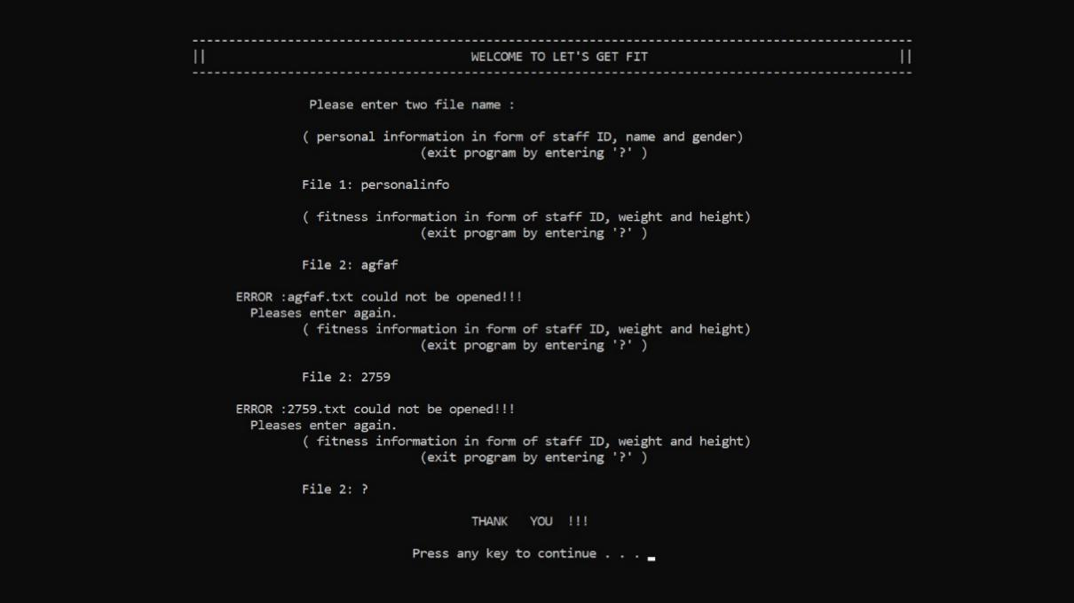

Print screen 2:

Validation to input the name of fitness information file(FILE 2) and way to stop input.

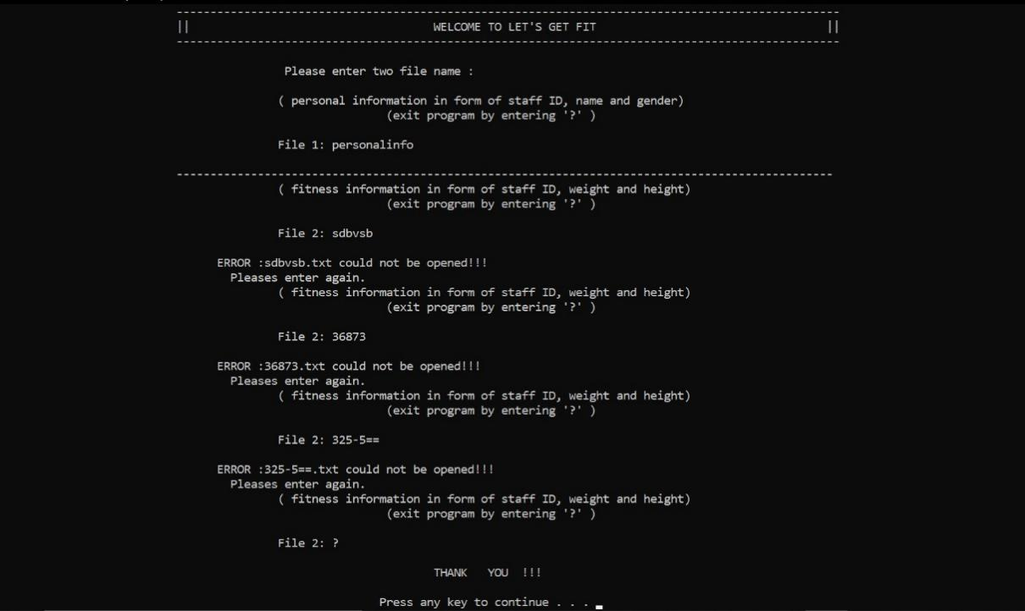

Print screen 3:

Validation to input the name of output file and way to stop input.

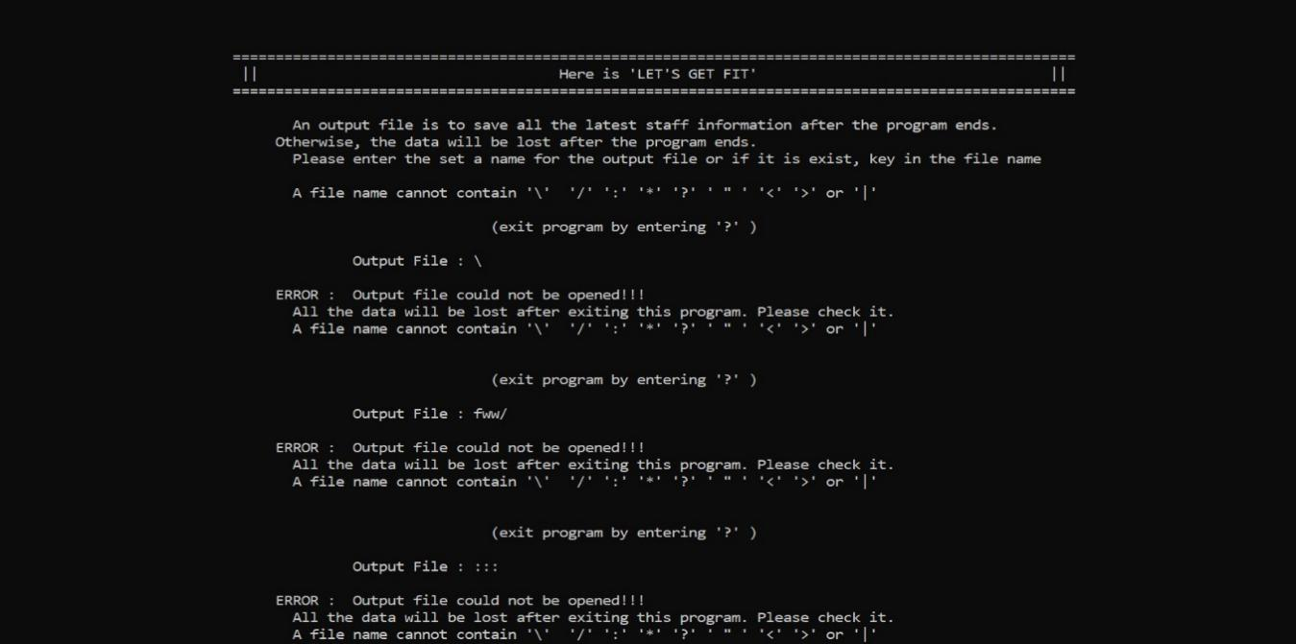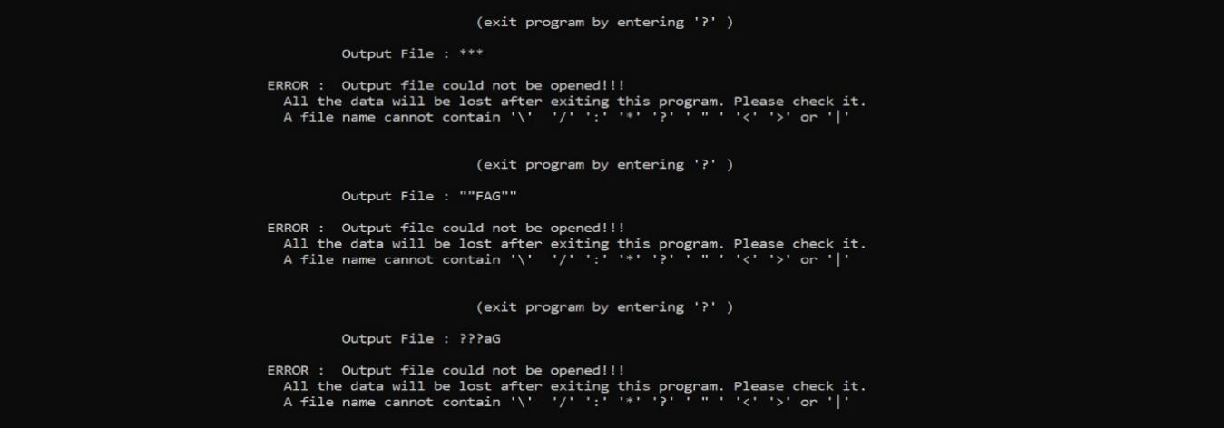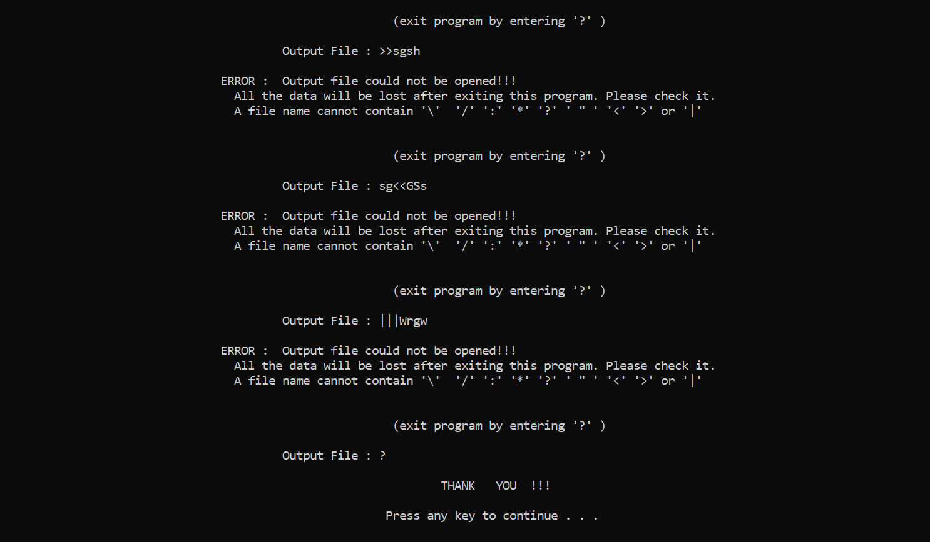

Print screen 4:

Screen print out when all the file can be read.

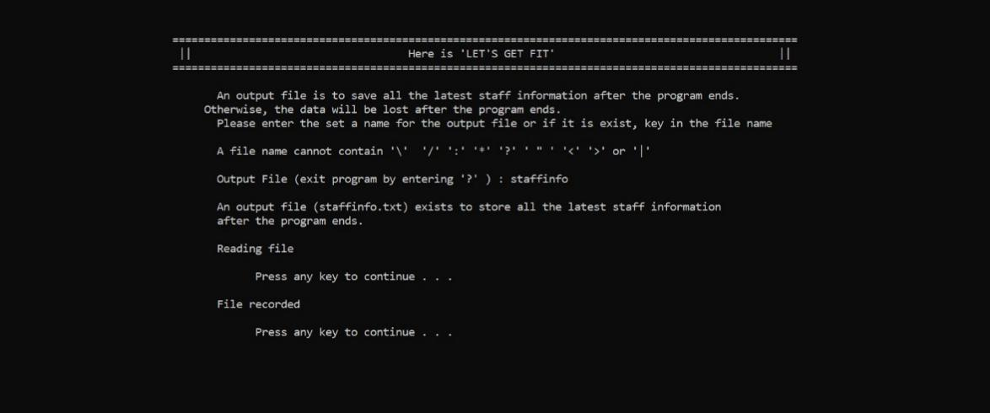

Print screen 5:

Display all the staff information of input files

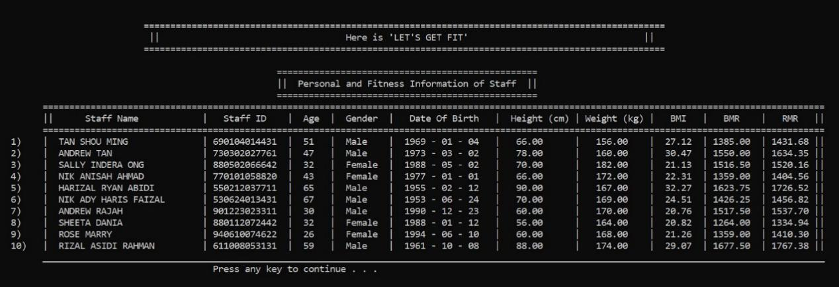

Print screen 6:

Display the main menu and the validation to input choices

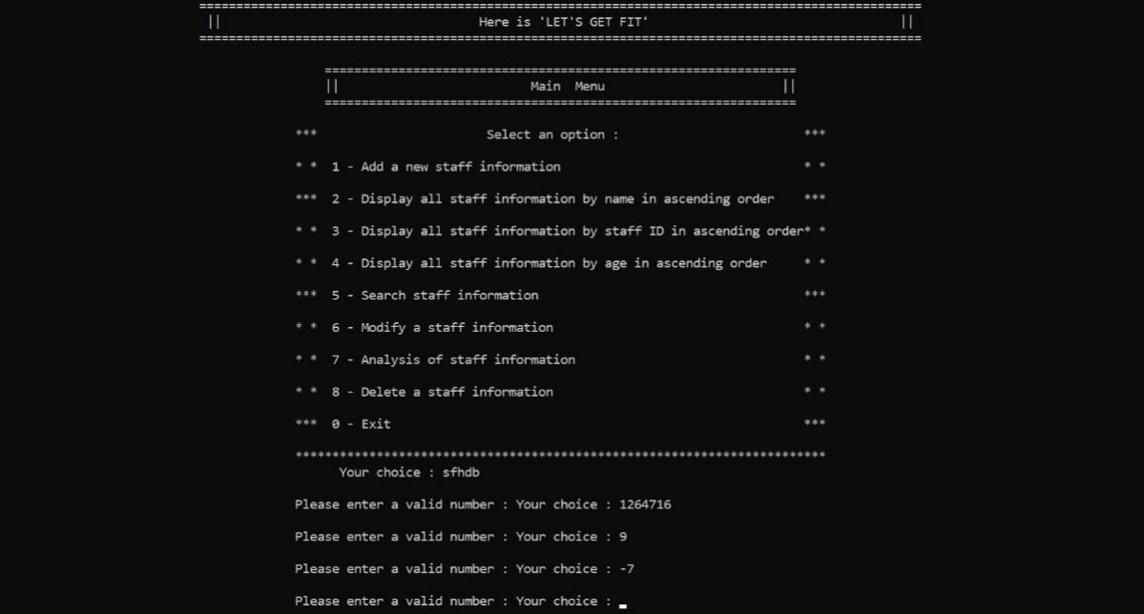

Print screen 7:

Choice 1: Add new staff information : validation to input the name and to stop adding new staff

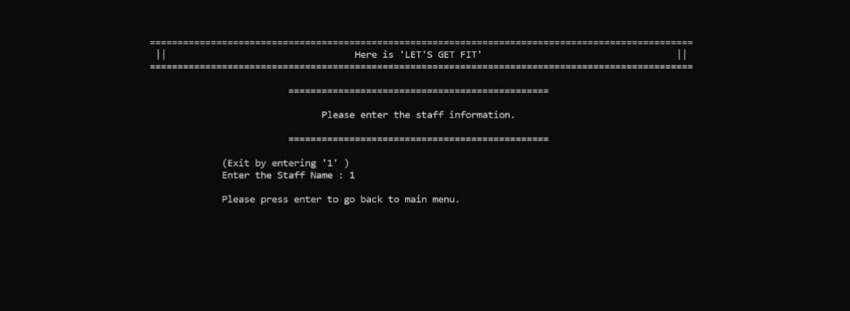

Print screen 8:

Choice 1: Add new staff information : validation to input the staff ID and to stop adding new staff

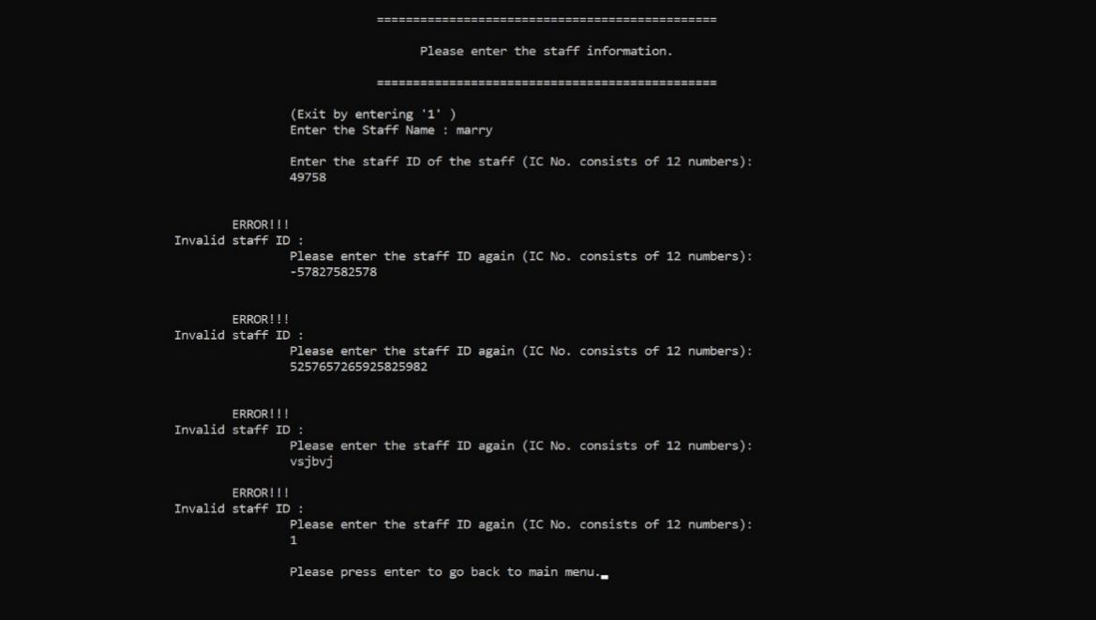

Print screen 9:

Choice 1: Add new staff information : validation to input the gender and to stop adding new staff

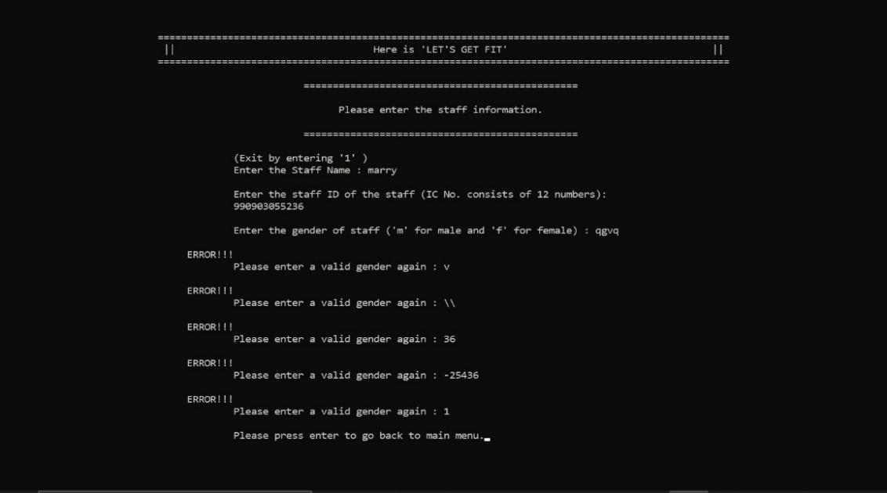

Print screen 10:

Choice 1: Add new staff information : validation to input the weight and to stop adding new staff

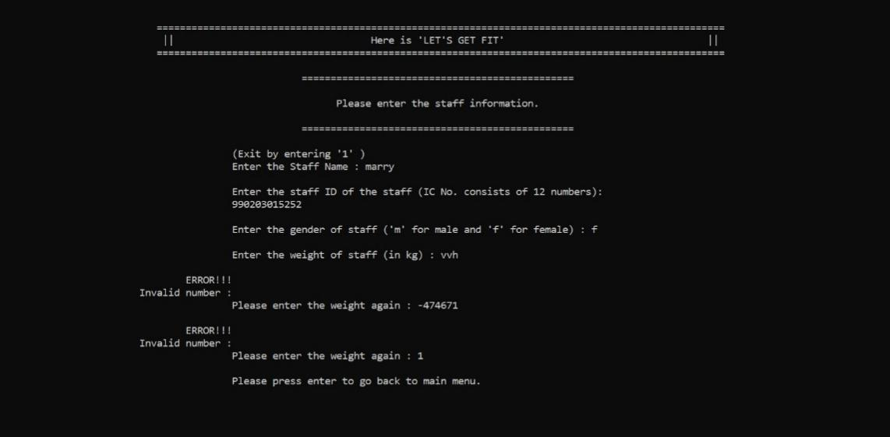

Print screen 11:

Choice 1: Add new staff information : validation to input the height and to stop adding new staff

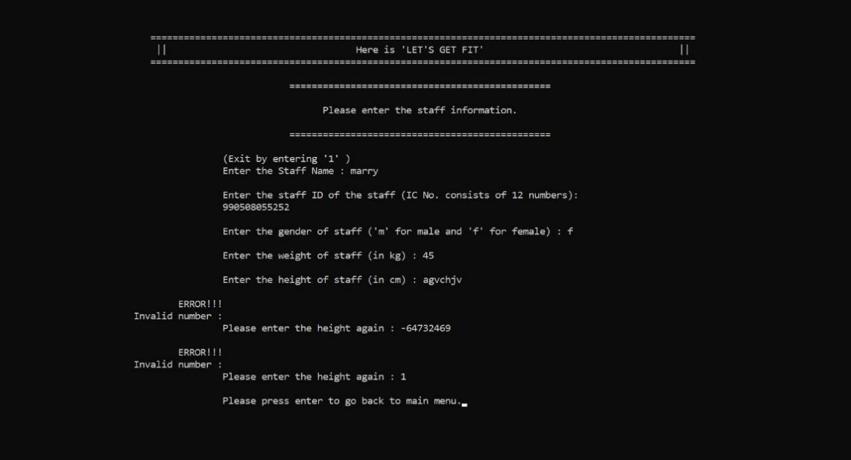

Print screen 12:

Choice 1: Add new staff information : Inform the user when the new staff information is added 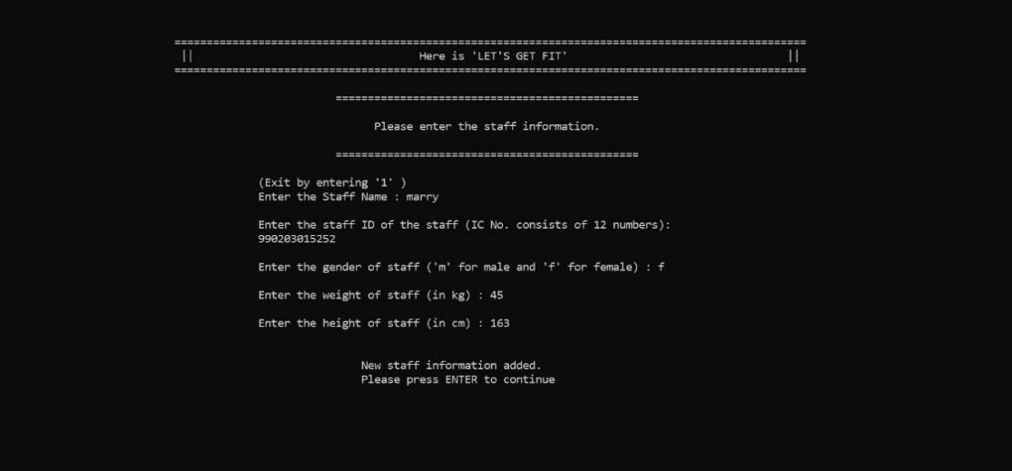

Print screen 13:

Choice 1: Add new staff information : Display the whole new staff information again after added to program

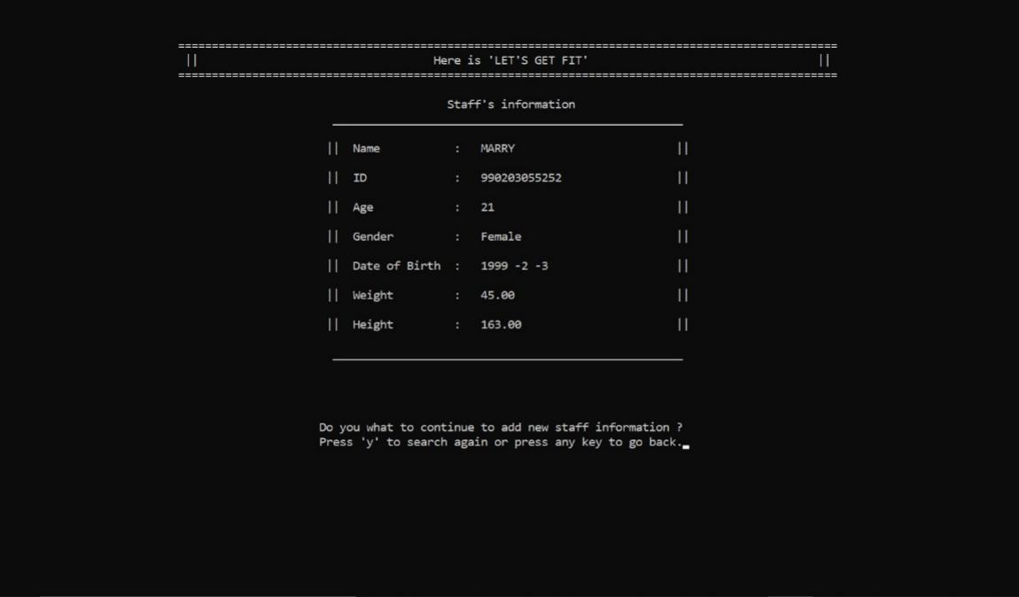

Print screen 14 :

Choice 1: Add new staff information : Inform that user the storage is full when it reach the limit of the array of object

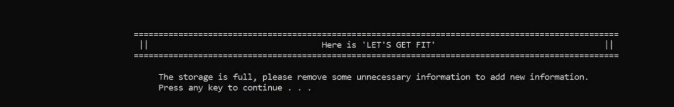

Print screen 15:

Choice 2: Display all staff information by name in ascending order 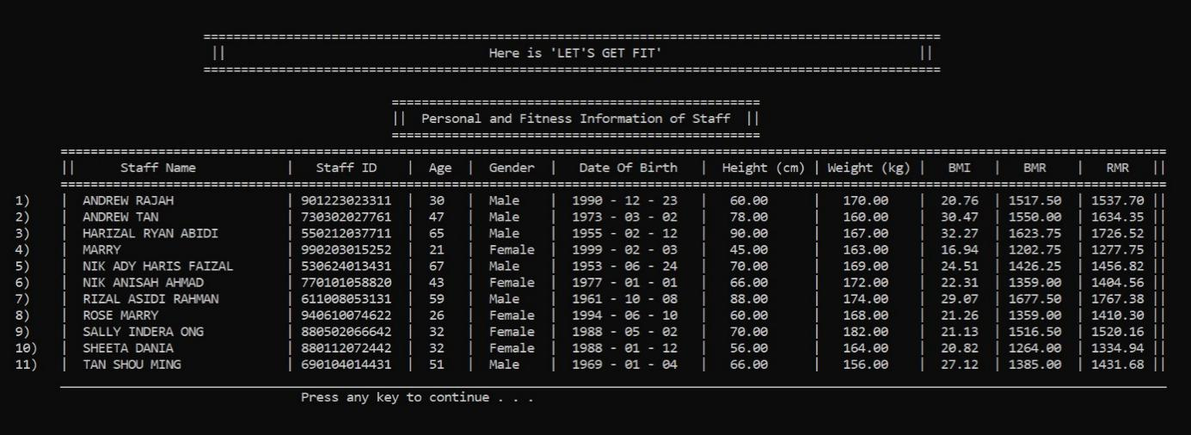

Print screen 16:

Choice 3: Display all staff information by staff ID in ascending order 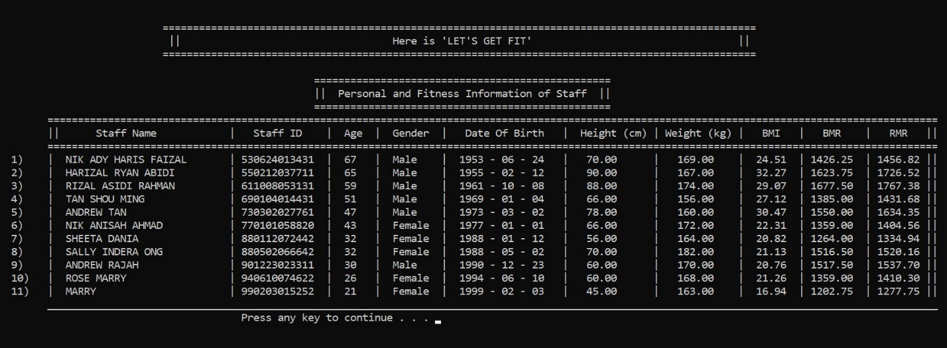

Print screen 17:

Choice 4: Display all staff information by age in ascending order

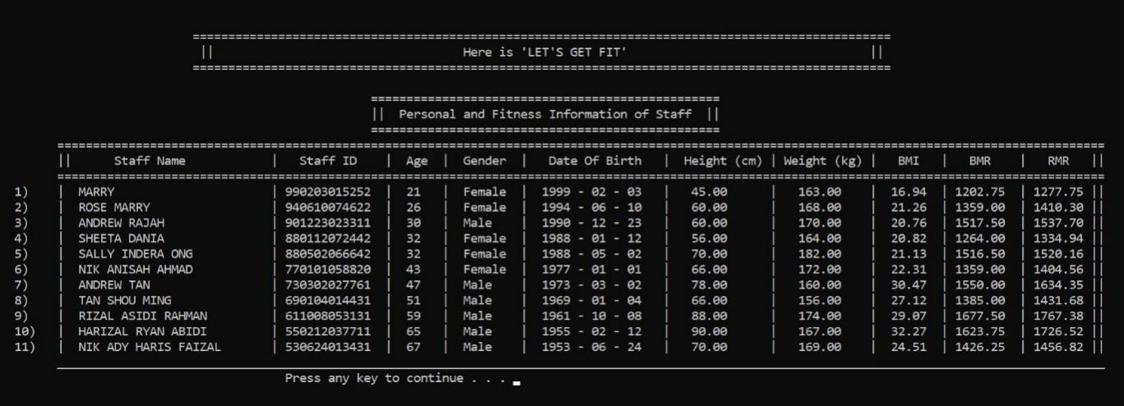

Print screen 18 :

Choice 5 : Display the Searching Menu and the validation to input the choices

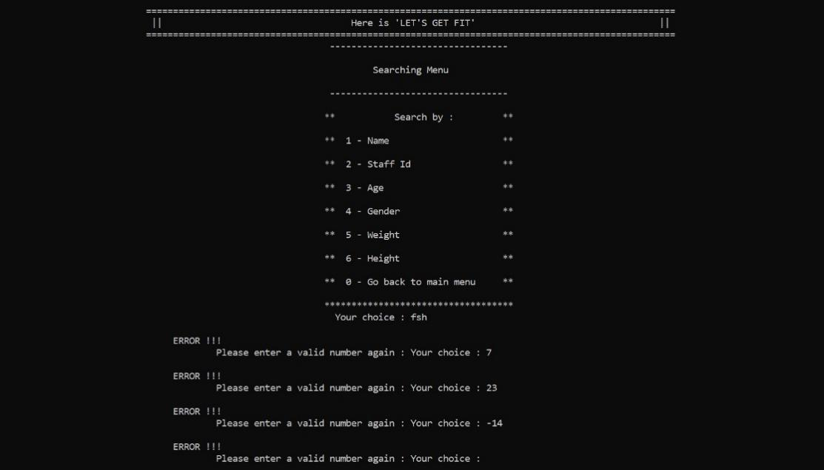

Print screen 19 :

Choice 5 : Search staff information : Display the results search by name

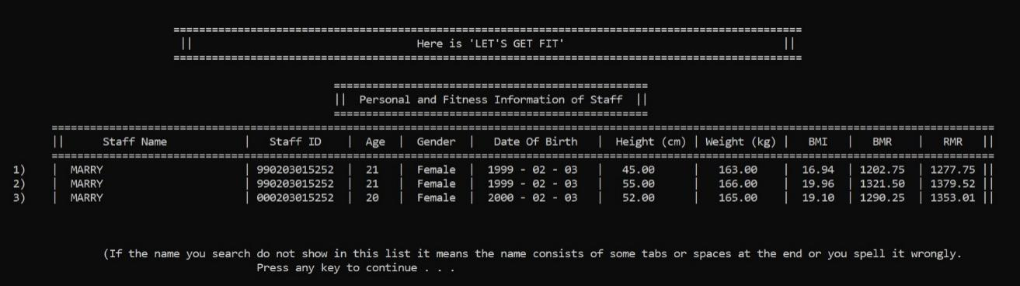

Print screen 20 :

Choice 5 : Search staff information : Display the results search by staff ID

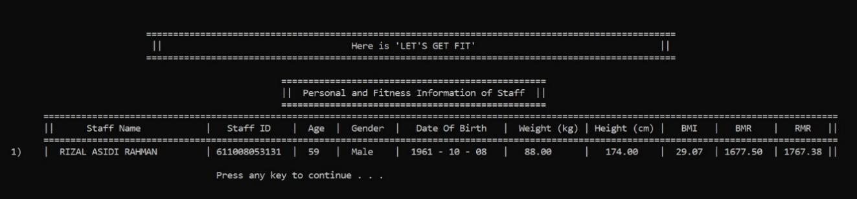

Print screen 21 :

Choice 5 : Search staff information : Display the results search by age

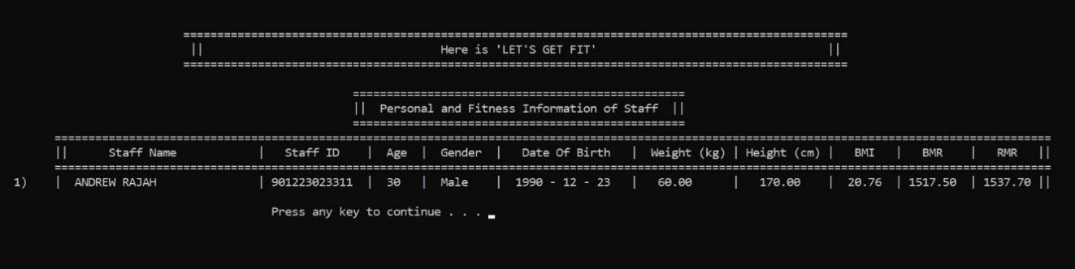

Print screen 22 :

Choice 5 : Search staff information : Display the results search by gender

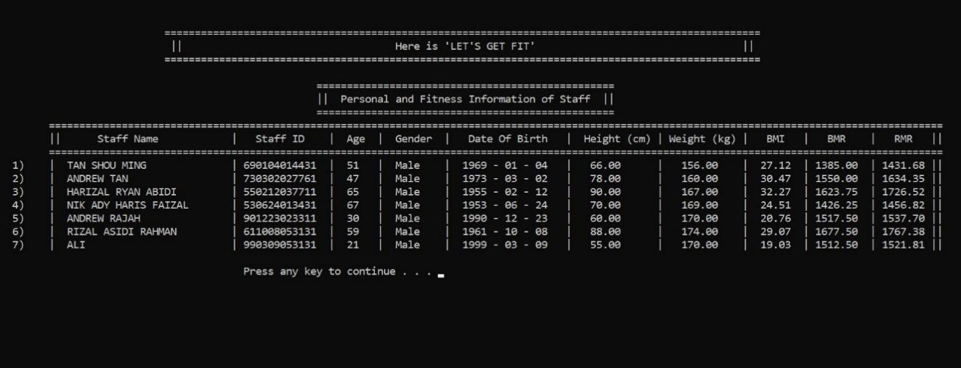

Print screen 23 :

Choice 5 : Search staff information : Display the results search by weight

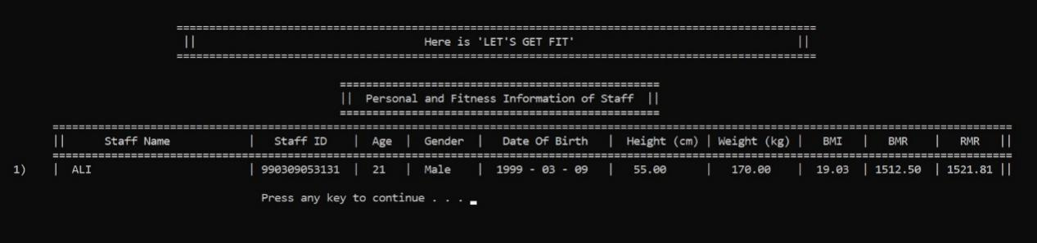

Print screen 24 :

Choice 5 : Search staff information : Display the results search by height

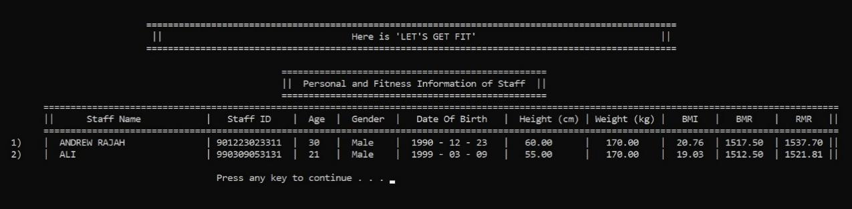

Print screen 25 :

Choice 5 : Search staff information : Display there is no result matched with name searched by user

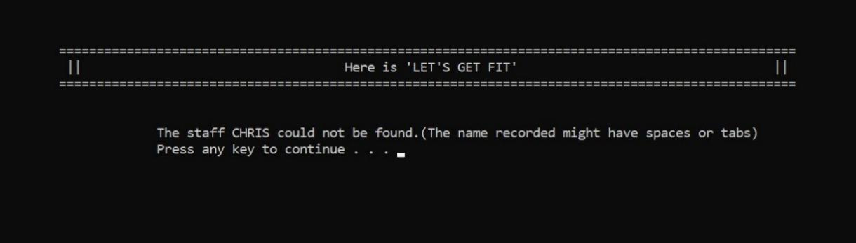

Print screen 26 :

Choice 5 : Search staff information : Display there is no result matched with staff ID searched by user



Print screen 27 :

Choice 5 : Search staff information : Display there is no result matched with age searched by user



Print screen 28 :

Choice 5 : Search staff information : Display there is no result matched with weight searched by user

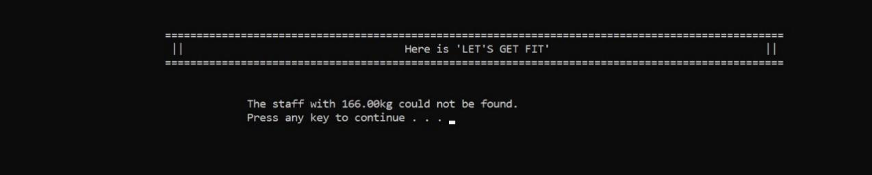

Print screen 29 :

Choice 5 : Search staff information : Display there is no result matched with height searched by user



Print screen 30 :

Choice 6 : Modify staff information : Display the Searching menu for modifying and validation to input choices

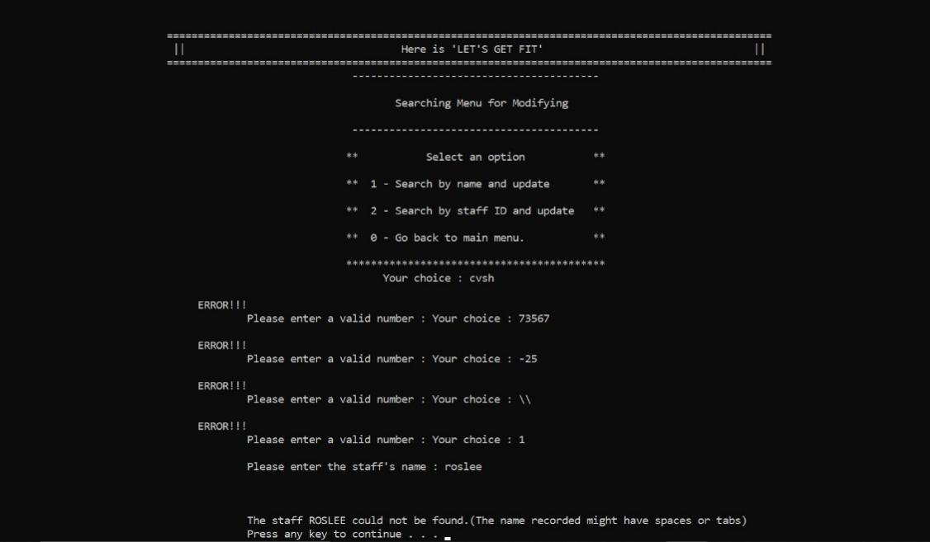

Print screen 31 :

Choice 6 : Modify staff information : Display the results found and validation to input the number of staff to update

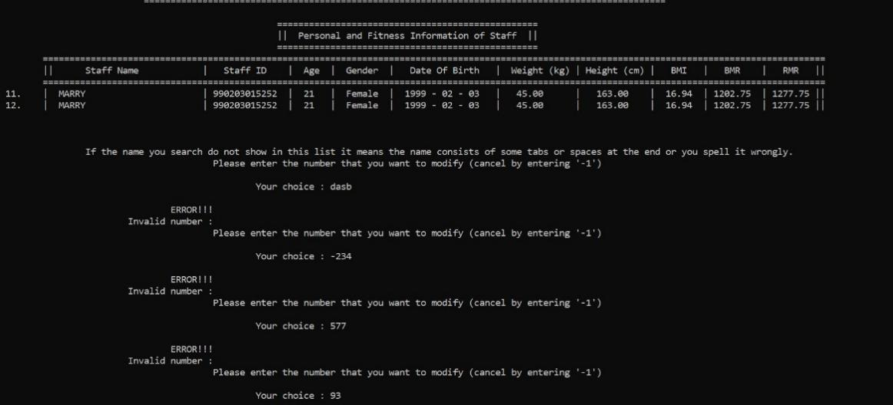

Print screen 32 :

Choice 6 : Show the only the one result found

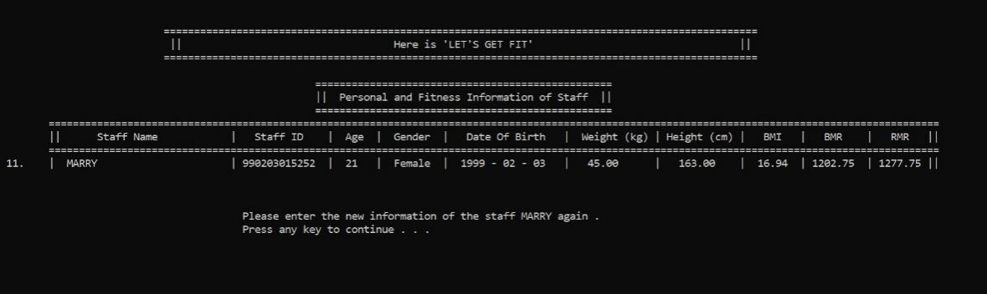

Print screen 33 :

Choice 6 : Modify staff information : Show no result matched

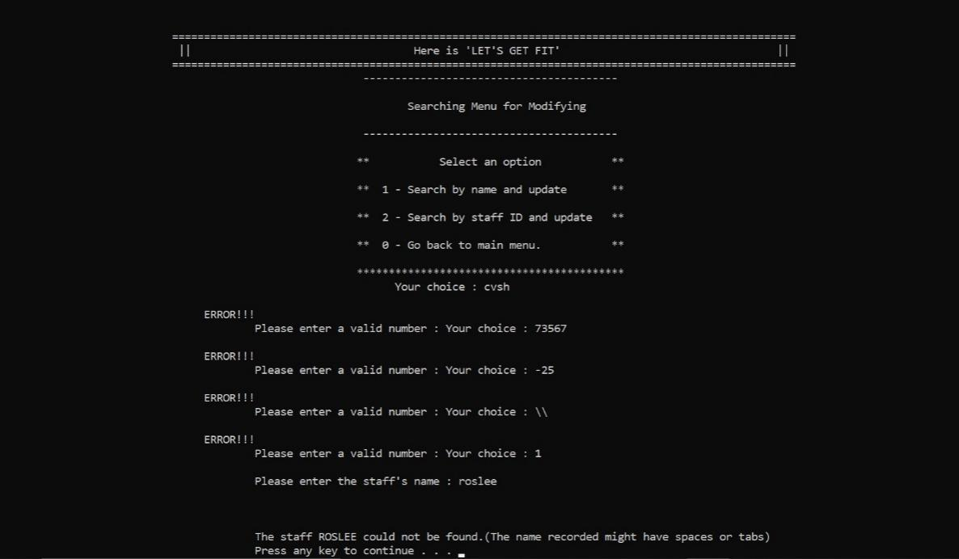

Print screen 34 :

Choice 6 : Modify staff information : Display the Modiying Menu and validation to input choices

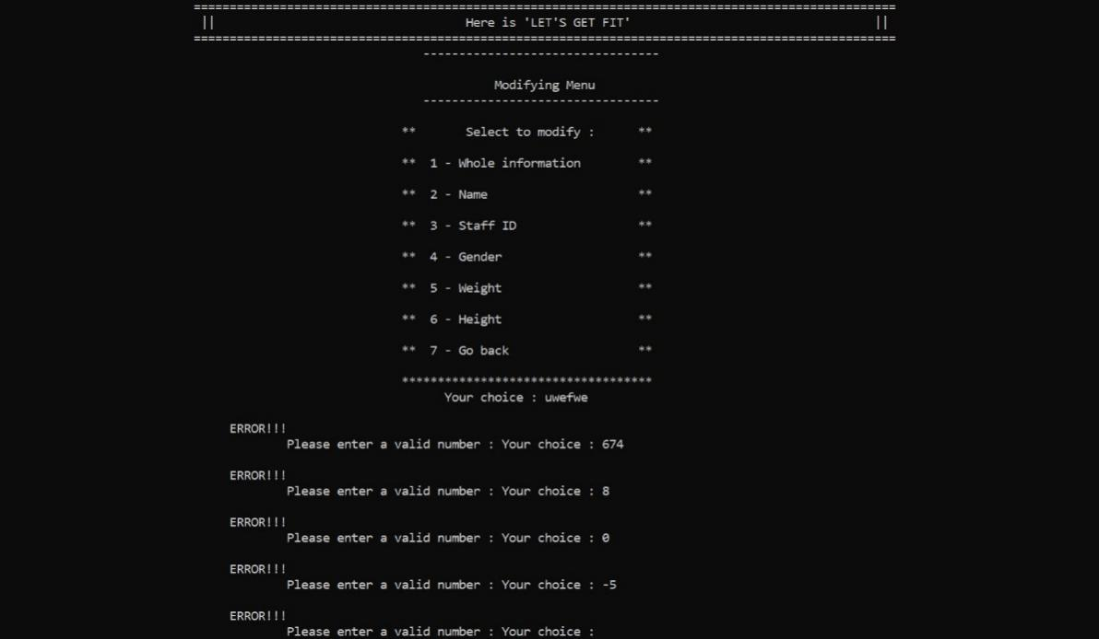

Print screen 35 :

Choice 6 : Modify staff information : modify the whole information

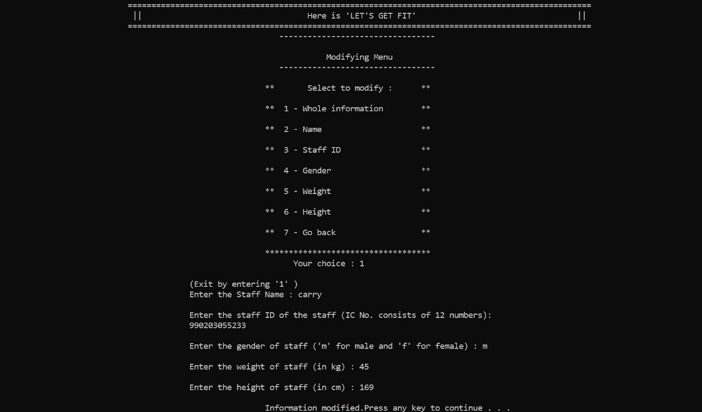

Print screen 36 :

Choice 6 : Modify staff information : modify the name

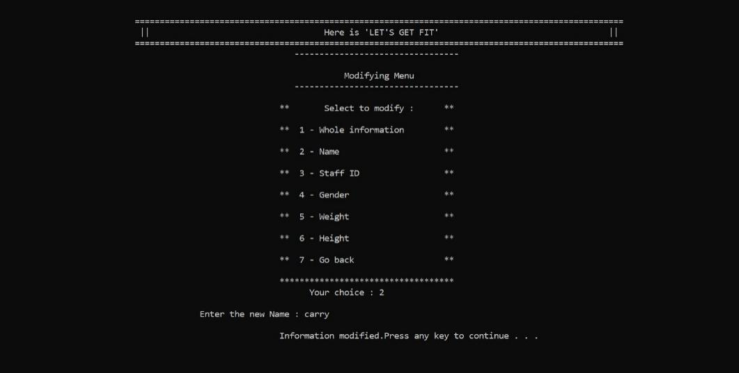

Print screen 37 :

Choice 6 : Modify staff information : modify the staff ID

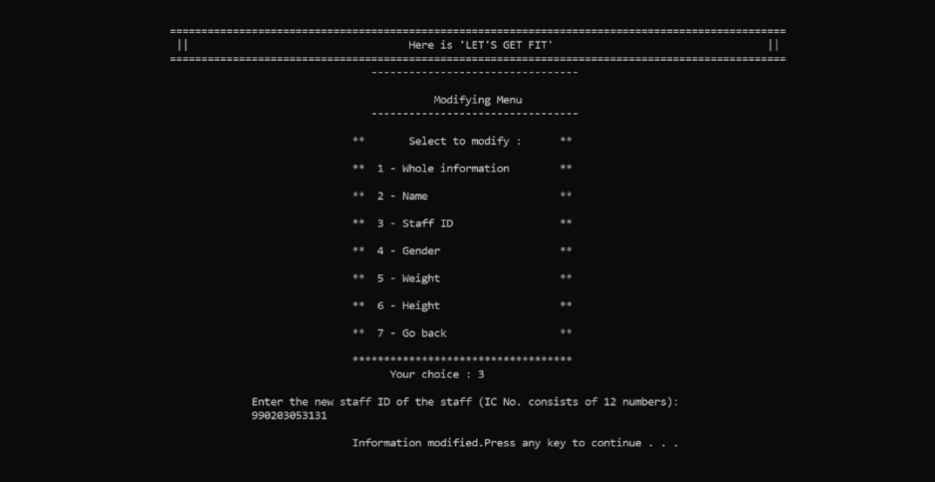

Print screen 38 :

Choice 6 : Modify staff information : modify the gender

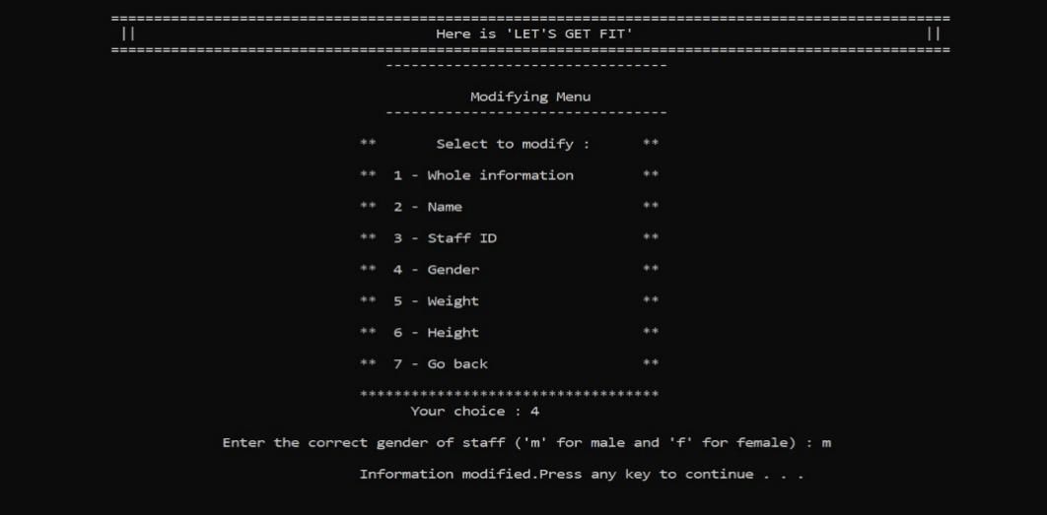

Print screen 39 :

Choice 6 : Modify staff information : modify the weight

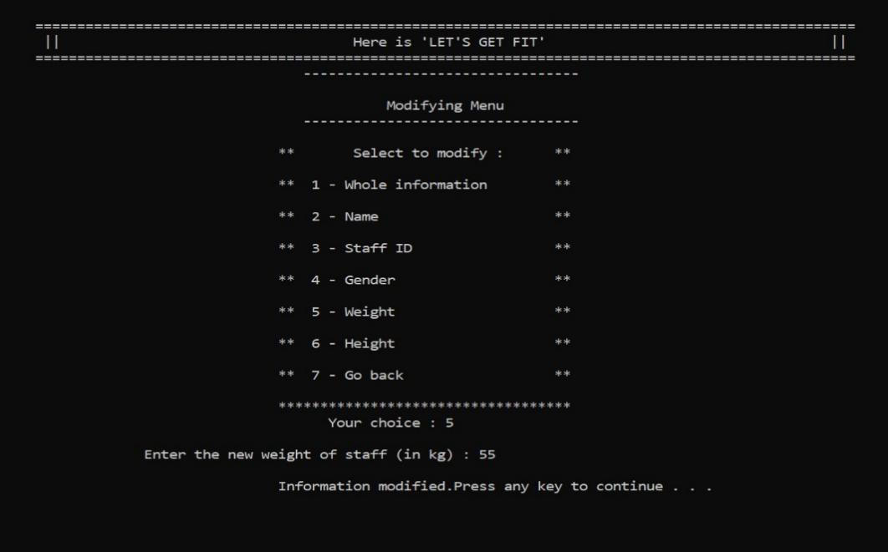

Print screen 40 :

Choice 6 : Modify staff information : modify the height

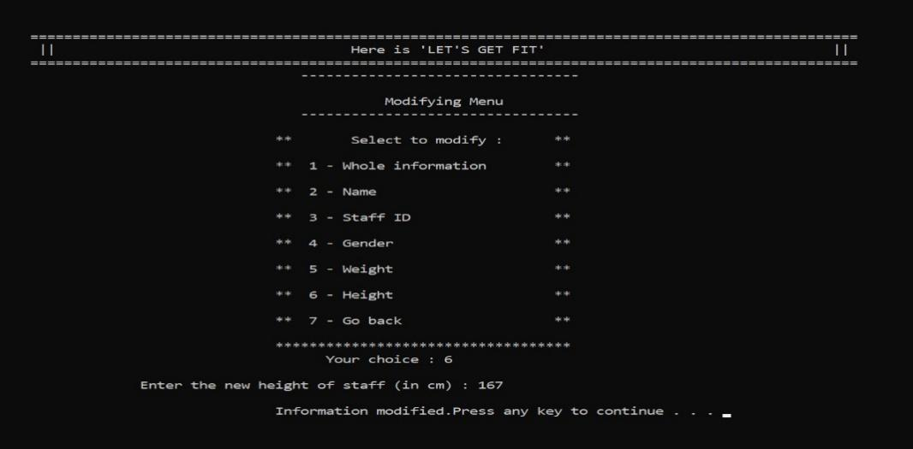

Print screen 41 :

Choice 7 : Analyze staff information : Display Analysis Menu and validation to input choice

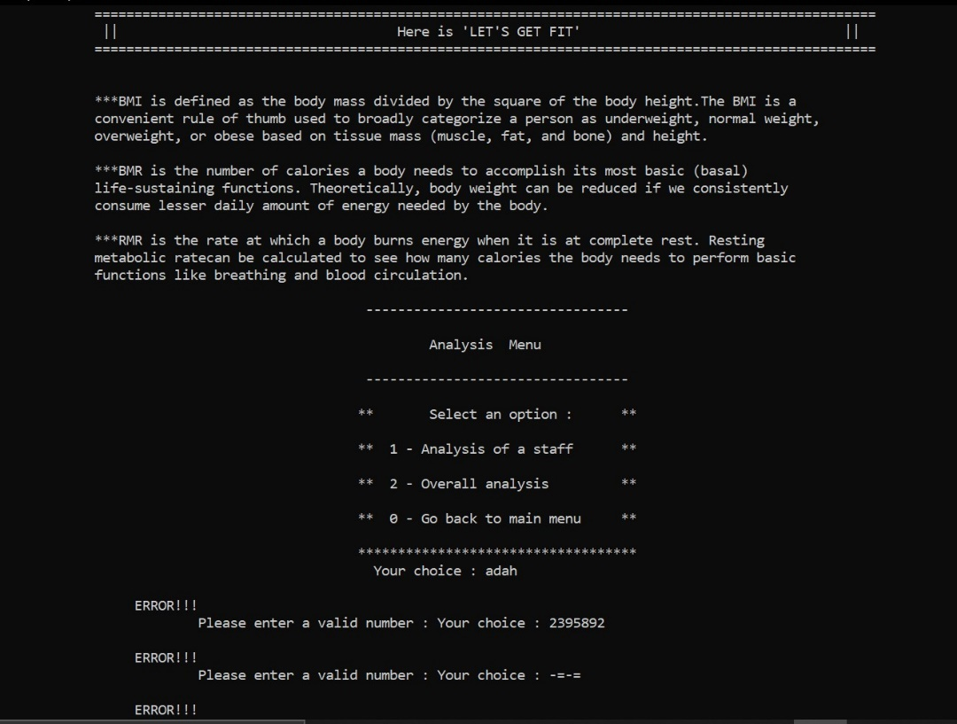

Print screen 42 :

Choice 7 : Analyze staff information : Display analysis of a staff

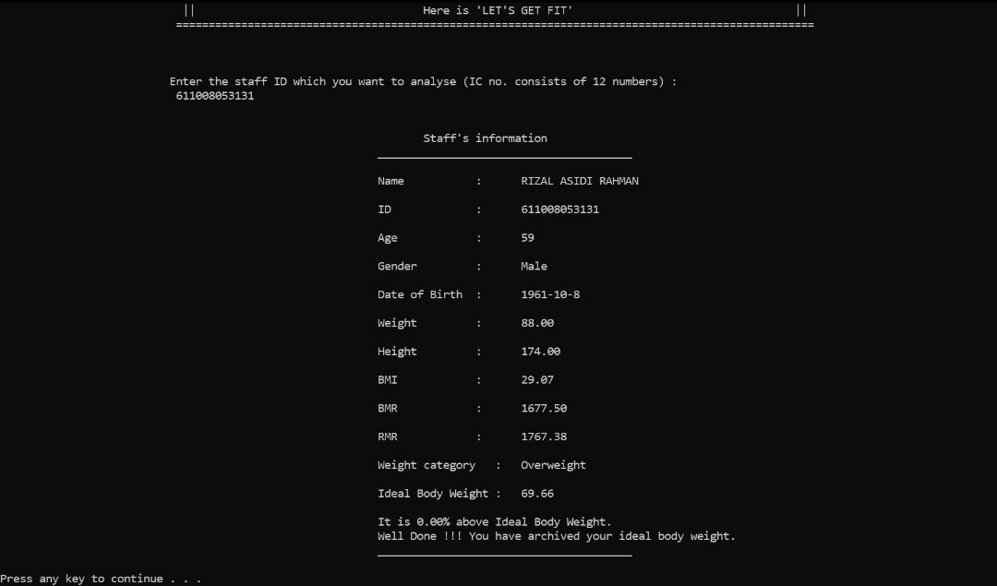

Print screen 43 :

Choice 7 : Analyze staff information : Display overall analysis among all the staff

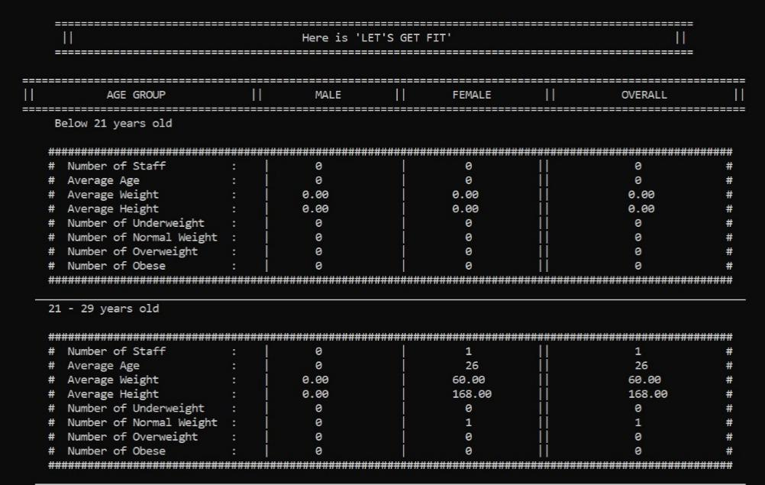

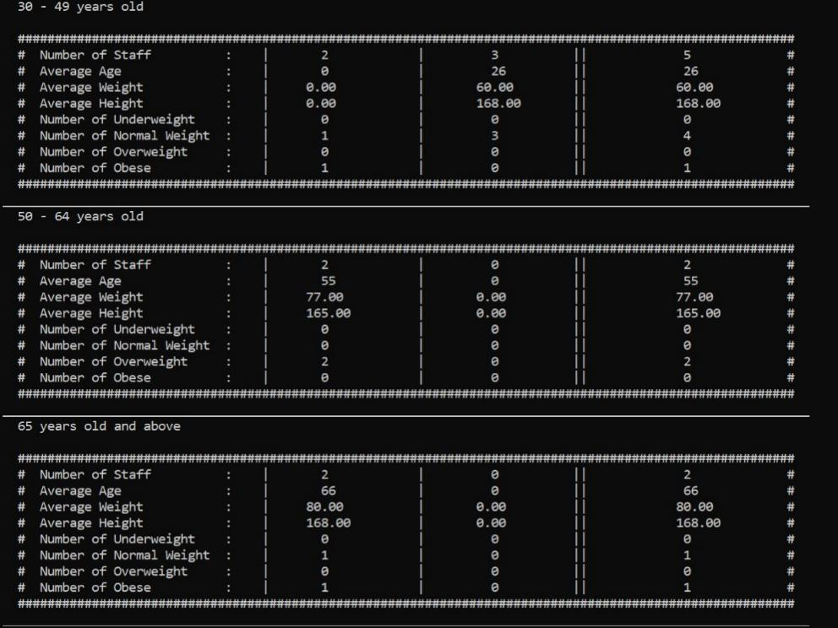

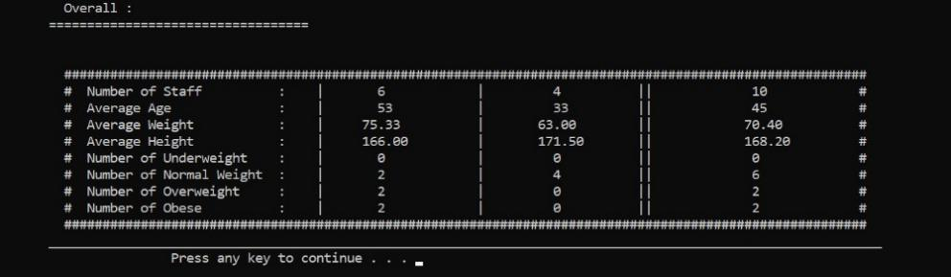

Print screen 44 :

Choice 8 : Delete staff information : Display a menu and validation of input choice

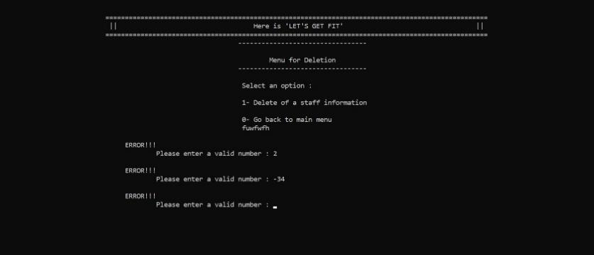

Print screen 45 :

Choice 8 : Delete staff information : Let user to input the staff ID that want to delete and validation to input staff ID

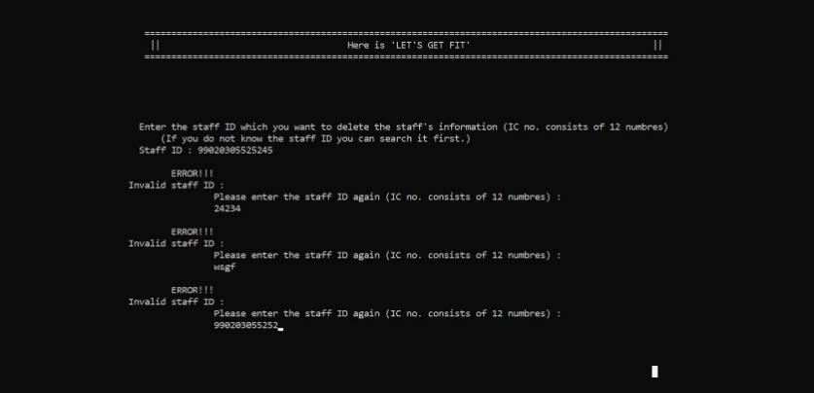

Print screen 46 :

Choice 8 : Delete staff information : Display the result found and ask user to confirm the deletion

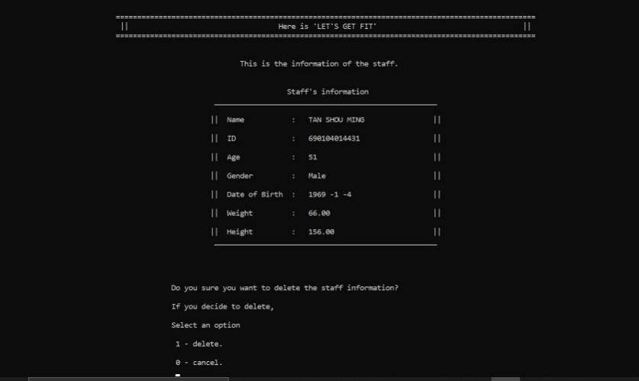

Print screen 47 :

Choice 8 : Delete staff information : Validation to input confirmation

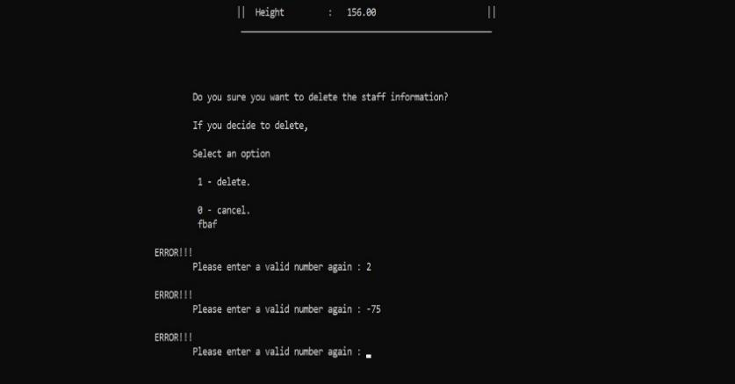

Print screen 48 :

Choice 0 : Exit program

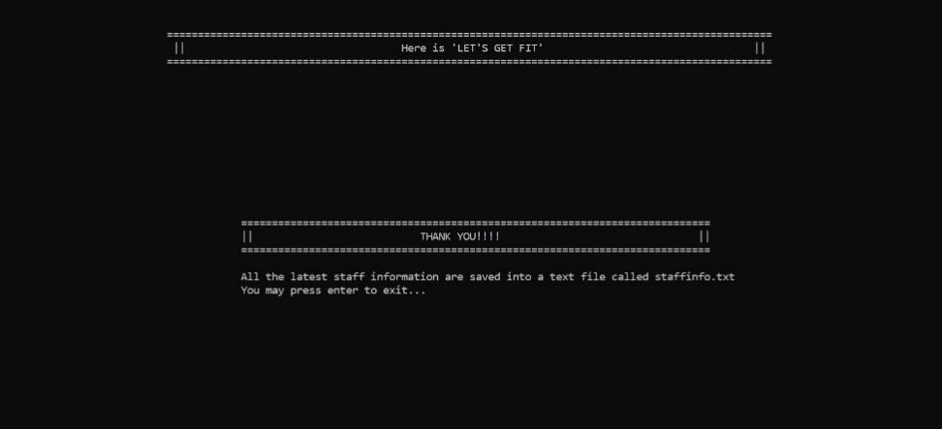

Print screen 49 :

Data stored in Output File

