Introduction to Pharmaceutical Engineering
Principles, Processes, and Quality Systems
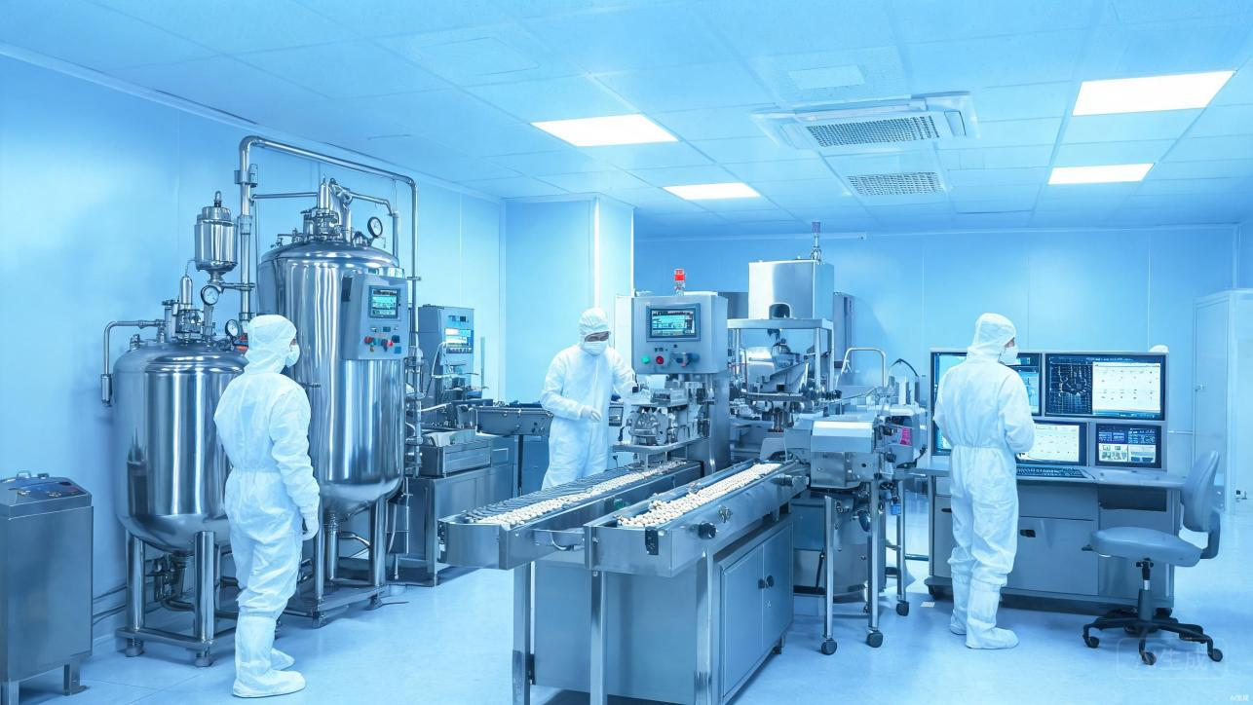
Figure 0 Modern Pharmaceutical Manufacturing Facility
Prepared: July 2026

1. Overview
Pharmaceutical engineering is a interdisciplinary field that integrates chemistry, biology, pharmacology, and engineering principles to develop, manufacture, and deliver safe and effective medicines. It covers the entire lifecycle of a drug, from early-stage discovery in the laboratory to large-scale commercial production.
The primary objective are to transform active pharmaceutical ingredients into stable, high-quality dosage forms that meet stringent regulatory standards. A modern pharmaceutical plant therefore relies on a close collaboration between chemists, pharmacists, and engineers to ensure that every batch is consistent, safe, and effective.
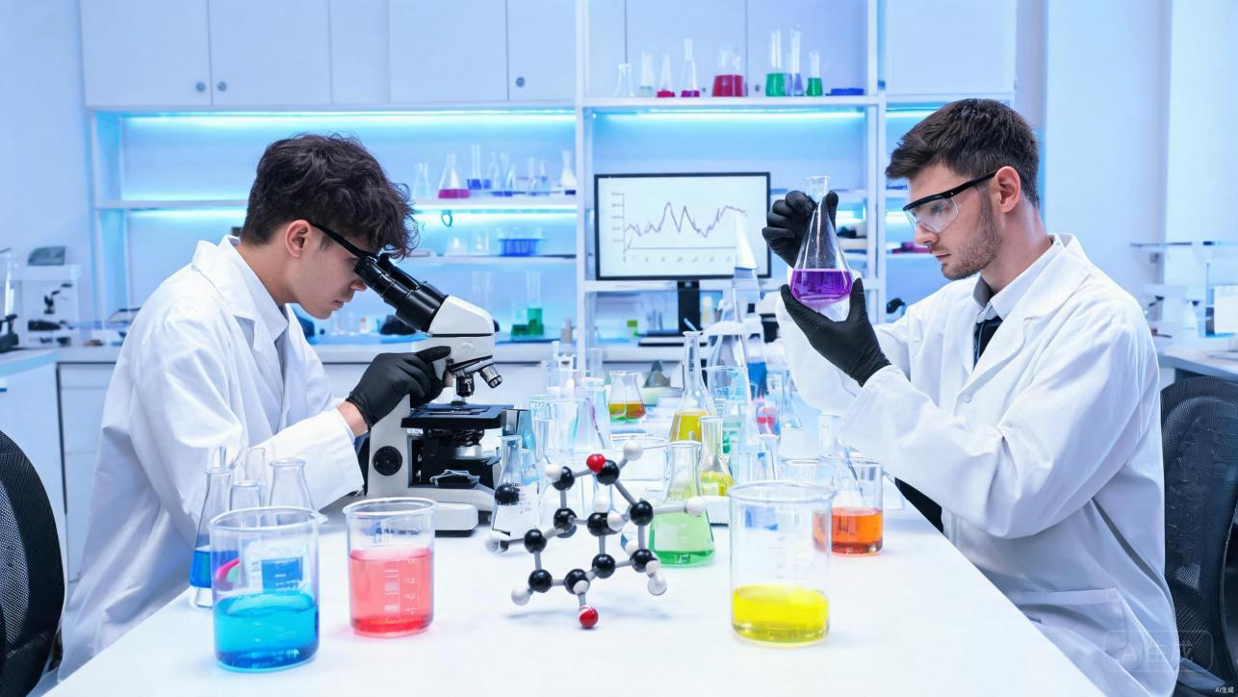
Figure 1 Pharmaceutical Research and Development Laboratory

2. Drug Discovery and Development
Bringing a new drug to market is a lengthy and costly endeavour. On average, the journey from initial molecule discovery to product launch spans 10 to 15 years, with an estimated cost ranging between 2 to 3 billion dollars. Only a small fraction of candidate compounds ultimately recieve regulatory approval.
The development pipeline can be divided into several stage: drug discovery, preclinical research, three phases of clinical trials, regulatory submission, and post-market surveillance. Each phase is designed to answer specific questions about safety, efficacy, and manufacturability.
Figure 2 Drug Development Pipeline
Process scale-up is one of the most critical challenges in pharmaceutical engineering. Moving from gram-scale synthesis in the lab to ton-scale production in the plant introduces risks such as uneven heat transfer, mixing dead zones, and changes in crystal-particle size. Pharmaceutical engineers address these issues through process validation, design-space modelling, and rigorous pilot studies.

3. Key Technologies

3.1 Continuous Manufacturing
Traditional pharmaceutical production follows a batch model, where each cycle of charging, reaction, and discharge is treated as an independent unit. Continuous manufacturing, by contrast, allow materials to flow continuously through sealed pipelines with real-time reaction and monitoring. This approach offers a smaller footprint, faster changeover, and reduced quality variability between batches.

3.2 Process Analytical Technology (PAT)
PAT emphasizes a "quality-by-design" philosophy. By deploying in-line sensors such as near-infrared and Raman spectroscopy, manufacturers can monitor critical quality attributes in real time. This shift from end-product testing to in-process control enables quicker corrective action and higher assurance of final product quality.

3.3 Biopharmaceuticals and Single-Use Technology
With the rapid growth of biologics — including monoclonal antibodies, vaccines, and cell and gene therapies — single-use bioreactors and disposable tubing have become increasingly common. These systems significantly reduce the risk of cross-contamination and eliminate the need for costly cleaning validation, making them especially attractive for multi-product facilities.

4. Quality Control and GMP
Quality control is a essential component of pharmaceutical engineering. Good Manufacturing Practice (GMP) serves as the foundational regulatory framework, governing every aspect of production from facility design and air cleanliness to equipment maintenance and personnel hygiene. The core principles can be summarised as follows:
- Prevent contamination and cross-contamination through zoning, air-classification, and unidirectional flow design.
- Prevent mix-ups and errors through material labelling, barcode traceability, and dual-person verification.
- Maintain a comprehensive documentation system covering batch records, deviations, change control, and CAPA closure.
In recent years, data integrity has recieved heightened attention. All production and testing data must be attributable, legible, contemporaneous, original, and accurate — commonly known by the acronym ALCOA. This principle is the bedrock of public trust in medicines.
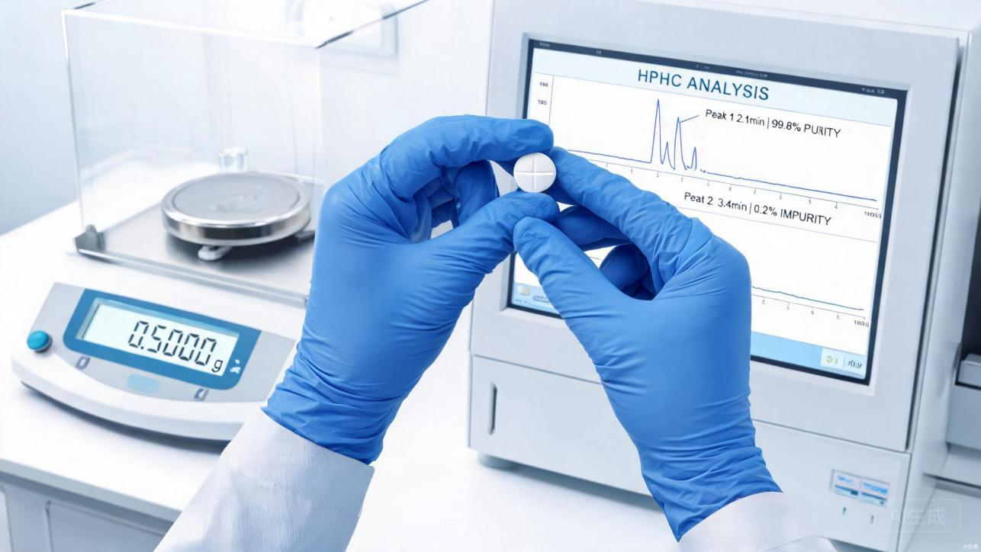
Figure 3 Quality Control and Analytical Testing

5. Supporting Disciplines
Pharmaceutical engineering draws on a broad range of scientific and engineering disciplines. The table below highlights the key contributing fields and their typical applications.
Discipline | Core Contribution | Typical Application
Chemical Engineering | Reaction and separation principles, mass and heat transfer | Reactor design, crystallisation and extraction
Pharmaceutics | Dosage-form design, drug release | Sustained-release tablets, liposomal formulations
Mechanical & Automation | Equipment integration, process control | Continuous production lines, PAT in-line monitoring
Quality Management | GMP, quality risk management | Deviation investigation, release and traceability systems

6. Industry Trends
The pharmaceutical engineering landscape is undergoing significant transformation, driven by digitalisation, sustainability goals, and evolving therapeutic modalities. Several trends are particularly noteworthy:
- Digital and smart manufacturing: Manufacturing Execution Systems (MES), digital twins, and AI-assisted process optimisation are gradually enabling "lights-out" production.
- Green pharmaceuticals: Biocatalysis and continuous-flow microreactors are being adopted to reduce energy consumption and solvent emissions.
- Personalised and novel delivery: 3D-printed tablets, nanoparticle formulations, and mRNA delivery systems is expanding the boundaries of formulation engineering.
- Supply-chain resilience: Following the COVID-19 pandemic, many countries are prioritising both global and domestic API production capacity.

7. Conclusion
Pharmaceutical engineering forms the crucial bridge between a laboratory discovery and a medicine in the hands of a patient — the final mile of translating scientific insight into clinical benefit. As the disease landscape shifts, technologies iterate, and regulations evolve, pharmaceutical engineers must combine solid engineering expertise with a deep respect for quality and human life. Only by balancing continuous innovation with rigorous compliance can we ensure that safe, effective, and accessible medicines reach those who need them most.

