IEE505 Information Systems Engineering

**PROJECT REPORT**

**Garments Worker Productivity Database management system**

Project Group:

Aqib Badimoole: 1225936636

Bharat Narayan Giridharan: 1225922791

Teja Phani Kumar: 1226361931

Dinesh Pammi: 1226396914

### 

**Table of Contents**

**EXECUTIVE SUMMARY** 3

**INTRODUCTION** 4

**DATABASE DESIGN** 5

**Department – Production:** 5

**Production – Team:** 5

**Production – Productivity:** 6

**USER CASES** 6

**Worker Productivity Analysis** 6

**Production Optimization** 6

**Incentive Program Evaluation** 7

**Predictive Modeling** 7

**Reporting and Visualization** 7

**RESULTS AND DISCUSSION** 8

**Attribute Information:** 8

**SQL Query** 9

**Model Performance** 13

**CONCLUSION** 14

# **EXECUTIVE SUMMARY**

ABC Garments Inc. faces significant challenges in managing the productivity data of its garment workers, resulting in operational inefficiencies and hindered decision-making. To address this, the company initiated a project to develop a comprehensive Database Management System (DBMS) tailored for garment worker productivity monitoring.

The project aims to integrate disparate data sources, providing real-time insights into worker efficiency and facilitating informed decision-making. By consolidating worker productivity data from all facilities, the DBMS enables managers to identify improvement areas and implement targeted training programs.

The system offers flexible query capabilities, allowing users to analyze productivity trends across various dimensions such as department, time period, and incentive structure. Additionally, machine learning algorithms are employed to predict and optimize production efficiency, demand forecasting, and product quality.

Through the implementation of this DBMS, ABC Garments Inc. demonstrates the power of data-driven solutions in optimizing productivity and decision-making within the garment industry. The project underscores the importance of leveraging technology to enhance competitiveness and contribute to global manufacturing and trade dynamics.

Key findings highlight the synergy between SQL and Python in enabling data-driven innovation, with implications for optimizing production processes and driving business growth. Lessons learned emphasize the significance of robust data engineering practices and the integration of machine learning solutions into existing workflows.

Overall, the project represents a transformative step towards operational excellence and underscores ABC Garments Inc.'s commitment to driving efficiency and innovation in the garment manufacturing sector.

# **INTRODUCTION**

The project addresses the challenge faced by ABC Garments Inc. in managing and analyzing the productivity data of its garment workers. This problem stems from fragmented data management practices across various platforms and databases, hindering the company's ability to monitor worker productivity, output levels, material usage, and operational timings effectively.

The dataset provided offers a detailed snapshot of the production environment within ABC Garments Inc., a leading player in the garment manufacturing sector. It serves as a treasure trove of information encapsulating various facets of the production process, workforce dynamics, and operational performance.

Within this dataset, each entry represents a distinct production instance, capturing crucial attributes such as the date of production, the quarter in which it occurred, the department responsible for overseeing the process, and the specific day of the week. Additionally, it provides insights into the teams involved, the targeted productivity levels set for each production task, and the standard minute value (SMV) representing the expected time for completion.

Moreover, the dataset delves into the intricacies of the production environment, shedding light on factors such as work in progress (WIP), overtime hours expended by workers, and any incentives provided to motivate performance. It also highlights instances of idle time and idle workforce, along with the frequency of style changes encountered during production runs.

Crucially, the dataset quantifies the human element within the production equation by detailing the number of workers engaged in each production instance and the actual productivity achieved. This comprehensive dataset offers a panoramic view of the garment manufacturing process, providing analysts and decision-makers with a rich tapestry of information to drive operational optimization and strategic decision-making.

The motivation behind tackling this problem lies in the potential for data engineering to optimize manufacturing processes and enhance productivity. By integrating data from various sources such as production equipment, supply chain logistics, and workforce management systems, manufacturers can gain valuable insights into operational efficiency and identify areas for improvement. This project provides an opportunity to leverage quantitative analysis and computational techniques to drive innovation and streamline manufacturing processes, ultimately contributing to greater competitiveness and sustainability in the industry.

# **DATABASE DESIGN**

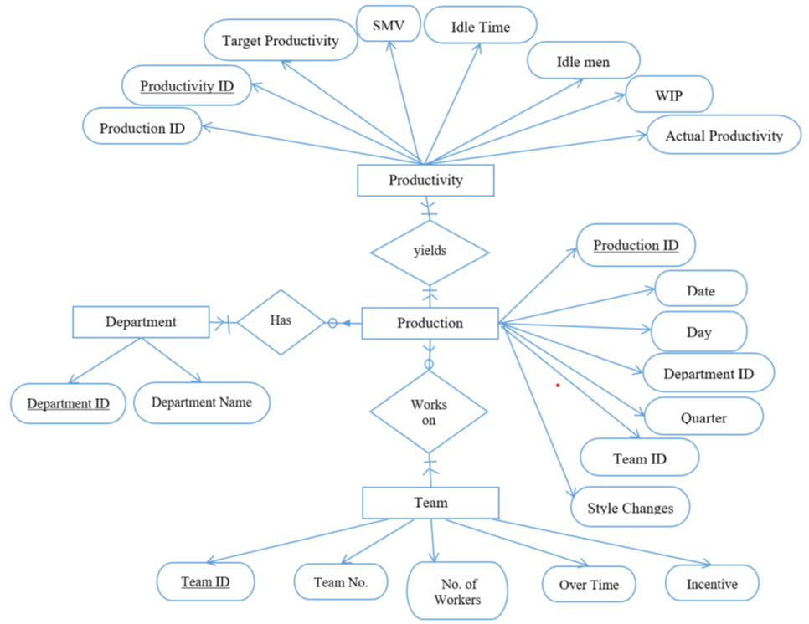

## **Department – Production:**

Maximum Cardinality: many to many

Production from different dates can be related to one department, many departments can work on the same production date.

Minimum cardinality: one to optional

If there is production, it must be related to at least one department, but a department does not necessarily have to have production on a particular day.

## **Production – Team:**

Maximum Cardinality: many to many

Many teams can work on a single production date and a single team can work on multiple production dates.

Minimum cardinality: one to optional

If there is production, at least one team must be assigned to it, but a particular work team might not be accounted to any production on a day.

## **Production – Productivity:**

Maximum Cardinality: many to many

Many production dates can have the same productivity results. Similarly, many productivity results can be achieved on the same production date.

Minimum cardinality: mandatory to mandatory

If a production happens, there must be at least one productivity result and if there’s productivity there must be a production.

# **USER CASES**

## **Worker Productivity Analysis**

Users analyze worker productivity across departments, teams, and time periods to identify top performers and areas for improvement.

Query Usage: Querying idle time greater than zero on specific dates and quarters to identify instances of low productivity and potential areas for improvement.

## **Production Optimization**

Users optimize production processes by correlating worker productivity with factors like style changes, work-in-progress, and overtime.

Query Usage: Calculating the average productivity for different numbers of style changes to understand how style changes affect worker efficiency.

## **Incentive Program Evaluation**

Users assess the effectiveness of incentive programs on worker productivity by analyzing the relationship between incentive amount and actual productivity.

Query Usage: Examining how the average productivity varies across departments considering the number of workers in each department and the incentive provided.

## **Predictive Modeling**

Users develop predictive models to forecast future worker productivity based on historical data and key influencing factors.

Query Usage: Analyzing how the average productivity changes over different quarters to identify seasonal trends and patterns.

## **Reporting and Visualization**

Users require interactive dashboards and reports to visualize productivity trends and generate insights.

Query Usage: Investigating how the average productivity relates to the number of workers and incentives for each department to assess the effectiveness of incentive programs.

# **RESULTS AND DISCUSSION**

The dataset comprises 1198 instances, each characterized by 15 attributes.

## **Attribute Information:**

01 date : Date in MM-DD-YYYY

02 day : Day of the Week

03 quarter : A portion of the month. A month was divided into four quarters

04 department : Associated department with the instance

05 teamno : Associated team number with the instance

06 noofworkers : Number of workers in each team

07 noofstylechange : Number of changes in the style of a particular product

08 targetedproductivity : Targeted productivity set by the Authority for each team for each day.

09 smv : Standard Minute Value, it is the allocated time for a task

10 wip : Work in progress. Includes the number of unfinished items for products

11 overtime : Represents the amount of overtime by each team in minutes

12 incentive : Represents the amount of financial incentive (in BDT) that enables or motivates a particular course of action.

13 idletime : The amount of time when the production was interrupted due to several reasons

14 idlemen : The number of workers who were idle due to production interruption

15 actual_productivity : The actual % of productivity that was delivered by the workers. It ranges from 0-1.

## **SQL Query**

**1) What is the SQL query to identify bottlenecks characterized by high idle time in production, including details such as date, quarter, day, department, and idle time?**

SELECT p.date, p.quarter, p.day, d.department, pt.idle_time

FROM production_table p

INNER JOIN productivity_table pt ON p.production_id = pt.production_id

INNER JOIN department_table d ON p.department_id = d.department_id

WHERE pt.idle_time > 0;

**2)How does the frequency of style changes correlate with average productivity, as represented in the provided SQL query linking production table data to productivity table data?**

SELECT p.no_of_style_change, AVG(pt.actual_productivity) AS avg_productivity

FROM production_table p

INNER JOIN productivity_table pt ON p.production_id = pt.production_id

GROUP BY p.no_of_style_change;

**3)What is the SQL query to retrieve department information alongside the number of workers and the average productivity, drawing data from the team table, production table, productivity table, and department table, grouped by department and the corresponding number of workers?**

SELECT d.department, t.no_of_workers, AVG(pt.actual_productivity) AS avg_productivity

FROM team_table t

INNER JOIN production_table p ON t.team_id = p.team_id

INNER JOIN productivity_table pt ON p.production_id = pt.production_id

INNER JOIN department_table d ON p.department_id = d.department_id

GROUP BY d.department, t.no_of_workers;

**4)What SQL query retrieves departmental data including the number of workers, incentive schemes, and the corresponding average productivity, utilizing tables such as team, production, productivity, and department, while sorting the results by incentive in ascending order?**

SELECT d.department, t.no_of_workers, t.incentive, AVG(pt.actual_productivity) AS avg_productivity

FROM team_table t

INNER JOIN production_table p ON t.team_id = p.team_id

INNER JOIN productivity_table pt ON p.production_id = pt.production_id

INNER JOIN department_table d ON p.department_id = d.department_id

GROUP BY d.department, t.no_of_workers, t.incentive

ORDER BY t.incentive ASC;

**5)What SQL query examines trends in productivity by quarter, aggregating average productivity data from the production and productivity tables and grouping it by quarter?**

SELECT p.quarter, AVG(pt.actual_productivity) AS avg_productivity

FROM production_table p

INNER JOIN productivity_table pt ON p.production_id = pt.production_id

GROUP BY p.quarter;

After querying the relevant data using SQL, the extracted dataset is then exported to a Jupyter Notebook environment through a connector, facilitating seamless integration for data visualization and the execution of machine learning models. Leveraging the capabilities of Jupyter Notebook, analysts and data scientists can employ various libraries and tools to explore the dataset visually, uncovering insights and trends. Additionally, with the data readily available within the notebook, they can efficiently build and train machine learning models to predict future outcomes or classify patterns based on the extracted features. This streamlined workflow within Jupyter Notebook enhances the efficiency and effectiveness of data analysis and modeling tasks, fostering informed decision-making and actionable insights.

**Time series analysis on productivity forecast**  
  
This code snippet demonstrates time series analysis using ARIMA modeling in Python. Initially, it imports necessary libraries such as pandas, matplotlib, and statsmodels. Then, it prepares the time series data for analysis by setting the date column as the index and plotting the actual productivity over time. Next, it fits an ARIMA model to the data and displays a summary of the model's performance. Additionally, it visualizes the model diagnostics to assess its goodness of fit. Finally, it forecasts future productivity values and overlays them with the actual productivity data for comparison.

## **Model Performance**

The Mean Squared Error (MSE) and Root Mean Squared Error (RMSE) obtained from the ARIMA model are 0.0229 and 0.1512, respectively.

# **CONCLUSION**

In conclusion, the implementation of a comprehensive Database Management System (DBMS) tailored for garment worker productivity monitoring at ABC Garments Inc. represents a significant step toward enhancing operational efficiency and decision-making within the garment manufacturing sector. By consolidating and analyzing disparate data sources, the DBMS enables real-time insights into worker efficiency, facilitating targeted interventions and continuous improvement initiatives. The successful integration of SQL querying capabilities and Python-based time series analysis further underscores the efficacy of data-driven approaches in addressing complex operational challenges. Looking ahead, future endeavors could focus on refining predictive modeling techniques to enhance forecasting accuracy and exploring advanced analytics methodologies for deeper insights into production optimization. Additionally, continued emphasis on user-centric design and interactive visualization tools could foster greater adoption and utilization of data-driven insights across organizational hierarchies, driving sustained improvements in productivity and competitiveness.