**Student Online Admission System**

**“Dissemination of Education for Propagation Knowledge, Achievement and Culture”**

**-Shikshanmaharashi Dr. Bapuji Salunkhe.**

**Shri Swami Vivekanand Shikshan Sanstha’s**

**Vivekanand College,Kolhapur**

**A Project Report on**

**“Student Online Admission System”**



**Submitted By**

**Miss.Pranali Rajendra Patil.**

**Miss.Amruta Pandurang Darekar.**

**Class:B.Sc.III**

**Under The Guidance**

**Miss.Samrin Mullani**

**Submitted To**

**Shivaji University,Kolhapur.**

**For the Year 2019-2020**

**Student Online Admission System**

**Shri Swami Vivekanand Shikshan Sanstha’s**

**Vivekanand College,Kolhapur**

**A Project Report on**

**“Student Online Admission System”**

**ACKNOWLEDGMENT**

**We have great pleasure to express our Deep Gratitude to Mujawar Sir and Miss.R.Y.Patil Madam for the valuable Guidance and useful suggestion throughout the project.**

**All Guides have always a source of inspiration for us. It is grateful Guidance and constant Encouragement which held successful completion of project.**

**In the last but not least we thank all our Faculties, entire Computer Department and all others who have directly or indirectly helped us in completion of this project.**

**Miss.Pranali Rajendra Patil.**

**Miss.Amruta Pandurang Darekar.**

**Student Online Admission System**

**Shri Swami Vivekanand ShikshanSanstha’s**

**Vivekanand College,Kolhapur**

**A Project Report on**

**“Student Online Admission System”**

**DECLARATION**

**To**

**The Principle**

**Vivekanand College,**

**Kolhapur.**

**We undersigned declare that the project Report on “Student Online Admission System” is developed .This project work is based on the Information collected by us.**

**We understand that any such copying is liable to be punished in a way the college authorities deem it.**

**Date:**

**Place:**

**Miss.Pranali Rajendra Patil.**

**Miss.Amruta Pandurang Darekar.**

**Student Online Admission System**

**Shri Swami Vivekanand Shikshan Sanstha’s**

**Vivekanand College,Kolhapur**

**A Project Report on**

**“Student Online Admission System”**

**GUIDE CERTIFICATE**

**This is to certify that,**

**Miss.Pranali Rajentra Patil and Amruta Pandurang Darekar has satisfactorily carried out our project work entitled “Student Online Admission System” for Vivekanand college,Kolhapur as partial fulfillment of course B.Sc Computer Science of shivaji university Kolhapur for academic year 2019-2020.To the best of my knowledge and belief the project presented by them is their original work.**

**Date:**

**Place:**

**Dept.of computer science**

**(Project Guide)**

**Student Online Admission System**

**5] Output Screen-**

**Home Page:**

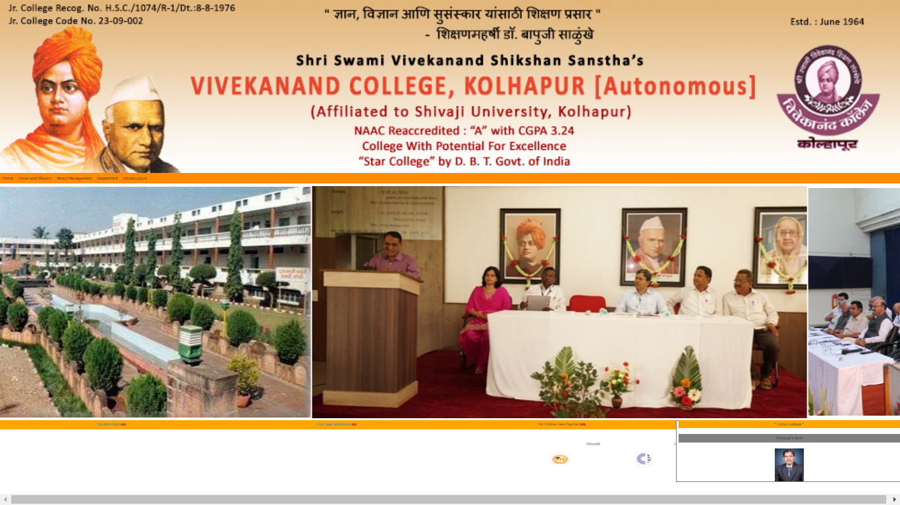

**Registration Page:**

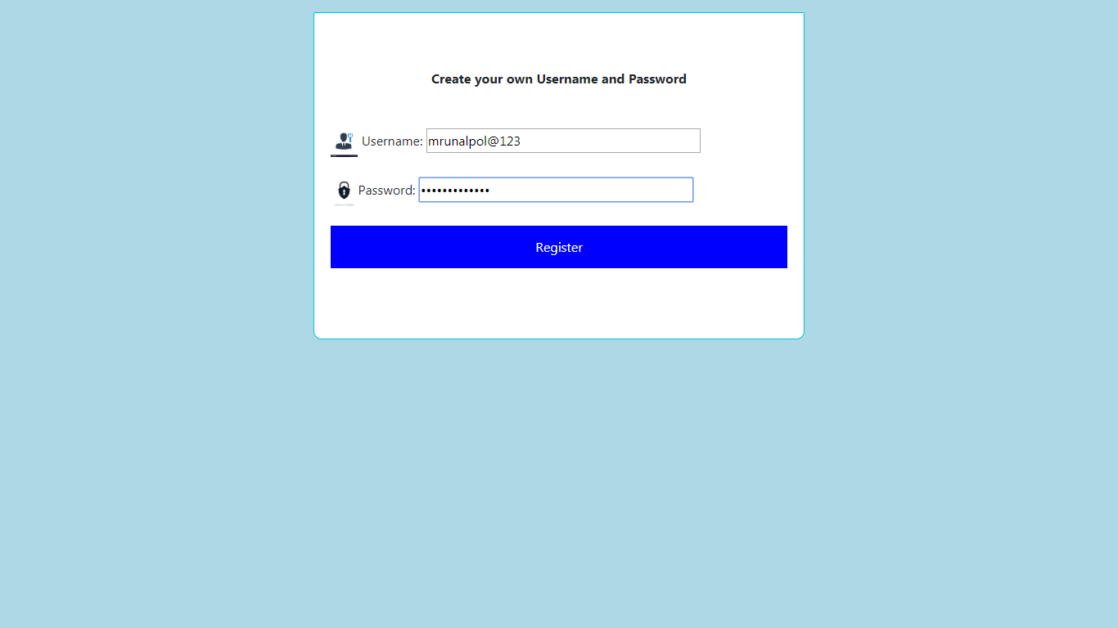

**Student Online Admission System**

**Sign in:**

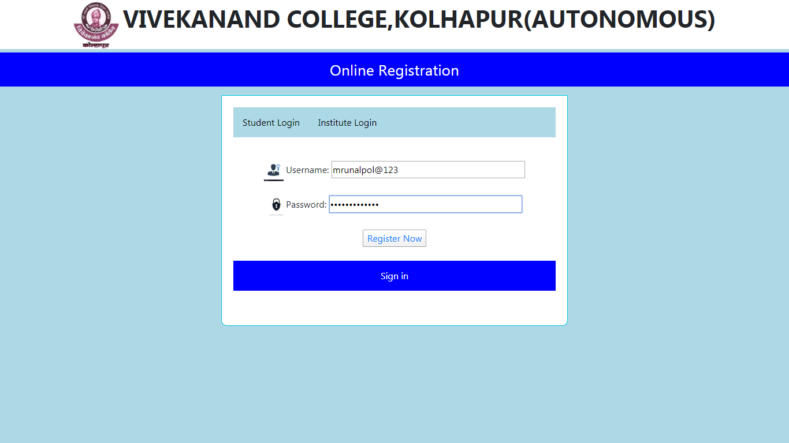

**Personal Information:**

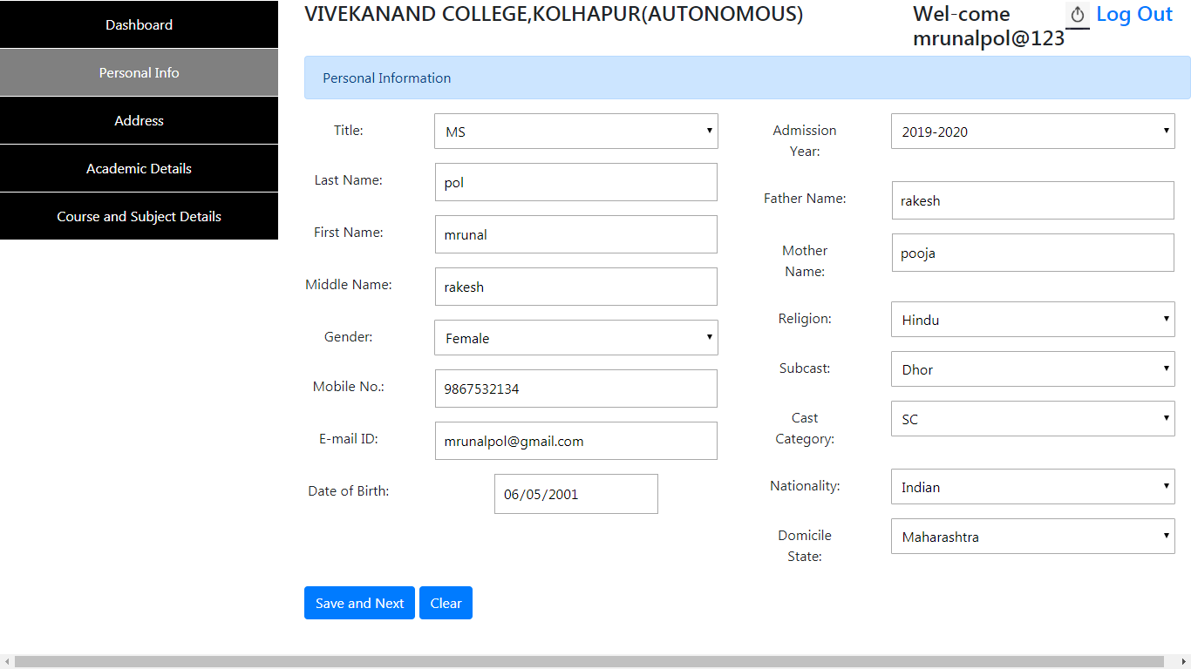

**Student Online Admission System**

**Address Details:**

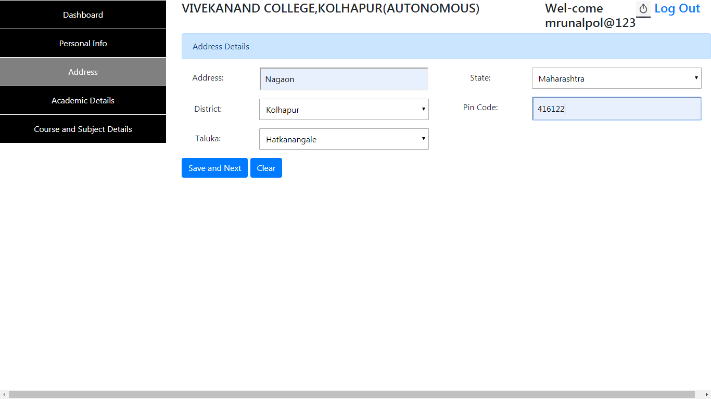

**Academic Details:**

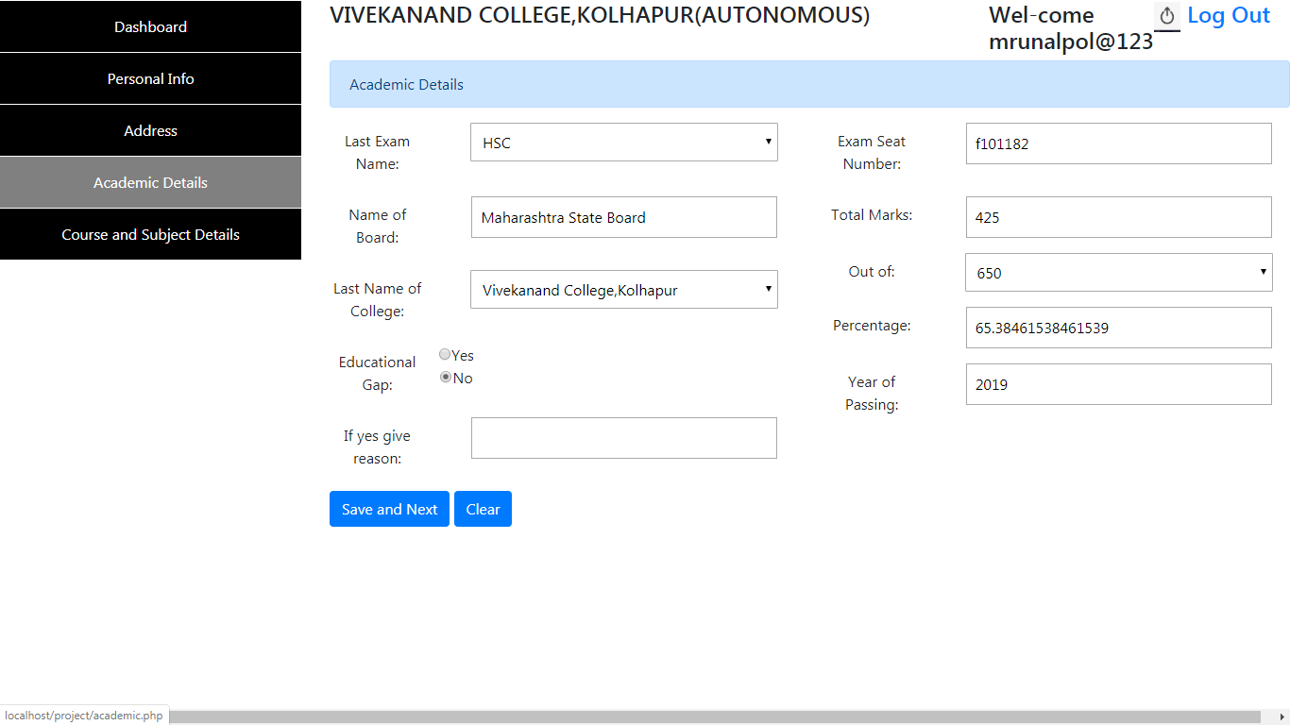

**Student Online Admission System**

**Course and Subject Details:**

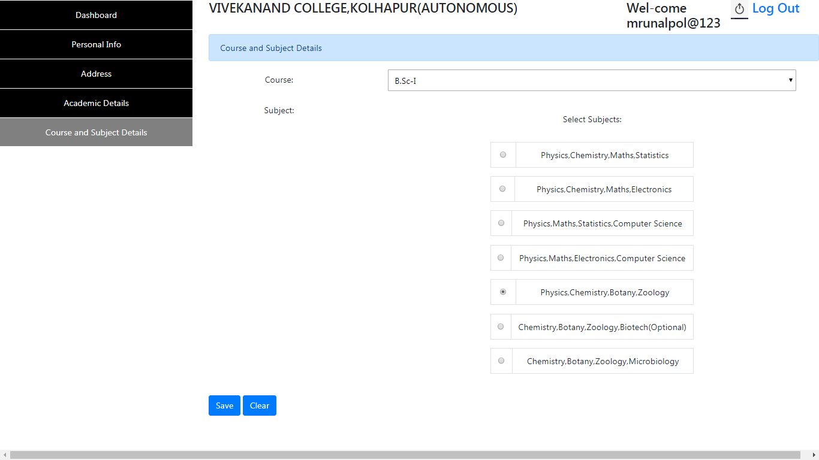

**Student Online Admission System**

**Admin Login Page:**

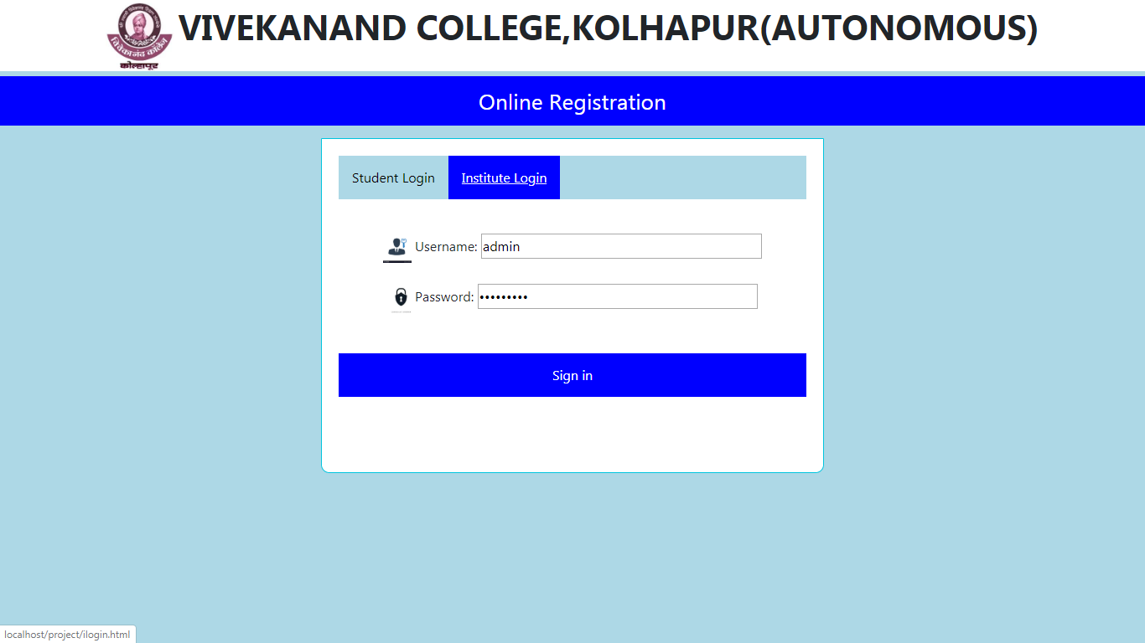

**Admin Panel:**

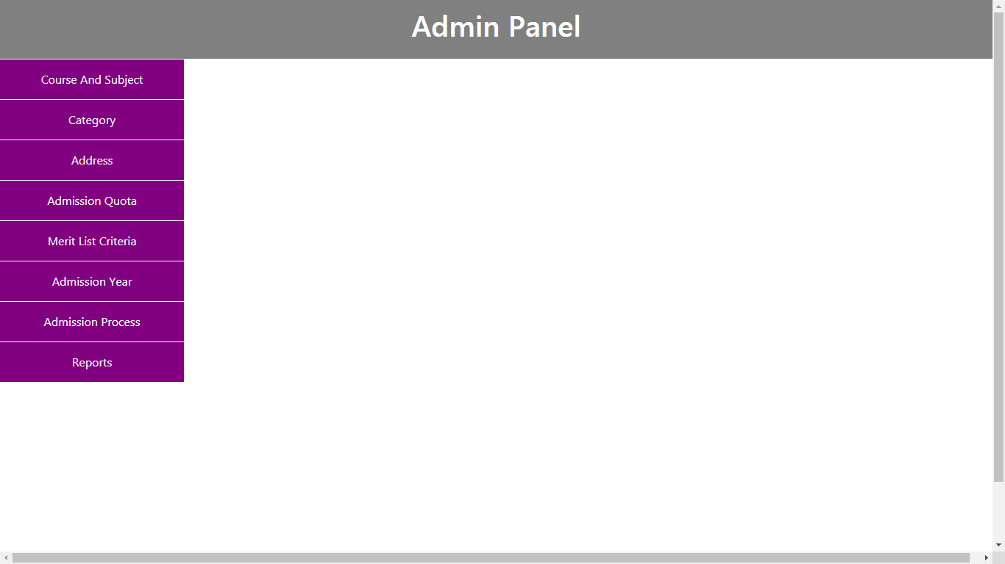

**Student Online Admission System**

**For add Course:**

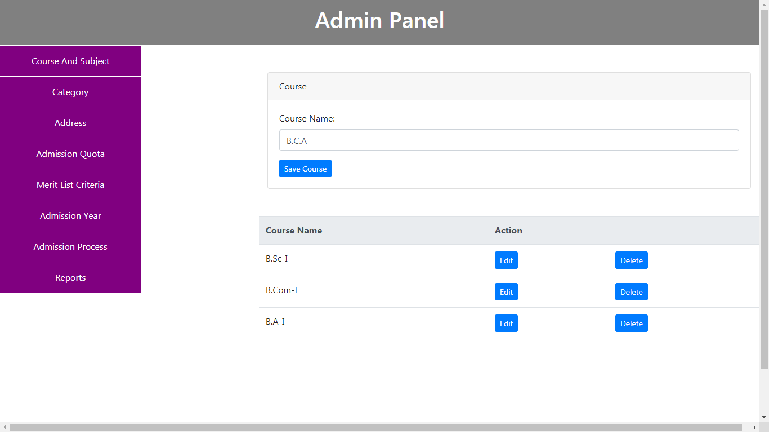

**For add Subject:**

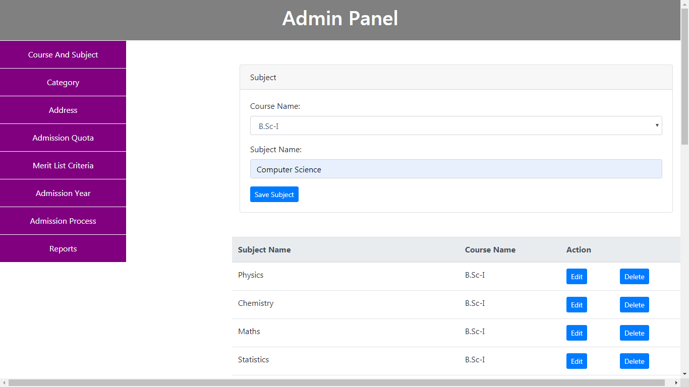

**Student Online Admission System**

**For Group Creation**

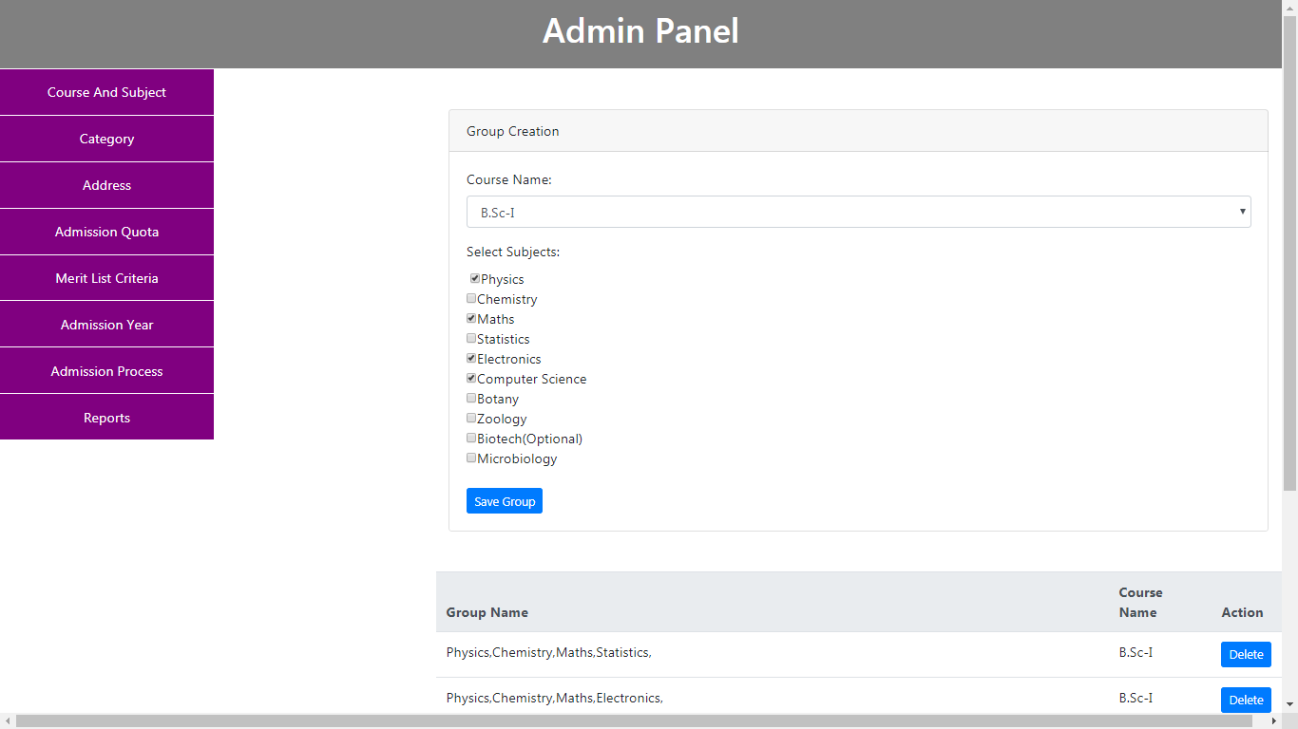

**For add Religion:**

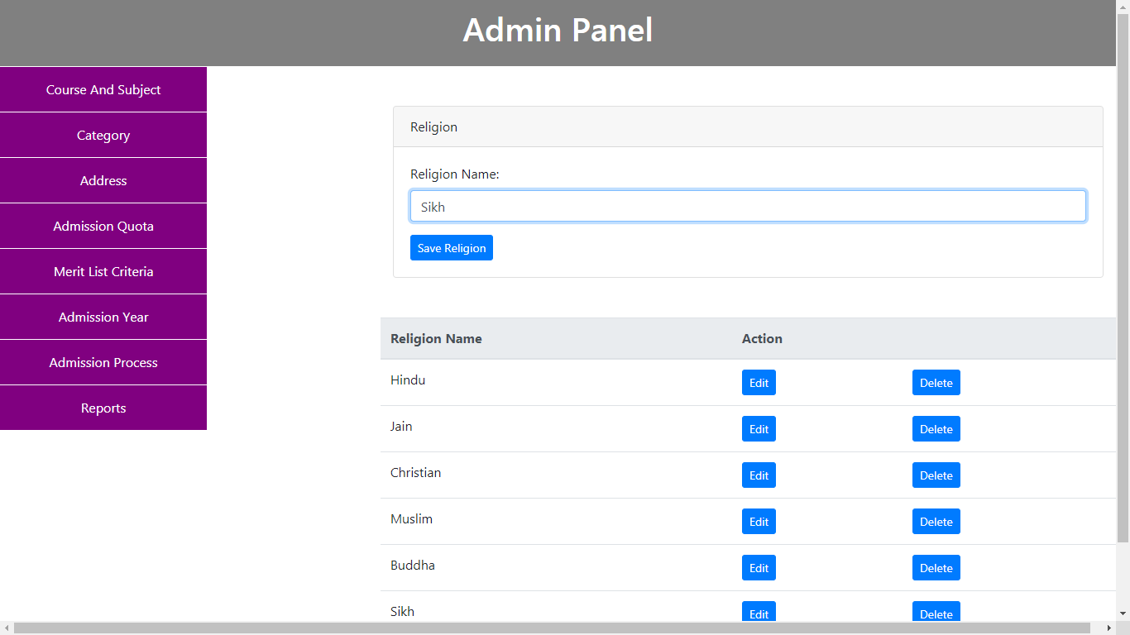

**Student Online Admission System**

**For add Subcategory:**

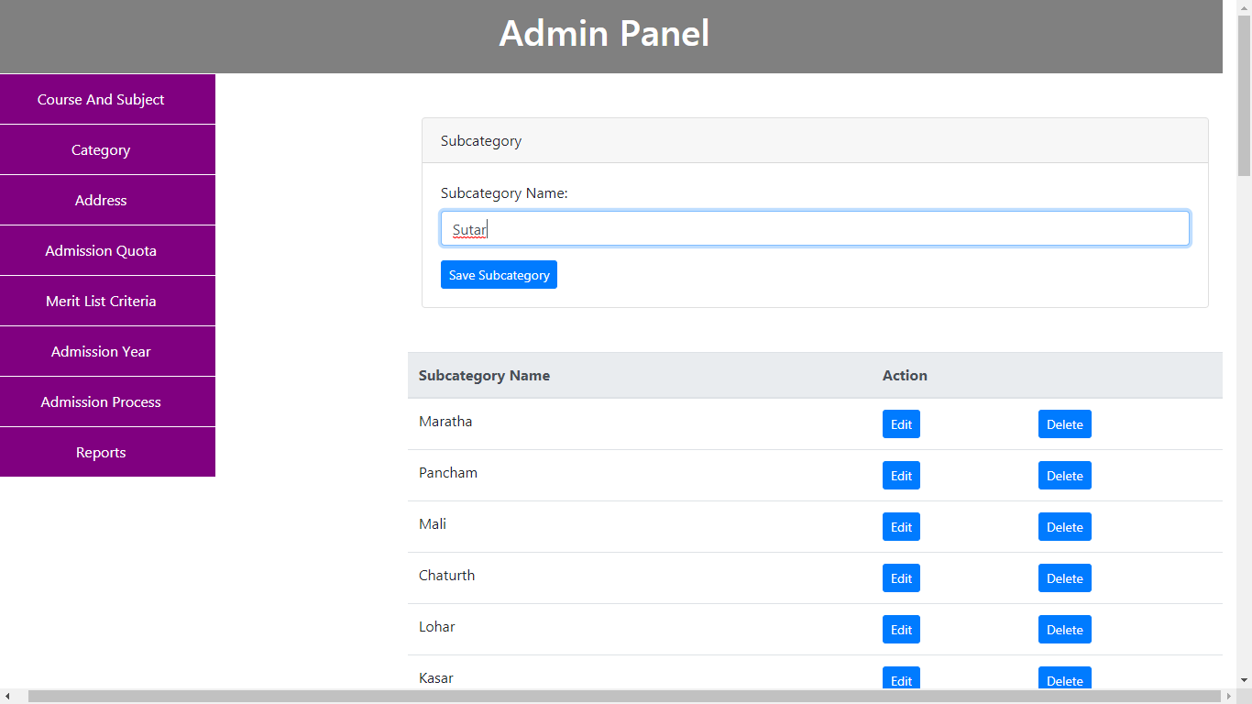

**For add category:**

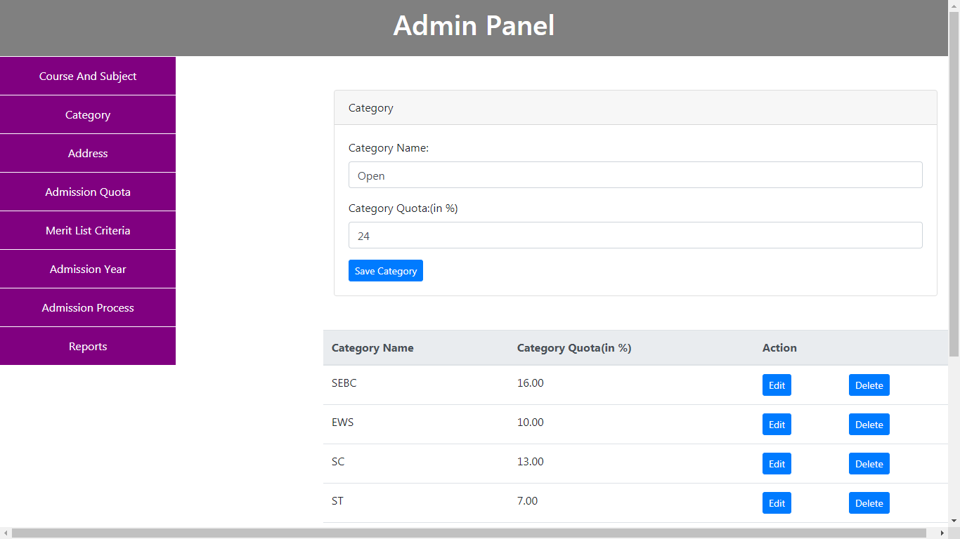

**Student Online Admission System**

**For add State:**

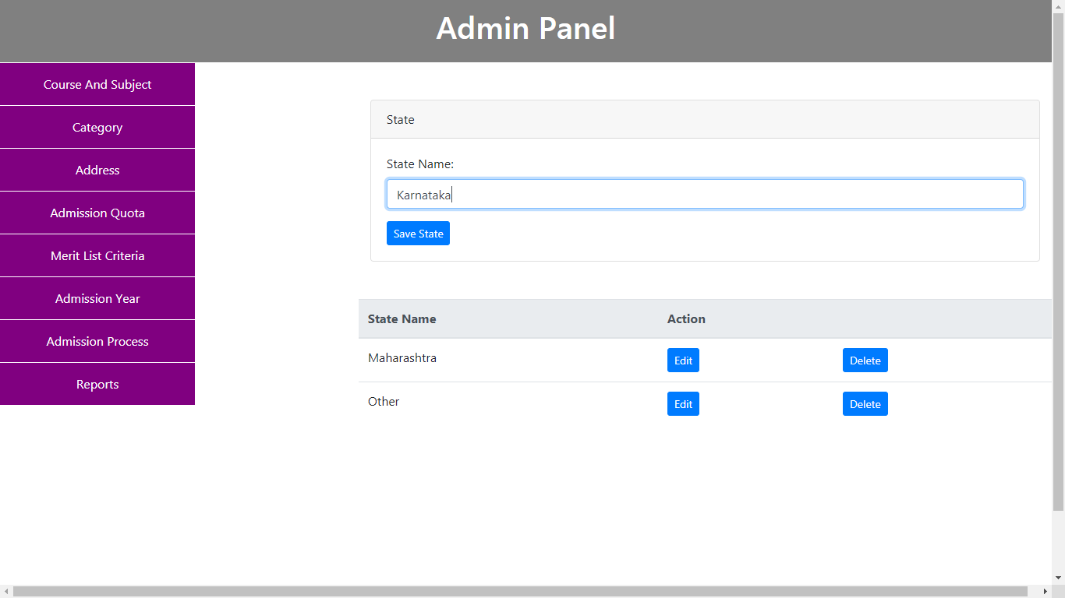

**For add District:**

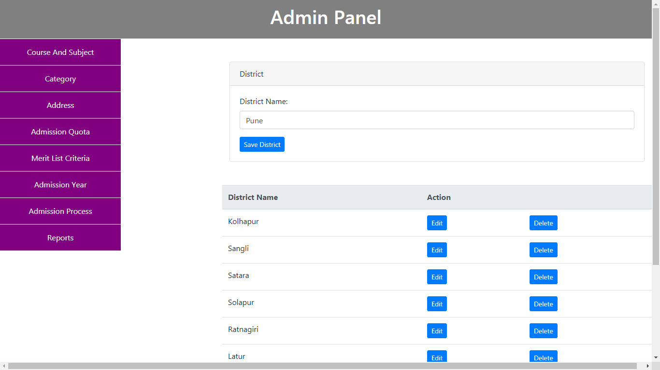

**Student Online Admission System**

**For add Domicile State:**

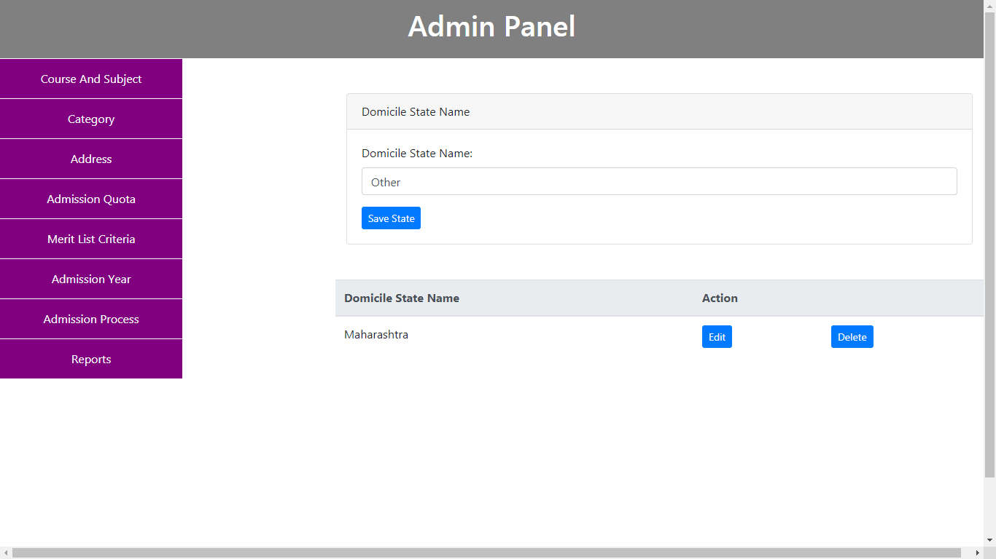

**For add Nationality:**

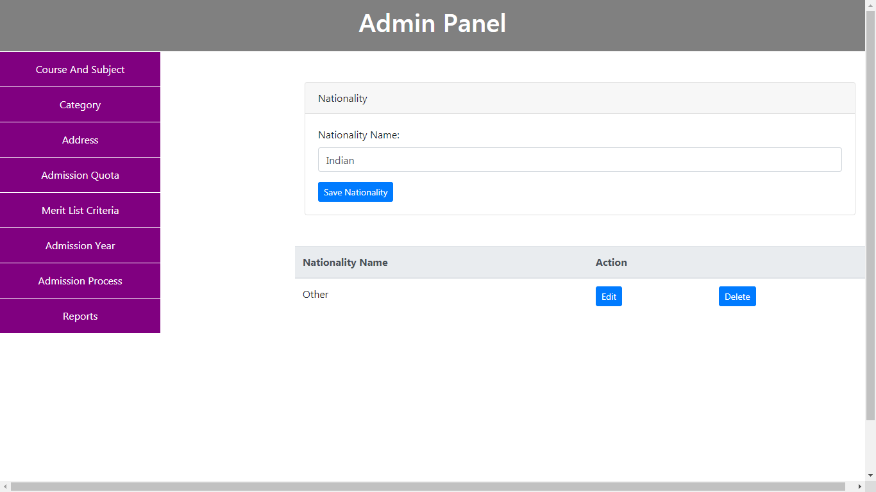

**Student Online Admission System**

**For adding Group name wise Grantable Admission Quota:**

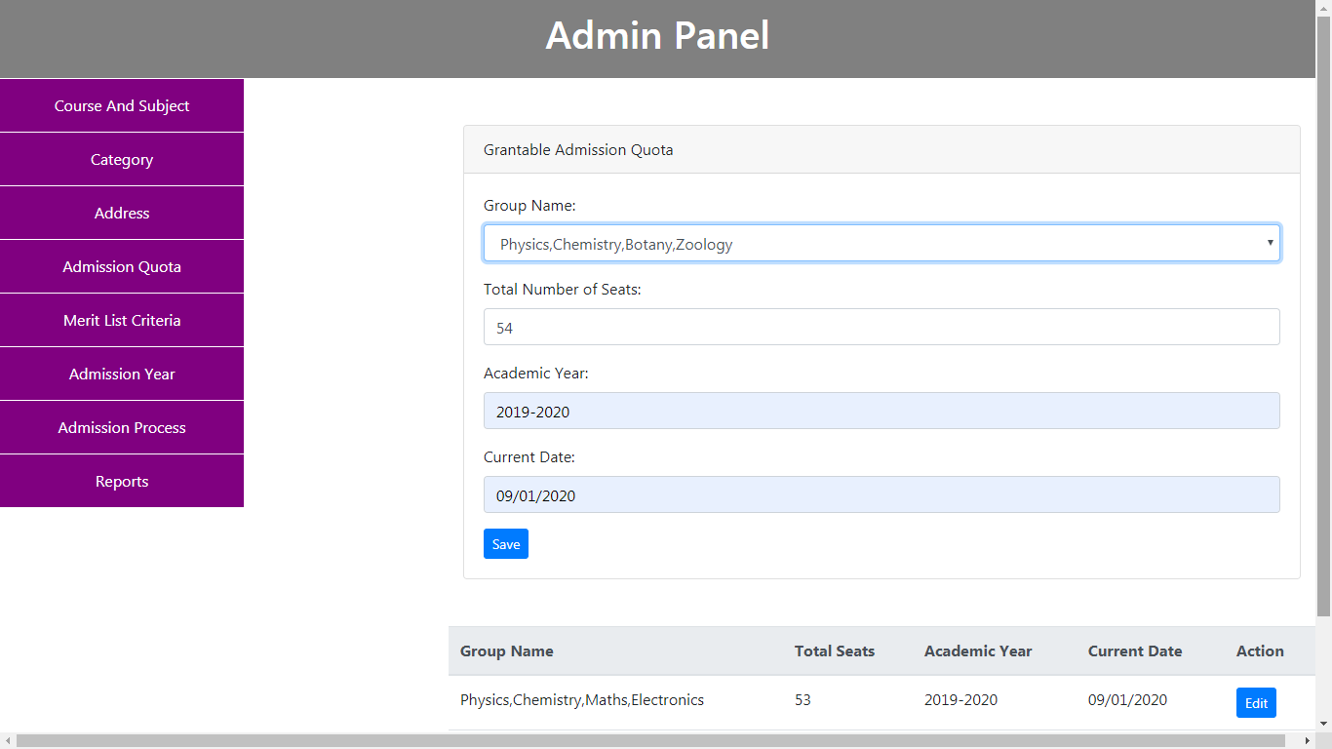

**For adding Group name wise Nongrantable Admission Quota:**

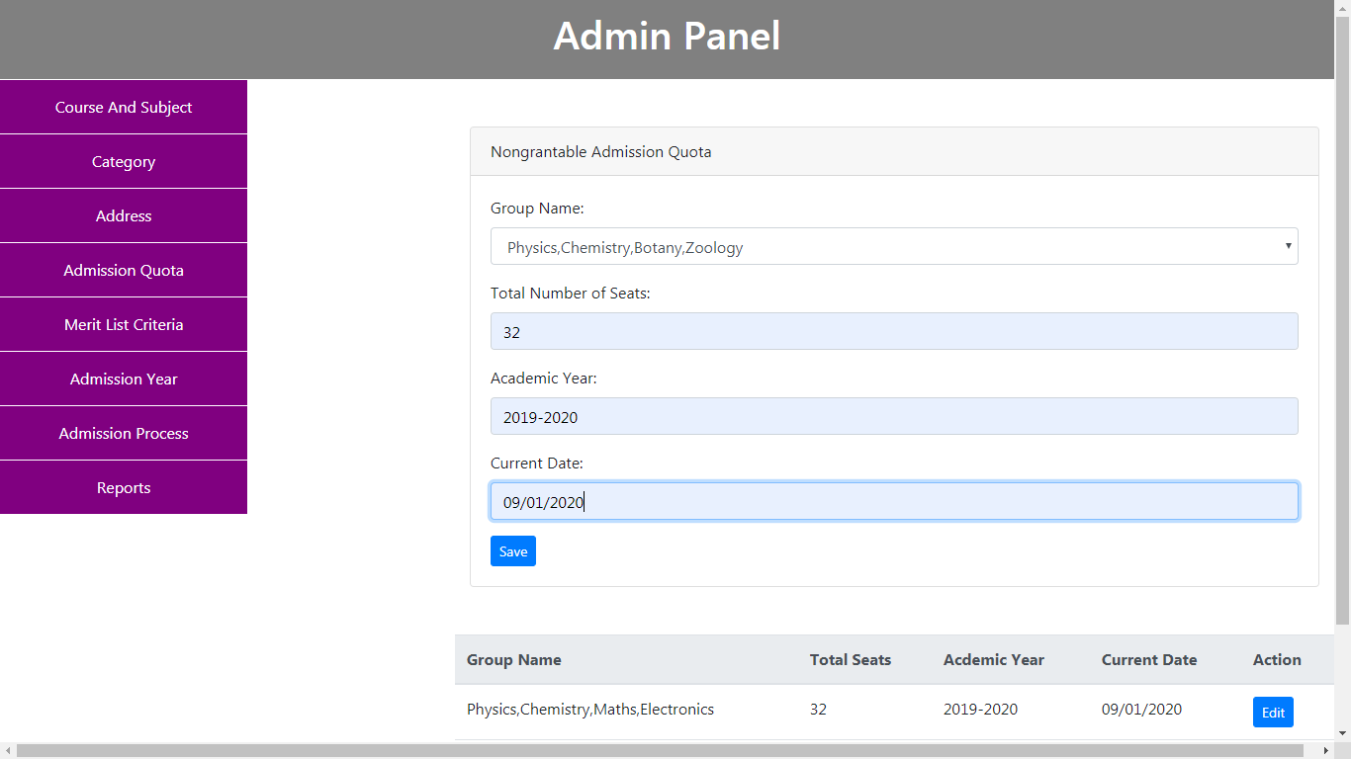

**Student Online Admission System**

**Grantable Merit List Criteria:**

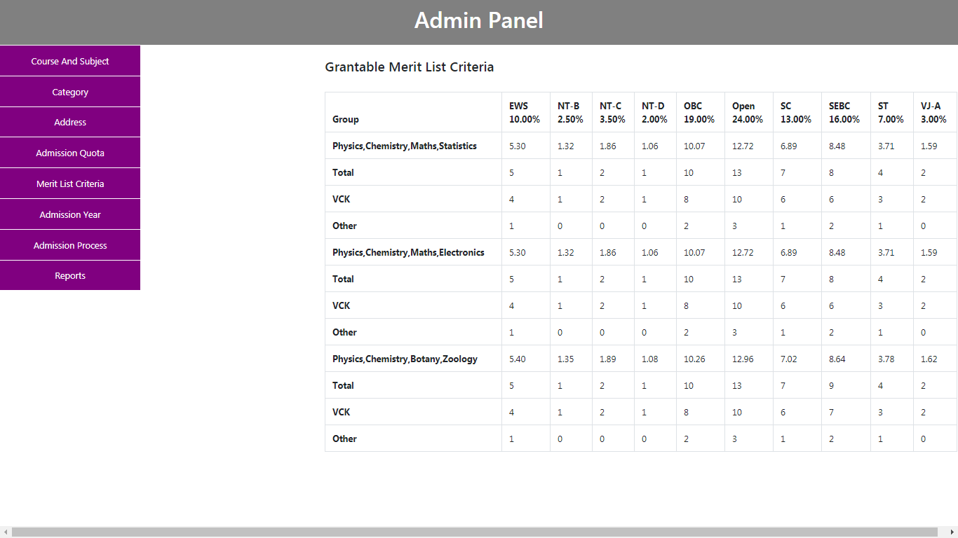

**Grantable Merit List Criteria:**

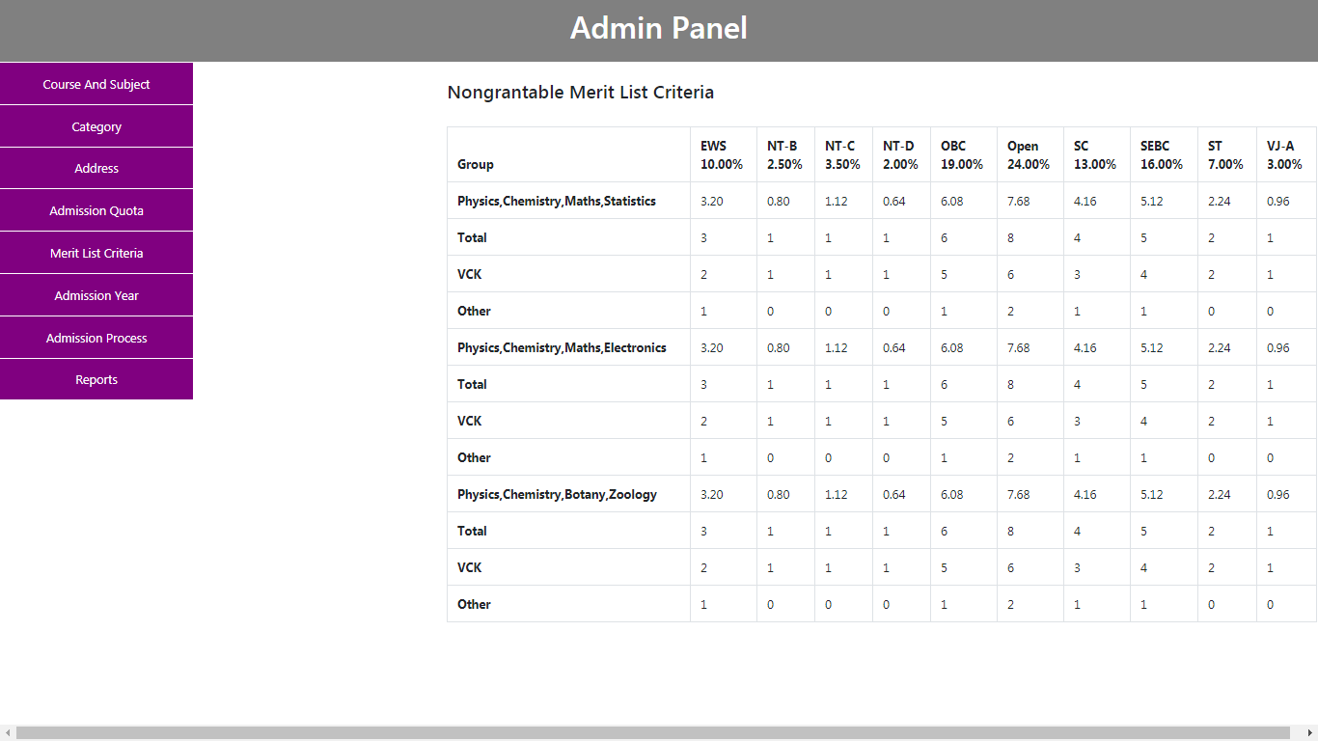

**Student Online Admission System**

**For add Admission Year:**

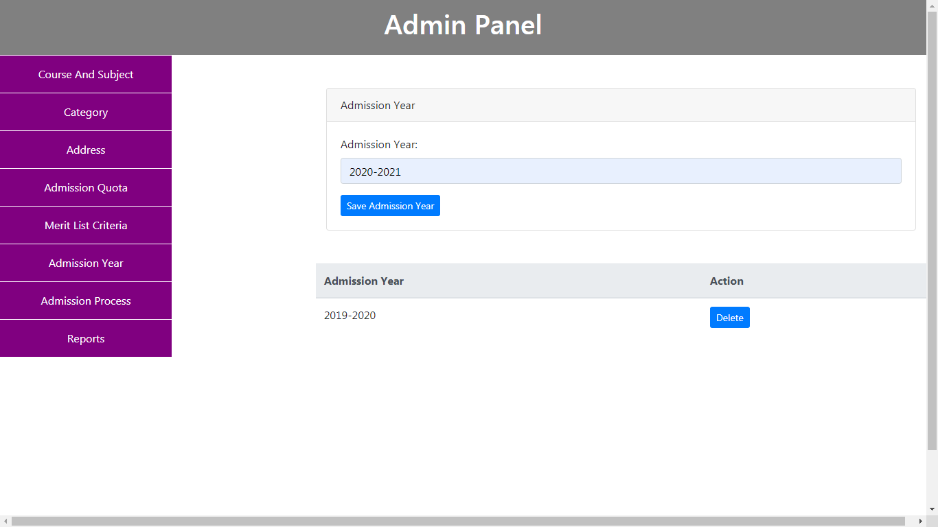

**Verification of Admission Form:**

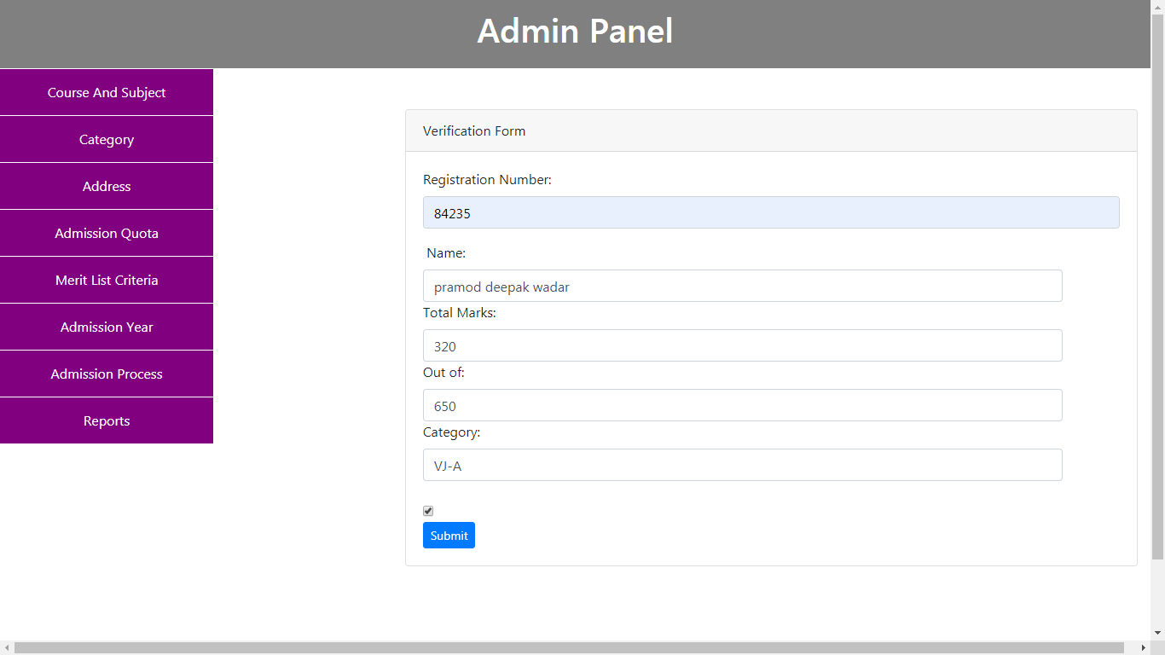

**Student Online Admission System**

**Reports:**

**Yearwise General Merit List :**

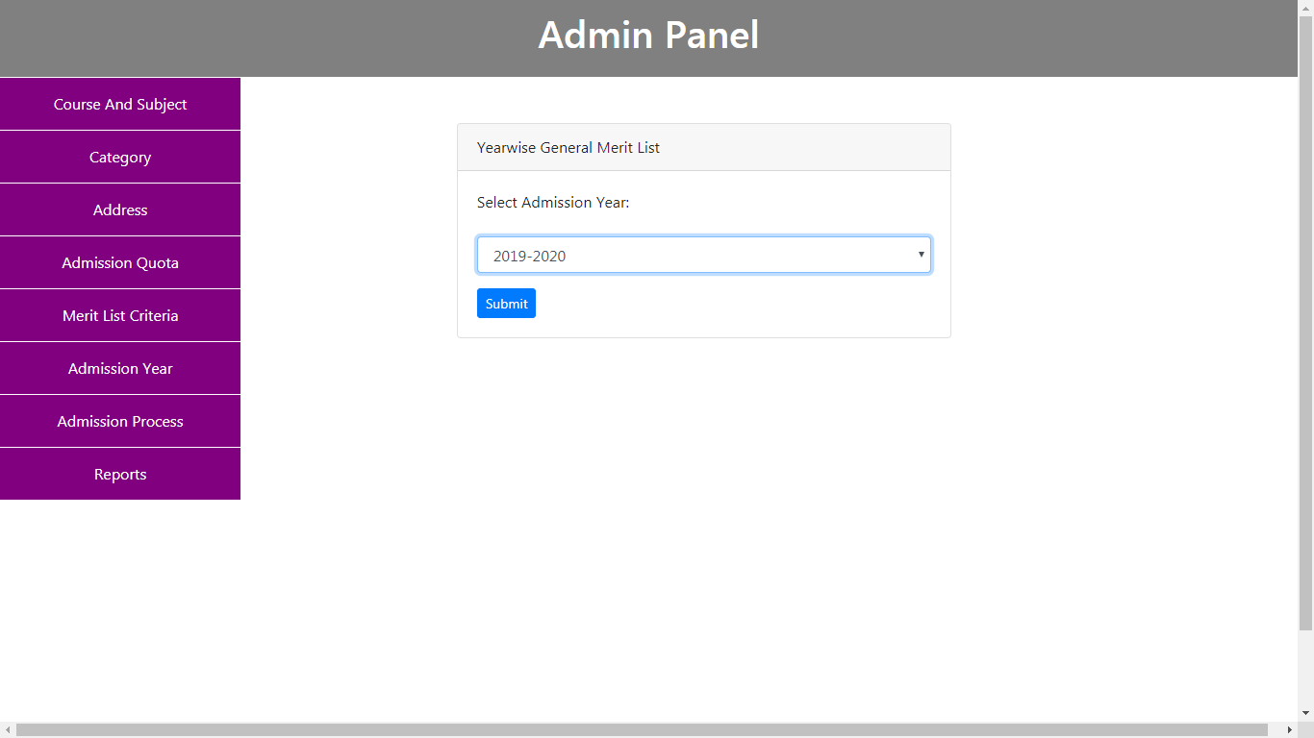

**Student Online Admission System**

**Groupwise General Merit List:**

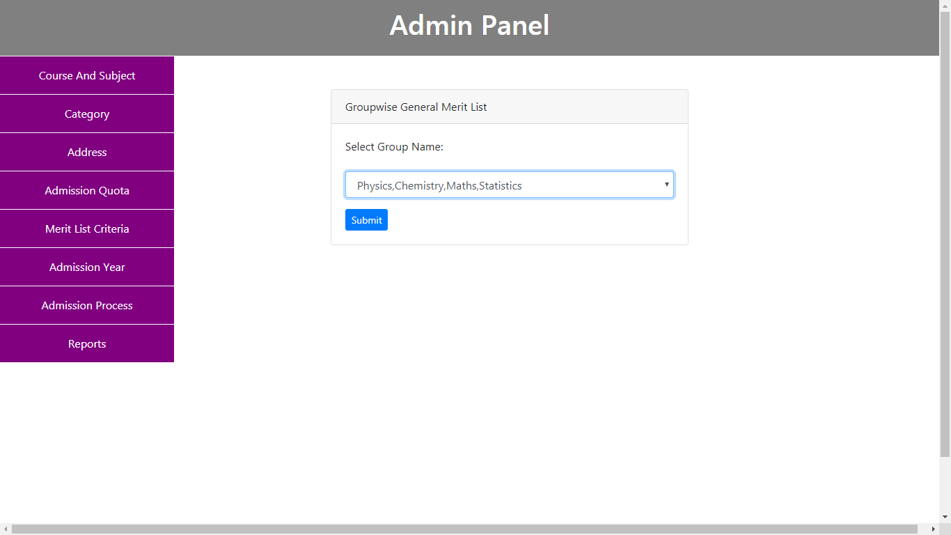

**Student Online Admission System**

**Groupwise General Merit List:**

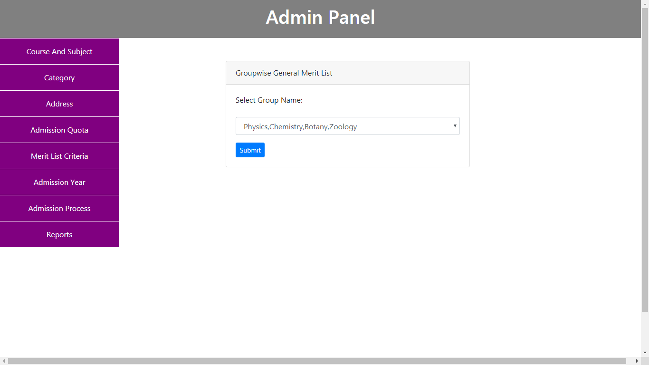

**Student Online Admission System**

**Categorywise General Merit List:**

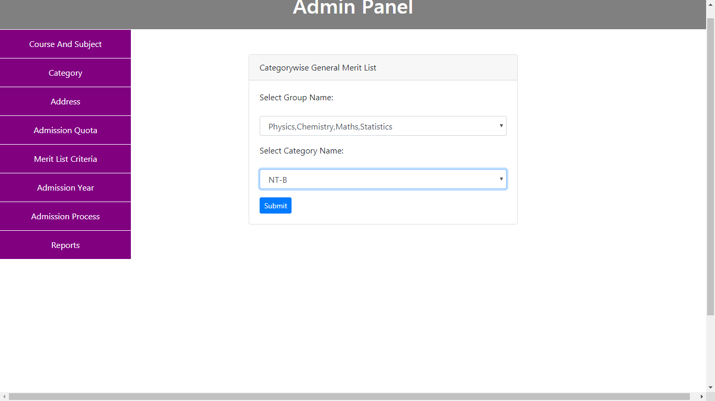

**Student Online Admission System**

**Categorywise General Merit List:**

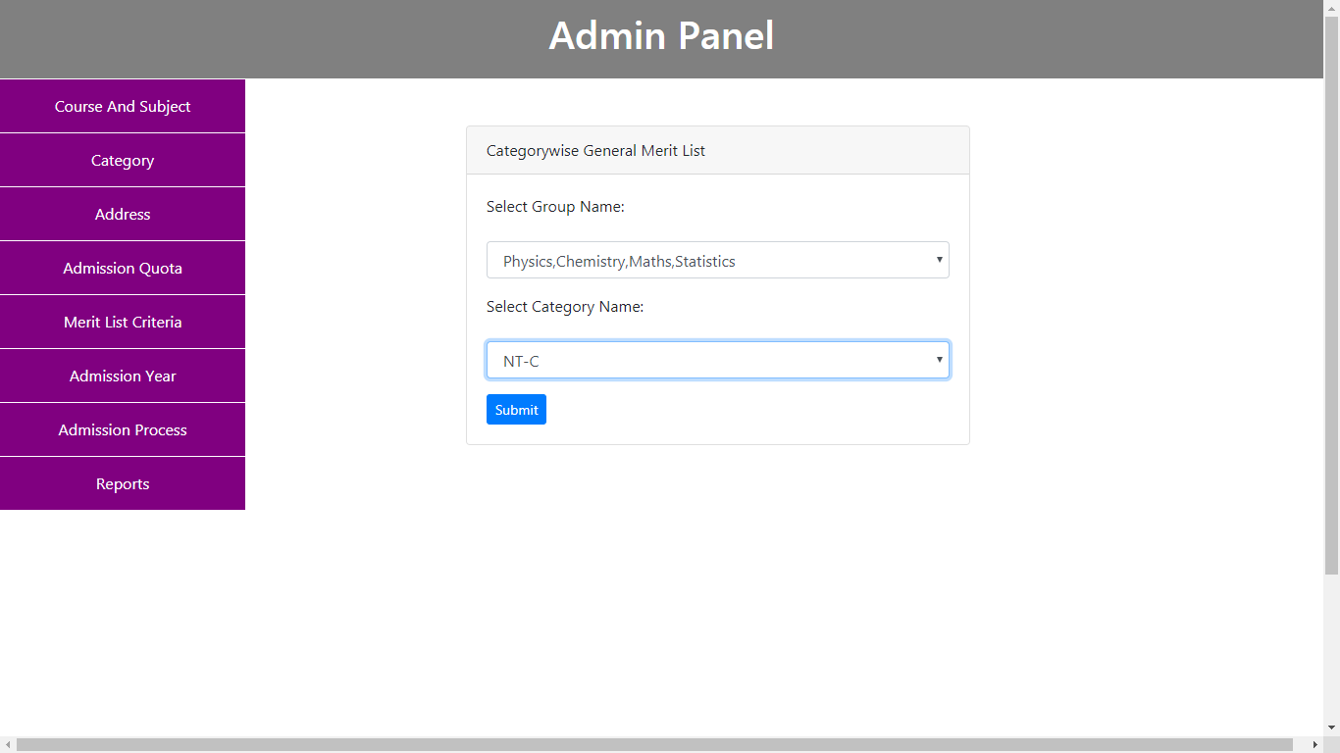

**Student Online Admission System**

**Categorywise General Merit List:**

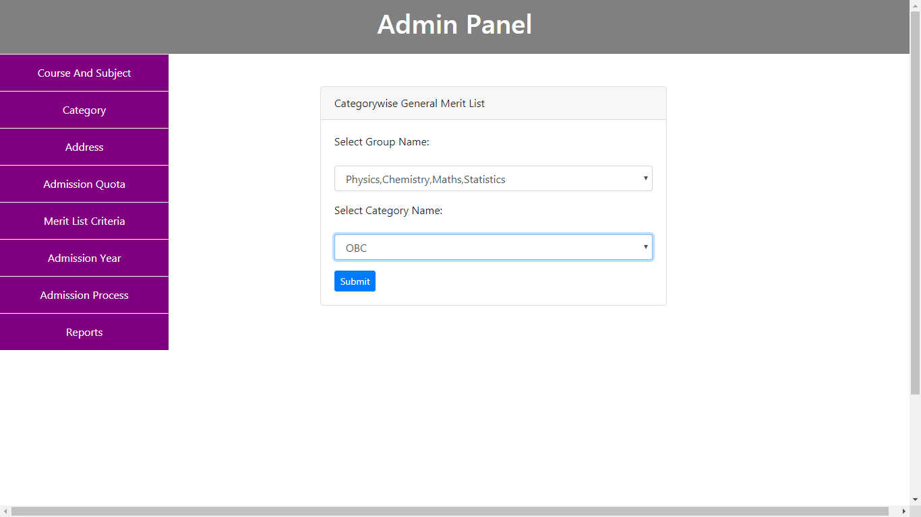

**Student Online Admission System**

**Categorywise General Merit List:**

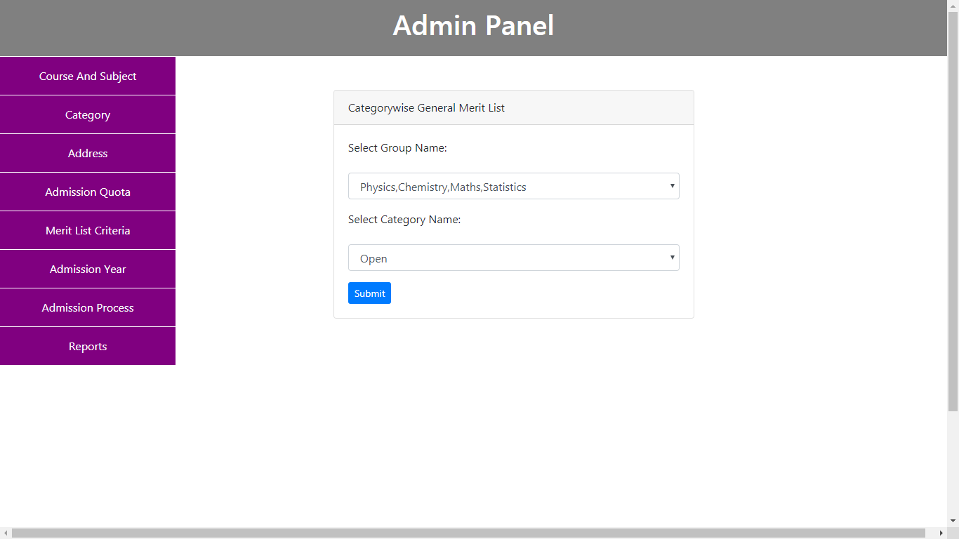

**Student Online Admission System**

**Categorywise General Merit List:**

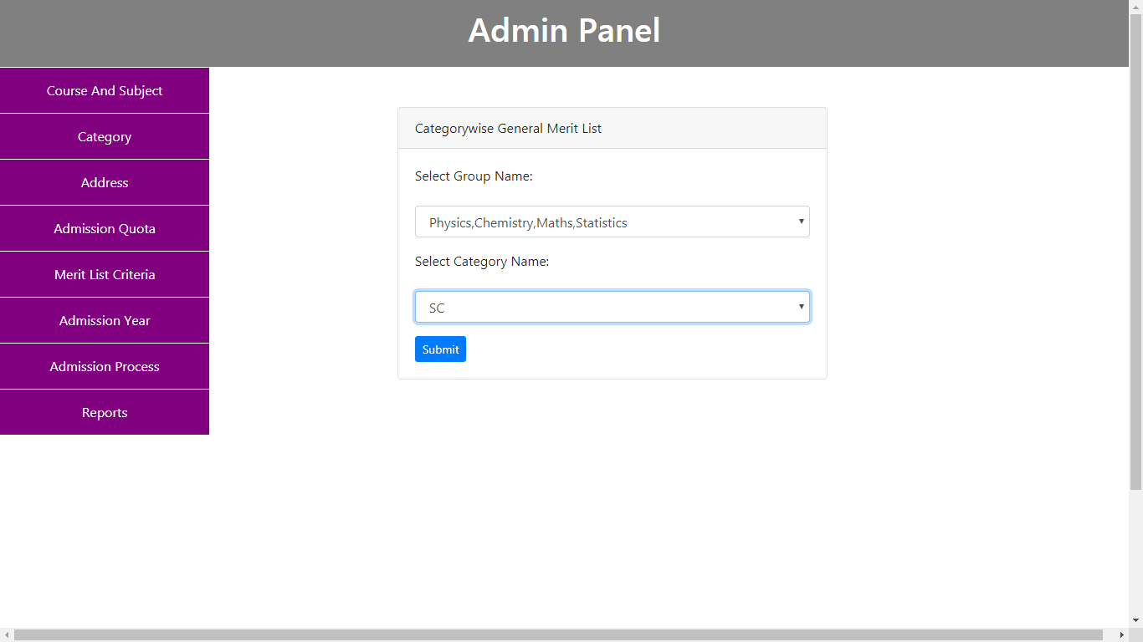

**Student Online Admission System**

**Categorywise General Merit List:**

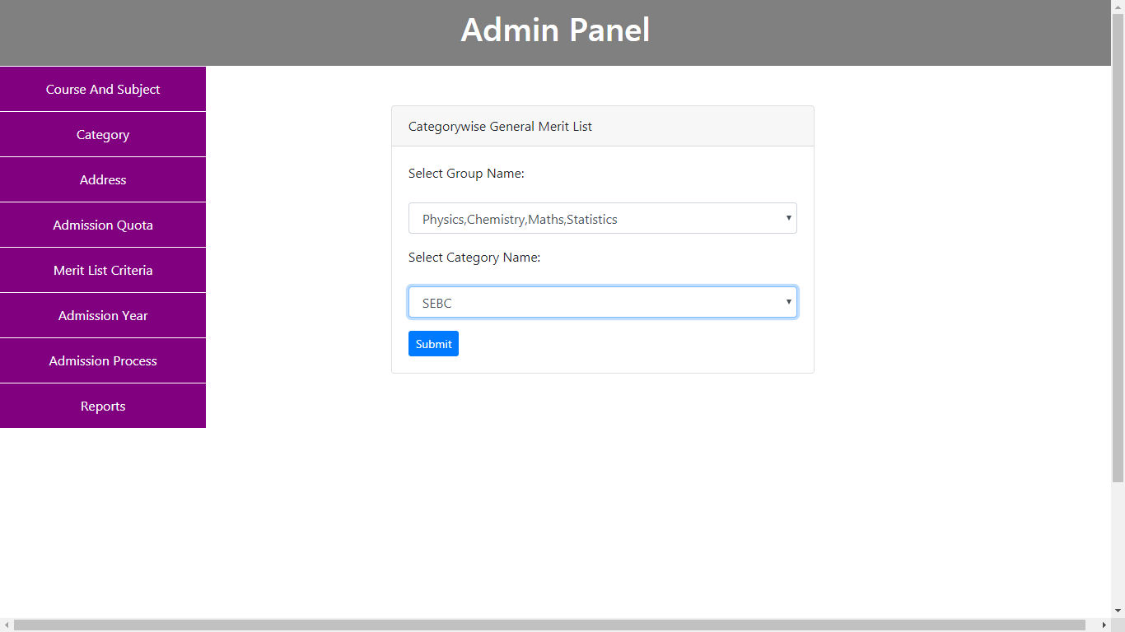

**Student Online Admission System**

**Categorywise General Merit List:**

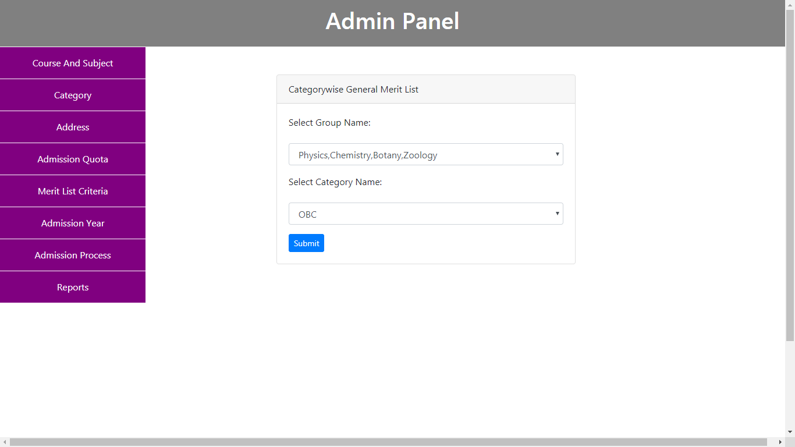

**Student Online Admission System**

**Categorywise General Merit List:**

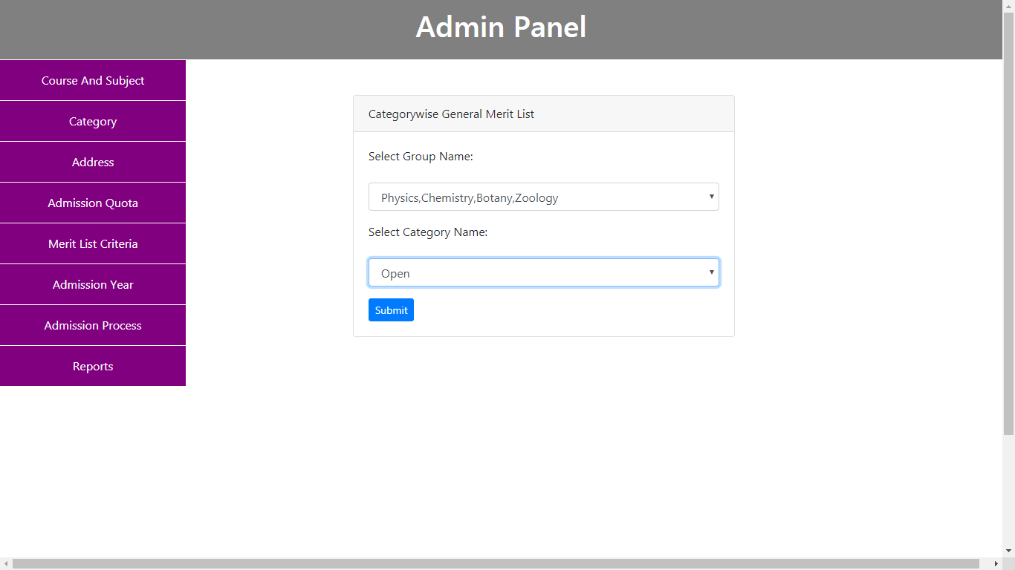

**Student Online Admission System**

**Groupwise General Merit List with Previous College Name:**

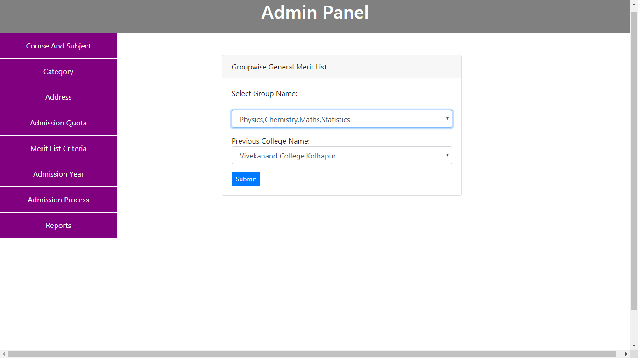

**Student Online Admission System**

**Groupwise General Merit List with Previous College Name:**

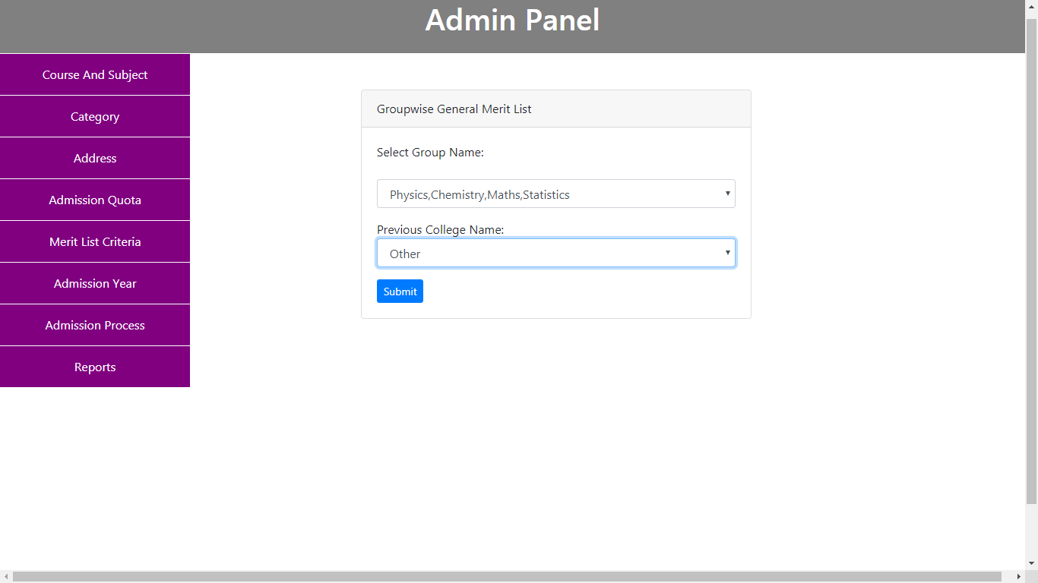

**Student Online Admission System**

**Categorywise General Merit List with Previous College Name:**

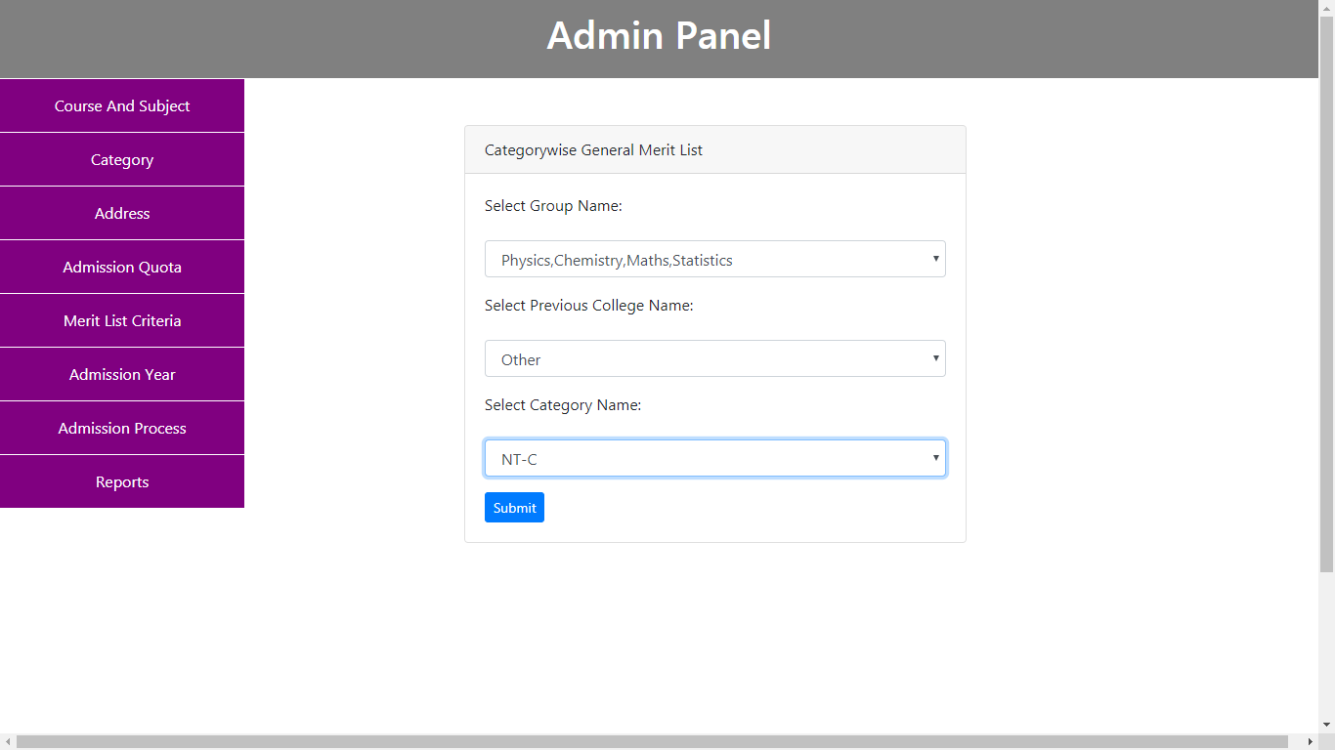

**Student Online Admission System**

**Categorywise General Merit List with Previous College Name:**

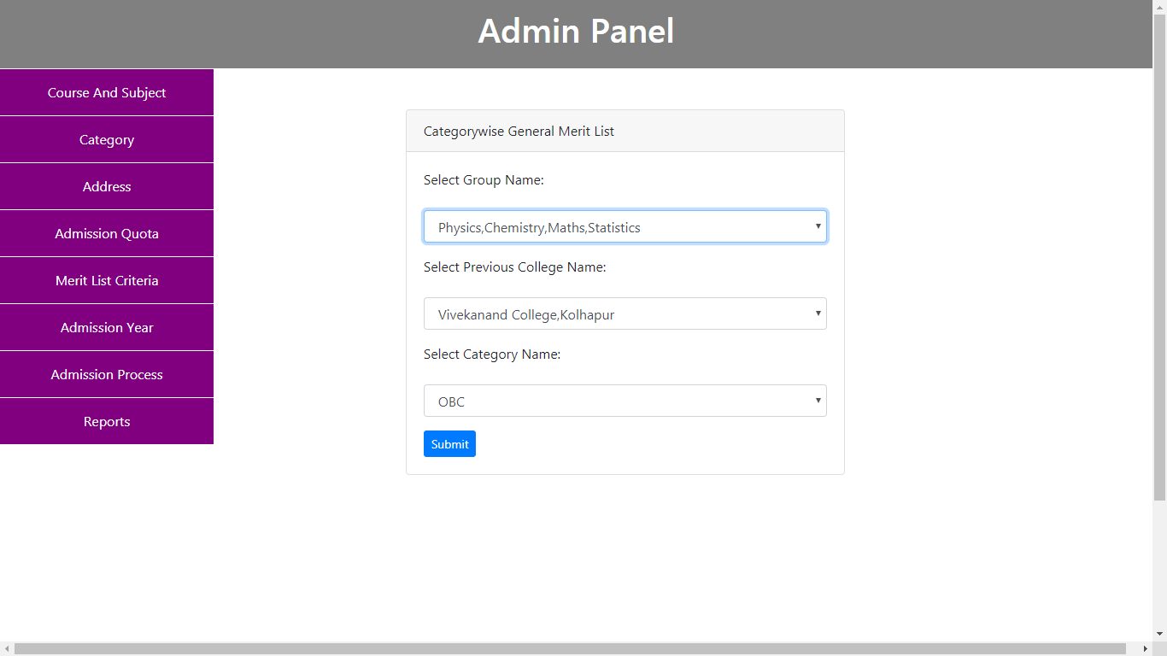

**Student Online Admission System**

**Categorywise General Merit List with Previous College Name:**

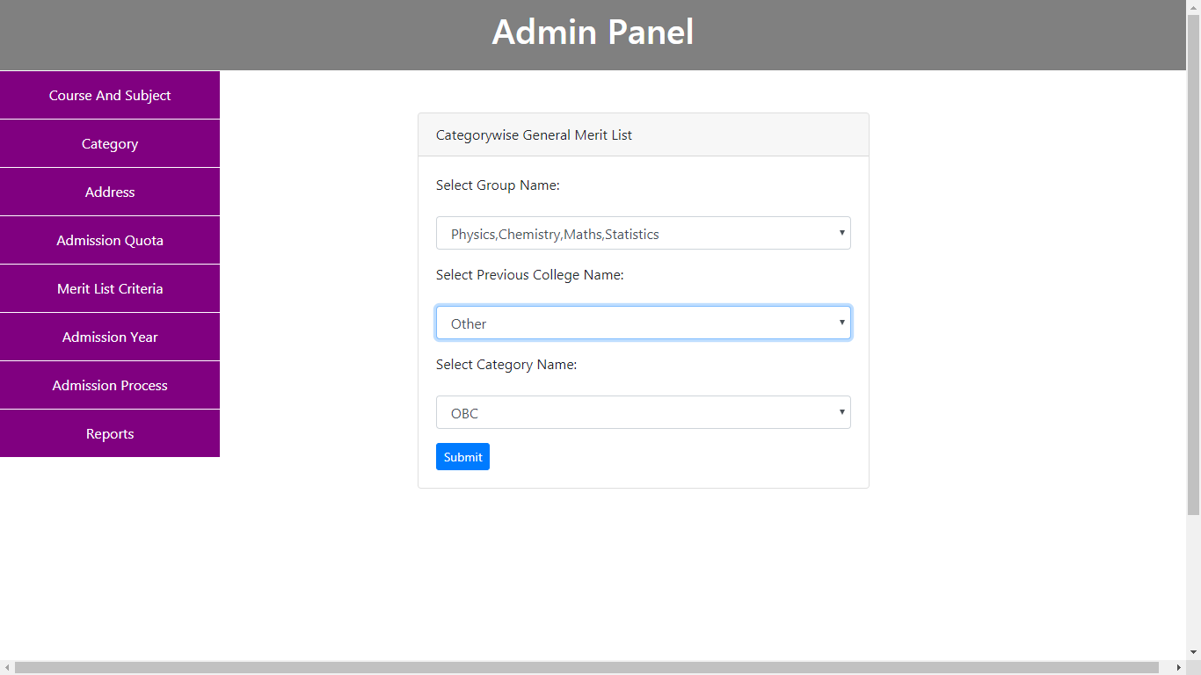

**Student Online Admission System**

**Categorywise General Merit List with Previous College Name:**

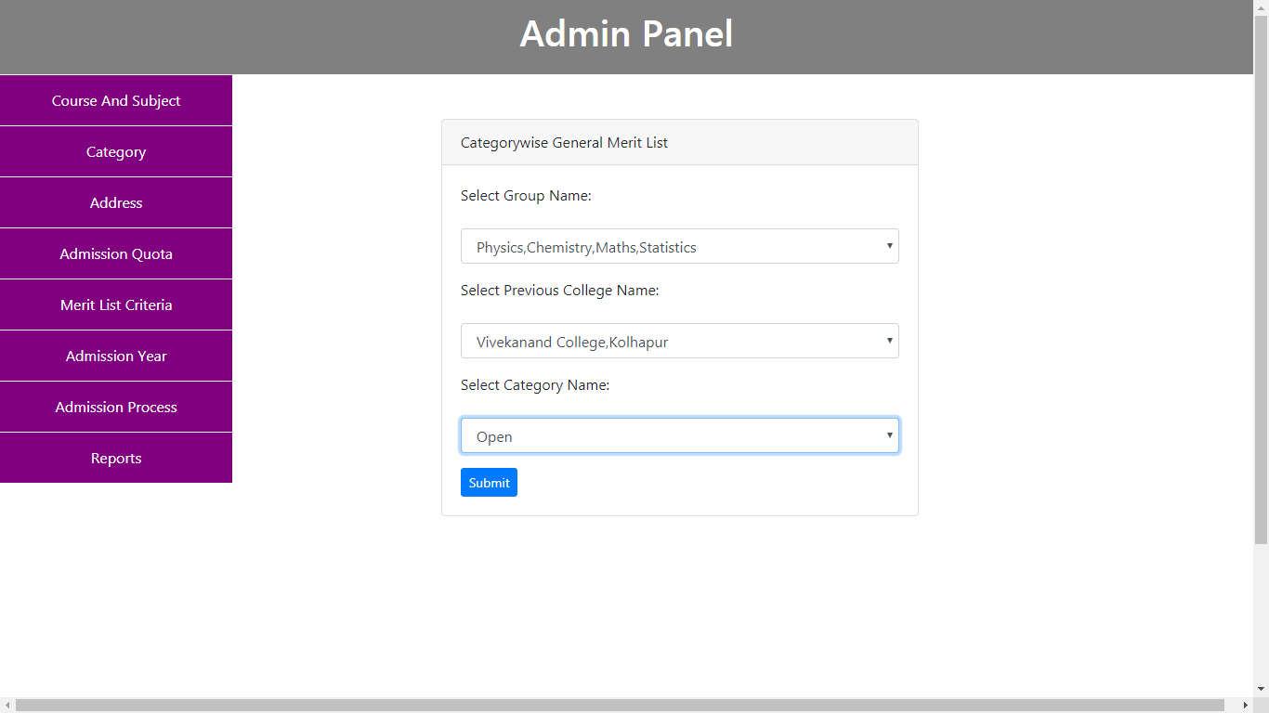

**Student Online Admission System**

**Categorywise General Merit List with Previous College Name:**

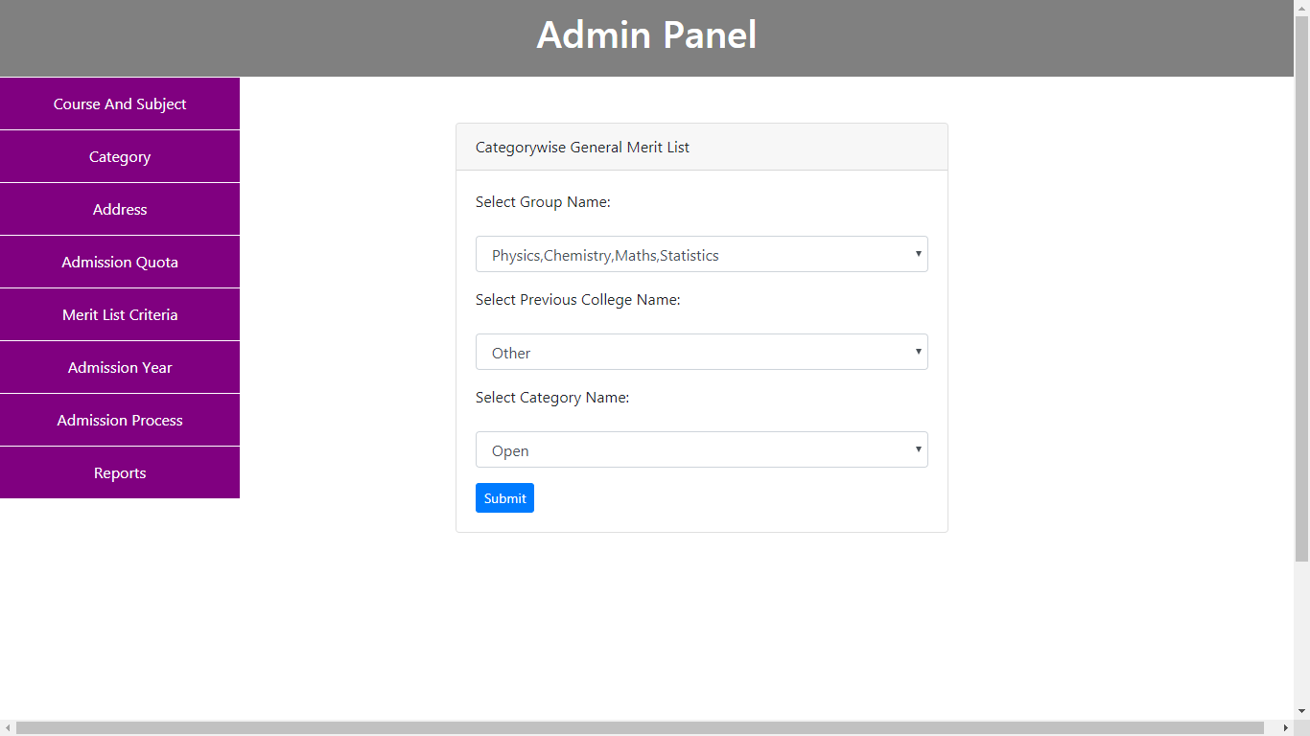

**Student Online Admission System**

**Categorytwise General Merit List with Previous College Name:**

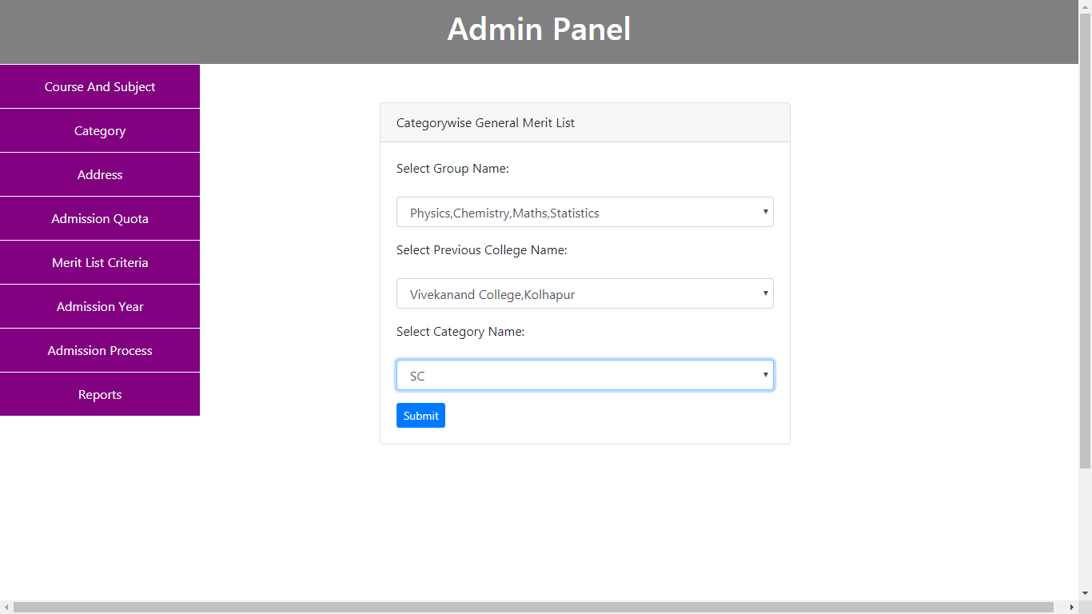

**Student Online Admission System**

**Categorywise General Merit List with Previous College Name:**

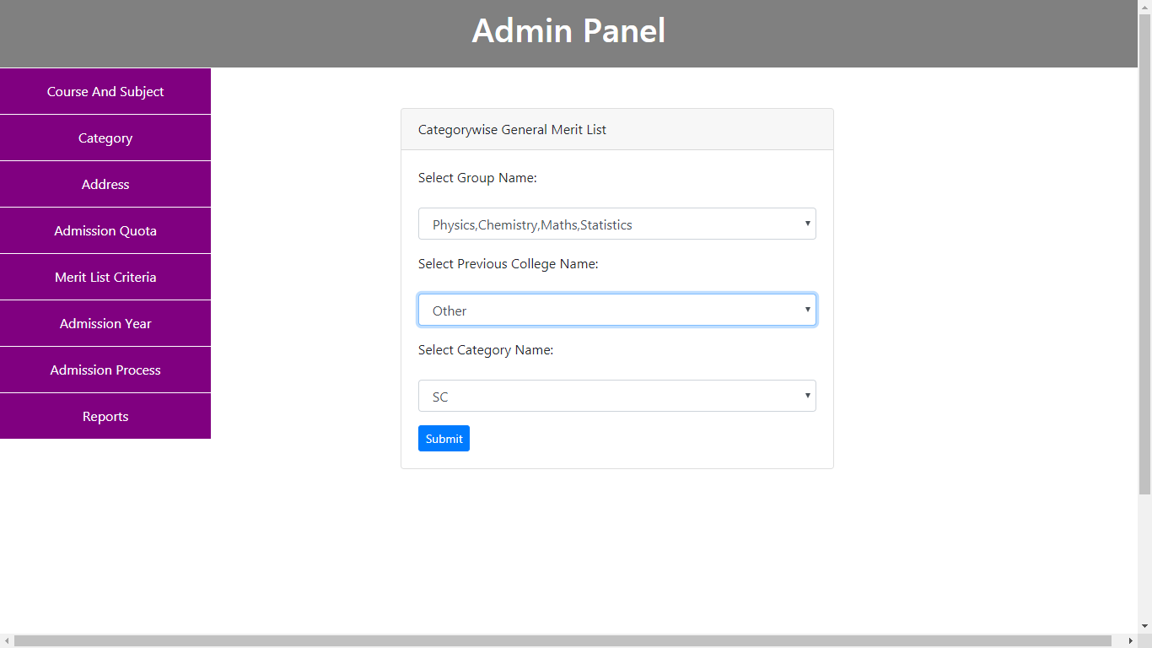

**Student Online Admission System**

**Categorywise General Merit List with Previous College Name:**

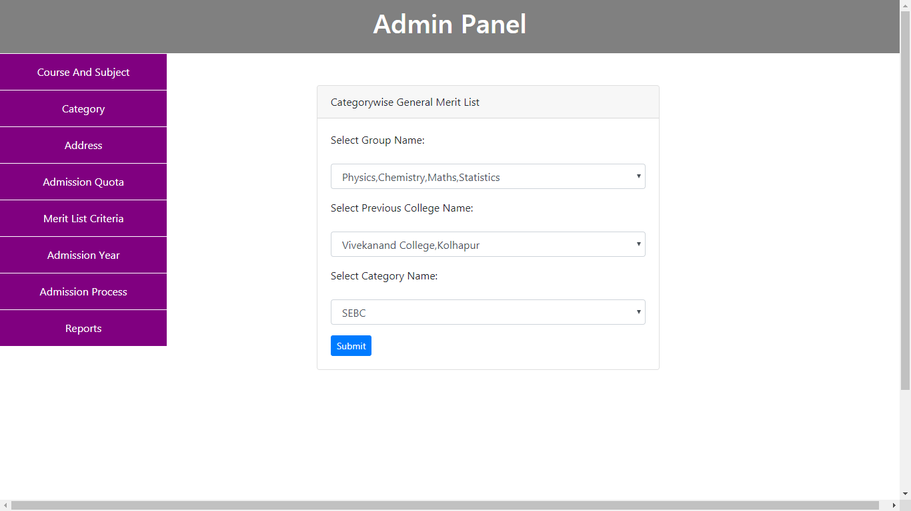

**Student Online Admission System**

**Categorywise General Merit List with Previous College Name:**

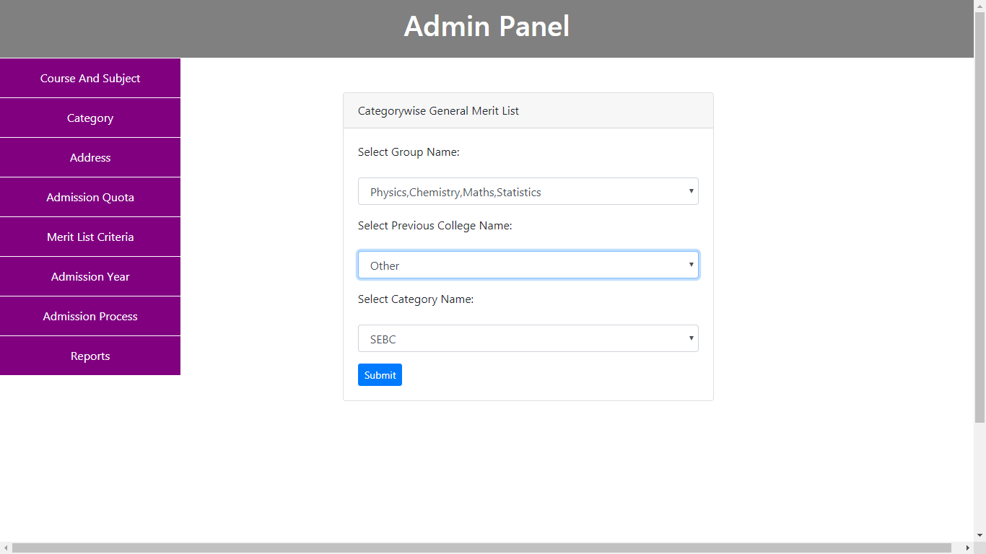

**Student Online Admission System**

**Groupwise First Merit List (Grantable):**

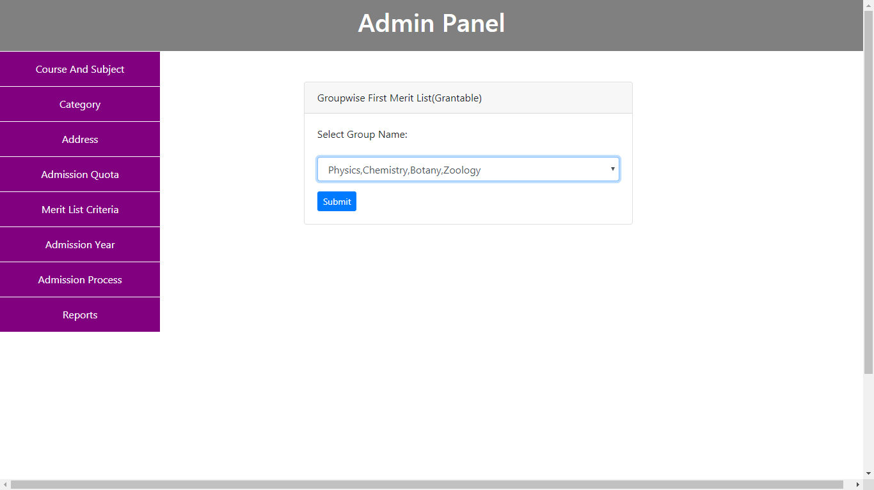

**Student Online Admission System**

**Groupwise First Merit List (Nongrantable):**

