**VIVEKANAND COLLEGE ,KOLHAPUR**

**STUDY TOUR REPORT**

**2019-2020**

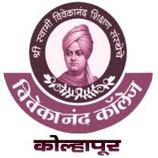

REGARDS TO

**“Skylark Global BPO Services Pvt. Ltd”**

SUBMITED BY

**PATIL PRANALI RAJENDRA**

**ROLL NO:8269**

**BSCIII COMPUTER SCIENCE**

**INDEX**

* **Introduction**
* **Objective of study tour**
* **About SKYLARK**
* **Services Provided by SKYLARK**
* **Conclusion**

**Introduction**

Department of computer science of Vivekanad college, Kolhapur visited on 08/02/2020 at **Skylark Global BPO Services Pvt. Ltd**. for the study tour. The Staff of Skylark welcome us. After some time we gathered in the ‘Conference Hall’, the experts provide the introductory session regarding different services provided by Skylark. After this session we visited different departments. We got very useful and productive information from this study tour of Skylark Company.

**Objectives of Study Tour**

We the Department of Computer Science arranged the study tour at the company named “Skylark Global BPO Services Pvt. Ltd.” . For the purpose of learning, through readings, writing, research and creative thinking assignments in order to meet the specific learning objectives of the course.

The objectives of our Study Tour are as follows:

1. To learn from wide range of experiences and be exposure to new ideas.
2. To observe different ways of designing and managing an inclusive education project and consider how to adapt them in our own work.
3. To develop long-term practical and motivational links with other people working on inclusive education.
4. To reflect on and share what we have done in our project.
5. To help us prepare for writing a new long-term plan, or with starting a new project phase or direction.

To complement an ongoing training or awareness raising program with staff and /or stakeholders

**Founder**

Kailash Medhe is the Founder and CEO of Skylark Global BPO. He leads all global operations and sales at Skylark. Under his visionary leadership, Skylark has become one of the fastest growing IT/ITeS companies. His inspirational leadership has led Skylark to be conferred with various awards over the years, including India’s Best SME’s, Special Award for Placement Support to Disabled people, Dream Companies to work for and Best Business Partner from one of the esteemed clients. He also founded, first private ISP in Kolhapur in 2015. He holds a degree in Bachelor of Engineering in Electronics. He is the President of IT Association of Kolhapur.

**About Skylark Global BPO Services Pvt. Ltd.**

Skylark has established its operations in year 2002 having its primary focus on providing software services and providing IT enabled services. However, we gradually developed our expertise in providing various outsourcing services like Data Conversion Services, data entry, Image indexing services, customer care, transaction processing and other value added services.

Over a decade the company has developed and expanded its operations. This is evident as now we are 200 employees company. We have been instrumental in providing Employment opportunities not only for the candidates located in heart of the Kolhapur city but from nearby villages. Our Human Resources team has mainly focused on providing employment opportunities not only to the candidates belonging to lower strata of the society but also for physically challenged people. We call ourselves as an “Employee Centric company” and have motivated our employees to display the core values of always being Available, Attentive and Reliable to our customers. It has helped us to be a preferred outsourcing partner to our client. We have developed a culture to go one step ahead to provide something called as “Customer delight”. We have a strong and experienced Leadership & Human resources team which is consistently helping us to achieve our desired growth and objectives.

Day by day we have continued our development, expanded our operation and have invested in technology. We have developed new method of training so that we can deliver the quality output to our client. We are following the Best practices and highly committed to deliver high quality data, customer service, electronic stapling and Mortgage document indexing services etc. We provide service to huge magnitude of clients from simple one time keying requirements or complex multi entry and multi levels of quality checking entries. Our customers are from all market sectors, including both Small/Medium sized Companies. We are strongly committed to deliver superior quality, at the low cost & timely solutions to our clients.

Today’s business environment is volatile and we are adapting new technologies to achieve maximum profitability by using the method of maximum utilization of resources. We see the world through our client’s eyes and identify key issues in customer’s business so that we can provide end to end services solutions to those areas. We believe in maintaining long term relationship with our client. We are committed to provide best-in-class services to our clients and believe in continuously developing a business, which will allow us to provide long term and continuing benefits to our clients.

**SERVICES PROVIDED BY SKYLARK GLOBAL BPO SERVICES PVT. LTD.**

Skylark offers the wide range of services to help our client's business growth.

1.Accounts Payable

2.Healthcare

3.Mortgage Services

4.Legal Indexing

5.Abstract Keying

6.Electronic Stappling

7.Back Office Support Services

8.Document Processing

9.Data Entry Services

10.E-Book Conversion

**Study tour at KYLARK GLOBAL BPO SERVICES PVT. LTD**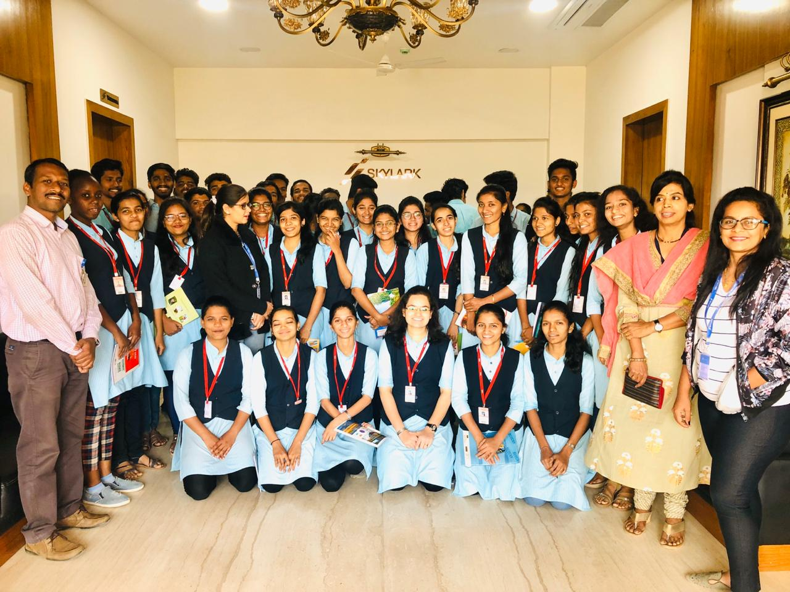

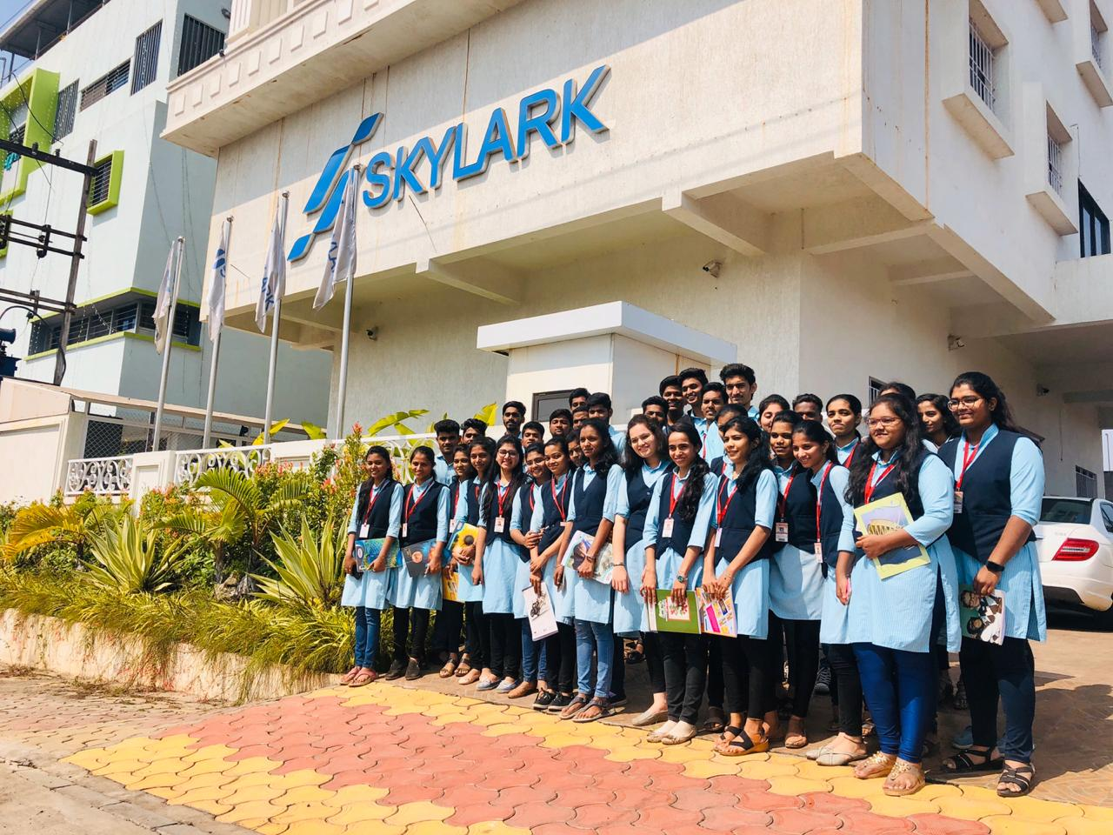

**Conclusion**

This study tour provided real life experience to understand our practical knowledge and use of latest technologies in better way. It helps us to know different services provided by company and system used in companies networking infrastructure. We also got information about company’s working system and facilities provided to their employees. We gained lot of real life experience about how the services are implemented and actual working by staff to run the system.

Skylark Global BPO Services Pvt. Ltd. has its own training centre. The Skylark Global BPO Services Pvt. Ltd. Employees plays an important role of providing services on their own base in India. Company also performs their testing process. The co-ordination between employees is well established and they have perfection in their particular fields.

Skylark Global BPO Services Pvt. Ltd. has real life embedded system working procedure through networking system in whole company. All the units are connected by computerized system in company using network.