1) Create new collection and map the API's in the same folder
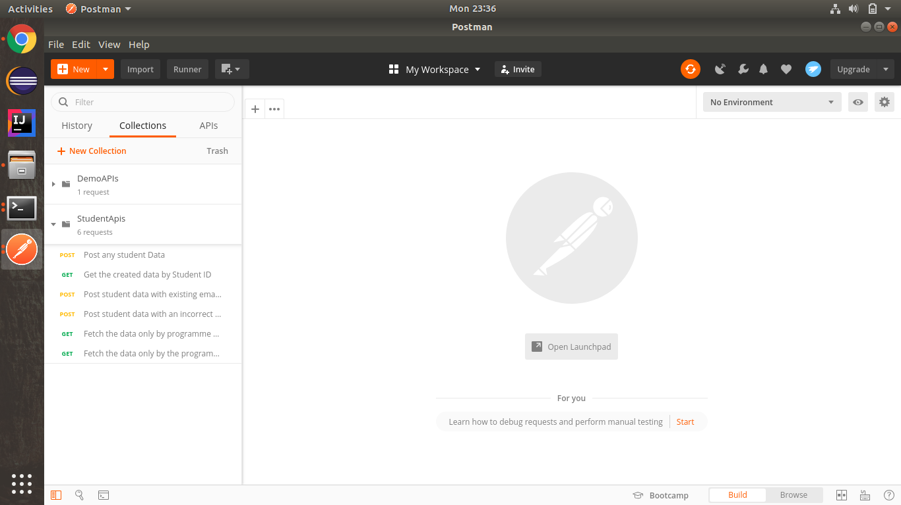

2) Post any student Data and get the created data by Student ID
Post : http://localhost:8080/student/
Body :
{
"id": 101,
"firstName": "Tushar",
"lastName": "Bansal",
"email": "tushar@ttn.com",
"programme": "BootCamp",
"courses": ["Java", "Selenium"]
}

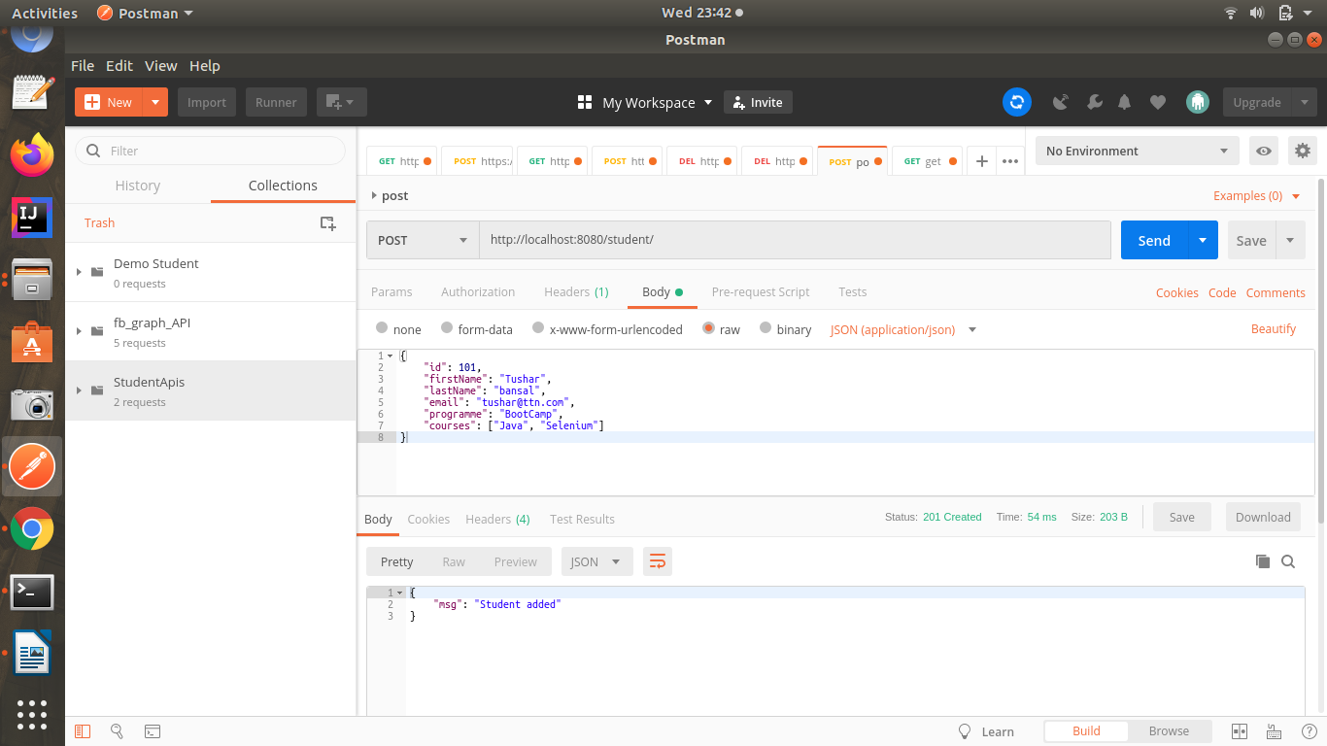
Get : http://localhost:8080/student/101

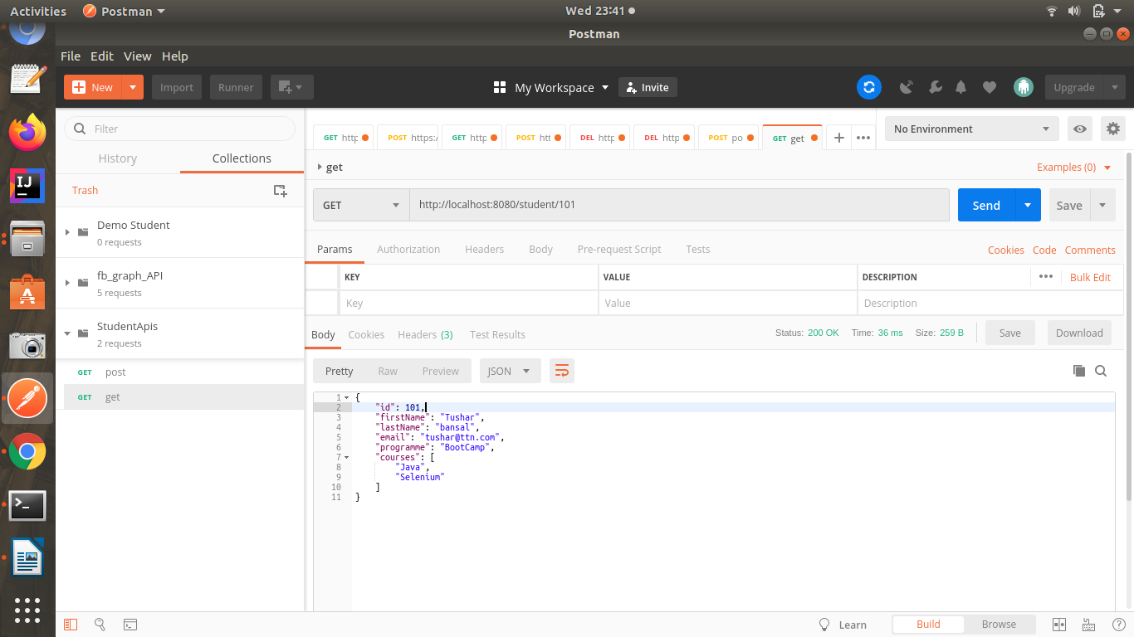
3) Fetch the data only by programme "Financial Analysis"
Get : http://localhost:8080/student/?programme=Financial Analysis
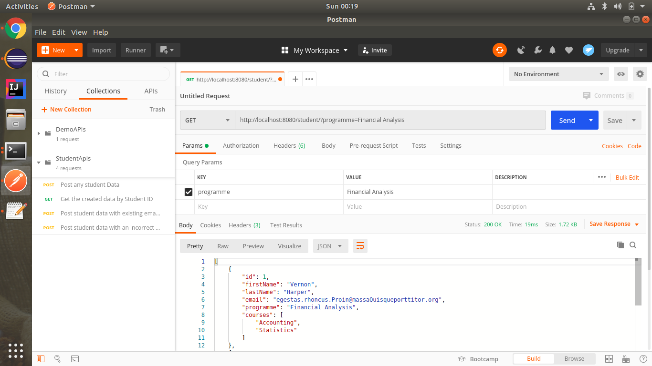
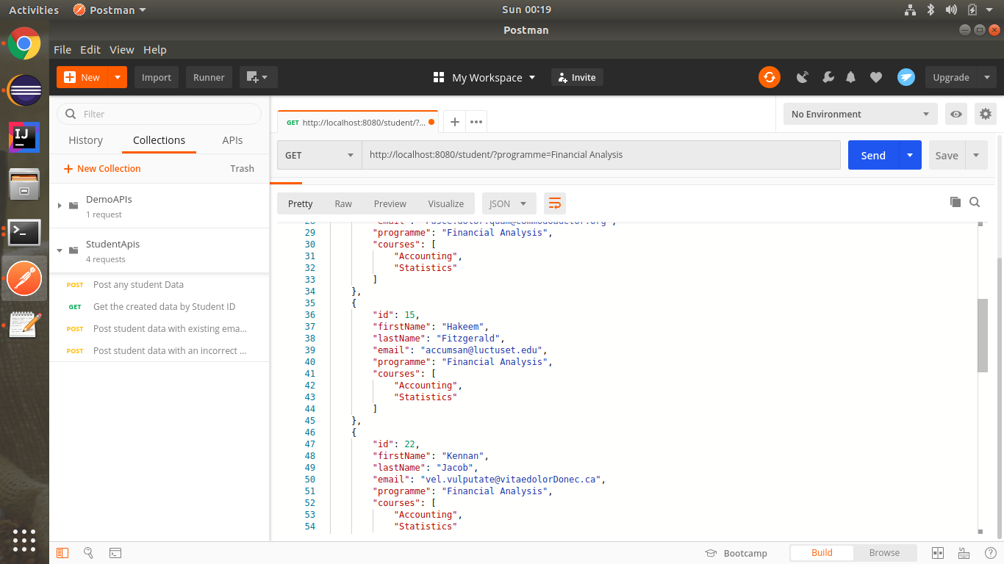

4) Post student data with existing email Id and check for the error message. Mention the test script.
Post : http://localhost:8080/student/
Body :
{
"id": 102,
"firstName": "Anubhav",
"lastName": "Kumar",
"email": "mohit@ttn.com",
"programme": "BootCamp",
"courses": ["Java", "Selenium"]
}
Test :
tests["Check for error message"] = responseBody.has("error");
tests["Check for Status"] = responseCode.code === 500;

Output :-
Body :
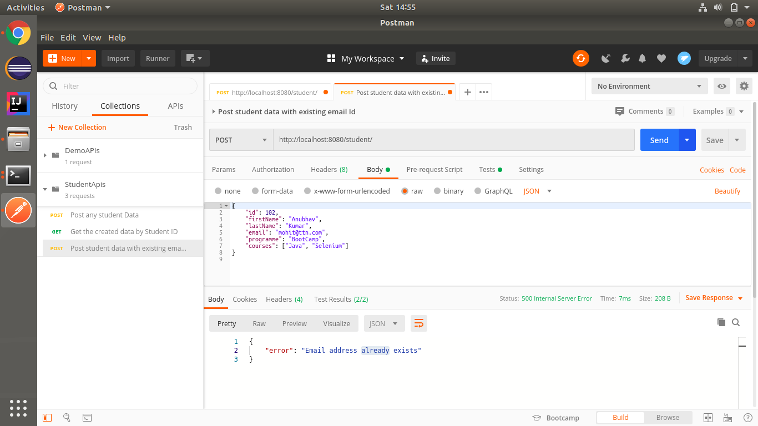
Test :
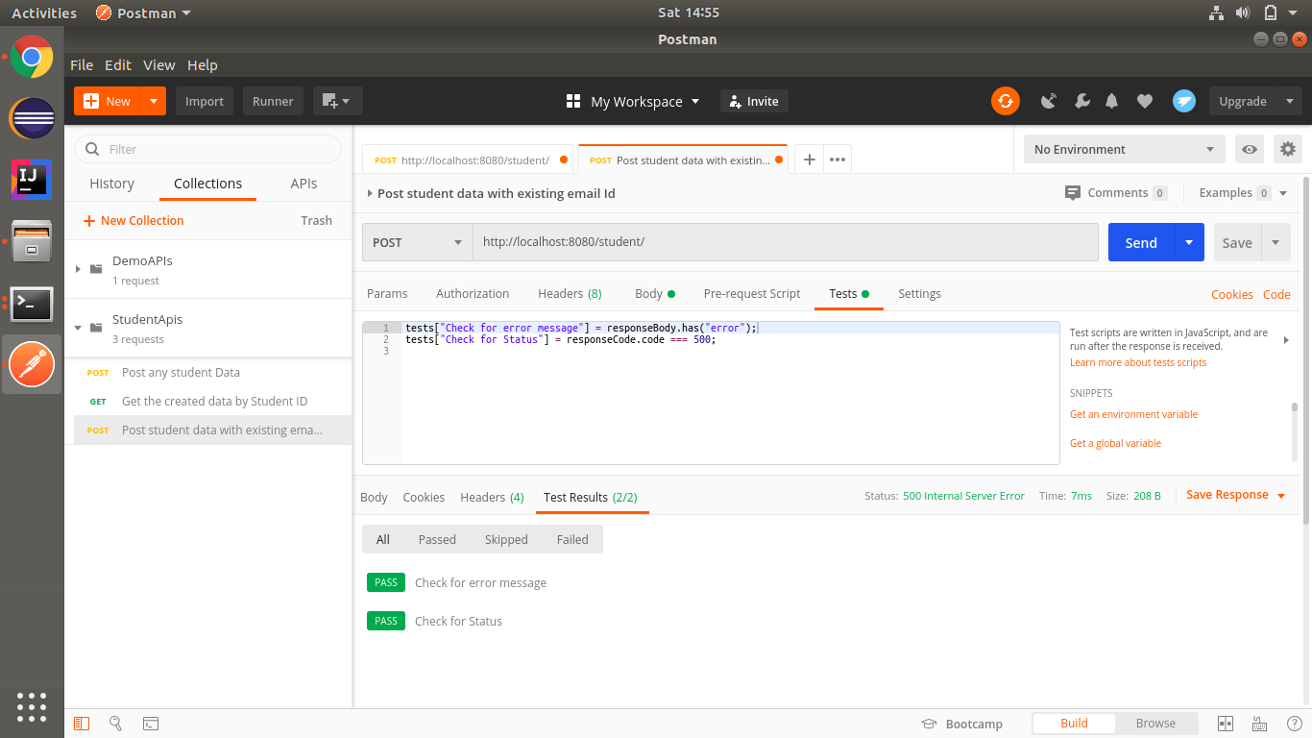

5) Post student data with an incorrect format of email Id and check for the error message. Mention the test script.

Post : http://localhost:8080/student/
Body :
{
"id": 102,
"firstName": "Anubhav",
"lastName": "Kumar",
"email": "abcxyz",
"programme": "BootCamp",
"courses": ["Java", "Selenium"]
}
Tests:
tests["Check for error message"] = responseBody.has("error");
tests["Check for field error message"] = responseBody.has("fieldErrors");
tests["Check for Status"] = responseCode.code === 500;

Output :-
Body :
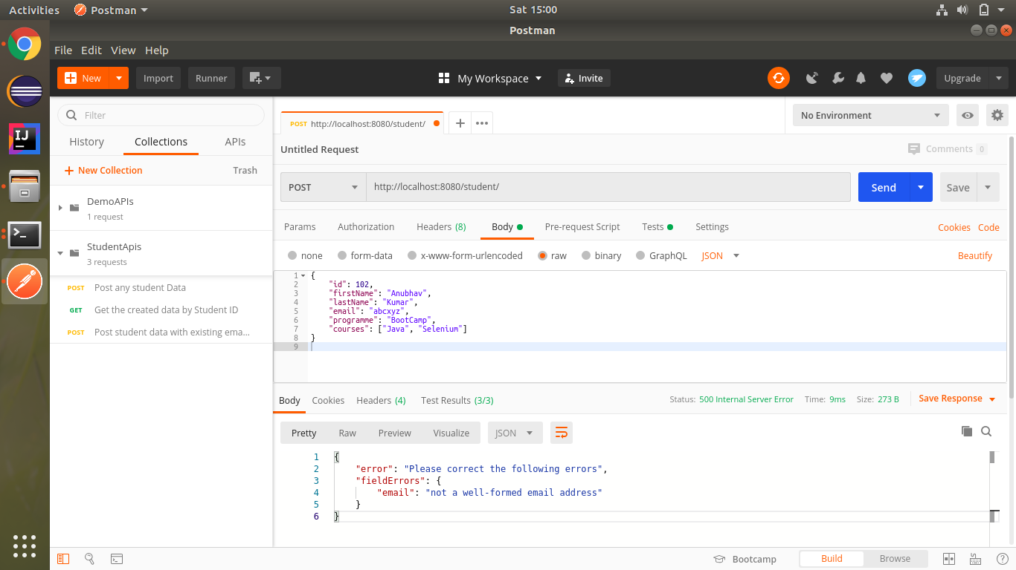
Test :
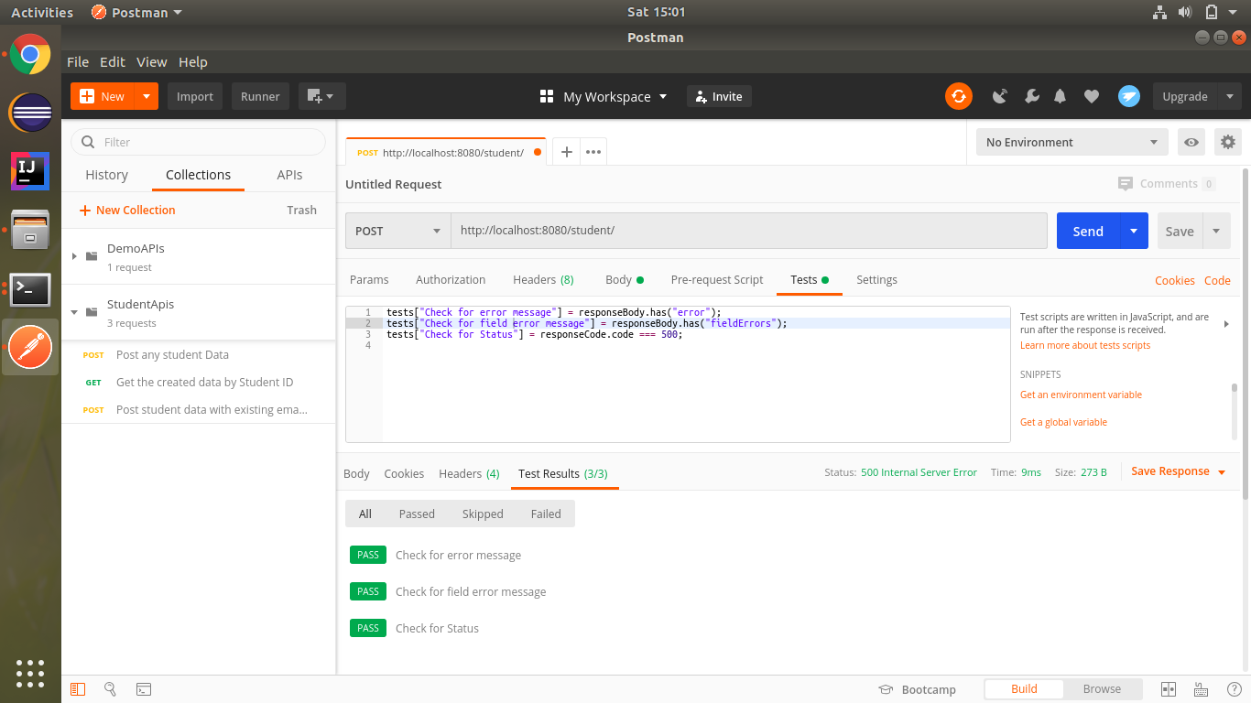

6) Fetch the data only by the programme "Computer Science" and " Criminology". Mention the test script
Get : http://localhost:8080/student/?programme=Computer Science&Programme=Criminology
Tests :
pm.test("Not contains error",function(){
pm.response.to.not.be.error;
});
pm.test("Check for status", function(){
pm.response.to.have.status(200);
});
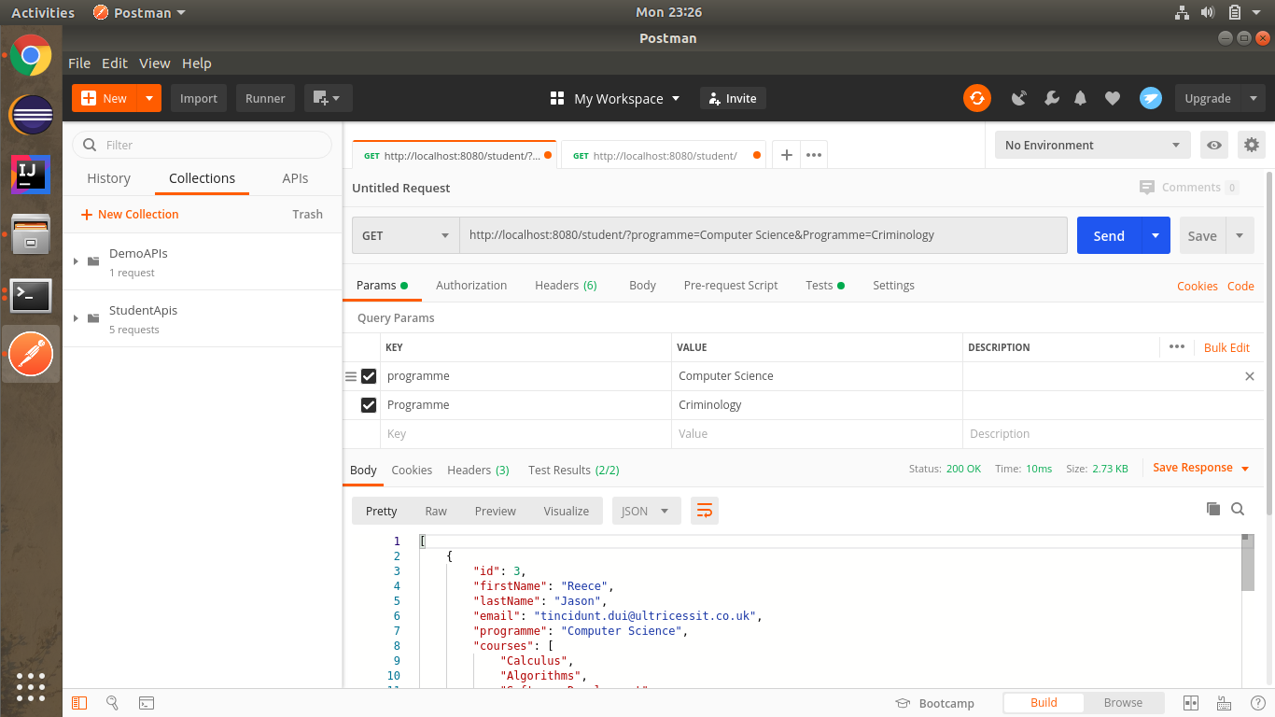
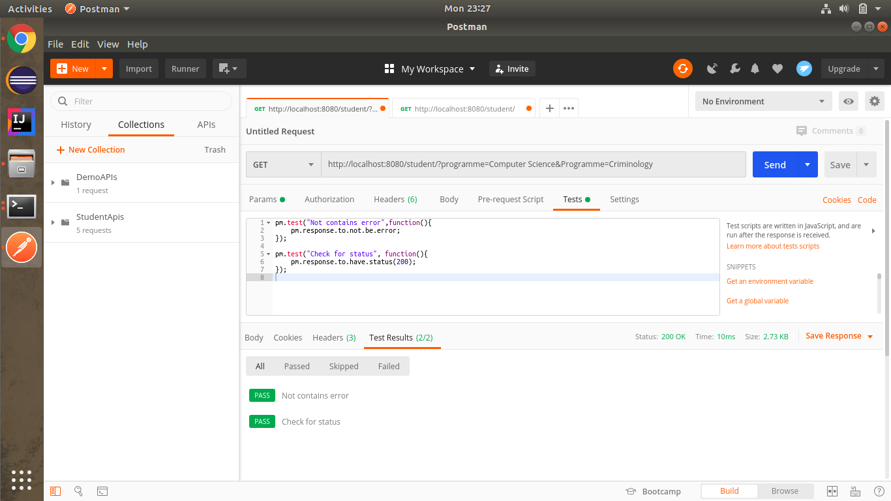

7) Run all the above cases and generate the report.
