Chapter 1: Introduction to Artificial Intelligence
- Artificial Intelligence
- The foundation of Artificial Intelligence
- History of Artificial Intelligence
- The state of Art
- Agents and environments
- Good behavior: The concept of rationality
- The nature of environments
- The structure of agents

Introduction to Artificial Intelligence

Artificial Intelligence (AI) is one of the hottest topics in the tech industry right now. It has been around for decades, but recent advances in machine learning and deep learning have brought AI back into the mainstream. AI is a field of computer science that aims to create intelligent machines that can perform tasks that normally require human intelligence. These tasks can range from recognizing speech to playing chess. AI has the potential to revolutionize the way we live and work, but it also raises some important ethical questions.
Here are some key points to understand about AI:
- AI is not a single technology or technique. It is a broad field that encompasses many different subfields, such as machine learning, natural language processing, and
computer vision. Each of these subfields has its own set of techniques and algorithms
that are used to create intelligent machines.
- Machine learning is one of the most important subfields of AI. It is a method of teaching computers to learn from data, without being explicitly programmed. For example, a machine learning algorithm could be trained on a large dataset of images, and then used to recognize objects in new images.
- Deep learning is a type of machine learning that uses artificial neural networks to
model complex patterns in data. These neural networks are inspired by the structure of the human brain, and are capable of learning and adapting to new data.
- AI has many practical applications, such as self-driving cars, voice assistants, and
fraud detection systems. These applications are already having a significant impact on various industries, and are expected to become even more widespread in the coming years.
- There are also some important ethical questions surrounding AI. For example, how can we ensure that AI systems are fair and unbiased? How can we prevent AI from
being used for malicious purposes? These questions are still being debated by researchers and policymakers.

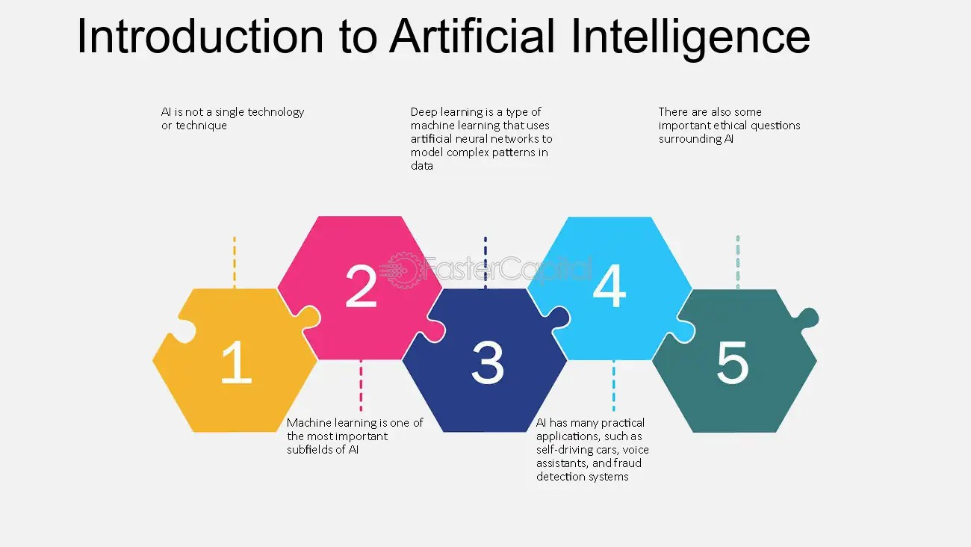

Introduction to Artificial Intelligence - Artificial intelligence: Base i: The Foundation of Artificial Intelligence

Advantages:
Reduction in Human Error
One of the biggest achievements of Artificial Intelligence is that it can reduce human error. Unlike humans, a computer machine can't make mistakes if programmed correctly, while humans make mistakes from time to time. Therefore, Artificial Intelligence uses some set of algorithms by gathering previously stored data, reducing the chances of error and increasing the accuracy and precision of any task. Hence, Artificial Intelligence helps to solve complex problems that require difficult calculations and can be done without any error.
Reduce the Risk (Zero Risk)
It is also one of the biggest advantages of Artificial Intelligence. The technology of developing AI Robots can overcome many risky limitations of humans and do risky things for us such as defusing a bomb, oil and coal mining and exploring the deepest part of the ocean, etc. So, it helps in any worst situation, either human or natural disasters too. AI Robots can be used in such situations where intervention can be hazardous.
24/7 Support
Unlike humans, a computer does not require breaks and refreshers. A normal human can continue work till 8-9 hours, including breaks and refreshers, while a computer machine can work 24x7 without any breaks and don't even get bored, unlike humans. Chatbots and helpline centres can be seen as the best example of 24/7 support of various websites continuously engaged in receiving customers queries and automatically resolved by Artificial Intelligence.
Perform Repetitive Jobs
We perform so many repetitive works in our day-to-day life, such as automatic replies to emails, sending birthday and anniversary quotes and verifying documents, etc. Therefore, Artificial Intelligence (AI) helps to automate the business by performing these repetitive jobs.
Faster decision
Unlike humans, a machine helps to take decisions faster than a human and carry out actions quicker. While taking a decision, humans analyze many factors while the machine works on what it is programmed and delivers the results faster. The best example of the faster decision can be seen in an online chess game in the third level. It is impossible to beat a computer machine because it takes the best possible step in a very short time, according to the algorithms used behind it.
New Inventions
For new inventions, AI is helping humans almost in each sector, it can be healthcare, medical, educational, sports, technology, entertainment or research industry etc. Using advanced AI-based technologies, doctors can predict various dangerous diseases like cancer at a very early stage.
Challenges in AI:
Technical Challenges in AI
These challenges deal with the technical hurdles we face in developing advanced AI systems:
1. Handling Complex Tasks
Current AI struggles with tasks requiring common sense reasoning. Imagine an AI trying to understand a joke or navigate a crowded sidewalk. These situations involve real-world complexities that AI models often lack the ability to process.
Example: A self-driving car encountering an unexpected obstacle like a child playing in the street. The car might struggle to react appropriately without the ability to understand the situation’s.

2. Scalability and Efficiency
Training powerful AI models often requires massive amounts of data and computing resources. This can be expensive and time-consuming, making it difficult to deploy AI solutions in real-world applications.
Example: Training a large language model like me on a massive dataset of text and code requires significant computing power, which can be a barrier for smaller companies or research institutions.
3. Interoperability
There’s no universal standard for AI development. Different AI platforms may have different formats or structures for data and models. This makes it difficult to share information and collaborate across different AI systems.
Example: Imagine an AI healthcare system developed by one company being incompatible with another company’s system, hindering the sharing of patient data for better diagnosis.
Social and Economic Challenges in AI
These challenges address the broader societal impacts of AI:
1. Impact on Jobs
AI automation is likely to replace many jobs currently done by humans, potentially leading to widespread unemployment and economic disruption.
Example: Automation in factories could lead to job losses for assembly line workers.
2. Widening Inequality
Access to AI could exacerbate existing social and economic inequalities. Those with access to powerful AI technology could become even more powerful, while those without access could be left behind.
Example: Wealthy companies might leverage AI for further automation and profit, while smaller businesses struggle to keep up.
3. Need for New Regulations
As AI becomes more sophisticated, we need to develop new regulations and policies to govern its development and use. These policies might address issues like bias, privacy, and safety.
Example: Regulations on how AI can be used in facial recognition software to ensure it doesn’t infringe on people’s privacy.

The Foundation of AI
Artificial Intelligence has become a buzzword in the technological world, with the
potential to transform the way we live and work. The foundation of AI lies in the Base, which refers to the fundamental building blocks that make up the technology. These
building blocks include machine learning, natural language processing, computer
vision, and robotics, among others. Together, these components form the backbone of AI, allowing machines to learn, adapt, and improve over time.
  - machine learning: Machine learning is a subset of AI that focuses on the
development of algorithms that enable machines to learn from data and make predictions or decisions without being explicitly programmed. For instance, an e- commerce platform uses machine learning algorithms to recommend products to customers based on their browsing history, purchases, and search history.
  - Natural Language Processing: Natural Language Processing (NLP) refers to the ability of machines to understand, interpret, and generate human language. NLP is essential for chatbots, virtual assistants, and voice recognition systems that allow users to interact with machines using natural language.
  - computer vision: Computer Vision involves training machines to interpret and understand visual data from the world around them. With computer vision, machines can recognize objects, faces, and even emotions, which is critical for applications such as facial recognition, surveillance, and self-driving cars.
  - Robotics: Robotics is the application of AI in the development of robots that can
perform tasks autonomously. This includes everything from industrial robots used in manufacturing to autonomous drones and self-driving cars.
AI has the potential to transform industries and solve some of the world's most
pressing problems. For instance, AI can help in the diagnosis and treatment of diseases, reduce carbon emissions, and improve crop yields. However, the success of AI depends on the strength of the Base i, which requires continued investment in research and
development.

- History of Artificial Intelligence: read from separate ppt

- Agents in Artificial Intelligence
An AI system can be defined as the study of the rational agent and its environment. The agents sense the environment through sensors and act on their environment through actuators. An AI agent can have mental properties such as knowledge, belief, intention, etc.
What are Agent and Environment?
An agent is anything that can perceive its environment through sensors and acts upon that environment through effectors.
A human agent has sensory organs such as eyes, ears, nose, tongue and skin parallel to the sensors, and other organs such as hands, legs, mouth, for effectors.
A robotic agent replaces cameras and infrared range finders for the sensors, and various motors and actuators for effectors.
A software agent has encoded bit strings as its programs and actions.

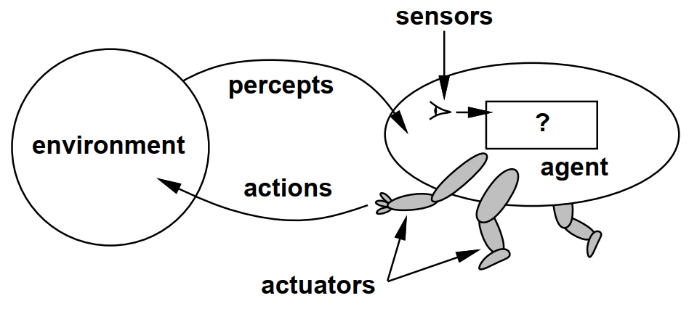
Agent Terminology
- Performance Measure of Agent − It is the criteria, which determines how successful an agent is.
- Behavior of Agent − It is the action that agent performs after any given sequence of percepts.
- Percept − It is agent’s perceptual inputs at a given instance.
- Percept Sequence − It is the history of all that an agent has perceived till date.
- Agent Function − It is a map from the precept sequence to an action.

The Structure of Intelligent Agents
- Agent’s structure can be viewed as −
- Agent = Architecture + Agent Program
- Architecture = the machinery that an agent executes on.
- Agent Program = an implementation of an agent function.
Example: The vacuum-cleaner world
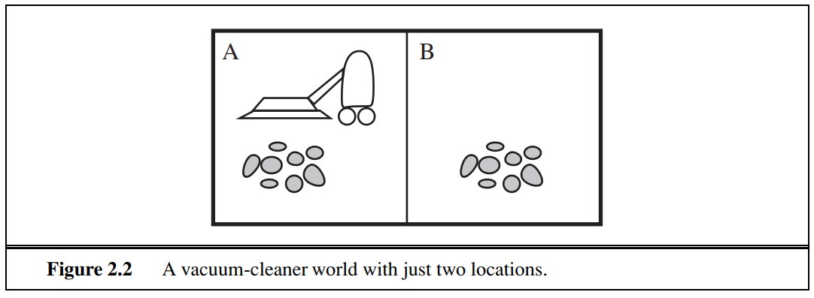
- Percepts: location and contents, e.g., [A, Dirty]
- Actions: Left, Right, Suck, NoOp
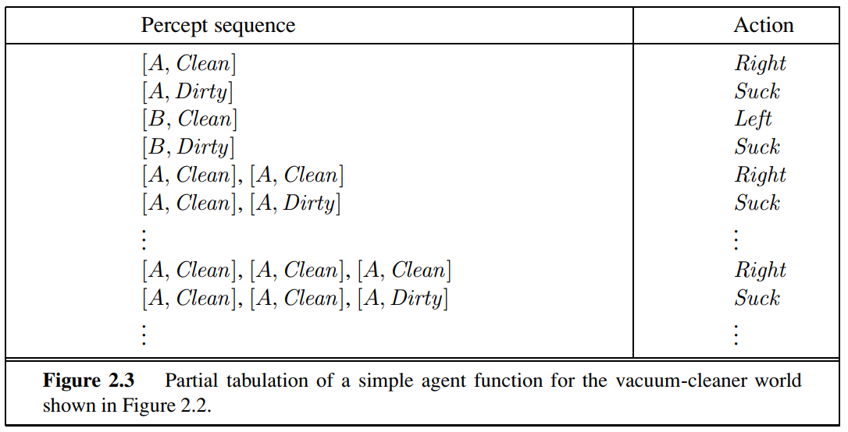

Good behavior: The concept of rationality
Rationality is nothing but status of being reasonable, sensible, and having good sense of judgment.
Rationality is concerned with expected actions and results depending upon what the agent has perceived. Performing actions with the aim of obtaining useful information is an important part of rationality.
What is Ideal Rational Agent?
An ideal rational agent is the one, which is capable of doing expected actions to maximize its performance measure, on the basis of −
- Its percept sequence
- Its built-in knowledge base
Rationality of an agent depends on the following −
- The performance measures, which determine the degree of success.
- Agent’s Percept Sequence till now.
- The agent’s prior knowledge about the environment.
- The actions that the agent can carry out.
A rational agent always performs right action, where the right action means the action that causes the agent to be most successful in the given percept sequence. The problem the agent solves is characterized by Performance Measure, Environment, Actuators, and Sensors (PEAS).
Task Environment : Which are essentially the “problems” to which rational agents are the “solutions.”
Use PEAS to describe task environment
- Performance measure
- Environment
- Actuators
- Sensors
Example: Taxi driver
Performance measure: safe, fast, comfortable (maximize profits)
Environment: roads, other traffic, pedestrians, customers
Actuators: steering, accelerator, brake, signal, horn
Sensors: cameras, sonar, speedometer, GPS, odometer, accelerometer, engine sensors

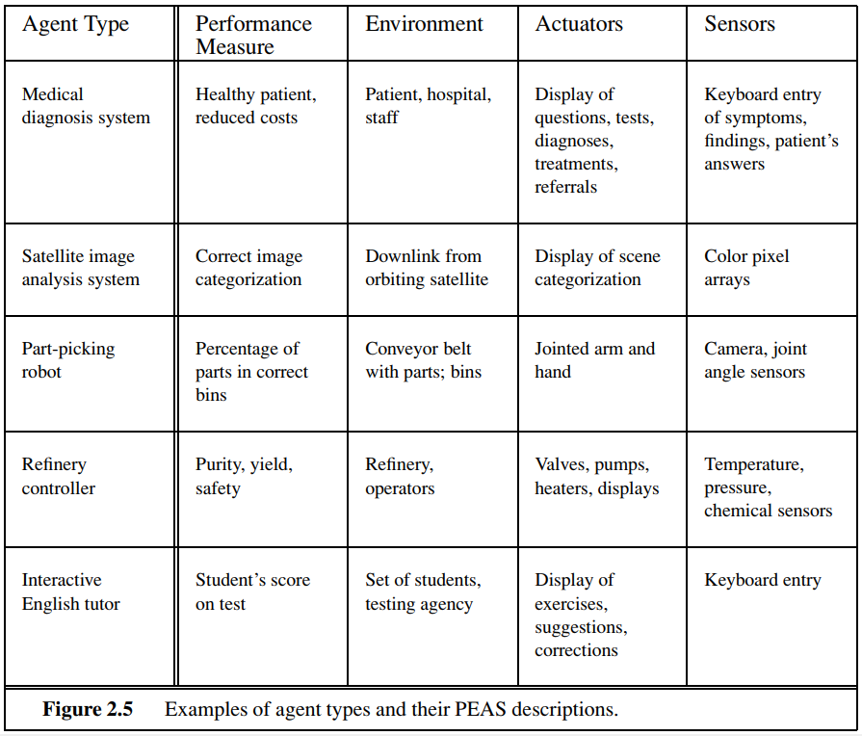
Types of Agents
- Simple Reflex Agents
- Model Based Reflex Agents
- Goal Based Agents
- Utility Based Agents
- Learning Agent

- Simple Reflex Agents
A Simple Reflex Agent is a type of AI agent that only uses current data and it ignores any past data. It uses a set of condition-action rules coded into the system to make its decision or take any action. They are rational only if a correct decision is made only on the basis of current precept.
Their environment is completely observable.
Condition-Action Rule − It is a rule that maps a state (condition) to an action.
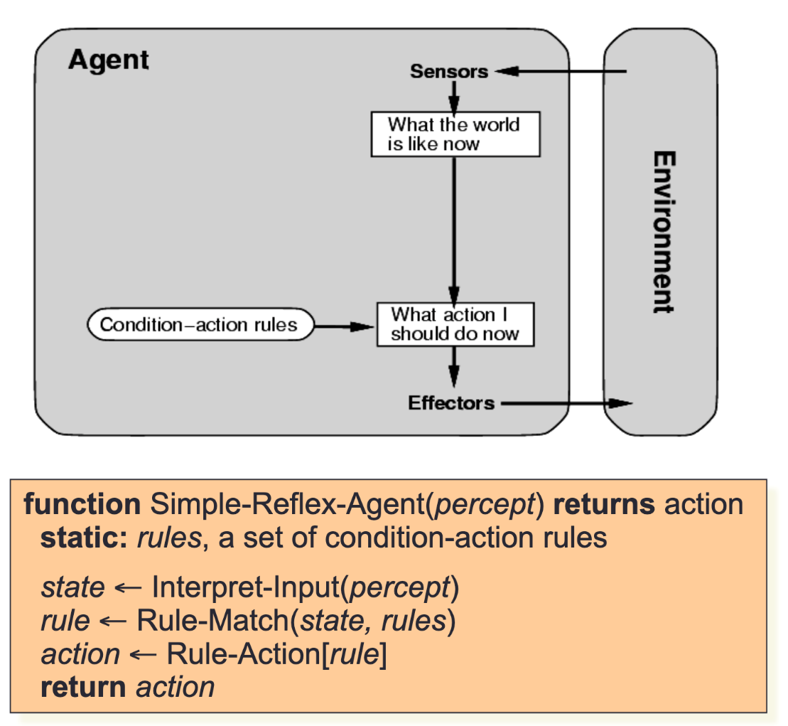
Example: The vacuum agent is a simple reflex agent because the decision is based only on the current location, and whether the place contains dirt.

Pros and Cons of using Simple reflex agents:
Pros:
- Easy to design
- Easy to implement for specific tasks.
- Responses quickly to any stimuli without complex processing.
Cons:
- Limited Flexibility: Unable to handle unexpected or unprogrammed situations.
- Lack of Context: Does not consider past interactions, leading to potentially suboptimal decisions.

- Model Based Reflex Agents
Model-based reflex agents use the current state of the world & the internal model of that world, to decide on the best action. It partially observes the external environment by maintaining an internal environment.
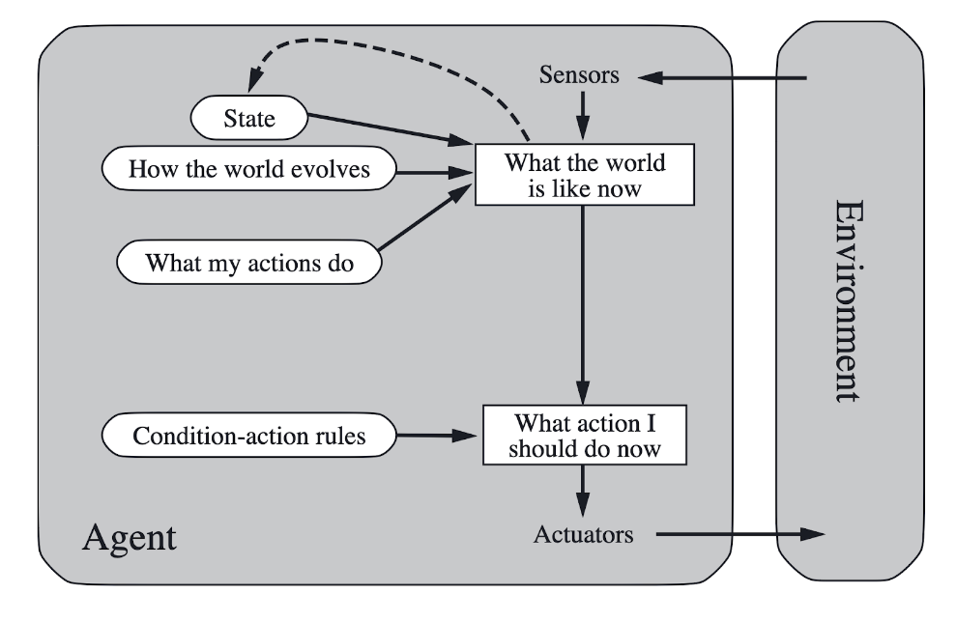
Example of a thermostat which regulates the house temperature. It compares the inner house temperature (environment) with the temperature set by the user (internal environment) to identify whether it should turn heating/cooling on or off (action).
Model-based reflex agents are useful in environments where complete information isn’t available, and some form of history or state needs to be considered. They're effective in applications like autocorrect where it adjusts based on the user's typing habits.
Pros and Cons of using model based reflex agents
Pros:
- You can adjust actions based on changes in the environment.
- It uses an internal model to make informed decisions, even with incomplete information.
Cons:
- Complex to design and implement than simple reflex agents.
- The internal model may need regular updates.

- Goal Based Agents
Goal-based agents act to achieve specific goals, using the model of the world to consider the future consequences of their actions. They choose actions that lead them closer to their predefined goals.
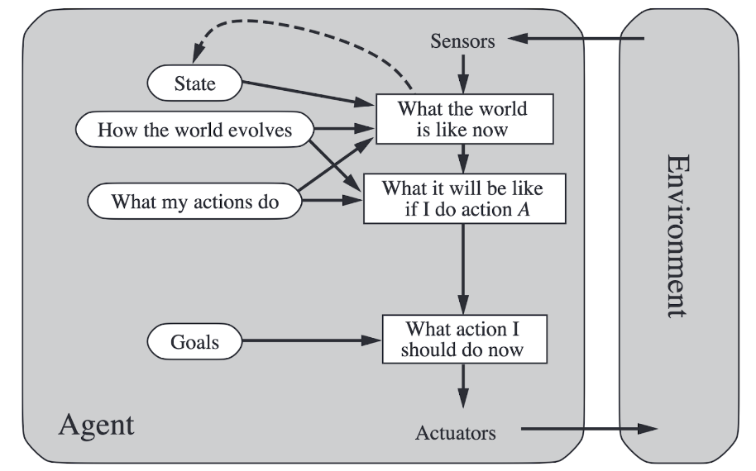
Example: Imagine a goal-based agent as a GPS navigation system. Given a destination (goal), it evaluates various routes (actions) using its world model (maps and traffic conditions) to recommend the fastest or shortest path, adjusting as conditions change.
Goal-based agents are ideal for complex planning and decision-making tasks where achieving a specific outcome is the priority. They're used in strategic game playing, automated planning in logistics, and resource allocation in project management, where considering future steps towards a goal is essential.
Pros and Cons of using goal-based agents
Pros:
- It is capable of adapting to achieve goals under changing conditions.
- It considers future consequences of actions, leading to more strategic decision-making.
Cons:
- It requires more processing power for planning and evaluating potential actions.
- It is focused on goal achievement, which may not always align with the best overall outcome.

- Utility Based Agents
Utility-based agents aim not just to achieve goals but to maximize a measure of satisfaction or happiness, known as utility. They evaluate the potential utility of different states and choose actions that maximize this utility.
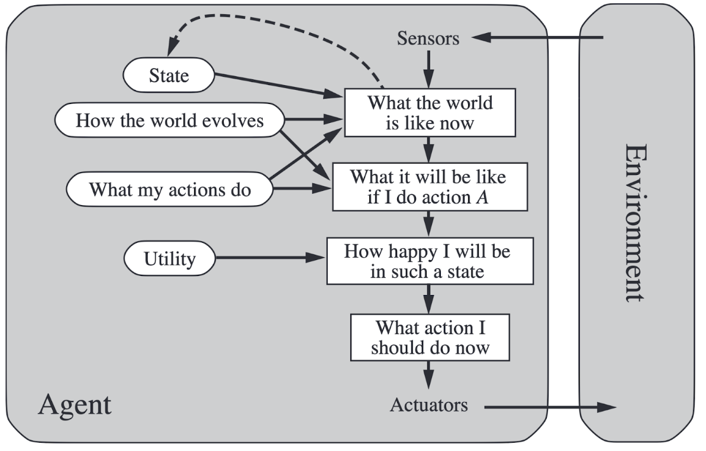
Example: Think of a utility-based agent as a savvy investor. Given various investment options (states), the investor evaluates each based on potential returns and risks (utility), aiming to maximize overall portfolio satisfaction rather than just achieving a set financial goal.
Utility-based agents are useful in scenarios requiring optimization among various competing criteria or preferences. They excel in financial analysis, complex resource management, and personalized recommendation systems where the best outcome depends on maximizing certain metrics.
Pros and Cons of using utility based agents
Pros:
- It focuses on maximizing satisfaction, leading to potentially better overall outcomes.
- It considers a broader range of factors, leading to more nuanced decision-making.
Cons:
- Determining and quantifying utility can be challenging.
- Evaluating and comparing utilities for different actions can be resource-intensive.

- Learning Agent
Learning agents improve their performance and adapt to new circumstances over time. They can modify their behavior based on past experiences and feedback, learning from the environment to make better decisions.
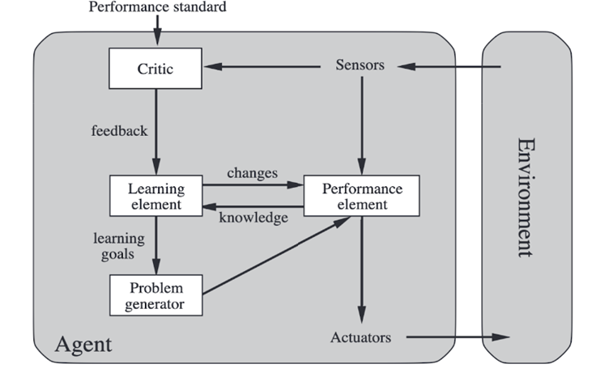
Learning AI agent
Example: Consider a learning agent as a student mastering a subject. With each lesson, homework, and test (experiences and feedback), the student (agent) learns and adjusts study habits (behavior) to improve grades (performance) over time.
Learning agents are pivotal in dynamic environments where conditions constantly change, or in tasks where human expertise and intuition are difficult to codify. They're employed in adaptive systems such as personalized learning platforms, market trend analysis tools, and evolving security systems that adapt to new threats.
Pros and Cons of using learning agents
Pros:
- It continuously improves and adapts to new information.
- It learns from experiences, reducing the need for extensive programming for all possible scenarios.
Cons:
- It may perform sub optimally during the initial learning phase.
- The learning processes can lead to unexpected behaviors, requiring safeguards and monitoring.

The Nature of Environments
Some programs operate in the entirely artificial environment confined to keyboard input, database, computer file systems and character output on a screen.
In contrast, some software agents (software robots or softbots) exist in rich, unlimited softbots domains. The simulator has a very detailed, complex environment. The software agent needs to choose from a long array of actions in real time. A softbot designed to scan the online preferences of the customer and show interesting items to the customer works in the real as well as an artificial environment.
The most famous artificial environment is the Turing Test environment, in which one real and other artificial agents are tested on equal ground. This is a very challenging environment as it is highly difficult for a software agent to perform as well as a human.
Turing Test
The success of an intelligent behavior of a system can be measured with Turing Test.
Two persons and a machine to be evaluated participate in the test. Out of the two persons, one plays the role of the tester. Each of them sits in different rooms. The tester is unaware of who is machine and who is a human. He interrogates the questions by typing and sending them to both intelligences, to which he receives typed responses.
This test aims at fooling the tester. If the tester fails to determine machine’s response from the human response, then the machine is said to be intelligent.
Properties of Environment
The environment has multifold properties −
- Discrete / Continuous − If there are a limited number of distinct, clearly defined, states of the environment, the environment is discrete (For example, chess); otherwise it is continuous (For example, driving).
- Observable / Partially Observable − If it is possible to determine the complete state of the environment at each time point from the percepts it is observable; otherwise it is only partially observable.
- Static / Dynamic − If the environment does not change while an agent is acting, then it is static; otherwise it is dynamic.
- Single agent / Multiple agents − The environment may contain other agents which may be of the same or different kind as that of the agent.
- Accessible / Inaccessible − If the agent’s sensory apparatus can have access to the complete state of the environment, then the environment is accessible to that agent.
- Deterministic / Non-deterministic − If the next state of the environment is completely determined by the current state and the actions of the agent, then the environment is deterministic; otherwise it is non-deterministic.
- Episodic / Non-episodic − In an episodic environment, each episode consists of the agent perceiving and then acting. The quality of its action depends just on the episode itself. Subsequent episodes do not depend on the actions in the previous episodes. Episodic environments are much simpler because the agent does not need to think ahead.
 | Fully vs Partially Observable | Deterministic vs Stochastic | Episodic vs Sequential | Static vs Dynamic | Discrete vs Continuous | Single vs Multi Agents
Brushing Your Teeth | Fully | Stochastic | Sequential | Static | Continuous | Single
Playing Chess | Partially | Stochastic | Sequential | Dynamic | Continuous | Multi-Agent
Playing Cards | Partially | Stochastic | Sequential | Dynamic | Continuous | Multi-Agent
Playing | Partially | Stochastic | Sequential | Dynamic | Continuou | Multi Agent
Autonomous Vehicles | Fully | Stochastic | Sequential | Dynamic | Continuous | Multi-Agent
Order in Restaurant | Fully | Deterministic | Episodic | Static | Discrete | Single Agent
