Chapter 2: Solving Problems by Searching

Problem-solving agents: Uninformed search strategy, Informed search strategy, Heuristic Functions

Local search algorithms and optimization problems,

Local search in continuous space

searching with non-deterministic approach, Searching with partial observations, Online search agents and unknown environments.

Games, Optimal decisions in games

Alpha-beta pruning

Imperfect real life decisions, Stochastic games, Partially observable games, Alternative approaches

Problem-solving agents
The reflex agents are known as the simplest agents because they directly map states into actions. Unfortunately, these agents fail to operate in an environment where the mapping is too large to store and learn. Goal-based agent, on the other hand, considers future actions and the desired outcomes.
Here, we will discuss one type of goal-based agent known as a problem-solving agent, which uses atomic representation with no internal states visible to the problem-solving algorithms.

The problem-solving agent perfoms precisely by defining problems and its several solutions.
- According to psychology, “a problem-solving refers to a state where we wish to reach to a definite goal from a present state or condition.”
- According to computer science, a problem-solving is a part of artificial intelligence which encompasses a number of techniques such as algorithms, heuristics to solve a problem.
Therefore, a problem-solving agent is a goal-driven agent and focuses on satisfying the goal.

Example: self-driving cars.
Types of Problems in AI
In AI, problems are classified based on their characteristics and how they affect the problem-solving process. Understanding these types helps in designing effective problem-solving agents.
- Classification Criteria: AI problems can be categorized into three main types:
- Ignorable Problems: Problems where certain steps can be disregarded without impacting the outcome.
- Recoverable Problems: Problems where mistakes can be corrected or undone.
- Irrecoverable Problems: Problems where actions are permanent, requiring careful planning.
Each type has unique implications for AI agent design and strategy.
1. Ignorable Problems
Definition: These are problems where certain solution steps can be skipped or ignored without affecting the overall outcome.
Characteristics: Simpler problem structure, Lesser computational resources required.
Examples: Optimization tasks where some variables have negligible impact, like tuning hyperparameters in a machine learning model.
2. Recoverable Problems
Definition: Problems where agents can undo or correct their actions, allowing flexibility in the problem-solving process.
Characteristics: Reversible actions, Lower risk compared to irrecoverable problems.
Examples: Decision-making in game-playing AI, where moves can be adjusted based on opponent actions.
3. Irrecoverable Problems
Definition: Problems where actions are irreversible, making careful planning critical.
Characteristics: High-risk problem-solving, Requires precise execution.
Examples:
Autonomous vehicle navigation, where a wrong action (e.g., crossing a red light) can lead to permanent consequences.

Steps in Problem Solving in Artificial Intelligence (AI)
Problem-solving in AI involves a systematic process where agents identify a challenge, develop strategies, and execute solutions to achieve a goal. Below are the key steps:
1. Problem Identification
What It Is: Recognizing and defining the problem within the environment.
Example: An AI assistant identifying a user request, such as booking a flight or finding a nearby restaurant.
2. Formulating the Problem
What It Is: Structuring the problem in a way the AI agent can understand and solve, often using state-space representation.
Example: Representing a chessboard as a state space, where each move changes the state.
3. Strategy Formulation
What It Is: Developing a plan to navigate from the initial state to the goal state. This includes selecting appropriate algorithms or heuristics.
Example: Using A* search to find the shortest path in a navigation system.
4. Execution and Monitoring
What It Is: Implementing the chosen strategy while continuously monitoring its effectiveness.
Example: A robot vacuum executing a cleaning path and adjusting if it encounters obstacles.
5. Learning and Adaptation
What It Is: Learning from experiences to improve future problem-solving abilities. This often involves reinforcement learning or machine learning techniques.
Example: A self-driving car improving its route planning after encountering unexpected traffic patterns.

Components of Problem Formulation in AI
1. Initial State
What It Is: The starting point of the problem-solving process.
Example: In a chess game, the initial state is the standard arrangement of pieces on the board.
2. Actions
What It Is: The set of possible actions an AI agent can take to move from one state to another.
Example: In a navigation system, actions could include moving left, right, up, or down.
3. Transition Model
What It Is: A description of how actions change the current state into a new state.
Example: In a game, moving a pawn forward changes the board configuration.
4. Goal Test
What It Is: The criteria to determine whether the goal has been achieved.
Example: In a puzzle-solving task, the goal test checks if the puzzle pieces are arranged correctly.
5. Path Cost
What It Is: The cumulative cost associated with a sequence of actions leading to the goal.
Example: In a delivery system, the path cost could be the total distance traveled.

Example Problems
Basically, there are two types of problem approaches:

- Toy Problem: It is a concise and exact description of the problem which is used by the researchers to compare the performance of algorithms.
- Real-world Problem: It is real-world based problems which require solutions. Unlike a toy problem, it does not depend on descriptions, but we can have a general formulation of the problem.
Some Toy Problems
- 8 Puzzle Problem: Here, we have a 3×3 matrix with movable tiles numbered from 1 to 8 with a blank space. The tile adjacent to the blank space can slide into that space. The objective is to reach a specified goal state similar to the goal state, as shown in the below figure.
- In the figure, our task is to convert the current state into goal state by sliding digits into the blank space.
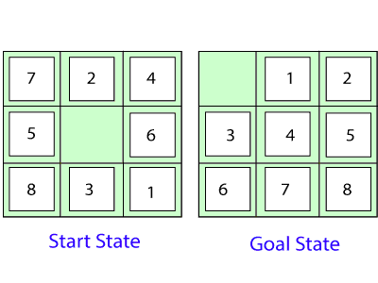

In the above figure, our task is to convert the current(Start) state into goal state by sliding digits into the blank space.

The problem formulation is as follows:

- States: It describes the location of each numbered tiles and the blank tile.
- Initial State: We can start from any state as the initial state.
- Actions: Here, actions of the blank space is defined, i.e., either left, right, up or down
- Transition Model: It returns the resulting state as per the given state and actions.
- Goal test: It identifies whether we have reached the correct goal-state.
- Path cost: The path cost is the number of steps in the path where the cost of each step is 1. Note: The 8-puzzle problem is a type of sliding-block problem which is used for testing new search algorithms in artificial intelligence.
- 8-queens problem: The aim of this problem is to place eight queens on a chessboard in an order where no queen may attack another. A queen can attack other queens either diagonally or in same row and column.
From the following figure, we can understand the problem as well as its correct solution.
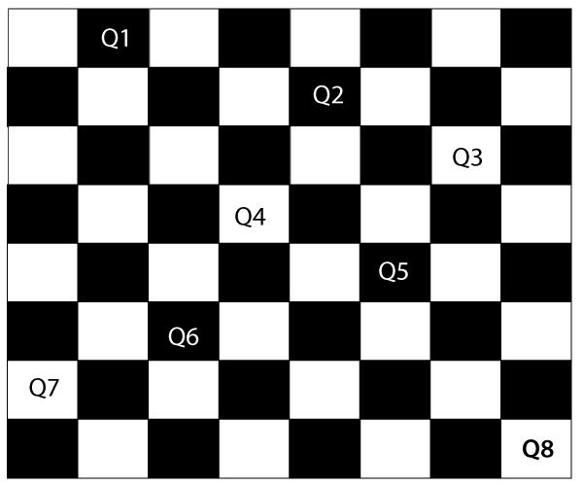

It is noticed from the above figure that each queen is set into the chessboard in a position where no other queen is placed diagonally, in same row or column. Therefore, it is one right approach to the 8-queens problem.

For this problem, there are two main kinds of formulation:

- Incremental formulation: It starts from an empty state where the operator augments a queen at each step.

Following steps are involved in this formulation:
  - States: Arrangement of any 0 to 8 queens on the chessboard.
  - Initial State: An empty chessboard
  - Actions: Add a queen to any empty box.
  - Transition model: Returns the chessboard with the queen added in a box.
  - Goal test: Checks whether 8-queens are placed on the chessboard without any attack.
  - Path cost: There is no need for path cost because only final states are counted. In this formulation, there is approximately 1.8 x 1014 possible sequence to investigate.
- Complete-state formulation: It starts with all the 8-queens on the chessboard and moves them around, saving from the attacks.

Following steps are involved in this formulation

  - States: Arrangement of all the 8 queens one per column with no queen attacking the other queen.
  - Actions: Move the queen at the location where it is safe from the attacks.
This formulation is better than the incremental formulation as it reduces the state space from 1.8 x 1014 to 2057, and it is easy to find the solutions.

Some Real-world problems
    - Traveling salesperson problem(TSP): It is a touring problem where the salesman can visit each city only once. The objective is to find the shortest tour and sell-out the stuff in each city.
    - VLSI Layout problem: In this problem, millions of components and connections are positioned on a chip in order to minimize the area, circuit-delays, stray-capacitances, and maximizing the manufacturing yield.

Searching for solutions

We have seen many problems. Now, there is a need to search for solutions to solve them. For solving different kinds of problem, an agent makes use of different strategies to reach the goal by searching the best possible algorithms. This process of searching is known as search strategy.

Techniques for Problem Solving in AI
AI agents use a variety of techniques to solve problems efficiently. These techniques include search algorithms, constraint satisfaction methods, optimization techniques, and machine learning approaches. Each is suited to specific problem types.
1. Search Algorithms
a. Uninformed Search
These algorithms explore the problem space without prior knowledge about the goal’s location.
Examples:
Breadth-First Search (BFS): Explores all nodes at one level before moving to the next.
Depth-First Search (DFS): Explores as far as possible along a branch before backtracking.
b. Informed Search
These algorithms use heuristics to guide the search process, making them more efficient.
Examples:
A Search:* Combines path cost and heuristic estimates to find the shortest path.
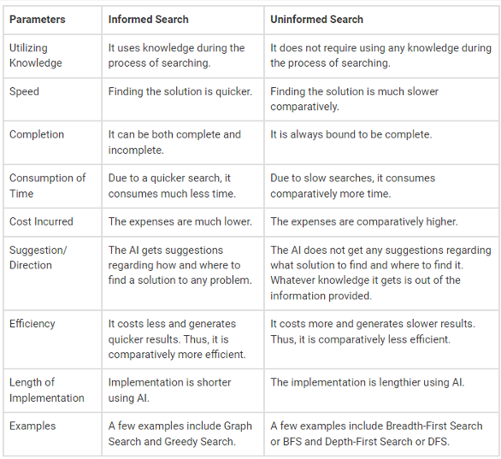

UNINFORMED SEARCH ALGORITHMS
Uninformed search is a class of general-purpose search algorithms which operates in brute force-way. Uninformed search algorithms do not have additional information about state or search space other than how to traverse the tree, so it is also called blind search.

Following are the various types of uninformed search algorithms:

- Breadth-first Search
- Depth-first Search
- Depth-limited Search
- Iterative deepening depth-first search
- Uniform cost search
- Bidirectional Search

BREADTH-FIRST SEARCH:
  - Breadth-first search is the most common search strategy for traversing a tree or graph. This algorithm searches breadthwise in a tree or graph, so it is called breadth-first search.
  - BFS algorithm starts searching from the root node of the tree and expands all successor node at the current level before moving to nodes of next level.
  - The breadth-first search algorithm is an example of a general-graph search algorithm.
  - Breadth-first search implemented using FIFO queue data structure.

Advantages:

  - BFS will provide a solution if any solution exists.
  - If there are more than one solutions for a given problem, then BFS will provide the minimal solution which requires the least number of steps.

Disadvantages:

  - It requires lots of memory since each level of the tree must be saved into memory to expand the next level.
  - BFS needs lots of time if the solution is far away from the root node.

Example:

In the below tree structure, we have shown the traversing of the tree using BFS algorithm from the root node S to goal node K. BFS search algorithm traverse in layers, so it will follow the path which is shown by the dotted arrow, and the traversed path will be:

1. S---> A--->B---->C--->D---->G--->H--->E---->F---->I >K
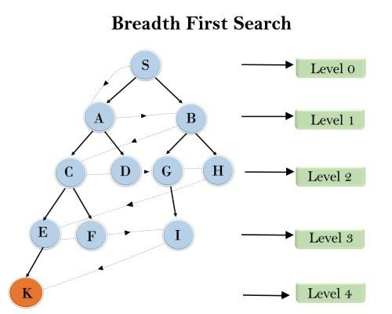

Time Complexity: Time Complexity of BFS algorithm can be obtained by the number of nodes traversed in BFS until the shallowest Node. Where the d= depth of shallowest solution and b is a node at every state.

T (b) = 1+b2+b3+. + bd= O (bd)
Space Complexity: Space complexity of BFS algorithm is given by the Memory size of frontier which is O(b^{d}).
Completeness: BFS is complete, which means if the shallowest goal node is at some finite depth, then BFS will find a solution.
Optimality: BFS is optimal if path cost is a non-decreasing function of the depth of the node.

DEPTH-FIRST SEARCH
  - Depth-first search isa recursive algorithm for traversing a tree or graph data structure.
  - It is called the depth-first search because it starts from the root node and follows each path to its greatest depth node before moving to the next path.
  - DFS uses a stack data structure for its implementation.
  - The process of the DFS algorithm is similar to the BFS algorithm.

Advantage:
  - DFS requires very less memory as it only needs to store a stack of the nodes on the path from root node to the current node.
  - It takes less time to reach to the goal node than BFS algorithm (if it traverses in the right path).

Disadvantage:
  - There is the possibility that many states keep re-occurring, and there is no guarantee of finding the solution.
  - DFS algorithm goes for deep down searching and sometime it may go to the infinite loop.
Example:
In the below search tree, we have shown the flow of depth-first search, and it will follow the order as:
Root node--->Left node > right node.
It will start searching from root node S, and traverse A, then B, then D and E, after traversing E, it will backtrack the tree as E has no other successor and still goal node is not found. After backtracking it will traverse node C and then G, and here it will terminate as it found goal node.
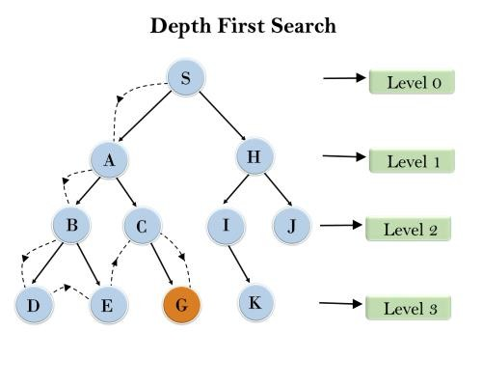

Time Complexity: Time complexity of DFS will be equivalent to the node traversed by the algorithm. It is given by:

T(n)= 1+ n2+ n3 +. + nm=O(nm)

Where, m= maximum depth of any node and this can be much larger than d (Shallowest solution depth)

Space Complexity: DFS algorithm needs to store only single path from the root node, hence space complexity of DFS is equivalent to the size of the fringe set, which is O(bm).

DEPTH-LIMITED SEARCH ALGORITHM:
A depth-limited search algorithm is similar to depth-first search with a predetermined limit. Depth- limited search can solve the drawback of the infinite path in the Depth-first search. In this algorithm, the node at the depth limit will treat as it has no successor nodes further.

Depth-limited search can be terminated with two Conditions of failure:
  - Standard failure value: It indicates that problem does not have any solution.
  - Cutoff failure value: It defines no solution for the problem within a given depth limit.

Advantages:
Depth-limited search is Memory efficient.

Disadvantages:
  - Depth-limited search also has a disadvantage of incompleteness.
  - It may not be optimal if the problem has more than one solution.
Example:

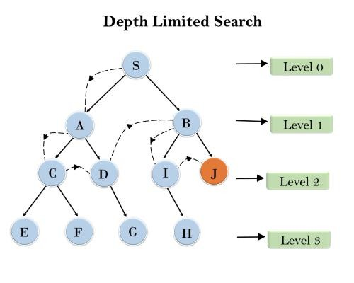
Completeness: DLS search algorithm is complete if the solution is above the depth-limit.
Time Complexity: Time complexity of DLS algorithm is O(bℓ). Space Complexity: Space complexity of DLS algorithm is O(b×ℓ).
Optimal: Depth-limited search can be viewed as a special case of DFS, and it is also not optimal even if ℓ>d.

UNIFORM-COST SEARCH ALGORITHM:
Uniform-cost search is a searching algorithm used for traversing a weighted tree or graph. This algorithm comes into play when a different cost is available for each edge. The primary goal of the uniform-cost search is to find a path to the goal node which has the lowest cumulative cost. Uniform-cost search expands nodes according to their path costs form the root node. It can be used to solve any graph/tree where the optimal cost is in demand. A uniform-cost search algorithm is implemented by the priority queue. It gives maximum priority to the lowest cumulative cost. Uniform cost search is equivalent to BFS algorithm if the path cost of all edges is the same.

Advantages:
  - Uniform cost search is optimal because at every state the path with the least cost is chosen.

Disadvantages:
  - It does not care about the number of steps involve in searching and only concerned about path cost. Due to which this algorithm may be stuck in an infinite loop.
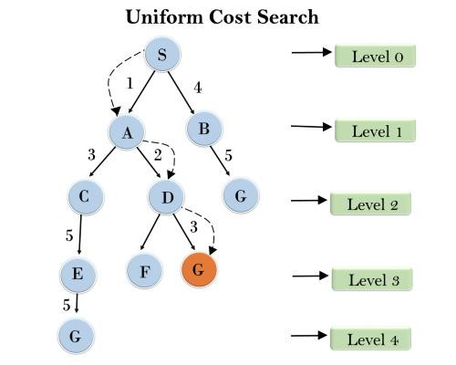
Example:

Completeness:
Uniform-cost search is complete, such as if there is a solution, UCS will find it.

Time Complexity:
Let C* is Cost of the optimal solution, and ε is each step to get closer to the goal node. Then the number of steps is = C*/ε+1. Here we have taken +1, as we start from state 0 and end to C*/ε.

Hence, the worst-case time complexity of Uniform-cost search isO(b1 + [C*/ε])/.

Space Complexity:
The same logic is for space complexity so, the worst-case space complexity of Uniform-cost search is O(b1 + [C*/ε]).

Optimal: Uniform-cost search is always optimal as it only selects a path with the lowest path cost.

ITERATIVE DEEPENING DEPTH-FIRST SEARCH:
The iterative deepening algorithm is a combination of DFS and BFS algorithms. This search algorithm finds out the best depth limit and does it by gradually increasing the limit until a goal is found.
This algorithm performs depth-first search up to a certain "depth limit", and it keeps increasing the depth limit after each iteration until the goal node is found.
This Search algorithm combines the benefits of Breadth-first search's fast search and depth- first search's memory efficiency.
The iterative search algorithm is useful uninformed search when search space is large, and depth of goal node is unknown.

Advantages:
- It combines the benefits of BFS and DFS search algorithm in terms of fast search and memory efficiency.
Disadvantages:
- The main drawback of IDDFS is that it repeats all the work of the previous phase.
Example:
Following tree structure is showing the iterative deepening depth-first search. IDDFS algorithm performs various iterations until it does not find the goal node. The iteration performed by the algorithm is given as:
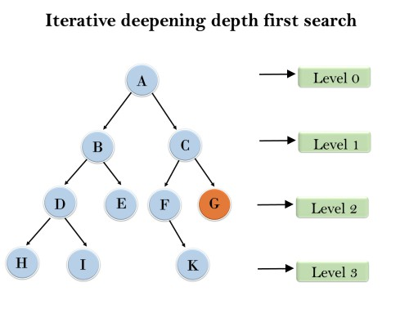
1'st Iteration-----> A
2'nd Iteration----> A, B, C
3'rd Iteration------>A, B, D, E, C, F, G
4'th Iteration------>A, B, D, H, I, E, C, F, K, G
In the fourth iteration, the algorithm will find the goal node.

Completeness:
This algorithm is complete if the branching factor is finite.
Time Complexity: Let's suppose b is the branching factor and depth is d then the worst-case time complexity is O(bd).

Space Complexity:
The space complexity of IDDFS will be O(bd). Optimal:
IDDFS algorithm is optimal if path cost is a non- decreasing function of the depth of the node.

BIDIRECTIONAL SEARCH ALGORITHM:

Bidirectional search algorithm runs two simultaneous searches, one form initial state called as forward-search and other from goal node called as backward-search, to find the goal node. Bidirectional search replaces one single search graph with two small subgraphs in which one starts the search from an initial vertex and other starts from goal vertex. The search stops when these two graphs intersect each other.
Bidirectional search can use search techniques such as BFS, DFS, etc.

Advantages:
  - Bidirectional search is fast.
  - Bidirectional search requires less memory

Disadvantages:
  - Implementation of the bidirectional search tree is difficult.

In bidirectional search, one should know the goal state in advance.
Example:
In the below search tree, bidirectional search algorithm is applied. This algorithm divides one graph/tree into two sub-graphs. It starts traversing from node 1 in the forward direction and starts from goal node 16 in the backward direction.
The algorithm terminates at node 9 where two searches meet.
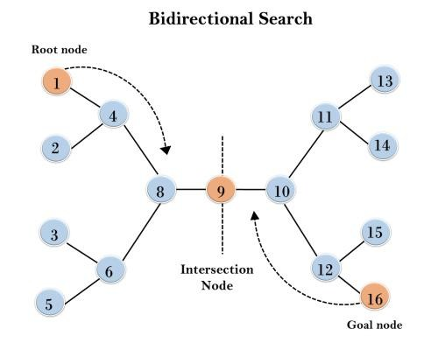

Forward search. 1 4 2 8 6 3 5 9
Backward search. 16 12 15 10 11 13 14 9
1 4 8 9
16 12 10 9
Final path 1 4 8 9 10 12 19
Completeness: Bidirectional Search is complete if we use BFS in both searches.
Time Complexity: Time complexity of bidirectional search using BFS is O(bd).
Space Complexity: Space complexity of bidirectional search is O(bd).
Optimal: Bidirectional search is Optimal.

INFORMED SEARCH ALGORITHMS
So far we have talked about the uninformed search algorithms which looked through search space for all possible solutions of the problem without having any additional knowledge about search space. But informed search algorithm contains an array of knowledge such as how far we are from the goal, path cost, how to reach to goal node, etc. This knowledge help agents to explore less to the search space and find more efficiently the goal node.

The informed search algorithm is more useful for large search space. Informed search algorithm uses the idea of heuristic, so it is also called Heuristic search.

Heuristics function: Heuristic is a function which is used in Informed Search, and it finds the most promising path. It takes the current state of the agent as its input and produces the estimation of how close agent is from the goal. The heuristic method, however, might not always give the best solution, but it guaranteed to find a good solution in reasonable time. Heuristic function estimates how close a state is to the goal. It is represented by h(n), and it calculates the cost of an optimal path between the pair of states. The value of the heuristic function is always positive.

Admissibility of the heuristic function is given as:
- h(n) <= h*(n)

Here h(n) is heuristic cost, and h*(n) is the estimated cost. Hence heuristic cost should be less than or equal to the estimated cost.

Pure Heuristic Search:
Pure heuristic search is the simplest form of heuristic search algorithms. It expands nodes based on their heuristic value h(n). It maintains two lists, OPEN and CLOSED list. In the CLOSED list, it places those nodes which have already expanded and in the OPEN list, it places nodes which have yet not been expanded.

On each iteration, each node n with the lowest heuristic value is expanded and generates all its successors and n is placed to the closed list. The algorithm continues unit a goal state is found.

In the informed search we will discuss two main algorithms which are given below:
  - Best First Search Algorithm(Greedy search)
  - A* Search Algorithm

- BEST-FIRST SEARCH ALGORITHM (GREEDY SEARCH):
Greedy best-first search algorithm always selects the path which appears best at that moment. It is the combination of depth-first search and breadth-first search algorithms. It uses the heuristic function and search. Best-first search allows us to take the advantages of both algorithms. With the help of best-first search, at each step, we can choose the most promising node. In the best first search algorithm, we expand the node which is closest to the goal node and the closest cost is estimated by heuristic function, i.e.

  - f(n)= g(n).
Were, h(n)= estimated cost from node n to the goal.

The greedy best first algorithm is implemented by the priority queue.

Best first search algorithm:
  - Step 1: Place the starting node into the OPEN list.
  - Step 2: If the OPEN list is empty, Stop and return failure.
  - Step 3: Remove the node n, from the OPEN list which has the lowest value of h(n), and places it in the CLOSED list.
  - Step 4: Expand the node n, and generate the successors of node n.
  - Step 5: Check each successor of node n, and find whether any node is a goal node or not. If any successor node is goal node, then return success and terminate the search, else proceed to Step 6.
  - Step 6: For each successor node, algorithm checks for evaluation function f(n), and then check if the node has been in either OPEN or CLOSED list. If the node has not been in both list, then add it to the OPEN list.
  - Step 7: Return to Step 2.

Advantages:
  - Best first search can switch between BFS and DFS by gaining the advantages of both the algorithms.
  - This algorithm is more efficient than BFS and DFS algorithms.

Disadvantages:
  - It can behave as an unguided depth-first search in the worst case scenario.
  - It can get stuck in a loop as DFS.
  - This algorithm is not optimal.

Example:
Consider the below search problem, and we will traverse it using greedy best-first search. At each iteration, each node is expanded using evaluation function f(n)=h(n) , which is given in the below table.

Consider the below search problem, and we will traverse it using greedy best-first search. At each iteration, each node is expanded using evaluation function f(n)=h(n) , which is given in the below table.
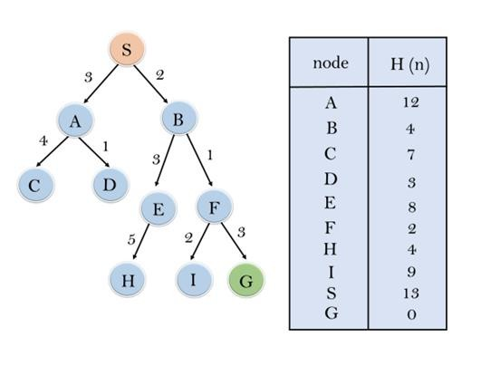

In this search example, we are using two lists which are OPEN and CLOSED Lists. Following are the iteration for traversing the above example.

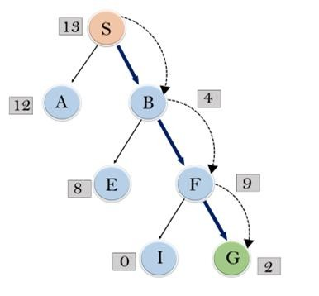

Expand the nodes of S and put in the CLOSED list

Initialization: Open [A, B], Closed [S]

Iteration 1: Open [A], Closed [S, B]

Iteration 2: Open [E, F, A], Closed [S, B]
: Open [E, A], Closed [S, B, F]

Iteration 3: Open [I, G, E, A], Closed [S, B, F]
: Open [I, E, A], Closed [S, B, F, G]

Hence the final solution path will be: S----> B----->F > G

Time Complexity: The worst case time complexity of Greedy best first search is O(b^{m}).

Space Complexity: The worst case space complexity of Greedy best first search is O(b^{m}). Where, m is the maximum depth of the search space.

Complete: Greedy best-first search is also incomplete, even if the given state space is finite.

Optimal: Greedy best first search algorithm is not optimal.

A* SEARCH ALGORITHM:
A* search is the most commonly known form of best-first search. It uses heuristic function h(n), and cost to reach the node n from the start state g(n). It has combined features of UCS and greedy best-first search, by which it solve the problem efficiently. A* search algorithm finds the shortest path through the search space using the heuristic function. This search algorithm expands less search tree and provides optimal result faster. A* algorithm is similar to UCS except that it uses g(n)+h(n) instead of g(n).

In A* search algorithm, we use search heuristic as well as the cost to reach the node.
Hence we can combine both costs as following, and this sum is called as a fitness number.
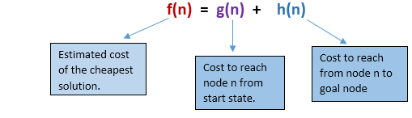
At each point in the search space, only those node is expanded which have the lowest value of f(n), and the algorithm terminates when the goal node is found.

Algorithm of A* search:
Step1: Place the starting node in the OPEN list.

Step 2: Check if the OPEN list is empty or not, if the list is empty then return failure and stops.

Step 3: Select the node from the OPEN list which has the smallest value of evaluation function (g+h), if node n is goal node then return success and stop, otherwise

Step 4: Expand node n and generate all of its successors, and put n into the closed list. For each successor n', check whether n' is already in the OPEN or CLOSED list, if not then compute evaluation function for n' and place into Open list.

Step 5: Else if node n' is already in OPEN and CLOSED, then it should be attached to the back pointer which reflects the lowest g(n') value.
Step 6: Return to Step 2.

Advantages:
- A* search algorithm is the best algorithm than other search algorithms.
- A* search algorithm is optimal and complete.
- This algorithm can solve very complex problems.

Disadvantages:
- It does not always produce the shortest path as it mostly based on heuristics and approximation.
- A* search algorithm has some complexity issues.
- The main drawback of A* is memory requirement as it keeps all generated nodes in the memory, so it is not practical for various large-scale problems.

Example:
In this example, we will traverse the given graph using the A* algorithm. The heuristic value of all states is given in the below table so we will calculate the f(n) of each state using the formula f(n)= g(n) + h(n), where g(n) is the cost to reach any node from start state.
Here we will use OPEN and CLOSED list.
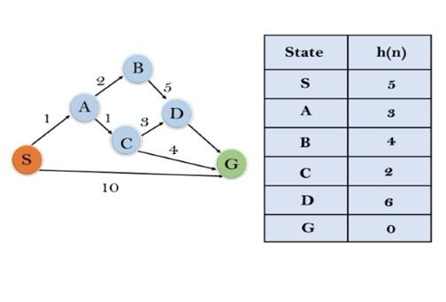
Solution:

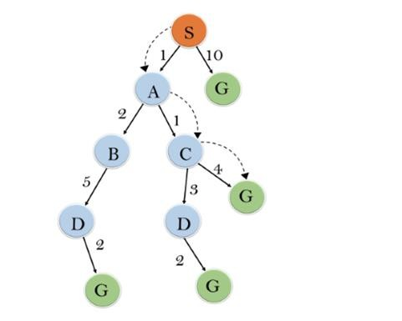
Initialization: {(S, 5)}

Iteration1: {(S--> A, 4), (S-->G, 10)}

Iteration2: {(S--> A-->C, 4), (S--> A-->B, 7), (S-->G, 10)}

Iteration3: {(S--> A-->C--->G, 6), (S--> A-->C--->D, 11), (S--> A-->B, 7), (S-->G, 10)}

Iteration 4 will give the final result, as S--->A--->C--->G it provides the optimal path with cost 6.

Points to remember:

- A* algorithm returns the path which occurred first, and it does not search for all remaining paths.
- The efficiency of A* algorithm depends on the quality of heuristic.
- A* algorithm expands all nodes which satisfy the condition f(n)<="" li="">

Complete: A* algorithm is complete as long as:

- Branching factor is finite.
- Cost at every action is fixed.

Optimal: A* search algorithm is optimal if it follows below two conditions:
- Admissible: the first condition requires for optimality is that h(n) should be an admissible heuristic for A* tree search. An admissible heuristic is optimistic in nature.
- Consistency: Second required condition is consistency for only A* graph-search.

If the heuristic function is admissible, then A* tree search will always find the least cost path.

Time Complexity: The time complexity of A* search algorithm depends on heuristic function, and the number of nodes expanded is exponential to the depth of solution d. So the time complexity is O(b^d), where b is the branching factor.

Space Complexity: The space complexity of A* search algorithm is O(b^d)

LOCAL SEARCH AND OPTIMIZATION PROBLEMS

Hill Climbing Algorithm in Artificial Intelligence
- Hill climbing algorithm is a local search algorithm which continuously moves in the direction of increasing elevation/value to find the peak of the mountain or best solution to the problem. It terminates when it reaches a peak value where no neighbor has a higher value.
- Hill climbing algorithm is a technique which is used for optimizing the mathematical problems. One of the widely discussed examples of Hill climbing algorithm is Traveling- salesman Problem in which we need to minimize the distance traveled by the salesman.
- It is also called greedy local search as it only looks to its good immediate neighbor state and not beyond that.
- A node of hill climbing algorithm has two components which are state and value.
- Hill Climbing is mostly used when a good heuristic is available.
- In this algorithm, we don't need to maintain and handle the search tree or graph as it only keeps a single current state.

Features of Hill Climbing:

Following are some main features of Hill Climbing Algorithm:

- Generate and Test variant: Hill Climbing is the variant of Generate and Test method. The Generate and Test method produce feedback which helps to decide which direction to move in the search space.
- Greedy approach: Hill-climbing algorithm search moves in the direction which optimizes the cost.
- No backtracking: It does not backtrack the search space, as it does not remember the previous states.

State-space Diagram for Hill Climbing:

The state-space landscape is a graphical representation of the hill-climbing algorithm which is showing a graph between various states of algorithm and Objective function/Cost.

On Y-axis we have taken the function which can be an objective function or cost function, and state-space on the x-axis. If the function on Y-axis is cost then, the goal of search is to find the global minimum and local minimum. If the function of Y-axis is Objective function, then the goal of the search is to find the global maximum and local to find the global maximum and local maximum.
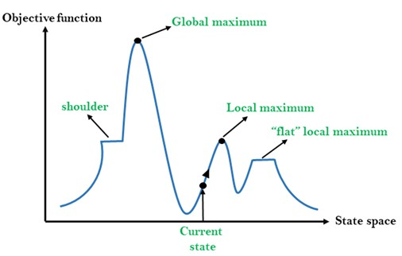

Different regions in the state space landscape:
Local Maximum: Local maximum is a state which is better than its neighbor states, but there is also another state which is higher than it.
Global Maximum: Global maximum is the best possible state of state space landscape. It has the highest value of objective function.

Current state: It is a state in a landscape diagram where an agent is currently present.
Flat local maximum: It is a flat space in the landscape where all the neighbor states of current states have the same value.
Shoulder: It is a hill region which has an uphill edge.

Types of Hill Climbing Algorithm:
- Simple hill Climbing:
- Steepest-Ascent hill-climbing:
- Stochastic hill Climbing:

- Simple Hill Climbing:

Simple hill climbing is the simplest way to implement a hill climbing algorithm. It only evaluates the neighbor node state at a time and selects the first one which optimizes current cost and set it as a current state. It only checks it's one successor state, and if it finds better than the current state, then move else be in the same state. This algorithm has the following features:
  - Less time consuming
  - Less optimal solution and the solution is not guaranteed Algorithm for Simple Hill Climbing:
  - Step 1: Evaluate the initial state, if it is goal state then return success and Stop.
  - Step 2: Loop Until a solution is found or there is no new operator left to apply.
  - Step 3: Select and apply an operator to the current state.
  - Step 4: Check new state:
    - If it is goal state, then return success and quit.
    - Else if it is better than the current state then assigns new state as a current state.
    - Else if not better than the current state, then return to step2.
  - Step 5: Exit.

- Steepest-Ascent hill climbing:
The steepest-Ascent algorithm is a variation of simple hill climbing algorithm. This algorithm examines all the neighboring nodes of the current state and selects one neighbor node which is closest to the goal state. This algorithm consumes more time as it searches for multiple neighbors

Algorithm for Steepest-Ascent hill climbing:
  - Step 1: Evaluate the initial state, if it is goal state then return success and stop, else make current state as initial state.
  - Step 2: Loop until a solution is found or the current state does not change.
    - Let SUCC be a state such that any successor of the current state will be better than it.
    - For each operator that applies to the current state:
      - Apply the new operator and generate a new state.
      - Evaluate the new state.
      - If it is goal state, then return it and quit, else compare it to the SUCC.
      - If it is better than SUCC, then set new state as SUCC.
      - If the SUCC is better than the current state, then set current state to SUCC.
  - Step 5: Exit.

- Stochastic hill climbing:
Stochastic hill climbing does not examine for all its neighbor before moving. Rather, this search algorithm selects one neighbor node at random and decides whether to choose it as a current state or examine another state.

Problems in Hill Climbing Algorithm:
Local Maximum: A local maximum is a peak state in the landscape which is better than each of its neighboring states, but there is another state also present which is higher than the local maximum.
Solution: Backtracking technique can be a solution of the local maximum in state space landscape. Create a list of the promising path so that the algorithm can backtrack the search space and explore other paths as well.
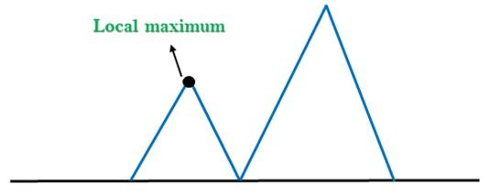

Plateau: A plateau is the flat area of the search space in which all the neighbor states of the current state contains the same value, because of this algorithm does not find any best direction to move. A hill-climbing search might be lost in the plateau area.

Solution: The solution for the plateau is to take big steps or very little steps while searching, to solve the problem. Randomly select a state which is far away from the current state so it is possible that the algorithm could find non-plateau region.
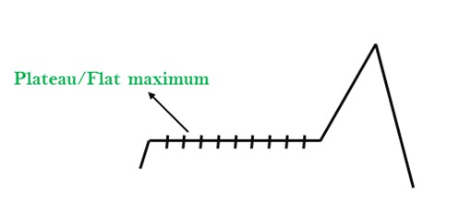
Ridges: A ridge is a special form of the local maximum. It has an area which is higher than its surrounding areas, but itself has a slope, and cannot be reached in a single move.

Solution: With the use of bidirectional search, or by moving in different directions, we can improve this problem.
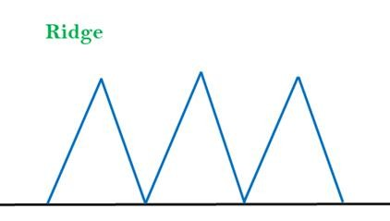

ADVERSARIAL SEARCH/searching with non-deterministic approach

Adversarial search is a search, where we examine the problem which arises when we try to plan ahead of the world and other agents are planning against us.
- We have studied the search strategies which are only associated with a single agent that aims to find the solution which often expressed in the form of a sequence of actions.
- But, there might be some situations where more than one agent is searching for the solution in the same search space, and this situation usually occurs in game playing.
- The environment with more than one agent is termed as multi-agent environment, in which each agent is an opponent of other agent and playing against each other. Each agent needs to consider the action of other agent and effect of that action on their performance.
- So, Searches in which two or more players with conflicting goals are trying to explore the same search space for the solution, are called adversarial searches, often known as Games.
- Games are modeled as a Search problem and heuristic evaluation function, and these are the two main factors which help to model and solve games in AI.
Types of Games in AI: https://cse.poriyaan.in/topic/types-of-games-50980/

Based on chance  Based on information | Deterministic | Non-Deterministic
Perfect information | Chess, Checkers, go, Othello | Backgammon, monopoly
Imperfect information | Battleships, blind, tic-tac-toe | Bridge, poker, scrabble, nuclear war

- Perfect information: A game with the perfect information is that in which agents can look into the complete board. Agents have all the information about the game, and they can see each other moves also. Examples are Chess, Checkers, Go, etc.
- Imperfect information: If in a game agents do not have all information about the game and not aware with what's going on, such type of games are called the game with imperfect information, such as tic-tac-toe, Battleship, blind, Bridge, etc.
- Deterministic games: Deterministic games are those games which follow a strict pattern and set of rules for the games, and there is no randomness associated with them. Examples are chess, Checkers, Go, tic-tac-toe, etc.
- Non-deterministic games: Non-deterministic are those games which have various unpredictable events and has a factor of chance or luck. This factor of chance or luck is introduced by either dice or cards. These are random, and each action response is not fixed. Example: Backgammon, Monopoly, Poker, etc.

Zero-Sum Game
- Zero-sum games are adversarial search which involves pure competition.
- In Zero-sum game each agent's gain or loss of utility is exactly balanced by the losses or gains of utility of another agent.
- One player of the game tries to maximize one single value, while other player tries to minimize it.
- Each move by one player in the game is called as ply.
- Chess and tic-tac-toe are examples of a Zero-sum game.

Zero-sum game: Embedded thinking
The Zero-sum game involved embedded thinking in which one agent or player is trying to figure out:
- What to do.
- How to decide the move?
- Needs to think about his opponent as well
- The opponent also thinks what to do
Each of the players is trying to find out the response of his opponent to their actions. This requires embedded thinking or backward reasoning to solve the game problems in AI.

Formalization of the problem:
A game can be defined as a type of search in AI which can be formalized of the following elements:
- Initial state: It specifies how the game is set up at the start.
- Player(s): It specifies which player has moved in the state space.
- Action(s): It returns the set of legal moves in state space.
- Result(s, a): It is the transition model, which specifies the result of moves in the state space.
- Terminal-Test(s): Terminal test is true if the game is over, else it is false at any case. The state where the game ends is called terminal states.
- Utility(s, p): A utility function gives the final numeric value for a game that ends in terminal states s for player p. It is also called payoff function.
For Chess, the outcomes are a win, loss, or draw and its payoff values are +1, 0, ½. And for tic-tac-toe, utility values are +1, -1, and 0.

Game Tree/Alpha-beta pruning https://www.youtube.com/watch?v=_i-lZcbWkps

A game tree is a tree where nodes of the tree are the game states and Edges of the tree are the moves by players. Game tree involves initial state, actions function, and result Function.
Example: Tic-Tac-Toe game tree:
The following figure is showing part of the game-tree for tic-tac-toe game. Following are some key points of the game:

- There are two players MAX and MIN.
- Players have an alternate turn and start with MAX.
- MAX maximizes the result of the game tree
- MIN minimizes the result.
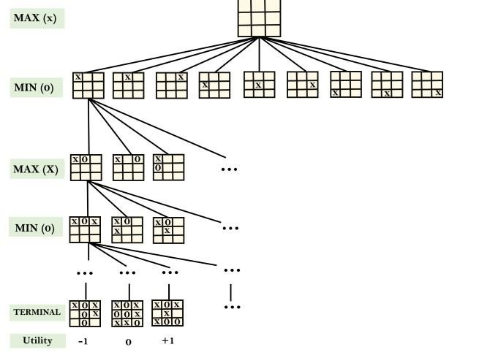

Example Explanation:
- From the initial state, MAX has 9 possible moves as he starts first. MAX place x and MIN place o, and both player plays alternatively until we reach a leaf node where one player has three in a row or all squares are filled.
- Both players will compute each node, minimax, the minimax value which is the best achievable utility against an optimal adversary.
- Suppose both the players are well aware of the tic-tac-toe and playing the best play. Each player is doing his best to prevent another one from winning. MIN is acting against Max in the game.
- So in the game tree, we have a layer of Max, a layer of MIN, and each layer is called as Ply. Max place x, then MIN puts o to prevent Max from winning, and this game continues until the terminal node.
- In this either MIN wins, MAX wins, or it's a draw. This game-tree is the whole search space of possibilities that MIN and MAX are playing tic-tac-toe and taking turns alternately.

Hence adversarial Search for the minimax procedure works as follows:

- It aims to find the optimal strategy for MAX to win the game.
- It follows the approach of Depth-first search.
- In the game tree, optimal leaf node could appear at any depth of the tree.
- Propagate the minimax values up to the tree until the terminal node discovered.

In a given game tree, the optimal strategy can be determined from the minimax value of each node, which can be written as MINIMAX(n). MAX prefer to move to a state of maximum value and MIN prefer to move to a state of minimum value then:

