Tech-Symposium 2K26

Events
DEPARTMENT - Civil Engineering

EVENT No 1 - CADONOVA: Crafting Dreams into the Digital Canvas

Round 1: Quiz - Auto CAD/ Building Planning and Drawing.
Round 2: Planning and Drawing on Auto CAD

Student Coordinator – PATIL ABHISHEK RAMESH - 99234 96620
Payment QR CODE
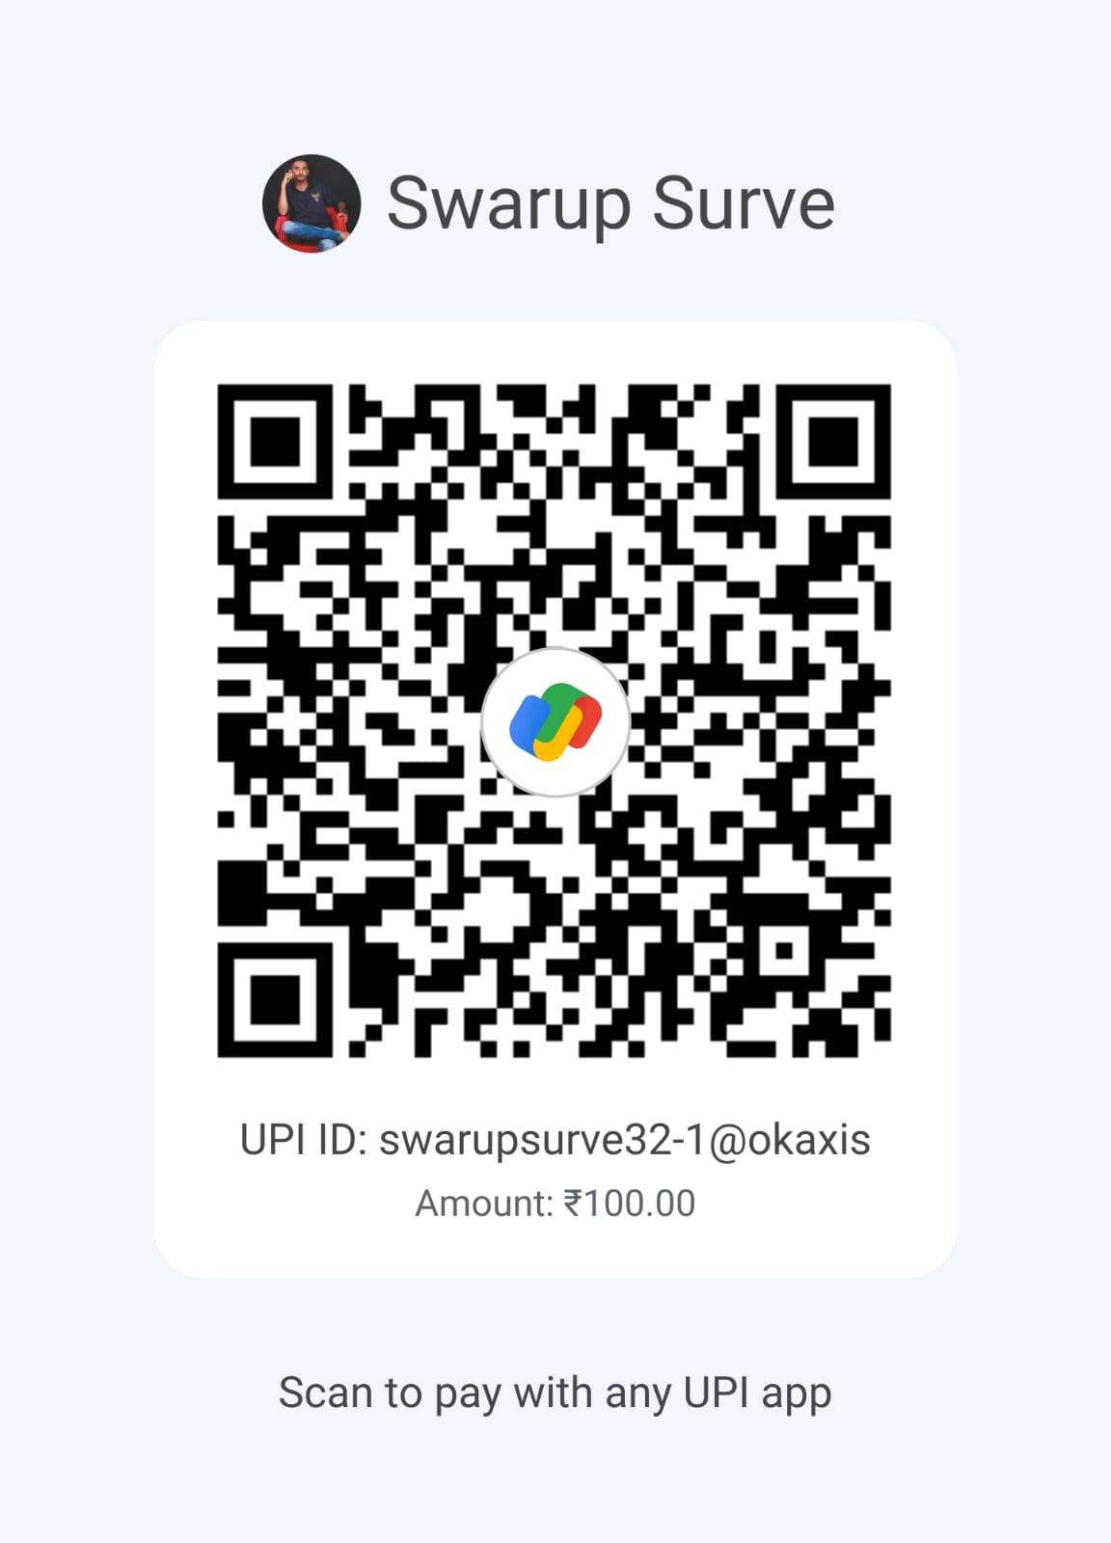
What’s App link - https://chat.whatsapp.com/IXwRrEkpGbe7SSef1D4dTP?mode=gi_c

EVENT No 2 - The Survey Sprint
Rules:
- Each team must consist of two participants.
- Participants must bring their own required tools for the Puzzle Round (e.g. scissors, glue, etc.).

Round 1: Surveying Quiz - MCQs.
Round 2: Instrument Puzzle
- Each team will receive a picture of an instrument/machine, cut into pieces.
- Teams must reassemble the image correctly within 20 minutes.
Round 3: Survey Treasure Hunt

Student Coordinator - SURVE SWARUP TANAJI - 93259 79889
Payment QR CODE -
What’s App link - https://chat.whatsapp.com/IGldciFaa6FH6SE6XemmsV

