Tech-Symposium 2K26

Events
Department of Electronics and Telecommunication Engineering

EVENT No. 1 – RoboTantra (Robotic Competition)
One Day Event on 07/03/2026

- Rules:
Round 1: Screening Round
Round 2: Final Round

- Student Coordinator:
1. Manthan Satpute: 7058329919
2. Ms. Ankita Molekar: 9022342008

- Location of Event:
Open space near back gate

- WhatsApp Group:
https://chat.whatsapp.com/D4oeBe4FO4dD9ZAWSg5wKf

- Student QR Code:
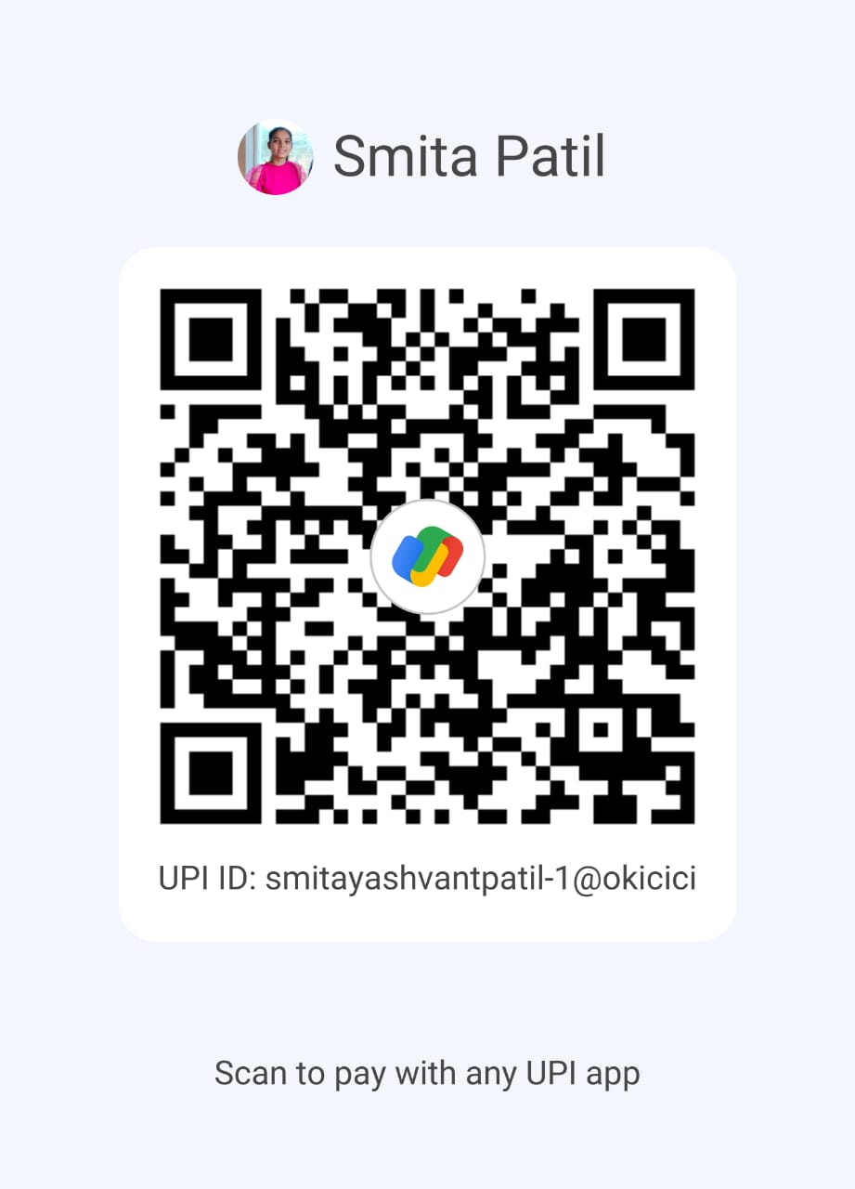

EVENT No. 2 – Eco Canvas (Poster Presentation)
One Day Event on 07/03/2026

- Rules:
Round 1: Screening Round
Round 2: Final Round

- Student Coordinator:
1. Mr. Aditya Patil: 8799928755
2. Mr. Harshad Sherekar: 8657544050

- Location of Event:
Microprocessor Lab (ETC Dept.)

- WhatsApp Group:
https://chat.whatsapp.com/D4oeBe4FO4dD9ZAWSg5wKf

- Student QR Code:

