**Requirements (as for now)**

**Platform as a Service (PaaS) facilitates deployment of applications, application development, testing, and also supports the building, testing and hosting of Web applications. PaaS enables IT to develop, test, deploy, host, and also update from a single streamlined environment. May also be referred to as cloudware.**

# Server Side:

**Cloud Infrastructure (High performance) ->** Cloud infrastructure is made up of several components, each integrated with one another into a single architecture supporting business operations. As our operations/services requires high end servers, we will be requiring highly configured cloud infrastructure.

**Internet connectivity (Low latency, high speed fiber optic/5G) ->** as our service is totally rely on web servers, we will be using LAN connectivity with fiber optic cables to connect our local systems to create a web server (PaaS), which in return help us to compile and track activities that our customers will be doing on our platform.

**Website as a Web platform ->** Web platforms are used to build interactive websites in which creator can also use different API(s) to make it more realistic. In our case, we will be providing our website to user to create his AR or VR or MR environments.

We will be using RAPID APPLICATION DEVELOPMENT methodology of Software Development for the projects that will be created on our platform. The key benefit of a RAD approach is fast project turnaround, making it an attractive choice for developers working in a fast-paced environment. By reducing planning time and emphasizing prototype iterations, RAD allows project managers and stakeholders to accurately measure progress and communicate in real time on evolving issues or changes. This results in greater efficiency, faster development, and effective communication.

**Phases of RAD methodology:**

* Phase 1: Requirements planning
* Phase 2: User design
* Phase 3: Rapid construction
* Phase 4: Cutover

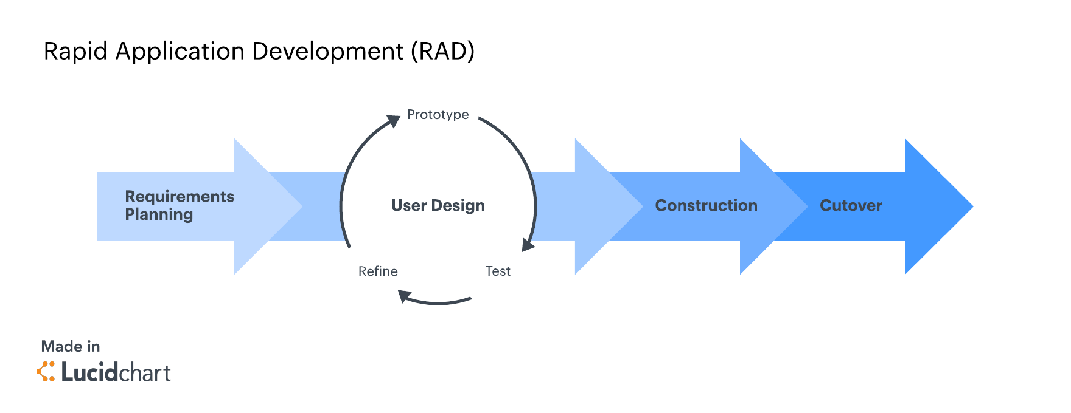

**Requirements we assume from our customers.**

# User end:

**Computer with basic GPU ->** User need not to bring his hardware with high configurations, he can work with basic devices which includes minimum CPU(s) and GPU(s).

Some official standard hardware requirement from **HTC:**

GPU: Nvidia GeForce GTX 970 or AMD Radeon R9 290 equivalent

CPU: Intel i5-4590 or AMD FX 8350 equivalent

RAM: 4 GB or more

Video Output: HDMI 1.4, DisplayPort 1.2 or newer

USB Port: 1x USB 2.0 or better port

Operating System: Windows 7 SP1, Windows 8.1 or later, Windows 10

**Internet connectivity (fiber optic/5G with low latency) ->** as our service is totally rely on web server, user needs a good internet connectivity for communicating with our platform. LAN connections are preferred because of their connectivity.

**Deploying Devices ->** with our platform user can only create his software i.e. VR environment or AR environment or MR environment, he need his own device (Example: VR headsets, AR headsets, MR headsets, Smartphones, PC-connected headsets, Standalone headsets, Smart glasses, Holographic devices) to deploy his creation into reality.