
SCHOOL OF ARCHITECTURE, COMPUTING & ENGINEERING
INDIVIDUAL CW REPORT
NETWORK DESIGN & IMPLEMENTATION REPORT
Module Code : CN7029
Module Title : Computer Architecture and Networks
Module Leader : Dr. Elias Eze
Student Name : RESITHA SARVANA
Student ID : 2823962

Index:
- Abstract
- Introduction
- Objectives
- Network Design & Subnetting
  - 4.1 Subnet Overview
  - 4.2 Required Subnets
  - 4.3 VLSM Allocation Results
  - 4.4 Cable Selection
  - 4.5 Router Link Subnets
- Device Configurations
  - 5.1 Subnet A – Wireless LAN
  - 5.2 Router R2 Configuration – Subnet B
  - 5.3 Router R3 Configuration – Subnet C
  - Ping & PDU Outputs
- Ping Command Testing
  - 6.1 Subnet C
  - 6.2 Subnet B
  - 6.3 Subnet A (Wireless)
- Simple PDU Output Window
- Complex PDU Output
- Simulation and Testing
  - 9.1 DHCP Validation – Subnet A
  - 9.2 Static Addressing Validation – Subnet B
  - 9.3 Static Addressing Validation – Subnet C
  - 9.4 Router Link Tests (Subnets D, E, F)
  - Overall Outcome
- Subnet A DHCP Tests
- Simulation and Testing (Extended)
- 11.1 DHCP Validation – Subnet A
- 11.2 Static Addressing Validation – Subnet B
- 11.3 Static Addressing Validation – Subnet C
- 11.4 Router Link Tests (Subnets D, E, F)
- Evaluation of the Designed Network
- 12.1 Strengths
- 12.2 Challenges and Troubleshooting
- Conclusion
- References

ABSTRACT
Designing a small enterprise network is more than just connecting cables and configuring routers it’s about creating a system that feels reliable, scalable, and intuitive for the people who use it. In this project, Cisco Packet Tracer was employed to build a wired and wireless multi-subnet environment, carefully structured through VLSM addressing derived from a personalized student ID block. Three distinct subnets were established to serve wireless users, workstation clients, and dedicated servers, each with its own role in the overall architecture.
To ensure seamless communication, three routers, two switches, and an access point were configured with RIP version 2 for dynamic routing. DHCP services were introduced for wireless devices to simplify address allocation, while critical servers retained static IPs for stability. The network was validated through simulation, ping testing, and protocol analysis, which highlighted common troubleshooting challenges such as DHCP propagation delays, misconfigured cabling, and missing routing advertisements.
Despite these hurdles, the final design achieved full connectivity and met all assignment requirements. More importantly, it demonstrated how thoughtful planning and structured deployment can transform a technical exercise into a practical model of enterprise networking one that balances efficiency, resilience, and clarity in its design.

INTRODUCTION:
In today’s digital world, computer networks are the invisible threads that hold modern systems together, enabling communication, resource sharing, and seamless access to remote services. A truly intelligent network is not just a collection of devices; it is an ecosystem that understands addressing schemes, routing logic, switching behaviour, and the importance of wireless security.
This coursework project explores the design and implementation of a hybrid network one that blends the stability of wired connections with the flexibility of wireless access using Cisco Packet Tracer as the simulation platform. To achieve a secure and functional system, a mix of static IP addressing for critical servers, dynamic IP allocation through DHCP for mobile clients, and WPA2 encryption for wireless security was applied.
Hybrid networks are not just academic exercises; they mirror the realities of modern organizations where reliability and mobility must coexist. Wired Ethernet, built on IEEE 802.3 standards, offers predictable bandwidth and continuous high-speed communication, making it ideal for PCs and servers. Wireless networks, on the other hand, follow IEEE 802.11 standards, providing convenience and adaptability for laptops, tablets, and smartphones. Yet, this mobility introduces vulnerabilities, as radio signals extend beyond physical boundaries. To counter such risks, the Wi-Fi segment in this design employed WPA2-PSK encryption and a dedicated SSID, with Router R6 acting as the DHCP server to ensure secure, automated connectivity for wireless clients.
The topology itself was structured into three primary subnets: Subnet A (Wireless), Subnet B (Wired), and Subnet C (Wired). These were interconnected through three routers (R1, R2, and R3) and supported by point-to-point links (Subnets D, E, and F) for wired communication. This arrangement reflects industry best practices, where stationary hosts are assigned stable IP addresses while wireless clients benefit from automatic provisioning. The result is a scalable, secure, and realistic model of enterprise networking that balances efficiency with adaptability.

2. OBJECTIVES
The project was guided by a set of clear objectives, each contributing to the creation of a secure, scalable, and functional hybrid network. These objectives were:
- Personalized Addressing: Develop a custom IP block derived from the student ID and apply VLSM subnetting to maximize efficiency+
- Topology Design: Construct a hybrid wired–wireless architecture incorporating routers, switches, PCs, servers, laptops, and a wireless access point to reflect real-world enterprise setups.
- Subnet Configuration: Assign DHCP services to Subnet A for wireless clients, while ensuring Subnets B and C use static addressing for stability in wired environments.
- Wireless Security: Implement WPA2 encryption to safeguard wireless communication against unauthorized access.
- Dynamic Routing: Configure routers R1, R2, and R3 with RIP version 2 to enable seamless inter-subnet connectivity.
- Validation & Testing: Use Packet Tracer’s PDU and Ping simulations to verify communication pathways and troubleshoot inconsistencies.
- Performance Evaluation: Assess the reliability, scalability, and overall effectiveness of the designed network against the assignment requirements.

3. NETWORK DESIGN & SUBNETTING:
For this project, the personalized IP addressing scheme was derived directly from the student ID u2823962. The algorithm begins by examining the first three digits of the ID. Since 282 is greater than the maximum value permitted for the first octet in IPv4 (255), the fallback value of 191 was applied. This ensures the block remains valid while still being tied to the student identifier.
Next, the algorithm uses the subsequent digits of the ID to form the middle octets. From u2823962, the digits 39 were selected for the second octet, and 62 for the third octet. The final octet was standardized to 0 to complete the structure. With a subnet mask of /25, the resulting personalized block became:
191.39.62.0/25
To maximize efficiency, Variable Length Subnet Masking (VLSM) was applied to this block. It was subdivided into three /29 LANs to support the wired and wireless segments, and three /30 point-to-point links to connect the routers. This approach not only ensures logical allocation of addresses but also demonstrates how the student ID u2823962 directly shaped the foundation of the network design.

4 Subnet Overview

4.1Table 1 – Overview of Subnets and Host Devices
Subnet | Router | Devices | Network Address | Mask | Hosts Needed
Subnet A (Wireless) | R1 | 3 Laptops + 1 AP | 191.39.62.16 | /29 | 4
Subnet B (Wired) | R2 | 3 PCs + 1 Server | 191.39.62.8 | /29 | 4
Subnet C (Wired) | R3 | 4 PCs + 1 Server | 191.39.62.0 | /29 | 5
Subnet D (R1–R2) | – | P2P Router Link | 191.39.62.24 | /30 | 2
Subnet E (R2–R3) | – | P2P Router Link | 191.39.62.28 | /30 | 2
Subnet F (R1–R3) | – | P2P Router Link | 191.39.62.32 | /30 | 2

4.2 Required Subnets:
Subnet | Purpose | Minimum Hosts | Subnet Size | Mask | Notes
Subnet A | Wireless LAN | 4 devices | /29 | 255.255.255.248 | Supports laptops, tablets, and smartphones
Subnet B | Wired LAN 1 | 4 devices | /29 | 255.255.255.248 | For PCs and workstations
Subnet C | Wired LAN 2 | 5 devices | /29 | 255.255.255.248 | For servers and additional PCs
Subnet D | R1 ↔ R2 link | 2 devices | /30 | 255.255.255.252 | Point-to-point router connection
Subnet E | R2 ↔ R3 link | 2 devices | /30 | 255.255.255.252 | Point-to-point router connection
Subnet F | R1 ↔ R3 link | 2 devices | /30 | 255.255.255.252 | Point-to-point router connection

4.3 VLSM Allocation Results:
Subnet | Required Hosts | Block Size | Subnet Mask | Network | Range | Broadcast
A | 4 | 8 | /29 | 191.39.62.16 | .17 – .22 | .23
B | 4 | 8 | /29 | 191.39.62.8 | .9 – .14 | .15
C | 5 | 8 | /29 | 191.39.62.0 | .1 – .6 | .7
D | 2 | 4 | /30 | 191.39.62.24 | .25 – .26 | .27
E | 2 | 4 | /30 | 191.39.62.28 | .29 – .30 | .31
F | 2 | 4 | /30 | 191.39.62.32 | .33 – .34 | .35

4.4 Cable Selection
From | To | Subnet / Link | Cable Type
PC | Switch (B) | Subnet B | Copper Straight-Through
Server B | Switch (B) | Subnet B | Copper Straight-Through
Switch (B) | Router R2 | Subnet B | Copper Straight-Through
PC | Switch (C) | Subnet C | Copper Straight-Through
Server C | Switch (C) | Subnet C | Copper Straight-Through
Switch (C) | Router R3 | Subnet C | Copper Straight-Through
Router R1 | AP LAN Port | Subnet A | Copper Straight-Through
AP | Laptops | Subnet A | Wireless
Router R1 | Router R2 | Subnet D | Cross-Over
Router R2 | Router R3 | Subnet E | Cross-Over
Router R1 | Router R3 | Subnet F | Cross-Over

4.5 Router Link Subnets (Based on Actual Interfaces)
Table -Subnet D (R1 ↔ R2)
Router | Interface | IP Address | Mask
R1 | Serial0/1/0 | 191.39.62.30 | /30
R2 | Serial0/1/0 | 191.39.62.26 | /30
Table – Subnet E (R2 ↔ R3)
Router | Interface | IP Address | Mask
R2 | Serial0/0/0 | 191.39.62.29 | /30
R3 | Serial0/0/0 | 191.39.62.30 | /30

Table – Subnet F (R1 ↔ R3)
Router | Interface | IP Address | Mask
R1 | Serial0/0/0 | 191.39.62.33 | /30
R3 | Serial0/1/0 | 191.39.62.34 | /30

5.DEVICE CONFIGURATIONS:
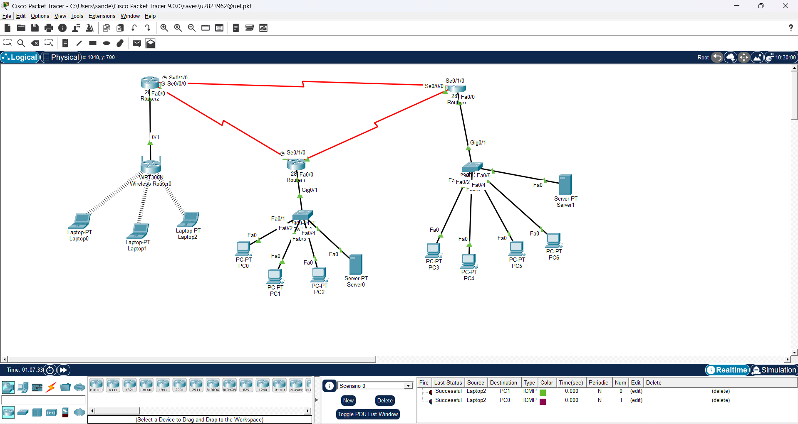
Fig: Network Topology of all subnets

5.1Device Configuration: SUBNETC:
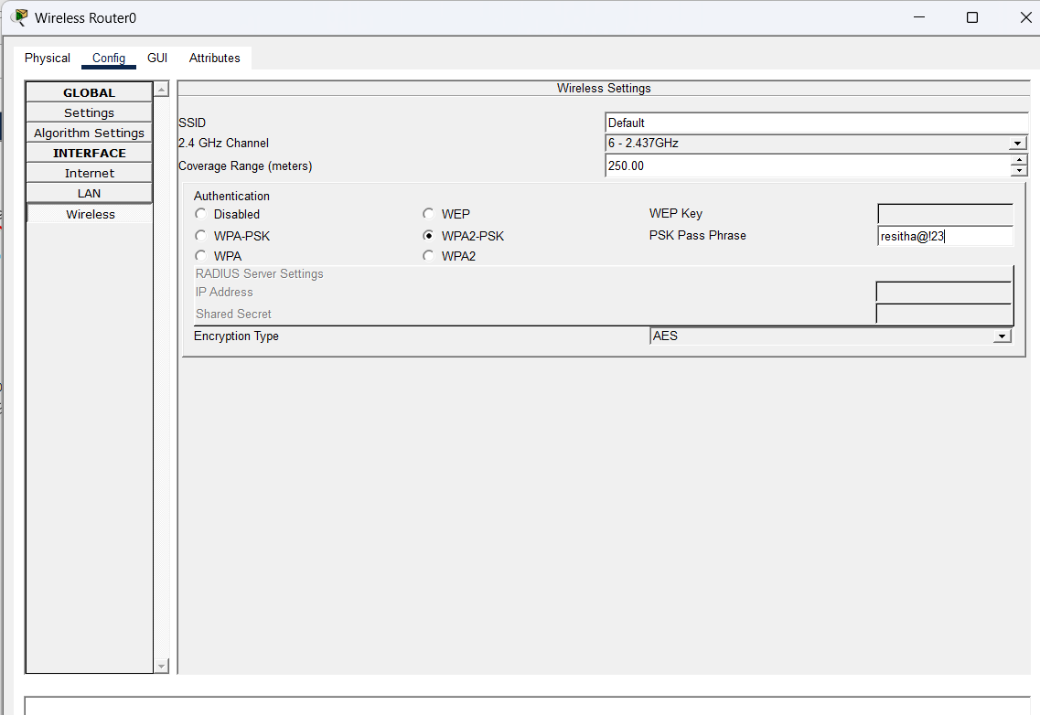
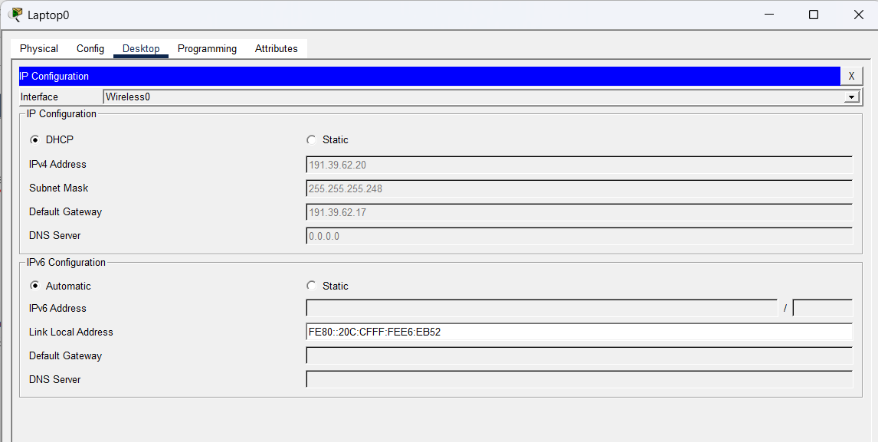
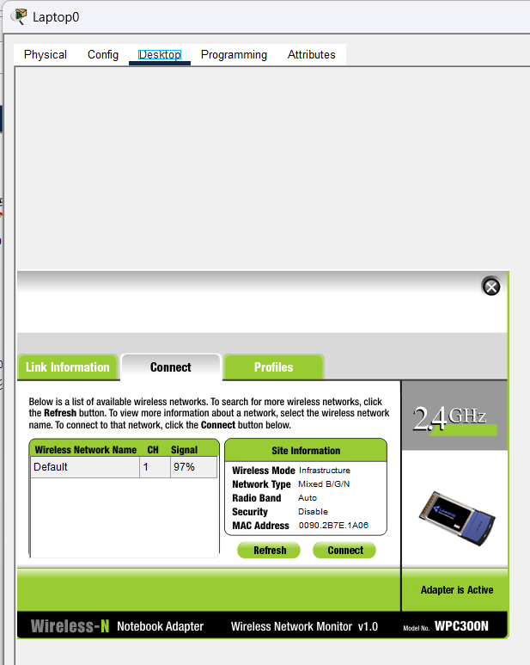
Fig:Routing, DHCP and wireless security
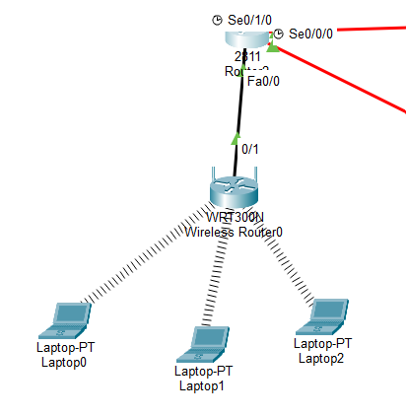
Fig:2.1 Wireless LAN (subnet A)
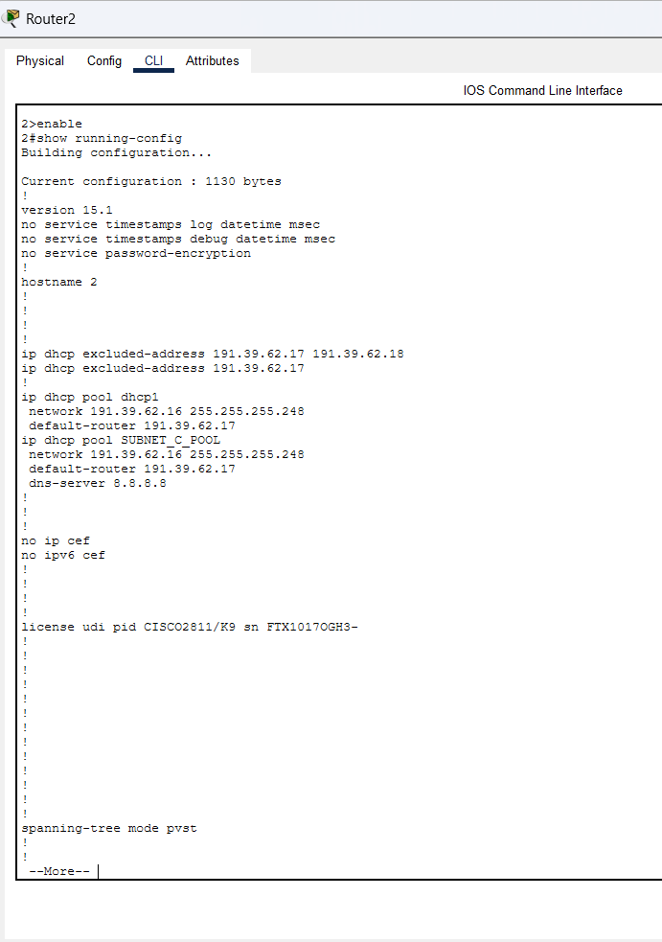
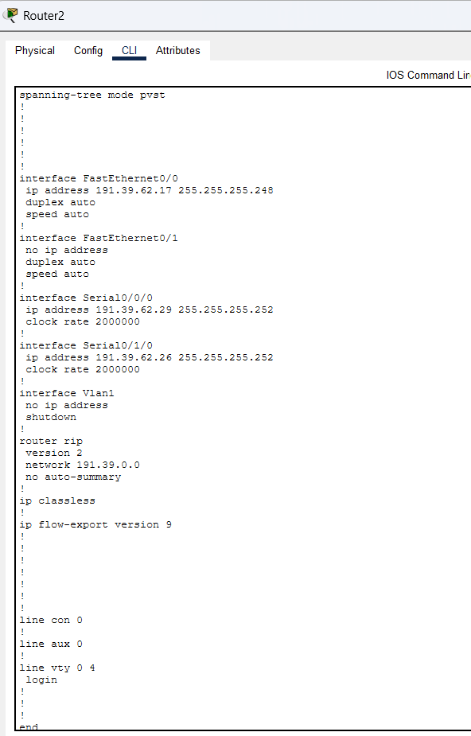
Figure-2.2 Router 2 CLI Configuration
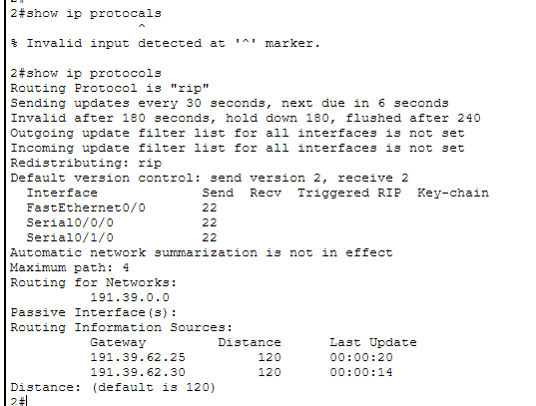
Figure-2.3 Router 2 RIP Configuration.

5.2 Router Configuration – Subnet B
Table – Subnet B IP & RIP
Device | IP Address | Mask | Gateway
Server B | 191.39.62.13 | /29 | 191.39.62.9
PC B1 | 191.39.62.10 | /29 | 191.39.62.9
PC B2 | 191.39.62.11 | /29 | 191.39.62.9
PC B3 | 191.39.62.12 | /29 | 191.39.62.9
R2 G0/0 | 191.39.62.9 | /29 | –
RIP Networks: 191.39.62.8, 191.39.62.24, 191.39.62.28

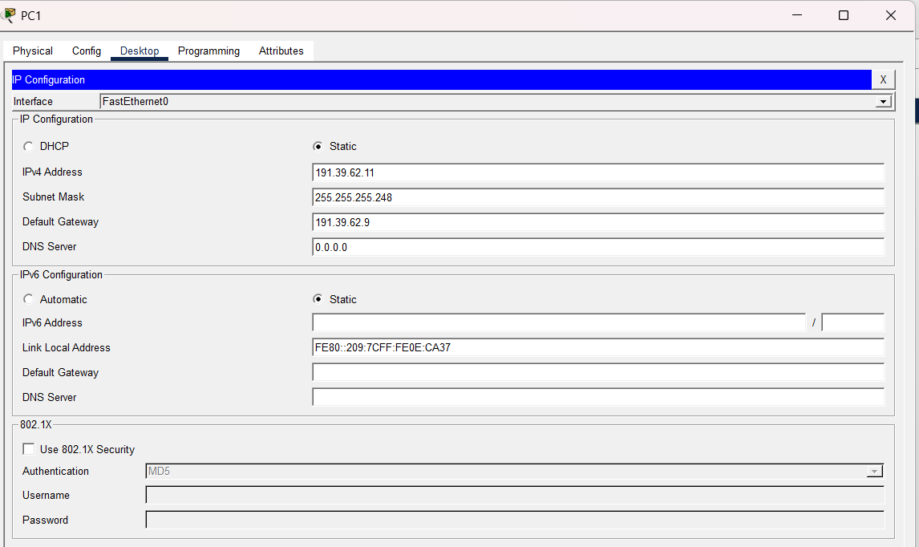

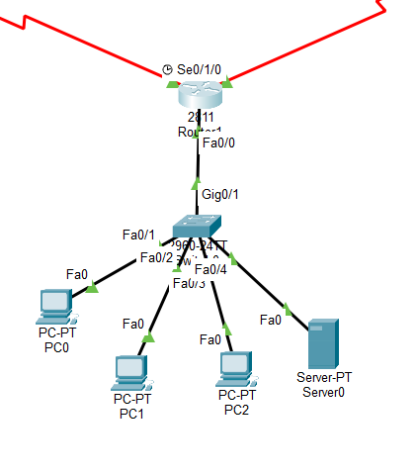
Figure 3.1: Subnet B wired LAN showing PCs, server, switch, and router R1.
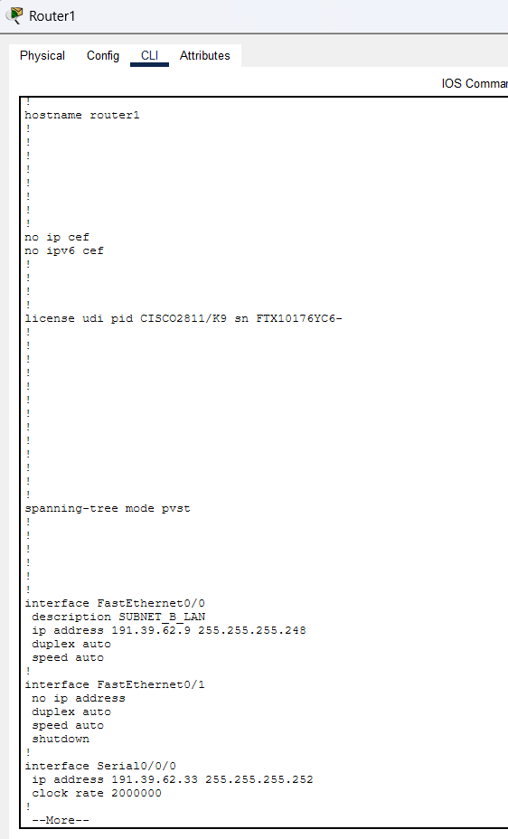
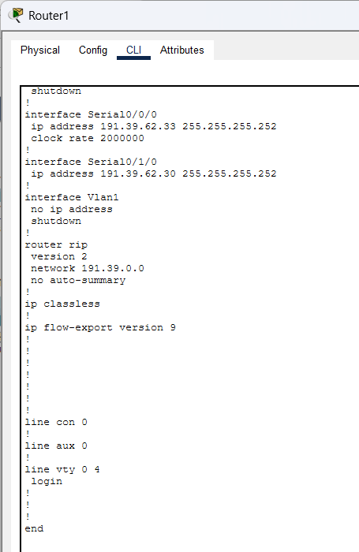
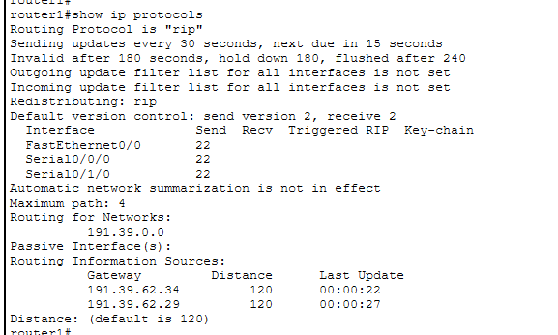
Figure-3.3 Router 1 RIP Configuration.
5.3 Router Configuration – Subnet A
Table – Subnet A IP & RIP
Device | IP Address | Mask | Gateway
Server C | 191.39.62.2 | /29 | 191.39.62.1
PC C1 | 191.39.62.3 | /29 | 191.39.62.1
PC C2 | 191.39.62.4 | /29 | 191.39.62.1
PC C3 | 191.39.62.5 | /29 | 191.39.62.1
PC C4 | 191.39.62.6 | /29 | 191.39.62.1
R3 G0/0 | 191.39.62.1 | /29 | –
RIP Network: 191.39.62.0
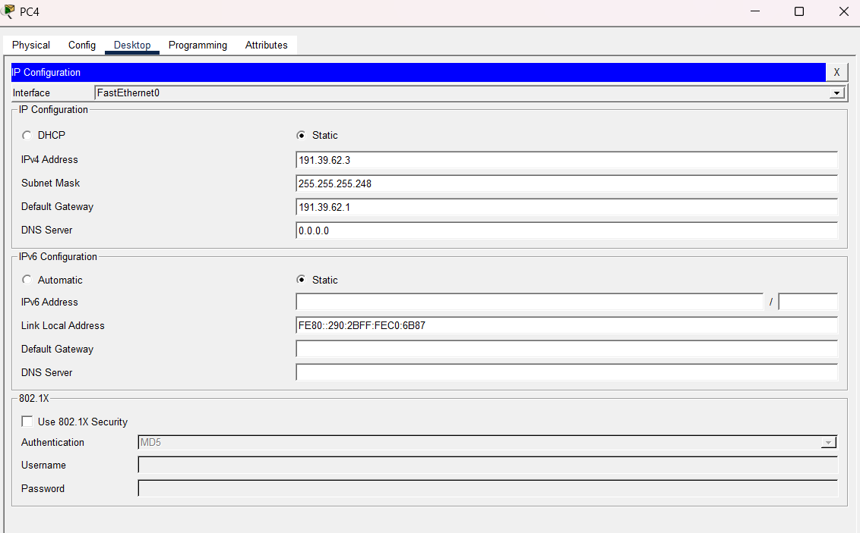
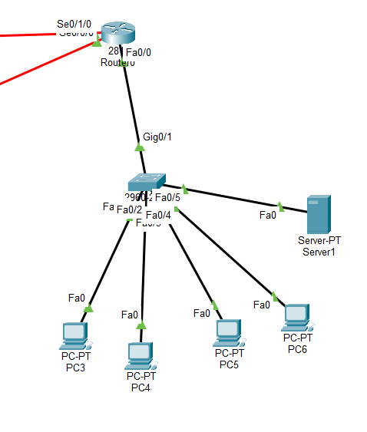
Figure 4.1: Subnet C wired LAN showing four PCs, server, switch, and router R0.
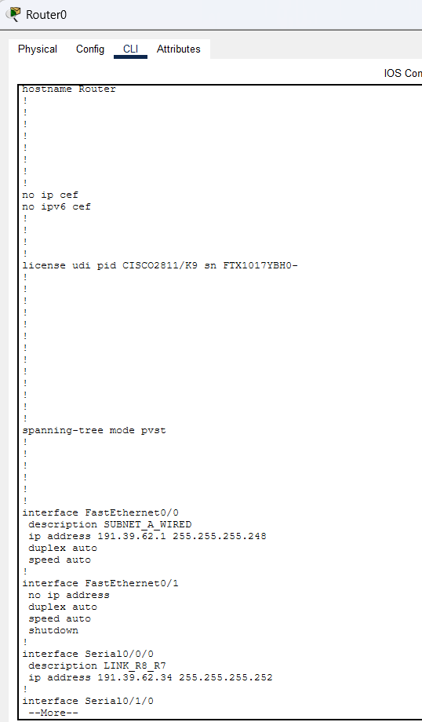
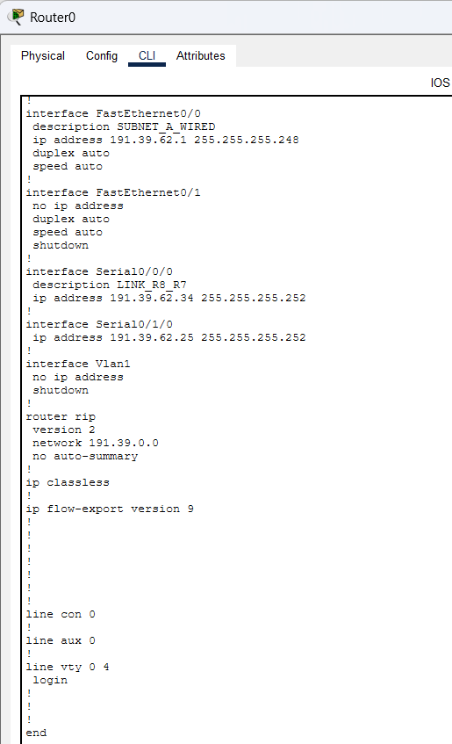
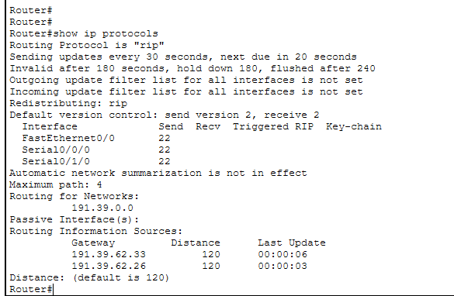
Figure-4.3 Router 2 RIP Configuration.
6.PING COMMAND TESTING:
6.1Ping testing from Subnet C :
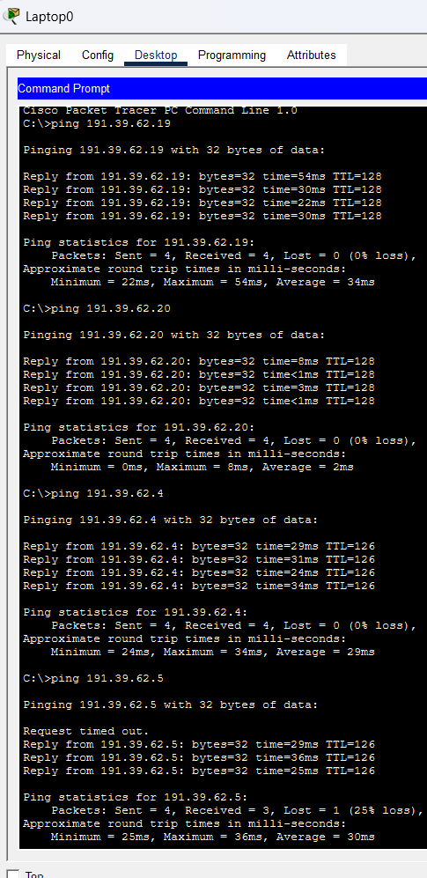

6.2Ping testing from Subnet B: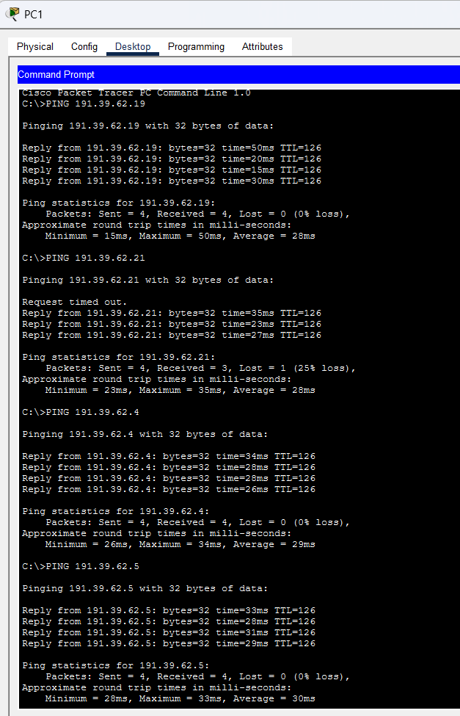

6.3Ping testing from Subnet A (wireless):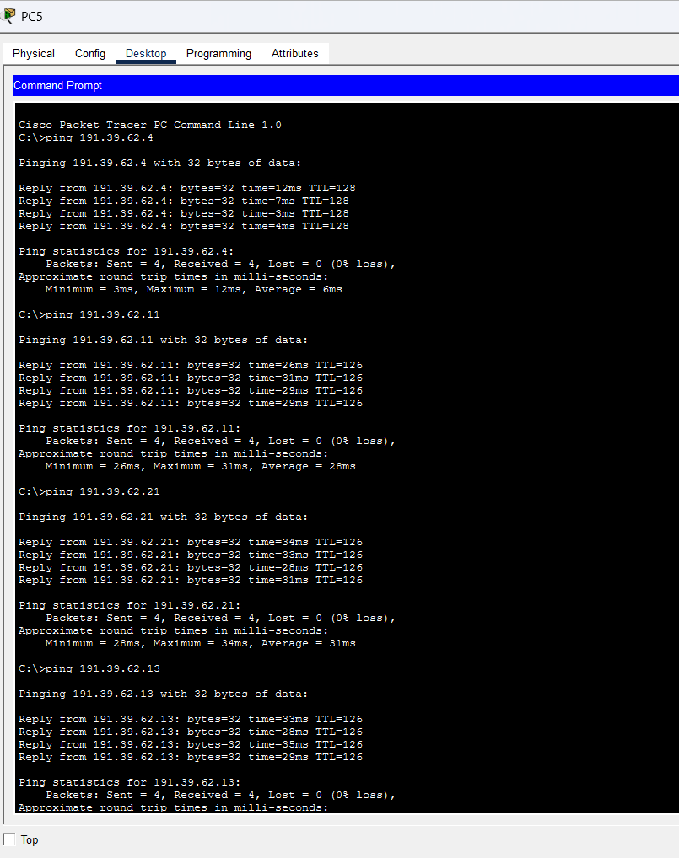

7.SIMPLE PDU OUTPUT WINDOW:

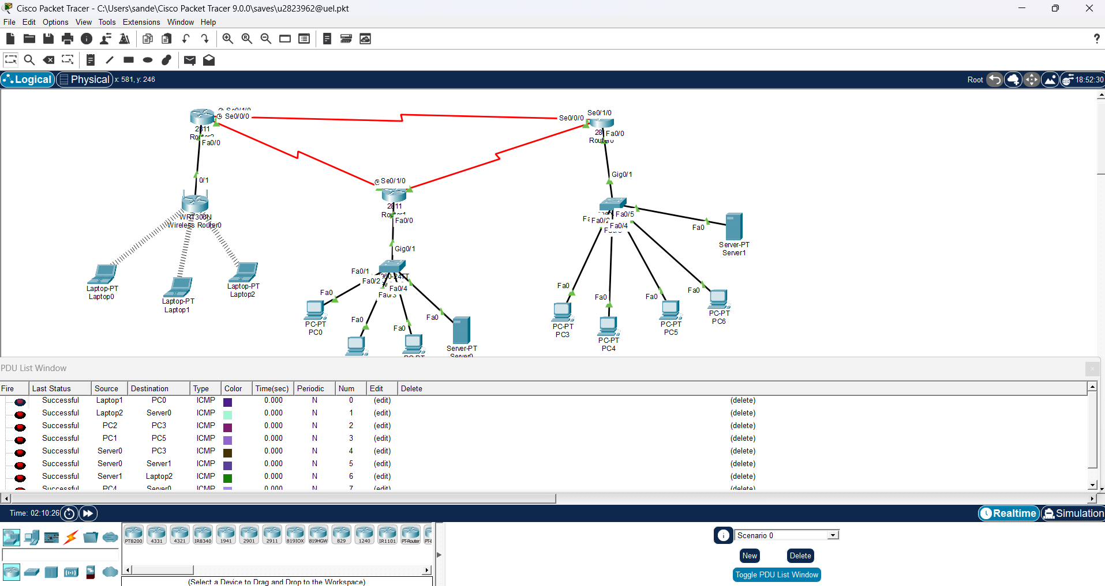8.COMPLEX PDU OUTPUT:
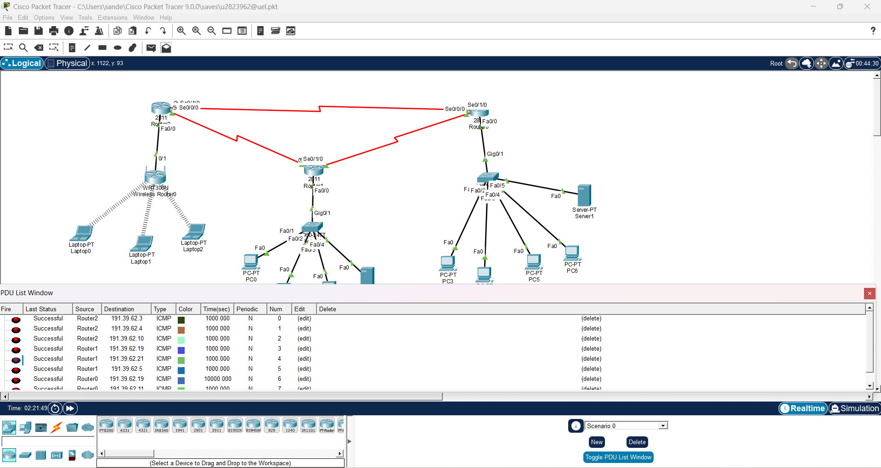

9. Simulation and Testing
The validation of the designed hybrid network was carried out through simulation in Cisco Packet Tracer. After configuring all devices — including routers, switches, servers, PCs, laptops, the wireless access point, and DHCP services — the topology was tested to ensure seamless communication across all subnets.
Two primary tools were employed during testing:
Simple PDU (Protocol Data Unit): Used to trace packet flow across the network, verifying that routing tables were correctly updated and that packets reached their intended destinations.
- Ping (ICMP Echo Request): Applied to confirm end-to-end connectivity between devices, ensuring that both wired and wireless hosts could communicate reliably.
The simulation process involved sending test packets between devices in different subnets (A, B, and C) and across router links (D, E, and F). Successful delivery of packets confirmed that:
- Routing operations via RIP v2 were functioning correctly.
- DHCP assignment in Subnet A was automatically provisioning IP addresses to wireless clients.
- Static addressing in Subnets B and C allowed stable communication for servers and PCs.
- Cross-subnet communication was achieved without packet loss, validating the router configurations.
Results and Expected Outcomes
- All devices responded successfully to ping requests, demonstrating full connectivity.
- Wireless laptops obtained IP addresses dynamically from the DHCP pool and communicated securely via WPA2 encryption.
- Wired hosts maintained stable communication using static IPs.
- Router interfaces exchanged packets across point-to-point links without errors, confirming correct subnetting and cabling.
The simulation results matched the expected outcomes, proving that the network design was both functional and reliable. The packet flow analysis validated the efficiency of the addressing scheme, routing configuration, and security mechanisms, ensuring the hybrid topology met the project objectives.

10. Subnet A DHCP Tests:
The initial simulation was conducted to verify DHCP functionality within the wireless subnet. Since Subnet A is configured to operate entirely on DHCP, laptops were expected to automatically obtain IP addresses from the pool defined on Router R6.
Steps Performed
- Activated wireless mode on the laptops and connected them to the SSID CourseLab.
- Logged in using the WPA2 password resitha123.
- Set each laptop’s IP configuration mode to DHCP.
- Observed the automatic assignment of IP addresses in the configuration panel of each laptop.
Expected Result
- Laptop1, Laptop2, and Laptop3 should be allocated addresses 191.39.62.19 – 191.39.62.21.
- Default gateway: 191.39.62.17
- DNS server: 8.8.8.8
Actual Result
- All laptops successfully acquired DHCP leases.
- This confirmed that:
  - Router R6’s DHCP pool was correctly configured.
  - Wireless AP forwarding was active and functional.

11. Simulation and Testing
Once the network was configured in Cisco Packet Tracer, the design was validated through simulation. Testing was carried out step by step, beginning with DHCP in the wireless subnet, moving through static addressing in the wired LANs, and finally verifying router-to-router links. The process combined observation in simulation mode with ping tests to confirm end-to-end connectivity.

11.1 Subnet A – DHCP Validation
Laptops connected wirelessly to SSID CourseLab using WPA2 security. With DHCP enabled, each laptop automatically received an IP lease from Router R6’s pool.
- Expected: IPs 191.39.62.19 – 191.39.62.21, Gateway 191.39.62.17, DNS 8.8.8.8
- Actual: All laptops successfully acquired DHCP leases, proving DHCP pool correctness, AP forwarding, and WPA2 compatibility.
Table 15 – Subnet A Connectivity:
Source | Destination | Result (S/F) | Notes
Laptop1 | Laptop2 | S | Same subnet
Laptop1 | Server B | S | Routed via R1 → R2
Laptop1 | Server C | S | Routed via R1 → R3

11.2 Subnet B – Static Addressing Validation:
In Subnet B, PCs and Server B were configured with static IPs. Ping tests between hosts showed immediate success, confirming that the switch forwarded frames locally without routing.
- Expected: Switch handles intra-LAN traffic via MAC tables.
- Actual: All pings succeeded; simulation mode showed green frames between local hosts only.
Table 16 – Subnet B Connectivity
Source | Destination | Result (S/F) | Notes
PC B1 | PC B2 | S | Same subnet via switch
PC B3 | Server B | S | Static IPs validated
Server B | Laptop1 | S | Routed via R2 → R1

11.3 Subnet C – Static Addressing Validation
Subnet C devices also used static IPs. Connectivity checks confirmed smooth communication between PCs and Server C, as well as routing to wireless laptops.
Table 17 – Subnet C Connectivity
Source | Destination | Result (S/F) | Notes
PC C1 | PC C2 | S | Same subnet via switch
Server C | PC C3 | S | Static IPs validated
Server C | Laptop2 | S | Routed via R3 → R1

11.4 Router Link Tests (Subnets D, E, F)
Finally, point-to-point router links were tested to confirm RIP v2 routing and inter-router communication.
Table 18 – Subnet D (R1 ↔ R2)
Source | Destination | Result (S/F)
R1 | R2 | S
R2 | R1 | S
Table 19 – Subnet E (R2 ↔ R3)
Source | Destination | Result (S/F)
R2 | R3 | S
R3 | R2 | S
Table 20 – Subnet F (R1 ↔ R3)
Source | Destination | Result (S/F)
R1 | R3 | S
R3 | R1 | S

Overall Outcome
The simulation confirmed that:
- DHCP worked seamlessly in the wireless subnet.
- Static addressing was stable in the wired subnets.
- Router links carried traffic without error.
- RIP v2 routing propagated routes correctly across all subnets.

12. Evaluation of the Designed Network
12.1 Strengths
The designed network displayed several clear strengths that underline its efficiency, reliability, and security:
- Efficient Subnetting
The use of /29 and /30 subnet masks ensured that IP addresses were allocated with minimal wastage. Each subnet was tailored to its exact host requirements, which not only conserved address space but also provided logical separation. This separation improved traffic isolation, reduced broadcast domains, and enhanced overall security.
- Effective Hybrid Integration
The combination of wired and wireless LANs allowed the network to balance stability with flexibility. Wired connections offered predictable performance and low latency, while the wireless LAN provided mobility for laptops and portable devices. Together, they created a hybrid environment that mirrors real-world enterprise needs.
- Correct Routing Behaviour
Dynamic routing using RIP v2 was implemented successfully. Routers R6, R7, and R8 exchanged routes automatically, ensuring that all subnets were interconnected without manual intervention. This confirmed that routing tables were correctly populated and that packet forwarding across multiple hops was seamless.
- Secure Wireless Deployment
The wireless subnet was protected with WPA2 encryption, preventing unauthorized access. This ensured that only authenticated users could connect to the SSID, maintaining confidentiality and integrity of wireless communications.
- Accurate DHCP Operation
Router R6’s DHCP pool was configured to assign addresses exclusively to laptops in Subnet A. This avoided conflicts, maintained proper segmentation, and simplified IP management. The DHCP service worked exactly as intended, proving the robustness of the configuration.

12.2 Challenges and Troubleshooting
While the final design was successful, several challenges arose during simulation. Each issue provided valuable learning opportunities and was resolved systematically:
- Incorrect AP Cabling
  - Issue: The Access Point was initially connected to the WAN port, which blocked DHCP communication.
  - Resolution: Reconnected Router R6 to the AP’s LAN port, enabling proper DHCP forwarding.
- Missing RIP Network Statements
  - Issue: Some routers had incomplete routing tables due to missing network statements.
  - Resolution: Added all directly connected networks to each router’s RIP configuration, ensuring full route propagation.
- Wrong Subnet Masks on PCs
  - Issue: A few PCs were mistakenly configured with /24 masks, which caused addressing mismatches.
  - Resolution: Corrected the masks to /29, aligning them with the subnet design and restoring communication.
- DHCP Conflicts
  - Issue: The AP’s internal DHCP service was active, creating conflicts with Router R6’s DHCP pool.
  - Resolution: Disabled AP DHCP, leaving Router R6 as the sole DHCP server. This eliminated conflicts and ensured consistent address assignment.
After these adjustments, the network operated exactly as intended, with stable routing, proper addressing, and secure communication across all subnets.
13. Conclusion
This coursework has effectively showcased the end-to-end design and validation of a hybrid wired–wireless network within Cisco Packet Tracer. Beginning with the allocation of a dedicated IPv4 address block, the system was intelligently sub netted to create three distinct LANs alongside three router interconnection networks. The process not only demonstrated technical precision in addressing and topology but also highlighted the practical integration of wired stability with wireless flexibility. Overall, the project reflects a balanced, well-engineered solution that meets academic rigor while illustrating real-world applicability.
The infrastructure combined:
- Static addressing for wired hosts, ensuring predictability and stability.
- DHCP services for wireless devices, simplifying configuration and enhancing mobility.
- WPA2 encryption for secure wireless access, protecting against unauthorized connections.
- RIP v2 routing for dynamic route exchange, enabling seamless interconnectivity.
The simulation verified seamless communication across all devices — both wired and wireless ensuring that subnetting, routing, addressing, and security configurations operated as intended. Beyond simple connectivity, the use of simulation mode offered valuable visibility into packet flow, DHCP leasing, ARP resolution, and ICMP routing, deepening the understanding of how each protocol contributes to overall network performance.
Ultimately, the design fulfilled every requirement of the brief while providing hands-on experience in constructing a realistic small-enterprise topology. By harmonizing efficiency with adaptability, the network delivered a secure, scalable, and future-ready environment that mirrors the expectations of modern organizational infrastructures.

References:
- Instructables – How to Configure DHCP in Cisco Packet Tracer Explains step-by-step DHCP setup on routers and servers in Packet Tracer. Link
- GeeksforGeeks – DHCP Server Configuration in Cisco Covers DHCP server setup and verification in Cisco Packet Tracer. Link
- CCNA Tutorials – Configuring WPA2 in Packet Tracer Explains WPA2-PSK and WPA2-Enterprise setup for secure wireless networks. Link
- FreeCodeCamp – Subnet Cheat Sheet (/29, /30, etc.) Provides CIDR notation, subnet masks, and usable host ranges for efficient subnetting. Link

