**NAME-JATIN AGGARWAL**

**UID-19BCS3786**

**SUBJECT-BEEE LAB**

**AIM:**

**Design an automatic night lighting system (with 4 connected led’s) such the system is only activated when the master control switch is pressed. a) Below 50% value of full brightness all LED’s constantly ON. b) Above 50% value of full brightness only first LED is ON.**

**CIRCUIT DIAGRAM:**

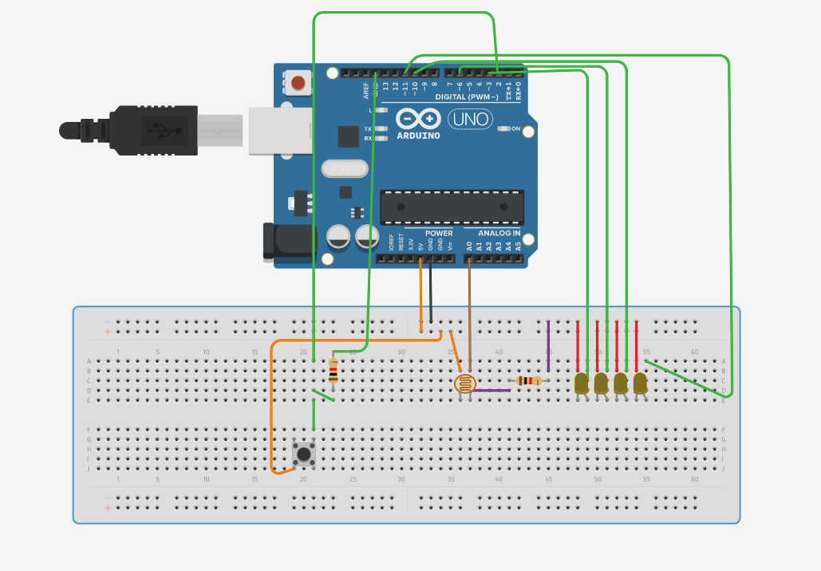

**THEORY:**

Arduino is an open-source electronics platform based on easy-to-use hardware and software. Arduino boards are able to read inputs - light on a sensor, a finger on a button. Arduino can also be used for led chasers .

**LEARNING AND OBSERVATIONS:**

1. How led blink with using code.
2. How we can change the delay that is time of blinking.
3. When the LDR senses the light, accordingly led changes.

**PROBLEM AND TROUBLESHOOTING:**

1) Setting up a connection.

2) Errors in code.

3) Port was not selected.

4) Internet network poor.

**PRECAUTIONS:**

1. Don’t plug in a LED without a current limiting resistor.
2. Circuit should be properly set into breadboard.
3. Don’t supply high voltage.

**LEARNING OUTCOMES:**

1. Came to know about Arduino.
2. Came to know about how to design a circuit and blink LED without using battery.
3. Came to know about loops.