**EXPERIMENT:-5**

**Design an automatic Night Lamp.**

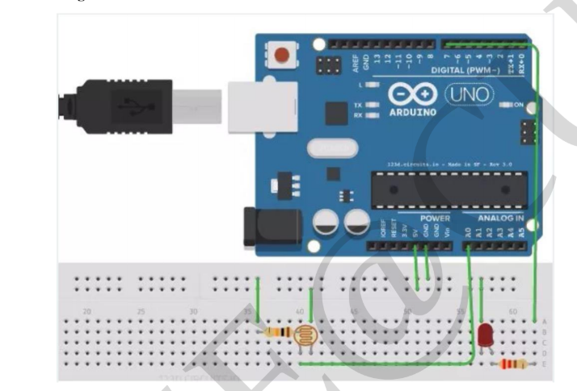

**THEORY:-**

**The automatic light lamp is made up of LED ,LDR,Resistors.**

**The LDR is a component that has variable resistance that changes with the light intensity that falls on it,this allows them to be used in light sensing circuits.**

**Projects:-**

**Learning and Observations**

**1.Observed the blinking of LED when it is dark.**

**2.The LED stops blinking when there is light.**

**3.Working of arduino .**

**4.Coding for arduino to glow the LED in dark.**

**Code:**

**Program**

**const int lamp = 7;**

**void setup() {**

**Serial.begin(9600);**

**pinMode(lamp, OUTPUT);**

**}**

**void loop() {**

**int c = analogRead(A0);**

**delay(500);**

**if ( c<300){**

**digitalWrite(lamp,HIGH);**

**delay(1000);**

**}**

**else {**

**digitalWrite(lamp,LOW);**

**delay(1000);**

**}**

**}**

**PRECAUTION:-**

**1.There should not be any loose in connections.**

**2.Code should be written properly.**

**3.Arduino should be attached to the PC properly.**