**Exeperiment:7**

**Design a programmable digital data system.**

**Circuit: tt**

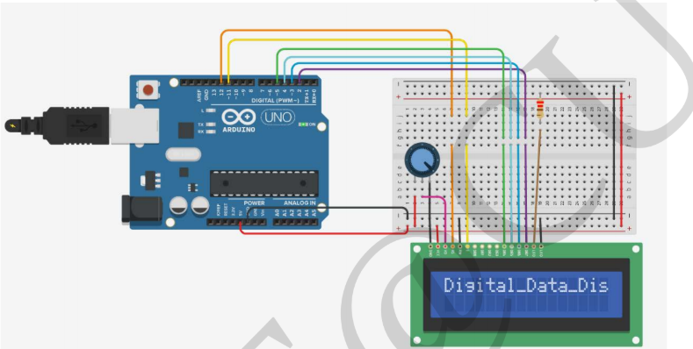

Theory:

This design helps us to see the words on the screen.every digital data we are obersving now depends on this circuit.

Learning and objectives:

1.Connecting of display to arduino.

2.coding for the display.

3.working of display.

PROJECT:

CODE:

#include <LiquidCrystal.h>

int rs = 12, en = 11, d4 = 5, d5 = 4, d6 = 3, d7 = 2;

LiquidCrystal lcd(rs, en, d4, d5, d6, d7);

void setup() {

lcd.begin(16, 2);

Serial.begin(9600);

}

void loop()

if (Serial.available()) {

delay(100);

while (Serial.available() > 0) {

lcd.write(Serial.read());}

}

}

**PRECAUTION:-**

**1.There should not be any loose in connections.**

**2.Code should be written properly.**

**3.Arduino should be attached to the PC properly.**