**EXPERIMENT:- 4**

Design a smart phone controlled system to control light and

motor.

Block Diagram:-

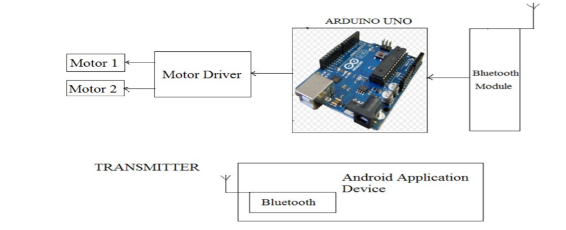

**Theory:-**

**Now a days everything is connected to smartphones .In this circuit the Bluetooth of the phone is connected with the Bluetooth of the module and help in glowing the LED and running the motor.**

**Learning and Outcome:-**

**1.To connect the Bluetooth of the smart phone to Bluetooth of the module.**

**2.To code for the circuit**

**3.Connection the Bluetooth module to the circuit.**

**Code:**

**char data = 0;**

**void setup()**

**{**

**Serial.begin(9600);**

**pinMode(13, OUTPUT);**

**}**

**void loop()**

**{**

**if(Serial.available() > 0)**

**{**

**data = Serial.read();**

**Serial.print(data);**

**Serial.print("\n");**

**if(data == '1')**

**digitalWrite(13, HIGH);**

**else if(data == '0')**

**digitalWrite(13, LOW);**

**}**

**}**

**PRECAUTION:-**

**1.There should not be any loose in connections.**

**2.Code should be written properly.**

**3.Arduino should be attached to the PC properly.**