**EXPERIMENT-3**

**Design a doorbell using push button.**

**Circuit Diagram:-**

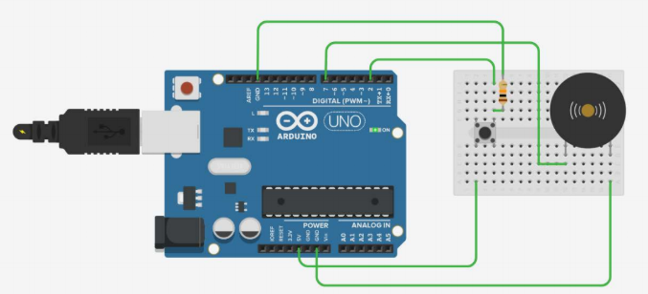

**Theory:-Using the push button we can ring the door bell .These are usually used at homes.**

**Projects:-**

**Learning and Observations:-**

**1.Observing the ringing of door bell.**

**2.Working of arduino.**

**3.Coding of arduino for blinking LED.**

**Precautions:-**

**1.There should not be any loose in connections.**

**2.Code should be written properly.**

**3.Arduino should be attached to the PC properly.**

**Code:-**

**Program**

**const int switchPin = 2;**

**const int bellPin = 7;**

**int bellState = LOW;**

**int switchState=LOW;**

**input pin**

**int lastswitchState = LOW;**

**pin**

**unsigned long lastDebounceTime = 0;**

**was toggled, unsigned longs because the time,**

**will quickly become a bigger number than can be stored in an int**

**unsigned long debounceDelay = 10;**

**if the output flickers**

**void setup() {**

**pinMode(switchPin, INPUT);**

**pinMode(bellPin, OUTPUT);**

**digitalWrite(bellPin, bellState);**

**}**

**void loop() {**

**int reading = digitalRead(switchPin)**

**if (reading != lastswitchState) {**

**lastDebounceTime = millis();**

**}**

**if ((millis() - lastDebounceTime) > debounceDelay) {**

**the debounce**

**if (reading != switchState) {**

**switchState = reading;**

**if (switchState == HIGH) {**

**bellState = !bellState;**

**}**

**}**

**}**

**digitalWrite(bellPin, bellState);**

**lastswitchState:**

**lastswitchState = reading;**

**}**