**EXPERIMENT:-6**

**Design an obstacle detector and distance measuring device.**

**Circuit Diagram:-**

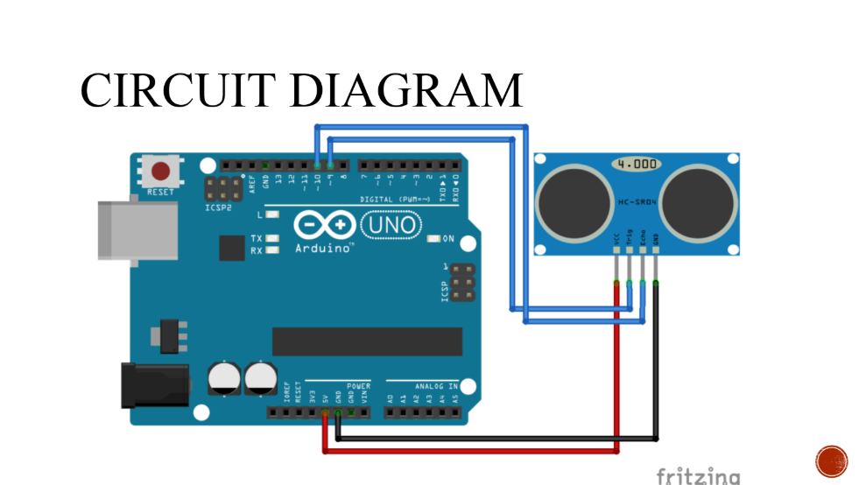

**Theory:-**

**The ultrasonic sensor which is used in it helps in measuring distance by ultrasonic waves.The sensor head emits an ultrasonic wave and receives the wave reflected back from the target.It is used for helping blind people.**

**Project:-**

**Learning and Observation:-**

**1.Working of arduino when connected with ultrasonic sensor.**

**2.Fuction of ultrasonic sensor.**

**3.Coding for arduino when connected with ultrasonic sensor.**

**Code:**

**const int trigPin = 9;**

**const int echoPin = 10;**

**long duration;**

**int distance;**

**void setup() {**

**pinMode(trigPin, OUTPUT);**

**pinMode(echoPin, INPUT);**

**Serial.begin(9600);**

**}**

**void loop() {**

**digitalWrite(trigPin, LOW);**

**delayMicroseconds(2);**

**digitalWrite(trigPin, HIGH);**

**delayMicroseconds(10);**

**digitalWrite(trigPin, LOW);**

**duration = pulseIn(echoPin, HIGH);**

**Serial.print("Distance: ");**

**Serial.println(distance);**

**}**

**PRECAUTION:-**

**1.There should not be any loose in connections.**

**2.Code should be written properly.**

**3.Arduino should be attached to the PC properly.**