**BEEE Evaluation phase-1**

***Question*:-**Design a system that automatically rings a bell for 2 ms whenever someone enters a temple, assuming only one person can enter at a time.

**Circuit Diagram:-**

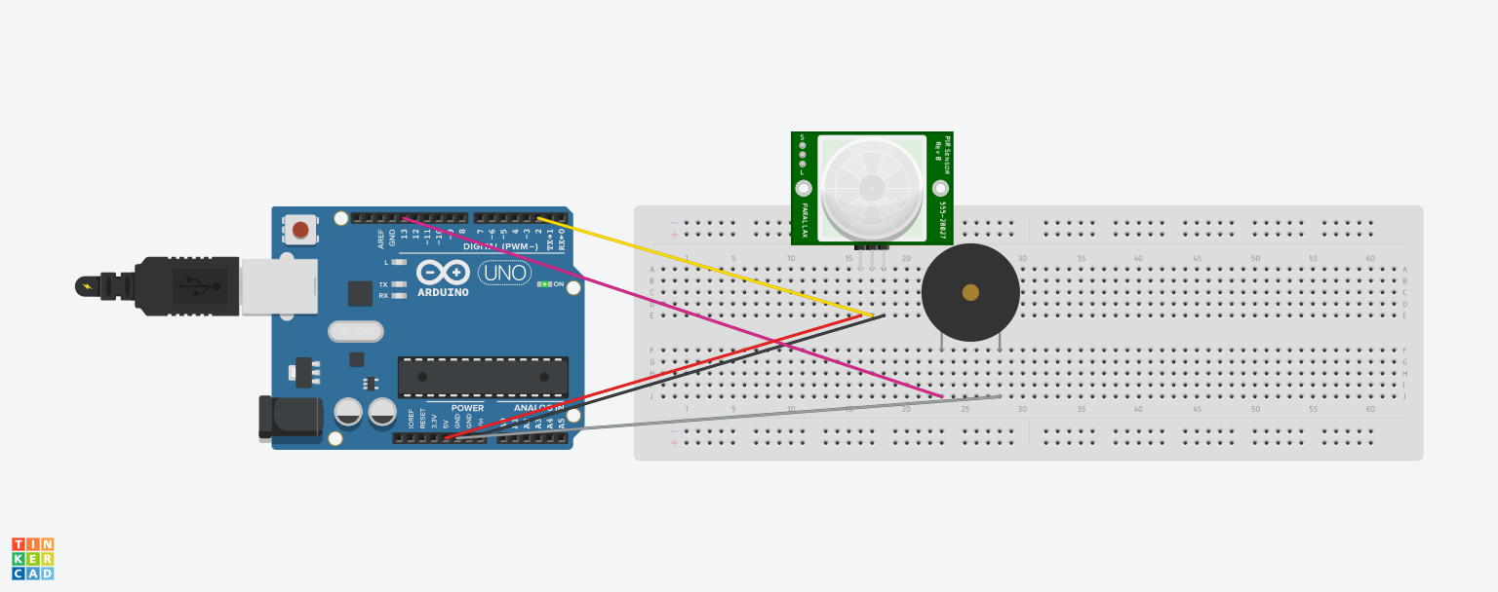

**Theory:-**

**This experiment is on motion detection sensor and buzzer.**

**Components Required:-**

**1-PIR Motion Detector**

**2-Piezo Buzzer**

**3-Bread Board**

**4- Arduino UNO**

**5.Connecting wires**

**Learning and Observations:-**

**1.This is a motion detector and buzzer**

**2.This buzzer starts ringing when PIR Motion detector detects motion.**

**3. In this when a person enters a temple the Buzzer starts ringing and continues for 2 ms.**

**Precautions:-**

1. **There should be no loose connections in the circuit.**
2. **Code should be written properly.**
3. **Arduino should be attached to the PC or Laptop properly.**

**Code:-**

**int buzzerPin = 13;**

**int inputPin = 2;**

**int pirState = LOW;**

**int signal = 0;**

**void setup() {**

**pinMode(buzzerPin, OUTPUT);**

**pinMode(inputPin, INPUT);**

**Serial.begin(9600);**

**}**

**void loop(){**

**signal = digitalRead(inputPin);**

**if (signal == HIGH) {**

**digitalWrite(buzzerPin, HIGH);**

**delay(2000);**

**if (pirState == LOW) {**

**Serial.println("Motion detected!");**

**pirState = HIGH;**

**}**

**} else {**

**digitalWrite(buzzerPin, LOW);**

**if (pirState == HIGH){**

**Serial.println("Motion ended!");**

**pirState = LOW;**

**}**

**}**

**}**