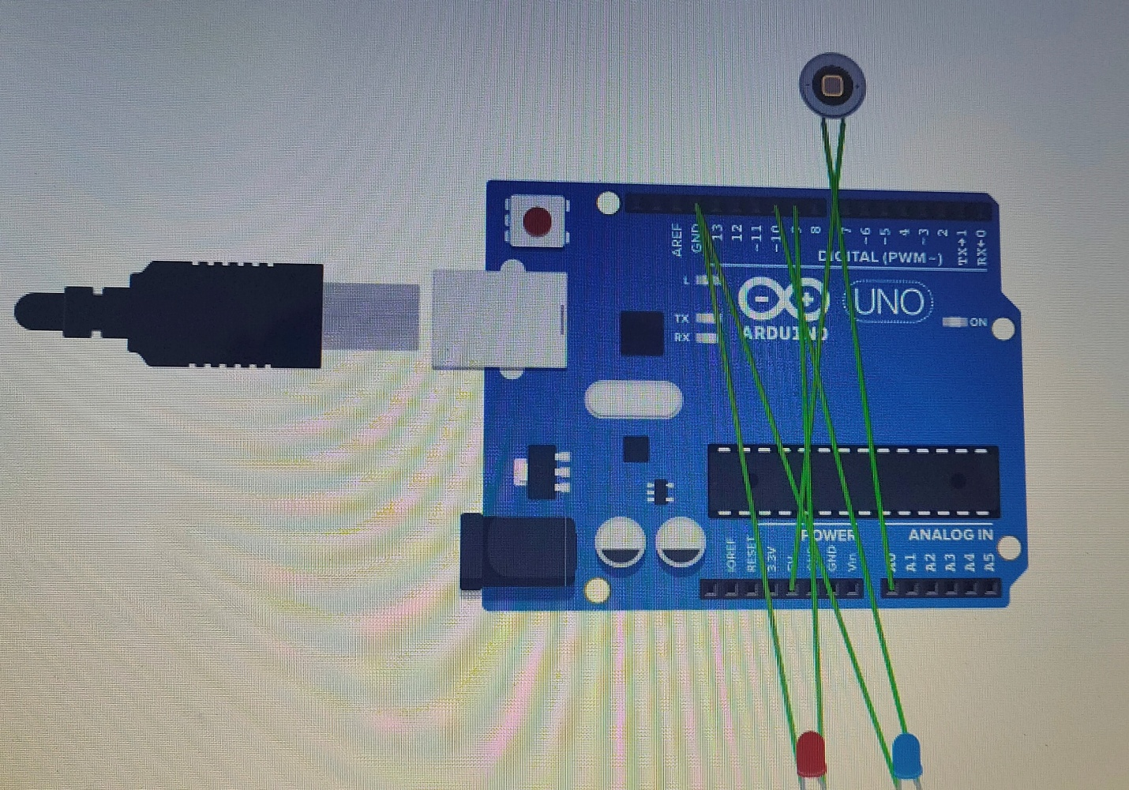

**Theory:-**

**Concept used:-** As the task says Design a system for a red colored magical heart pendant that blinks 60 times a minute and stops blinking and turns blue during night. So, according to the darkness, the sensor will detect the light , if it’s a day then the light will blink 60 times in one minute and if it’s night then the light will turn blue.

**Learning And Observation:-** Learned about connecting circuits and the mechanism used in this task and working of sensor.

**Problems And Troubleshooting:-**

1.Detection of day and night.

I searched about how sensor detects brightness and darkness and according to that I coded the circuit.

**Precautions:-**

1.We have to use analog pins for the sensors.

**Learning And Outcomes:-** As the sensor detects that it is day time it starts blinking the red light 60 times in a minute and when it is night the color of pendant turns blue.