EXP-5:Light System

(Controlled by smartphone)

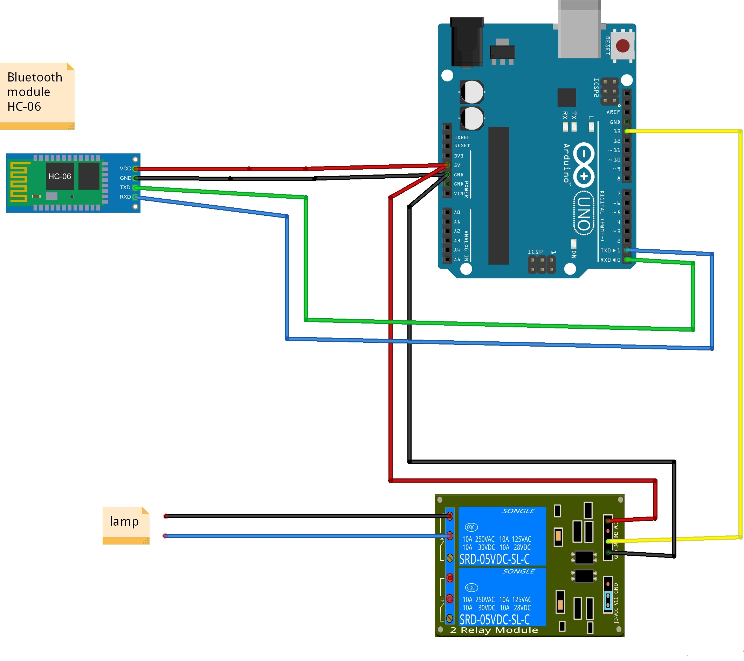

Circuit diagram-:

Theory-:

Concept Used-:

* With bluetooth module light can be controlled.
* Use of HC-05 Bluetooth module.
* Use of external module.

LEARNING AND OBSERVATIONS:

• Connections in Breadboard and wiring.

• How to control arduino and its coding.

• Use of multimeter for continuity.

OBSERVATION:

* Led controlled with Bluetooth.
* Relation between software and hardware.

PROBLEMS & TROUBLESHOOTING:

* To select the right port and type of Arduino.
* To check the loose connections.
* To check the connections according to the codes.
* To check the continuity of the circuit.
* To check the flow of current in the circuit.

PRECAUTIONS:

* Handle Module carefully.
* Do not connect arduino till the circuit is complete.

OUTCOMES:

* Light blinking when pressed on from smartphone.