**Exp. 6 :Obstacle Detector and Distance Measurement**

**Circuit Diagram:**

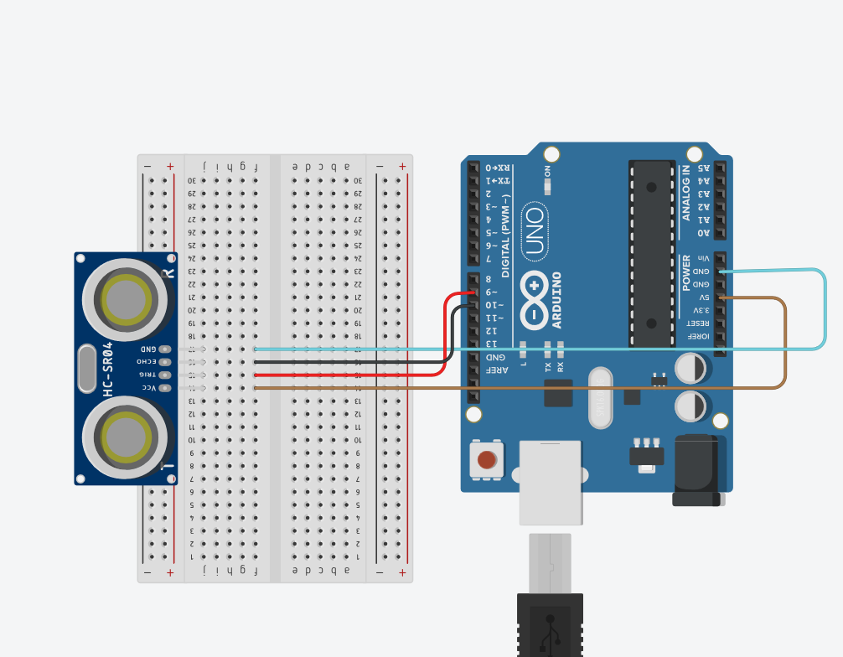

**Theory:-**

Concept Used:

* Ultra Sonic sensor is a device which is capable of transmitting and receiving ultra sonic sound waves out into the air and calculates the distance from the sensor to the obstacle by making use of the time required for the sound wave to reach back the sensor.

Learning & Observations:

* I learned how A Ultrasonic Sensor works and its connections with Arduino using breadboard.
* I learned about how Ultrasonic Sensor real life Applications.
* When the wave hits obstacle it reverts back and the distance between obstacle and the sensor is calculated.

Problems & Troubleshooting:

* There was problem while uploading code to Arduino , as the port selected was incorrect hence, to solve it I change the PORT.
* The sensor was not detecting the object as there was error in code . So, code was debugged.

Precautions:

* Arduino Board should be kept at dry place.
* Correct Board/Port is to be selected.
* All connections should be tight.
* No objects should be placed in front of sensor.
* The Trigger pin should be connected with pin as Output mode.
* The Echo pin should be connected with pin as Input Mode.

Learning Outcomes:

* How the waves are sent and received by sensor when object is detected.
* Whenever person passes by The waves are bounced back and the whole time taken is T whereas to reach the object it is t/2.
* Learnt how to make connections between sensor and Arduino using breadboard.