**Exp. 1** **Design a system that automatically turns on the lights inside an almirah whenever it is opened, (irrespective of day/night)**

**Circuit Diagram:**

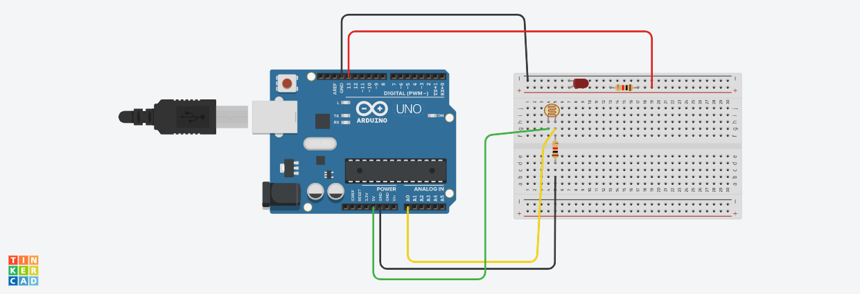

**Theory:**

**Concept Used:** Way in which photo resistor reacts with light to perform certain functions like the turning ON and OFF of an LED.

**Learning & Observations:** Learned how photo resistor reacts with light. When light is put over the sensor, Led connected gets lit up, and when there is no light(below a certain value) Led does not glow.

**Problems & Troubleshooting**

1. Some errors in the circuit like connection of wires to the wrong ports were to be corrected in order to attain a working circuit.
2. Errors in the code for pin connections occurred that were resolved after some corrections.

**Precautions**

* Check every connection twice.
* Grounds should be connected, unless you know you want them separated.
* Don't plug in an LED without a current limiting resistor.
* Don't plug it into unknown circuit.

**Learning Outcomes**

* Familiar with Arduino environment and its applications.
* Getting familiar with the working of light sensor.
* Able to Design Smart systems applications.