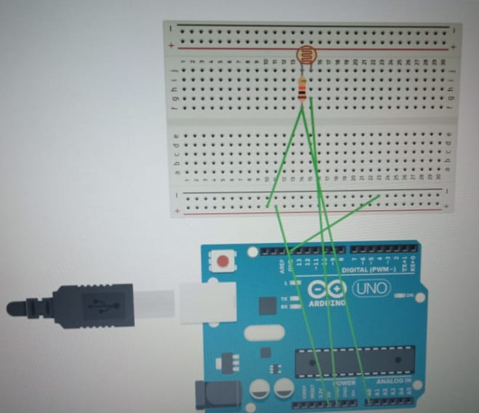Theory

Light dependent resistor (LDR) or a photo resistor is a device whose resistivity is a function of the incident electromagnetic radiation. Hence, they are light sensitive devices. They are also called as photo conductors, photo conductive cells or simply photocells.

Learning & observations:

In this project we create a detection system with which we can monitor for number of people entering a building.it can be used as a sec.

#### Problems & troubleshooting

Problems faced during this project:-

Load short-circuiting

Incorrect wiring

### Precautions

Do not short-circuit the load doing so may cause explosion or burning.

Do not reverse the power supply polarity or otherwise wire incorrectly. Doing so may cause explosion or burning.

#### Learning outcomes

We need to be careful with the wiring and power supply so as not to damage the circuit due to overload and short circuiting.

#### 

#### Experimenting:-We placed the lights in different connection and finally reached the concluding circuit.