# Blood bank Management System in Java

**A** **Project** **Work** **Report**

*Submitted* *in* *the* *partial* *fulfilment* *for* *the* *award* *of* *the* *degree* *of*

**BACHELOR** **OF** E**NGINEERING**

**IN**

# Internet of things

**Submitted** **by:**

**NAME** **OF** **THE** S**TUDENT**

**Parikshit sharma**

**University** **Roll** **Number=19BCS4520**

**Under** **the** **Supervision** **of:**

**SUPERVISOR’S** **NAME**

Dr.Durgesh Kumar Srivastava

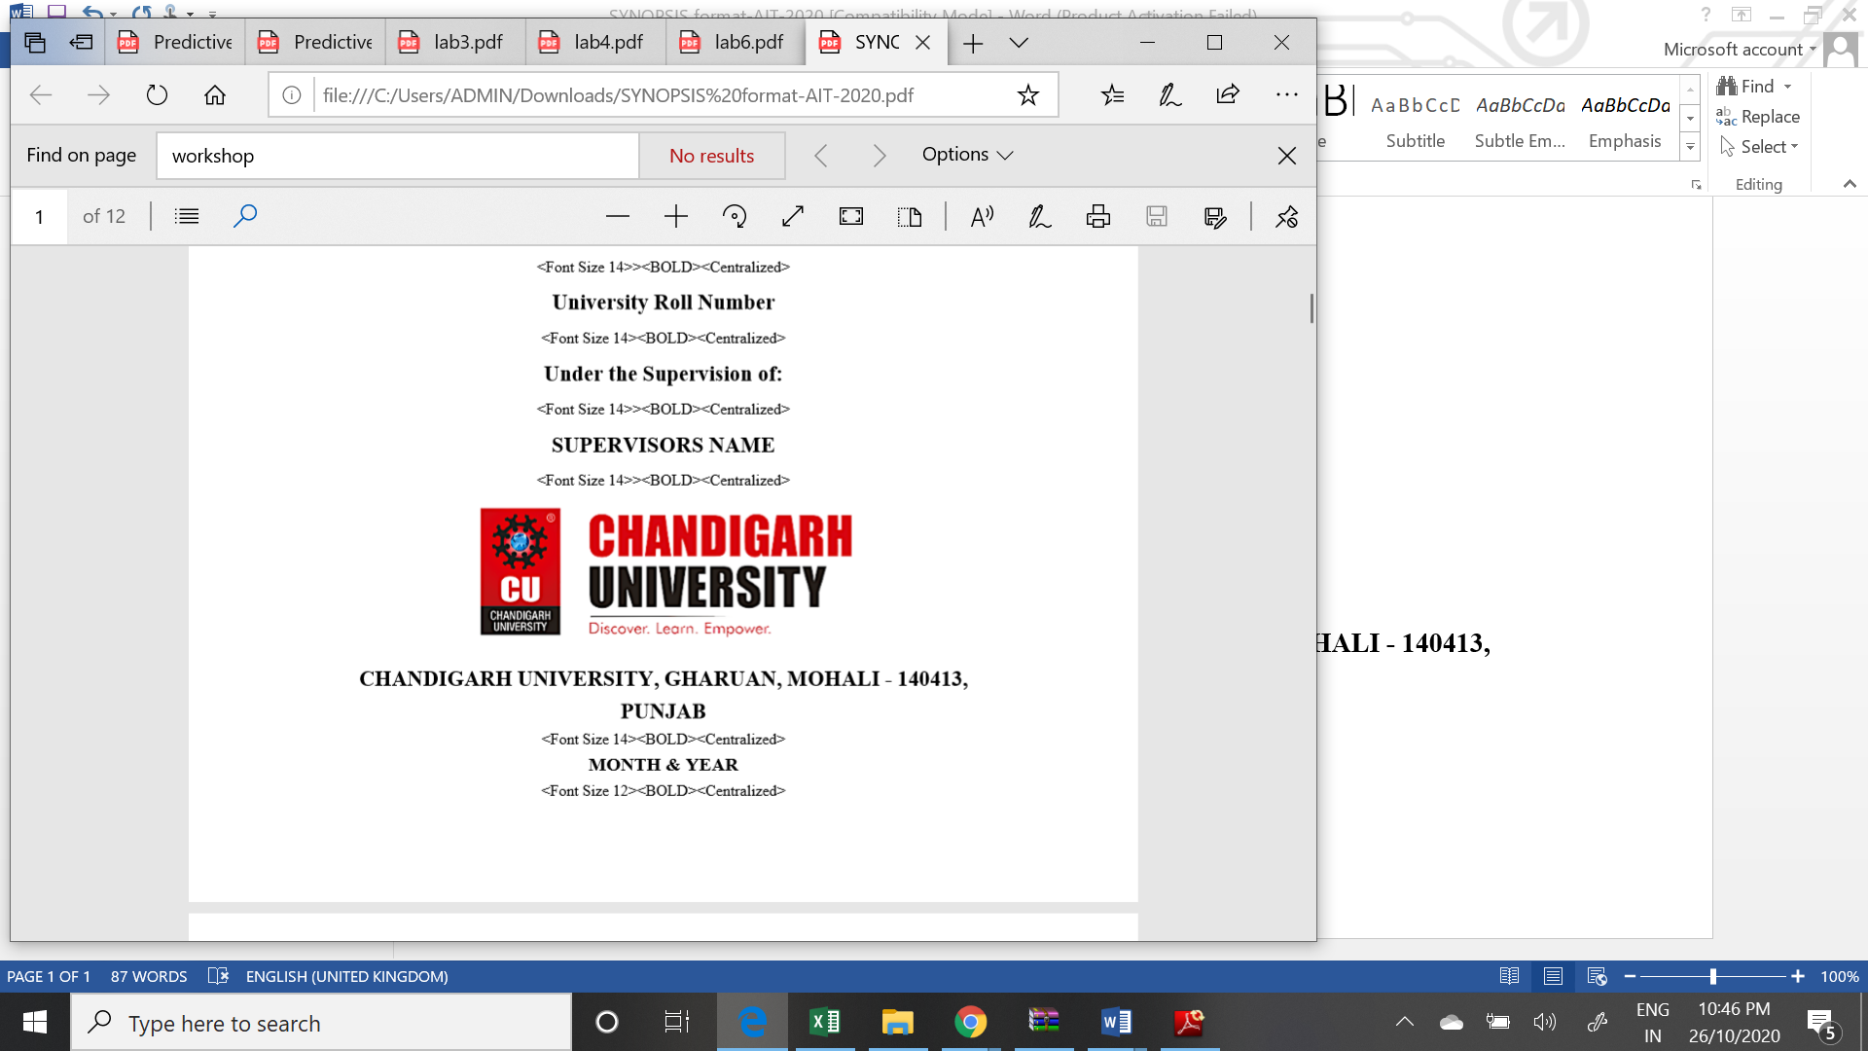

**CHANDIGARH** **UNIVERSITY,** **GHARUAN,** **MOHALI** **-** **140413,** **PUNJAB**

**December, 2020**

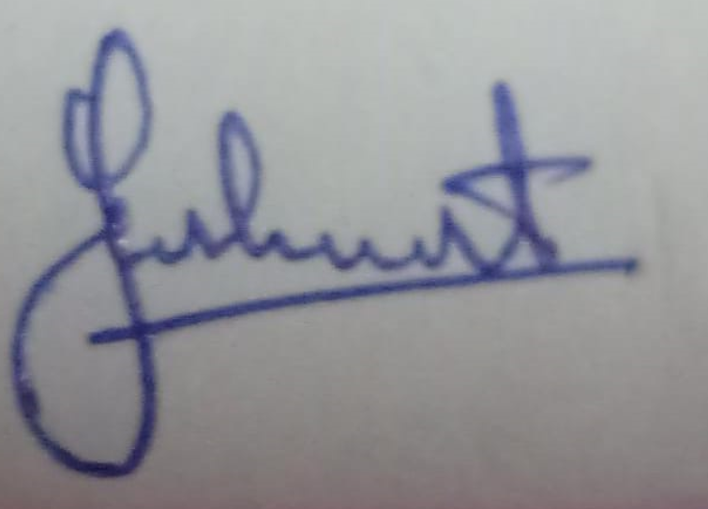

Name and signature of student(s)

Name and signature of Supervisor

# 

# PROJECT COMPLETION CERTIFICATE

## Blood bank Management System in Java

# This is to certify that the _Parikshit sharma__has successfully completed the project work titled Blood bank Mangement System in Java *Submitted* *in* *the* *partial* *fulfilment* *for* *the* *award* *of* *the* *degree of* BACHELOR OF ENGINEERING IN IOT This project is the record of authentic work carried out during the academic year .

Dr.Durgesh Kumar Srivastava

**________________**

Project Guide

**Date:**

# DECLARATION

I the undersigned solemnly declare that the project report is based on my own work carried out during the course of our study under the supervision of_Dr Durgesh Srivastava. I assert the statements made and conclusions drawn are an outcome of my work. I further certify that the work contained in the report is original and has been done by me under the general supervision of my supervisor.

II. The work has not been submitted to any other Institution for any other degree/diploma/certificate in this university or any other University of India or abroad.

III. We have followed the guidelines provided by the university in writing the report.

IV. Whenever we have used materials (data, theoretical analysis, and text) from other sources, we have given due credit to them in the text of the report and giving their details in the references.

Name: Parikshit sharma

19BCS4520

# ACKNOWLEDGEMENT

I have taken efforts in this project. However, it would not have been possible without the kind support and help of many individuals and organizations. I would like to extend my sincere thanks to all of them.

I am highly indebted to (Dr Durgesh Srivastava) for their guidance and constant supervision as well as for providing necessary information regarding the project & also for their support in completing the project.

I would like to express my gratitude towards my parents and my department for their kind co-operation and encouragement which help me in completion of this project.

THANKS AGAIN TO ALL WHO HELPED

# Blood bank Management System in Java

## Objective of Blood bank management System project in java

**The main objective of blood bank management is to provide an easy and handy platform to search for a blood doner according to the location.**

1. **A web platform to search blood and donors details.**
2. **Organized way to know the available blood in hospitals according to the location.**
3. **Find the bool banks and the organization in your area.**
4. **Add ,update and delete the donor details**

## Modules and functionalists of Blood bank management system

1. **Admin can ADD/DELETE/EDIT any organization or blood bank.**
2. **Admin can ADD/DELETE/EDIT users or blood donors in the application.**
3. **Admin can search donor by its bloodGroup.**
4. **Admin can search donor by location.**
5. **Admin can delete donor**
6. **Admin will responsible to handle backend activity of the application.**

**Project Requirements (Software/Hardware requirements)**

**Front-End: JFrame**

**Back-end:MYSQL**

**Server:XAMMP**

**Netbeans IDE**

# Blood bank Management project in Java

1 Login page

import javax.swing.JOptionPane;

/*

* To change this license header, choose License Headers in Project Properties.

* To change this template file, choose Tools | Templates

* and open the template in the editor.

*/

/**

*

* @Parikshit dell

*/

public class Login extends javax.swing.JFrame {

/**

* Creates new form Login

*/

public Login() {

initComponents();

}

/**

* This method is called from within the constructor to initialize the form.

* WARNING: Do NOT modify this code. The content of this method is always

* regenerated by the Form Editor.

*/

@SuppressWarnings("unchecked")

// <editor-fold defaultstate="collapsed" desc="Generated Code">

private void initComponents() {

jLabel1 = new javax.swing.JLabel();

jLabel2 = new javax.swing.JLabel();

jTextField1 = new javax.swing.JTextField();

jPasswordField1 = new javax.swing.JPasswordField();

jButton1 = new javax.swing.JButton();

jButton2 = new javax.swing.JButton();

jLabel3 = new javax.swing.JLabel();

setDefaultCloseOperation(javax.swing.WindowConstants.EXIT_ON_CLOSE);

setUndecorated(true);

getContentPane().setLayout(new org.netbeans.lib.awtextra.AbsoluteLayout());

jLabel1.setFont(new java.awt.Font("Tahoma", 1, 14)); // NOI18N

jLabel1.setText("Login");

getContentPane().add(jLabel1, new org.netbeans.lib.awtextra.AbsoluteConstraints(670, 300, -1, -1));

jLabel2.setFont(new java.awt.Font("Tahoma", 1, 14)); // NOI18N

jLabel2.setText("Password");

getContentPane().add(jLabel2, new org.netbeans.lib.awtextra.AbsoluteConstraints(670, 350, -1, -1));

jTextField1.setBackground(new java.awt.Color(255, 204, 204));

jTextField1.addActionListener(new java.awt.event.ActionListener() {

public void actionPerformed(java.awt.event.ActionEvent evt) {

jTextField1ActionPerformed(evt);

}

});

getContentPane().add(jTextField1, new org.netbeans.lib.awtextra.AbsoluteConstraints(790, 300, 283, -1));

jPasswordField1.setBackground(new java.awt.Color(255, 204, 204));

getContentPane().add(jPasswordField1, new org.netbeans.lib.awtextra.AbsoluteConstraints(790, 350, 283, -1));

jButton1.setFont(new java.awt.Font("Tahoma", 1, 14)); // NOI18N

jButton1.setIcon(new javax.swing.ImageIcon(getClass().getResource("/login.png"))); // NOI18N

jButton1.setText("Login");

jButton1.addActionListener(new java.awt.event.ActionListener() {

public void actionPerformed(java.awt.event.ActionEvent evt) {

jButton1ActionPerformed(evt);

}

});

getContentPane().add(jButton1, new org.netbeans.lib.awtextra.AbsoluteConstraints(790, 410, -1, -1));

jButton2.setFont(new java.awt.Font("Tahoma", 1, 14)); // NOI18N

jButton2.setIcon(new javax.swing.ImageIcon(getClass().getResource("/Exit application.png"))); // NOI18N

jButton2.setText("Close");

jButton2.addActionListener(new java.awt.event.ActionListener() {

public void actionPerformed(java.awt.event.ActionEvent evt) {

jButton2ActionPerformed(evt);

}

});

getContentPane().add(jButton2, new org.netbeans.lib.awtextra.AbsoluteConstraints(980, 410, -1, -1));

jLabel3.setIcon(new javax.swing.ImageIcon(getClass().getResource("/login background final.PNG"))); // NOI18N

jLabel3.setText("jLabel3");

getContentPane().add(jLabel3, new org.netbeans.lib.awtextra.AbsoluteConstraints(0, -150, 1740, 1070));

pack();

}// </editor-fold>

private void jButton2ActionPerformed(java.awt.event.ActionEvent evt) {

// TODO add your handling code here:

int a=JOptionPane.showConfirmDialog(null, "Do you really want to close appliction", "Select", JOptionPane.YES_NO_OPTION);

if(a==0){

System.exit(0);

}

}

private void jButton1ActionPerformed(java.awt.event.ActionEvent evt) {

// TODO add your handling code here:

if(jTextField1.getText().equals("dbms")&&jPasswordField1.getText().equals("1234")){

setVisible(false);

new home().setVisible(true);

}

else

JOptionPane.showMessageDialog(null,"Incorrect Username or Password");

}

private void jTextField1ActionPerformed(java.awt.event.ActionEvent evt) {

// TODO add your handling code here:

}

/**

* @param args the command line arguments

*/

public static void main(String args[]) {

/* Set the Nimbus look and feel */

//<editor-fold defaultstate="collapsed" desc=" Look and feel setting code (optional) ">

/* If Nimbus (introduced in Java SE 6) is not available, stay with the default look and feel.

* For details see http://download.oracle.com/javase/tutorial/uiswing/lookandfeel/plaf.html

*/

try {

for (javax.swing.UIManager.LookAndFeelInfo info : javax.swing.UIManager.getInstalledLookAndFeels()) {

if ("Nimbus".equals(info.getName())) {

javax.swing.UIManager.setLookAndFeel(info.getClassName());

break;

}

}

} catch (ClassNotFoundException ex) {

java.util.logging.Logger.getLogger(Login.class.getName()).log(java.util.logging.Level.SEVERE, null, ex);

} catch (InstantiationException ex) {

java.util.logging.Logger.getLogger(Login.class.getName()).log(java.util.logging.Level.SEVERE, null, ex);

} catch (IllegalAccessException ex) {

java.util.logging.Logger.getLogger(Login.class.getName()).log(java.util.logging.Level.SEVERE, null, ex);

} catch (javax.swing.UnsupportedLookAndFeelException ex) {

java.util.logging.Logger.getLogger(Login.class.getName()).log(java.util.logging.Level.SEVERE, null, ex);

}

//</editor-fold>

/* Create and display the form */

java.awt.EventQueue.invokeLater(new Runnable() {

public void run() {

new Login().setVisible(true);

}

});

}

// Variables declaration - do not modify

private javax.swing.JButton jButton1;

private javax.swing.JButton jButton2;

private javax.swing.JLabel jLabel1;

private javax.swing.JLabel jLabel2;

private javax.swing.JLabel jLabel3;

private javax.swing.JPasswordField jPasswordField1;

private javax.swing.JTextField jTextField1;

// End of variables declaration

}

**2 Home**

**import javax.swing.JOptionPane;**

**/\***

**\* To change this license header, choose License Headers in Project Properties.**

**\* To change this template file, choose Tools | Templates**

**\* and open the template in the editor.**

**\*/**

**/\*\***

**\***

**\* @author dell**

**\*/**

**public class home extends javax.swing.JFrame {**

**/\*\***

**\* Creates new form home**

**\*/**

**public home() {**

**initComponents();**

**}**

**/\*\***

**\* This method is called from within the constructor to initialize the form.**

**\* WARNING: Do NOT modify this code. The content of this method is always**

**\* regenerated by the Form Editor.**

**\*/**

**@SuppressWarnings("unchecked")**

**// <editor-fold defaultstate="collapsed" desc="Generated Code">**

**private void initComponents() {**

**jLabel1 = new javax.swing.JLabel();**

**jMenuBar1 = new javax.swing.JMenuBar();**

**jMenu1 = new javax.swing.JMenu();**

**jMenuItem1 = new javax.swing.JMenuItem();**

**jSeparator1 = new javax.swing.JPopupMenu.Separator();**

**jMenuItem2 = new javax.swing.JMenuItem();**

**jSeparator2 = new javax.swing.JPopupMenu.Separator();**

**jMenuItem3 = new javax.swing.JMenuItem();**

**jSeparator3 = new javax.swing.JPopupMenu.Separator();**

**jMenu2 = new javax.swing.JMenu();**

**jMenuItem4 = new javax.swing.JMenuItem();**

**jSeparator4 = new javax.swing.JPopupMenu.Separator();**

**jMenuItem5 = new javax.swing.JMenuItem();**

**jSeparator5 = new javax.swing.JPopupMenu.Separator();**

**jMenu4 = new javax.swing.JMenu();**

**jMenuItem9 = new javax.swing.JMenuItem();**

**jMenu5 = new javax.swing.JMenu();**

**jMenuItem11 = new javax.swing.JMenuItem();**

**jSeparator8 = new javax.swing.JPopupMenu.Separator();**

**jMenuItem10 = new javax.swing.JMenuItem();**

**setDefaultCloseOperation(javax.swing.WindowConstants.EXIT_ON_CLOSE);**

**setUndecorated(true);**

**getContentPane().setLayout(new org.netbeans.lib.awtextra.AbsoluteLayout());**

**jLabel1.setIcon(new javax.swing.ImageIcon(getClass().getResource("/home.png"))); // NOI18N**

**jLabel1.setText("jLabel1");**

**getContentPane().add(jLabel1, new org.netbeans.lib.awtextra.AbsoluteConstraints(1, -182, 1710, 1130));**

**jMenu1.setIcon(new javax.swing.ImageIcon(getClass().getResource("/Donor.png"))); // NOI18N**

**jMenu1.setText("Donor");**

**jMenuItem1.setAccelerator(javax.swing.KeyStroke.getKeyStroke(java.awt.event.KeyEvent.VK_A, java.awt.event.InputEvent.CTRL_MASK));**

**jMenuItem1.setIcon(new javax.swing.ImageIcon(getClass().getResource("/Add new.png"))); // NOI18N**

**jMenuItem1.setText("Add new");**

**jMenuItem1.addActionListener(new java.awt.event.ActionListener() {**

**public void actionPerformed(java.awt.event.ActionEvent evt) {**

**jMenuItem1ActionPerformed(evt);**

**}**

**});**

**jMenu1.add(jMenuItem1);**

**jMenu1.add(jSeparator1);**

**jMenuItem2.setAccelerator(javax.swing.KeyStroke.getKeyStroke(java.awt.event.KeyEvent.VK_Q, java.awt.event.InputEvent.CTRL_MASK));**

**jMenuItem2.setIcon(new javax.swing.ImageIcon(getClass().getResource("/Update details.png"))); // NOI18N**

**jMenuItem2.setText("Update Details");**

**jMenuItem2.addActionListener(new java.awt.event.ActionListener() {**

**public void actionPerformed(java.awt.event.ActionEvent evt) {**

**jMenuItem2ActionPerformed(evt);**

**}**

**});**

**jMenu1.add(jMenuItem2);**

**jMenu1.add(jSeparator2);**

**jMenuItem3.setAccelerator(javax.swing.KeyStroke.getKeyStroke(java.awt.event.KeyEvent.VK_W, java.awt.event.InputEvent.CTRL_MASK));**

**jMenuItem3.setIcon(new javax.swing.ImageIcon(getClass().getResource("/Details.png"))); // NOI18N**

**jMenuItem3.setText("All Donor Details");**

**jMenuItem3.addActionListener(new java.awt.event.ActionListener() {**

**public void actionPerformed(java.awt.event.ActionEvent evt) {**

**jMenuItem3ActionPerformed(evt);**

**}**

**});**

**jMenu1.add(jMenuItem3);**

**jMenu1.add(jSeparator3);**

**jMenuBar1.add(jMenu1);**

**jMenu2.setIcon(new javax.swing.ImageIcon(getClass().getResource("/search user.png"))); // NOI18N**

**jMenu2.setText("Search blood donor");**

**jMenuItem4.setAccelerator(javax.swing.KeyStroke.getKeyStroke(java.awt.event.KeyEvent.VK_L, java.awt.event.InputEvent.ALT_MASK));**

**jMenuItem4.setIcon(new javax.swing.ImageIcon(getClass().getResource("/Location.png"))); // NOI18N**

**jMenuItem4.setText("Location");**

**jMenuItem4.addActionListener(new java.awt.event.ActionListener() {**

**public void actionPerformed(java.awt.event.ActionEvent evt) {**

**jMenuItem4ActionPerformed(evt);**

**}**

**});**

**jMenu2.add(jMenuItem4);**

**jMenu2.add(jSeparator4);**

**jMenuItem5.setAccelerator(javax.swing.KeyStroke.getKeyStroke(java.awt.event.KeyEvent.VK_B, java.awt.event.InputEvent.ALT_MASK));**

**jMenuItem5.setIcon(new javax.swing.ImageIcon(getClass().getResource("/Blood group.png"))); // NOI18N**

**jMenuItem5.setText("Blood group");**

**jMenuItem5.addActionListener(new java.awt.event.ActionListener() {**

**public void actionPerformed(java.awt.event.ActionEvent evt) {**

**jMenuItem5ActionPerformed(evt);**

**}**

**});**

**jMenu2.add(jMenuItem5);**

**jMenu2.add(jSeparator5);**

**jMenuBar1.add(jMenu2);**

**jMenu4.setIcon(new javax.swing.ImageIcon(getClass().getResource("/delete donor.png"))); // NOI18N**

**jMenu4.setText("Delete Donor");**

**jMenuItem9.setAccelerator(javax.swing.KeyStroke.getKeyStroke(java.awt.event.KeyEvent.VK_D, java.awt.event.InputEvent.CTRL_MASK));**

**jMenuItem9.setIcon(new javax.swing.ImageIcon(getClass().getResource("/delete.png"))); // NOI18N**

**jMenuItem9.setText("Delete Donor");**

**jMenuItem9.addActionListener(new java.awt.event.ActionListener() {**

**public void actionPerformed(java.awt.event.ActionEvent evt) {**

**jMenuItem9ActionPerformed(evt);**

**}**

**});**

**jMenu4.add(jMenuItem9);**

**jMenuBar1.add(jMenu4);**

**jMenu5.setIcon(new javax.swing.ImageIcon(getClass().getResource("/exit.png"))); // NOI18N**

**jMenu5.setText("Exit");**

**jMenuItem11.setAccelerator(javax.swing.KeyStroke.getKeyStroke(java.awt.event.KeyEvent.VK_L, java.awt.event.InputEvent.CTRL_MASK));**

**jMenuItem11.setIcon(new javax.swing.ImageIcon(getClass().getResource("/Logout.png"))); // NOI18N**

**jMenuItem11.setText("Logout");**

**jMenuItem11.addActionListener(new java.awt.event.ActionListener() {**

**public void actionPerformed(java.awt.event.ActionEvent evt) {**

**jMenuItem11ActionPerformed(evt);**

**}**

**});**

**jMenu5.add(jMenuItem11);**

**jMenu5.add(jSeparator8);**

**jMenuItem10.setAccelerator(javax.swing.KeyStroke.getKeyStroke(java.awt.event.KeyEvent.VK_E, java.awt.event.InputEvent.CTRL_MASK));**

**jMenuItem10.setIcon(new javax.swing.ImageIcon(getClass().getResource("/Exit application.png"))); // NOI18N**

**jMenuItem10.setText("Exit application");**

**jMenuItem10.addActionListener(new java.awt.event.ActionListener() {**

**public void actionPerformed(java.awt.event.ActionEvent evt) {**

**jMenuItem10ActionPerformed(evt);**

**}**

**});**

**jMenu5.add(jMenuItem10);**

**jMenuBar1.add(jMenu5);**

**setJMenuBar(jMenuBar1);**

**pack();**

**}// </editor-fold>**

**private void jMenuItem11ActionPerformed(java.awt.event.ActionEvent evt) {**

**// TODO add your handling code here:**

**int a=JOptionPane.showConfirmDialog(null, "Do you really want to logout", "Select", JOptionPane.YES_NO_OPTION);**

**if(a==0){**

**setVisible(false);**

**new Login().setVisible(true);**

**}**

**}**

**private void jMenuItem10ActionPerformed(java.awt.event.ActionEvent evt) {**

**// TODO add your handling code here:**

**int a=JOptionPane.showConfirmDialog(null, "Do you really want to EXIT", "Select", JOptionPane.YES_NO_OPTION);**

**if(a==0){**

**System.exit(0);**

**}**

**}**

**private void jMenuItem1ActionPerformed(java.awt.event.ActionEvent evt) {**

**// TODO add your handling code here:**

**new addnewdonor().setVisible(true);**

**}**

**private void jMenuItem2ActionPerformed(java.awt.event.ActionEvent evt) {**

**// TODO add your handling code here:**

**new updateDetailsDonor().setVisible(true);**

**}**

**private void jMenuItem3ActionPerformed(java.awt.event.ActionEvent evt) {**

**// TODO add your handling code here:**

**new allDonorDetails().setVisible(true);**

**}**

**private void jMenuItem4ActionPerformed(java.awt.event.ActionEvent evt) {**

**// TODO add your handling code here:**

**new searchBloodDonorLocation().setVisible(true);**

**}**

**private void jMenuItem5ActionPerformed(java.awt.event.ActionEvent evt) {**

**// TODO add your handling code here:**

**new searchBloodDonorBloodGroup().setVisible(true);**

**}**

**private void jMenuItem9ActionPerformed(java.awt.event.ActionEvent evt) {**

**// TODO add your handling code here:**

**new deleteDonor().setVisible(true);**

**}**

**/\*\***

**\* @param args the command line arguments**

**\*/**

**public static void main(String args[]) {**

**/* Set the Nimbus look and feel */**

**//<editor-fold defaultstate="collapsed" desc=" Look and feel setting code (optional) ">**

**/* If Nimbus (introduced in Java SE 6) is not available, stay with the default look and feel.**

**\* For details see http://download.oracle.com/javase/tutorial/uiswing/lookandfeel/plaf.html**

**\*/**

**try {**

**for (javax.swing.UIManager.LookAndFeelInfo info : javax.swing.UIManager.getInstalledLookAndFeels()) {**

**if ("Nimbus".equals(info.getName())) {**

**javax.swing.UIManager.setLookAndFeel(info.getClassName());**

**break;**

**}**

**}**

**} catch (ClassNotFoundException ex) {**

**java.util.logging.Logger.getLogger(home.class.getName()).log(java.util.logging.Level.SEVERE, null, ex);**

**} catch (InstantiationException ex) {**

**java.util.logging.Logger.getLogger(home.class.getName()).log(java.util.logging.Level.SEVERE, null, ex);**

**} catch (IllegalAccessException ex) {**

**java.util.logging.Logger.getLogger(home.class.getName()).log(java.util.logging.Level.SEVERE, null, ex);**

**} catch (javax.swing.UnsupportedLookAndFeelException ex) {**

**java.util.logging.Logger.getLogger(home.class.getName()).log(java.util.logging.Level.SEVERE, null, ex);**

**}**

**//</editor-fold>**

**/* Create and display the form */**

**java.awt.EventQueue.invokeLater(() -> {**

**new home().setVisible(true);**

**});**

**}**

**// Variables declaration - do not modify**

**private javax.swing.JLabel jLabel1;**

**private javax.swing.JMenu jMenu1;**

**private javax.swing.JMenu jMenu2;**

**private javax.swing.JMenu jMenu4;**

**private javax.swing.JMenu jMenu5;**

**private javax.swing.JMenuBar jMenuBar1;**

**private javax.swing.JMenuItem jMenuItem1;**

**private javax.swing.JMenuItem jMenuItem10;**

**private javax.swing.JMenuItem jMenuItem11;**

**private javax.swing.JMenuItem jMenuItem2;**

**private javax.swing.JMenuItem jMenuItem3;**

**private javax.swing.JMenuItem jMenuItem4;**

**private javax.swing.JMenuItem jMenuItem5;**

**private javax.swing.JMenuItem jMenuItem9;**

**private javax.swing.JPopupMenu.Separator jSeparator1;**

**private javax.swing.JPopupMenu.Separator jSeparator2;**

**private javax.swing.JPopupMenu.Separator jSeparator3;**

**private javax.swing.JPopupMenu.Separator jSeparator4;**

**private javax.swing.JPopupMenu.Separator jSeparator5;**

**private javax.swing.JPopupMenu.Separator jSeparator8;**

**// End of variables declaration**

**}**

**3 Add new donor code**

**import java.awt.HeadlessException;**

**import java.sql.*;**

**import java.text.SimpleDateFormat;**

**import java.util.logging.Level;**

**import java.util.logging.Logger;**

**import javax.swing.JOptionPane;**

**import newproject.ConnectionProvider;**

**/\***

**\* To change this license header, choose License Headers in Project Properties.**

**\* To change this template file, choose Tools | Templates**

**\* and open the template in the editor.**

**\*/**

**/\*\***

**\***

**\* @author dell**

**\*/**

**public class addnewdonor extends javax.swing.JFrame {**

**/\*\***

**\* Creates new form addnewdonor**

**\*/**

**public addnewdonor() {**

**initComponents();**

**}**

**/\*\***

**\* This method is called from within the constructor to initialize the form.**

**\* WARNING: Do NOT modify this code. The content of this method is always**

**\* regenerated by the Form Editor.**

**\*/**

**@SuppressWarnings("unchecked")**

**// <editor-fold defaultstate="collapsed" desc="Generated Code">**

**private void initComponents() {**

**jLabel1 = new javax.swing.JLabel();**

**jSeparator1 = new javax.swing.JSeparator();**

**jLabel2 = new javax.swing.JLabel();**

**jLabel3 = new javax.swing.JLabel();**

**jLabel4 = new javax.swing.JLabel();**

**jLabel5 = new javax.swing.JLabel();**

**jLabel6 = new javax.swing.JLabel();**

**jLabel7 = new javax.swing.JLabel();**

**jLabel8 = new javax.swing.JLabel();**

**jLabel9 = new javax.swing.JLabel();**

**jTextField1 = new javax.swing.JTextField();**

**jTextField2 = new javax.swing.JTextField();**

**jTextField3 = new javax.swing.JTextField();**

**jDateChooser1 = new com.toedter.calendar.JDateChooser();**

**jTextField4 = new javax.swing.JTextField();**

**jComboBox1 = new javax.swing.JComboBox<>();**

**jLabel10 = new javax.swing.JLabel();**

**jLabel11 = new javax.swing.JLabel();**

**jLabel12 = new javax.swing.JLabel();**

**jLabel13 = new javax.swing.JLabel();**

**jTextField5 = new javax.swing.JTextField();**

**jComboBox2 = new javax.swing.JComboBox<>();**

**jTextField6 = new javax.swing.JTextField();**

**jScrollPane1 = new javax.swing.JScrollPane();**

**jTextArea1 = new javax.swing.JTextArea();**

**jSeparator2 = new javax.swing.JSeparator();**

**jButton1 = new javax.swing.JButton();**

**jButton2 = new javax.swing.JButton();**

**jButton3 = new javax.swing.JButton();**

**jLabel15 = new javax.swing.JLabel();**

**jLabel16 = new javax.swing.JLabel();**

**setDefaultCloseOperation(javax.swing.WindowConstants.EXIT_ON_CLOSE);**

**setLocation(new java.awt.Point(340, 130));**

**setUndecorated(true);**

**addComponentListener(new java.awt.event.ComponentAdapter() {**

**public void componentShown(java.awt.event.ComponentEvent evt) {**

**formComponentShown(evt);**

**}**

**});**

**getContentPane().setLayout(new org.netbeans.lib.awtextra.AbsoluteLayout());**

**jLabel1.setFont(new java.awt.Font("Modern No. 20", 1, 18)); // NOI18N**

**jLabel1.setText("ADD NEW DONOR");**

**getContentPane().add(jLabel1, new org.netbeans.lib.awtextra.AbsoluteConstraints(349, 7, 180, 28));**

**getContentPane().add(jSeparator1, new org.netbeans.lib.awtextra.AbsoluteConstraints(0, 50, 1100, 10));**

**jLabel2.setFont(new java.awt.Font("Tahoma", 1, 14)); // NOI18N**

**jLabel2.setText("New Donor ID");**

**getContentPane().add(jLabel2, new org.netbeans.lib.awtextra.AbsoluteConstraints(12, 71, -1, -1));**

**jLabel3.setFont(new java.awt.Font("Tahoma", 1, 13)); // NOI18N**

**getContentPane().add(jLabel3, new org.netbeans.lib.awtextra.AbsoluteConstraints(387, 71, -1, -1));**

**jLabel4.setFont(new java.awt.Font("Tahoma", 1, 14)); // NOI18N**

**jLabel4.setText("Full Name");**

**getContentPane().add(jLabel4, new org.netbeans.lib.awtextra.AbsoluteConstraints(12, 115, -1, -1));**

**jLabel5.setFont(new java.awt.Font("Tahoma", 1, 14)); // NOI18N**

**jLabel5.setText("Father Name");**

**getContentPane().add(jLabel5, new org.netbeans.lib.awtextra.AbsoluteConstraints(10, 160, -1, -1));**

**jLabel6.setFont(new java.awt.Font("Tahoma", 1, 14)); // NOI18N**

**jLabel6.setText("Mother Name");**

**getContentPane().add(jLabel6, new org.netbeans.lib.awtextra.AbsoluteConstraints(12, 209, -1, -1));**

**jLabel7.setFont(new java.awt.Font("Tahoma", 1, 14)); // NOI18N**

**jLabel7.setText("Date of Birth");**

**getContentPane().add(jLabel7, new org.netbeans.lib.awtextra.AbsoluteConstraints(12, 260, -1, -1));**

**jLabel8.setFont(new java.awt.Font("Tahoma", 1, 14)); // NOI18N**

**jLabel8.setText("Mobile No");**

**getContentPane().add(jLabel8, new org.netbeans.lib.awtextra.AbsoluteConstraints(12, 321, -1, -1));**

**jLabel9.setFont(new java.awt.Font("Tahoma", 1, 14)); // NOI18N**

**jLabel9.setText("Gender");**

**getContentPane().add(jLabel9, new org.netbeans.lib.awtextra.AbsoluteConstraints(12, 376, -1, -1));**

**getContentPane().add(jTextField1, new org.netbeans.lib.awtextra.AbsoluteConstraints(149, 113, 244, -1));**

**getContentPane().add(jTextField2, new org.netbeans.lib.awtextra.AbsoluteConstraints(149, 161, 244, -1));**

**getContentPane().add(jTextField3, new org.netbeans.lib.awtextra.AbsoluteConstraints(149, 207, 244, -1));**

**getContentPane().add(jDateChooser1, new org.netbeans.lib.awtextra.AbsoluteConstraints(149, 255, 244, -1));**

**getContentPane().add(jTextField4, new org.netbeans.lib.awtextra.AbsoluteConstraints(149, 319, 244, -1));**

**jComboBox1.setModel(new javax.swing.DefaultComboBoxModel<>(new String[] { "Male", "Female", "Others" }));**

**getContentPane().add(jComboBox1, new org.netbeans.lib.awtextra.AbsoluteConstraints(149, 374, 244, -1));**

**jLabel10.setFont(new java.awt.Font("Tahoma", 1, 14)); // NOI18N**

**jLabel10.setText("Email");**

**getContentPane().add(jLabel10, new org.netbeans.lib.awtextra.AbsoluteConstraints(489, 106, -1, -1));**

**jLabel11.setFont(new java.awt.Font("Tahoma", 1, 14)); // NOI18N**

**jLabel11.setText("Blood Group");**

**getContentPane().add(jLabel11, new org.netbeans.lib.awtextra.AbsoluteConstraints(489, 171, -1, -1));**

**jLabel12.setFont(new java.awt.Font("Tahoma", 1, 14)); // NOI18N**

**jLabel12.setText("City");**

**getContentPane().add(jLabel12, new org.netbeans.lib.awtextra.AbsoluteConstraints(489, 209, -1, -1));**

**jLabel13.setFont(new java.awt.Font("Tahoma", 1, 14)); // NOI18N**

**jLabel13.setText("Complete Address");**

**getContentPane().add(jLabel13, new org.netbeans.lib.awtextra.AbsoluteConstraints(489, 301, -1, -1));**

**getContentPane().add(jTextField5, new org.netbeans.lib.awtextra.AbsoluteConstraints(721, 104, 262, -1));**

**jComboBox2.setModel(new javax.swing.DefaultComboBoxModel<>(new String[] { "A+", "B+", "B-", "O+", "O-", "AB+", "AB-" }));**

**getContentPane().add(jComboBox2, new org.netbeans.lib.awtextra.AbsoluteConstraints(721, 169, 262, -1));**

**getContentPane().add(jTextField6, new org.netbeans.lib.awtextra.AbsoluteConstraints(721, 217, 262, -1));**

**jTextArea1.setColumns(20);**

**jTextArea1.setRows(5);**

**jScrollPane1.setViewportView(jTextArea1);**

**getContentPane().add(jScrollPane1, new org.netbeans.lib.awtextra.AbsoluteConstraints(676, 301, 307, -1));**

**getContentPane().add(jSeparator2, new org.netbeans.lib.awtextra.AbsoluteConstraints(0, 425, 1012, 10));**

**jButton1.setFont(new java.awt.Font("Tahoma", 1, 14)); // NOI18N**

**jButton1.setIcon(new javax.swing.ImageIcon(getClass().getResource("/save.png"))); // NOI18N**

**jButton1.setText("Save");**

**jButton1.addActionListener(new java.awt.event.ActionListener() {**

**public void actionPerformed(java.awt.event.ActionEvent evt) {**

**jButton1ActionPerformed(evt);**

**}**

**});**

**getContentPane().add(jButton1, new org.netbeans.lib.awtextra.AbsoluteConstraints(88, 471, -1, -1));**

**jButton2.setFont(new java.awt.Font("Tahoma", 1, 14)); // NOI18N**

**jButton2.setIcon(new javax.swing.ImageIcon(getClass().getResource("/Update details.png"))); // NOI18N**

**jButton2.setText("Reset");**

**jButton2.addActionListener(new java.awt.event.ActionListener() {**

**public void actionPerformed(java.awt.event.ActionEvent evt) {**

**jButton2ActionPerformed(evt);**

**}**

**});**

**getContentPane().add(jButton2, new org.netbeans.lib.awtextra.AbsoluteConstraints(441, 471, -1, -1));**

**jButton3.setFont(new java.awt.Font("Tahoma", 1, 14)); // NOI18N**

**jButton3.setIcon(new javax.swing.ImageIcon(getClass().getResource("/Exit application.png"))); // NOI18N**

**jButton3.setText("Close");**

**jButton3.addActionListener(new java.awt.event.ActionListener() {**

**public void actionPerformed(java.awt.event.ActionEvent evt) {**

**jButton3ActionPerformed(evt);**

**}**

**});**

**getContentPane().add(jButton3, new org.netbeans.lib.awtextra.AbsoluteConstraints(730, 471, -1, -1));**

**jLabel15.setBackground(new java.awt.Color(0, 51, 255));**

**jLabel15.setFont(new java.awt.Font("Tahoma", 1, 18)); // NOI18N**

**jLabel15.setForeground(new java.awt.Color(0, 51, 255));**

**jLabel15.setText("1");**

**getContentPane().add(jLabel15, new org.netbeans.lib.awtextra.AbsoluteConstraints(150, 70, 240, 20));**

**jLabel16.setIcon(new javax.swing.ImageIcon(getClass().getResource("/wp4323461.png"))); // NOI18N**

**jLabel16.setText("jLabel16");**

**getContentPane().add(jLabel16, new org.netbeans.lib.awtextra.AbsoluteConstraints(0, 0, -1, -1));**

**pack();**

**}// </editor-fold>**

**private void formComponentShown(java.awt.event.ComponentEvent evt) {**

**// TODO add your handling code here:**

**try{**

**Connection con=ConnectionProvider.getCon();**

**Statement st = null;**

**try {**

**st = con.createStatement();**

**} catch (SQLException ex) {**

**Logger.getLogger(addnewdonor.class.getName()).log(Level.SEVERE, null, ex);**

**}**

**ResultSet rs = null;**

**try {**

**rs = st.executeQuery("select max(donorId) from donor");**

**} catch (SQLException ex) {**

**Logger.getLogger(addnewdonor.class.getName()).log(Level.SEVERE, null, ex);**

**}**

**try {**

**if(rs.first()){**

**int id = 0;**

**try {**

**id = rs.getInt(1);**

**} catch (SQLException ex) {**

**Logger.getLogger(addnewdonor.class.getName()).log(Level.SEVERE, null, ex);**

**}**

**id=id+1;**

**String str=String.valueOf(id);**

**jLabel15.setText(str);**

**}**

**else**

**jLabel15.setText("1");**

**} catch (SQLException ex) {**

**Logger.getLogger(addnewdonor.class.getName()).log(Level.SEVERE, null, ex);**

**}**

**catch(Exception e){**

**JOptionPane.showMessageDialog(null,e);**

**}**

**}**

**private void jButton3ActionPerformed(java.awt.event.ActionEvent evt) {**

**// TODO add your handling code here:**

**setVisible(false);**

**}**

**private void jButton2ActionPerformed(java.awt.event.ActionEvent evt) {**

**// TODO add your handling code here:**

**setVisible(false);**

**new addnewdonor().setVisible(true);**

**}**

**private void jButton1ActionPerformed(java.awt.event.ActionEvent evt) {**

**// TODO add your handling code here:**

**String donorId=jLabel15.getText();**

**String name=jTextField1.getText();**

**String fatherName=jTextField2.getText();**

**String motherName=jTextField3.getText();**

**SimpleDateFormat dFormat=new SimpleDateFormat("dd-MM-yyyy");**

**String DOB=dFormat.format(jDateChooser1.getDate());**

**String MobileNo=jTextField4.getText();**

**String gender=(String)jComboBox1.getSelectedItem();**

**String email=jTextField5.getText();**

**String bloodGroup=(String)jComboBox2.getSelectedItem();**

**String city=jTextField6.getText();**

**String address=jTextArea1.getText();**

**try{**

**Connection con=ConnectionProvider.getCon();**

**Statement st=con.createStatement();**

**st.executeUpdate("insert into donor values('"+donorId+"','"+name+"','"+fatherName+"','"+motherName+"','"+DOB+"','"+MobileNo+"','"+gender+"','"+email+"','"+bloodGroup+"','"+city+"','"+address+"')");**

**JOptionPane.showMessageDialog(null, "Successfully updated");**

**setVisible(false);**

**new addnewdonor().setVisible(true);**

**}**

**catch(HeadlessException | SQLException e){**

**JOptionPane.showMessageDialog(null, e);**

**}**

**}**

**/\*\***

**\* @param args the command line arguments**

**\*/**

**public static void main(String args[]) {**

**/* Set the Nimbus look and feel */**

**//<editor-fold defaultstate="collapsed" desc=" Look and feel setting code (optional) ">**

**/* If Nimbus (introduced in Java SE 6) is not available, stay with the default look and feel.**

**\* For details see http://download.oracle.com/javase/tutorial/uiswing/lookandfeel/plaf.html**

**\*/**

**try {**

**for (javax.swing.UIManager.LookAndFeelInfo info : javax.swing.UIManager.getInstalledLookAndFeels()) {**

**if ("Nimbus".equals(info.getName())) {**

**javax.swing.UIManager.setLookAndFeel(info.getClassName());**

**break;**

**}**

**}**

**} catch (ClassNotFoundException ex) {**

**java.util.logging.Logger.getLogger(addnewdonor.class.getName()).log(java.util.logging.Level.SEVERE, null, ex);**

**} catch (InstantiationException ex) {**

**java.util.logging.Logger.getLogger(addnewdonor.class.getName()).log(java.util.logging.Level.SEVERE, null, ex);**

**} catch (IllegalAccessException ex) {**

**java.util.logging.Logger.getLogger(addnewdonor.class.getName()).log(java.util.logging.Level.SEVERE, null, ex);**

**} catch (javax.swing.UnsupportedLookAndFeelException ex) {**

**java.util.logging.Logger.getLogger(addnewdonor.class.getName()).log(java.util.logging.Level.SEVERE, null, ex);**

**}**

**//</editor-fold>**

**/* Create and display the form */**

**java.awt.EventQueue.invokeLater(() -> {**

**new addnewdonor().setVisible(true);**

**});**

**}**

**// Variables declaration - do not modify**

**private javax.swing.JButton jButton1;**

**private javax.swing.JButton jButton2;**

**private javax.swing.JButton jButton3;**

**private javax.swing.JComboBox<String> jComboBox1;**

**private javax.swing.JComboBox<String> jComboBox2;**

**private com.toedter.calendar.JDateChooser jDateChooser1;**

**private javax.swing.JLabel jLabel1;**

**private javax.swing.JLabel jLabel10;**

**private javax.swing.JLabel jLabel11;**

**private javax.swing.JLabel jLabel12;**

**private javax.swing.JLabel jLabel13;**

**private javax.swing.JLabel jLabel15;**

**private javax.swing.JLabel jLabel16;**

**private javax.swing.JLabel jLabel2;**

**private javax.swing.JLabel jLabel3;**

**private javax.swing.JLabel jLabel4;**

**private javax.swing.JLabel jLabel5;**

**private javax.swing.JLabel jLabel6;**

**private javax.swing.JLabel jLabel7;**

**private javax.swing.JLabel jLabel8;**

**private javax.swing.JLabel jLabel9;**

**private javax.swing.JScrollPane jScrollPane1;**

**private javax.swing.JSeparator jSeparator1;**

**private javax.swing.JSeparator jSeparator2;**

**private javax.swing.JTextArea jTextArea1;**

**private javax.swing.JTextField jTextField1;**

**private javax.swing.JTextField jTextField2;**

**private javax.swing.JTextField jTextField3;**

**private javax.swing.JTextField jTextField4;**

**private javax.swing.JTextField jTextField5;**

**private javax.swing.JTextField jTextField6;**

**// End of variables declaration**

**}**

**4Update donor details**

**import java.awt.HeadlessException;**

**import java.sql.*;**

**import java.util.logging.Level;**

**import java.util.logging.Logger;**

**import javax.swing.JOptionPane;**

**import newproject.ConnectionProvider;**

**/\***

**\* To change this license header, choose License Headers in Project Properties.**

**\* To change this template file, choose Tools | Templates**

**\* and open the template in the editor.**

**\*/**

**/\*\***

**\***

**\* @author dell**

**\*/**

**public class updateDetailsDonor extends javax.swing.JFrame {**

**/\*\***

**\* Creates new form updateDetailsDonor**

**\*/**

**public updateDetailsDonor() {**

**initComponents();**

**}**

**/\*\***

**\* This method is called from within the constructor to initialize the form.**

**\* WARNING: Do NOT modify this code. The content of this method is always**

**\* regenerated by the Form Editor.**

**\*/**

**@SuppressWarnings("unchecked")**

**// <editor-fold defaultstate="collapsed" desc="Generated Code">**

**private void initComponents() {**

**jLabel1 = new javax.swing.JLabel();**

**jSeparator1 = new javax.swing.JSeparator();**

**jLabel2 = new javax.swing.JLabel();**

**jTextField1 = new javax.swing.JTextField();**

**jButton1 = new javax.swing.JButton();**

**jSeparator2 = new javax.swing.JSeparator();**

**jLabel3 = new javax.swing.JLabel();**

**jLabel4 = new javax.swing.JLabel();**

**jLabel5 = new javax.swing.JLabel();**

**jLabel6 = new javax.swing.JLabel();**

**jLabel7 = new javax.swing.JLabel();**

**jLabel8 = new javax.swing.JLabel();**

**jTextField2 = new javax.swing.JTextField();**

**jTextField3 = new javax.swing.JTextField();**

**jTextField4 = new javax.swing.JTextField();**

**jTextField5 = new javax.swing.JTextField();**

**jTextField6 = new javax.swing.JTextField();**

**jTextField7 = new javax.swing.JTextField();**

**jLabel9 = new javax.swing.JLabel();**

**jTextField8 = new javax.swing.JTextField();**

**jLabel10 = new javax.swing.JLabel();**

**jTextField9 = new javax.swing.JTextField();**

**jLabel11 = new javax.swing.JLabel();**

**jTextField10 = new javax.swing.JTextField();**

**jLabel12 = new javax.swing.JLabel();**

**jScrollPane1 = new javax.swing.JScrollPane();**

**jTextArea1 = new javax.swing.JTextArea();**

**jSeparator3 = new javax.swing.JSeparator();**

**jButton2 = new javax.swing.JButton();**

**jButton3 = new javax.swing.JButton();**

**jButton4 = new javax.swing.JButton();**

**jLabel13 = new javax.swing.JLabel();**

**setDefaultCloseOperation(javax.swing.WindowConstants.EXIT_ON_CLOSE);**

**setLocation(new java.awt.Point(340, 130));**

**setUndecorated(true);**

**getContentPane().setLayout(new org.netbeans.lib.awtextra.AbsoluteLayout());**

**jLabel1.setFont(new java.awt.Font("Tahoma", 1, 24)); // NOI18N**

**jLabel1.setText("Update Donor Details");**

**getContentPane().add(jLabel1, new org.netbeans.lib.awtextra.AbsoluteConstraints(256, 13, -1, -1));**

**getContentPane().add(jSeparator1, new org.netbeans.lib.awtextra.AbsoluteConstraints(0, 49, 768, 10));**

**jLabel2.setFont(new java.awt.Font("Tahoma", 1, 14)); // NOI18N**

**jLabel2.setText("Donor Id");**

**getContentPane().add(jLabel2, new org.netbeans.lib.awtextra.AbsoluteConstraints(179, 72, -1, -1));**

**getContentPane().add(jTextField1, new org.netbeans.lib.awtextra.AbsoluteConstraints(307, 70, 151, -1));**

**jButton1.setFont(new java.awt.Font("Tahoma", 1, 14)); // NOI18N**

**jButton1.setIcon(new javax.swing.ImageIcon(getClass().getResource("/search1.png"))); // NOI18N**

**jButton1.setText("Search");**

**jButton1.addActionListener(new java.awt.event.ActionListener() {**

**public void actionPerformed(java.awt.event.ActionEvent evt) {**

**jButton1ActionPerformed(evt);**

**}**

**});**

**getContentPane().add(jButton1, new org.netbeans.lib.awtextra.AbsoluteConstraints(497, 66, -1, -1));**

**getContentPane().add(jSeparator2, new org.netbeans.lib.awtextra.AbsoluteConstraints(0, 102, 768, 10));**

**jLabel3.setFont(new java.awt.Font("Tahoma", 1, 14)); // NOI18N**

**jLabel3.setText("Name");**

**getContentPane().add(jLabel3, new org.netbeans.lib.awtextra.AbsoluteConstraints(12, 132, -1, -1));**

**jLabel4.setFont(new java.awt.Font("Tahoma", 1, 13)); // NOI18N**

**jLabel4.setText("Father Name");**

**getContentPane().add(jLabel4, new org.netbeans.lib.awtextra.AbsoluteConstraints(12, 184, -1, -1));**

**jLabel5.setFont(new java.awt.Font("Tahoma", 1, 14)); // NOI18N**

**jLabel5.setText("Mother Name");**

**getContentPane().add(jLabel5, new org.netbeans.lib.awtextra.AbsoluteConstraints(12, 239, -1, -1));**

**jLabel6.setFont(new java.awt.Font("Tahoma", 1, 14)); // NOI18N**

**jLabel6.setText("Date of Birth");**

**getContentPane().add(jLabel6, new org.netbeans.lib.awtextra.AbsoluteConstraints(12, 326, -1, -1));**

**jLabel7.setFont(new java.awt.Font("Tahoma", 1, 14)); // NOI18N**

**jLabel7.setText("MobileNo");**

**getContentPane().add(jLabel7, new org.netbeans.lib.awtextra.AbsoluteConstraints(12, 381, -1, -1));**

**jLabel8.setFont(new java.awt.Font("Tahoma", 1, 14)); // NOI18N**

**jLabel8.setText("gender");**

**getContentPane().add(jLabel8, new org.netbeans.lib.awtextra.AbsoluteConstraints(12, 429, -1, -1));**

**getContentPane().add(jTextField2, new org.netbeans.lib.awtextra.AbsoluteConstraints(118, 130, 154, -1));**

**getContentPane().add(jTextField3, new org.netbeans.lib.awtextra.AbsoluteConstraints(118, 181, 154, -1));**

**getContentPane().add(jTextField4, new org.netbeans.lib.awtextra.AbsoluteConstraints(118, 237, 154, -1));**

**getContentPane().add(jTextField5, new org.netbeans.lib.awtextra.AbsoluteConstraints(118, 324, 154, -1));**

**getContentPane().add(jTextField6, new org.netbeans.lib.awtextra.AbsoluteConstraints(118, 379, 154, -1));**

**getContentPane().add(jTextField7, new org.netbeans.lib.awtextra.AbsoluteConstraints(118, 427, 154, -1));**

**jLabel9.setFont(new java.awt.Font("Tahoma", 1, 14)); // NOI18N**

**jLabel9.setText("Email");**

**getContentPane().add(jLabel9, new org.netbeans.lib.awtextra.AbsoluteConstraints(350, 132, -1, -1));**

**getContentPane().add(jTextField8, new org.netbeans.lib.awtextra.AbsoluteConstraints(446, 130, 183, -1));**

**jLabel10.setFont(new java.awt.Font("Tahoma", 1, 14)); // NOI18N**

**jLabel10.setText("Blood group");**

**getContentPane().add(jLabel10, new org.netbeans.lib.awtextra.AbsoluteConstraints(350, 183, -1, -1));**

**getContentPane().add(jTextField9, new org.netbeans.lib.awtextra.AbsoluteConstraints(448, 181, 181, -1));**

**jLabel11.setFont(new java.awt.Font("Tahoma", 1, 14)); // NOI18N**

**jLabel11.setText("City");**

**getContentPane().add(jLabel11, new org.netbeans.lib.awtextra.AbsoluteConstraints(350, 239, -1, -1));**

**getContentPane().add(jTextField10, new org.netbeans.lib.awtextra.AbsoluteConstraints(448, 237, 181, -1));**

**jLabel12.setFont(new java.awt.Font("Tahoma", 1, 14)); // NOI18N**

**jLabel12.setText("Complete Address");**

**getContentPane().add(jLabel12, new org.netbeans.lib.awtextra.AbsoluteConstraints(350, 326, -1, -1));**

**jTextArea1.setColumns(20);**

**jTextArea1.setRows(5);**

**jScrollPane1.setViewportView(jTextArea1);**

**getContentPane().add(jScrollPane1, new org.netbeans.lib.awtextra.AbsoluteConstraints(506, 324, -1, -1));**

**getContentPane().add(jSeparator3, new org.netbeans.lib.awtextra.AbsoluteConstraints(0, 518, 768, 10));**

**jButton2.setFont(new java.awt.Font("Tahoma", 1, 14)); // NOI18N**

**jButton2.setIcon(new javax.swing.ImageIcon(getClass().getResource("/save.png"))); // NOI18N**

**jButton2.setText("Update");**

**jButton2.addActionListener(new java.awt.event.ActionListener() {**

**public void actionPerformed(java.awt.event.ActionEvent evt) {**

**jButton2ActionPerformed(evt);**

**}**

**});**

**getContentPane().add(jButton2, new org.netbeans.lib.awtextra.AbsoluteConstraints(70, 570, -1, -1));**

**jButton3.setFont(new java.awt.Font("Tahoma", 1, 14)); // NOI18N**

**jButton3.setIcon(new javax.swing.ImageIcon(getClass().getResource("/Update details.png"))); // NOI18N**

**jButton3.setText("Reset");**

**jButton3.addActionListener(new java.awt.event.ActionListener() {**

**public void actionPerformed(java.awt.event.ActionEvent evt) {**

**jButton3ActionPerformed(evt);**

**}**

**});**

**getContentPane().add(jButton3, new org.netbeans.lib.awtextra.AbsoluteConstraints(310, 570, -1, -1));**

**jButton4.setFont(new java.awt.Font("Tahoma", 1, 14)); // NOI18N**

**jButton4.setIcon(new javax.swing.ImageIcon(getClass().getResource("/Exit application.png"))); // NOI18N**

**jButton4.setText("Close");**

**jButton4.addActionListener(new java.awt.event.ActionListener() {**

**public void actionPerformed(java.awt.event.ActionEvent evt) {**

**jButton4ActionPerformed(evt);**

**}**

**});**

**getContentPane().add(jButton4, new org.netbeans.lib.awtextra.AbsoluteConstraints(570, 570, -1, -1));**

**jLabel13.setIcon(new javax.swing.ImageIcon(getClass().getResource("/wp4323461.png"))); // NOI18N**

**jLabel13.setText("jLabel13");**

**getContentPane().add(jLabel13, new org.netbeans.lib.awtextra.AbsoluteConstraints(-90, -310, -1, -1));**

**pack();**

**}// </editor-fold>**

**private void jButton4ActionPerformed(java.awt.event.ActionEvent evt) {**

**// TODO add your handling code here:**

**setVisible(false);**

**}**

**private void jButton3ActionPerformed(java.awt.event.ActionEvent evt) {**

**// TODO add your handling code here:**

**setVisible(false);**

**new updateDetailsDonor().setVisible(true);**

**}**

**private void jButton1ActionPerformed(java.awt.event.ActionEvent evt) {**

**// TODO add your handling code here:**

**String donorId=jTextField1.getText();**

**try**

**{**

**Connection con=ConnectionProvider.getCon();**

**Statement st=con.createStatement();**

**ResultSet rs= st.executeQuery("select*from donor where donorId='"+donorId+"'");**

**if(rs.next()){**

**jTextField2.setText(rs.getString(2));**

**jTextField3.setText(rs.getString(3));**

**jTextField4.setText(rs.getString(4));**

**jTextField5.setText(rs.getString(5));**

**jTextField6.setText(rs.getString(6));**

**jTextField7.setText(rs.getString(7));**

**jTextField8.setText(rs.getString(8));**

**jTextField9.setText(rs.getString(9));**

**jTextField10.setText(rs.getString(10));**

**jTextField1.setText(rs.getString(11));**

**jTextField1.setEditable(false);**

**}**

**else{**

**JOptionPane.showMessageDialog(null,"DonorId does not exist");**

**}**

**}**

**catch(HeadlessException | SQLException e){**

**JOptionPane.showMessageDialog(null,e);**

**}**

**}**

**private void jButton2ActionPerformed(java.awt.event.ActionEvent evt) {**

**// TODO add your handling code here:**

**String donorId=jTextField1.getText();**

**String name=jTextField2.getText();**

**String fatherName=jTextField3.getText();**

**String motherName=jTextField4.getText();**

**String DOB=jTextField5.getText();**

**String MobileNo=jTextField6.getText();**

**String gender=jTextField7.getText();**

**String email=jTextField8.getText();**

**String bloodGroup=jTextField9.getText();**

**String city=jTextField10.getText();**

**String address=jTextArea1.getText();**

**try{**

**Connection con=ConnectionProvider.getCon();**

**Statement st=con.createStatement();**

**st.("update donor set name='"+name+"',fatherName='"+fatherName+"',motherName='"+motherName+"',DOB='"+DOB+"',MobileNumber='"+MobileNumber+"',gender='"+gender+"',email='"+email+"',bloodGroup='"+bloodGroup+"',city='"+city+"',address='"+address+"' where donorId='"+donorId+"' ");**

**JOptionPane.showMessageDialog(null,"successfully updated");**

**setVisible(false);**

**new updateDetailsDonor().setVisible(true);**

**} catch (SQLException ex) {**

**Logger.getLogger(updateDetailsDonor.class.getName()).log(Level.SEVERE, null, ex);**

**}**

**}**

**/\*\***

**\* @param args the command line arguments**

**\*/**

**public static void main(String args[]) {**

**/* Set the Nimbus look and feel */**

**//<editor-fold defaultstate="collapsed" desc=" Look and feel setting code (optional) ">**

**/* If Nimbus (introduced in Java SE 6) is not available, stay with the default look and feel.**

**\* For details see http://download.oracle.com/javase/tutorial/uiswing/lookandfeel/plaf.html**

**\*/**

**try {**

**for (javax.swing.UIManager.LookAndFeelInfo info : javax.swing.UIManager.getInstalledLookAndFeels()) {**

**if ("Nimbus".equals(info.getName())) {**

**javax.swing.UIManager.setLookAndFeel(info.getClassName());**

**break;**

**}**

**}**

**} catch (ClassNotFoundException ex) {**

**java.util.logging.Logger.getLogger(updateDetailsDonor.class.getName()).log(java.util.logging.Level.SEVERE, null, ex);**

**} catch (InstantiationException ex) {**

**java.util.logging.Logger.getLogger(updateDetailsDonor.class.getName()).log(java.util.logging.Level.SEVERE, null, ex);**

**} catch (IllegalAccessException ex) {**

**java.util.logging.Logger.getLogger(updateDetailsDonor.class.getName()).log(java.util.logging.Level.SEVERE, null, ex);**

**} catch (javax.swing.UnsupportedLookAndFeelException ex) {**

**java.util.logging.Logger.getLogger(updateDetailsDonor.class.getName()).log(java.util.logging.Level.SEVERE, null, ex);**

**}**

**//</editor-fold>**

**/* Create and display the form */**

**java.awt.EventQueue.invokeLater(() -> {**

**new updateDetailsDonor().setVisible(true);**

**});**

**}**

**// Variables declaration - do not modify**

**private javax.swing.JButton jButton1;**

**private javax.swing.JButton jButton2;**

**private javax.swing.JButton jButton3;**

**private javax.swing.JButton jButton4;**

**private javax.swing.JLabel jLabel1;**

**private javax.swing.JLabel jLabel10;**

**private javax.swing.JLabel jLabel11;**

**private javax.swing.JLabel jLabel12;**

**private javax.swing.JLabel jLabel13;**

**private javax.swing.JLabel jLabel2;**

**private javax.swing.JLabel jLabel3;**

**private javax.swing.JLabel jLabel4;**

**private javax.swing.JLabel jLabel5;**

**private javax.swing.JLabel jLabel6;**

**private javax.swing.JLabel jLabel7;**

**private javax.swing.JLabel jLabel8;**

**private javax.swing.JLabel jLabel9;**

**private javax.swing.JScrollPane jScrollPane1;**

**private javax.swing.JSeparator jSeparator1;**

**private javax.swing.JSeparator jSeparator2;**

**private javax.swing.JSeparator jSeparator3;**

**private javax.swing.JTextArea jTextArea1;**

**private javax.swing.JTextField jTextField1;**

**private javax.swing.JTextField jTextField10;**

**private javax.swing.JTextField jTextField2;**

**private javax.swing.JTextField jTextField3;**

**private javax.swing.JTextField jTextField4;**

**private javax.swing.JTextField jTextField5;**

**private javax.swing.JTextField jTextField6;**

**private javax.swing.JTextField jTextField7;**

**private javax.swing.JTextField jTextField8;**

**private javax.swing.JTextField jTextField9;**

**// End of variables declaration**

**}**

**5 All donor Details**

**import java.sql.*;**

**import javax.swing.JOptionPane;**

**import newproject.ConnectionProvider;**

**import net.proteanit.sql.DbUtils;**

**/\***

**\* To change this license header, choose License Headers in Project Properties.**

**\* To change this template file, choose Tools | Templates**

**\* and open the template in the editor.**

**\*/**

**/\*\***

**\***

**\* @author dell**

**\*/**

**public class allDonorDetails extends javax.swing.JFrame {**

**/\*\***

**\* Creates new form allDonorDetails**

**\*/**

**public allDonorDetails() {**

**initComponents();**

**}**

**/\*\***

**\* This method is called from within the constructor to initialize the form.**

**\* WARNING: Do NOT modify this code. The content of this method is always**

**\* regenerated by the Form Editor.**

**\*/**

**@SuppressWarnings("unchecked")**

**// <editor-fold defaultstate="collapsed" desc="Generated Code">**

**private void initComponents() {**

**jLabel1 = new javax.swing.JLabel();**

**jSeparator1 = new javax.swing.JSeparator();**

**jScrollPane1 = new javax.swing.JScrollPane();**

**jTable1 = new javax.swing.JTable();**

**jSeparator2 = new javax.swing.JSeparator();**

**jButton1 = new javax.swing.JButton();**

**jButton2 = new javax.swing.JButton();**

**setDefaultCloseOperation(javax.swing.WindowConstants.EXIT_ON_CLOSE);**

**setLocation(new java.awt.Point(340, 130));**

**setUndecorated(true);**

**addComponentListener(new java.awt.event.ComponentAdapter() {**

**public void componentShown(java.awt.event.ComponentEvent evt) {**

**formComponentShown(evt);**

**}**

**});**

**getContentPane().setLayout(new org.netbeans.lib.awtextra.AbsoluteLayout());**

**jLabel1.setFont(new java.awt.Font("Tahoma", 1, 24)); // NOI18N**

**jLabel1.setText("ALL DONOR DETAILS");**

**getContentPane().add(jLabel1, new org.netbeans.lib.awtextra.AbsoluteConstraints(208, 28, -1, -1));**

**getContentPane().add(jSeparator1, new org.netbeans.lib.awtextra.AbsoluteConstraints(699, 64, 1, 10));**

**jTable1.setModel(new javax.swing.table.DefaultTableModel(**

**new Object [][] {**

**{null, null, null, null},**

**{null, null, null, null},**

**{null, null, null, null},**

**{null, null, null, null}**

**},**

**new String [] {**

**"Title 1", "Title 2", "Title 3", "Title 4"**

**}**

**));**

**jScrollPane1.setViewportView(jTable1);**

**getContentPane().add(jScrollPane1, new org.netbeans.lib.awtextra.AbsoluteConstraints(12, 127, 676, 325));**

**getContentPane().add(jSeparator2, new org.netbeans.lib.awtextra.AbsoluteConstraints(0, 104, 700, 10));**

**jButton1.setFont(new java.awt.Font("Tahoma", 1, 14)); // NOI18N**

**jButton1.setIcon(new javax.swing.ImageIcon(getClass().getResource("/print.png"))); // NOI18N**

**jButton1.setText("Print");**

**jButton1.addActionListener(new java.awt.event.ActionListener() {**

**public void actionPerformed(java.awt.event.ActionEvent evt) {**

**jButton1ActionPerformed(evt);**

**}**

**});**

**getContentPane().add(jButton1, new org.netbeans.lib.awtextra.AbsoluteConstraints(12, 453, -1, -1));**

**jButton2.setFont(new java.awt.Font("Tahoma", 1, 14)); // NOI18N**

**jButton2.setIcon(new javax.swing.ImageIcon(getClass().getResource("/Exit application.png"))); // NOI18N**

**jButton2.setText("Close");**

**jButton2.addActionListener(new java.awt.event.ActionListener() {**

**public void actionPerformed(java.awt.event.ActionEvent evt) {**

**jButton2ActionPerformed(evt);**

**}**

**});**

**getContentPane().add(jButton2, new org.netbeans.lib.awtextra.AbsoluteConstraints(595, 453, -1, -1));**

**pack();**

**}// </editor-fold>**

**private void formComponentShown(java.awt.event.ComponentEvent evt) {**

**// TODO add your handling code here:**

**try{**

**Connection con=ConnectionProvider.getCon();**

**Statement st=con.createStatement();**

**ResultSet rs=st.executeQuery("select *from donor");**

**jTable1.setAutoResizeMode(jTable1.AUTO_RESIZE_OFF);**

**jTable1.setModel(DbUtils.resultSetToTableModel(rs));**

**}**

**catch(Exception e){**

**JOptionPane.showMessageDialog(null, e);**

**}**

**}**

**private void jButton1ActionPerformed(java.awt.event.ActionEvent evt) {**

**// TODO add your handling code here:**

**try{**

**jTable1.print(jTable.PrintMode.NORMAL);**

**}**

**catch(Exception e){**

**JOptionPane.showmessageDialog(null,e);**

**}**

**}**

**private void jButton2ActionPerformed(java.awt.event.ActionEvent evt) {**

**// TODO add your handling code here:**

**setVisible(false);**

**}**

**/\*\***

**\* @param args the command line arguments**

**\*/**

**public static void main(String args[]) {**

**/* Set the Nimbus look and feel */**

**//<editor-fold defaultstate="collapsed" desc=" Look and feel setting code (optional) ">**

**/* If Nimbus (introduced in Java SE 6) is not available, stay with the default look and feel.**

**\* For details see http://download.oracle.com/javase/tutorial/uiswing/lookandfeel/plaf.html**

**\*/**

**try {**

**for (javax.swing.UIManager.LookAndFeelInfo info : javax.swing.UIManager.getInstalledLookAndFeels()) {**

**if ("Nimbus".equals(info.getName())) {**

**javax.swing.UIManager.setLookAndFeel(info.getClassName());**

**break;**

**}**

**}**

**} catch (ClassNotFoundException ex) {**

**java.util.logging.Logger.getLogger(allDonorDetails.class.getName()).log(java.util.logging.Level.SEVERE, null, ex);**

**} catch (InstantiationException ex) {**

**java.util.logging.Logger.getLogger(allDonorDetails.class.getName()).log(java.util.logging.Level.SEVERE, null, ex);**

**} catch (IllegalAccessException ex) {**

**java.util.logging.Logger.getLogger(allDonorDetails.class.getName()).log(java.util.logging.Level.SEVERE, null, ex);**

**} catch (javax.swing.UnsupportedLookAndFeelException ex) {**

**java.util.logging.Logger.getLogger(allDonorDetails.class.getName()).log(java.util.logging.Level.SEVERE, null, ex);**

**}**

**//</editor-fold>**

**/* Create and display the form */**

**java.awt.EventQueue.invokeLater(() -> {**

**new allDonorDetails().setVisible(true);**

**});**

**}**

**// Variables declaration - do not modify**

**private javax.swing.JButton jButton1;**

**private javax.swing.JButton jButton2;**

**private javax.swing.JLabel jLabel1;**

**private javax.swing.JScrollPane jScrollPane1;**

**private javax.swing.JSeparator jSeparator1;**

**private javax.swing.JSeparator jSeparator2;**

**private javax.swing.JTable jTable1;**

**// End of variables declaration**

**}**

**6 Search BloodGroup by Location**

**import java.awt.print.PrinterException;**

**import javax.swing.JTable;**

**import java.sql.*;**

**import javax.swing.JOptionPane;**

**import net.proteanit.sql.DbUtils;**

**import newproject.ConnectionProvider;**

**/\***

**\* To change this license header, choose License Headers in Project Properties.**

**\* To change this template file, choose Tools | Templates**

**\* and open the template in the editor.**

**\*/**

**/\*\***

**\***

**\* @author dell**

**\*/**

**public class searchBloodDonorLocation extends javax.swing.JFrame {**

**/\*\***

**\* Creates new form searchBloodDonorLocation**

**\*/**

**public searchBloodDonorLocation() {**

**initComponents();**

**}**

**/\*\***

**\* This method is called from within the constructor to initialize the form.**

**\* WARNING: Do NOT modify this code. The content of this method is always**

**\* regenerated by the Form Editor.**

**\*/**

**@SuppressWarnings("unchecked")**

**// <editor-fold defaultstate="collapsed" desc="Generated Code">**

**private void initComponents() {**

**jScrollPane2 = new javax.swing.JScrollPane();**

**jEditorPane1 = new javax.swing.JEditorPane();**

**jLabel1 = new javax.swing.JLabel();**

**jSeparator1 = new javax.swing.JSeparator();**

**jLabel2 = new javax.swing.JLabel();**

**jTextField1 = new javax.swing.JTextField();**

**jSeparator2 = new javax.swing.JSeparator();**

**jScrollPane1 = new javax.swing.JScrollPane();**

**jTable1 = new javax.swing.JTable();**

**jSeparator3 = new javax.swing.JSeparator();**

**jButton1 = new javax.swing.JButton();**

**jButton2 = new javax.swing.JButton();**

**jLabel3 = new javax.swing.JLabel();**

**jScrollPane2.setViewportView(jEditorPane1);**

**setDefaultCloseOperation(javax.swing.WindowConstants.EXIT_ON_CLOSE);**

**setLocation(new java.awt.Point(340, 130));**

**setUndecorated(true);**

**getContentPane().setLayout(new org.netbeans.lib.awtextra.AbsoluteLayout());**

**jLabel1.setFont(new java.awt.Font("Tahoma", 1, 36)); // NOI18N**

**jLabel1.setText("Search Blood Donor(Address)");**

**getContentPane().add(jLabel1, new org.netbeans.lib.awtextra.AbsoluteConstraints(93, 13, -1, -1));**

**getContentPane().add(jSeparator1, new org.netbeans.lib.awtextra.AbsoluteConstraints(0, 64, 771, 10));**

**jLabel2.setFont(new java.awt.Font("Tahoma", 1, 14)); // NOI18N**

**jLabel2.setIcon(new javax.swing.ImageIcon(getClass().getResource("/Location.png"))); // NOI18N**

**jLabel2.setText("Address");**

**getContentPane().add(jLabel2, new org.netbeans.lib.awtextra.AbsoluteConstraints(150, 92, -1, -1));**

**jTextField1.addKeyListener(new java.awt.event.KeyAdapter() {**

**public void keyReleased(java.awt.event.KeyEvent evt) {**

**jTextField1KeyReleased(evt);**

**}**

**});**

**getContentPane().add(jTextField1, new org.netbeans.lib.awtextra.AbsoluteConstraints(294, 92, 222, -1));**

**getContentPane().add(jSeparator2, new org.netbeans.lib.awtextra.AbsoluteConstraints(0, 132, 771, 10));**

**jTable1.setModel(new javax.swing.table.DefaultTableModel(**

**new Object [][] {**

**{null, null, null, null},**

**{null, null, null, null},**

**{null, null, null, null},**

**{null, null, null, null}**

**},**

**new String [] {**

**"Title 1", "Title 2", "Title 3", "Title 4"**

**}**

**));**

**jScrollPane1.setViewportView(jTable1);**

**getContentPane().add(jScrollPane1, new org.netbeans.lib.awtextra.AbsoluteConstraints(0, 149, 771, 319));**

**getContentPane().add(jSeparator3, new org.netbeans.lib.awtextra.AbsoluteConstraints(0, 496, 771, 10));**

**jButton1.setFont(new java.awt.Font("Tahoma", 1, 14)); // NOI18N**

**jButton1.setIcon(new javax.swing.ImageIcon(getClass().getResource("/print.png"))); // NOI18N**

**jButton1.setText("Print");**

**jButton1.addActionListener(new java.awt.event.ActionListener() {**

**public void actionPerformed(java.awt.event.ActionEvent evt) {**

**jButton1ActionPerformed(evt);**

**}**

**});**

**getContentPane().add(jButton1, new org.netbeans.lib.awtextra.AbsoluteConstraints(23, 524, -1, -1));**

**jButton2.setFont(new java.awt.Font("Tahoma", 1, 14)); // NOI18N**

**jButton2.setIcon(new javax.swing.ImageIcon(getClass().getResource("/Exit application.png"))); // NOI18N**

**jButton2.setText("Close");**

**jButton2.addActionListener(new java.awt.event.ActionListener() {**

**public void actionPerformed(java.awt.event.ActionEvent evt) {**

**jButton2ActionPerformed(evt);**

**}**

**});**

**getContentPane().add(jButton2, new org.netbeans.lib.awtextra.AbsoluteConstraints(610, 524, -1, -1));**

**jLabel3.setIcon(new javax.swing.ImageIcon(getClass().getResource("/wp4323461.png"))); // NOI18N**

**jLabel3.setText("jLabel3");**

**getContentPane().add(jLabel3, new org.netbeans.lib.awtextra.AbsoluteConstraints(0, 0, -1, -1));**

**pack();**

**}// </editor-fold>**

**private void jButton2ActionPerformed(java.awt.event.ActionEvent evt) {**

**// TODO add your handling code here:**

**setVisible(false);**

**}**

**private void jButton1ActionPerformed(java.awt.event.ActionEvent evt) {**

**// TODO add your handling code here:**

**try{**

**jTable1.print(JTable.PrintMode.NORMAL);**

**}**

**catch(PrinterException e){**

**JOptionPane.showMessageDialog(null,e);**

**}**

**}**

**private void jTextField1KeyReleased(java.awt.event.KeyEvent evt) {**

**// TODO add your handling code here:**

**String location=jTextField1.getText();**

**try{**

**Connection con= ConnectionProvider.getCon();**

**Statement st=con.createStatement();**

**ResultSet rs=st.executeQuery("select *from donor where city like '%"+location+"%' or address like '%"+location+"%'" );**

**jTable1.setAutoResizeMode(jTable1.AUTO_RESIZE_OFF);**

**jTable1.setModel(DbUtils.resultSetToTableModel(rs));**

**}**

**catch(Exception e){**

**JOptionPane.showMessageDialog(null,e);**

**}**

**}**

**/\*\***

**\* @param args the command line arguments**

**\*/**

**public static void main(String args[]) {**

**/* Set the Nimbus look and feel */**

**//<editor-fold defaultstate="collapsed" desc=" Look and feel setting code (optional) ">**

**/* If Nimbus (introduced in Java SE 6) is not available, stay with the default look and feel.**

**\* For details see http://download.oracle.com/javase/tutorial/uiswing/lookandfeel/plaf.html**

**\*/**

**try {**

**for (javax.swing.UIManager.LookAndFeelInfo info : javax.swing.UIManager.getInstalledLookAndFeels()) {**

**if ("Nimbus".equals(info.getName())) {**

**javax.swing.UIManager.setLookAndFeel(info.getClassName());**

**break;**

**}**

**}**

**} catch (ClassNotFoundException ex) {**

**java.util.logging.Logger.getLogger(searchBloodDonorLocation.class.getName()).log(java.util.logging.Level.SEVERE, null, ex);**

**} catch (InstantiationException ex) {**

**java.util.logging.Logger.getLogger(searchBloodDonorLocation.class.getName()).log(java.util.logging.Level.SEVERE, null, ex);**

**} catch (IllegalAccessException ex) {**

**java.util.logging.Logger.getLogger(searchBloodDonorLocation.class.getName()).log(java.util.logging.Level.SEVERE, null, ex);**

**} catch (javax.swing.UnsupportedLookAndFeelException ex) {**

**java.util.logging.Logger.getLogger(searchBloodDonorLocation.class.getName()).log(java.util.logging.Level.SEVERE, null, ex);**

**}**

**//</editor-fold>**

**/* Create and display the form */**

**java.awt.EventQueue.invokeLater(() -> {**

**new searchBloodDonorLocation().setVisible(true);**

**});**

**}**

**// Variables declaration - do not modify**

**private javax.swing.JButton jButton1;**

**private javax.swing.JButton jButton2;**

**private javax.swing.JEditorPane jEditorPane1;**

**private javax.swing.JLabel jLabel1;**

**private javax.swing.JLabel jLabel2;**

**private javax.swing.JLabel jLabel3;**

**private javax.swing.JScrollPane jScrollPane1;**

**private javax.swing.JScrollPane jScrollPane2;**

**private javax.swing.JSeparator jSeparator1;**

**private javax.swing.JSeparator jSeparator2;**

**private javax.swing.JSeparator jSeparator3;**

**private javax.swing.JTable jTable1;**

**private javax.swing.JTextField jTextField1;**

**// End of variables declaration**

**}**

**7 Search by Blood group**

**import java.sql.*;**

**import javax.swing.JOptionPane;**

**import newproject.ConnectionProvider;**

**import javax.swing.JTable;**

**import net.proteanit.sql.DbUtils;**

**/\***

**\* To change this license header, choose License Headers in Project Properties.**

**\* To change this template file, choose Tools | Templates**

**\* and open the template in the editor.**

**\*/**

**/\*\***

**\***

**\* @author dell**

**\*/**

**public class searchBloodDonorBloodGroup extends javax.swing.JFrame {**

**/\*\***

**\* Creates new form searchBloodDonorBloodGroup**

**\*/**

**public searchBloodDonorBloodGroup() {**

**initComponents();**

**}**

**/\*\***

**\* This method is called from within the constructor to initialize the form.**

**\* WARNING: Do NOT modify this code. The content of this method is always**

**\* regenerated by the Form Editor.**

**\*/**

**@SuppressWarnings("unchecked")**

**// <editor-fold defaultstate="collapsed" desc="Generated Code">**

**private void initComponents() {**

**jLabel1 = new javax.swing.JLabel();**

**jSeparator1 = new javax.swing.JSeparator();**

**jLabel2 = new javax.swing.JLabel();**

**jTextField1 = new javax.swing.JTextField();**

**jSeparator2 = new javax.swing.JSeparator();**

**jScrollPane1 = new javax.swing.JScrollPane();**

**jTable1 = new javax.swing.JTable();**

**jButton1 = new javax.swing.JButton();**

**jButton2 = new javax.swing.JButton();**

**jLabel3 = new javax.swing.JLabel();**

**setDefaultCloseOperation(javax.swing.WindowConstants.EXIT_ON_CLOSE);**

**setLocation(new java.awt.Point(340, 130));**

**setUndecorated(true);**

**getContentPane().setLayout(new org.netbeans.lib.awtextra.AbsoluteLayout());**

**jLabel1.setFont(new java.awt.Font("Tahoma", 3, 36)); // NOI18N**

**jLabel1.setText("Search blood donor(blood group)");**

**getContentPane().add(jLabel1, new org.netbeans.lib.awtextra.AbsoluteConstraints(33, 13, -1, -1));**

**getContentPane().add(jSeparator1, new org.netbeans.lib.awtextra.AbsoluteConstraints(0, 64, 731, 10));**

**jLabel2.setFont(new java.awt.Font("Tahoma", 1, 14)); // NOI18N**

**jLabel2.setIcon(new javax.swing.ImageIcon(getClass().getResource("/Blood group.png"))); // NOI18N**

**jLabel2.setText("BLOOD GROUP");**

**getContentPane().add(jLabel2, new org.netbeans.lib.awtextra.AbsoluteConstraints(115, 92, -1, -1));**

**jTextField1.addKeyListener(new java.awt.event.KeyAdapter() {**

**public void keyReleased(java.awt.event.KeyEvent evt) {**

**jTextField1KeyReleased(evt);**

**}**

**});**

**getContentPane().add(jTextField1, new org.netbeans.lib.awtextra.AbsoluteConstraints(321, 92, 237, -1));**

**getContentPane().add(jSeparator2, new org.netbeans.lib.awtextra.AbsoluteConstraints(0, 121, 731, 10));**

**jTable1.setModel(new javax.swing.table.DefaultTableModel(**

**new Object [][] {**

**{null, null, null, null},**

**{null, null, null, null},**

**{null, null, null, null},**

**{null, null, null, null}**

**},**

**new String [] {**

**"Title 1", "Title 2", "Title 3", "Title 4"**

**}**

**));**

**jScrollPane1.setViewportView(jTable1);**

**getContentPane().add(jScrollPane1, new org.netbeans.lib.awtextra.AbsoluteConstraints(0, 138, 719, 272));**

**jButton1.setFont(new java.awt.Font("Tahoma", 1, 14)); // NOI18N**

**jButton1.setIcon(new javax.swing.ImageIcon(getClass().getResource("/print.png"))); // NOI18N**

**jButton1.setText("Print");**

**jButton1.addActionListener(new java.awt.event.ActionListener() {**

**public void actionPerformed(java.awt.event.ActionEvent evt) {**

**jButton1ActionPerformed(evt);**

**}**

**});**

**getContentPane().add(jButton1, new org.netbeans.lib.awtextra.AbsoluteConstraints(25, 475, -1, -1));**

**jButton2.setFont(new java.awt.Font("Tahoma", 1, 14)); // NOI18N**

**jButton2.setIcon(new javax.swing.ImageIcon(getClass().getResource("/Exit application.png"))); // NOI18N**

**jButton2.setText("Close");**

**jButton2.addActionListener(new java.awt.event.ActionListener() {**

**public void actionPerformed(java.awt.event.ActionEvent evt) {**

**jButton2ActionPerformed(evt);**

**}**

**});**

**getContentPane().add(jButton2, new org.netbeans.lib.awtextra.AbsoluteConstraints(606, 475, -1, -1));**

**jLabel3.setIcon(new javax.swing.ImageIcon(getClass().getResource("/wp4323461.png"))); // NOI18N**

**jLabel3.setText("jLabel3");**

**getContentPane().add(jLabel3, new org.netbeans.lib.awtextra.AbsoluteConstraints(0, -260, 2420, 1560));**

**pack();**

**}// </editor-fold>**

**private void jButton2ActionPerformed(java.awt.event.ActionEvent evt) {**

**// TODO add your handling code here:**

**setVisible(false);**

**}**

**private void jButton1ActionPerformed(java.awt.event.ActionEvent evt) {**

**// TODO add your handling code here:**

**try{**

**jTable1.print(JTable.PrintMode.NORMAL);**

**}**

**catch(Exception e){**

**JOptionPane.showMessageDialog(null, e);**

**}**

**}**

**private void jTextField1KeyReleased(java.awt.event.KeyEvent evt) {**

**// TODO add your handling code here:**

**String bloodGroup=jTextField1.getText();**

**try{**

**Connection con=ConnectionProvider.getCon();**

**Statement st=con.createStatement();**

**ResultSet rs=st.executeQuery("select *from donor where bloodGroup like '%"+bloodGroup+"%'");**

**jTable1.setAutoResizeMode(jTable1.AUTO_RESIZE_OFF );**

**jTable1.setModel(DbUtils.resultSetToTableModel(rs));**

**}**

**catch(Exception e){**

**JOptionPane.showMessageDialog(null, e);**

**}**

**}**

**/\*\***

**\* @param args the command line arguments**

**\*/**

**public static void main(String args[]) {**

**/* Set the Nimbus look and feel */**

**//<editor-fold defaultstate="collapsed" desc=" Look and feel setting code (optional) ">**

**/* If Nimbus (introduced in Java SE 6) is not available, stay with the default look and feel.**

**\* For details see http://download.oracle.com/javase/tutorial/uiswing/lookandfeel/plaf.html**

**\*/**

**try {**

**for (javax.swing.UIManager.LookAndFeelInfo info : javax.swing.UIManager.getInstalledLookAndFeels()) {**

**if ("Nimbus".equals(info.getName())) {**

**javax.swing.UIManager.setLookAndFeel(info.getClassName());**

**break;**

**}**

**}**

**} catch (ClassNotFoundException ex) {**

**java.util.logging.Logger.getLogger(searchBloodDonorBloodGroup.class.getName()).log(java.util.logging.Level.SEVERE, null, ex);**

**} catch (InstantiationException ex) {**

**java.util.logging.Logger.getLogger(searchBloodDonorBloodGroup.class.getName()).log(java.util.logging.Level.SEVERE, null, ex);**

**} catch (IllegalAccessException ex) {**

**java.util.logging.Logger.getLogger(searchBloodDonorBloodGroup.class.getName()).log(java.util.logging.Level.SEVERE, null, ex);**

**} catch (javax.swing.UnsupportedLookAndFeelException ex) {**

**java.util.logging.Logger.getLogger(searchBloodDonorBloodGroup.class.getName()).log(java.util.logging.Level.SEVERE, null, ex);**

**}**

**//</editor-fold>**

**/* Create and display the form */**

**java.awt.EventQueue.invokeLater(new Runnable() {**

**public void run() {**

**new searchBloodDonorBloodGroup().setVisible(true);**

**}**

**});**

**}**

**// Variables declaration - do not modify**

**private javax.swing.JButton jButton1;**

**private javax.swing.JButton jButton2;**

**private javax.swing.JLabel jLabel1;**

**private javax.swing.JLabel jLabel2;**

**private javax.swing.JLabel jLabel3;**

**private javax.swing.JScrollPane jScrollPane1;**

**private javax.swing.JSeparator jSeparator1;**

**private javax.swing.JSeparator jSeparator2;**

**private javax.swing.JTable jTable1;**

**private javax.swing.JTextField jTextField1;**

**// End of variables declaration**

**}**

**8 Delete Donor**

**import java.sql.*;**

**import java.util.logging.Level;**

**import java.util.logging.Logger;**

**import javax.swing.JOptionPane;**

**import newproject.ConnectionProvider;**

**/\***

**\* To change this license header, choose License Headers in Project Properties.**

**\* To change this template file, choose Tools | Templates**

**\* and open the template in the editor.**

**\*/**

**/\*\***

**\***

**\* @author dell**

**\*/**

**public class deleteDonor extends javax.swing.JFrame {**

**/\*\***

**\* Creates new form deleteDonor**

**\*/**

**public deleteDonor() {**

**initComponents();**

**}**

**/\*\***

**\* This method is called from within the constructor to initialize the form.**

**\* WARNING: Do NOT modify this code. The content of this method is always**

**\* regenerated by the Form Editor.**

**\*/**

**@SuppressWarnings("unchecked")**

**// <editor-fold defaultstate="collapsed" desc="Generated Code">**

**private void initComponents() {**

**jLabel1 = new javax.swing.JLabel();**

**jSeparator1 = new javax.swing.JSeparator();**

**jLabel2 = new javax.swing.JLabel();**

**jTextField1 = new javax.swing.JTextField();**

**jButton1 = new javax.swing.JButton();**

**jSeparator2 = new javax.swing.JSeparator();**

**jLabel3 = new javax.swing.JLabel();**

**jLabel4 = new javax.swing.JLabel();**

**jLabel5 = new javax.swing.JLabel();**

**jLabel6 = new javax.swing.JLabel();**

**jLabel7 = new javax.swing.JLabel();**

**jLabel8 = new javax.swing.JLabel();**

**jTextField2 = new javax.swing.JTextField();**

**jTextField3 = new javax.swing.JTextField();**

**jTextField4 = new javax.swing.JTextField();**

**jTextField5 = new javax.swing.JTextField();**

**jTextField7 = new javax.swing.JTextField();**

**jTextField8 = new javax.swing.JTextField();**

**jLabel9 = new javax.swing.JLabel();**

**jLabel10 = new javax.swing.JLabel();**

**jLabel11 = new javax.swing.JLabel();**

**jLabel12 = new javax.swing.JLabel();**

**jTextField9 = new javax.swing.JTextField();**

**jTextField10 = new javax.swing.JTextField();**

**jTextField11 = new javax.swing.JTextField();**

**jScrollPane1 = new javax.swing.JScrollPane();**

**jTextArea1 = new javax.swing.JTextArea();**

**jSeparator3 = new javax.swing.JSeparator();**

**jButton2 = new javax.swing.JButton();**

**jButton3 = new javax.swing.JButton();**

**jButton4 = new javax.swing.JButton();**

**jLabel13 = new javax.swing.JLabel();**

**setDefaultCloseOperation(javax.swing.WindowConstants.EXIT_ON_CLOSE);**

**setLocation(new java.awt.Point(340, 130));**

**setUndecorated(true);**

**getContentPane().setLayout(new org.netbeans.lib.awtextra.AbsoluteLayout());**

**jLabel1.setFont(new java.awt.Font("Tahoma", 1, 36)); // NOI18N**

**jLabel1.setText("Delete Donor");**

**getContentPane().add(jLabel1, new org.netbeans.lib.awtextra.AbsoluteConstraints(348, 13, -1, -1));**

**getContentPane().add(jSeparator1, new org.netbeans.lib.awtextra.AbsoluteConstraints(0, 64, 1016, 10));**

**jLabel2.setFont(new java.awt.Font("Tahoma", 1, 14)); // NOI18N**

**jLabel2.setText("Donor Id");**

**getContentPane().add(jLabel2, new org.netbeans.lib.awtextra.AbsoluteConstraints(214, 104, -1, -1));**

**getContentPane().add(jTextField1, new org.netbeans.lib.awtextra.AbsoluteConstraints(337, 102, 218, -1));**

**jButton1.setFont(new java.awt.Font("Tahoma", 1, 14)); // NOI18N**

**jButton1.setIcon(new javax.swing.ImageIcon(getClass().getResource("/search1.png"))); // NOI18N**

**jButton1.setText("Search");**

**jButton1.addActionListener(new java.awt.event.ActionListener() {**

**public void actionPerformed(java.awt.event.ActionEvent evt) {**

**jButton1ActionPerformed(evt);**

**}**

**});**

**getContentPane().add(jButton1, new org.netbeans.lib.awtextra.AbsoluteConstraints(614, 98, -1, -1));**

**getContentPane().add(jSeparator2, new org.netbeans.lib.awtextra.AbsoluteConstraints(0, 134, 1016, 10));**

**jLabel3.setFont(new java.awt.Font("Tahoma", 1, 14)); // NOI18N**

**jLabel3.setText("Full Name");**

**getContentPane().add(jLabel3, new org.netbeans.lib.awtextra.AbsoluteConstraints(39, 179, -1, -1));**

**jLabel4.setFont(new java.awt.Font("Tahoma", 1, 14)); // NOI18N**

**jLabel4.setText("Father Name");**

**getContentPane().add(jLabel4, new org.netbeans.lib.awtextra.AbsoluteConstraints(39, 234, -1, -1));**

**jLabel5.setFont(new java.awt.Font("Tahoma", 1, 14)); // NOI18N**

**jLabel5.setText("Mother name");**

**getContentPane().add(jLabel5, new org.netbeans.lib.awtextra.AbsoluteConstraints(36, 287, -1, -1));**

**jLabel6.setFont(new java.awt.Font("Tahoma", 1, 14)); // NOI18N**

**jLabel6.setText("Date of Birth");**

**getContentPane().add(jLabel6, new org.netbeans.lib.awtextra.AbsoluteConstraints(36, 345, -1, -1));**

**jLabel7.setFont(new java.awt.Font("Tahoma", 1, 14)); // NOI18N**

**jLabel7.setText("MobileNo");**

**getContentPane().add(jLabel7, new org.netbeans.lib.awtextra.AbsoluteConstraints(36, 395, -1, -1));**

**jLabel8.setFont(new java.awt.Font("Tahoma", 1, 14)); // NOI18N**

**jLabel8.setText("Gender");**

**getContentPane().add(jLabel8, new org.netbeans.lib.awtextra.AbsoluteConstraints(36, 452, -1, -1));**

**getContentPane().add(jTextField2, new org.netbeans.lib.awtextra.AbsoluteConstraints(205, 177, 187, -1));**

**getContentPane().add(jTextField3, new org.netbeans.lib.awtextra.AbsoluteConstraints(205, 232, 187, -1));**

**getContentPane().add(jTextField4, new org.netbeans.lib.awtextra.AbsoluteConstraints(205, 285, 187, -1));**

**getContentPane().add(jTextField5, new org.netbeans.lib.awtextra.AbsoluteConstraints(205, 343, 187, -1));**

**getContentPane().add(jTextField7, new org.netbeans.lib.awtextra.AbsoluteConstraints(205, 393, 187, -1));**

**getContentPane().add(jTextField8, new org.netbeans.lib.awtextra.AbsoluteConstraints(205, 450, 187, -1));**

**jLabel9.setFont(new java.awt.Font("Tahoma", 1, 14)); // NOI18N**

**jLabel9.setText("Email");**

**getContentPane().add(jLabel9, new org.netbeans.lib.awtextra.AbsoluteConstraints(484, 179, -1, -1));**

**jLabel10.setFont(new java.awt.Font("Tahoma", 1, 14)); // NOI18N**

**jLabel10.setText("BloodGroup");**

**getContentPane().add(jLabel10, new org.netbeans.lib.awtextra.AbsoluteConstraints(484, 234, -1, -1));**

**jLabel11.setFont(new java.awt.Font("Tahoma", 1, 14)); // NOI18N**

**jLabel11.setText("City");**

**getContentPane().add(jLabel11, new org.netbeans.lib.awtextra.AbsoluteConstraints(484, 287, -1, -1));**

**jLabel12.setFont(new java.awt.Font("Tahoma", 1, 14)); // NOI18N**

**jLabel12.setText("Complete address");**

**getContentPane().add(jLabel12, new org.netbeans.lib.awtextra.AbsoluteConstraints(484, 345, -1, -1));**

**getContentPane().add(jTextField9, new org.netbeans.lib.awtextra.AbsoluteConstraints(661, 177, 246, -1));**

**getContentPane().add(jTextField10, new org.netbeans.lib.awtextra.AbsoluteConstraints(661, 232, 246, -1));**

**getContentPane().add(jTextField11, new org.netbeans.lib.awtextra.AbsoluteConstraints(661, 285, 246, -1));**

**jTextArea1.setColumns(20);**

**jTextArea1.setRows(5);**

**jScrollPane1.setViewportView(jTextArea1);**

**getContentPane().add(jScrollPane1, new org.netbeans.lib.awtextra.AbsoluteConstraints(661, 343, 246, -1));**

**getContentPane().add(jSeparator3, new org.netbeans.lib.awtextra.AbsoluteConstraints(0, 538, 1016, 10));**

**jButton2.setFont(new java.awt.Font("Tahoma", 1, 14)); // NOI18N**

**jButton2.setIcon(new javax.swing.ImageIcon(getClass().getResource("/delete.png"))); // NOI18N**

**jButton2.setText("Delete");**

**jButton2.addActionListener(new java.awt.event.ActionListener() {**

**public void actionPerformed(java.awt.event.ActionEvent evt) {**

**jButton2ActionPerformed(evt);**

**}**

**});**

**getContentPane().add(jButton2, new org.netbeans.lib.awtextra.AbsoluteConstraints(32, 584, -1, -1));**

**jButton3.setFont(new java.awt.Font("Tahoma", 1, 14)); // NOI18N**

**jButton3.setIcon(new javax.swing.ImageIcon(getClass().getResource("/Update details.png"))); // NOI18N**

**jButton3.setText("Reset");**

**jButton3.addActionListener(new java.awt.event.ActionListener() {**

**public void actionPerformed(java.awt.event.ActionEvent evt) {**

**jButton3ActionPerformed(evt);**

**}**

**});**

**getContentPane().add(jButton3, new org.netbeans.lib.awtextra.AbsoluteConstraints(344, 584, -1, -1));**

**jButton4.setFont(new java.awt.Font("Tahoma", 1, 14)); // NOI18N**

**jButton4.setIcon(new javax.swing.ImageIcon(getClass().getResource("/Exit application.png"))); // NOI18N**

**jButton4.setText("close");**

**jButton4.addActionListener(new java.awt.event.ActionListener() {**

**public void actionPerformed(java.awt.event.ActionEvent evt) {**

**jButton4ActionPerformed(evt);**

**}**

**});**

**getContentPane().add(jButton4, new org.netbeans.lib.awtextra.AbsoluteConstraints(663, 584, -1, -1));**

**jLabel13.setIcon(new javax.swing.ImageIcon(getClass().getResource("/wp4323461.png"))); // NOI18N**

**jLabel13.setText("jLabel13");**

**getContentPane().add(jLabel13, new org.netbeans.lib.awtextra.AbsoluteConstraints(0, -360, 2440, 1800));**

**pack();**

**}// </editor-fold>**

**private void jButton1ActionPerformed(java.awt.event.ActionEvent evt) {**

**// TODO add your handling code here:**

**Connection con=ConnectionProvider.getCon();**

**Statement st = null;**

**try {**

**st = con.createStatement();**

**} catch (SQLException ex) {**

**Logger.getLogger(deleteDonor.class.getName()).log(Level.SEVERE, null, ex);**

**}**

**String donorId = null;**

**ResultSet rs = null;**

**try {**

**rs = st.executeQuery("select *from donor where donorId='"+donorId+"'");**

**} catch (SQLException ex) {**

**Logger.getLogger(deleteDonor.class.getName()).log(Level.SEVERE, null, ex);**

**}**

**try {**

**if(rs.next())**

**{**

**try {**

**jTextField2.setText(rs.getString(2));**

**} catch (SQLException ex) {**

**Logger.getLogger(deleteDonor.class.getName()).log(Level.SEVERE, null, ex);**

**}**

**try {**

**jTextField3.setText(rs.getString(3));**

**} catch (SQLException ex) {**

**Logger.getLogger(deleteDonor.class.getName()).log(Level.SEVERE, null, ex);**

**}**

**try {**

**jTextField4.setText(rs.getString(4));**

**} catch (SQLException ex) {**

**Logger.getLogger(deleteDonor.class.getName()).log(Level.SEVERE, null, ex);**

**}**

**jTextField5.setText(rs.getString(5));**

**jTextField7.setText(rs.getString(7));**

**jTextField8.setText(rs.getString(8));**

**jTextField9.setText(rs.getString(9));**

**jTextField10.setText(rs.getString(10));**

**jTextField11.setText(rs.getString(11));**

**jTextArea1.setText(rs.getString(12));**

**jTextField1.setEditable(false);**

**}**

**else**

**JOptionPane.showMessageDialog(null, "Donor ID does not Exist");**

**} catch (SQLException ex) {**

**Logger.getLogger(deleteDonor.class.getName()).log(Level.SEVERE, null, ex);**

**}**

**catch(Exception e){**

**JOptionPane.showMessageDialog(null, e);**

**}**

**}**

**private void jButton2ActionPerformed(java.awt.event.ActionEvent evt) {**

**// TODO add your handling code here:**

**String doonorId=jTextField1.getText();**

**try{**

**Connection con=ConnectionProvider.getCon();**

**Statement st=con.createStatement();**

**String donorId = null;**

**st.executeUpdate("delete from donor where donorId='"+donorId+"'");**

**JOptionPane.showMessageDialog(null,"Successfully deleted");**

**setVisible(false);**

**new deleteDonor().setVisible(true);**

**}**

**catch(Exception e){**

**JOptionPane.showMessageDialog(null, e);**

**}**

**}**

**private void jButton3ActionPerformed(java.awt.event.ActionEvent evt) {**

**// TODO add your handling code here:**

**setVisible(false);**

**new deleteDonor().setVisible(true);**

**}**

**private void jButton4ActionPerformed(java.awt.event.ActionEvent evt) {**

**// TODO add your handling code here:**

**setVisible(false);**

**}**

**/\*\***

**\* @param args the command line arguments**

**\*/**

**public static void main(String args[]) {**

**/* Set the Nimbus look and feel */**

**//<editor-fold defaultstate="collapsed" desc=" Look and feel setting code (optional) ">**

**/* If Nimbus (introduced in Java SE 6) is not available, stay with the default look and feel.**

**\* For details see http://download.oracle.com/javase/tutorial/uiswing/lookandfeel/plaf.html**

**\*/**

**try {**

**for (javax.swing.UIManager.LookAndFeelInfo info : javax.swing.UIManager.getInstalledLookAndFeels()) {**

**if ("Nimbus".equals(info.getName())) {**

**javax.swing.UIManager.setLookAndFeel(info.getClassName());**

**break;**

**}**

**}**

**} catch (ClassNotFoundException ex) {**

**java.util.logging.Logger.getLogger(deleteDonor.class.getName()).log(java.util.logging.Level.SEVERE, null, ex);**

**} catch (InstantiationException ex) {**

**java.util.logging.Logger.getLogger(deleteDonor.class.getName()).log(java.util.logging.Level.SEVERE, null, ex);**

**} catch (IllegalAccessException ex) {**

**java.util.logging.Logger.getLogger(deleteDonor.class.getName()).log(java.util.logging.Level.SEVERE, null, ex);**

**} catch (javax.swing.UnsupportedLookAndFeelException ex) {**

**java.util.logging.Logger.getLogger(deleteDonor.class.getName()).log(java.util.logging.Level.SEVERE, null, ex);**

**}**

**//</editor-fold>**

**/* Create and display the form */**

**java.awt.EventQueue.invokeLater(new Runnable() {**

**public void run() {**

**new deleteDonor().setVisible(true);**

**}**

**});**

**}**

**// Variables declaration - do not modify**

**private javax.swing.JButton jButton1;**

**private javax.swing.JButton jButton2;**

**private javax.swing.JButton jButton3;**

**private javax.swing.JButton jButton4;**

**private javax.swing.JLabel jLabel1;**

**private javax.swing.JLabel jLabel10;**

**private javax.swing.JLabel jLabel11;**

**private javax.swing.JLabel jLabel12;**

**private javax.swing.JLabel jLabel13;**

**private javax.swing.JLabel jLabel2;**

**private javax.swing.JLabel jLabel3;**

**private javax.swing.JLabel jLabel4;**

**private javax.swing.JLabel jLabel5;**

**private javax.swing.JLabel jLabel6;**

**private javax.swing.JLabel jLabel7;**

**private javax.swing.JLabel jLabel8;**

**private javax.swing.JLabel jLabel9;**

**private javax.swing.JScrollPane jScrollPane1;**

**private javax.swing.JSeparator jSeparator1;**

**private javax.swing.JSeparator jSeparator2;**

**private javax.swing.JSeparator jSeparator3;**

**private javax.swing.JTextArea jTextArea1;**

**private javax.swing.JTextField jTextField1;**

**private javax.swing.JTextField jTextField10;**

**private javax.swing.JTextField jTextField11;**

**private javax.swing.JTextField jTextField2;**

**private javax.swing.JTextField jTextField3;**

**private javax.swing.JTextField jTextField4;**

**private javax.swing.JTextField jTextField5;**

**private javax.swing.JTextField jTextField7;**

**private javax.swing.JTextField jTextField8;**

**private javax.swing.JTextField jTextField9;**

**// End of variables declaration**

**}**

**Login page created where we can add login id and password**

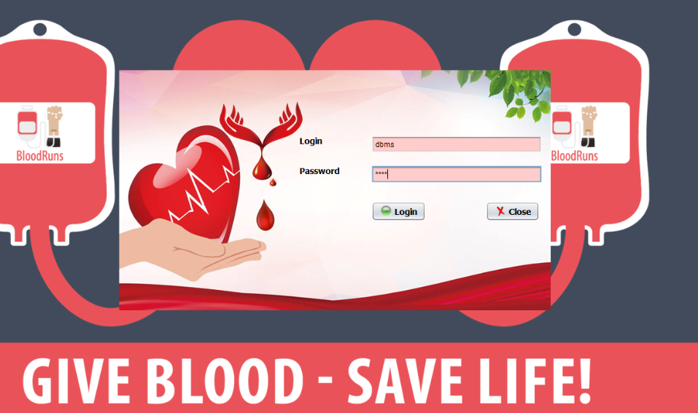

**If the login id password incorrect**

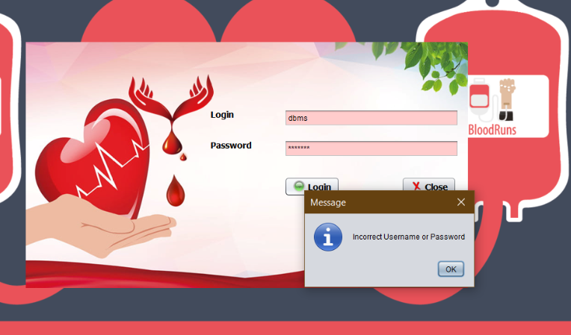

**If we want to close**

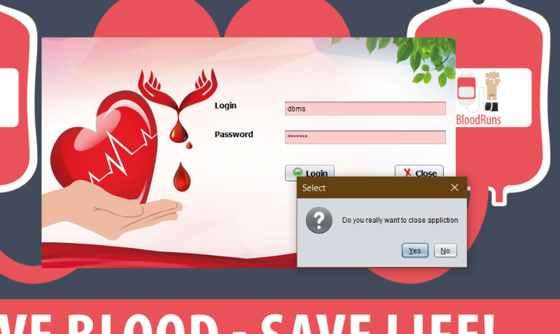

**Press login key we enter in the home page**



**For adding new donor we need to create connection(mysql)**

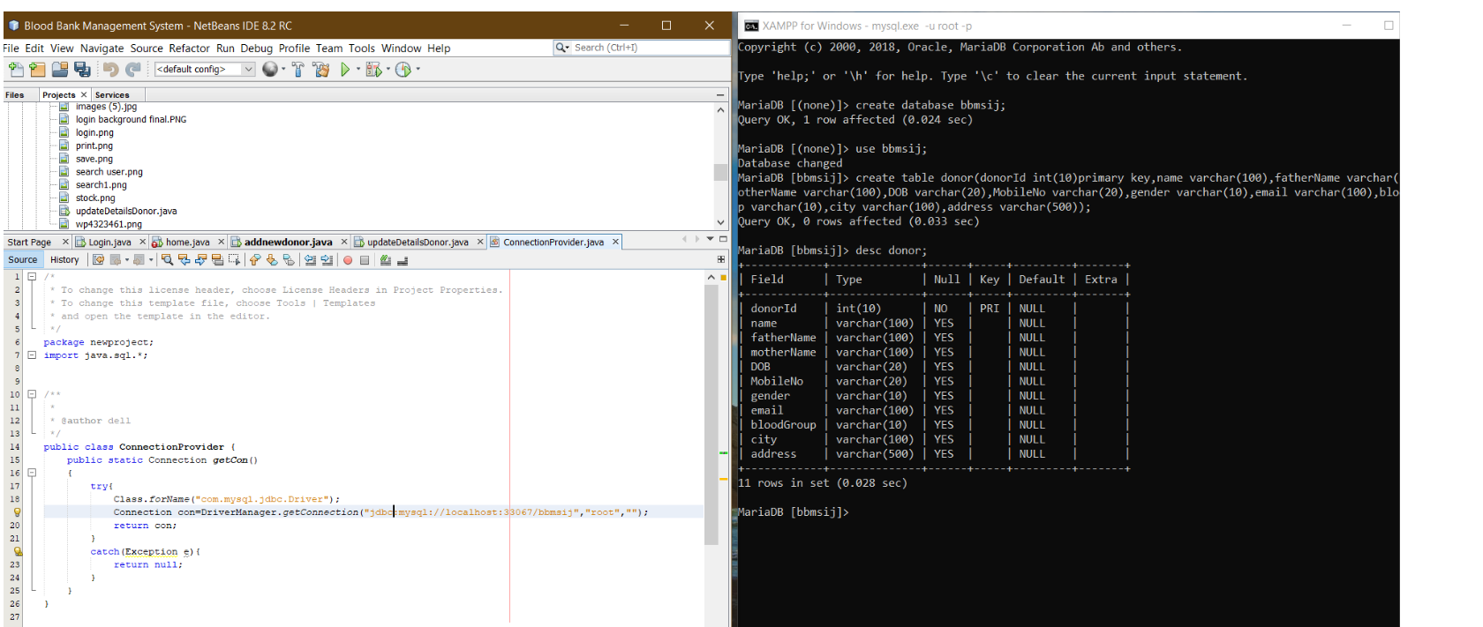

**If we want to add new donor (press on add new)**

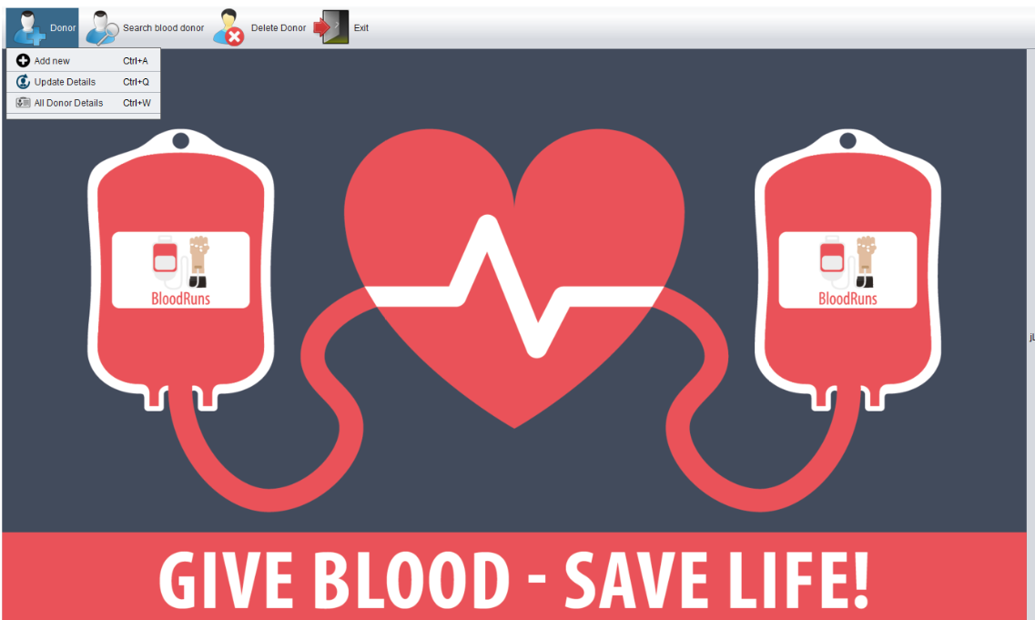

**Add donor information (then save it)**

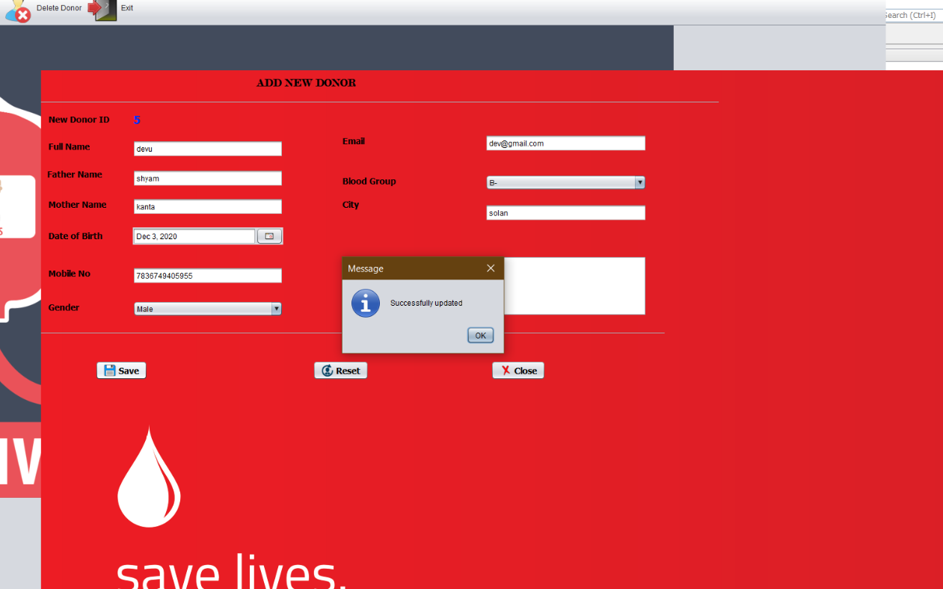

**Update details(press on update details)**

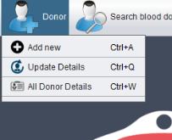

**Here just add the details and the update them**

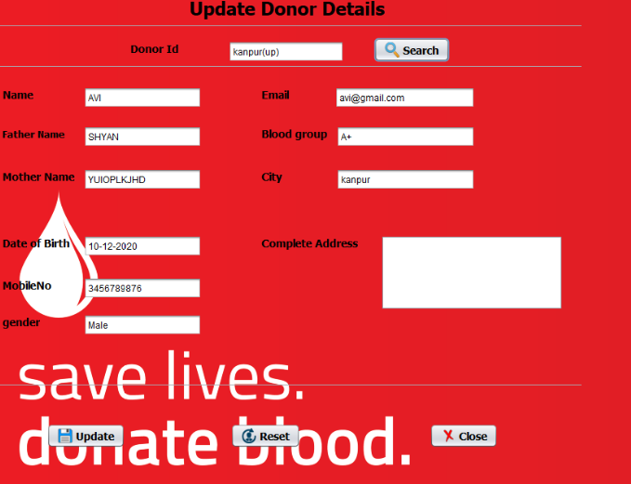

**To see all donor details**

**(press on last option)**

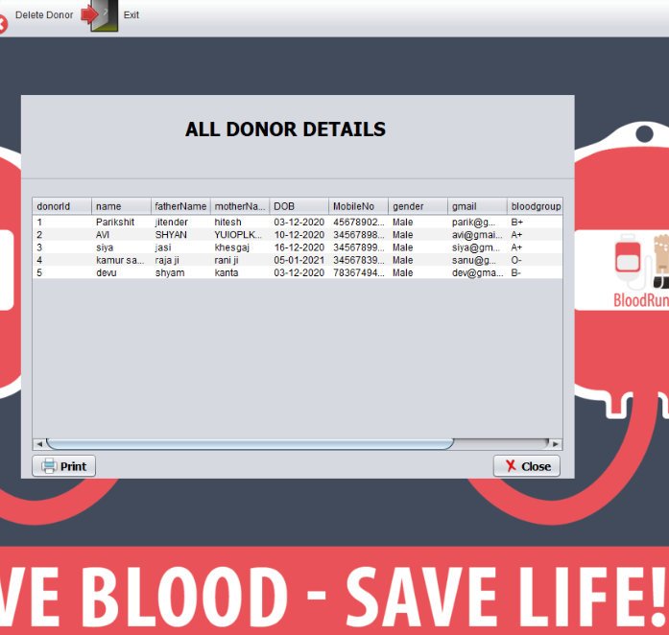

**Search the Donor by location**

**(press location)**

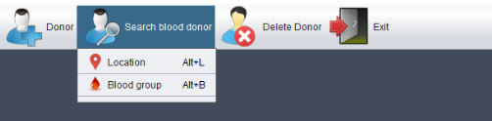

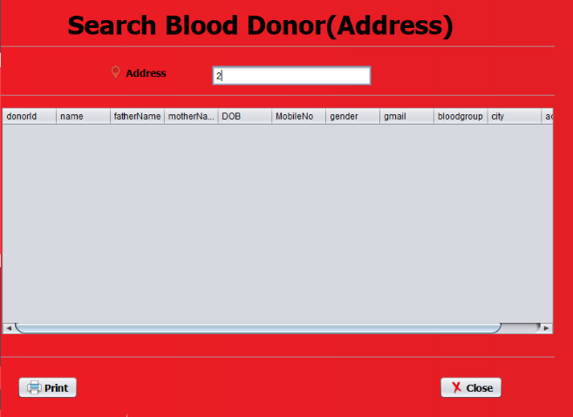

**For searching by blood Group**

**Select blood group option**



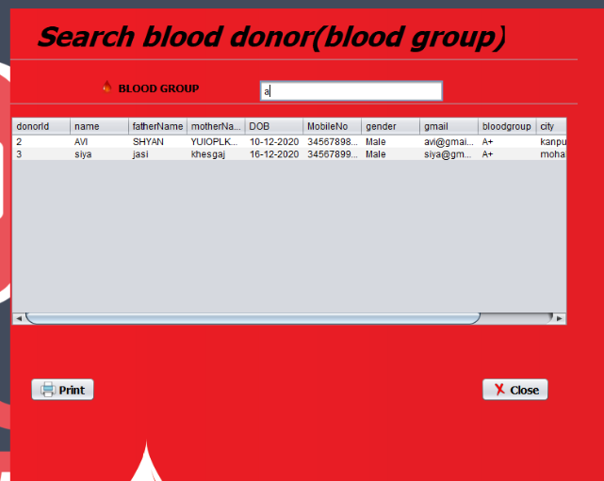

**If we want to print the result**

**1 press print option**

**2 select the size and number of copies option**

**3 then press print**

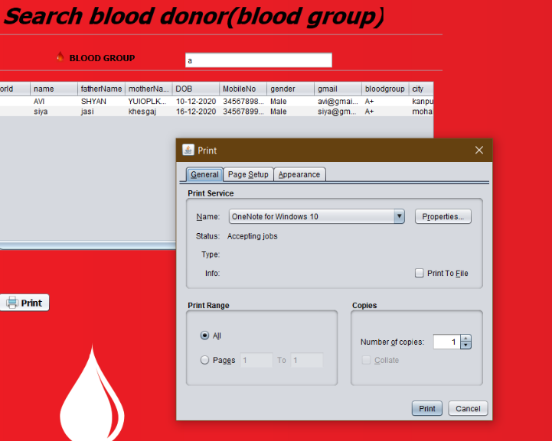

**Delete the donor**

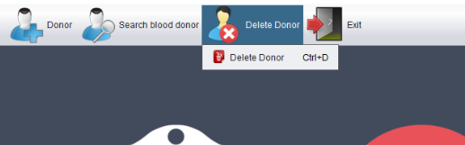

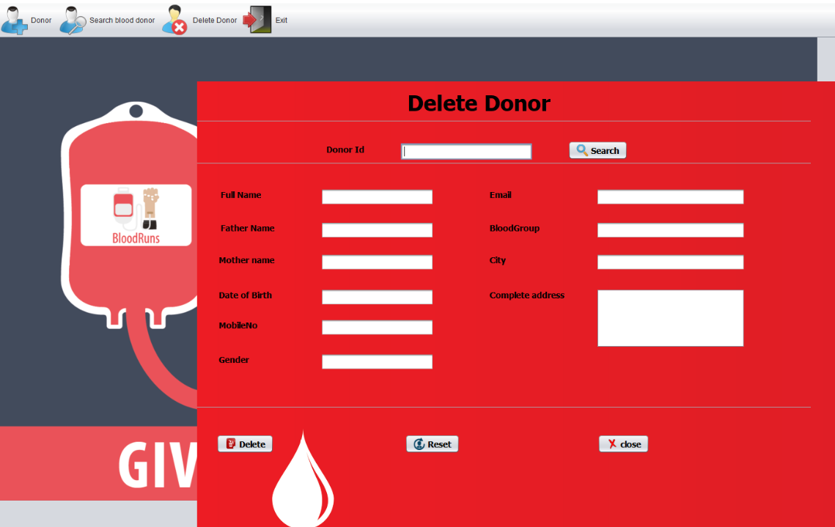

**Exit the application**

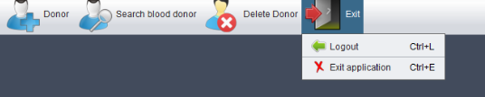

**If we press logout then we return back in login page or Exit application turn off the application**

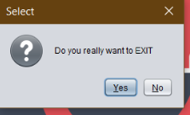

**Press yes to exit**

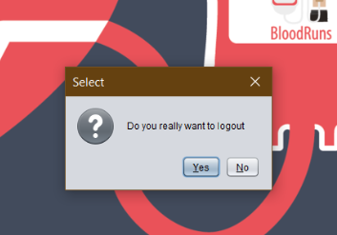

**Press yes for logout**

**(return back in login page)**

