**Experiment Title.** Program to demonstrate the use of Classes, Objects, Constructor, Inheritance, Function and function overloading, Constructor and Constructor overloading, and use of this keyword.

**Student Name:** Parikshit sharma **UID:**19BCS4520

**Branch:** CSE-IOT **Section/Group** IOT/A

**Semester:** 4  **Date of Performance:**24/4/2021

**Subject Name:** Python lab **Subject Code:**CSP-287

**1. Overview of Virtual Box:**

Program to demonstrate the use of Classes, Objects, Constructor, Inheritance, Function and function overloading, Constructor and Constructor overloading, and use of this keyword.

**2. Tasks to be done:**

Program to demonstrate the use of :

1 Class

2 Objects

3 Constructor

4 Inheritance

5 Function and function overloading

6 Constructor and Constructor overloading

7 use of this keyword.

**3. Steps for practical**: (Mention the steps for each and every task)

class Car:

def __init__(this, company):

''' Use of constructor '''

print("Making Car....")

this.manufacturer = company

def drive(this):

''' Functions '''

print("This car can drive @80 kmph.")

def show(this):

''' Use of this keyword '''

print(f'{this.manufacturer} has made this car')

class Tesla(Car):

def __init__(this, model='Roadster'):

''' Use of Inheritance '''

super().__init__('Tesla')

this.model = model

print("Making Tesla.")

def drive(this, speed=100):

''' Function Overriding and Overloading '''

this.speed = speed

print(f"{this.model} has max speed of {this.speed} kmph.")

def modelName(this):

print(f"This is a {this.model} made by {this.manufacturer}")

if __name__ == '__main__':

roadster = Tesla() # use of objects

roadster.drive()

roadster.show() # use of Inheritance

roadster.modelName()

print()

model3 = Tesla('Model 3')

model3.drive(120)

model3.show()

model3.modelName()

**4. Screenshots:**

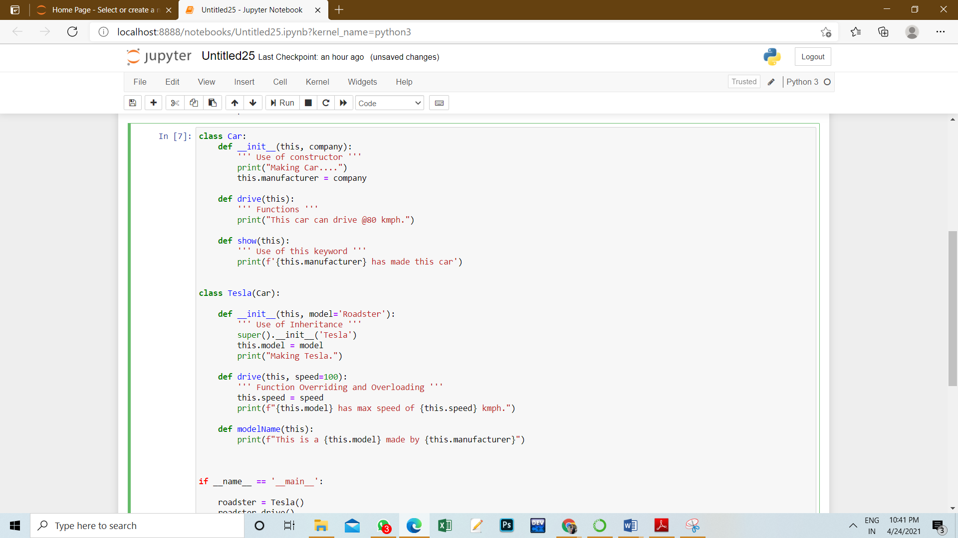

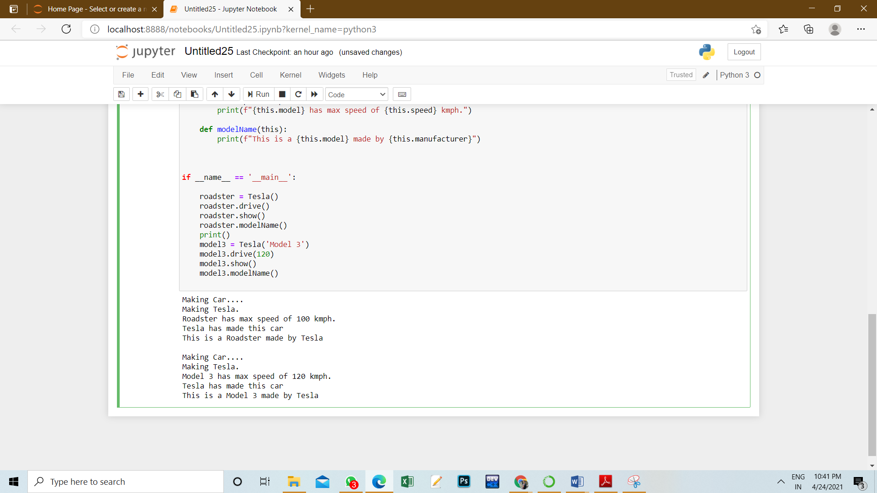

**5. Commands used:**

def – to make functions

class – to make classes

print – to print on console

super – to access the values from the parent class

**6. Result/Output/Writing Summary:**



**Learning outcomes (What I have learnt):**

1. Classes & Objects,

2. Inheritance,

3. Function and function overloading

4. Constructor and Constructor overloading

5. Use of this keyword.

**Evaluation Grid (To be created as per the SOP and Assessment guidelines by the faculty):**

|  |  |  |  |
| --- | --- | --- | --- |
| Sr. No. | Parameters | Marks Obtained | Maximum Marks |
| 1. |  |  |  |
| 2. |  |  |  |
| 3. |  |  |  |
|  |  |  |  |