**Experiment Title.** Write a program to Square Root of any given number and Display the result

**Student Name:**Parikshit sharma  **UID:**19BCS4520

**Branch:** CSE **Section/Group=**IOT/A

**Semester:** 4th **Date of Performance:**06/04/2021

**Subject Name:**Python lab **Subject Code:**CSP 287

**1. Overview of Virtual Box:**

Write a program to Square Root of any given number and Display the result

**2. Tasks to be done:**

Square Root of any given number and Display the result

1 By using importing math

2 without importing math

**3. Steps for practical**: (Mention the steps for each and every task)

**By importing math**

Step1 import math

Step2 take input value of the n

Step3 perform operation a=math.sqrt(n)

Step4 print output

Step5 exit

**Code:**

import math

n=9

a=math.sqrt(n)

print("the square root :",a)

**Without math**

Step1 take input value n

Step2 perform operation a=n**0.5

Step 3 print the output

Step4 exit

**Code:**

n=9

a=n**0.5

print("the square root is:",a)

**4. Screenshots**

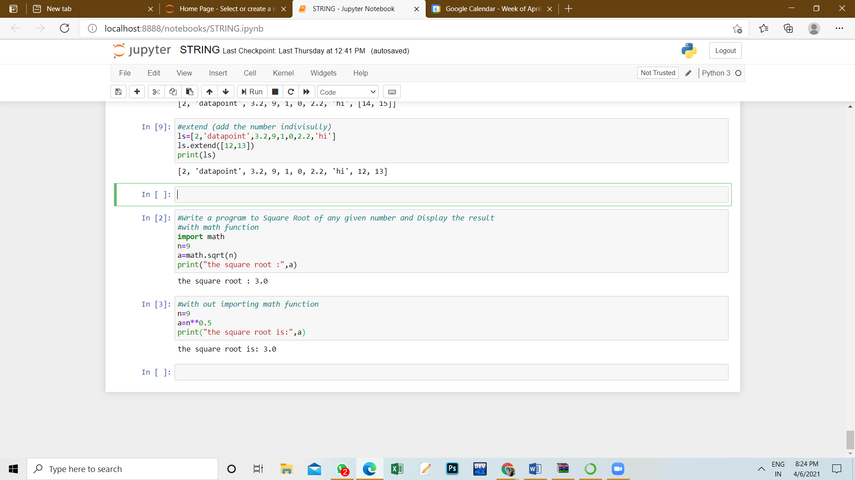

**5. Commands used:**

Import math

sqrt

**6. Result/Output/Writing Summary:**



**Learning outcomes (What I have learnt):**

1.Find the square root

2. how to import math

3.  Examine Python syntax and semantics and be fluent in the use of Python flow control and functions.

4. how to perform function like square root

**Evaluation Grid (To be created as per the SOP and Assessment guidelines by the faculty):**

|  |  |  |  |
| --- | --- | --- | --- |
| Sr. No. | Parameters | Marks Obtained | Maximum Marks |
| 1. |  |  |  |
| 2. |  |  |  |
| 3. |  |  |  |
|  |  |  |  |