**Experiment Title.** Create a class with a method that prints "This is parent class" and its subclass with another method that prints "This is child class". Now, create an object for each of the class and call

1 - method of parent class by object of parent class

2 - method of child class by object of child class

3 - method of parent class by object of child class

**Student Name:Parikshit sharma UID:19BCS4520**

**Branch:CSE Section/Group IOT/A**

**Semester: 4 Date of Performance:**

**Subject Name:Python Lab Subject Code:CSP-289**

**1. Overview of Virtual Box:**

Create a class with a method that prints "This is parent class" and its subclass with another method that prints "This is child class". Now, create an object for each of the class and call

1 - method of parent class by object of parent class

2 - method of child class by object of child class

3 - method of parent class by object of child class

**2. Tasks to be done:**

Create a class with a method that prints "This is parent class" and its subclass with another method that prints "This is child class". Create an object for each of the class and call

1 - method of parent class by object of parent class

2 - method of child class by object of child class

3 - method of parent class by object of child class

**3. Steps for practical**: (Mention the steps for each and every task)

ALGORITHM:

Step1: create two classes one is parent and other is child

Step2: define method in each class

Step3: using print function write according to the question

Step4: create object of each class

Step5: call the methods using these objects

CODE:

class Parent:

def showParent(self):

print("This is parent class.")

class Child(Parent):

def showChild(self):

print("This is a child class.")

if __name__ == "__main__":

par = Parent()

chi = Child()

par.showParent()

chi.showChild()

chi.showParent()

**4. Screenshots:**

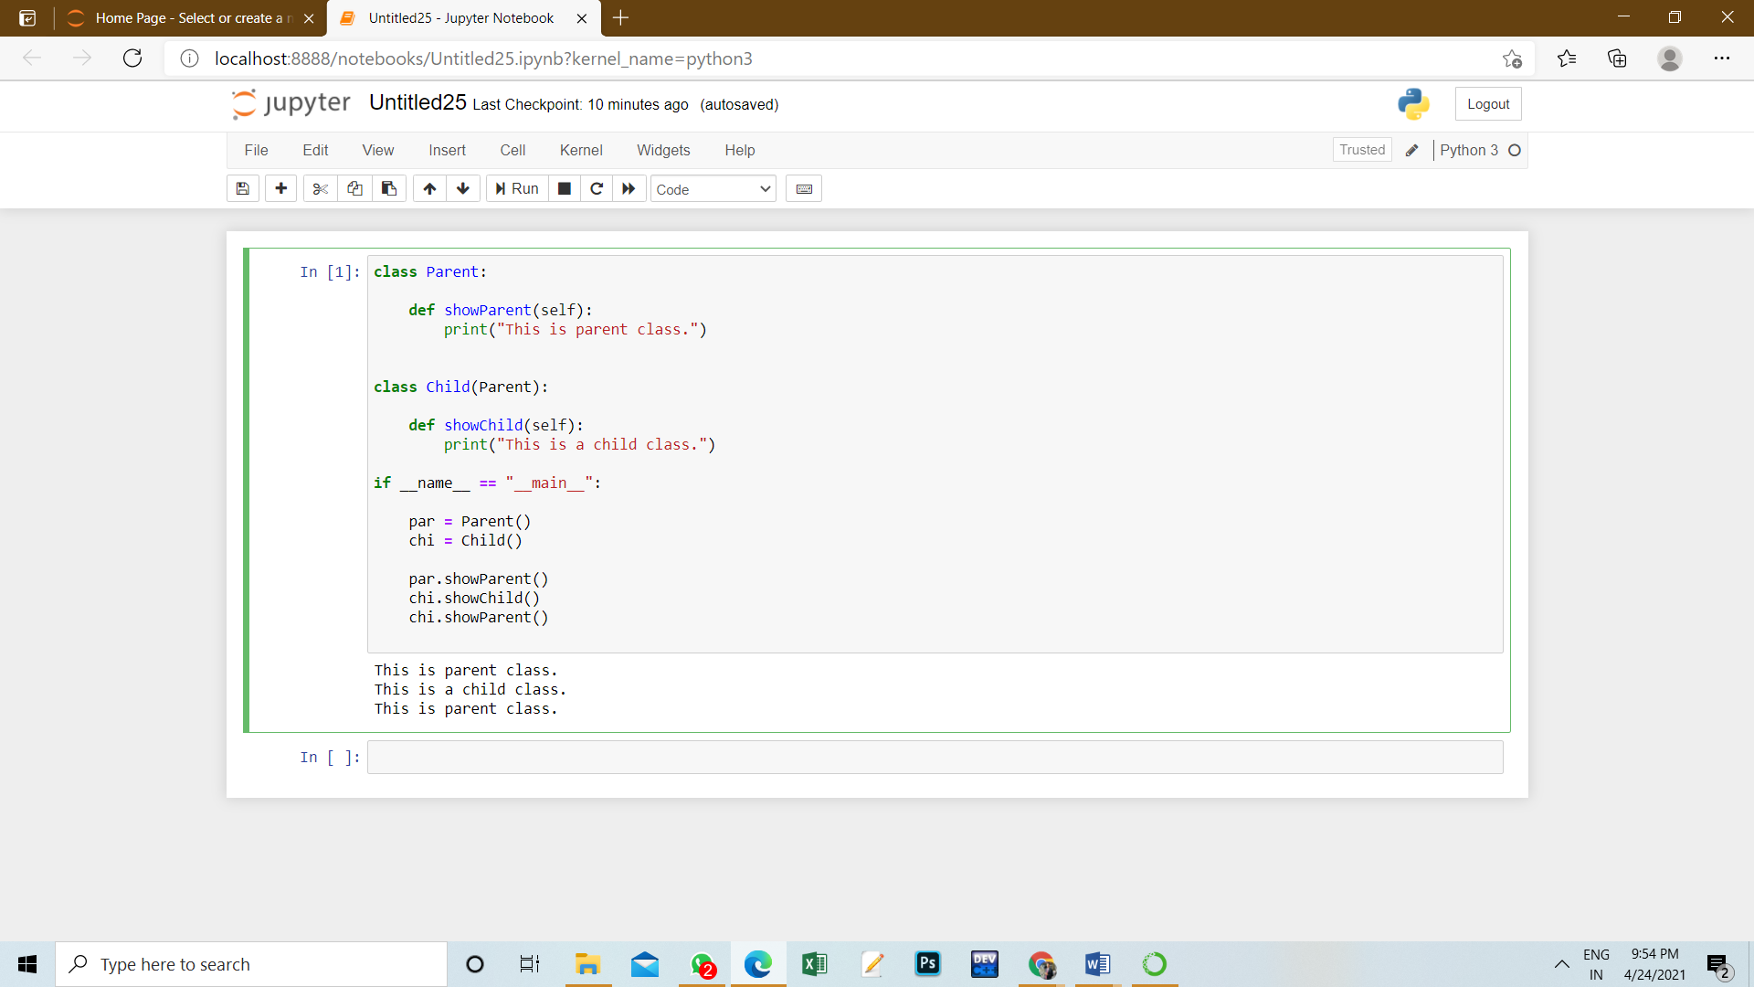

**5. Commands used:**

1 class – to make a class

2 print – to print on console

3 def – to define a function

**6. Result/Output/Writing Summary:**

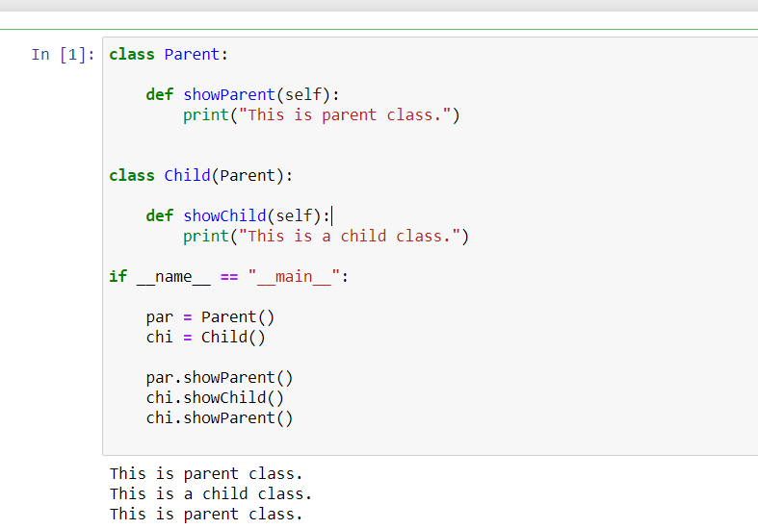

**Learning outcomes (What I have learnt):**

1. I have learnt the concept of classes and object

2. I have learnt the concept of inheritance

3. I have learnt how to call method

**Evaluation Grid (To be created as per the SOP and Assessment guidelines by the faculty):**

|  |  |  |  |
| --- | --- | --- | --- |
| Sr. No. | Parameters | Marks Obtained | Maximum Marks |
| 1. |  |  |  |
| 2. |  |  |  |
| 3. |  |  |  |
|  |  |  |  |