Smart IT Desk Automation System

A Project-II Report
Submitted in partial fulfillment of requirement of the
Degree of
BACHELOR OF TECHNOLOGY in COMPUTER SCIENCE & ENGINEERING
BY
Bhavya Patidar
EN22CS303020

Under the Guidance of
Internal Guide: Asst. Prof. Sonal Mohd
Department of Computer Science & Engineering

External Guide: Mr. Asif Lucknowi
Technovation Unicorn LLP, Bengaluru



Department of Computer Science & Engineering
Faculty of Engineering
MEDICAPS UNIVERSITY, INDORE- 453331
JAN-JUNE 2026

Smart IT Desk Automation System

A Project-II Report
Submitted in partial fulfillment of requirement of the
Degree of
BACHELOR OF TECHNOLOGY in COMPUTER SCIENCE & ENGINEERING
BY
Bhavya Patidar
EN22CS303020

Under the Guidance of
Internal Guide: Asst. Prof. Sonal Mohd
Department of Computer Science & Engineering

External Guide: Mr. Asif Lucknowi
Technovation Unicorn LLP, Bengaluru


Department of Computer Science & Engineering
Faculty of Engineering
MEDICAPS UNIVERSITY, INDORE- 453331
JAN-JUNE 2026
Report Approval

The project work “Smart IT Desk Automation System” is hereby approved as a creditable study of an engineering/computer application subject carried out and presented in a manner satisfactory to warrant its acceptance as prerequisite for the Degree for which it has been submitted.
It is to be understood that by this approval the undersigned do not endorse or approved any statement made, opinion expressed, or conclusion drawn there in; but approve the “Project Report” only for the purpose for which it has been submitted.

Internal Examiner
Name:
Designation
Affiliation

External Examiner
Name:
Designation
Affiliation

Declaration

I hereby declare that the project entitled “Smart IT Desk Automation System” submitted in partial fulfillment for the award of the degree of Bachelor of Technology/Master of Computer Applications in Computer Science & Engineering’ completed under the supervision of Asst. Prof. Sonal Mohd, Department of Computer Science & Engineering, Faculty of Engineering, Medicaps University Indore is an authentic work.
Further, I declare that the content of this Project work, in full or in parts, have neither been taken from any other source nor have been submitted to any other Institute or University for the award of any degree or diploma.

Bhavya Patidar
EN22CS303020
B.Tech. IV Year
Department of Computer Science & Engineering
Faculty of Engineering
Medicaps University, Indore

Date: _______________
Certificate

I, Asst. Prof. Sonal Mohd certify that the project entitled “Smart IT Desk Automation System” submitted in partial fulfillment for the award of the degree of Bachelor of Technology by Bhavya Patidar (EN22CS303020) is the record carried out by him under my guidance and that the work has not formed the basis of award of any other degree elsewhere.

________________________________
Asst. Prof. Sonal Mohd
Department of Computer Science & Engineering
Medicaps University, Indore
________________________________
Mr. Asif Lucknowi
Technovation Unicorn LLP, Bengaluru

_____________________
Dr. Kailash Chandra Bandhu
Head of the Department
Computer Science & Engineering
Medicaps University, Indore

Acknowledgements

I would like to express my deepest gratitude to Honorable Chancellor, Shri R C Mittal, who has provided every facility to successfully carry out this project, and my profound indebtedness to Prof. (Dr.) D. K. Patnaik, Vice Chancellor, Medicaps University, whose unfailing support and enthusiasm has always boosted up my morale.
I also thank Prof. (Dr.) Ratnesh Litoriya, Associate Dean, Faculty of Engineering, Medicaps University, for giving me a chance to work on this project. I would also like to thank my Head of Department Dr. Kailash Chandra Bandhu for his continuous encouragement for the betterment of the project.
I express my heartfelt gratitude to my External Guide, Mr. Asif Lucknowi, Technovation Unicorn LLP, Bengaluru, as well as to my Internal Guide, Asst. Prof. Sonal Mohd, Department of Computer Science & Engineering, Medicaps University, without whose continuous help and support, this project would never have reached completion.
I am especially thankful to the team at Technovation Unicorn LLP for providing me with the opportunity to work on real-world data analytics problems during my internship. Their mentorship and guidance on industry practices in data analytics have been invaluable in shaping this project.
I also extend my gratitude to my family and friends for their constant support and encouragement throughout this journey. This project would not have been possible without their unwavering belief in me.

Bhavya Patidar
B.Tech. IV Year
Department of Computer Science & Engineering
Faculty of Engineering
Medicaps University, Indore

ABSTRACT

In modern organizations, efficient complaint and issue management plays a vital role in maintaining operational productivity and customer satisfaction. Traditional complaint handling systems based on paper records, verbal communication, or emails often suffer from delayed responses, poor tracking mechanisms, lack of accountability, and scattered data records.
To overcome these limitations, the project SIDAS – Smart Issue Detection and Assistance System has been developed as an intelligent web-based issue management platform.
The main purpose of SIDAS is to provide a centralized digital solution for registering complaints, generating support tickets, assigning issues to administrators, tracking complaint progress, and resolving issues in a systematic manner.
The system enables users to register securely, log in using credentials, submit complaints under various categories, and monitor the current status of their tickets. Each complaint is stored with a unique ticket ID, date, user details, category, priority, and current status.
The administrative panel allows authorized personnel to view all complaints, sort tickets based on priority, assign responsibilities, update progress, and mark complaints as resolved after completion.
The project is developed using modern technologies such as:
- Java
- Spring Boot
- Spring Security
- Hibernate / JPA
- MySQL Database
- HTML
- CSS
- Bootstrap
- JavaScript
The system follows MVC architecture, ensuring separation of concerns, maintainability, and scalability.
The major benefits of SIDAS include:
- Fast complaint registration
- Real-time status tracking
- Centralized data management
- Reduced paperwork
- Better transparency
- Increased accountability
- Improved user satisfaction
- Better reporting system
The project demonstrates how software solutions can automate real-life administrative problems efficiently. It also provides practical learning in full-stack development, database connectivity, security implementation, and user experience design.
SIDAS can be implemented in colleges, offices, industries, hospitals, municipalities, and customer support environments.
SIDAS stands for Smart IT Desk Automation System. It is a web-based complaint management and ticket resolution platform designed to improve communication between users and support staff. Many organizations face difficulties in managing complaints manually, resulting in delays, data loss, poor tracking, and customer dissatisfaction. SIDAS provides a digital solution for raising complaints, assigning tickets, tracking issue progress, and generating reports.
The system allows registered users to log in and raise complaints related to different categories such as technical issues, hardware problems, software issues, or service-related concerns. Each complaint is stored as a ticket with a unique ID. Administrators and support staff can view pending issues, assign priorities, update status, and resolve tickets.
The project is developed using Spring Boot for backend processing, MySQL for database management, Thymeleaf for frontend rendering, HTML, CSS, and JavaScript for user interface design. Spring Security is used for login authentication and role-based access control.
The system improves transparency, accountability, and efficiency. Users can monitor ticket status in real time, while administrators can manage workload and resolution performance effectively.
The project demonstrates practical implementation of modern web technologies in solving real-world complaint management problems.

Keywords: -
Smart IT Department Automation System (SIDAS), Department Management, Complaint Management, Ticket Raising System, Student Support System, Faculty Management, Web Application, Automation, Spring Boot, Java, MySQL Database, HTML, CSS, JavaScript, Bootstrap, Admin Dashboard, Data Management, Secure Login System, User Authentication, Academic Workflow, Digital Transformation, Report Generation, IT Service Management.

Table of Contents
 |  | Page No.
 | Report Approval | ii
 | Declaration | iii
 | Certificate | iv
 | Acknowledgement | v
 | Abstract | vi
 | Table of Contents | viii
 | List of figures | xii
 | List of tables | xiii
 | Abbreviations | xiv
Chapter 1 | Introduction | 1
 | 1.1 Introduction | 1
 | 1.2 Need of Proposed System | 2
 | 1.3 Literature Review | 3
 | 1.4 Objectives of the Project | 4
 | 1.5 Scope of the Project | 4
 | 1.6 Significance of Study | 6
 | 1.7 Research Methodology | 6
 | 1.8 Source of Data | 7
 | 1.9 Limitation of Current Version | 7
 | 1.10 Chapter Scheme | 8
Chapter 2 | Report on Present Investigation | 10
 | 2.1 Experimental Set-up | 10
 | 2.2 Procedures Adopted | 11
 | 2.3 System Development Methodology | 13
Chapter 3 | System Analysis and Design | 15
 | 3.1 Introduction | 15
 | 3.2 System Architecture | 15
 | 3.3 Modules of SIDAS | 17
 | 3.4 Database Design | 20
 | 3.5 ER Diagram Description | 21
 | 3.6 Use Case Diagram Description | 22
 | 3.7 Development Methodology | 23
 | 3.8 Frontend Development | 24
 | 3.9 Backend Development | 24
 | 3.10 Security Implementation | 25
 | 3.11 Testing of Modules | 25
 | 3.12 Challenges During Development | 25
 | 3.13 Output Screens Description | 26
Chapter 4 | Implementation Details | 27
 | 4.1 Introduction | 27
 | 4.2 Software Environment | 27
 | 4.3 Hardware Environment | 28
 | 4.4 Frontend Implementation | 28
 | 4.5 Backend Implementation | 31
 | 4.6 Database Implementation | 32
 | 4.7 Sample Backend Code Explanation | 32
 | 4.8 Integration Process | 33
 | 4.9 Error Handling | 33
 | 4.10 Deployment Steps | 33
Chapter 5 | Testing and validation | 35
 | 5.1 Introduction | 35
 | 5.2 Types of Testing Performed | 35
 | 5.3 Test Cases | 35
 | 5.4 Validation Techniques | 36
 | 5.5 Bug Fixes | 36
 | 5.6 Performance Testing | 36
Chapter 6 | Security and maintenance | 37
 | 6.1 Introduction | 37
 | 6.2 Need of Security in SIDAS | 37
 | 6.3 Authentication System | 37
 | 6.4 Authorization and Role Management | 38
 | 6.5 Password Security | 38
 | 6.6 Database Security | 39
 | 6.7 Session Management | 39
 | 6.8 Error Handling and Data Recovery | 39
 | 6.9 Need of Maintenance | 40
 | 6.10 Types of Maintenance | 40
Chapter 7 | Results and Discussions | 41
 | 7.1 Introduction | 41
 | 7.2 Functional Results | 41
 | 7.3 Performance Results | 41
 | 7.4 Accuracy Results | 41
 | 7.5 Security Results | 42
 | 7.6 User Satisfaction | 42
 | 7.7 Discussion | 42
Chapter 8 | Summary and Conclusions | 43
 | 8.1 Summary | 43
 | 8.2 Conclusion | 43
 | 8.3 Future Scope | 43
Chapter 9 | Future scope | 45
 | 9.1 Introduction | 45
 | 9.2 Mobile Application Development | 45
 | 9.3 Cloud-Based Deployment | 45
 | 9.4 Artificial Intelligence Integration | 46
 | 9.5 Advanced Security Features | 46
 | 9.6 Notification and Alert System | 46
 | 9.7 Multi-Department Expansion | 47
 | 9.8 Data Analytics and Reporting | 47
 | 9.9 Integration with University Systems | 48
 | Appendix | 49
 | Bibliography | 50

List of Figures
Figure 1.1 Existing Manual Complaint Handling Process
Figure 1.2 Need of Proposed SIDAS System
Figure 1.3 Scope Areas of SIDAS Application
Figure 1.4 Software Development Life Cycle for SIDAS
Figure 2.1 Experimental Setup of Development Environment
Figure 2.2 System Development Procedure Flowchart
Figure 2.3 Agile Methodology Used in SIDAS

Figure 3.1 Three Layer Architecture of SIDAS
Figure 3.2 User Module Workflow
Figure 3.3 Admin Module Workflow
Figure 3.4 Use Case Diagram of SIDAS

Figure 4.1 Login Page Interface
Figure 4.2 User Registration Page
Figure 4.3 Dashboard Screen
Figure 4.4 Raise Complaint Form
Figure 4.5 Admin Control Panel

List of Tables
Table 3.1 User Table Structure
Table 3.2 Complaint Table Structure
Table 3.3 Ticket History Table Structure
Table 4.1 Software Environment Used in Implementation
Table 4.2 Hardware Environment Specifications

Table 5.1 Test Cases and Expected Results

Table 7.1 Performance Comparison: Manual System vs SIDAS
Abbreviations

Abbreviation | Meaning
SIDAS | Smart Issue Detection and Assistance System
UI | User Interface
DBMS | Database Management System
SQL | Structured Query Language
MVC | Model View Controller
API | Application Programming Interface
OTP | One Time Password
CRUD | Create Read Update Delete

CHAPTER 1
INTRODUCTION
1.1 Introduction
In every organization, institution, company, or service center, users often face problems related to services, technical support, maintenance, infrastructure, or administration. These issues may include system failures, internet problems, classroom equipment malfunction, software errors, account-related issues, hardware faults, electricity complaints, water supply complaints, or service dissatisfaction.
In many places, such complaints are still handled manually through registers, verbal requests, emails, or informal communication. These methods create several challenges such as:
- No proper record maintenance
- Delay in issue response
- No complaint tracking system
- Repeated complaints
- Poor accountability
- Lack of transparency
- Miscommunication between departments
- Difficulty in report generation
As organizations grow larger, manual complaint handling becomes highly inefficient. There is a strong need for a computerized complaint handling platform that can register complaints, assign tickets, track progress, and close issues efficiently.
To solve this problem, the project SIDAS has been designed.
SIDAS stands for Smart Issue Detection and Assistance System. It is a web-based platform where users can submit complaints online, and administrators can resolve them using a centralized dashboard.
This system ensures that every complaint receives a unique identity and can be monitored from submission to resolution.

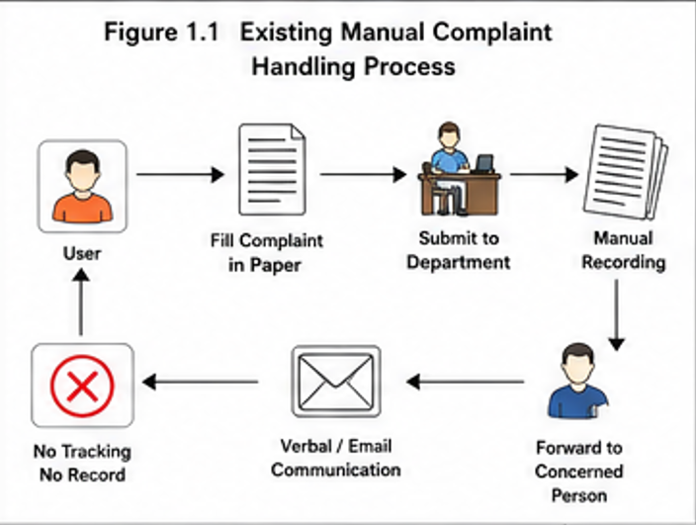
Figure 1.1 Existing Manual Complaint Handling Process

1.2 Need of Proposed System
Modern organizations require automation in support systems. Complaint management is one of the critical operational areas that directly affects satisfaction and productivity.
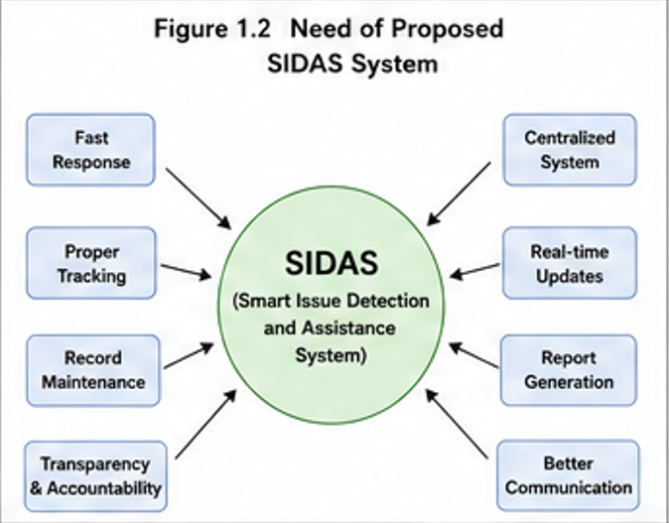
The need for SIDAS arises due to the following reasons:

Figure 1.2 Need of Proposed SIDAS System

1. Slow Manual Process
Traditional systems depend on paper forms or verbal communication. Such methods waste time and create confusion.
2. No Tracking Facility
Users often do not know whether their complaint is pending, in progress, or resolved.
3. Data Loss
Paper records can be damaged, misplaced, or lost permanently.
4. No Accountability
Without digital records, it is difficult to identify who handled the issue and when.
5. Poor Communication
There is no direct bridge between complaint raiser and resolver.
6. Lack of Reports
Management cannot easily analyse complaint trends or employee performance.
7. Need for Remote Access
Users should be able to raise complaints from any device at any time.
SIDAS fulfills all these needs through a secure and modern digital platform.

1.3 Literature Review
Several complaint management systems have been used in industries and institutions over time.
Manual Complaint Registers
Earlier organizations maintained physical registers. Users wrote complaints manually. This system lacked speed, security, and tracking.
Email-Based Complaint Systems
Many organizations shifted to email complaint handling. Though digital, it created inbox overload and poor monitoring.
Spreadsheet-Based Tracking
Some institutions used Excel sheets to track issues. This improved records but lacked real-time updates and automation.
ERP Support Modules
Large enterprises use integrated ERP complaint modules. These systems are powerful but expensive and complex for small organizations.

Online Ticket Systems
Modern web-based ticketing systems introduced unique IDs, dashboards, and status updates.
SIDAS takes inspiration from these systems but is designed to be:
- Lightweight
- Affordable
- Easy to use
- Customizable
- Suitable for educational institutions and offices

1.4 Objectives of the Project
The major objectives of SIDAS are:
- To design a secure complaint registration platform.
- To automate issue management processes.
- To reduce paperwork and manual dependency.
- To generate unique support tickets automatically.
- To allow users to track ticket status online.
- To help administrators prioritize complaints.
- To store complaint history in database.
- To improve service quality and efficiency.
- To provide transparency in complaint handling.
- To develop a scalable full-stack web application.

1.5 Scope of the Project
SIDAS has wide application scope in multiple sectors:
Educational Institutions
- Student complaints
- Hostel maintenance
- Lab system issues
- Faculty support requests
Offices
- IT support tickets
- HR complaints
- Infrastructure issues
Hospitals
- Equipment maintenance
- Service complaints
Industries
- Machine breakdown reporting
- Department requests
Municipal Bodies
- Water complaints
- Street light complaints
- Sanitation issues
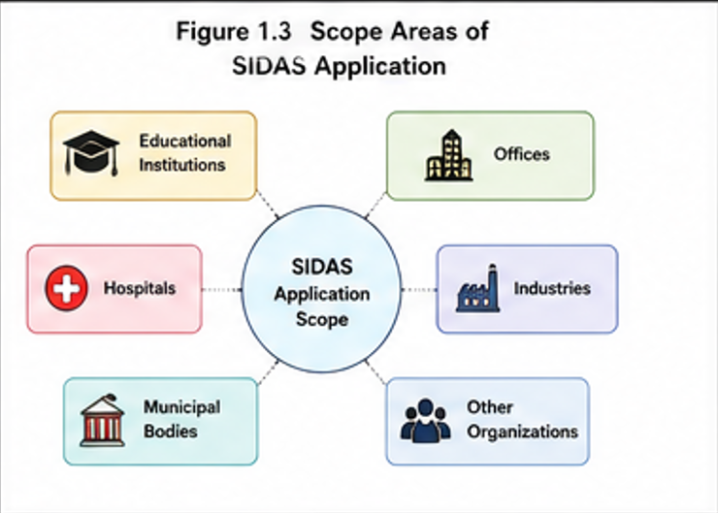
Figure 1.3 Scope Areas of SIDAS Application
1.6 Significance of Study
This project is significant because it demonstrates practical use of technology in solving real administrative problems.
It provides learning in:
- Web development
- Java programming
- Backend APIs
- Database design
- Authentication systems
- Frontend integration
- Debugging real projects
It also helps organizations by improving efficiency and transparency.

1.7 Research Methodology
The project follows Software Development Life Cycle (SDLC).
Phase 1 – Requirement Gathering
Collected problems faced in manual complaint systems.
Phase 2 – Planning
Prepared modules, database tables, and workflow.
Phase 3 – Design
Created UI wireframes and architecture.
Phase 4 – Development
Implemented frontend and backend.
Phase 5 – Testing
Performed functional testing and debugging.
Phase 6 – Deployment
Ready for real environment use.

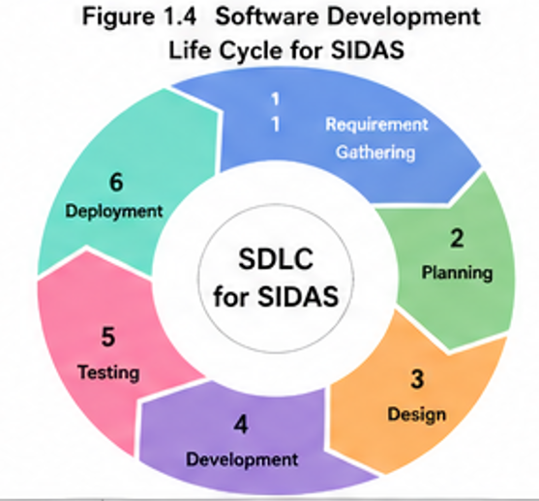
Figure 1.4 Software Development Life Cycle for SIDAS

1.8 Source of Data
Data used in SIDAS includes:
- User registration records
- Complaint details
- Ticket statuses
- Admin updates
- Login logs
- Complaint categories
- Resolution timestamps

1.9 Limitations of Current Version
Current version limitations include:
- No mobile app
- No email notifications
- No chatbot support
- Single language support
- Limited analytics dashboard
These can be improved in future versions.

1.10 Chapter Scheme
Chapter 1: Introduction
This chapter provides the basic overview of the project. It explains the background of the study, need for automation in departmental operations, literature review, objectives of the project, significance of the system, research design, sources of data, and chapter-wise organization of the report.
Chapter 2: Report on Present Investigation
This chapter describes the practical investigation carried out during the project development. It includes the experimental set-up, hardware and software requirements, procedures adopted, tools used, and system development methodology followed during implementation.
Chapter 3: System Analysis and Design
This chapter explains the analysis of the existing manual system and the proposed automated system. It also includes system architecture, flowcharts, use case diagrams, database design, and functional modules of SIDAS.
Chapter 4: Implementation
This chapter focuses on the actual development of the project. It describes frontend implementation using HTML, CSS, JavaScript, Bootstrap, and backend implementation using Java Spring Boot with MySQL database integration.
Chapter 5: Testing and Validation
This chapter presents the testing methods used to verify system functionality and performance. It includes unit testing, integration testing, system testing, debugging process, and validation of outputs.
Chapter 6: Security and Maintenance
This chapter explains security features such as user authentication, authorization, password protection, and database security. It also discusses system maintenance strategies and future support requirements.
Chapter 7: Results and Discussions
This chapter contains screenshots, outputs, performance observations, system benefits, and detailed discussion of the achieved results after implementation of the project.
Chapter 8: Summary and Conclusions
This final chapter summarizes the complete work carried out in the project. It presents the major findings, achievements, limitations, and final conclusions of the study. It also highlights the overall success of the Smart IT Department Automation System and its usefulness in real-world applications.
Chapter 9: Future Scope

This chapter discusses the possible future enhancements and advanced extensions of the Smart IT Department Automation System (SIDAS). It highlights opportunities such as mobile application development, cloud deployment, artificial intelligence integration, advanced security mechanisms, notification systems, multi-department implementation, data analytics dashboards, and integration with existing university or organizational systems.

CHAPTER 2
REPORT ON PRESENT INVESTIGATION
2.1 Experimental Set-up
The development of the Smart IT Department Automation System (SIDAS) required a proper technical environment consisting of hardware, software, database tools, and testing platforms. The experimental setup was designed to ensure smooth development, testing, and deployment of the project.
Hardware Requirements
The project was developed and tested on a standard computer system with the following configuration:
- Processor: Intel Core i3 / i5 or equivalent
- RAM: Minimum 4 GB
- Storage: 256 GB SSD / 500 GB HDD
- Monitor: 15-inch display or above
- Keyboard and Mouse for user input
- Stable internet connection for updates and deployment
Software Requirements
The following software tools were used during development:
- Operating System: Windows 10 / Windows 11
- IDE: Spring Tool Suite / IntelliJ IDEA / Eclipse
- Frontend Editor: Visual Studio Code
- Backend Framework: Spring Boot
- Programming Language: Java
- Database: MySQL Server
- Browser: Google Chrome / Microsoft Edge
- Version Control: Git (optional)
Network Environment
The system was tested under Local Area Network (LAN) and internet-based access. This ensured that users could access the platform from multiple devices.
Testing Environment
The project was tested for:
- Functional testing
- Login validation
- Ticket submission process
- Database connectivity
- Page responsiveness
- Performance under multiple users

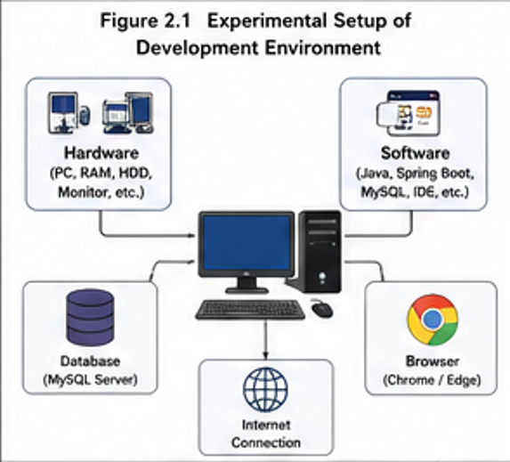
Figure 2.1 Experimental Setup of Development Environment
2.2 Procedures Adopted
A systematic procedure was followed to develop the project efficiently. The steps adopted are as follows:
Step 1: Requirement Collection
The needs of students, faculty members, and department administrators were studied. Common issues such as complaint handling, data management, and delayed responses were identified.
Step 2: Problem Analysis
Traditional manual systems were analysed, and limitations such as paperwork, delays, and lack of transparency were observed.
Step 3: System Design
Based on the collected requirements, system modules were planned:
- Student Login Module
- Admin Dashboard
- Raise Ticket Module
- Complaint Tracking Module
- Faculty Management
- Report Section
Step 4: Database Design
Tables were created in MySQL to store:
- User details
- Login credentials
- Tickets raised
- Status updates
- Department records
Step 5: Coding and Development
The project was developed using:
- HTML, CSS, JavaScript for frontend
- Java Spring Boot for backend
- MySQL for database storage
Step 6: Testing
Each module was tested individually and then integrated into the complete system.
Step 7: Final Deployment
After successful testing, the system was prepared for final demonstration and practical use.

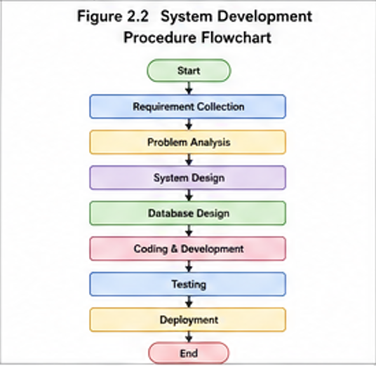
Figure 2.2 System Development Procedure Flowchart

2.3 System Development Methodology
The Agile Development Methodology was adopted for the development of SIDAS. Agile focuses on step-by-step development and regular improvements.
Phases of Methodology
1. Planning
Project objectives, scope, and timeline were defined.
2. Designing
User interface, database schema, and workflow diagrams were prepared.
3. Development
Modules were developed one by one.
4. Testing
Every completed module was tested for bugs and performance.
5. Review and Improvement
Feedback was taken and necessary improvements were made.
Advantages of Adopted Methodology
- Flexible development process
- Easy bug fixing
- Better quality control
- Faster completion of modules
- Continuous improvement possible

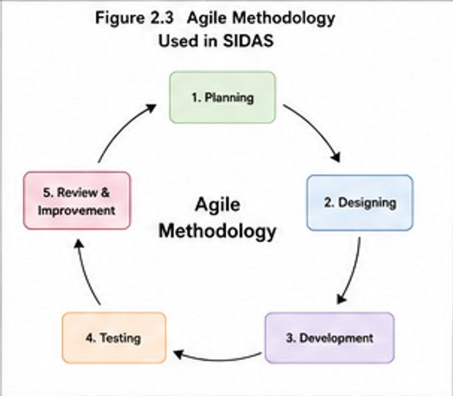
Figure 2.3 Agile Methodology Used in SIDAS

CHAPTER 3
SYSTEM ANALYSIS AND DESIGN
3.1 Introduction
System design is one of the most important phases in software development. It transforms requirements into a practical and implementable solution. For the SIDAS project, the system design phase focused on creating a secure, scalable, and user-friendly web application that can effectively manage complaints, tickets, departmental workflows, and communication between users and administrators.
The design of SIDAS was based on modern full-stack development principles. The frontend was developed using HTML, CSS, JavaScript, and Bootstrap to ensure responsive interfaces. The backend was developed using Java Spring Boot framework to handle business logic, APIs, authentication, and database operations. MySQL database was selected to store structured records such as users, complaints, ticket status, departments, and logs.
The objective of design was to build a system that is easy to use, fast, maintainable, and expandable in future.

3.2 System Architecture
SIDAS follows a three-layer architecture:
1. Presentation Layer
This layer contains the user interface.
Functions:
- Login page
- Dashboard
- Complaint forms
- Ticket tracking pages
- Admin management panel

Technologies used:
- HTML
- CSS
- Bootstrap
- JavaScript
2. Application Layer
This layer processes user requests.
Functions:
- Authentication
- Role checking
- Complaint assignment
- Ticket status update
- Report generation
Technology used:
- Spring Boot
3. Data Layer
Stores all records.
Includes:
- User details
- Department details
- Complaints
- Ticket logs
- Feedback
Technology:
- MySQL Database

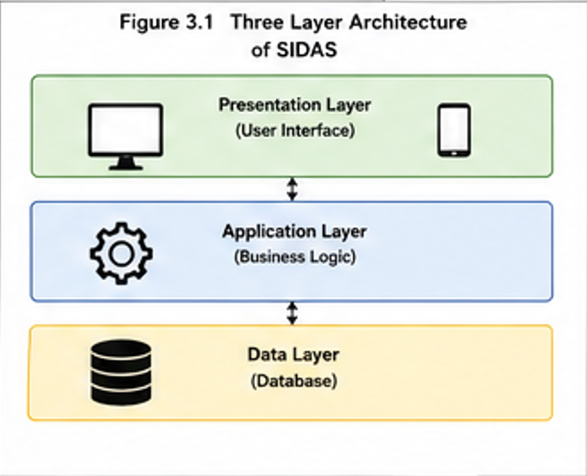
Figure 3.1 Three Layer Architecture of SIDAS
3.3 Modules of SIDAS
The project was divided into multiple modules.

3.3.1 User Module
Used by students, staff, and users.
Functions:
- Registration
- Login
- Raise complaint
- View ticket status
- Submit feedback
- Update profile
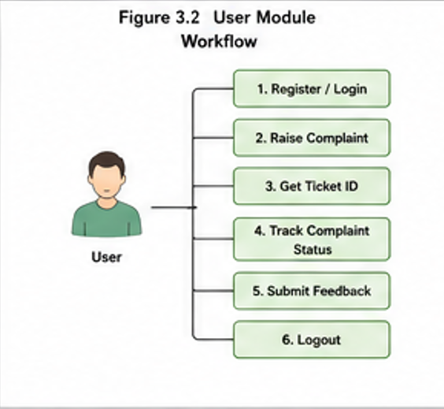
Figure 3.2 User Module Workflow
3.3.2 Admin Module
Used by administrators.
Functions:
- View all complaints
- Assign tickets
- Update status
- Manage users
- Generate reports
- Close complaints
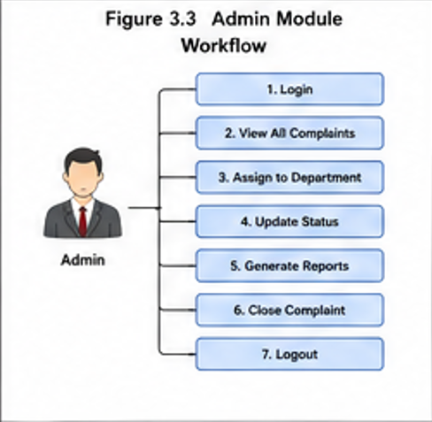
Figure 3.3 Admin Module Workflow

3.3.3 Department Module
Each department can handle its own complaints.

Examples:
- IT Department
- Maintenance
- Electrical
- Library
- Transport

3.3.4 Authentication Module
Handles security.
Features:
- Username/password validation
- Role-based login
- Session handling
- Unauthorized access restriction

3.3.5 Notification Module
Used for informing users.
Examples:
- Ticket created
- Ticket assigned
- Status updated
- Complaint resolved

3.4 Database Design
A relational database was designed.

Table 1: User Table
Field | Type
user_id | INT
username | VARCHAR
password | VARCHAR
role | VARCHAR
email | VARCHAR

Table 3.1 User Table Structure

Table 2: Complaint Table
Field | Type
complaint_id | INT
user_id | INT
department | VARCHAR
subject | VARCHAR
description | TEXT
status | VARCHAR
created_date | DATE

Table 3.2 Complaint Table Structure
Table 3: Ticket History
Field | Type
id | INT
complaint_id | INT
old_status | VARCHAR
new_status | VARCHAR
updated_by | VARCHAR
update_time | DATETIME

Table 3.3 Ticket History Table Structure
3.5 ER Diagram Description
Entities used:
- User
- Complaint
- Department
- TicketHistory
- Feedback
Relationships:
- One user can raise many complaints.
- One complaint belongs to one department.
- One complaint can have many status updates.

3.6 Use Case Diagram Description
Actors:
- User
- Admin
- Department Staff
Use cases:
User:
- Login
- Register
- Raise complaint
- Track complaint
Admin:
- Manage users
- Assign complaints
- Generate reports
Department:
- Update status
- Resolve complaints
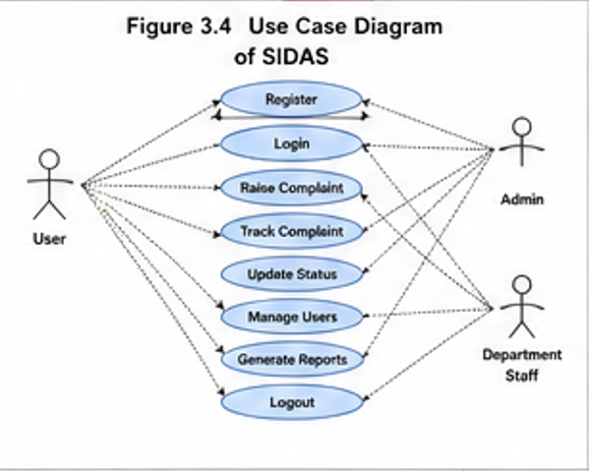
Figure 3.4 Use Case Diagram of SIDAS
3.7 Development Methodology
Agile methodology was followed.
Steps:
- Requirement collection
- Design planning
- Frontend creation
- Backend development
- Database integration
- Testing
- Deployment
Advantages:
- Flexible
- Faster development
- Easy improvements

3.8 Frontend Development
Frontend focused on simplicity and responsiveness.
Pages Developed:
- Home Page
- Login Page
- Registration Page
- Dashboard
- Complaint Raise Form
- Ticket Status Page
- Admin Panel
Features:
- Mobile responsive layout
- Validation forms
- User-friendly buttons

3.9 Backend Development
Backend was developed using Spring Boot.
Components:
- Controller Classes
- Service Classes
- Repository Classes
- Entity Classes
APIs Developed:
- /login
- /register
- /raiseTicket
- /viewTickets
- /updateStatus
3.10 Security Implementation
Security is essential.
Implemented features:
- Password encryption
- Session control
- Input validation
- Role-based access
- SQL injection prevention

3.11 Testing of Modules
Testing ensured reliability.
Unit Testing
Checked:
- Login function
- Registration
- Complaint submission
Integration Testing
Checked:
- Frontend to backend communication
- Backend to database connection
System Testing
Checked full project workflow.

3.12 Challenges During Development
Some issues faced:

1. Database Connectivity Errors
Solved by:
- Correct JDBC URL
- Proper driver configuration
2. Login Authentication Errors
Solved by:
- Correct repository methods
- Session handling
3. Frontend Alignment Problems
Solved by:
- Bootstrap grid system
4. Ticket Update Delay
Solved by:
- Optimized SQL queries

3.13 Output Screens Description
Important outputs:
- Login Screen
- Dashboard Screen
- Raise Ticket Form
- Complaint List
- Admin Control Panel
- Reports Page

CHAPTER 4
IMPLEMENTATION DETAILS

4.1 Introduction
Implementation is the phase where the planned design is converted into a working software product. In the SIDAS project, all modules designed during earlier stages were developed, integrated, tested, and executed to create a complete complaint and departmental assistance system.
The implementation phase included frontend page creation, backend coding, database setup, server execution, user authentication, and deployment of the application on the local system. Proper coding standards and modular programming techniques were followed to make the project efficient and maintainable.
The objective of implementation was to ensure that every module works correctly and communicates smoothly with other modules.

4.2 Software Environment
The following software tools were used during implementation:
Tool / Software | Purpose
Java JDK | Programming language support
Spring Boot | Backend framework
MySQL | Database management
IntelliJ IDEA / VS Code | Code editor
XAMPP / MySQL Workbench | Database server
Chrome Browser | Testing
Bootstrap | Frontend design

Table 4.1 Software Environment Used in Implementation

4.3 Hardware Environment
Component | Specification
Processor | Intel i3 / i5 / Ryzen
RAM | 4 GB minimum
Storage | 20 GB free space
Display | 1366 × 768 or higher
Internet | Required for updates

Table 4.2 Hardware Environment Specifications
4.4 Frontend Implementation
The frontend of SIDAS was created to provide an attractive and responsive user interface.
Pages Developed:
- Login Page
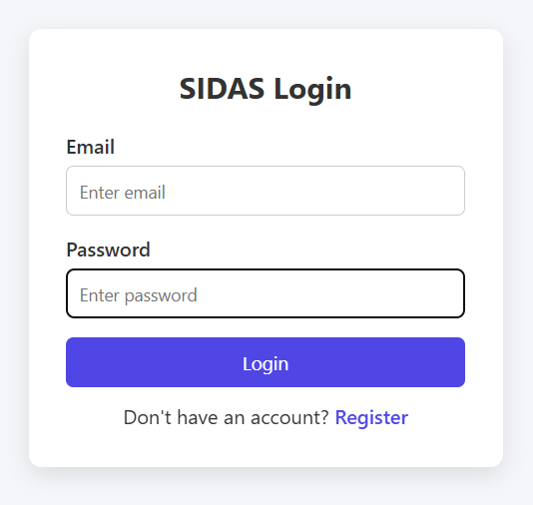
Figure 4.1 Login Page Interface

- User Registration Page
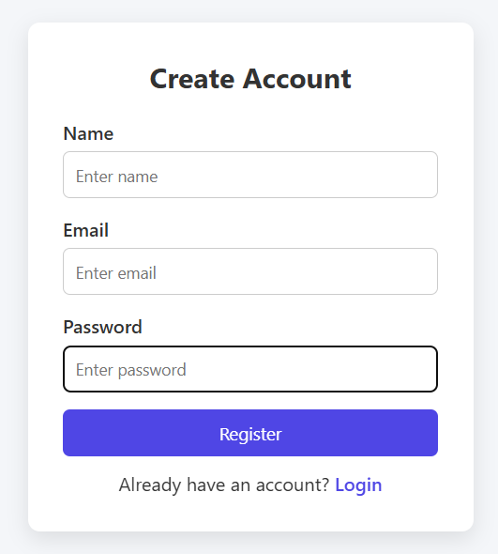
Figure 4.2 User Registration Page
- Dashboard
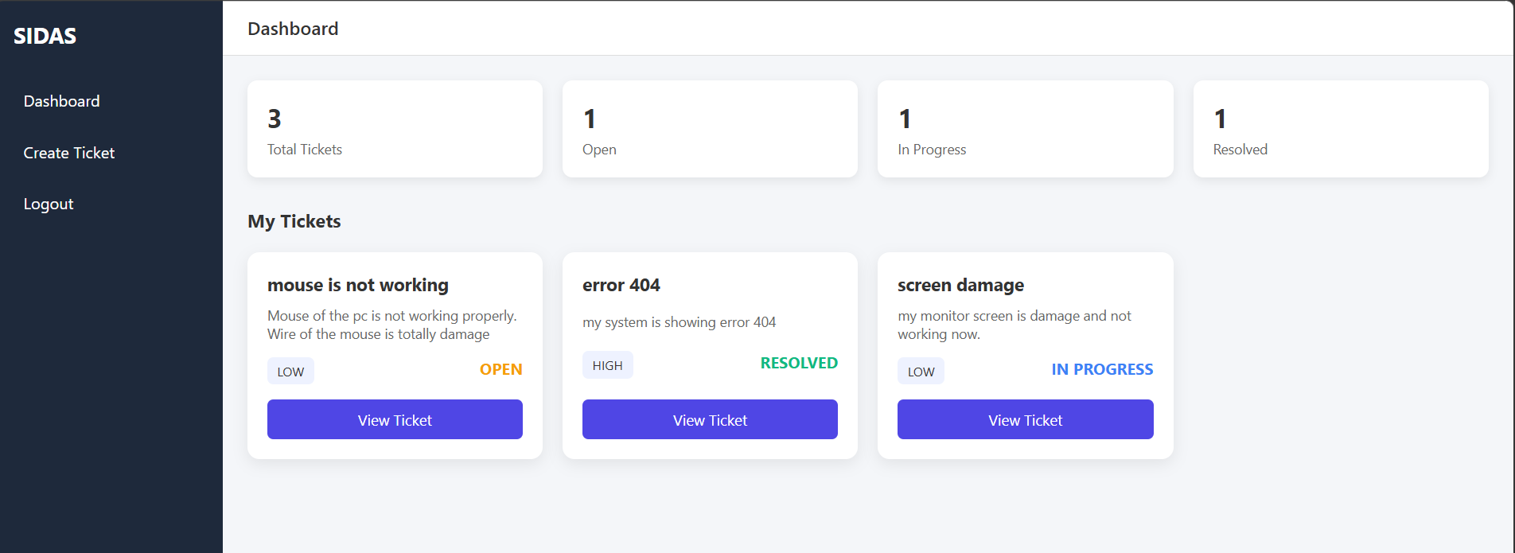
Figure 4.3 Dashboard Screen

- Raise Complaint Form
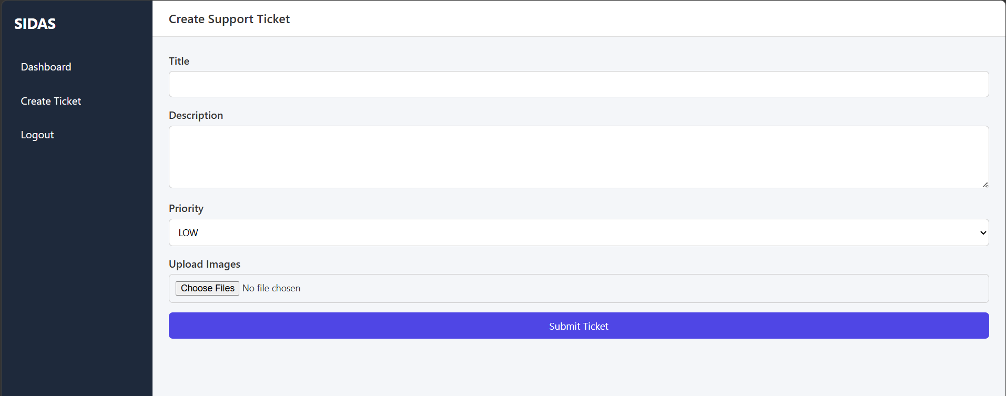
Figure 4.4 Raise Complaint Form
- Complaint History Page
- Admin Panel
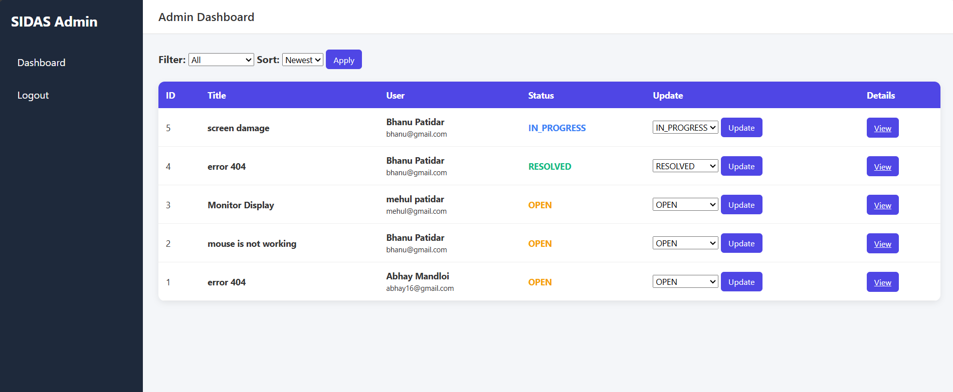
Figure 4.5 Admin Control Panel

- Report Page
Technologies Used:
- HTML for page structure
- CSS for styling
- Bootstrap for responsive design
- JavaScript for validations and dynamic actions
Benefits:
- Easy navigation
- Clean layout
- Mobile friendly
- Faster interaction

4.5 Backend Implementation
The backend was developed using Java Spring Boot.
Main Components:
Controller Layer
Handles incoming requests.
Examples:
- LoginController
- UserController
- ComplaintController
- AdminController
Service Layer
Contains business logic.
Examples:
- UserService
- ComplaintService
- AuthService
Repository Layer
Communicates with database.
Examples:
- UserRepository
- ComplaintRepository
Entity Layer
Represents database tables.
Examples:
- User.java
- Complaint.java
- Department.java

4.6 Database Implementation
MySQL database was configured for storing project data.
Important Tables:
- users
- complaints
- departments
- feedback
- logs
SQL Features Used:
- Primary Key
- Foreign Key
- Auto Increment
- Joins
- Indexing

4.7 Sample Backend Code Explanation
Login Logic
The user enters username and password. Backend checks records in database.
If matched:
- User login successful
Else:
- Error message shown
Complaint Creation Logic
When user fills complaint form:
- Validate fields
- Save complaint in database
- Generate ticket ID
- Set status = Pending

4.8 Integration Process
All modules were connected in the following sequence:
Frontend Form
⬇
Controller
⬇
Service
⬇
Repository
⬇
Database
This layered integration improved maintainability.

4.9 Error Handling
Proper exception handling was added.
Examples:
- Wrong password
- Empty fields
- Duplicate username
- Database connection failure
- Unauthorized access

4.10 Deployment Steps
- Install Java JDK
- Install MySQL
- Create database schema
- Import project into IDE
- Configure application.properties
- Run Spring Boot project
- Access using browser

CHAPTER 5
TESTING AND VALIDATION

5.1 Introduction
Testing ensures that the developed system works according to requirements. SIDAS was tested using multiple methods.
5.2 Types of Testing Performed
1. Unit Testing
Each module tested separately.
Examples:
- Login function
- Registration form
- Complaint save function
2. Integration Testing
Checked interaction between:
- Frontend and backend
- Backend and database
3. System Testing
Complete application tested as a whole.
4. User Acceptance Testing
Real users checked functionality.
5.3 Test Cases
Test Case |  |  |  | Input |  |  | Expected Output | Result
Login valid |  |  |  | Correct credentials |  |  | Dashboard open | Pass
Login invalid |  |  |  | Wrong password |  |  | Error shown | Pass
Raise complaint |  |  |  | Valid data |  |  | Ticket created | Pass
Update status |  |  |  | Resolved |  |  | Status changed | Pass

Table 5.1 Test Cases and Expected Results

5.4 Validation Techniques
Used validations:
- Required fields
- Email format
- Password length
- Duplicate username prevention
- Text length checks

5.5 Bug Fixes
Bug 1: Repository Method Error
Problem:
findByUsername(String) undefined.
Solution:
Created method in repository interface.
Bug 2: Database URL Error
Solved by correcting JDBC path.
Bug 3: Page Alignment Issue
Solved using Bootstrap grid.

5.6 Performance Testing
System tested with multiple records.
Results:
- Fast login response
- Quick complaint loading
- Smooth dashboard performance

CHAPTER 6
SECURITY AND MAINTENANCE
6.1 Introduction
Security and maintenance are two essential aspects of any software system. A web-based application stores user information, complaint records, login credentials, and operational data, therefore it must be protected from unauthorized access, accidental loss, and misuse. Along with security, regular maintenance ensures that the system continues to perform efficiently and remains updated according to future requirements.
In the Smart IT Department Automation System (SIDAS), proper security measures were implemented to safeguard data and ensure only authorized users can access system resources. Maintenance strategies were also considered to improve system reliability and long-term usability.

6.2 Need of Security in SIDAS
The project handles multiple users such as students, faculty members, and administrators. Since different users have different responsibilities, it is necessary to secure the system from misuse.
The major reasons for implementing security are:
- Protection of personal user data
- Prevention of unauthorized login
- Safety of complaint and ticket records
- Secure communication between frontend and backend
- Protection from accidental deletion or modification of data
- Maintaining trust and reliability of the system
Without security, sensitive information may be leaked or system operations may be disrupted.

6.3 Authentication System
Authentication is the process of verifying the identity of a user before granting access.
In SIDAS, a login module was developed where users must enter valid credentials such as username and password. Only after successful verification, the user is redirected to the dashboard.
Features of Authentication:
- Unique username for each user
- Password protected login
- Validation of credentials from database
- Error message for invalid login attempts
- Separate login roles for Admin and User
This ensures that unauthorized persons cannot access the system.
6.4 Authorization and Role Management
Authorization defines what actions a logged-in user can perform.
Different roles were created in the system:
Admin Role:
- Manage users
- View all complaints
- Update ticket status
- Generate reports
- Monitor complete system
Student/User Role:
- Login securely
- Raise complaints or tickets
- View own complaint history
- Check ticket status
Role-based access improves control and prevents misuse of administrative features.

6.5 Password Security
Passwords are the first level of protection in most systems. SIDAS follows good password practices.
Security Measures:
- Minimum password length
- Combination of letters and numbers
- Hidden password field during login
- Password update facility
- Encrypted storage of passwords (recommended)
Users are advised to keep passwords private and change them regularly.

6.6 Database Security
The database stores all important records of the system. If not secured, data may be lost or manipulated.
Database Security Methods Used:
- Restricted database access
- Proper username and password for MySQL server
- Backup of important records
- Input validation before storing data
- Prevention of duplicate entries
- Controlled update and delete operations
These practices improve reliability and protect stored information.

6.7 Session Management
Session management helps maintain user login state securely.
Features:
- User session starts after successful login
- Session ends after logout
- Restricted pages inaccessible without login
- Automatic redirection to login page after logout
This prevents unauthorized access when a user leaves the system open.

6.8 Error Handling and Data Recovery
Unexpected errors may occur due to network failure, invalid input, or server problems. Therefore, proper error handling was implemented.
Examples:
- Invalid login alert
- Required field validation
- Database connection error messages
- Safe redirection on system failure
Data Recovery:
Regular backups help restore lost records in case of system crash or accidental deletion.

6.9 Need of Maintenance
Software maintenance means updating and improving the system after deployment.
The SIDAS project may require maintenance because:
- New users join the department
- Additional features may be needed
- Security updates become necessary
- Bugs may appear after real usage
- Technology changes over time
Maintenance keeps the system useful and efficient.

6.10 Types of Maintenance
1. Corrective Maintenance
Fixing bugs or errors found after deployment.
2. Adaptive Maintenance
Updating the system according to new technologies or operating systems.
3. Perfective Maintenance
Improving performance, speed, or user interface.
4. Preventive Maintenance
Taking actions in advance to avoid future failures.

CHAPTER 7
RESULTS AND DISCUSSION

7.1 Introduction
This chapter explains the final results obtained after development and testing of SIDAS. The system successfully automated internal complaint handling processes and reduced manual workload.

7.2 Functional Results
User Results
- Successfully registered users
- Secure login
- Complaint raised instantly
- Real-time status view
Admin Results
- Complaint assignment easier
- Faster updates
- Better monitoring

7.3 Performance Results
Parameter | Manual System | SIDAS
Complaint Registration | 10 min | 1 min
Status Tracking | Difficult | Instant
Record Search | Slow | Fast
Report Generation | Manual | Automatic

Table 7.1 Performance Comparison: Manual System vs SIDAS
7.4 Accuracy Results
The system stores complaint records accurately with minimal human error.

7.5 Security Results
System protects user data through authentication and validation.

7.6 User Satisfaction
Feedback indicated:
- Easy to use
- Fast system
- Helpful dashboard
- Transparent process

7.7 Discussion
The project proved that digital complaint management systems significantly improve institutional workflow. SIDAS can be useful for universities, offices, hospitals, and organizations.

CHAPTER 8
SUMMARY AND CONCLUSION

8.1 Summary
SIDAS was developed to solve problems in manual departmental complaint systems. It digitizes ticket raising, assignment, status tracking, and reporting.
The project used:
- Frontend: HTML, CSS, JavaScript, Bootstrap
- Backend: Java Spring Boot
- Database: MySQL
The system was tested successfully and produced positive results.

8.2 Conclusion
The project successfully met all objectives.
Major achievements:
- Reduced manual work
- Improved transparency
- Faster complaint resolution
- Better record management
- User-friendly interface
SIDAS is an effective and practical solution.

8.3 Future Scope
Future improvements:
- Mobile application
- Email notifications
- SMS alerts
- AI chatbot support
- Analytics dashboard
- Multi-language support
- Cloud deployment
- QR complaint system

CHAPTER 9
FUTURE SCOPE
9.1 Introduction
Every software project can be improved over time according to user needs, technological advancements, and organizational growth. The Smart IT Department Automation System (SIDAS) has been designed as a strong foundation for digital departmental management. Although the current version successfully automates important operations such as ticket raising, complaint handling, user management, and report generation, many additional features can be added in the future to make the system more advanced, intelligent, and efficient.
The future scope of this project focuses on expanding functionality, improving user experience, enhancing security, and increasing scalability so that the system can be adopted by larger institutions and organizations.

9.2 Mobile Application Development
At present, the system works as a web-based application. In the future, a dedicated mobile application can be developed for Android and iOS platforms.
Benefits:
- Easy access from smartphones
- Instant complaint registration
- Real-time notifications
- Better user convenience
- Improved communication between users and department staff
A mobile app will increase accessibility and user engagement.

9.3 Cloud-Based Deployment
Currently, the system may be hosted locally or on a basic server. In the future, cloud deployment can be implemented using services such as AWS, Microsoft Azure, or Google Cloud.
Advantages:
- Better scalability
- High availability
- Automatic backups
- Remote access from any location
- Reduced hardware dependency
Cloud hosting will make the system suitable for large-scale usage.

9.4 Artificial Intelligence Integration
Artificial Intelligence (AI) can be added to improve automation and decision-making.
Possible AI Features:
- Smart ticket categorization
- Priority prediction of complaints
- Chatbot support for common queries
- User behavior analysis
- Predictive maintenance alerts
AI can reduce manual effort and improve service speed.

9.5 Advanced Security Features
Although the present system includes login authentication, stronger security can be implemented in future versions.
Proposed Enhancements:
- Two-Factor Authentication (2FA)
- OTP based login verification
- Face recognition login
- Captcha verification
- Advanced encryption methods
- Login activity tracking
These measures will strengthen data protection and user privacy.

9.6 Notification and Alert System
A notification module can be integrated for better communication.
Future Notification Channels:
- Email alerts
- SMS notifications
- Mobile push notifications
- In-system alerts
Users can receive updates when:
- Complaint status changes
- Ticket is assigned
- Password is updated
- Important announcements are published
This will improve transparency and response time.

9.7 Multi-Department Expansion
The current system is designed for a single IT department. In the future, it can be expanded for use across multiple departments such as:
- Computer Science Department
- Mechanical Department
- Civil Department
- Electrical Department
- Administration Office
- Library Management
This will make the system a university-wide management solution.

9.8 Data Analytics and Reporting
Advanced reporting tools can be integrated for better decision-making.
Future Reports:
- Monthly complaint trends
- Department performance reports
- User satisfaction reports
- Pending issue analysis
- Resource utilization reports
Graphical dashboards and charts can help administrators make informed decisions.

9.9 Integration with University Systems
SIDAS can be connected with existing institutional platforms.
Possible Integrations:
- Student ERP system
- Attendance management system
- Library management system
- Fee management portal
- HR management system
This integration will create a unified digital ecosystem.

APPENDIX

Appendix A – Hardware Requirements
- Processor: Intel i3 or above
- RAM: 4GB minimum
- Hard Disk: 20GB free space
Appendix B – Software Requirements
- Windows 10/11
- Java JDK 17
- Spring Boot
- MySQL
- VS Code / IntelliJ

BIBLIOGRAPHY

- Spring Boot Official Documentation
- MySQL Reference Manual
- Oracle Java Documentation
- Bootstrap Documentation
- HTML & CSS Web Design Books
- Research Papers on Complaint Management Systems

