**P1: Learn and Apply ECMASCRIPT Concept**

* **let, var and const**
* **Theory:**
* There are 3 ways to declare a JavaScript variable:

-Using var

-Using let

-Using const

* The let keyword was introduced in [ES6 (2015)](https://www.w3schools.com/js/js_es6.asp).
* Variables defined with let cannot be Redeclared.
* Variables defined with let must be Declared before use.
* Variables defined with let have Block Scope.
* The const keyword was introduced in [ES6 (2015)](https://www.w3schools.com/js/js_es6.asp).
* Variables defined with const cannot be Redeclared.
* Variables defined with const cannot be Reassigned.
* Variables defined with const have Block Scope.
* Arrow functions were introduced in ES6.
* Arrow functions allow us to write shorter function syntax.
* **Code practice:**

//---------------------------------------------------------------------var practice

var x = 5;

var y = 6;

var z = x + y;

console.log(z);

//------------------------------------------------------------------let practice

let x = "Yagnik Desai";

let x = 0;

console.log(x);

var x = "John Doe";

var x = 0;

console.log(x);

var x = 10;

// Here x is 10

{

var x = 2;

// Here x is 2

}

console.log(x);

// Here x is 2

let x = 10;

// Here x is 10

{

let x = 2;

console.log(x);

// Here x is 2

}

console.log(x);

// Here x is 10

//------------------------------------------------------------------const practice

const x = 10;

// Here x is 10

console.log(x);

{

const x = 2;

// Here x is 2

console.log(x);

}

console.log(x);

// Here x is 10

* **Output:**

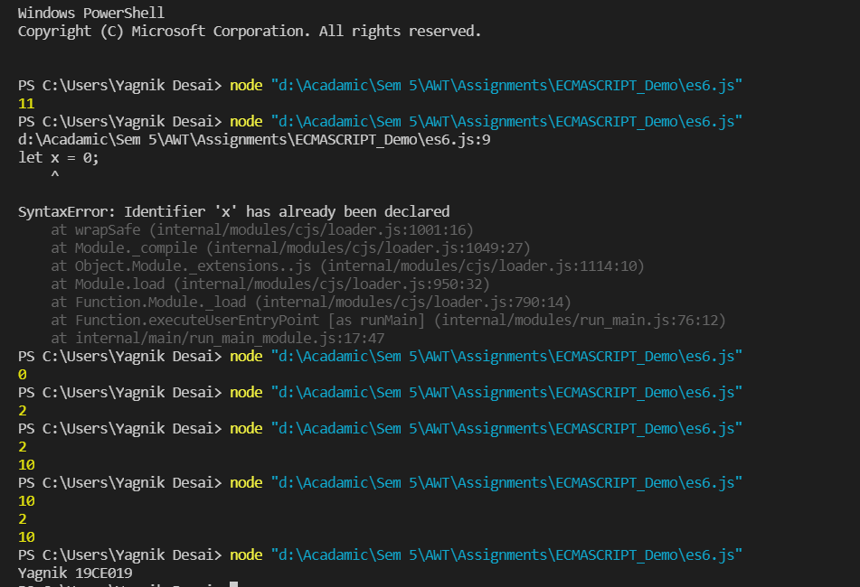

* **Destructuring**
* **Theory:**

Destructuring Assignment is a JavaScript expression that allows to unpack values from arrays, or properties from objects, into distinct variables data can be extracted from arrays, objects, nested objects and assigning to variables. In Destructuring Assignment on the left-hand side defined that which value should be unpacked from the sourced variable.

* **Code:**

//----------------------------------------------------destructuring assignment

var names = ["alpha", "beta", "gamma", "delta"];

var firstName = names[0];

var secondName = names[1];

console.log(firstName);//"alpha"

console.log(secondName);//"beta"

//----------------------------------------------------array destructuring

var names = ["alpha", "beta", "gamma", "delta"];

var [firstName, secondName] = names;

console.log(firstName);//"alpha"

console.log(secondName);//"beta"

//Both of the procedure are same

var [firstName, secondName] = ["alpha", "beta", "gamma", "delta"];

console.log(firstName);//"alpha"

console.log(secondName);//"beta

//----------------------------------------------------object destructuring

var marks = { x: 21, y: -34, z: 47 };

var x = marks.x; // x = 21

var y = marks.y; // y = -34

var z = marks.z; // z = 47

console.log(x);

console.log(y);

console.log(z);

var z = "Yagnik 19CE019";

console.log(z);

* **Output:**

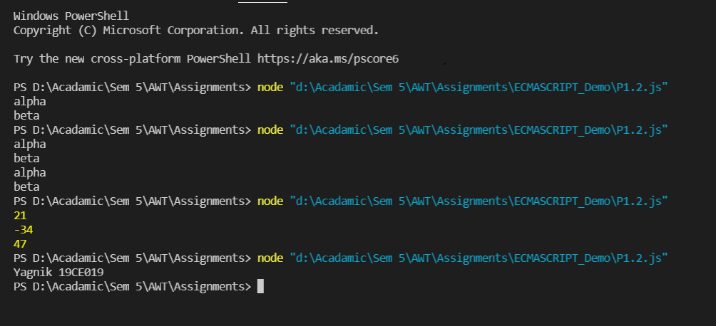

* **map, filter and reduce**
* **Theory:**
* The map() method creates a new array with the results of calling a function for every array element.
* The map() method calls the provided function once for each element in an array, in order.
* map() does not execute the function for empty elements.
* map() does not change the original array.
* The filter() method creates an array filled with all array elements that pass a test (provided by a function).
* filter() does not execute the function for empty array elements.
* filter() does not change the original array.
* The reduce() method executes a reducer function for each value of an array.
* reduce() returns a single value which is the function's accumulated result.
* reduce() does not execute the function for empty array elements.
* reduce() does not change the original array.
* **Code practice:**

//-------------------------------------------------map

const persons = [

{firstname : "Malcom", lastname: "Reynolds"},

{firstname : "Kaylee", lastname: "Frye"},

{firstname : "Jayne", lastname: "Cobb"}

];

var x = persons.map(getFullName);

console.log(x);

function getFullName(item) {

return [item.firstname,item.lastname].join(" ");

}

//-------------------------------------------------filter

const ages = [32, 33, 16, 40];

var x = ages.filter(checkAdult) // Returns [32, 33, 40]

console.log(x);

function checkAdult(age) {

return age >= 18;

}

//-------------------------------------------------reduce

const numbers = [15.5, 2.3, 1.1, 4.7];

var x = numbers.reduce(getSum, 0);

console.log(x);

function getSum(total, num) {

return total + Math.round(num);

}

var x="Yagnik 19CE019";

console.log(x);

* **Output:**

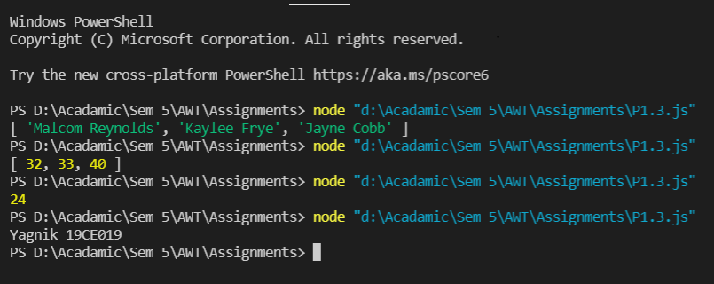

* **callback, promises and async/wait**
* **Theory:**
* A callback is a function passed as an argument to another function. This technique allows a function to call another function. A callback function can run after another function has finished.
* "Producing code" is code that can take some time. "Consuming code" is code that must wait for the result. A Promise is a JavaScript object that links producing code and consuming code.
* async makes a function return a Promise
* await makes a function wait for a Promise.
* **Code practice:**

//-----------------------------------------------------callback

function myDisplayer(some) {

var x = some;

console.log(x);

}

function myCalculator(num1, num2, myCallback) {

let sum = num1 + num2;

myCallback(sum);

}

myCalculator(5, 5, myDisplayer);

//-----------------------------------------------------promises

function myDisplayer(some) {

var x = some;

console.log(x);

}

let myPromise = new Promise(function (myResolve, myReject) {

let x = 0;

// The producing code (this may take some time)

if (x == 0) {

myResolve("OK");

} else {

myReject("Error");

}

});

myPromise.then(

function (value) { myDisplayer(value); },

function (error) { myDisplayer(error); }

);

//-----------------------------------------------------Async/Await

async function myDisplay() {

let myPromise = new Promise(function (myResolve, myReject) {

setTimeout(function () { myResolve("I love You !!"); }, 3000);

});

var x = await myPromise;

console.log(x);

}

myDisplay();

var x = "Yagnik 19CE019";

console.log(x);

* **Output:**

