Tello project

1. Tello project requirements:

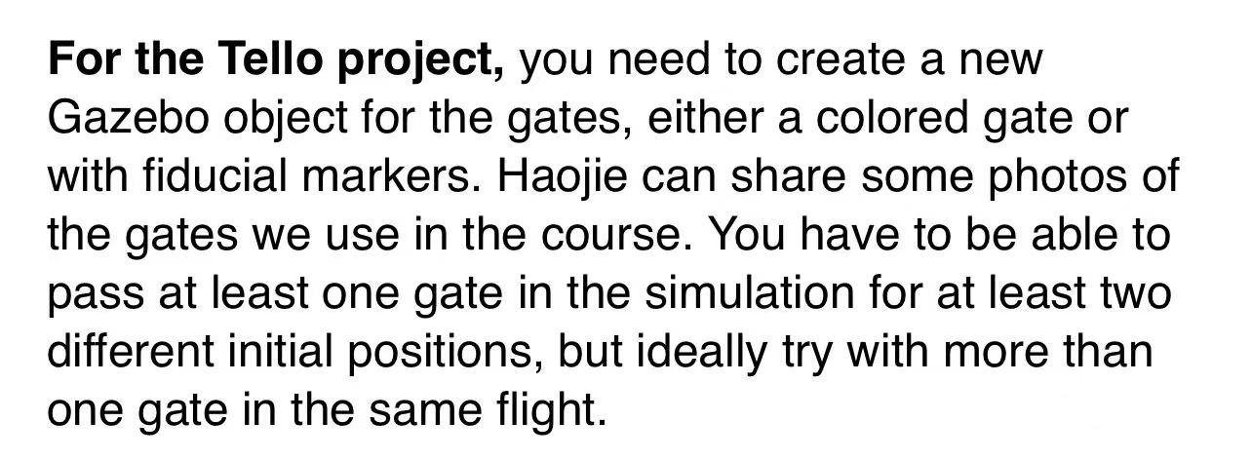

1. Introduction:

The specific process for tello project introduced in install_instruction.txt.

We tried drone could pass one gate or two gates in different initial positions and angles(90 degree and 60 degree).

The gates in different angles named by their angles in models.(Gate_90, Gate_60)

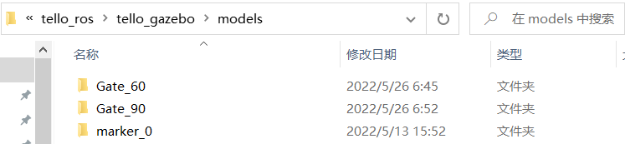

And we record two short videos for simulation.

The file tellopassgate.py is the main python file for this project.

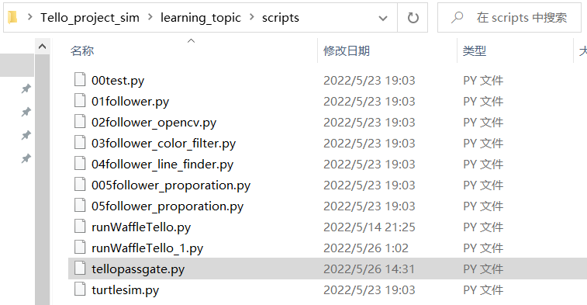

Note: We used to try to implement tello project in lab, but the lab is closed. We finished the tello project simulation based on our open project. And it will be a little complex. And it has almost the same process with our open project.

1. Code explanation
2. Subscriber and Publisher topic:

/drone1/image_raw for tello image

/drone1/cmd_vel for tello movement

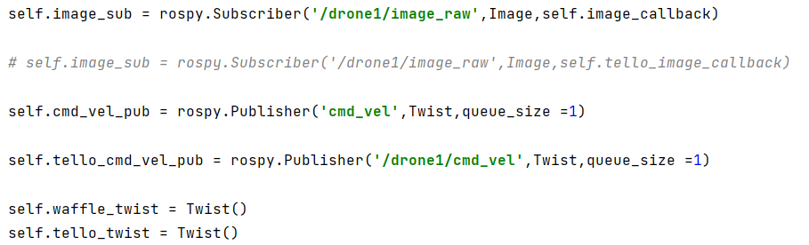

(2) Change the image to hsv and gray for future use.

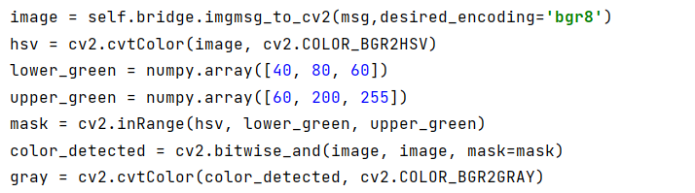

1. Get the point set.

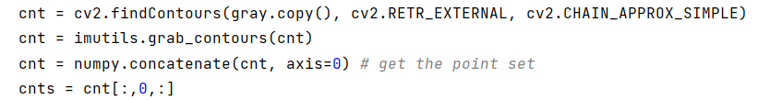

1. Draw the smallest rectangle outline and center and calculate the area of the outline.

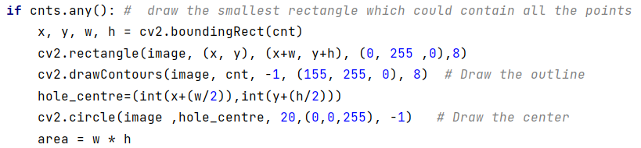

1. Using the center and the area for moving.

