Part 1:

Q1:

import pytest

def checkbcd(inb):

    if inb >= 0 and inb < 1001:

        return True

    else:

        return False

try:

    num = int(input("Input binary value: "), 2)

    checkbcd(num)

except ValueError:

    print("Please input only binary value.")

#Test

a_equal = 100

a_ans = True

b_1bigger = 1100

b_ans = False

c_empty = 123

c_ans = False

@pytest.mark.parametrize("x,y",[(a_equal,a_ans),(b_1bigger,b_ans),(c_empty,c_ans)])

def test_combine(x,y):

    assert y==checkbcd(x)

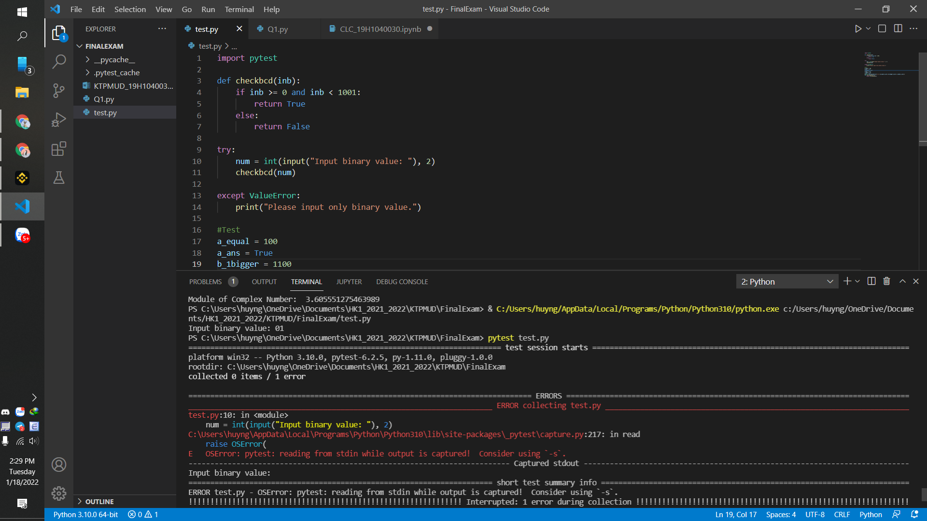

Part 2:

Q1:

class Real_Number :

    def __init__(self,real_number) :

        self.real_number = real_number

    def module(self) :

        return (self.real_number **2) ** 0.5

class Complex_Number(Real_Number) :

    def __init__(self,real_number, image_number) :

        super().__init__(real_number)

        self.image_number = image_number

    def module(self) :

        return (self.real_number**2 + self.image_number**2) ** 0.5

a = float(input("Real number input: "))

b = float(input("Image number input: "))

real = Real_Number(a)

comp = Complex_Number(a,b)

print("Module of Real Number: ",real.module())

print("Module of Complex Number: ",comp.module())

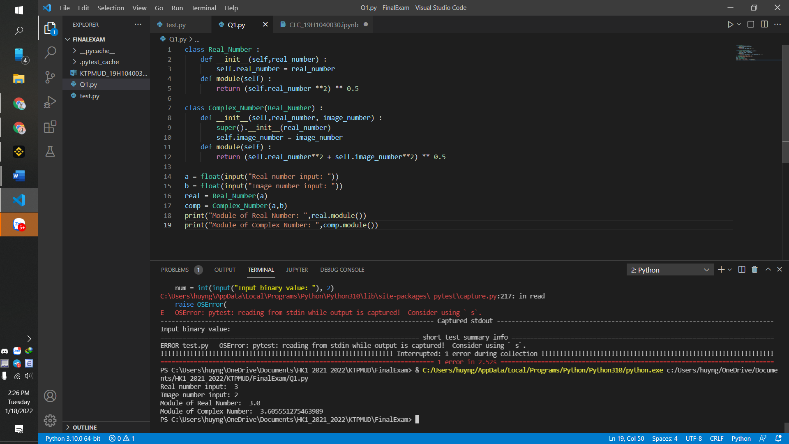

Q2:

a)

SELECT city, SUM(commission)

FROM salesman

GROUP BY city;

b)

SELECT c.customer_id, c.cust_name, s.salesman_id, s.name

FROM salesman s

JOIN customer c ON s.salesman_id = c.salesman_id

WHERE s.commission > 0.12

ORDER BY s.commission;