**PRACTICAL: 2**

**AIM:**

The transmission of information need to be secure over the communication channel and the data has to be confidential. To do so, steganography is the technique to concealing/hiding the secrete file, message, audio or video in some another  
format of file. OpenPuff is one of the free steganography tool for windows environment. Study and implement the practical approach for Steganography.

-Using DOS commands  
-Using OpenPuff Tool

**THEORY:**

Steganography is the practice of hiding a secret message inside of (or even on top of) something that is not secret. steganography involve embedding a secret piece of text inside of a picture. Or hiding a secret message or script inside of a Word or Excel document.

The purpose of steganography is to conceal and deceive. It is a form of covert communication and can involve the use of any medium to hide messages. It’s not a form of cryptography, because it doesn’t involve scrambling data or using a key. Instead, it is a form of data hiding.

OpenPuff is used primarily for anonymous asynchronous data sharing tool in which sender hides a hidden stream inside some public available carrier files (password + carrier files + carrier order are the secret key) the receiver unhides the hidden stream knowing the secret key.

**CODE:**

|  |
| --- |
| Copy /b C:\Users\Raj\OneDrive\Desktop\p2\Nature.jpg +C:\Users\Raj\OneDrive \Desktop \p2\Message.txt C:\Users\Raj\OneDrive\Desktop\p2\NatureMessage.jpg |

**OUTPUT:**

1. **DOS command:**

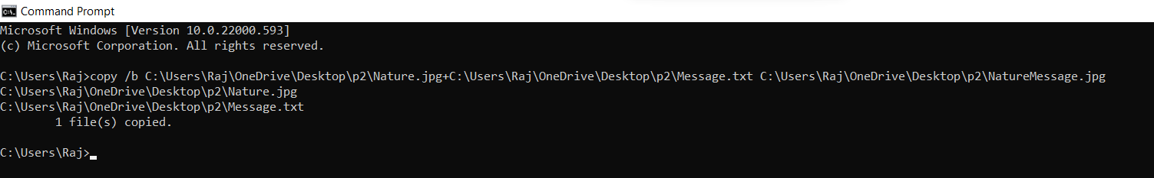

Figure 1: DOS command for adding text in image file

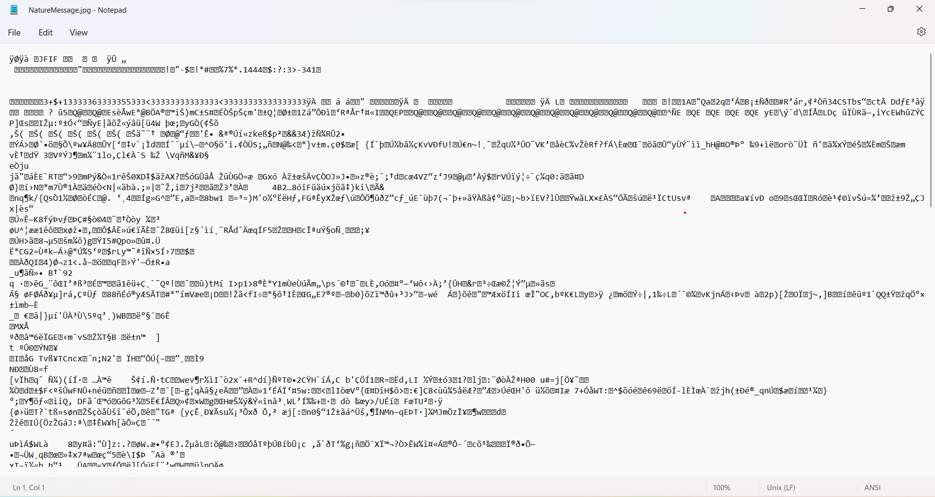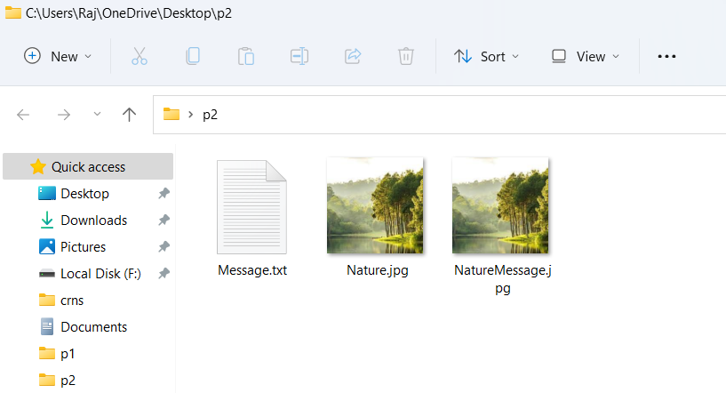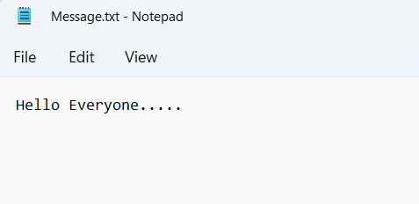

Figure 2: added text in image file using command

1. **OpenPuff Tool:**

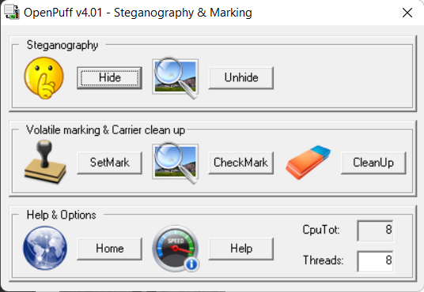Image Steganography

Figure 1:Click hide button to hide our data

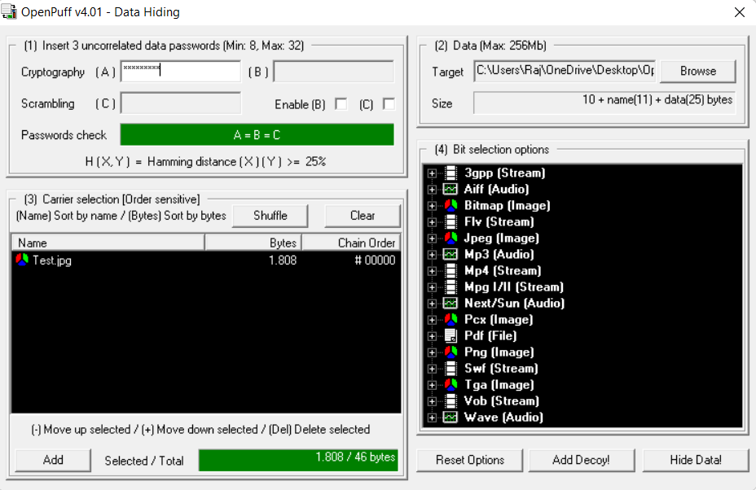Figure 2: Define Strong Password to encryption data

Define Target File 19it152.txt

Select Targate Image Test.jpg And Click on HideDate Button To hide data

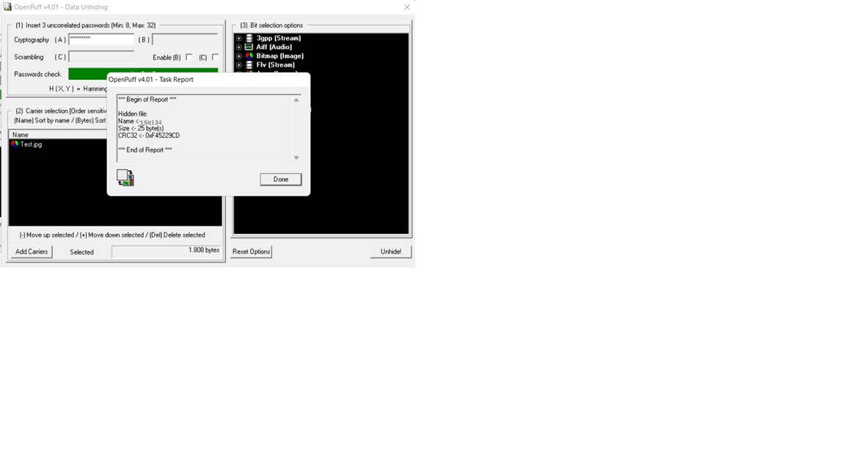

Figure 3: Embedded text file into image file

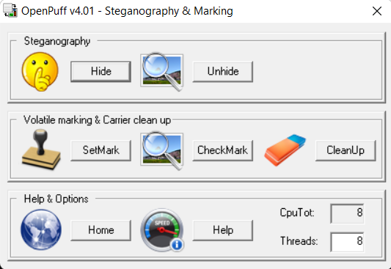

Figure 4: Click Unhide Button to Unhide Data

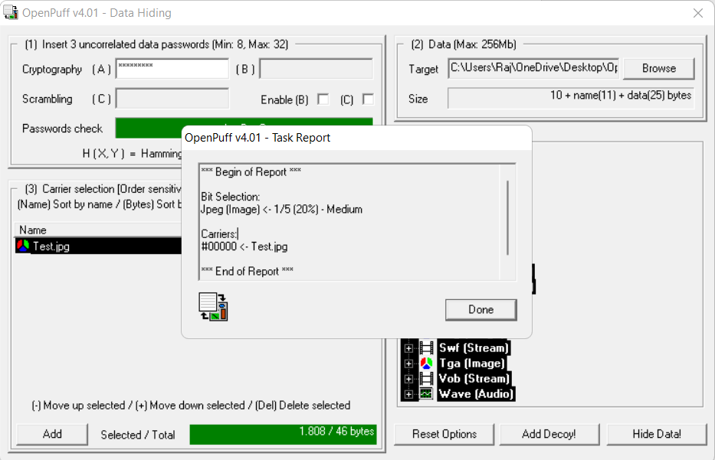

Figure 3: Extracted text file from image file

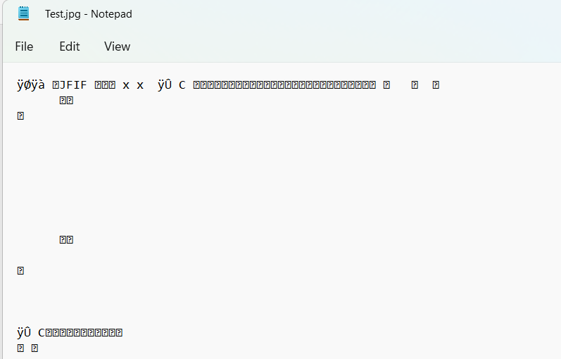

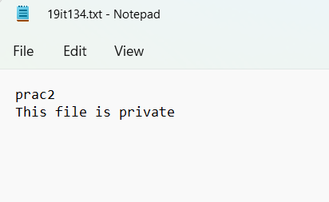

Figure 4: Output image with text file

**LATEST APPLICATIONS:**

There are a number of apps that can be used for steganography, including Steghide, Xiao, Stegais and Concealment.

1. Steganography us used to send news and information without being censored and without the fear of the messages being intercepted and traced back to us.
2. It is also possible to simply use steganography to store information on a location.

**LEARNING OUTCOME:** In this practical I have learned that how to embed and extract data from the image, audio and video using openPuff tool and also learned DOS command for doing steganography.

**REFERENCES:**

**openPuff Wikipedia :** <https://en.wikipedia.org/wiki/OpenPuff>

**steganography overview:** <https://www.comptia.org/blog/what-is-steganography>