**19IT134 IT348: CRNS**

**PRACTICAL: 1**

**AIM**

Installation of Kali Linux or Parrot Security Operating System in Virtual Box.

**THEORY:**

✧ Kali Linux is a security distribution of Linux derived from Debian and specifically ✧ designed for computer forensics and advanced penetration testing.

✧ It was developed through rewriting of Backtrack by Mati Aharoni and Devon Kearns of Offensive Security.

✧ Kali Linux contains several hundred tools that are well-designed towards various information security tasks, such as penetration testing, security research, computer forensics and reverse engineering .

✧ Kali Linux is truly a unique operating system, as its one of the few platforms openly used by both good guys and bad guys .

✧ Security Administrators, and Black Hat Hackers both use this operating system extensively. ✧ One to detect and prevent security breaches, and the other to identify and possibly exploit security breaches.

**CODE:**

**echo “Hello World”**

**CSPIT-IT** 1

**19IT134 IT348: CRNS**

**OUTPUT:**

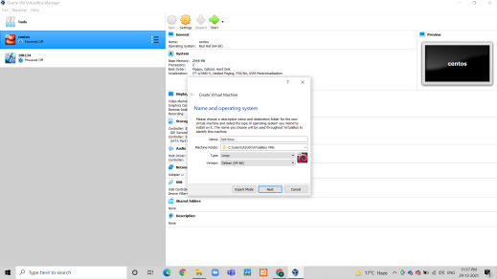

**FIGURE 1 GIVING NAME OF OS AND CHANGING TYPE TO LINUX**

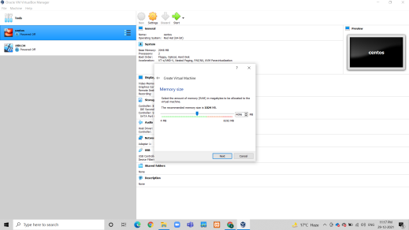**Figure 2 Memory Size of VM**

**CSPIT-IT** 2

**19IT134 IT348: CRNS** 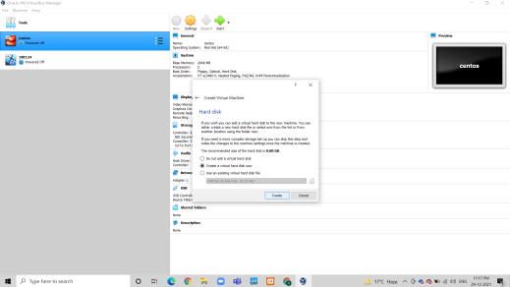

**Figure 3 Size Of VirtuAl HDD**

**CSPIT-IT** 3

**19IT134 IT348: CRNS** 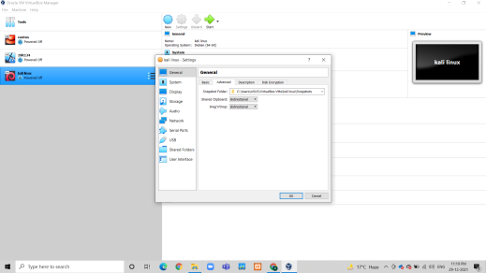

**FIGURE 4 IN GENERAL CHANGING SHARED CLIPBOARD AND DRAG AND DROP TO BIDIRECTIONAL**

**CSPIT-IT** 4

**19IT134 IT348: CRNS** 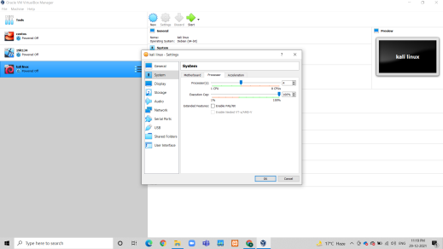

**Figure 5 Selecting The OS**

**CSPIT-IT** 5

**19IT134 IT348: CRNS** 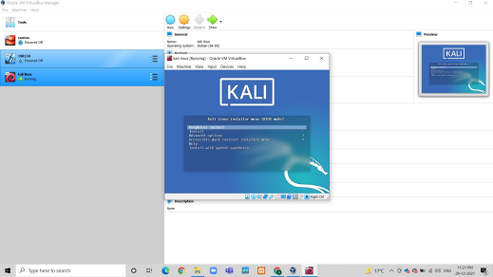

**FIGURE 6 INSTALLATION OF KALI LINUX AND CONFIGURING**

**CSPIT-IT** 6

**19IT134 IT348: CRNS** 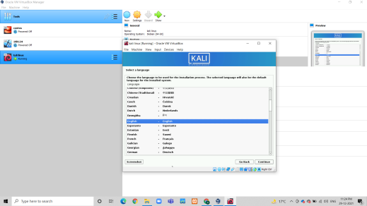

**FIGURE 7 GIVING THE USERNAME**

**CSPIT-IT** 7

**19IT134 IT348: CRNS** 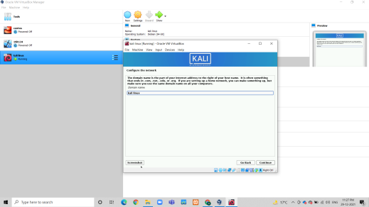

**Figure 8 Giving The PAssword**

**CSPIT-IT** 8

**19IT134 IT348: CRNS** 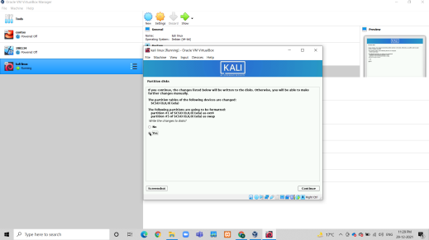

**FIGURE 9 SELECTING YES FOR PARTITION DISKS**

**CSPIT-IT** 9

**19IT134 IT348: CRNS** 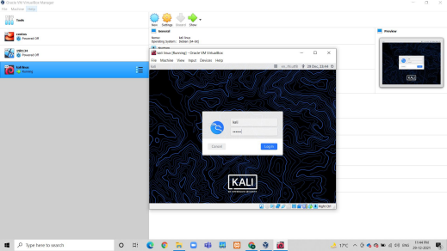

**FIGURE 10 SELECTING SECOND OPTION IN INSTALL GRUB BOOT LOADER**

**CSPIT-IT** 10

**19IT134 IT348: CRNS** 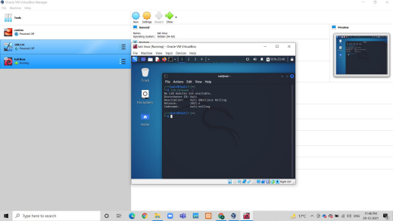

**FIGURE 11 SUCCESSFUL COMPLETION OF INSTALLATION FIGURE 12 HELLO WORLD PROGRAM**

**CSPIT-IT** 11

**19IT134 IT348: CRNS**

**LATEST APPLICATIONS:**

Kali Linux does excellent job separating these useful utilities into the following categories: ✧ Information Gathering

✧ Vulnerability Analysis

✧ Wireless Attacks

✧ Web Applications

✧ Exploitation Tools

✧ Stress Testing

Forensics Tools

✧ Sniffing & Spoofing

✧ Password Attacks

✧ Maintaining Access

✧ Reverse Engineering

✧ Reporting Tools

✧ Hardware Hacking

**LEARNING OUTCOME:**

✧ Difference Between Kali Linux vs Parrot Security

**REFERENCES:**

1. Kali OS: https://www.youtube.com/watch?v=jk2KGdJU2OI

2. Parrot Security OS: https://www.youtube.com/watch?v=4qvFp99rfXw

3. Download Kali Linux OS: https://www.kali.org/docs/introduction/download-official-kali-linux images/

4. Download Parrot Security OS: https://parrotlinux.org/download/

**CSPIT-IT** 12

**19IT134 IT348: CRNS CSPIT-IT** 13