BLUE*

**O2C(ORDER TO CASH)**

**Tables Affected:**

OE_ORDER_HEADERS_ALL

OE_ORDER_LINES_ALL

WSH_NEW_DELIVERIES

WSH_DELIVERY_ASSIGNMENTS

WSH_DELIVERY_DETAILS

RA_INTERFACE_TABLES

RA_CUSTOMER_TRX_ALL

RA_CUSTOMER_TRX_LINES_ALL

**STEP 1: ENTER SALES ORDER**

GOTO NAVIGATOR: Order Management Super User, USA

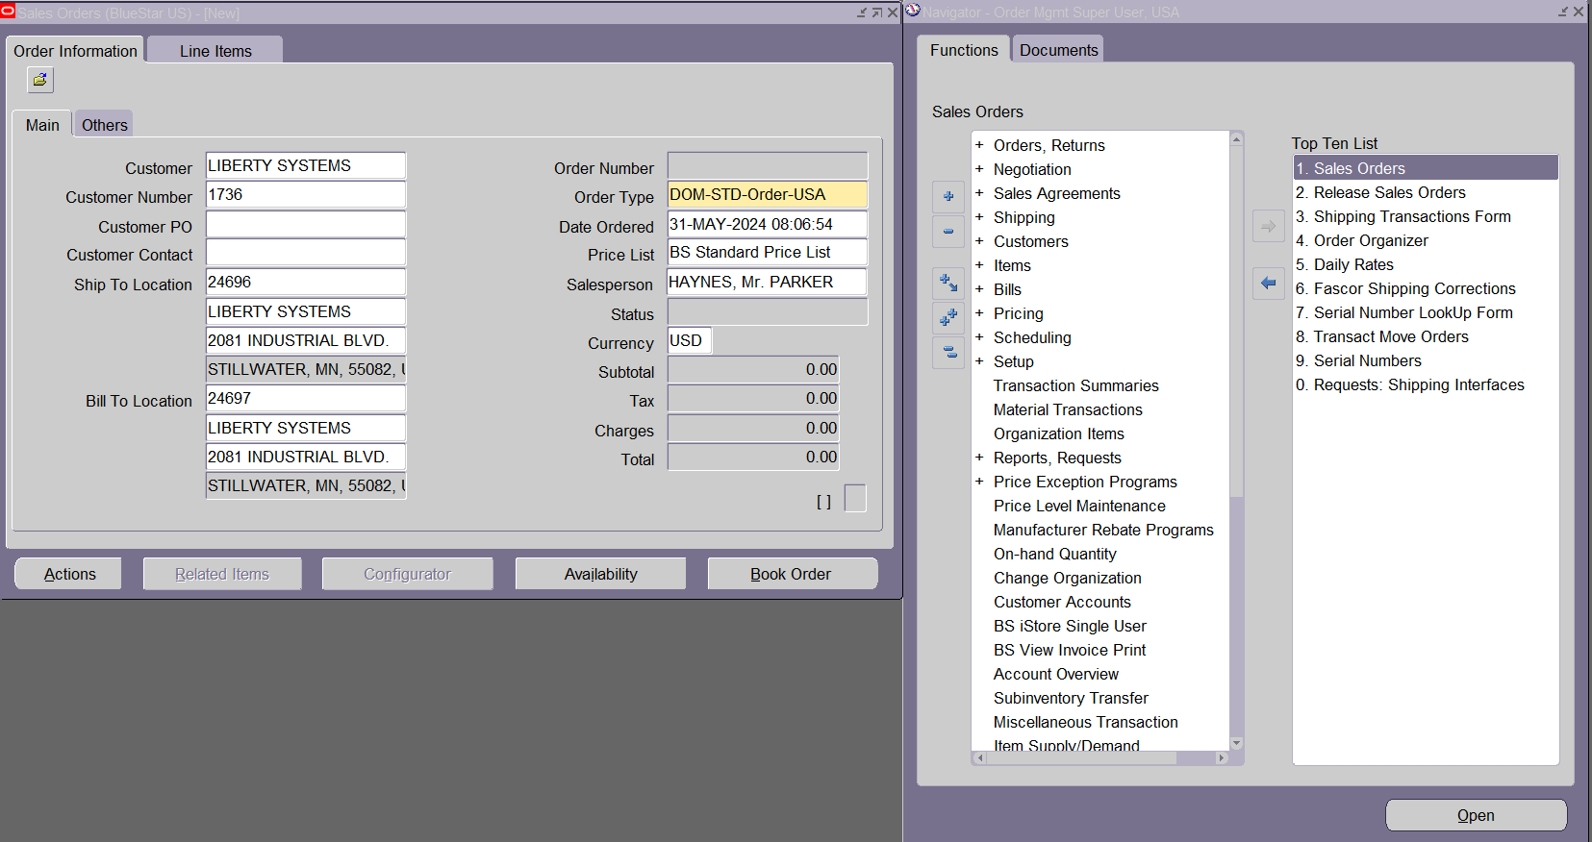

If you observe we don’t have Order Number to know order number click on line items and back to order information.

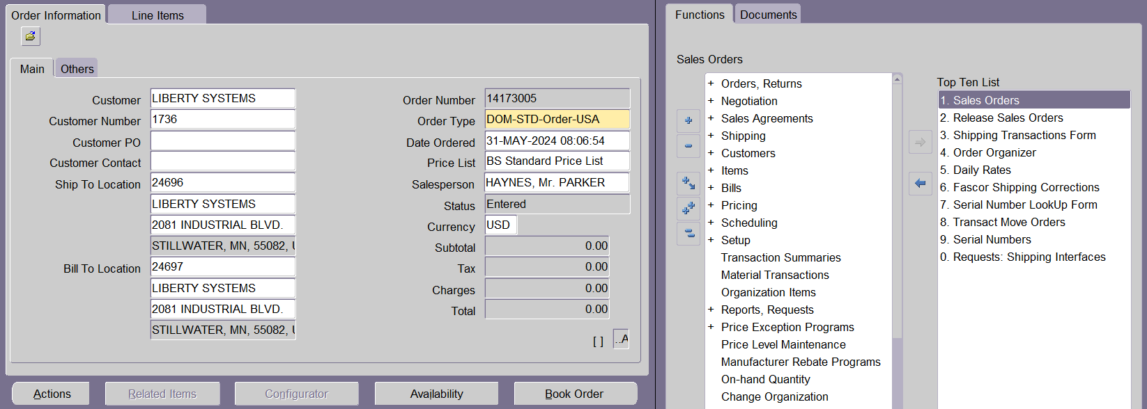

SELECT header_id,

order_number,

flow_status_code,

order_category_code,

booked_flag,

org_id

FROM oe_order_headers_all

WHERE order_number = 14173005;

--FLOW_STATUS_CODE='ENTERED'

--BOOKED_FLAG='N'

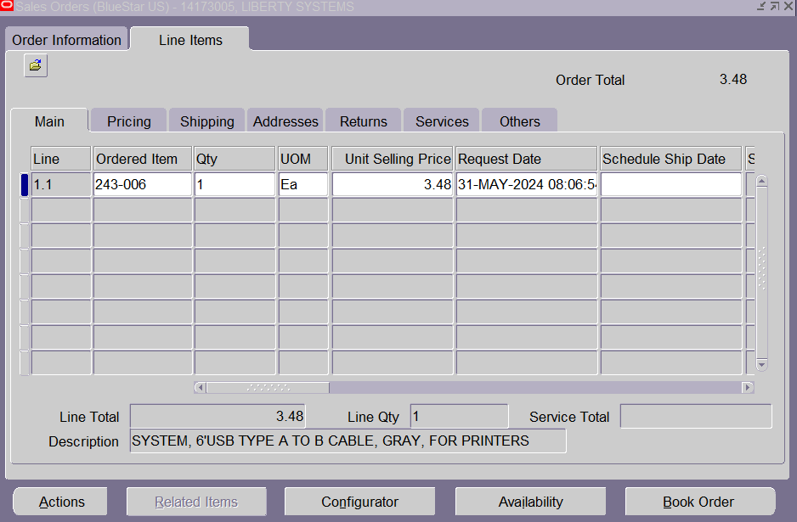

CLICK BOOK ORDER

**2.BOOK THE ORDER**

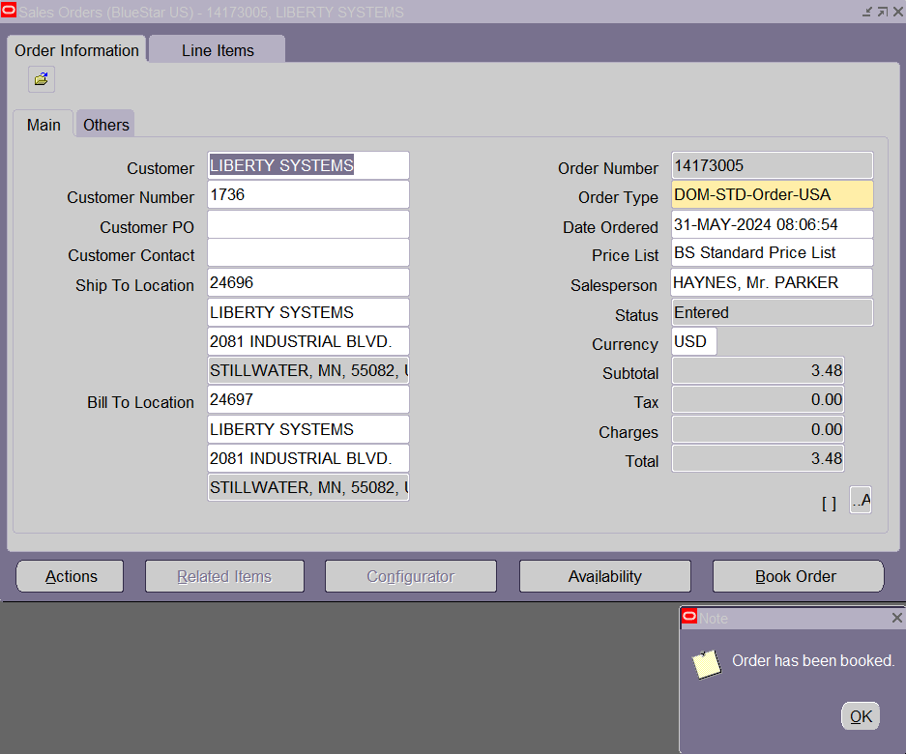

Now check what are the tables effected

SELECT

HEADER_ID

,ORDER_NUMBER

,FLOW_STATUS_CODE

,ORDER_CATEGORY_CODE

,BOOKED_FLAG

,ORG_ID

FROM oe_order_headers_all

WHERE order_number = 14173005;

--FLOW_STATUS_CODE='BOOKED'

--BOOKED_FLAG='Y'

SELECT

HEADER_ID

,LINE_ID

,LINE_TYPE_ID

,FLOW_STATUS_CODE

,LINE_NUMBER

,ORDERED_ITEM

,ORDERED_QUANTITY

,UNIT_LIST_PRICE_PER_PQTY

FROM OE_ORDER_LINES_ALL

WHERE 1=1

AND HEADER_ID = 23737273;

--FLOW_STATUS_CODE='AWAITING_SHIPPING'

STEP3:

**3.Launch Pick Release:**

GOTO Release Sales Orders>

In order>

1.give order number

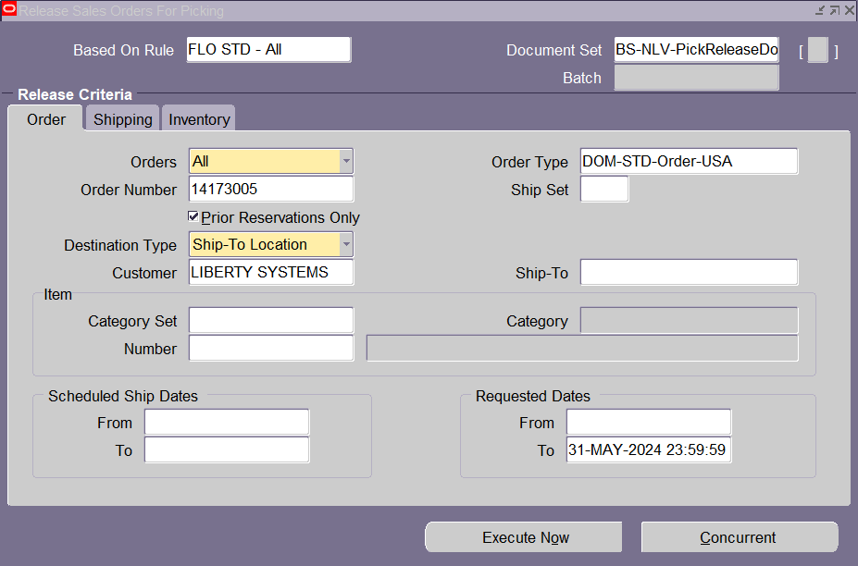

In Shipping>

1.Auto create Delivery=’Yes’

2.Auto Pick Conform= ’Yes’

3.Auto Pack Delivery= ’Yes’

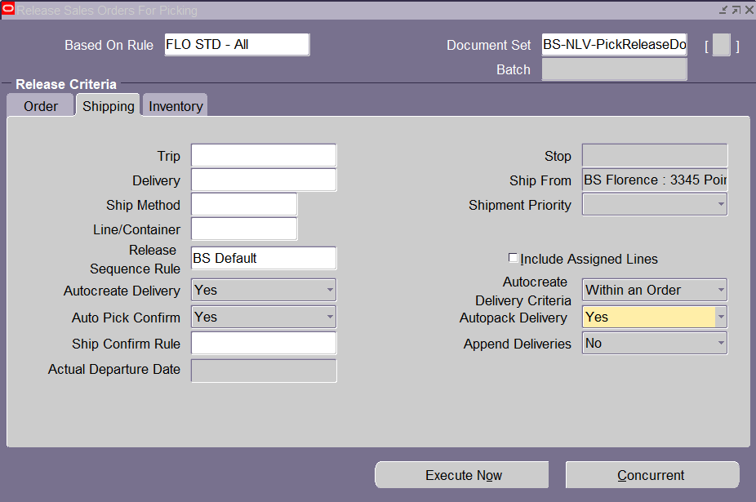

In Inventory>

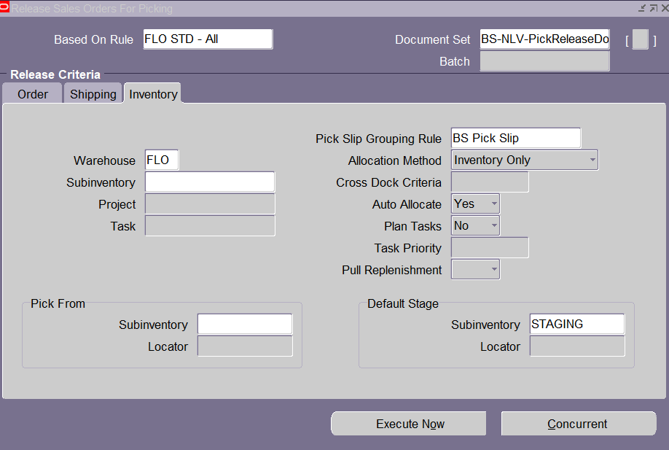

Execute Now

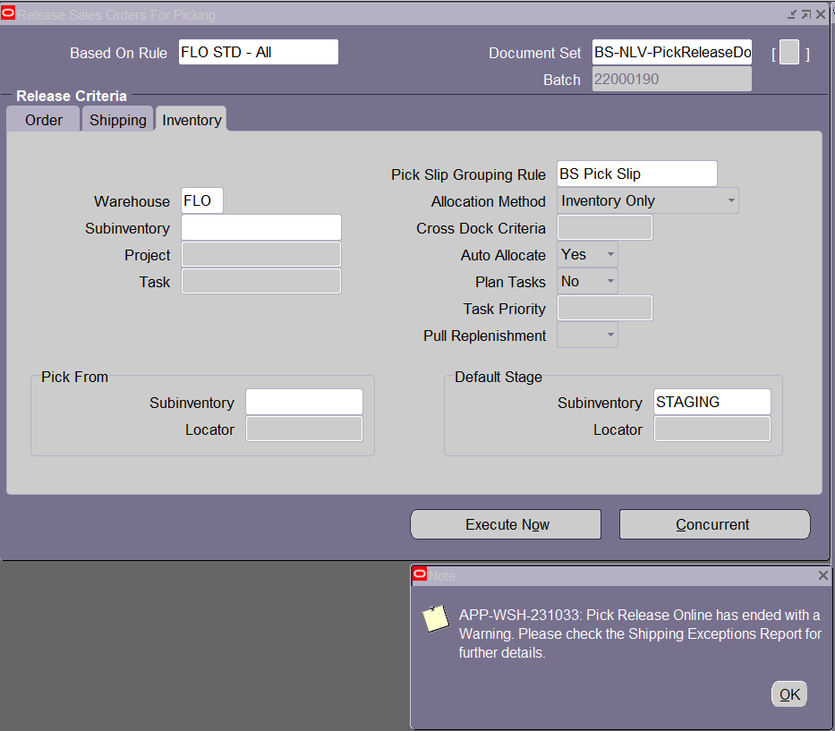

Ok

View>Request>Find>Pick Slip Report>View Output

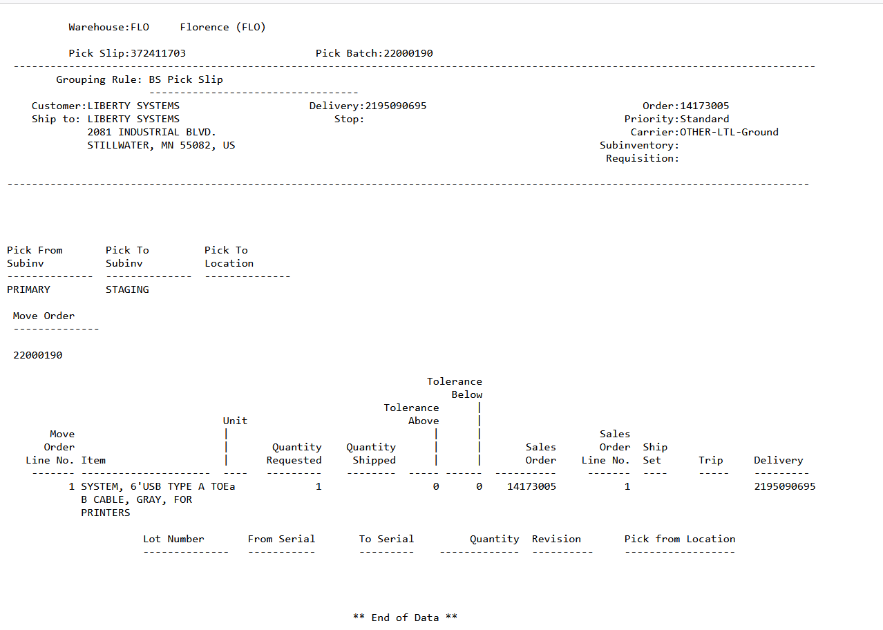

SELECT

DELIVERY_DETAIL_ID

,SOURCE_HEADER_ID

,SOURCE_LINE_ID

,CUSTOMER_ID

,INVENTORY_ITEM_ID

,RELEASED_STATUS

FROM WSH_DELIVERY_DETAILS

WHERE 1=1

AND SOURCE_HEADER_ID = 23737273;

--Released_Status='Y'

STEP4:  
**4.Ship Confirm the Order:**

GOTO Shipping>Transactions>

Give From Order Number & To Order Number

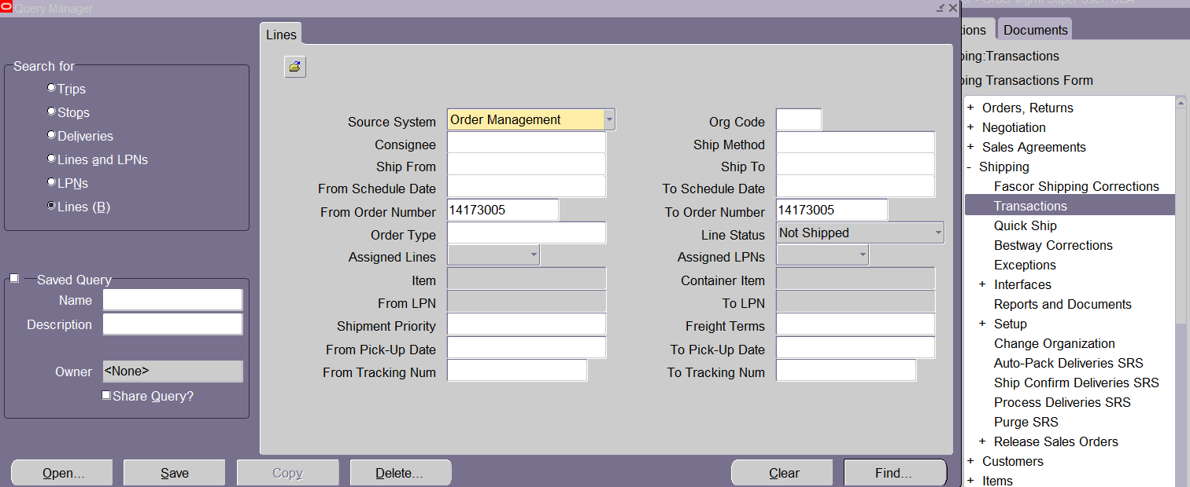

Find

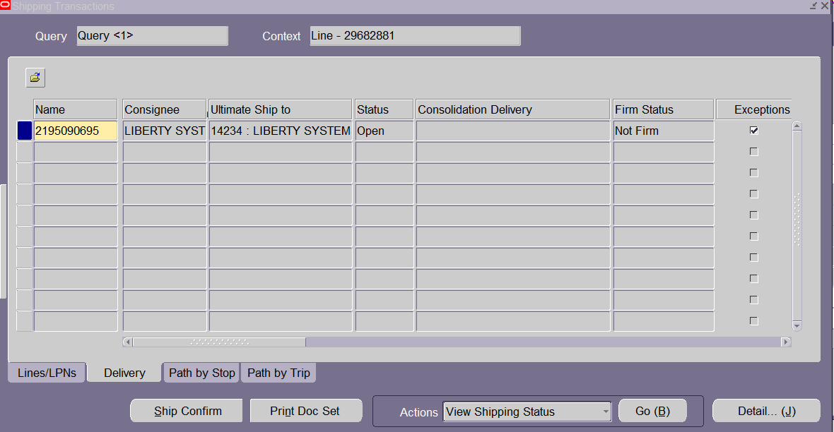

Click Delivery>Ship Confirm

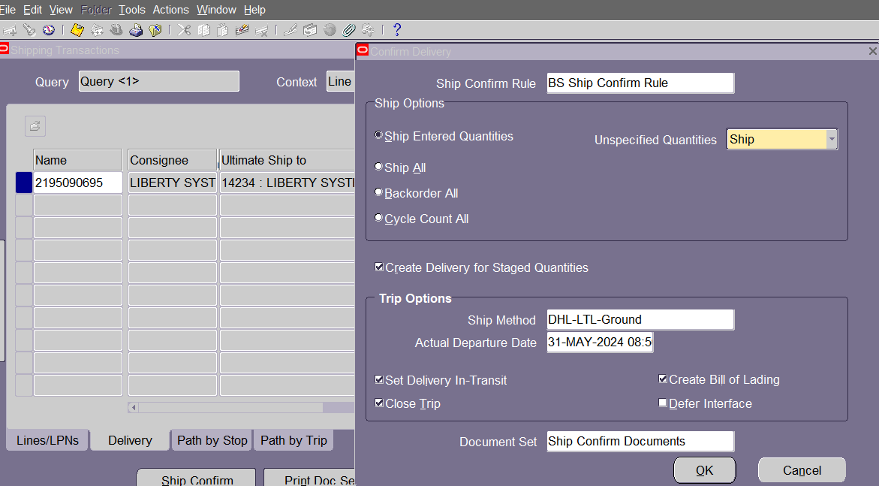

Note :Mandatory Fields are

*Ship Method

*Create Bill of Lading(Tick)

*Defer Interface(Untick)

Ok

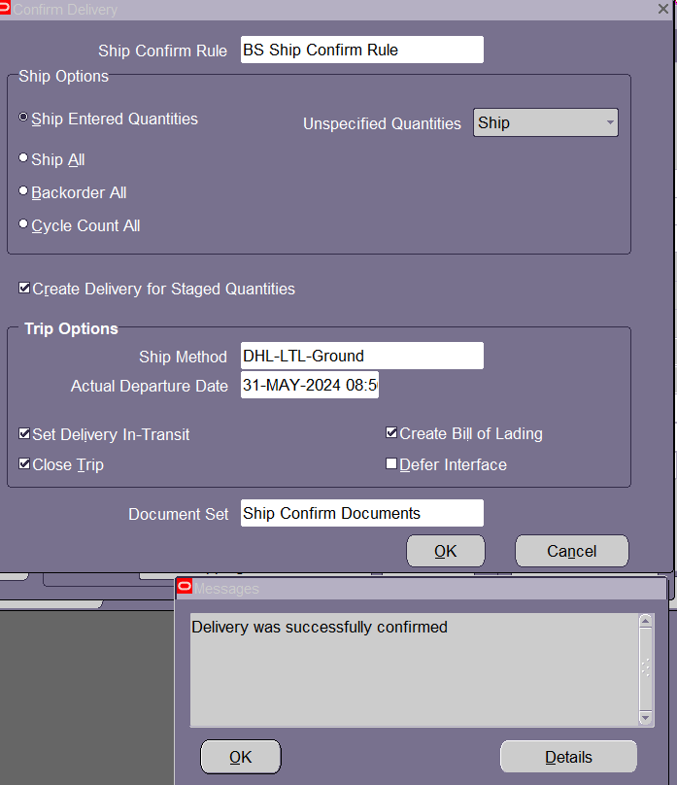

SELECT

HEADER_ID

,LINE_ID

,LINE_TYPE_ID

,FLOW_STATUS_CODE

,LINE_NUMBER

,ORDERED_ITEM

,ORDERED_QUANTITY

,UNIT_LIST_PRICE_PER_PQTY

FROM OE_ORDER_LINES_ALL

WHERE 1=1

AND HEADER_ID = 23737273;

--FLOW_STATUS_CODE='SHIPPED'

SELECT

DELIVERY_DETAIL_ID

,SOURCE_HEADER_ID

,SOURCE_LINE_ID

,CUSTOMER_ID

,INVENTORY_ITEM_ID

,RELEASED_STATUS

FROM WSH_DELIVERY_DETAILS

WHERE 1=1

AND SOURCE_HEADER_ID = 23737273;

--Released_Status='C'

STEP5:  
**5.Create Invoice:**

Responsibility>System Administrator Super User U.S.A

View>Request>Submit New Request>Work Flow Background Process>OM ORDER LINE >YES>YES

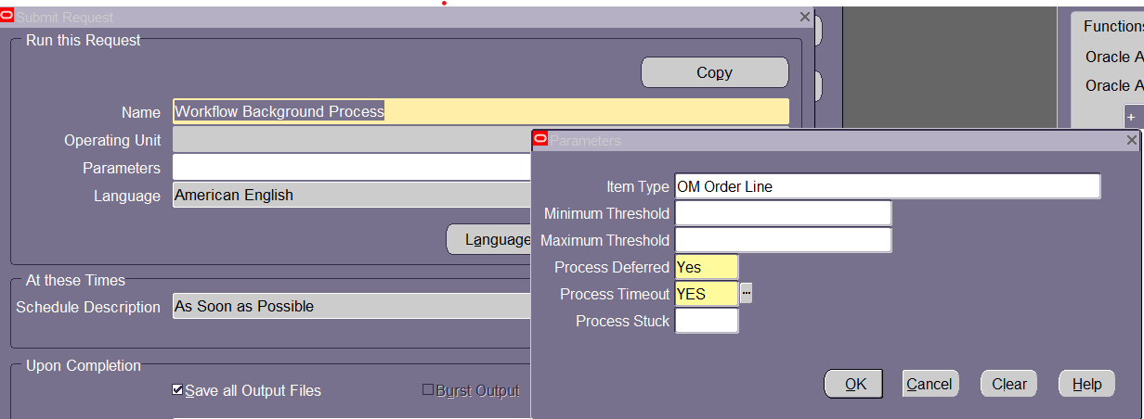

OK

SUBMIT

Navigator> Receivables Super User U.S.A>

View>Request>Submit New Request>Auto Invoice Master Program>

Invoice Source=BS Order Management

Default Date=SYSDATE

(Low)Sales Order Number=Order Number

(High)Sales Order Number=Order Number

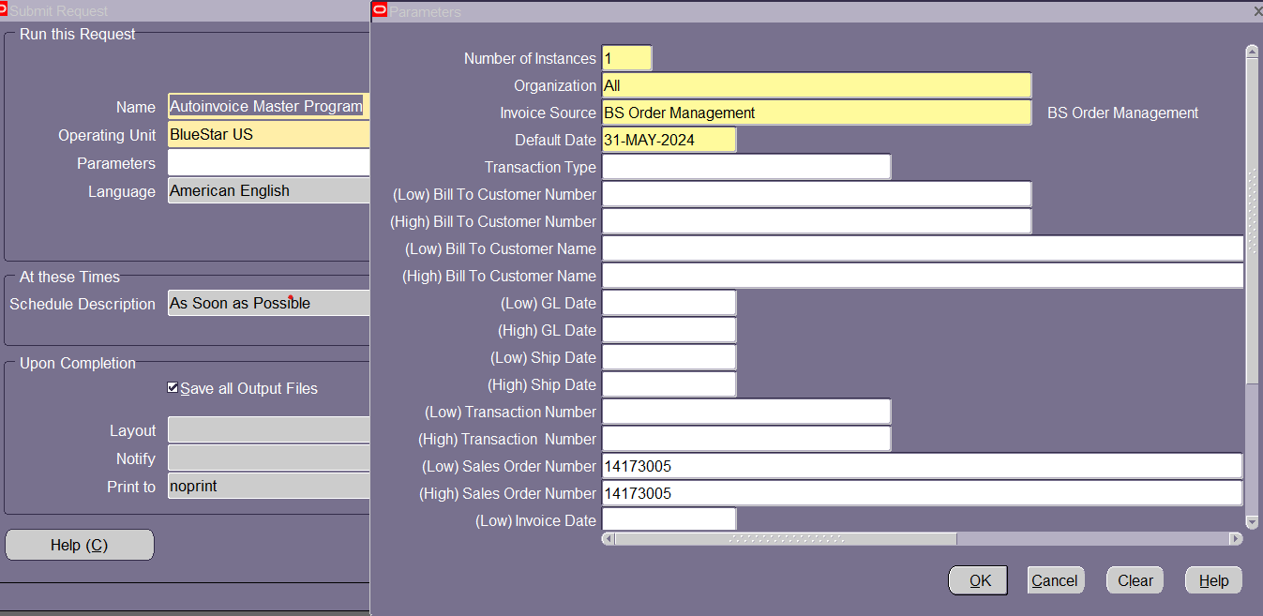

Ok

Submit

GOTO Navigator>Order management Super User U.S.A>Sales Order> Give Order Number>

Actions>Addition Order Information

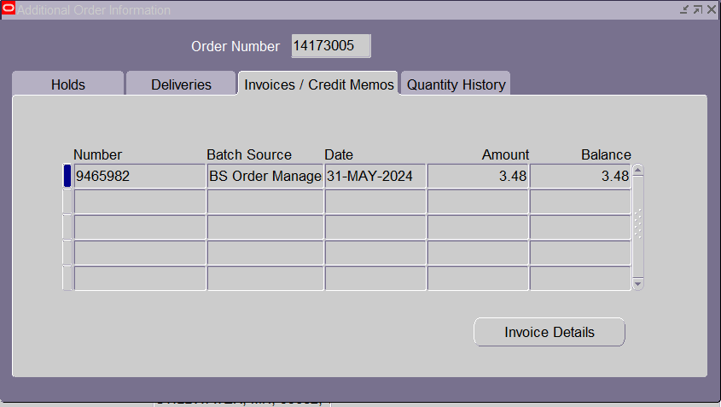

GOTO Receivables super user U.S.A>Transactions>

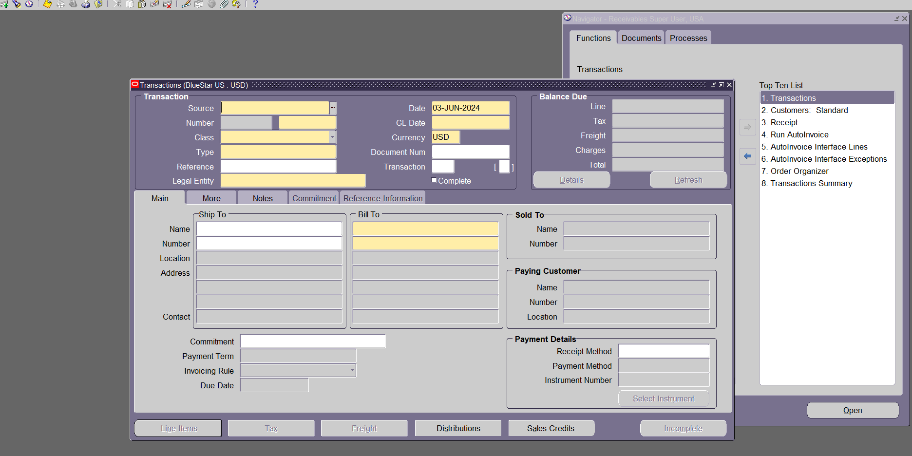

Click torch>give sales order number

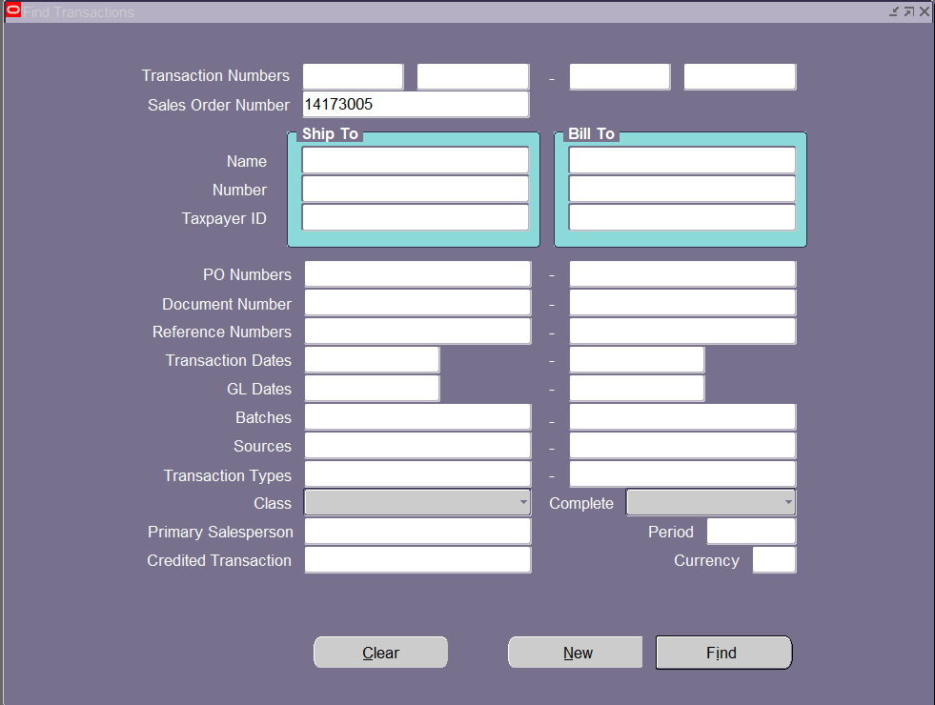

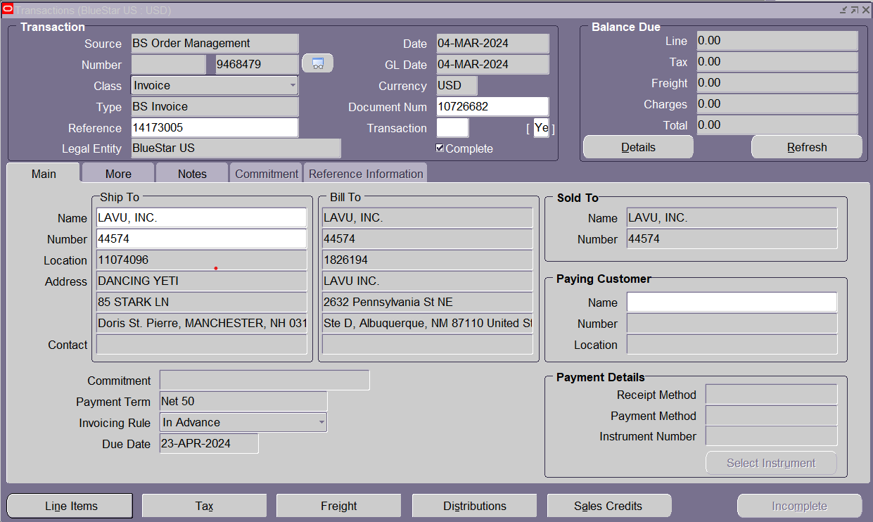

Click line items

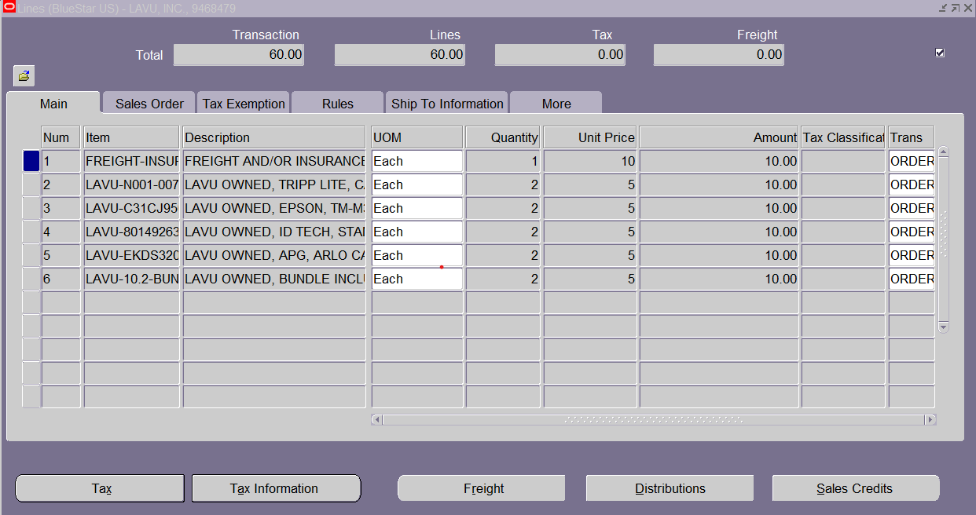

SELECT

CUSTOMER_TRX_ID

,TRX_NUMBER

,INTERFACE_HEADER_ATTRIBUTE1

,INTERFACE_HEADER_ATTRIBUTE2

,INTERFACE_HEADER_ATTRIBUTE3

,INTERFACE_HEADER_CONTEXT

,STATUS_TRX

FROM RA_CUSTOMER_TRX_ALL

WHERE 1=1

AND INTERFACE_HEADER_CONTEXT = 'ORDER ENTRY'

AND INTERFACE_HEADER_ATTRIBUTE1 = ‘14173005’—order number

AND INTERFACE_HEADER_ATTRIBUTE3 = 2195090695 — Delivery_id

ORDER BY CREATION_DATE DESC

SELECT * FROM RA_CUSTOMER_TRX_LINES_ALL

WHERE 1=1

AND TRX_NUMBER = ’10037546’

AND INTERFACE_LINE_CONTEXT = 'ORDER ENTRY'

AND INTERFACE_LINE_ATTRIBUTE1 = 66435

AND INTERFACE_LINE_ATTRIBUTE3 = 3773405

ORDER BY CREATION_DATE DESC

STEP6:

**6.Create receipt:**

Responsibility> Receivables Super U.S.A>Receipts>Receipts>

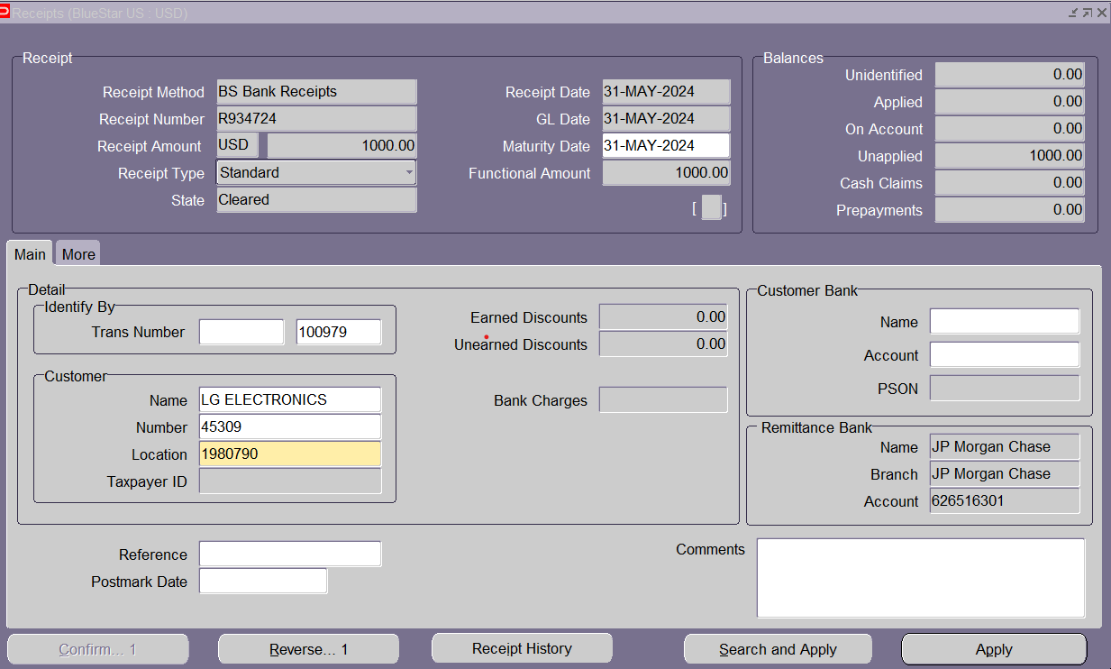

APPLY

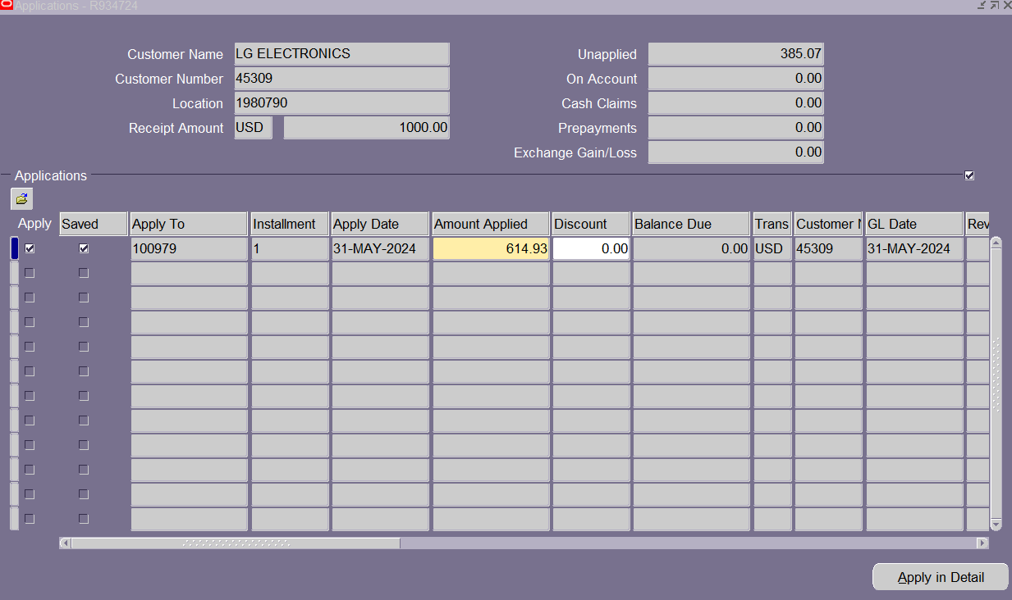

TOOL>Create Accounting

STEP7:

**7.Transfer to General Ledger:**

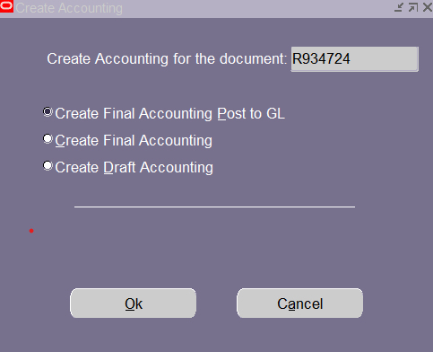

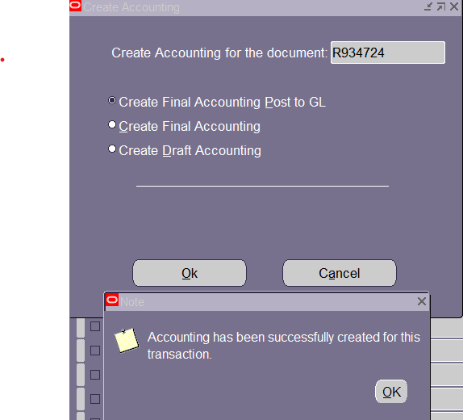

VIEW>REQUESTS>

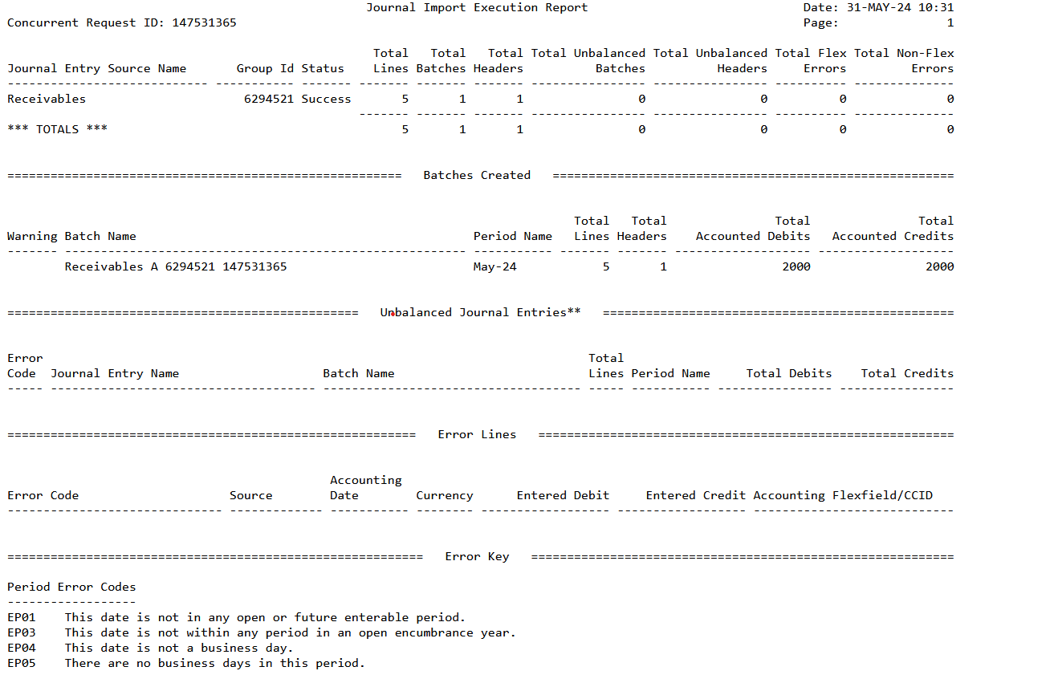

RESPONSIBILITY : GL SUPER USER U.S.A

JOURNALS>ENTER>

