STEP1:

Create a table

CREATE TABLE xxRam_Ramesh_ms_word

(

item_code varchar2(2000),

item_name varchar2(2000),

price Number,

org_id NUMBER,

uom varchar2(2000),

template_name VARCHAR2 (2000)

);

STEP2:

Create an excel sheet with table name columns and save

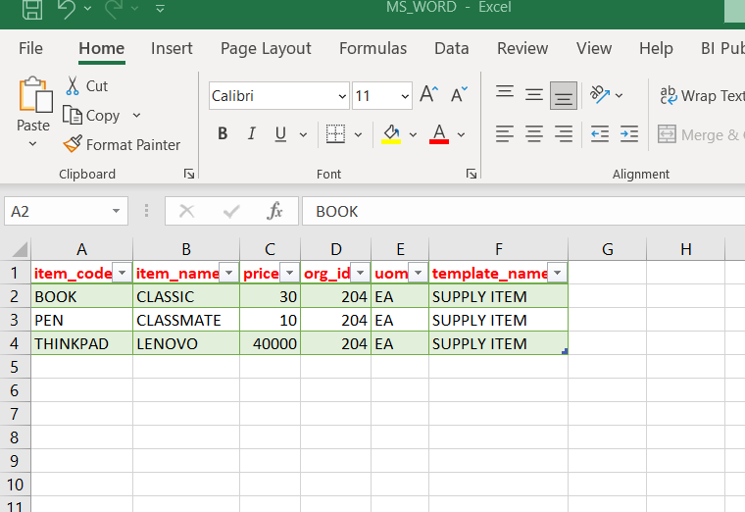

STEP3:

GOTO >DATABASE>IMPORT>IMPORT_TABLE DATA

*SEARCH OBJECT NAME WITH THE CREATED TABLE NAME.*

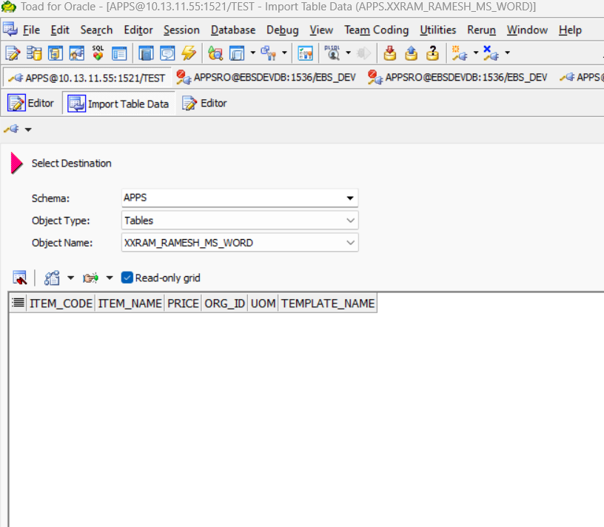

STEP4:  
click Next>change the option to excel file and give your excel file location then click next

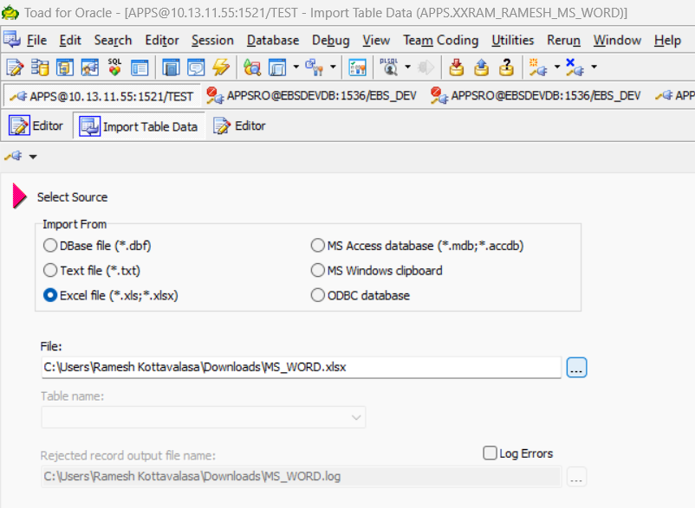

STEP5:

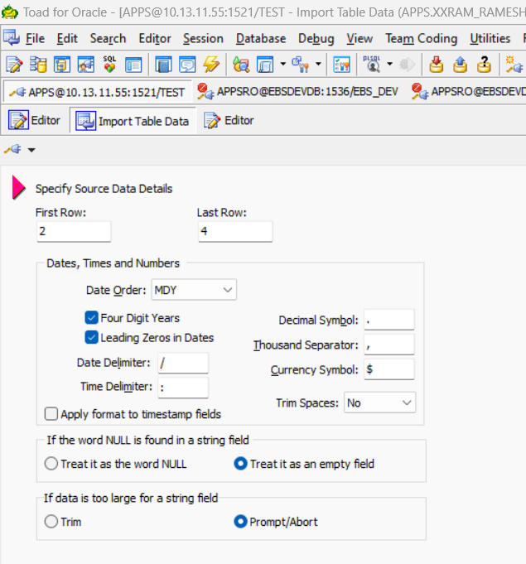

Here give first row:2 & last row to end of the excel column size why first row 2 means the first row is occupied with headings.

Click next

STEP6:  
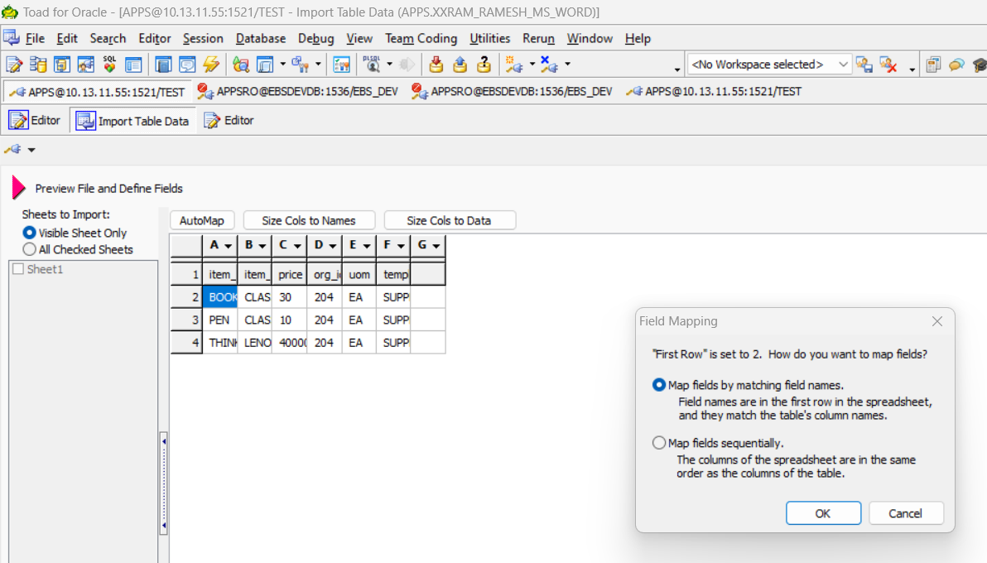

Click ok and hit next.

STEP7:  
click next>next>Execute>

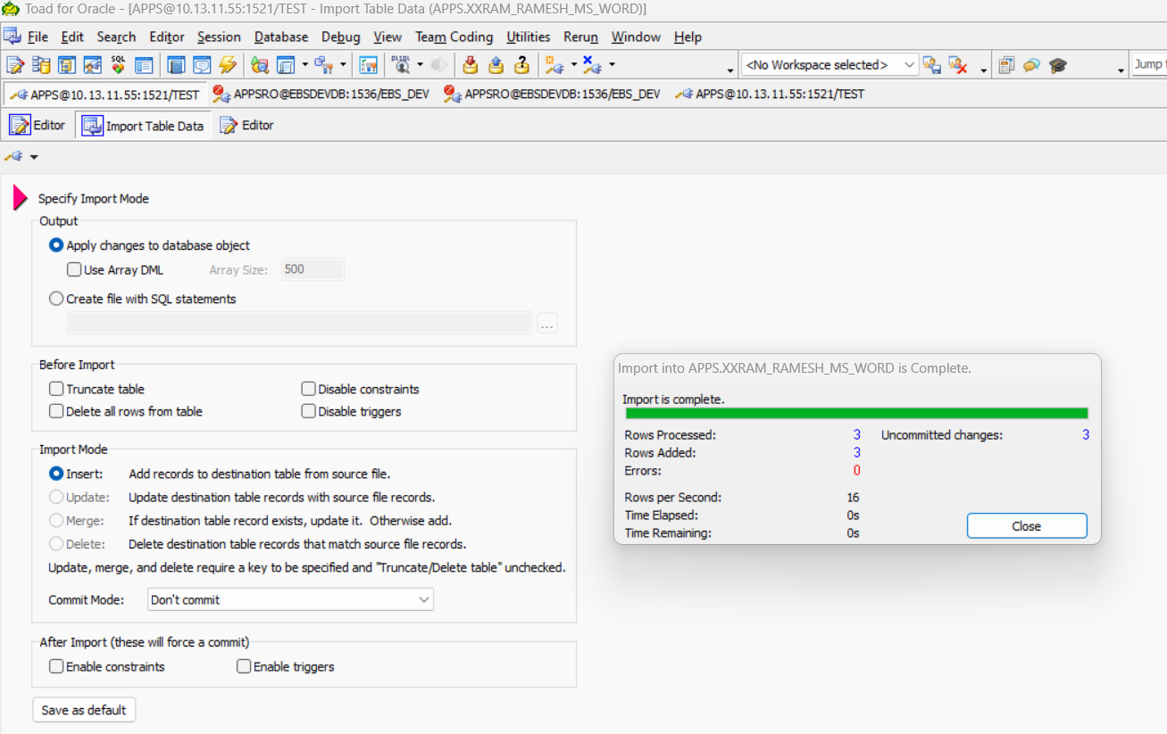

After execution we get like this successfully added excel data into oracle data base.

STEP8:

If you checked with the table name the data is dumped successfully.  
