**TICKET NO: Invoice PO Cost Report - D-Ship Order Lines [#040600]**

Requirement:

->develop one XML based report with this query

->we need .xml file and RTF template

->create new concurrent program with parameters

1.Create one Query for this Columns:

  SELECT xss.oe_line_source_type     oe_line_source_type,  
         xss.creation_date           line_creation_date,  
         xss.organization_code,  
         xss.trx_number              invoice_number,  
         xss.ar_create_date          invoice_date,  
         xss.invoice_currency_code,  
         xss.salesrep_name,  
         xss.account_number,  
         xss.cust_name,  
         xss.order_number,  
         xss.line_number,  
         xss.mfg_code,  
         xss.mfg_desc,  
         xss.item_number,  
         xss.description,  
         xss.quantity_invoiced,  
         xss.uom_code,  
         xss.unit_selling_price,  
         xss.extended_amount,  
         xss.std_unit_cost           std_cost,  
         xss.extend_cost             std_extended_cost,  
         xss.mfg_rebate_amt,  
         xss.mfg_rebate_amt_extend,  
         xss.special_rebate_amt,  
         xss.MFG_REBATE_AMT_EXTEND,  
         --Gross_Margin  
         xss.unit_cost               std_unit_cost,  
         xss.term_name,  
         xss.line_category_code,  
         xss.mfg_program_desc,  
         xss.partner_authorization,  
         xss.partner_level,  
         xss.special_rebate_descr,  
         xss.mfg_price_exception_num,  
         xss.po_number,  
         pol.line_num                po_line_number,  
         xss.price_level             po_cost,  
         --po_cost_ext  
         api.invoice_num             ap_invoice,  
         apil.line_number            ap_invoice_line,  
         api.invoice_amount          ap_invoice_cost  
    --Ap_invoices_cost_Ext  
    FROM oe_drop_ship_sources     oed,  
         apps.xbsi_sales_summary  xss,  
         po_headers_all           poh,  
         po_lines_all             pol,  
         apps.ap_invoice_lines_all apil,  
         ap_invoices_all          api  
   WHERE     1 = 1  
         AND oed.line_id = xss.line_id  
         AND oed.header_id = xss.header_id  
         AND poh.po_header_id = pol.po_header_id  
         AND oed.po_header_id = poh.po_header_id  
         AND oed.po_line_id = pol.po_line_id  
         AND pol.po_header_id = apil.po_header_id  
         AND pol.po_line_id = apil.PO_LINE_ID  
         AND apil.invoice_id = api.invoice_id  
         AND xss.order_number = 14254087  
ORDER BY xss.creation_date DESC;

STEP2:

Create one XML file for this Query:

<?xml version="1.0" encoding="UTF-8"?>

<dataTemplate>

<parameters>

<parameter name="p_mfg_code" datatype="character" defaultValue=""/>

<parameter name="p_start_date" datatype="DATE" defaultValue=""/>

<parameter name="p_end_date" datatype="DATE" defaultValue=""/>

<parameter name="p_bs_org" datatype="character" defaultValue=""/>

</parameters>

<dataQuery>

<sqlStatement name="G_PO_DATA">

<![CDATA[

SELECT xss.OPERATING_UNIT_ID,

xss.oe_line_source_type oe_line_source_type,

xss.creation_date line_creation_date,

xss.organization_code,

xss.trx_number invoice_number,

xss.ar_create_date invoice_date,

xss.invoice_currency_code,

xss.salesrep_name,

xss.account_number,

xss.cust_name,

xss.order_number,

xss.line_number,

xss.mfg_code,

xss.mfg_desc,

xss.item_number,

xss.description,

xss.quantity_invoiced,

xss.uom_code,

xss.unit_selling_price,

xss.extended_amount,

xss.std_unit_cost std_cost,

xss.extend_cost std_extended_cost,

xss.mfg_rebate_amt,

xss.mfg_rebate_amt_extend,

xss.special_rebate_amt,

xss.MFG_REBATE_AMT_EXTEND,

NULL Gross_Margin,

xss.unit_cost std_unit_cost,

xss.term_name,

xss.line_category_code,

xss.mfg_program_desc,

xss.partner_authorization,

xss.partner_level,

xss.special_rebate_descr,

xss.mfg_price_exception_num,

xss.po_number,

pol.line_num po_line_number,

xss.price_level po_cost,

NULL po_cost_ext,

api.invoice_num ap_invoice,

apil.line_number ap_invoice_line,

api.invoice_amount ap_invoice_cost,

NULL ap_invoices_cost_Ext

FROM oe_drop_ship_sources oed,

apps.xbsi_sales_summary xss,

po_headers_all poh,

po_lines_all pol,

apps.ap_invoice_lines_all apil,

ap_invoices_all api

WHERE 1 = 1

AND oed.line_id = xss.line_id

AND oed.header_id = xss.header_id

AND poh.po_header_id = pol.po_header_id

AND oed.po_header_id = poh.po_header_id

AND oed.po_line_id = pol.po_line_id

AND pol.po_header_id = apil.po_header_id

AND pol.po_line_id = apil.PO_LINE_ID

AND apil.invoice_id = api.invoice_id

AND xss.mfg_code = :p_mfg_code

AND TRUNC (xss.ar_create_date) >= TRUNC ( :p_start_date)

AND TRUNC (xss.ar_create_date) <=

(CASE

WHEN :p_end_date IS NULL THEN TRUNC ( :p_start_date)

ELSE TRUNC ( :p_end_date)

END)

AND xss.OPERATING_UNIT_ID IN

(CASE

WHEN UPPER ( :p_bs_org) = 'BSUS' THEN 121

WHEN UPPER ( :p_bs_org) = 'BSCA' THEN 124

WHEN UPPER ( :p_bs_org) = 'BSLA' THEN 165

WHEN UPPER ( :p_bs_org) = 'BSMA' THEN 185

ELSE NULL

END)

ORDER BY xss.ar_create_date;

]]>

</sqlStatement>

</dataQuery>

<dataStructure>

<group name="G_INVOICE" source="G_PO_DATA">

<element name="OE_LINE_SOURCE_TYPE" value="oe_line_source_type"/>

<element name="LINE_CREATION_DATE" value="line_creation_date"/>

<element name="ORGANIZATION_CODE" value="organization_code"/>

<element name="INVOICE_NUMBER" value="invoice_number"/>

<element name="INVOICE_DATE" value="invoice_date"/>

<element name="INVOICE_CURRENCY_CODE" value="invoice_currency_code"/>

<element name="SALESREP_NAME" value="salesrep_name"/>

<element name="ACCOUNT_NUMBER" value="account_number"/>

<element name="CUST_NAME" value="cust_name"/>

<element name="ORDER_NUMBER" value="order_number"/>

<element name="LINE_NUMBER" value="line_number"/>

<element name="MFG_CODE" value="mfg_code"/>

<element name="MFG_DESC" value="mfg_desc"/>

<element name="ITEM_NUMBER" value="item_number"/>

<element name="DESCRIPTION" value="description"/>

<element name="QUANTITY_INVOICED" value="quantity_invoiced"/>

<element name="UOM_CODE" value="uom_code"/>

<element name="UNIT_SELLING_PRICE" value="unit_selling_price"/>

<element name="EXTENDED_AMOUNT" value="extended_amount"/>

<element name="STD_COST" value="std_cost"/>

<element name="STD_EXTENDED_COST" value="std_extended_cost"/>

<element name="MFG_REBATE_AMT" value="mfg_rebate_amt"/>

<element name="MFG_REBATE_AMT_EXTEND" value="mfg_rebate_amt_extend"/>

<element name="GROSS_MARGIN" value="gross_margin"/>

<element name="SPECIAL_REBATE_AMT" value="special_rebate_amt"/>

<element name="UNIT_COST" value="std_unit_cost"/>

<element name="TERM_NAME" value="term_name"/>

<element name="LINE_CATEGORY_CODE" value="line_category_code"/>

<element name="MFG_PROGRAM_DESC" value="mfg_program_desc"/>

<element name="PARTNER_AUTHORIZATION" value="partner_authorization"/>

<element name="PARTNER_LEVEL" value="partner_level"/>

<element name="SPECIAL_REBATE_DESCR" value="special_rebate_descr"/>

<element name="MFG_PRICE_EXCEPTION_NUM" value="mfg_price_exception_num"/>

<element name="PO_NUMBER" value="po_number"/>

<element name="PO_LINE_NUMBER" value="po_line_number"/>

<element name="PO_COST" value="po_cost"/>

<element name="PO_COST_EXT" value="po_cost_ext"/>

<element name="AP_INVOICE" value="ap_invoice"/>

<element name="AP_INVOICE_LINE" value="ap_invoice_line"/>

<element name="AP_INVOICE_COST" value="ap_invoice_cost"/>

<element name="AP_INVOICES_COST_EXT" value="ap_invoices_cost_Ext"/>

</group>

</dataStructure>

</dataTemplate>

STEP3:

Loading Data Through BI-PUBLISHER:

Open MS Word>Add xml file to sample XML it says Data loaded Successfully

Later Table Wizard open in Excel format you will get data like this.

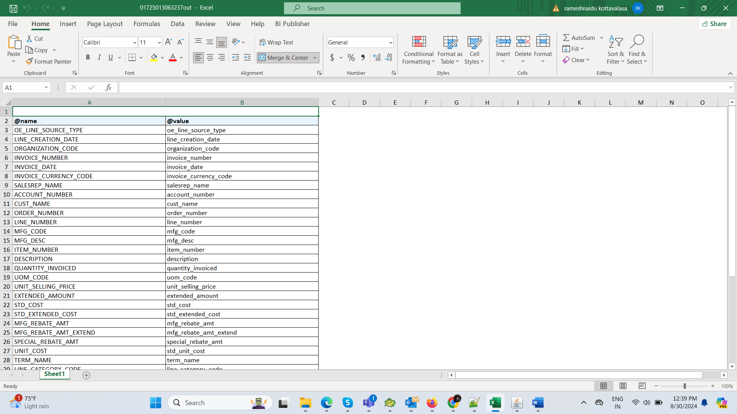

STEP4:

Create one Concurrent Program:

Program_Name: BS Invoice PO Cost Report

Short_Name: BSINV_POCOS

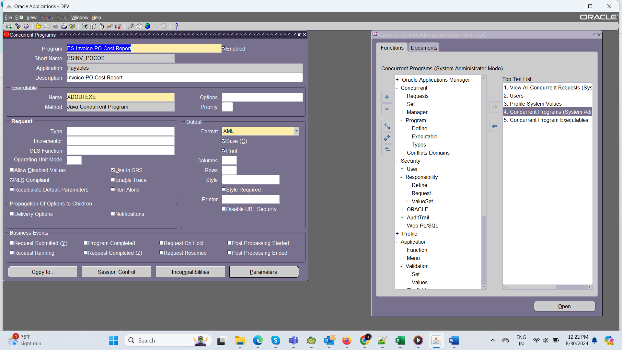

NOTE: Executable name must be ‘XDODTEXE’

Assign this program name to the Responsibility like System administrator>Security>Responsibility>Request>ctrlf11>

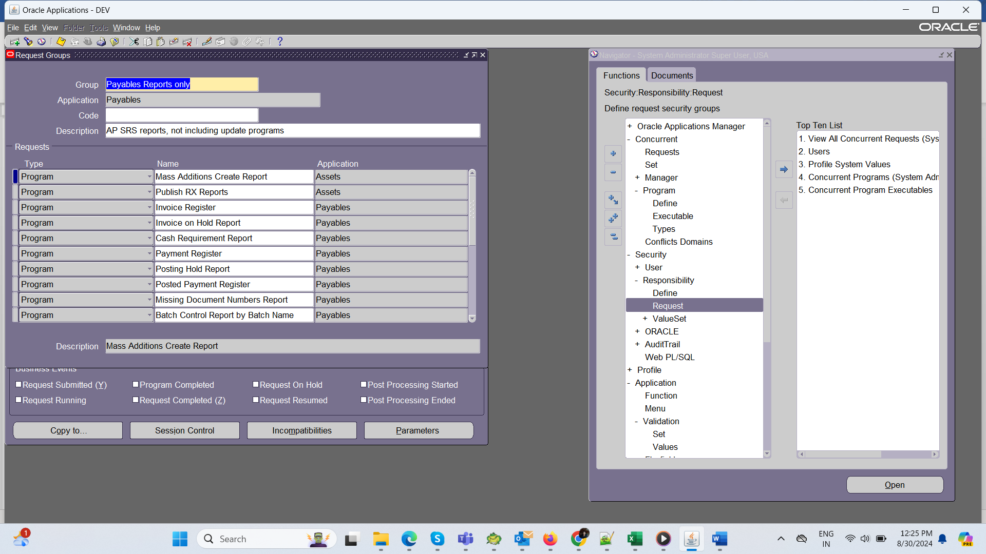

Create one new

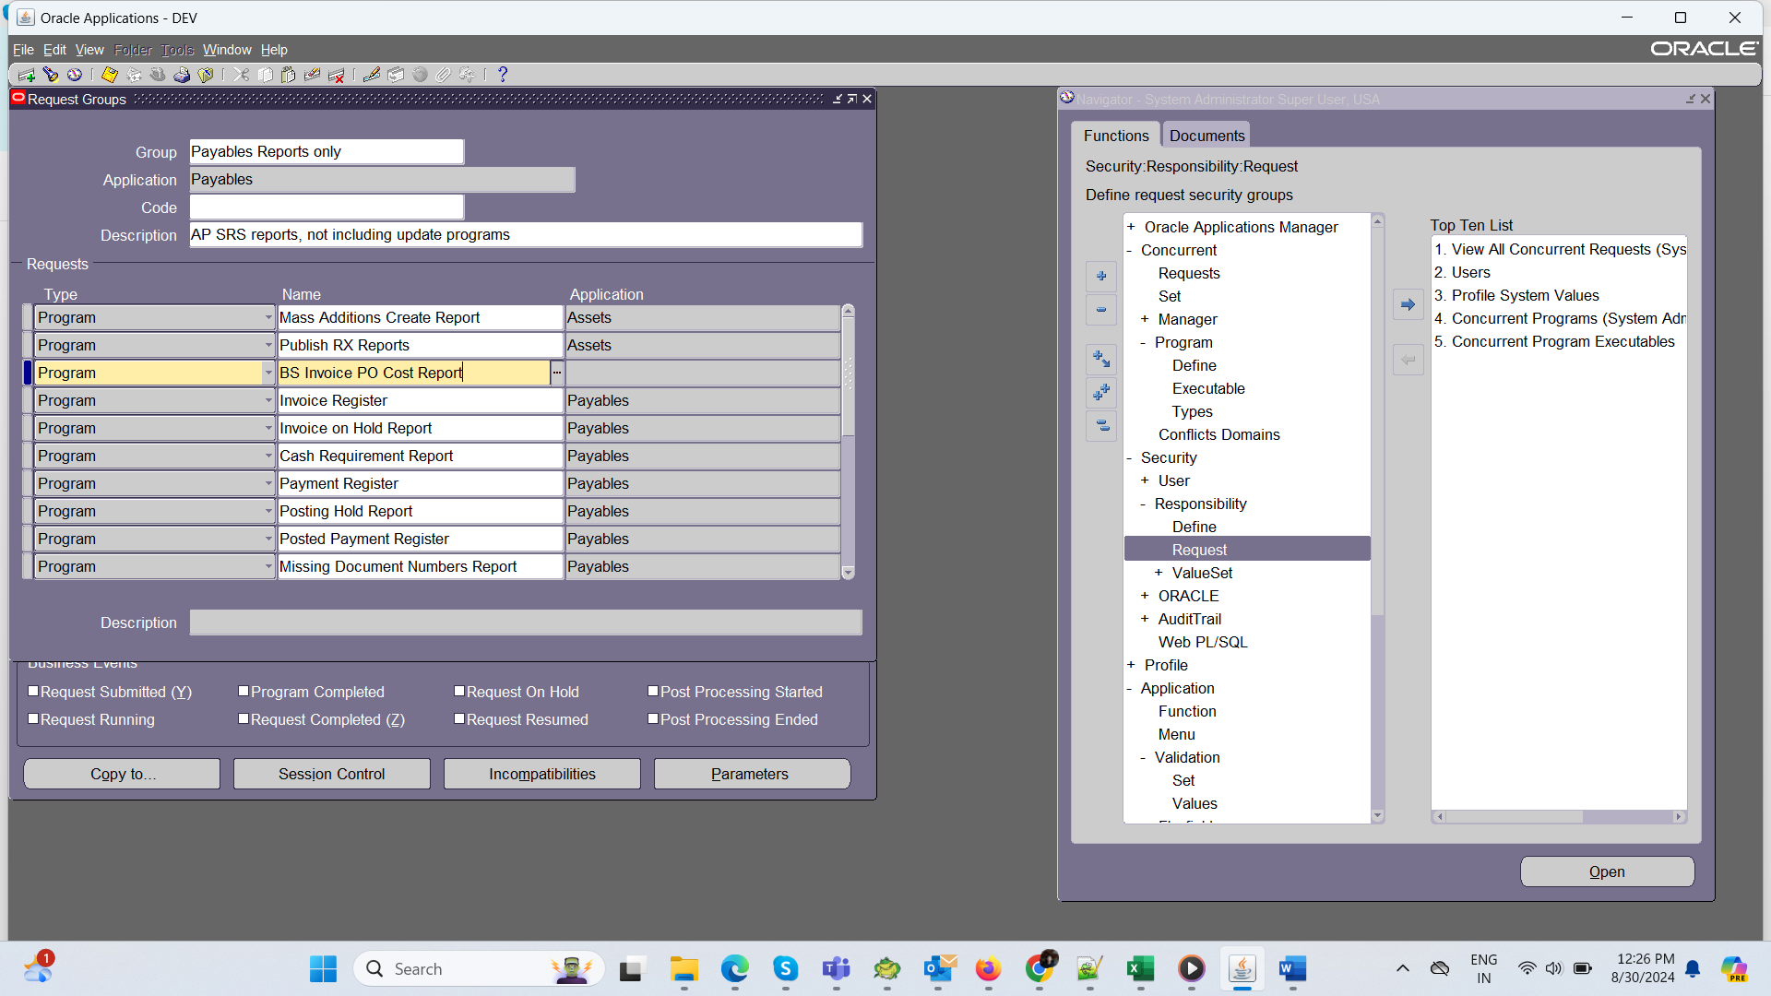

After creating Concurrent Program Create data definition and data Template.

STEP5:

Data Definition:

*Take Concurrent program short name (copy)

*Goto XML publisher>Home>Define.

*paste that short name>go

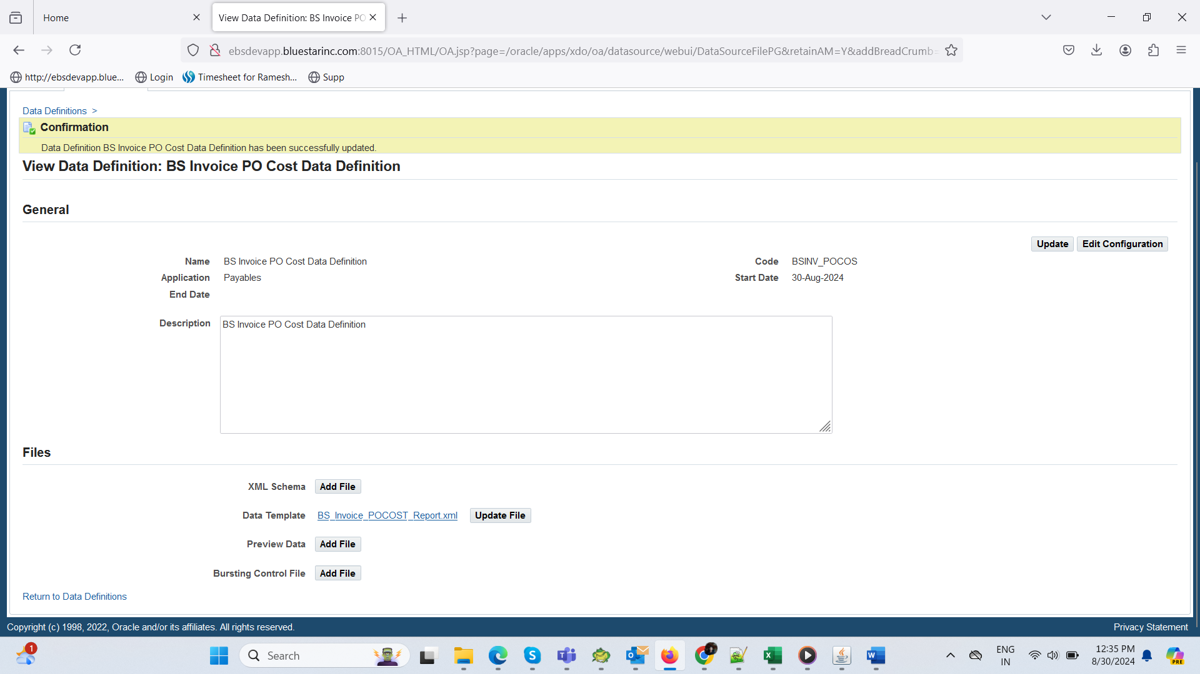

Add XML file in Data Template.

STEP6:

Data Template:

* Create Data Template like Below

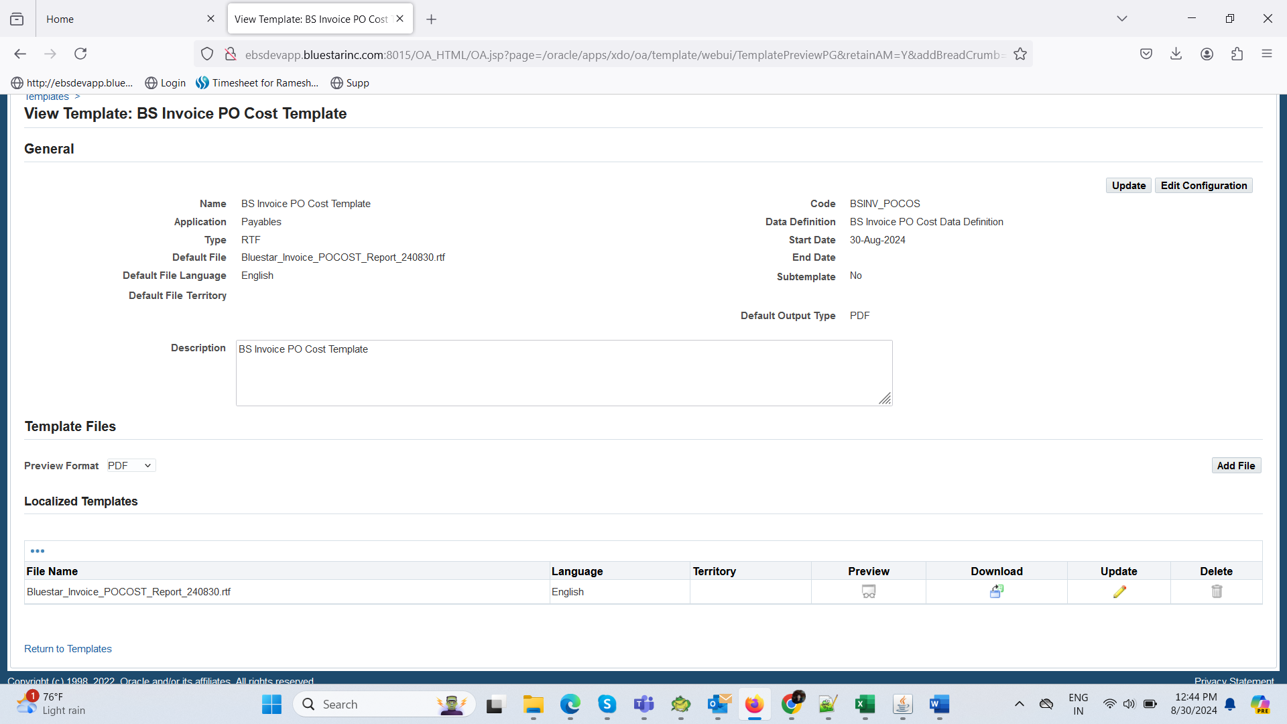

*Add .RTF file means

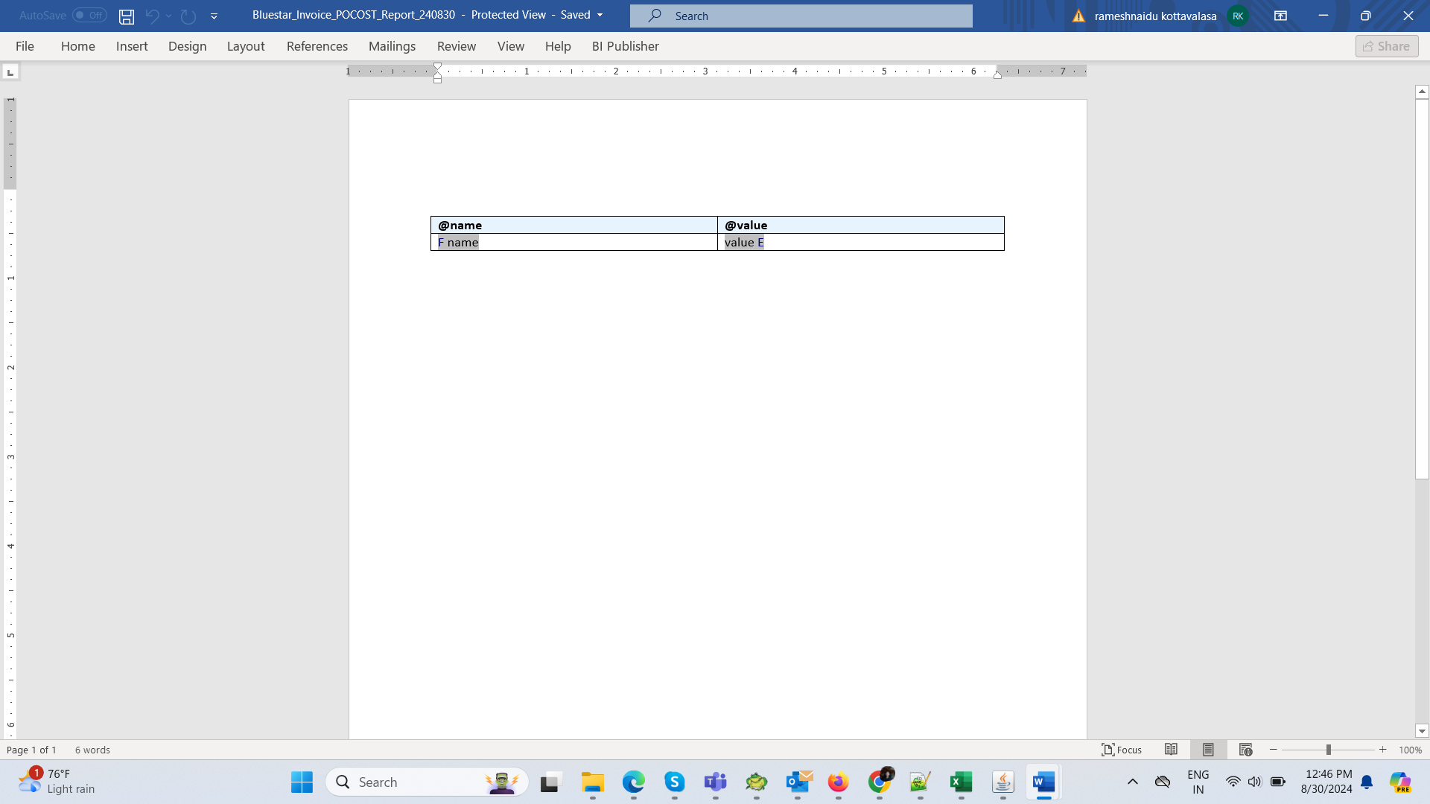

*Add this file in Data Template.

STEP7:

In excel create one excel sheet with columns.  
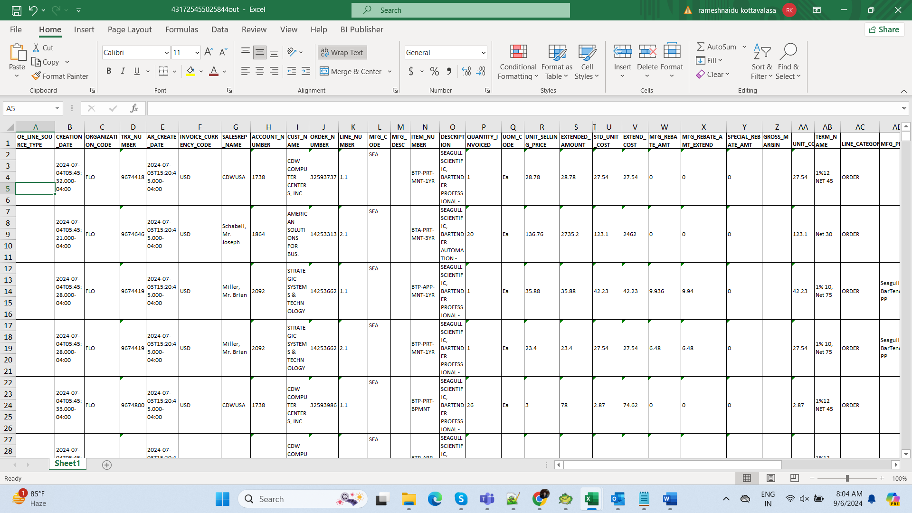

And bi publisher add xml >open in excel or pdf Formate.