Exp No: 3 Represent all entities and relationships in a tabular fashion(Relational Model)

**E-R Diagram for E-Commerce**

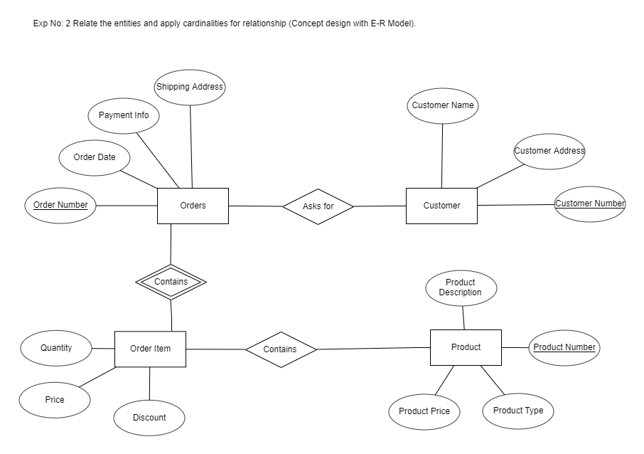

Orders: Customer:

|  |  |  |
| --- | --- | --- |
| **Column Name** | **Data Type** | **Constraint** |
| Order Number | Integer | Primary Key |
| Order Date | Date |  |
| Payment Info | Integer |  |
| Shipping Address | Varchar(50) |  |

|  |  |  |
| --- | --- | --- |
| **Column Name** | **Data Type** | **Constraint** |
| Customer Number | Integer | Primary Key |
| Customer Name | Varchar(20) |  |
| Customer Address | Varchar(50) |  |

Order Item: Product:

|  |  |  |
| --- | --- | --- |
| **Column Name** | **Data Type** | **Constraint** |
| Price | Decimal |  |
| Quantity | Integer |  |
| Discount | Decimal |  |

|  |  |  |
| --- | --- | --- |
| **Column Name** | **Data Type** | **Constraint** |
| Product Number | Integer | Primary Key |
| Product Type | Varchar(20) |  |
| Product Description | Varchar(50) |  |
| Product Price | Decimal |  |
| Result | Varchar(50) |  |