**Exp No:7 Practice Queries using ANY, ALL, IN, EXISTS, UNION, INTERSECT Set Operators**

**SELECT ProductName FROM Products WHERE ProductID = ANY ( SELECT ProductID FROM OrderDetails WHERE Quantity = 10);**

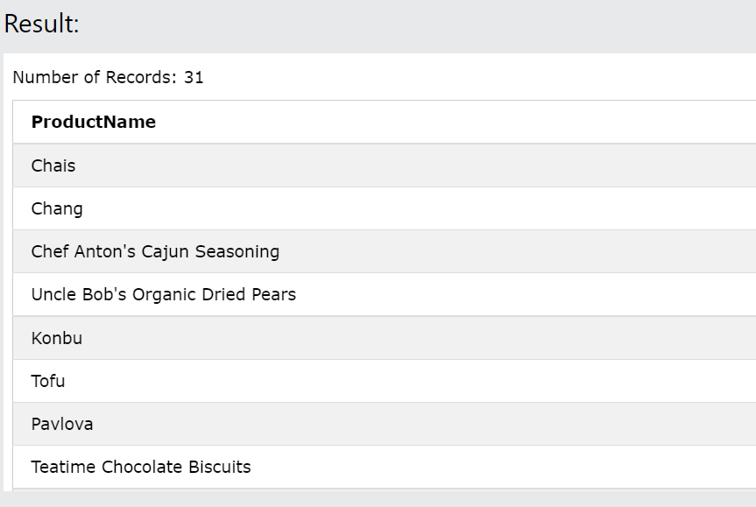

**SELECT ALL ProductName FROM Products WHERE TRUE;**

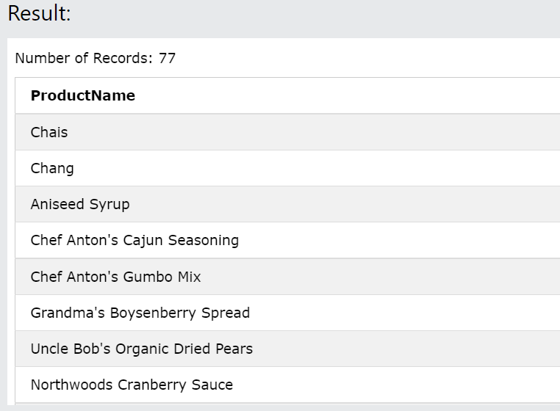

**SELECT ProductName FROM Products WHERE ProductID = ALL (SELECT ProductID FROM OrderDetails WHERE Quantity = 10);**

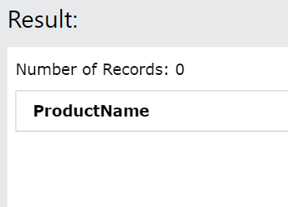

**SELECT * FROM Customers WHERE Country IN ('Germany', 'France', 'UK');**

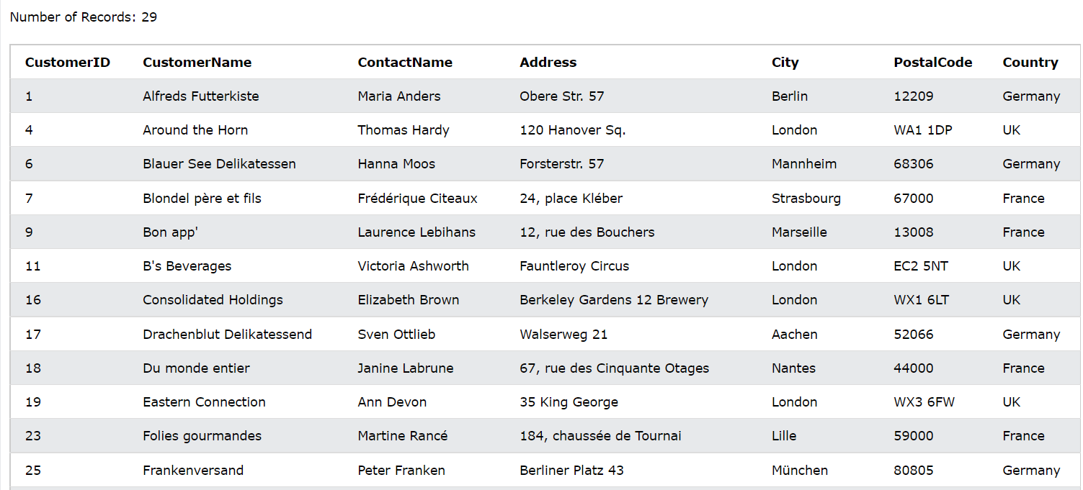

**SELECT * FROM Customers WHERE Country NOT IN ('Germany', 'France', 'UK');**

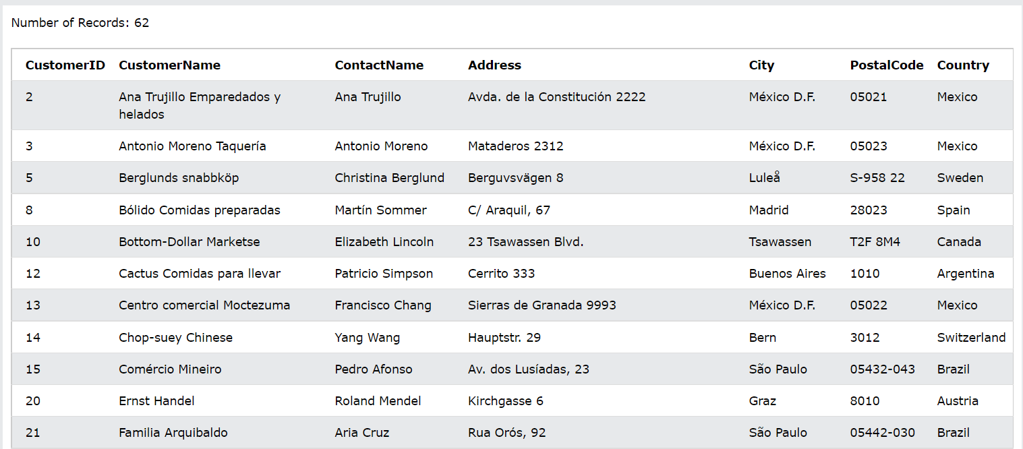

**SELECT * FROM Customers WHERE Country IN (SELECT Country FROM Suppliers);**

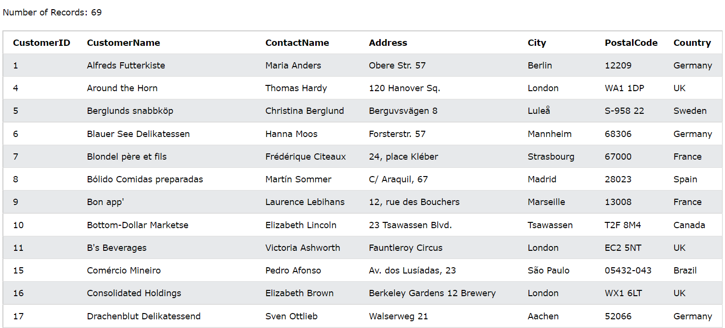

**SELECT SupplierName FROM Suppliers WHERE EXISTS (SELECT ProductName FROM Products WHERE Products.SupplierID = Suppliers.supplierID AND Price < 20);**

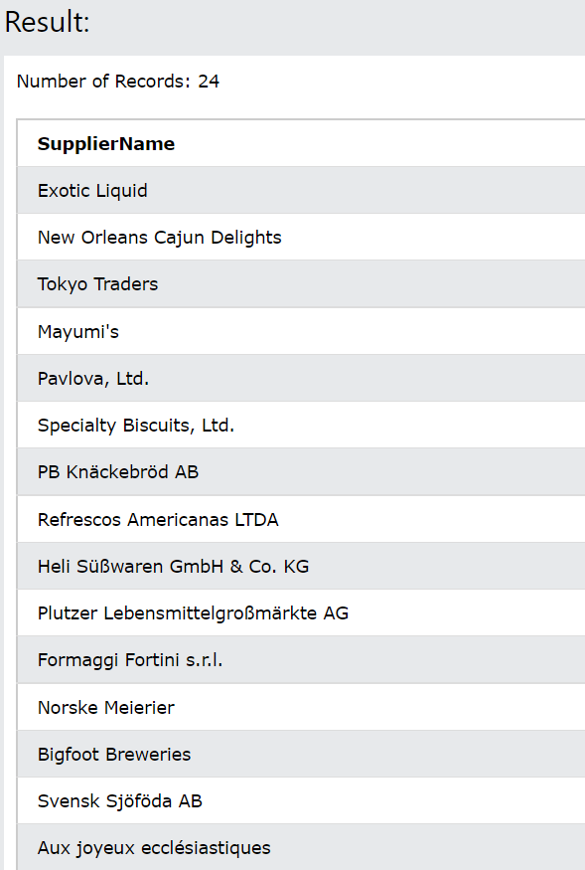

**SELECT 'Customer' AS Type, ContactName, City, Country FROM Customers UNION SELECT 'Supplier', ContactName, City, Country FROM Suppliers;**

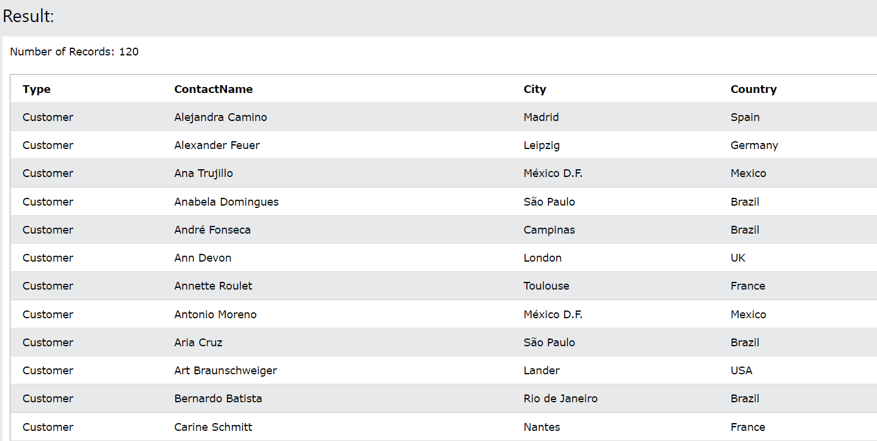

**SELECT supplier_id FROM suppliers INTERSECT SELECT supplier_id FROM orders;**