**Experiment 4 and 5**

The DDL commands in SQL are used to create database schema and to define the type and structure of the data that will be stored in a database. SQL DDL commands are further divided into the following major categories:

* CREATE
* ALTER
* DROP
* TRUNCATE

create database db;

use db;

create table employee(emp_id int not null,emp_name varchar(20) not null,DOB date,primary key(emp_id));

desc employee;

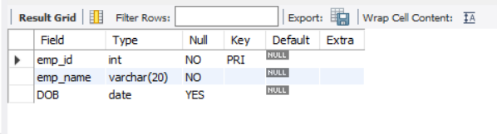

drop table employee;

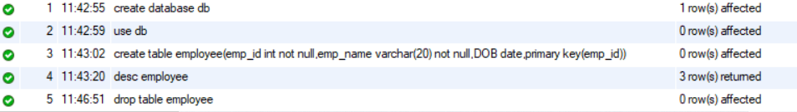

create table employee(emp_id int not null,emp_name varchar(20) not null,DOB date,age int,primary key(emp_id));



rename table employee to employees;



desc employees;

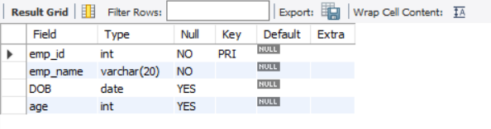

alter table employees add email varchar(20);



truncate employees;

